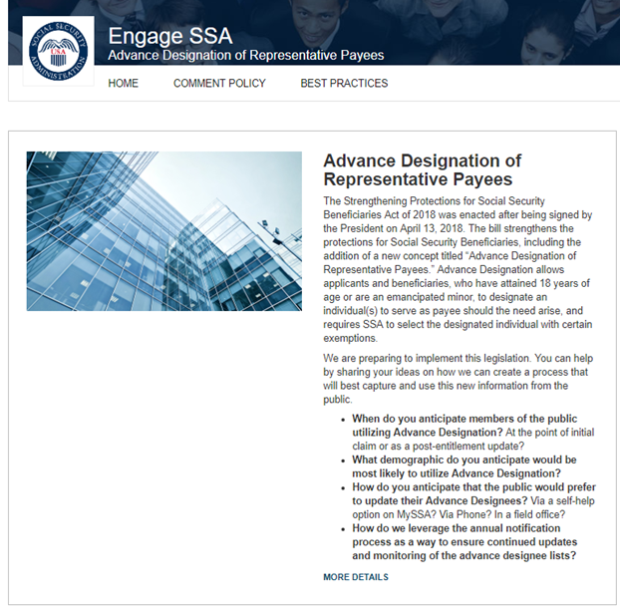

The screenshot above shows a sample of possible questions that may be asked in the IdeaScale forum.