Kevin Liebkemann - Moderator
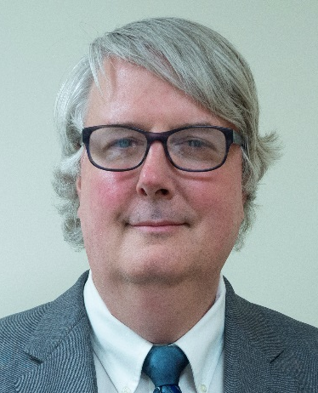

Chief Counsel

Legal Services of New Jersey

Kevin Liebkemann is Chief Counsel for Disability Rights and Veterans Rights at Legal Services of New Jersey (LSNJ), a not-for-profit company providing free legal services to people who cannot afford representation. He has published over 30 articles on disability-related legal topics. Kevin has drafted and presented materials at over 50 continuing legal education sessions to help enable attorneys and advocates to better assist people with disabilities. He has represented clients in Social Security Disability claims for 25 years and currently handles an active caseload of Social Security Disability cases at the ALJ hearing level through Federal District Court. His practice area also includes advising clients concerning disability rights, work incentive programs, and Veterans legal issues. Kevin meets with groups of physicians and other clinicians at hospitals served by LSNJ’s Legal Assistance for Medical Patients program, for presentations on the topic of how to properly and ethically document disability.
Kevin works with other advocates who identify needs for positive policy changes for people with disabilities, and then advocate for those changes. One of several recent efforts included presenting materials at the National Academies of Science, Engineering, and Medicine’s Committee on Functional Assessment for Adults with Disabilities. Kevin recently received the Eileen P. Sweeney Award for outstanding service resulting in significant improvement for Social Security claimants and increase in the availability of advocacy for Social Security claimants. Kevin is a graduate of the Tulane School of Law (1991).

Andy Gettinger

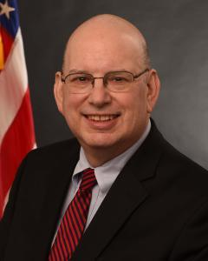

Chief Clinical Officer

Office of the National Coordinator for Health Information Technology (ONC)
Dr. Andrew Gettinger serves as chief clinical officer for ONC. He is a professor of anesthesiology, adjunct professor of computer science at Dartmouth, and senior scholar at the Koop Institute, Geisel School of Medicine at Dartmouth, and was formerly the chief medical information officer (CMIO) for Dartmouth-Hitchcock and associate dean for clinical informatics at Geisel.
Dr. Gettinger has extensive experience in the field of health information technology. He led the development of an electronic health record (EHR) system at Dartmouth and subsequently was the senior physician leader during Dartmouth’s transition to a vendor-based EHR. Dr. Gettinger’s clinical practice and research has been focused both on anesthesiology and critical care medicine, and on information technology as it applies generally to health care.
He founded the clinical informatics group at Dartmouth. He has been an active participant in the policy debates regarding patient privacy at both the state and federal level, testifying before the senate HELP committee. He recently completed service in Senator Orrin G. Hatch’s office as a Robert Wood Johnson health policy fellow.
Dr. Gettinger received his A.B. from Dartmouth College and his M.D. from Dartmouth Medical School. He trained at the Hartford Hospital, Boston Children’s Hospital, and Dartmouth-Hitchcock Medical Center in anesthesiology, pediatric anesthesiology, and critical care medicine. He is board certified in anesthesiology, critical care medicine and was among the inaugural cohort of physicians certified in clinical informatics by the American Board of Preventive Medicine in 2013.
Mariann Yeager
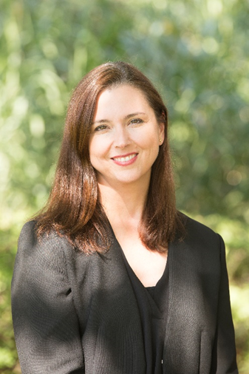
Chief Executive Officer
The Sequoia Project
Mariann Yeager (CEO) has more than 20 years of experience in the health information technology field. She currently serves as CEO for The Sequoia Project, a non-profit solely focused on advancing secure, interoperable nationwide health data sharing in the US. The Sequoia Project serves as a steward of independently governed health IT interoperability initiatives including the eHealth Exchange, Carequality, and the RSNA Image Share Validation Program. Under her leadership, the eHealth Exchange has more than quadrupled connectivity, making it not only the first but the largest public-private health data sharing network in the US, connecting more than 75% of all US hospitals, four federal agencies, and supporting 120 million patients including active duty, retired, and veteran service members and their families. Ms. Yeager also led the successful launch of Carequality which is now interconnecting data sharing networks much like the telecommunications industry did for linking cell phone networks. Today, more than 600,000 physicians are enabled to share health information across 35,000 clinics and 1,250 hospitals via the framework. Prior to her tenure at The Sequoia Project, she worked with the HHS Office of National Coordinator (ONC) for five years on nationwide health information network initiatives. She also led the launch and operation of the first ambulatory and inpatient EHR certification program in the US.

Hans Buitendijk, M.Sc.

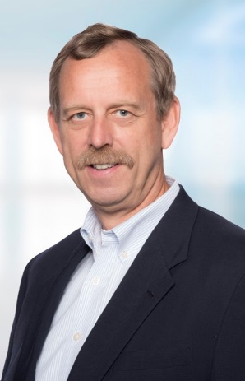

Director, Interoperability Strategy
Cerner
For more than 35 years Hans Buitendijk, M.Sc., FHL7, has been involved in the development of HIT solutions, client consulting on strategic IT planning, health care application development and implementations, large scale business process re-engineering and systems integration, complex project management, and interoperability standards development, bridging the gap between business process optimization and IT support. As Director of Interoperability Strategy at Cerner, Hans Buitendijk is primarily focused on establishing and propagating industry standards to enable interoperability across the diverse systems prevalent in health IT. He represents Cerner in various industry organizations to advance interoperability such as HL7 (board member and workgroup co-chair), IHE (participant), EHRA (executive committee member and workgroup chair), CommonWell (participant), Carequality (steering committee member), and the Da Vinci initiative (steering committee vice-chair) to increase adoption of standards based interoperability.

Dr. William Gray-Roncal

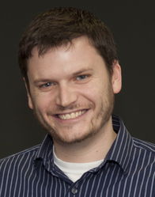

Senior Research Engineer
Johns Hopkins Applied Physics Laboratory

John Mattison, M.D.

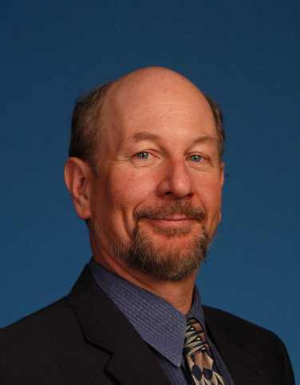

Chief Medical Information Officer and Assistant Medical Director

Kaiser Permanente
John Mattison, M.D. practiced Internal Medicine, Critical Care, Trauma Medicine, Primary Care and Preventive Medicine. He currently is Assistant Medical Director and Chief Medical Information Officer (CMIO) for the largest region of Kaiser Permanente, and co-chairs KP National Virtual Care and Virtual Visit Programs. He has been actively involved in standards development for several decades. He founded the international XML standard for healthcare interoperability, now represented by Health Level 7 (HL7) Clinical Document Architecture (CDA, cCDA) and Continuity of Care Document (CCD) standards. His work includes membership on various FACAs and participation in the JASON’s first report on Health IT.
He currently chairs the eHealth workgroup of the Global Alliance for Genomics and Health (GA4GH). John actively participates in the American Medical Association initiative for Digital Medicine Payment Advisory Group (DMPAG), which is defining and recommending standards for coding and reimbursement for telemedicine and all digital medicine in the US. John led the largest deployment of an integrated electronic health record in the US, and continues to sponsor one of the most advanced health analytics team in the US.
He has published numerous paper, book chapters and is co-editor of the 2017 McGraw Hill textbook on Health IT. His work has resulted in various national awards and has been cited in WSJ, Forbes, and many others. He is an active innovator in genomics, AI big data analytics, medical applications of drones, IOT, blockchain, bioinformatics, mobile healthcare, regulatory policy, telemedicine, privacy, ethics in precision medicine, and is involved in several global not-for-profit initiatives for health and internet access, He is a board member of numerous not-for-profit boards dedicated to improving health, wellness, and resilience of diverse communities, especially those focused on improving early childhood experiences. He is passionate about using modern technology to restore ancient wisdom and create a ‘behaviroal symphony for wellness’. He is faculty at Singularity University and lectures frequently at numerous universities globally, and is a consultant to the X-Prize. Numerous keynote addresses are available on YouTube.

Brian Jones, DO

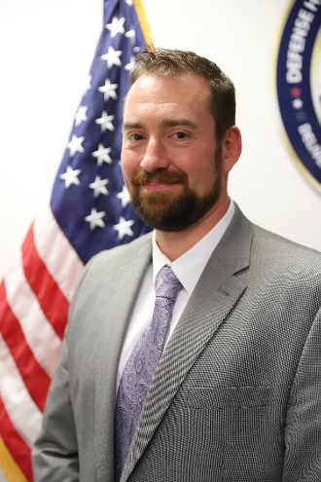

Managing Director

Guidehouse, LLP
Dr. Brian Jones has over 15 years of executive level Health Plan Operations experience encompassing both commercial and government organizations and over 18 years total in the healthcare industry. As a practicing physician, Dr. Jones has championed the integration of IT tools into large healthcare systems in order to create an efficient & sustainable clinical and business workflow. He was tasked by the Surgeon General of the Army and led the introduction of clinical efficiency tools, business process reengineering and enhanced system training initiatives that resulted in an improved provider experience and enhanced access to care at Army facilities. While in the DHA, Dr. Jones led Tri-Service groups in developing the enterprise workflows that was the basis of the human centric configuration build for the $4.3 billion MHS GENESIS project. As the DHA User Integration Branch Chief, Dr. Jones was the lead for all enterprise Business Process Management and Clinical System training initiatives in support of the enterprise IT portfolio. While in Europe, Dr. Jones was the Chief Medical Information Officer for the Bavaria MEDDAC. Bavaria MEDDAC consisted of seven facilities, and at the time, and was the only ARMY MEDDAC that was solely outpatient primary care facilities serving an active duty, dependent and retiree population of over 100K. Also during this time, Dr. Jones was the medical director of the Grafenwoehr Health. Dr. Jones is a graduate of Gannon University and Lake Erie College of Osteopathic Medicine.

