APPENDIX A: Prenotification Letter to Agencies
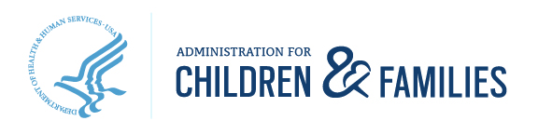
330 C Street, S.W., Washington, DC 20201 | www.acf.hhs.gov

[AGENCY ADMINSTRATOR/DIRECTOR]
[ADDRESS]
[DATE]

Dear ____________,

Since 1999, the Administration for Children and Families (ACF) in the Department of Health and Human Services has sponsored a national longitudinal survey of children and families involved in the child welfare system (CWS). This effort – the National Survey of Child and Adolescent Well-Being or NSCAW – is the only source of nationally representative information about the functioning and well-being, service needs, and service utilization of CWS-involved children and families. I’m writing to request your agency’s participation in the next round of NSCAW.

To date, there have been two cohorts of children enrolled in the survey – in 1999 and in 2008. Your agency may have participated in one or both of these efforts.
- In 2017, we will begin enrolling a new cohort of 4,500 children sampled from over 80 child welfare agencies nationwide.
- To ensure that the sample represents the entire child welfare population, we need the participation of all states and agencies selected.
- In this round, we will attempt to better understand children’s service needs and receipt by linking the NSCAW data to Medicaid claims data. We will also focus attention on children ages 12 and older who may be less likely to achieve permanency, and on infants who are the most likely to be victimized.

NSCAW findings are widely used to inform federal, state, and local policies and practices. For example, findings related to the higher use of psychotropic medications among children in foster care and in residential care have led to federal guidelines promoting greater state oversight of children receiving these medications.
- The many research briefs and reports from the study are publicly available on the ACF website (http://www.acf.hhs.gov/programs/opre/research/project/national-survey-of-child-and-adolescent-well-being-nscaw).

A member of the NSCAW team – led by RTI International - will be providing additional information and contacting you about participation. I would like to extend my appreciation for the time and effort I hope your agency will commit to NSCAW to contribute to our shared goal of continuing to improve services to children and families. If you have any questions about the above information or any concerns you would like to discuss, please do not hesitate to contact me at (202) 401-5460.

Sincerely,

Christine Fortunato, Ph.D.
NSCAW Federal Project Officer
Administration for Children and Families

Participation in the described collection of information is voluntary. An agency may not conduct or sponsor, and a person is not required to respond to, a collection of information unless it displays a currently valid OMB control number. The OMB number for this information collection is 0970-0202 and the expiration date is XX/XX/XXXX.

