Application Screenshots for Jurisdictions

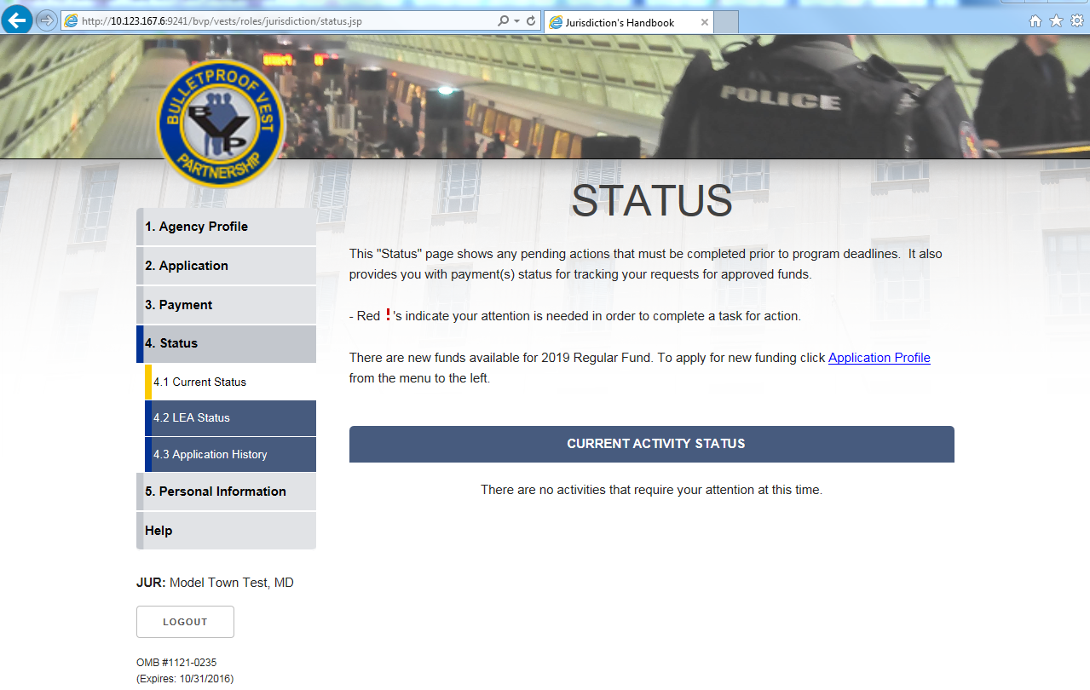
Figure 1 – Status
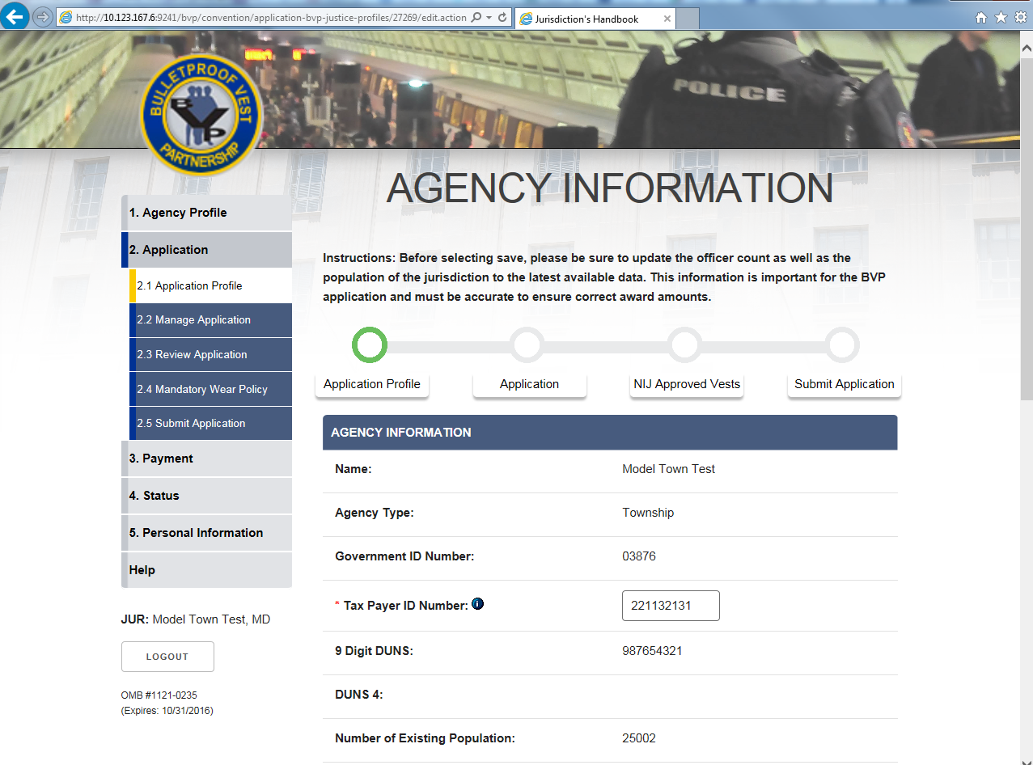
Figure 2 – Application Profile: Agency Information (continue)
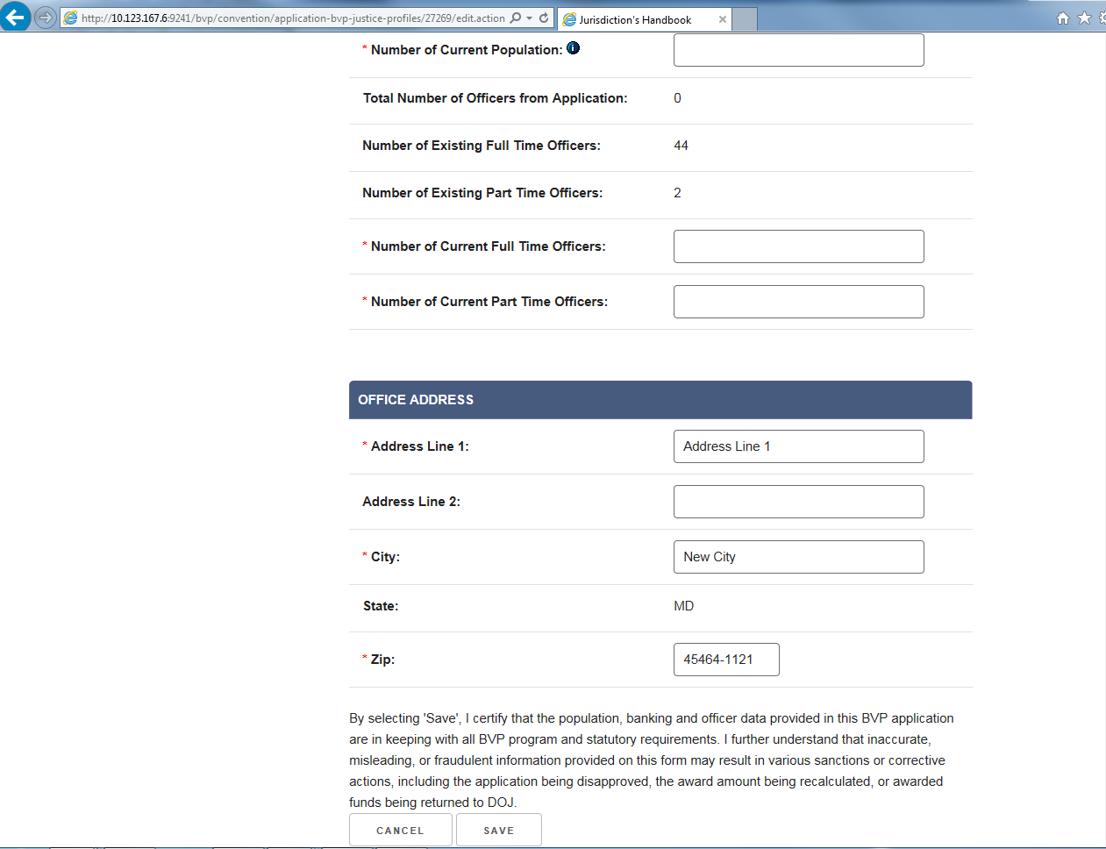
Figure 3 – Application Profile: Agency Information
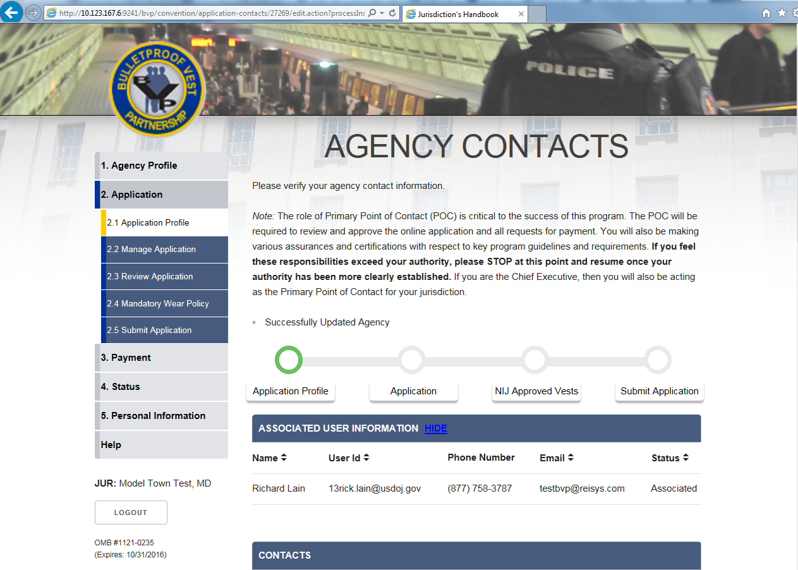
Figure 4 – Application Profile: Agency Contacts (continue)
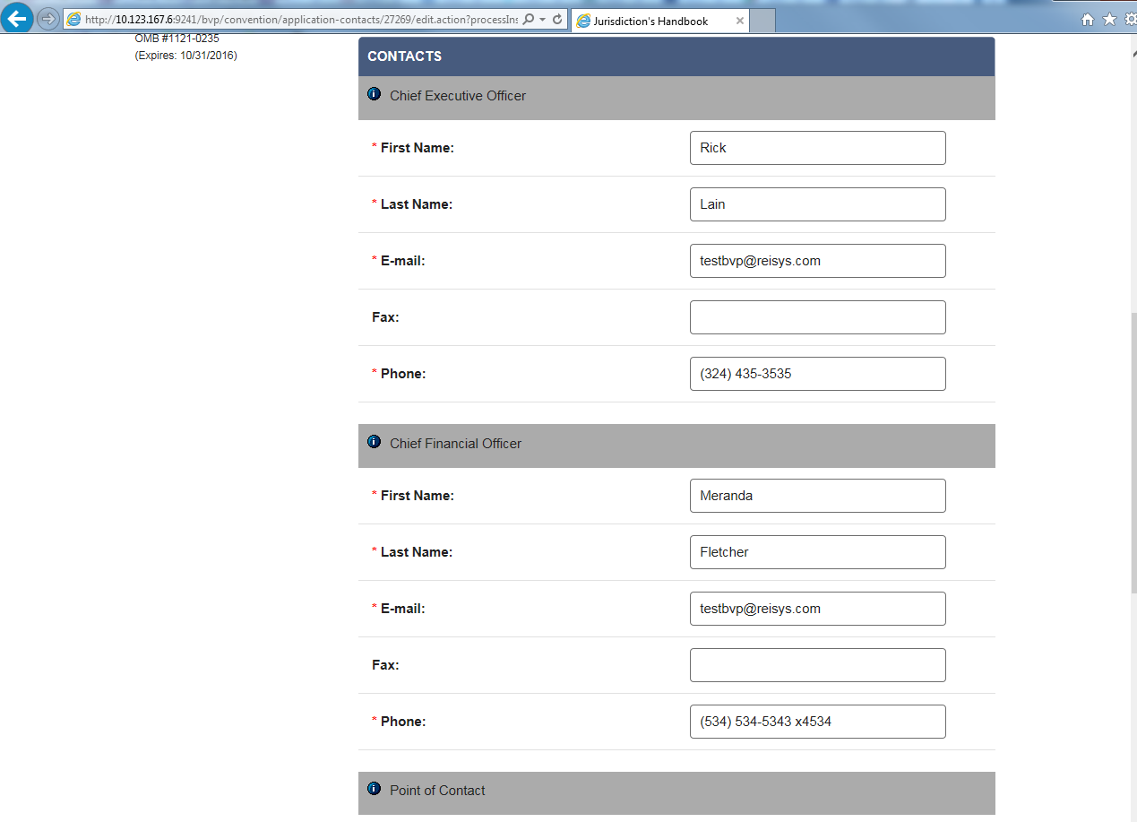
Figure 5 – Application Profile: Agency Contacts (continue)
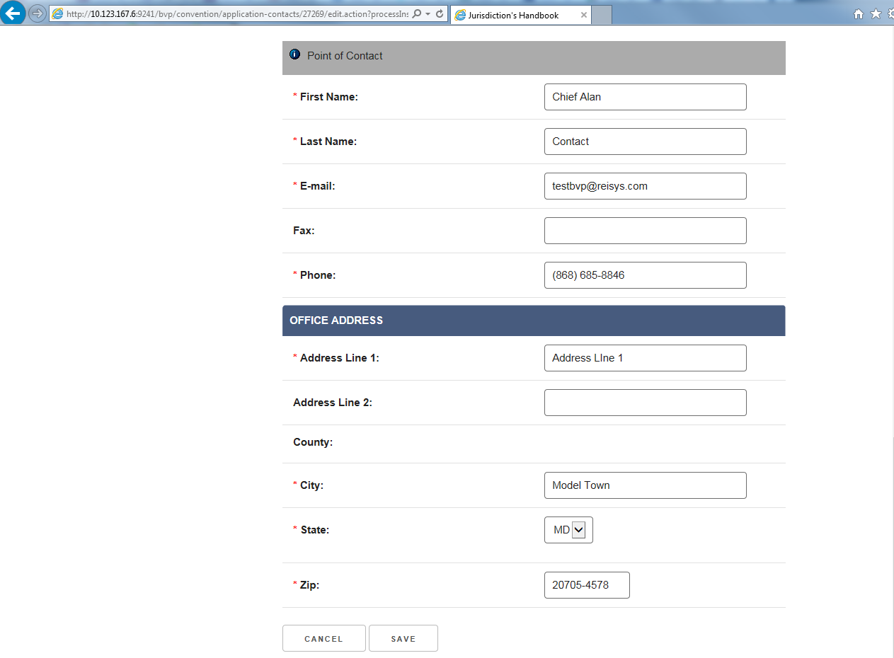
Figure 6 – Application Profile: Agency Contacts

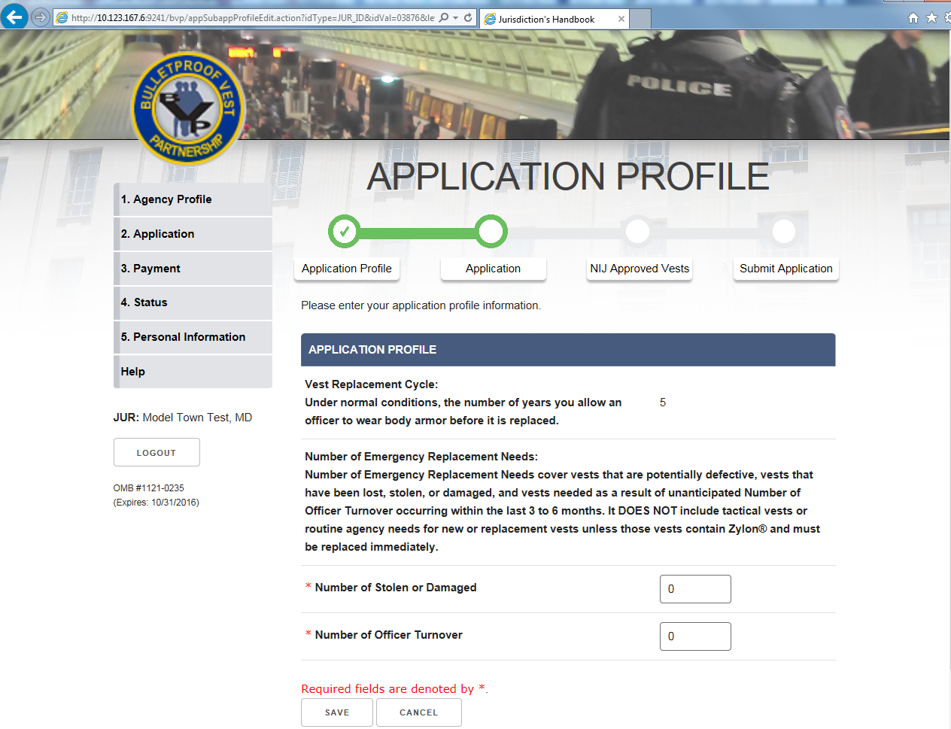
Figure 7 – Application Profile: Application Profile
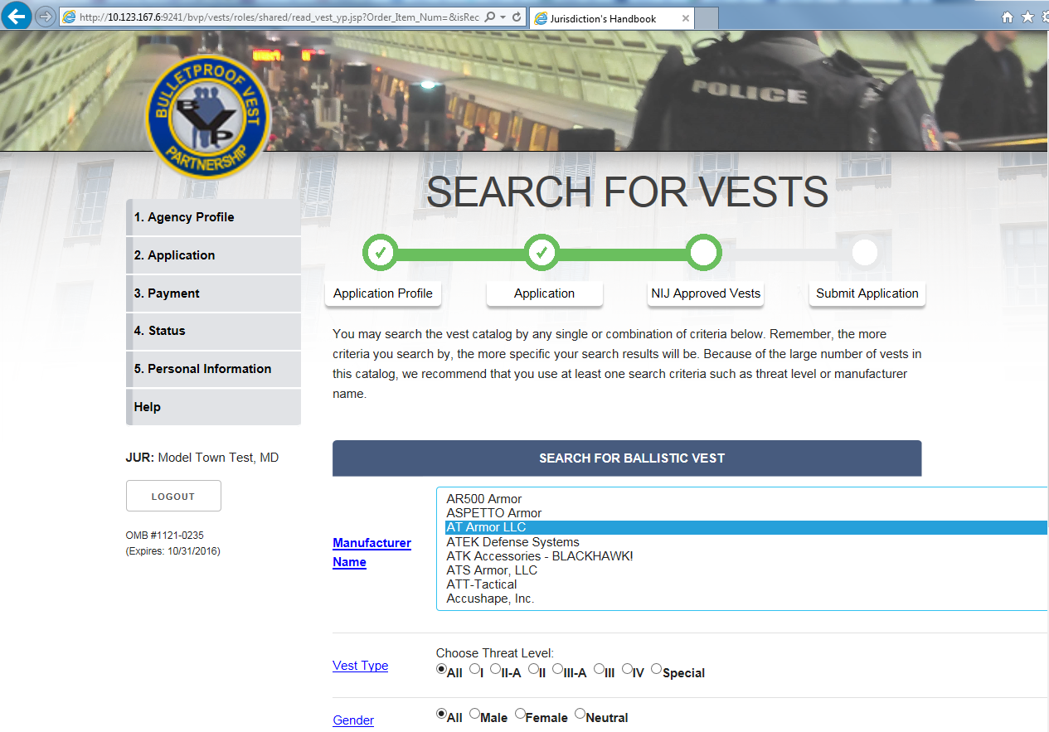
Figure 8 – Manage Application: Search for Vests (continue)
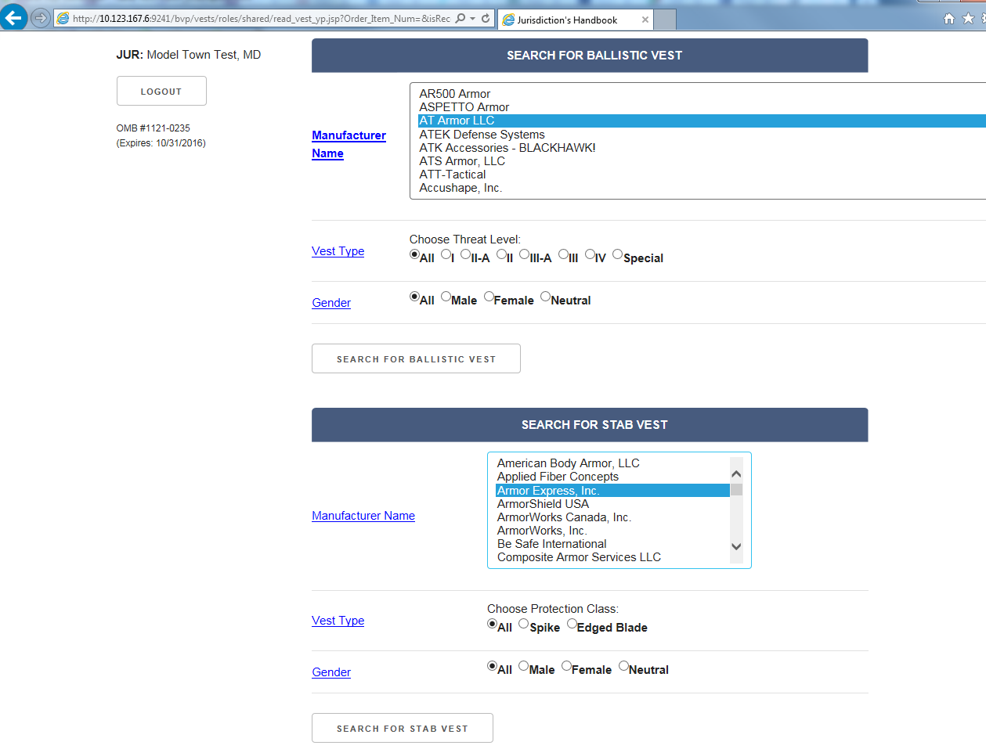
Figure 9 – Manage Application: Search for Vests (continue)
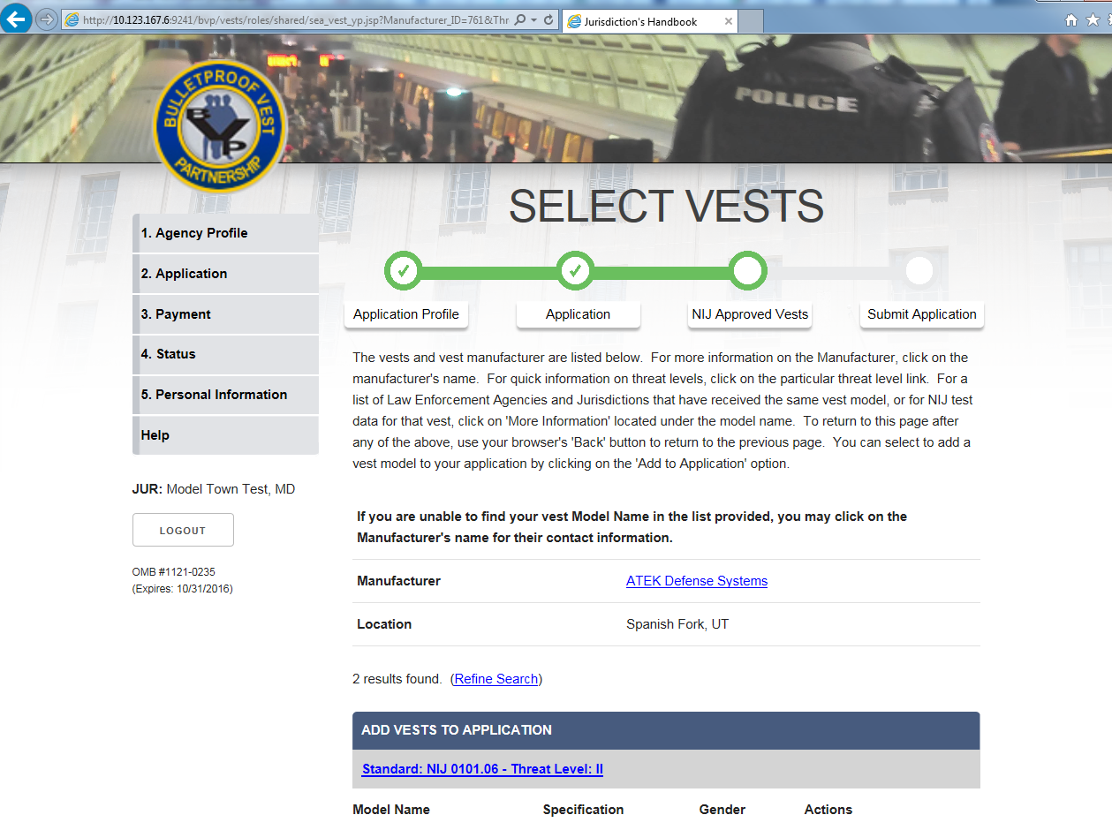
Figure 10 – Manage Application: Search for Vests (continue)
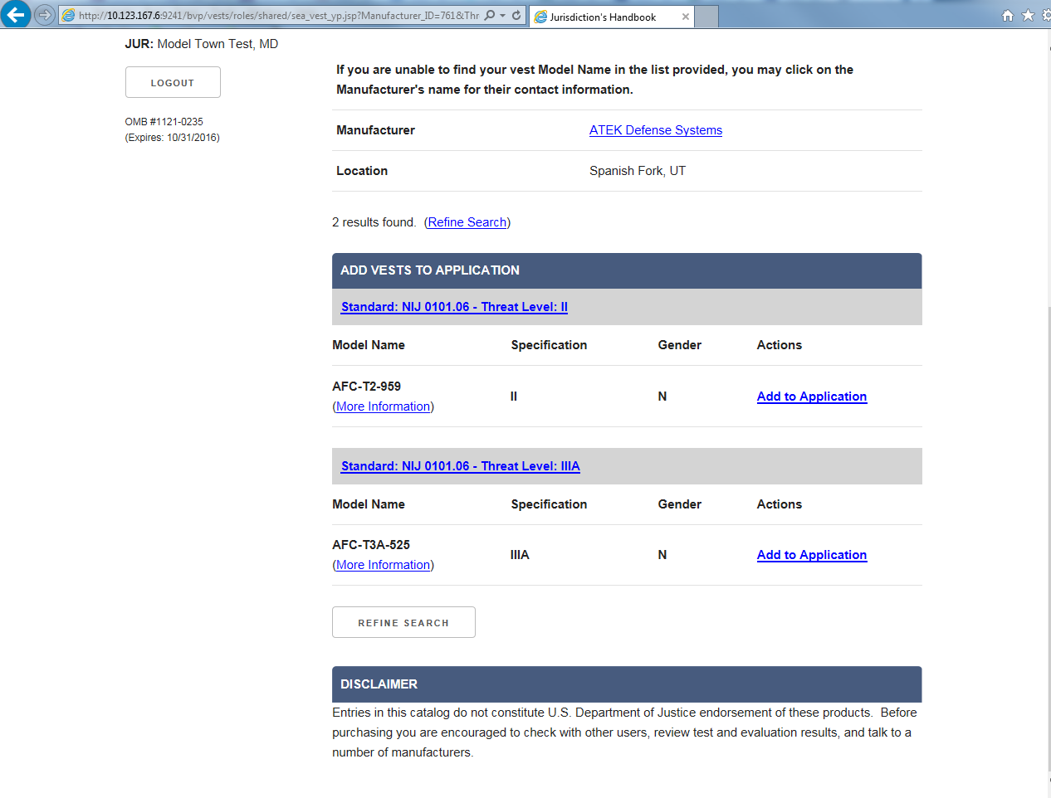
Figure 11 – Manage Application: Search for Vests
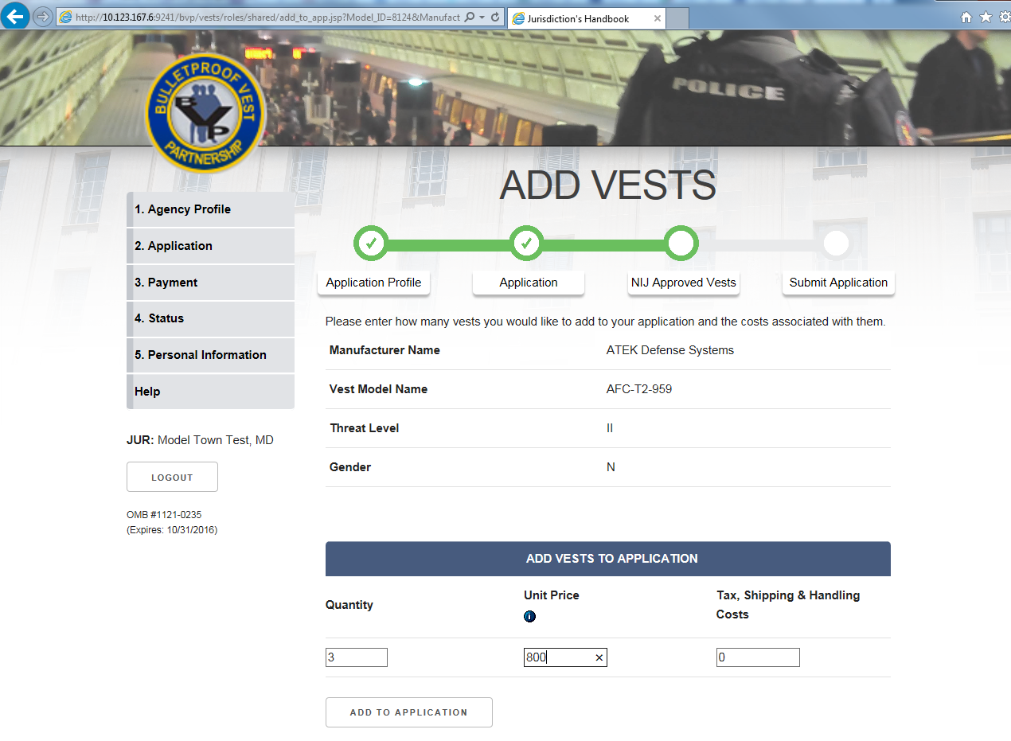
Figure 12 – Manage Application: Add Vests
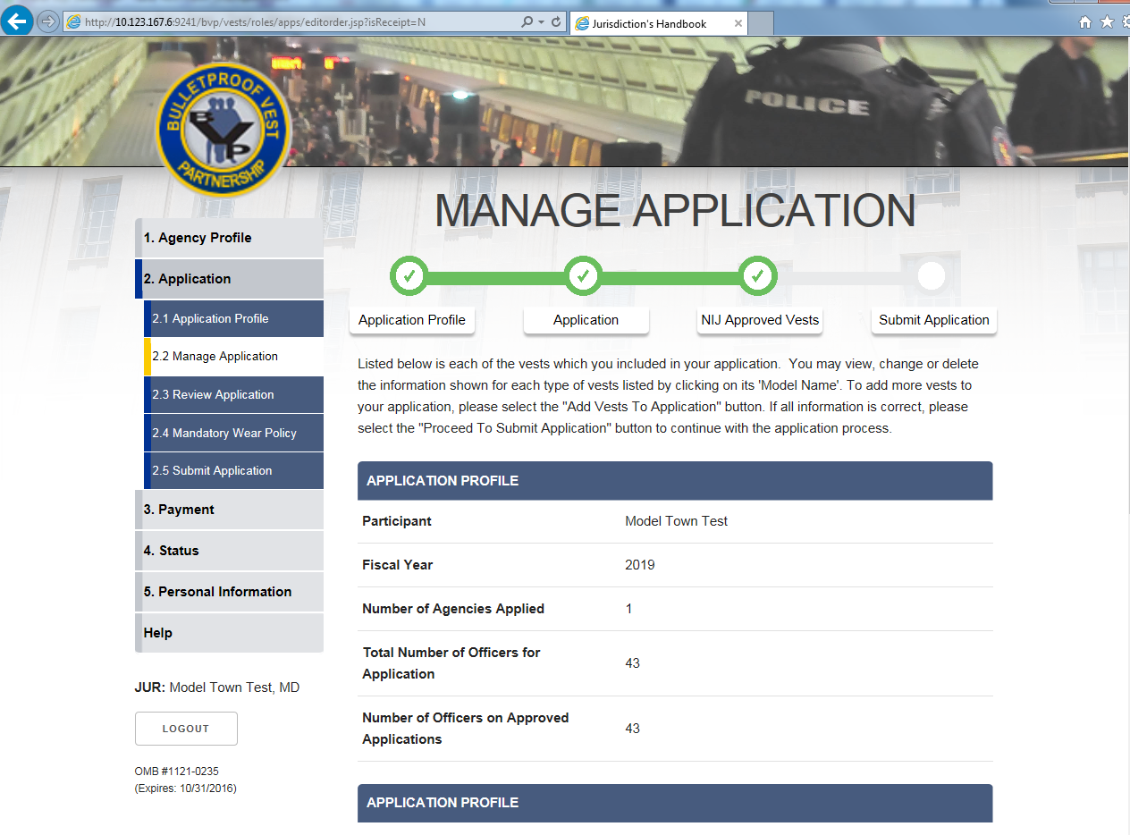
Figure 13 – Manage Application: Vests Added (continue)
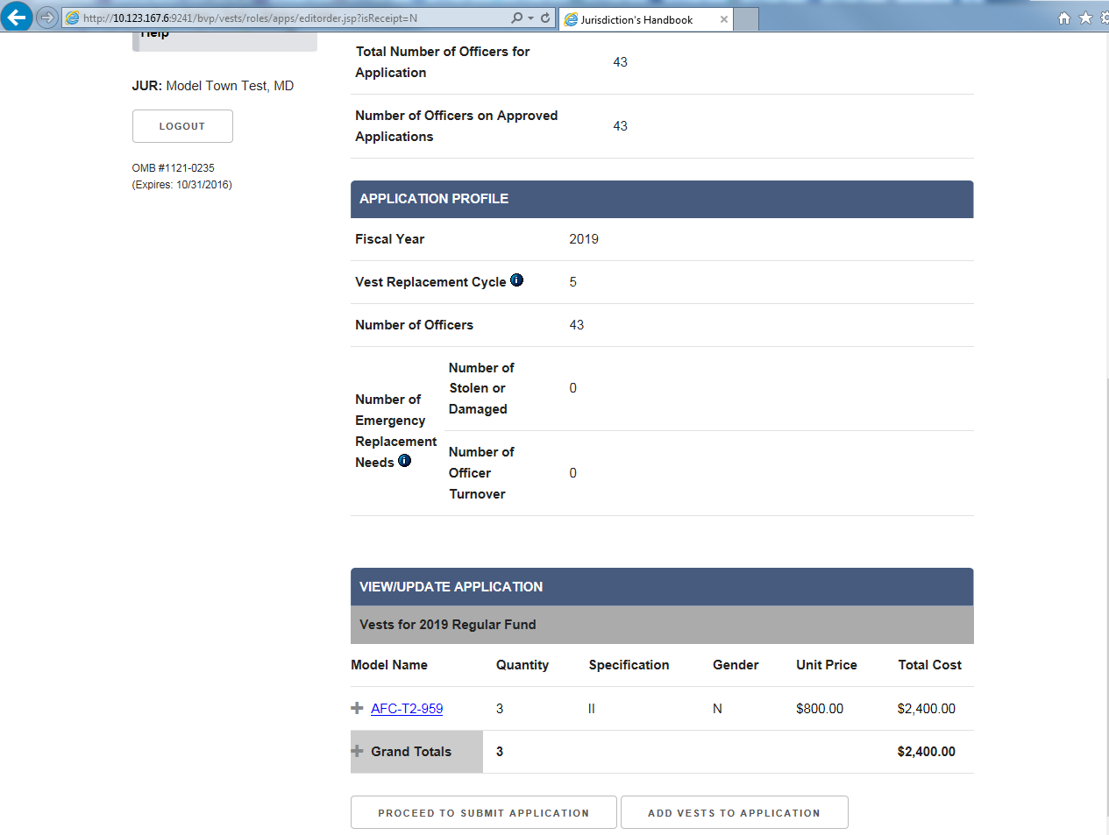
Figure 14 – Manage Application: Vests Added
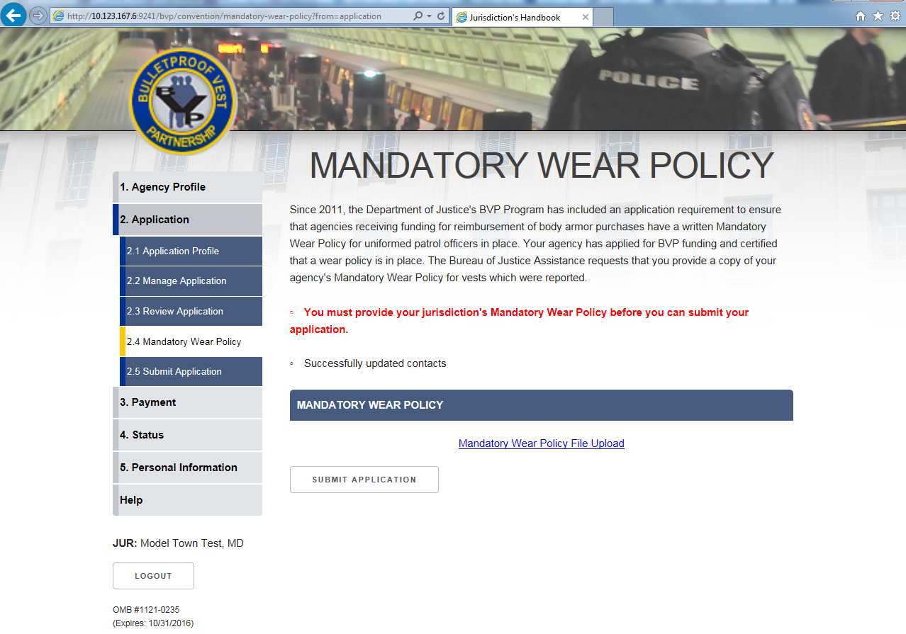
Figure 15 – Mandatory Wear Policy (continue)
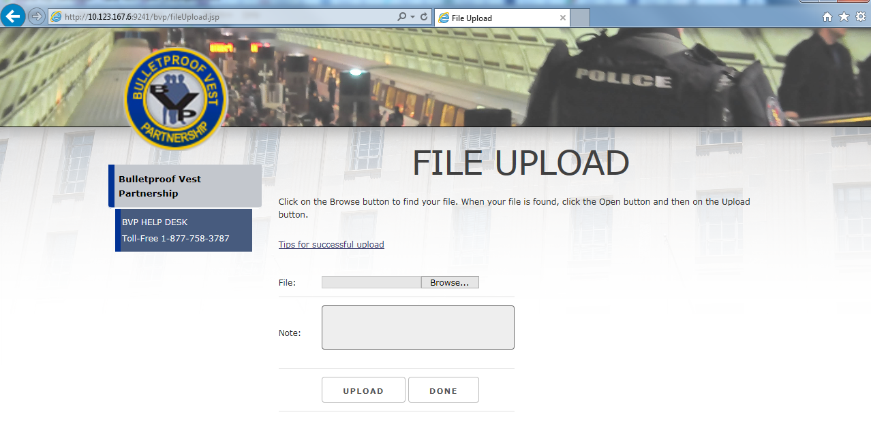
Figure 16 – Mandatory Wear Policy: File Upload (continue)
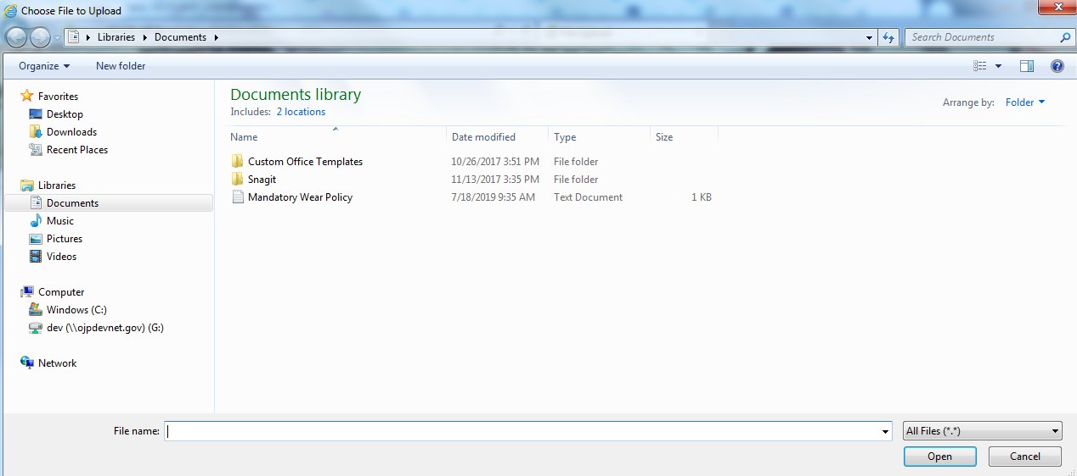
Figure 17 – Mandatory Wear Policy: File Upload (continue)

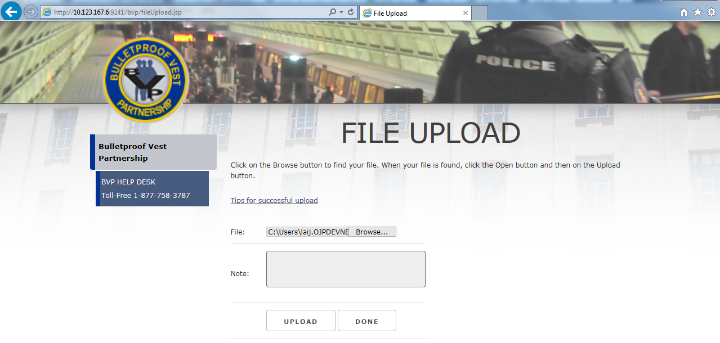
Figure 18 – Mandatory Wear Policy: File Upload (continue)

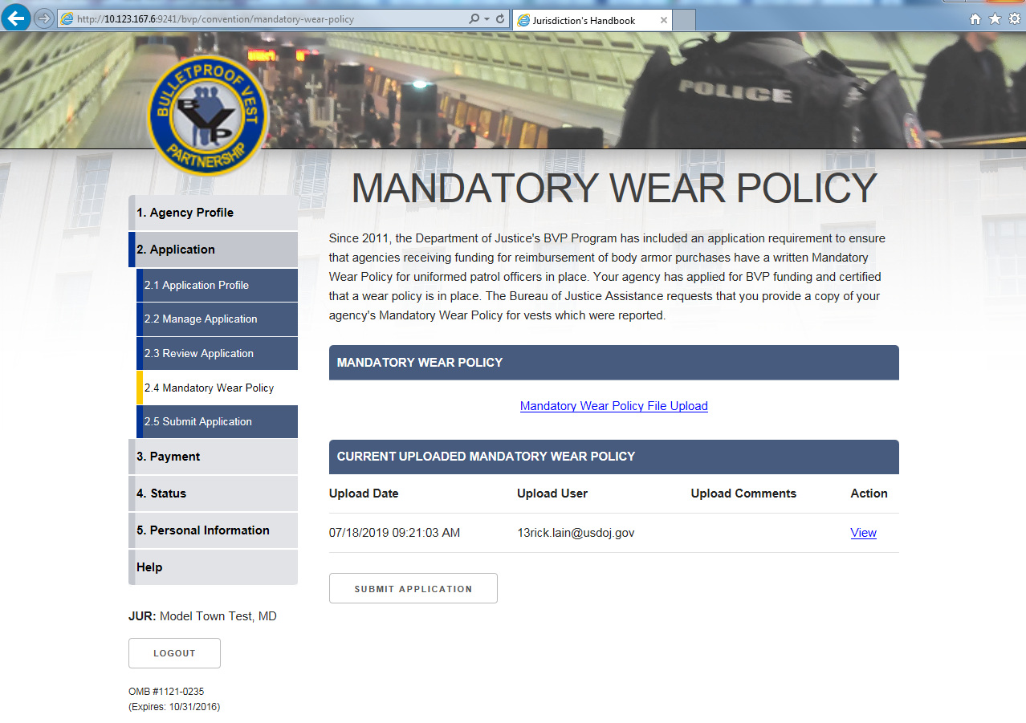
Figure 19 – Mandatory Wear Policy: File Uploaded

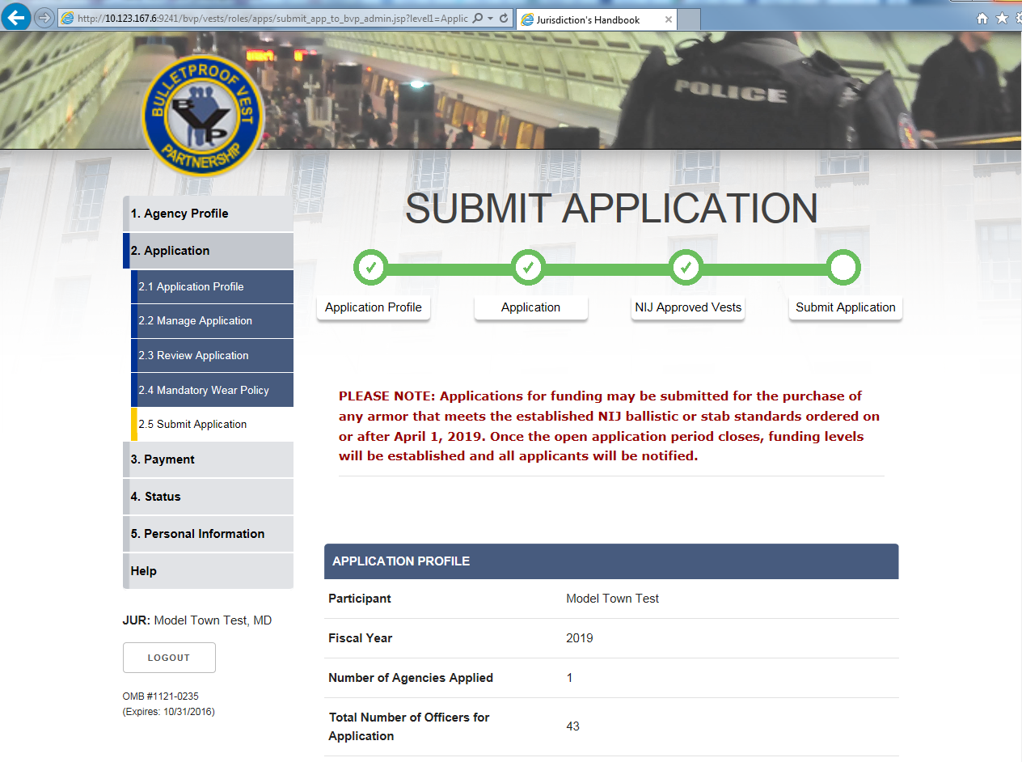
Figure 20 – Submit Application (continue)
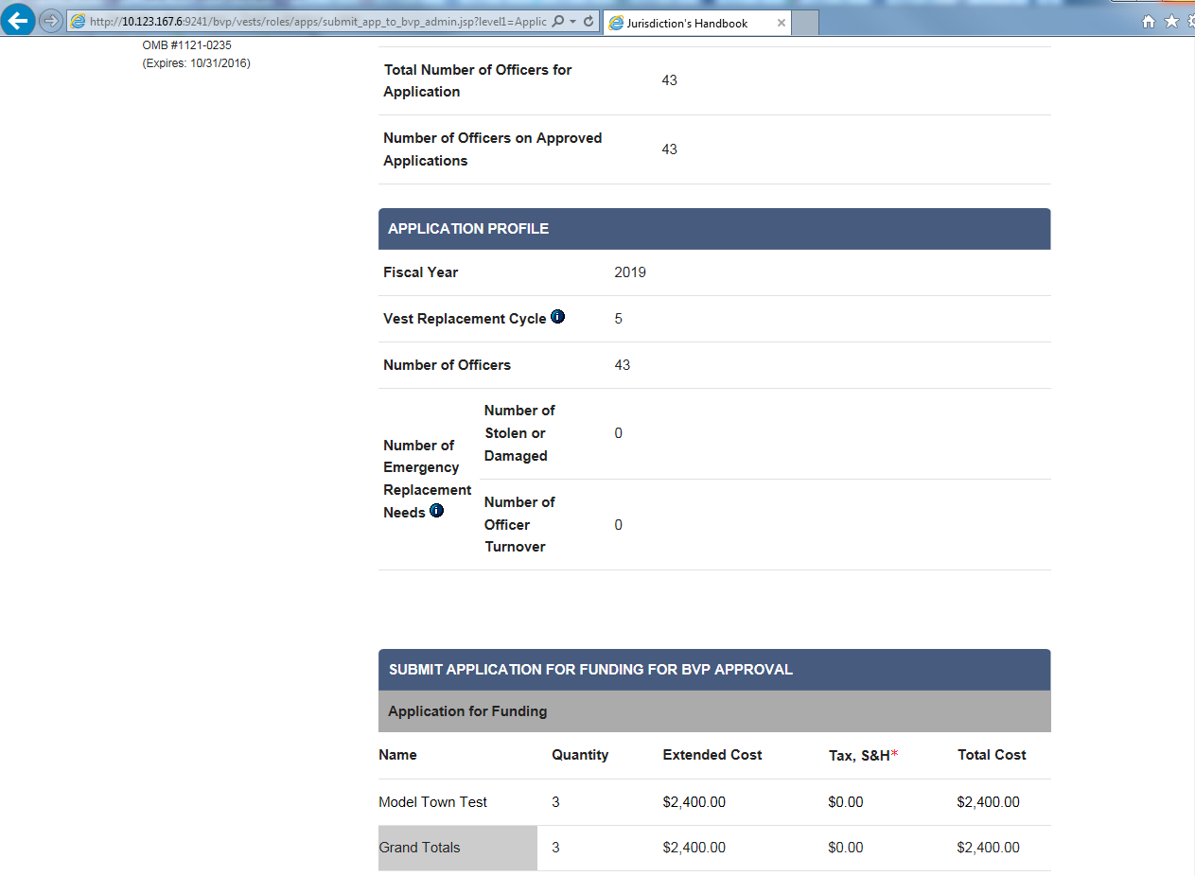
Figure 21 – Submit Application (continue)

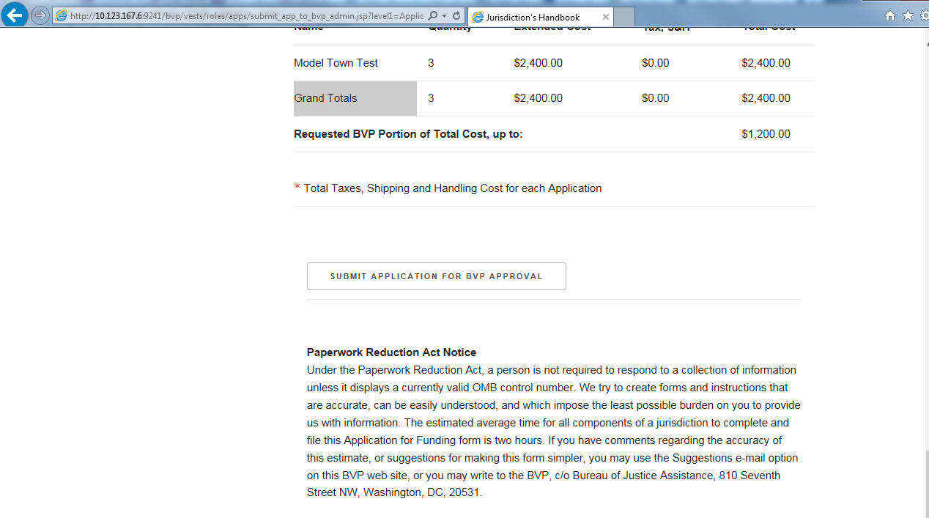
Figure 22 – Submit Application (continue)
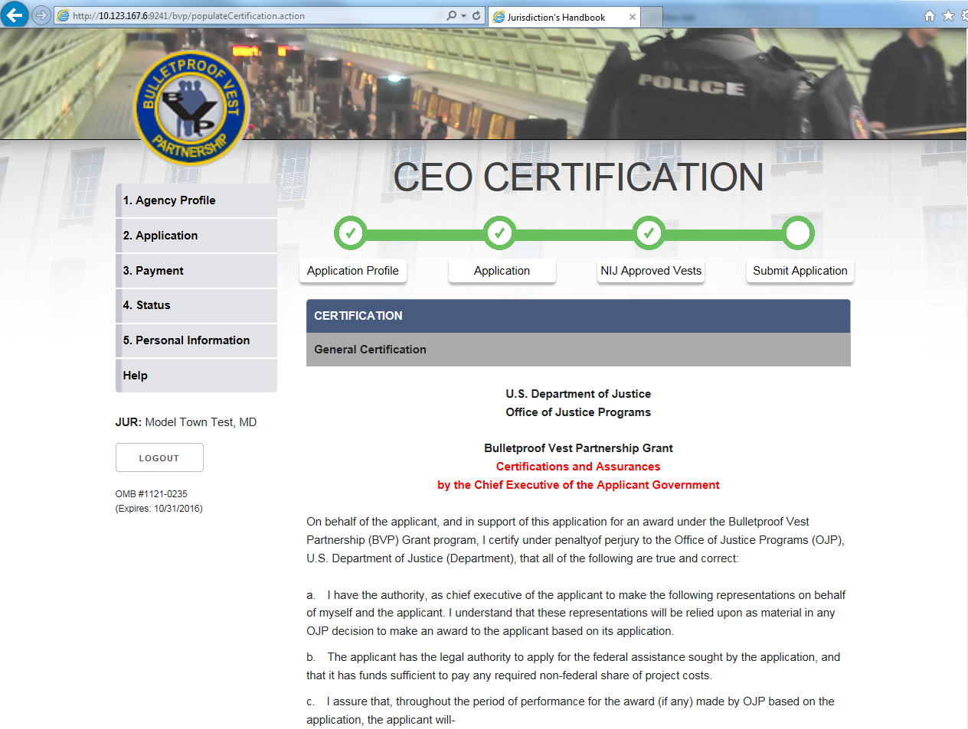
Figure 23 – Submit Application: CEO Certification (continue)
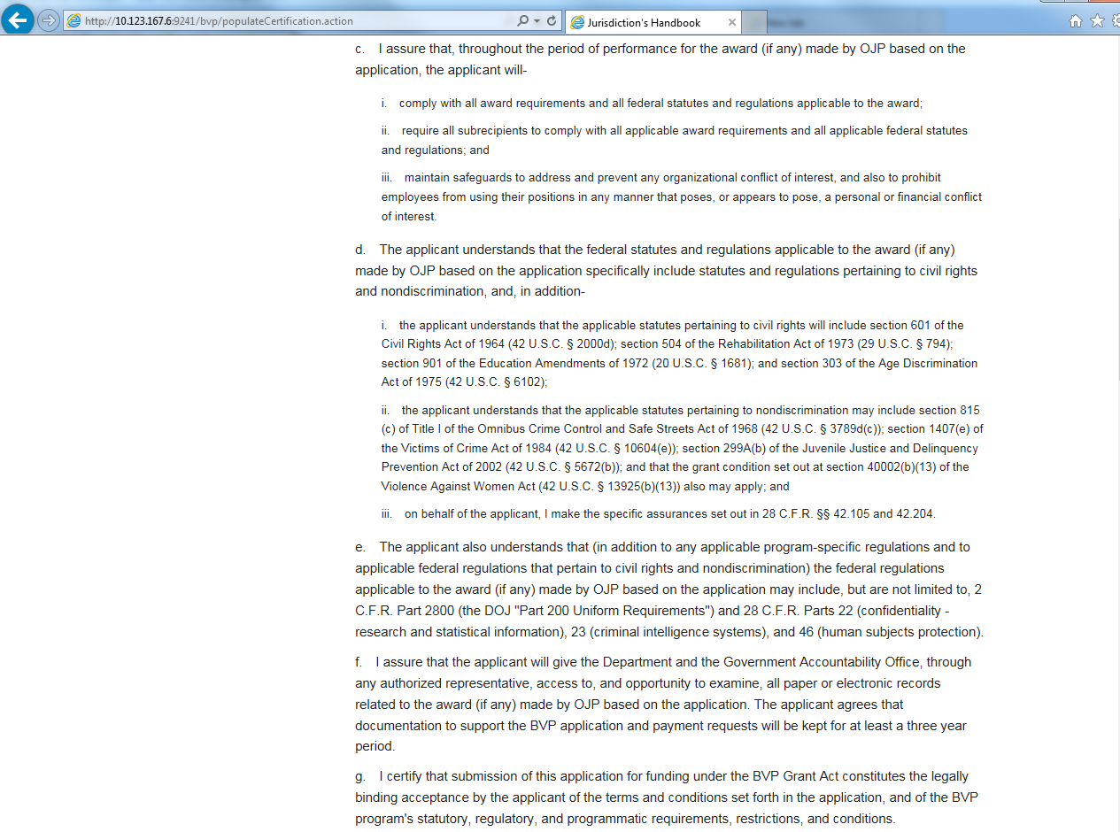
Figure 24 – Submit Application: CEO Certification (continue)
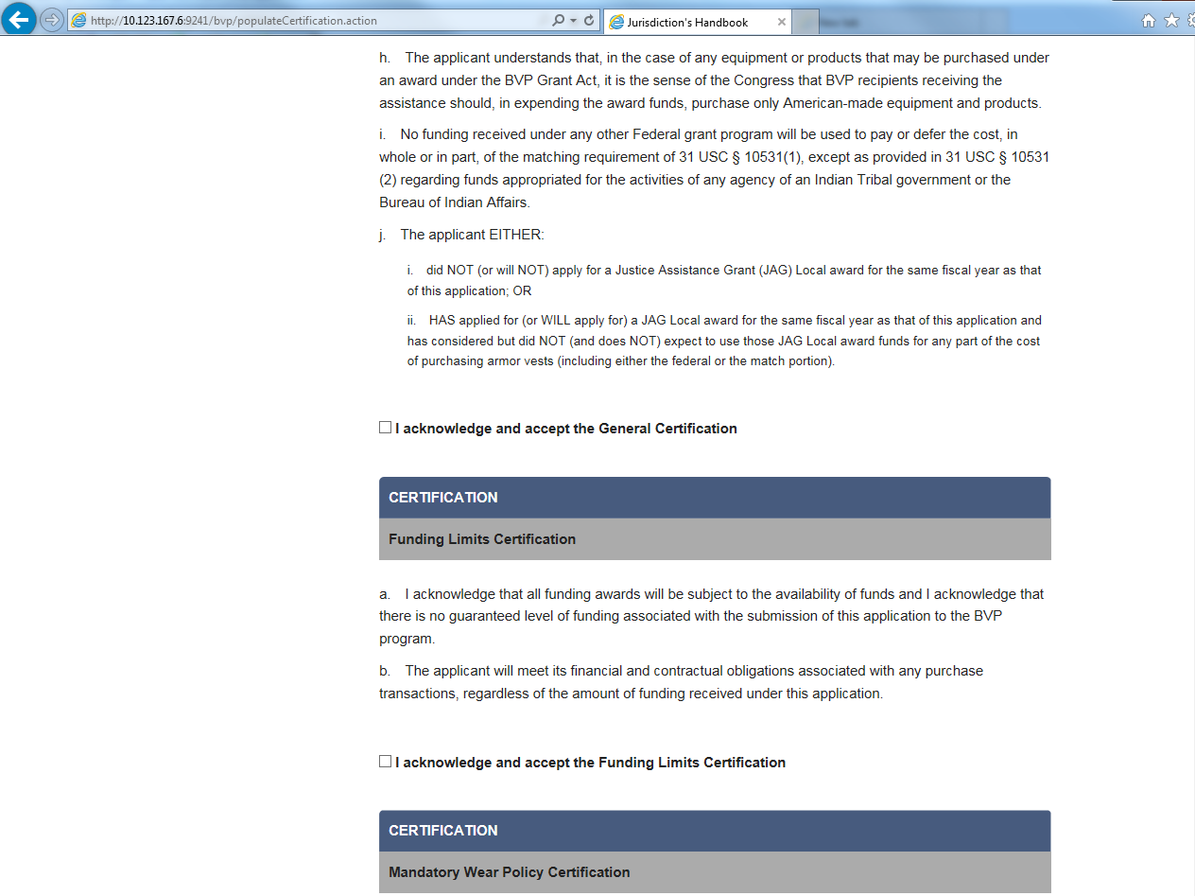
Figure 25 – Submit Application: CEO Certification (continue)

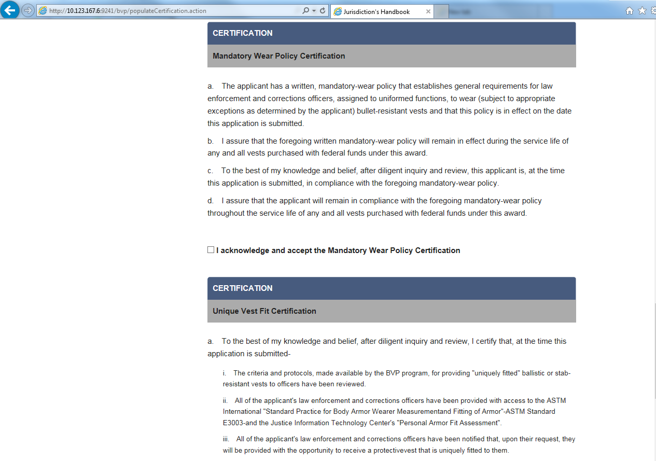
Figure 26 – Submit Application: CEO Certification (continue)
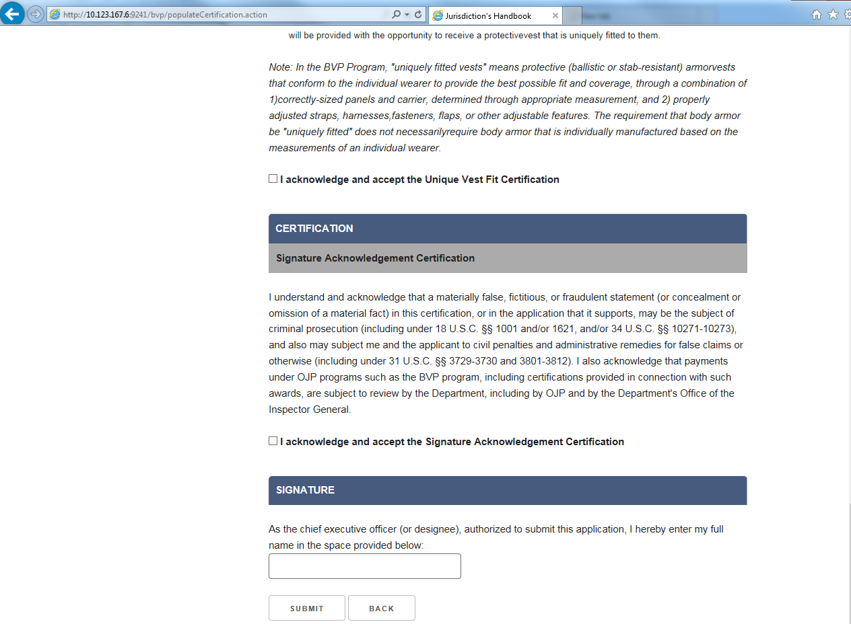
Figure 27 – Submit Application: CEO Certification

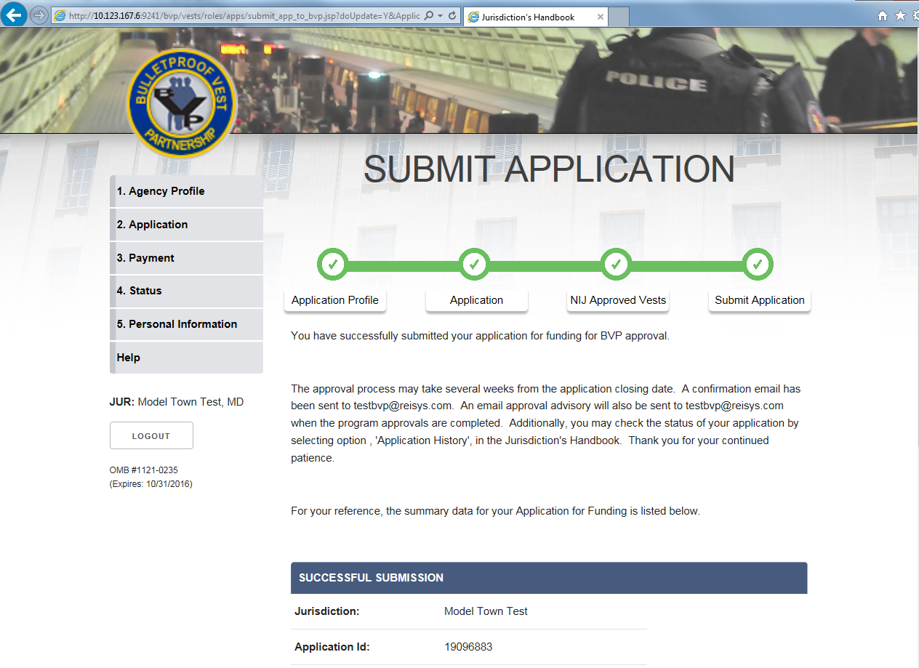
Figure 28 – Submit Application: Successful Submission (continue)
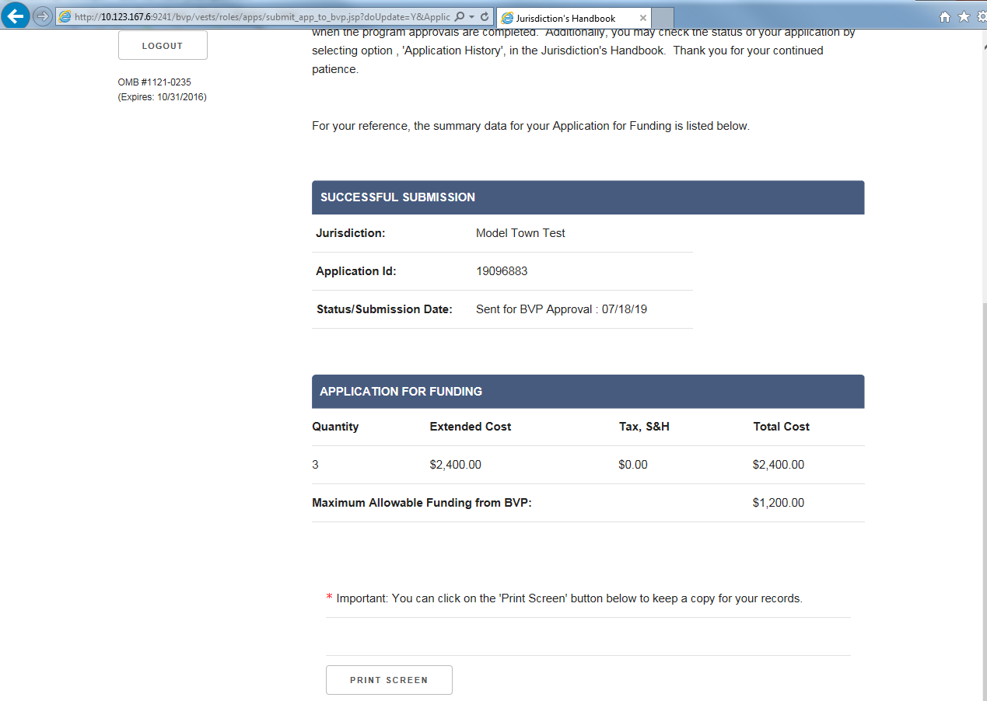
Figure 29 – Submit Application: Successful Submission

