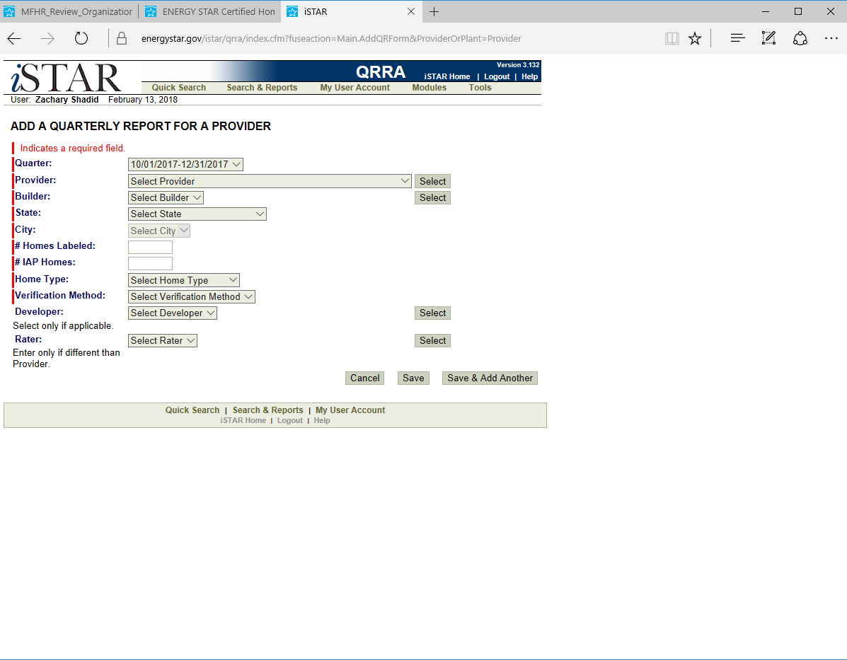

EPA Form 5900-421

The public reporting and recordkeeping burden for this collection of information is estimated to average 15 minutes per response. Send comments on the Agency's need for this information, the accuracy of the provided burden estimates, and any suggested methods for minimizing respondent burden, including through the use of automated collection techniques to the Director, Collection Strategies Division, U.S. Environmental Protection Agency (2822T), 1200 Pennsylvania Ave., NW, Washington, D.C. 20460. Include the OMB control number in any correspondence. Do not send the completed form to this address.

OMB Control No. 2060-0586