Step 1
What’s Your Score? Use our Home Energy Yardstick to compare your home’s energy use to others across the country. Is higher or lower than average? If your score is low, set a goal to increase efficiency. Even if your home scores well, there are always opportunities to increase performance!

Step 2
Get Recommendations. Our online Home Advisor will quickly give you recommendations to improve your home’s energy efficiency. You can also contact a professional energy consultant to give you more customized recommendations and guide you through the improvement process. They can use specialized software to estimate what improvements will help you reach your goal.

Step 3
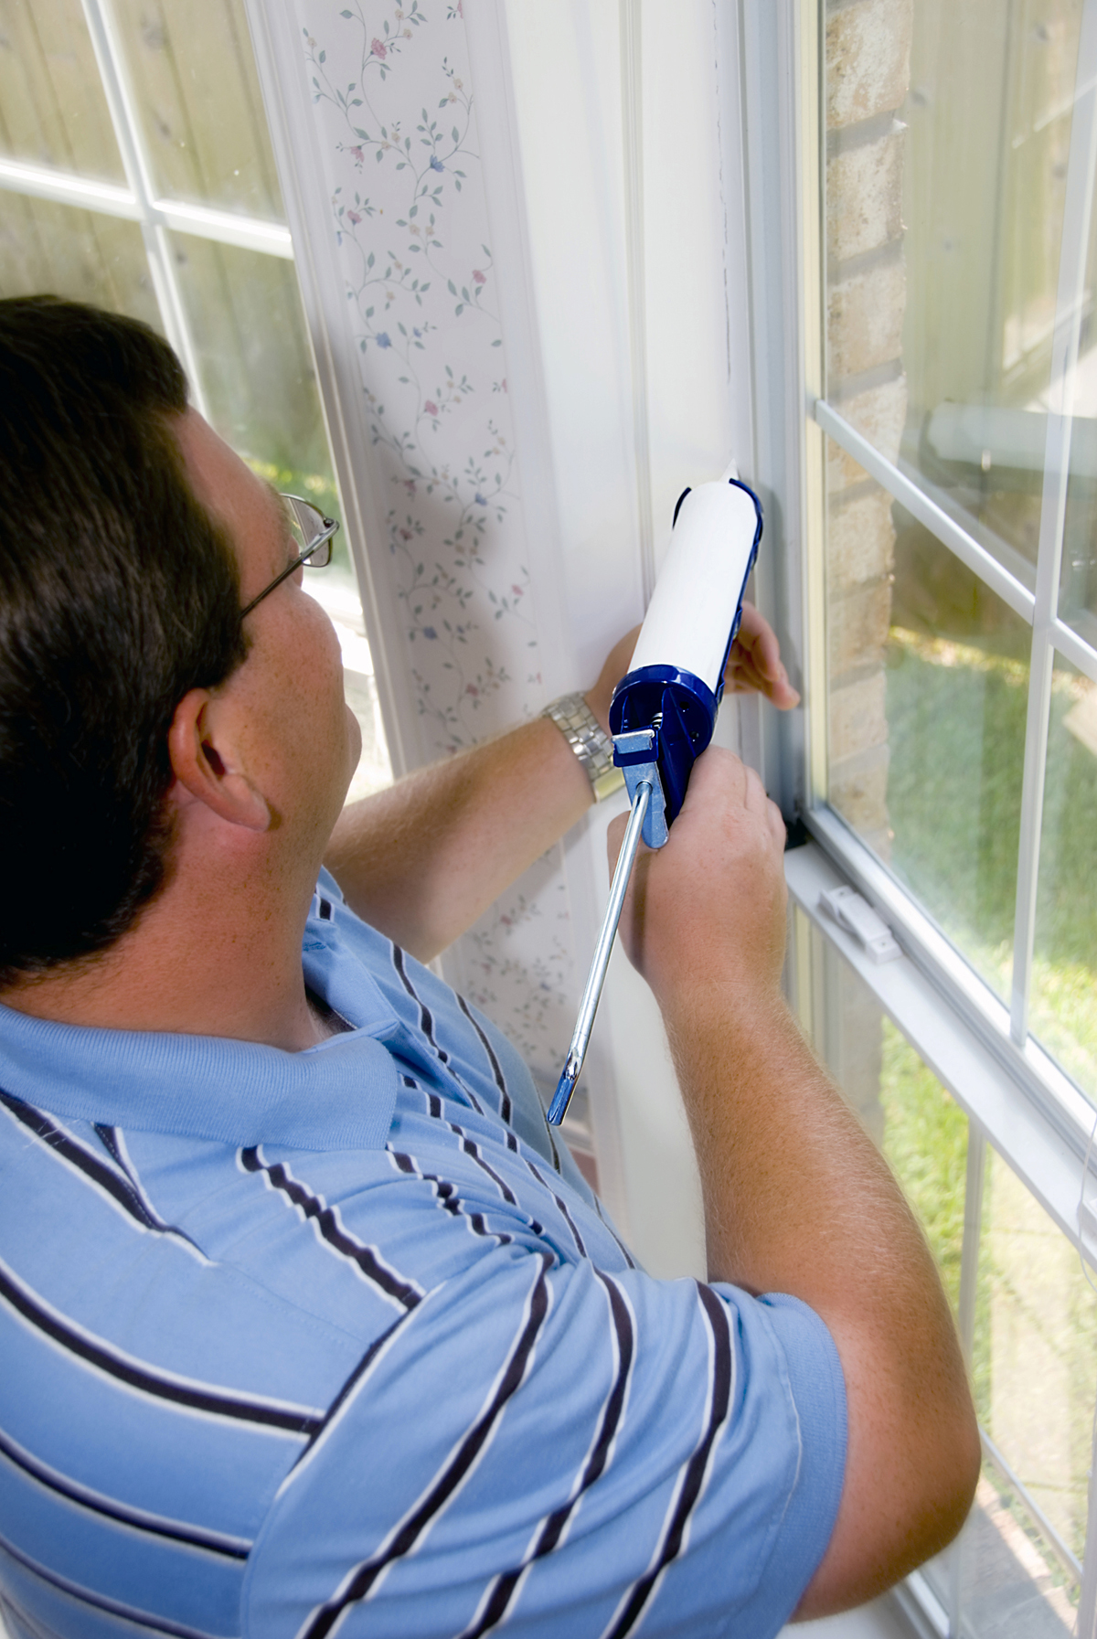Take the Pledge. “Change the World, Start with ENERGY STAR” is a national campaign that encourages all Americans to take steps to help fight global warming by using less energy at home, at work, and in their communities. Through the ENERGY STAR Pledge, you can commit to taking specific actions to improve energy efficiency.

Step 4
Track Your Progress. Twelve months after you make the improvements, come back to the Home Energy Yardstick and see how much your score gone up. Complete the ‘Home Improvement Profile’ to show the changes you’ve made and the results you’ve achieved. If you wish, send us the completed Profile – and your project might be featured on the ENERGY STAR Web site!

Homeowner Name
[City, State]
[Annual Energy Saved]
Project Cost |  |  |  | Project Professionals
[$500] |  |  |  | [Consultant X]  [Contractor Y]
ENERGY USE | Electric  (kWh) |  | Natural Gas (therms) | Oil  (gallons) |  | Other | Yardstick  Score
Pre Project
[Dates]
Post Project
[Dates]
How We Changed the World with ENERGY STAR (check all the apply)
ENERGY STAR  Products Installed |  | ENERGY STAR  Home Improvements Made |  |  | Recommended  Behavior Changes Made
Appliances:  Refrigerator/Freezer # ______  Dishwasher  Clothes Washer  Water Heater  Room Air Conditioner  Central Conditioner  Ceiling Fans # ______  Heat Pump  Furnace  Boiler  Lighting:  Light Fixtures # ______  CFLs #_______  Home Office Equipment:  Computers/Laptops #_______  Printer/Scanner/Copier #_______  Electronics:  Televisions #_______  DVD/VCR Players #_______  Cable Box #_______  Home Audio Equipment #______  Portable Phone #_______  Battery Charger #_______ |  | Installed weather stripping around doors and windows  Sealed air leaks in attic and basement  Reduced whole-house air leakage (________ACH @ 50 Pa)  Added attic insulation  (R-value_________)  Added wall insulation  (R-value_________)  Added floor insulation  (R-value ________)  Added crawlspace insulation  Sealed and insulated ductwork  Installed ENERGY STAR windows, doors, and/or skylights (#_______)  Installed a programmable thermostat  Other _________________________ __________________________________________________________________ |  |  | Cleared registers and vents covered by furniture or rugs  Changed furnace air filter regularly  Removed leaves, dirt, and debris from outdoor parts of HVAC system  Used ceiling fans to reduce need for air conditioning  Lowered water heater thermostat to 120º  Wrapped water heater with an insulating jacket  Installed low-flow shower heads and faucets  Turned off lights when you leave a room (or install a motion sensor)  Unplugged chargers and power adaptors when not in use  Used power strips to shut off electronics when not in use  Tightly closed fireplace damper when not in use  Other _______________________

