2020 Customer Loyalty Survey
Req-14
For PRA Review only – Contents of this box will not be displayed to recipients.

Note that this survey depends on embedded data to determine which questions will be displayed to each recipient. Embedded data are commands built into the survey that draw information from the contact list. Survey responses remain confidential.

The embedded data fields that are used in this survey are:
- Program Office (GSA program being rated)

Screen 1
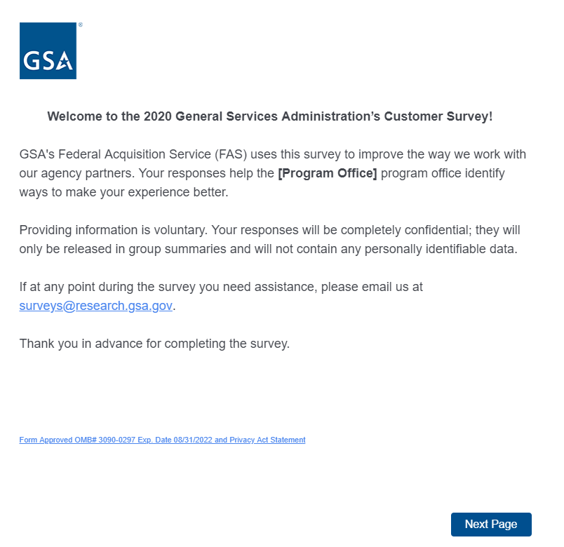
On Screens 1, 2, 3, 5, 6, 7a, 7c, 31, and 32, [Program Office] will be replaced by one of the following:
- GSA Information Technology Category
- GSA Personal Property Management
- GSA 4PL Retail Store (ServMart)
- GSA Global Supply
- GSA SmartPay
- U.S. Web Design System
- Data.gov
- DigitalGov

Link at the bottom of above page goes to a pdf displaying the PRA statement and a GSA Privacy Act Statement. See next page for screenshot.

Screen 1, continued

Screenshot of pdf linked from bottom of first page:
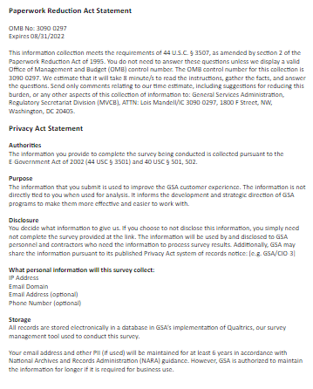

Screen 2

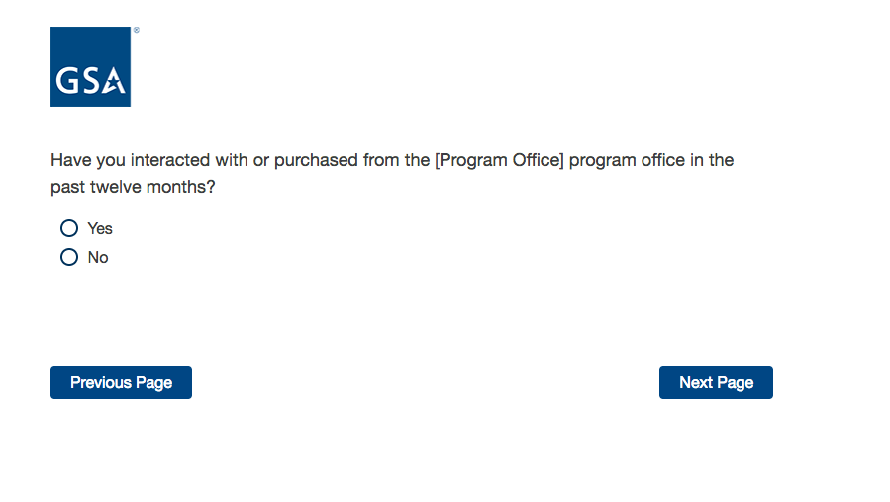

If No, then display Screen 3.

If Yes, skip to Screen 5.

Screen 3

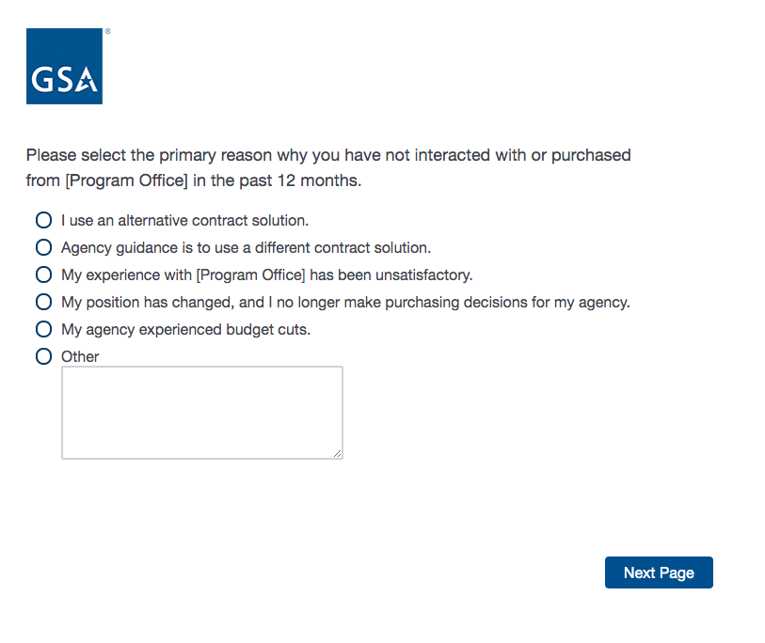

Screen 4

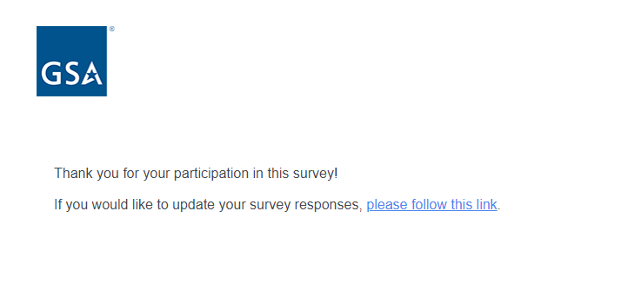

Exit survey (for respondents who select “No” on Screen 2).
Screen 5

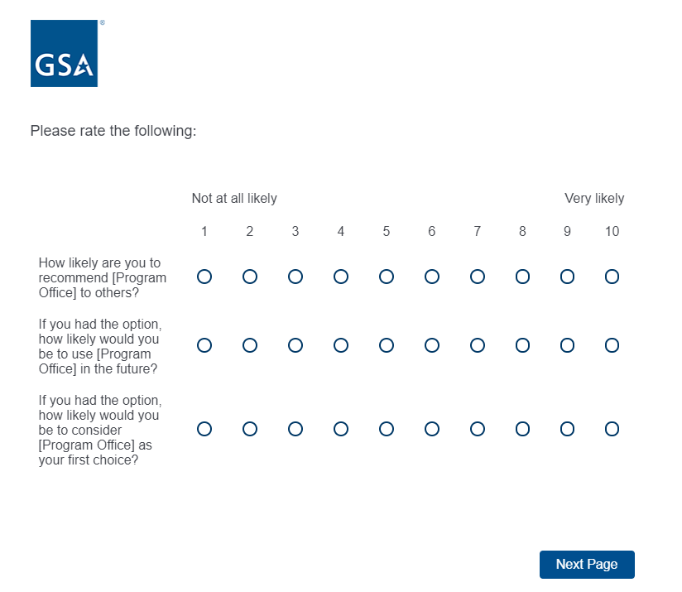

Screen 6

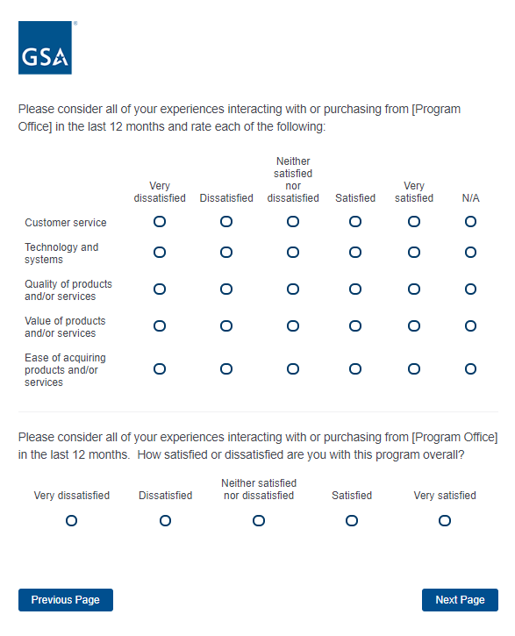
If “How satisfied or dissatisfied are you with this program?” = Very Dissatisfied, Dissatisfied, or Neither satisfied nor dissatisfied, move to Screen 7a.
If “How satisfied or dissatisfied are you with this program?” = Satisfied, skip to Screen 7b.
If “How satisfied or dissatisfied are you with this program?” = Very Satisfied, skip to Screen 7c.
Screen 7a

Display if “How satisfied or dissatisfied are you with this program?” = 1, 2, 3, 4, 5, or 6.

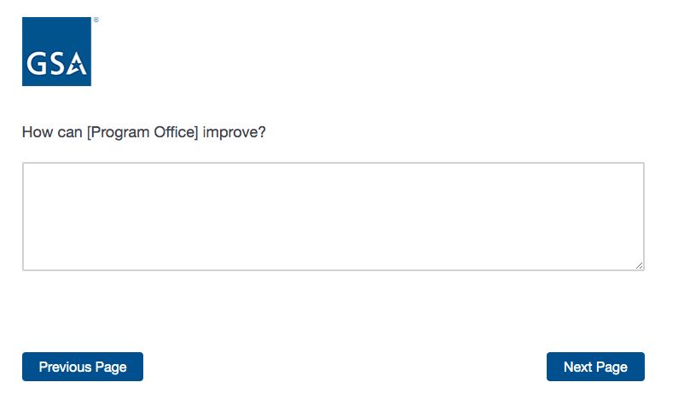

If Program Office = U.S. Web Design System, skip to Screen 8.
If Program Office = GSA Information Technology Category, skip to Screen 9.
If Program Office = GSA Personal Property Management, skip to Screen 10.
If Program Office = GSA 4PL Retail Store (ServMart), skip to Screen 14.
If Program Office = GSA Global Supply, skip to Screen 18.
If Program Office = Data.gov, skip to Screen 24.
If Program Office = GSA SmartPay, skip to Screen 25.
If Program Office = DigitalGov, skip to Screen 28.
Screen 7b

Display if “How satisfied or dissatisfied are you with this program?” = 7 or 8.

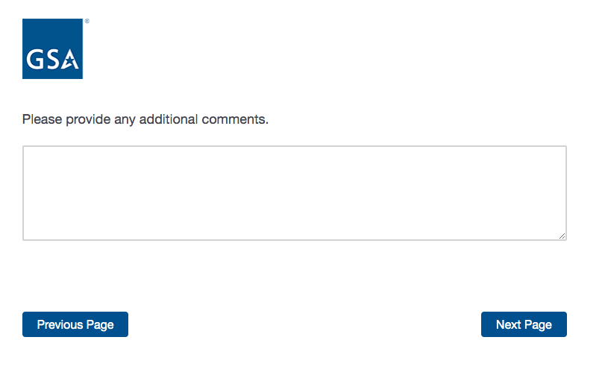

If Program Office = U.S. Web Design System, skip to Screen 8.
If Program Office = GSA Information Technology Category, skip to Screen 9.
If Program Office = GSA Personal Property Management, skip to Screen 10.
If Program Office = GSA 4PL Retail Store (ServMart), skip to Screen 14.
If Program Office = GSA Global Supply, skip to Screen 18.
If Program Office = Data.gov, skip to Screen 24.
If Program Office = GSA SmartPay, skip to Screen 25.
If Program Office = DigitalGov, skip to Screen 28.
Screen 7c

Display if “How satisfied or dissatisfied are you with this program?” = 9 or 10.

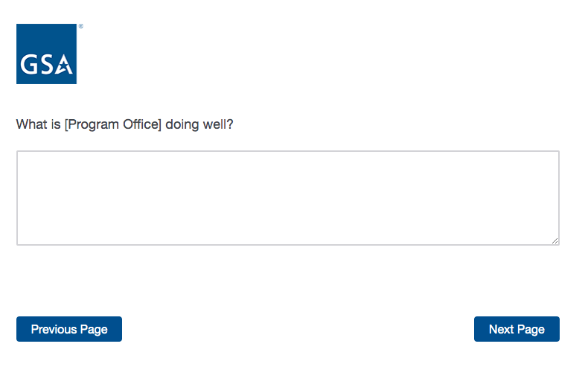

If Program Office = U.S. Web Design System, skip to Screen 8.
If Program Office = GSA Information Technology Category, skip to Screen 9.
If Program Office = GSA Personal Property Management, skip to Screen 10.
If Program Office = GSA 4PL Retail Store (ServMart), skip to Screen 14.
If Program Office = GSA Global Supply, skip to Screen 18.
If Program Office = Data.gov, skip to Screen 24.
If Program Office = GSA SmartPay, skip to Screen 25.
If Program Office = DigitalGov, skip to Screen 28.
Screen 8

Display if Program = U.S. Web Design System

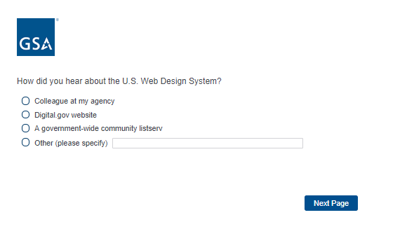

Proceed to Screen 31.
Screen 9

Display if Program Office = GSA Information Technology Category

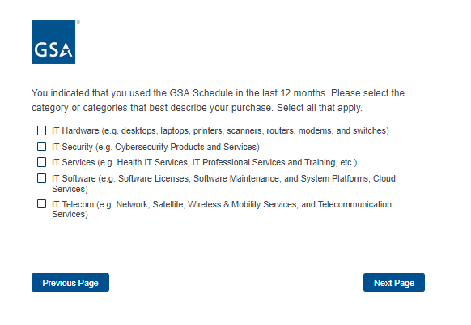
Proceed to Screen 31.
Screen 10

Display if Program Office = GSA Personal Property Management
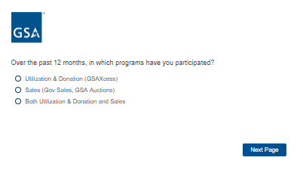
Screen 11

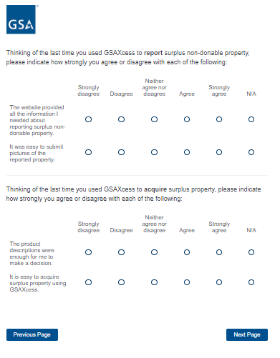
Screen 12

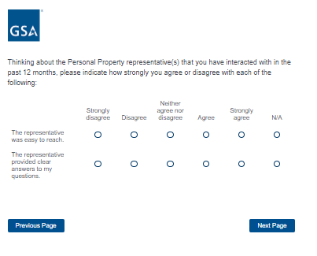
Screen 13
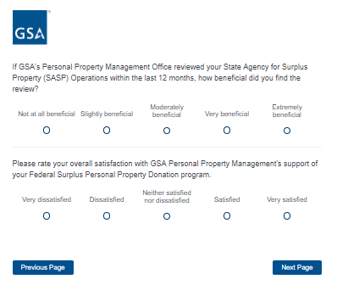
Proceed to Screen 31.

Screen 14

Display if Program = GSA 4PL Retail Store (ServMart)

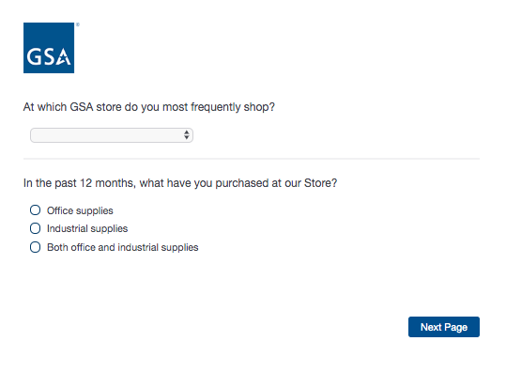
If “In the past 12 months, what have you purchased at our Store” = Office supplies, move to Screen 15a.
If “In the past 12 months, what have you purchased at our Store” = Industrial supplies, skip to Screen 15b.
If “In the past 12 months, what have you purchased at our Store” = Both office and industrial supplies, skip to Screen 15c.
Screen 15a

Display if “In the past 12 months, what have you purchased at our Store” = Office supplies.

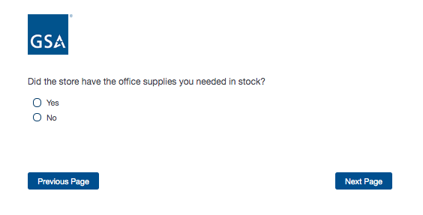

Proceed to Screen 16.
Screen 15b

Display if “In the past 12 months, what have you purchased at our Store” = Industrial supplies.

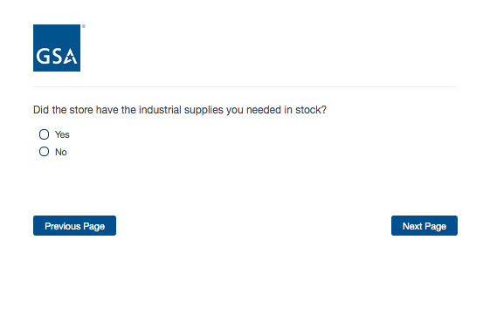
Proceed to Screen 16.
Screen 15c

Display if “In the past 12 months, what have you purchased at our Store” = Both office and industrial supplies.

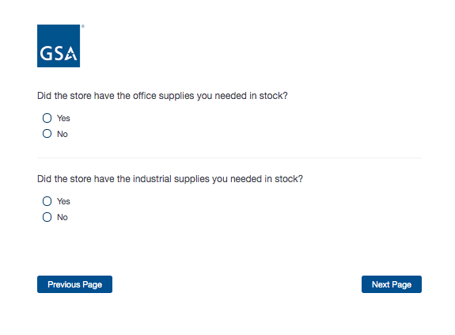

Proceed to Screen 16.
Screen 16

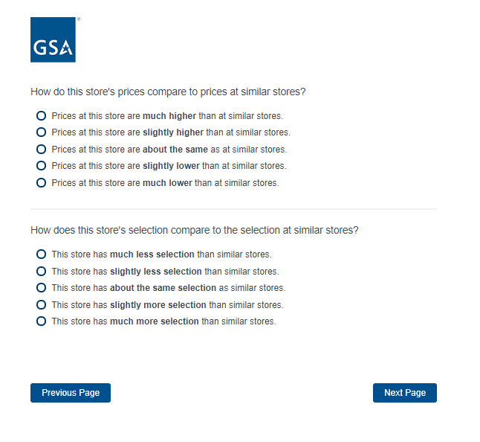
Screen 17

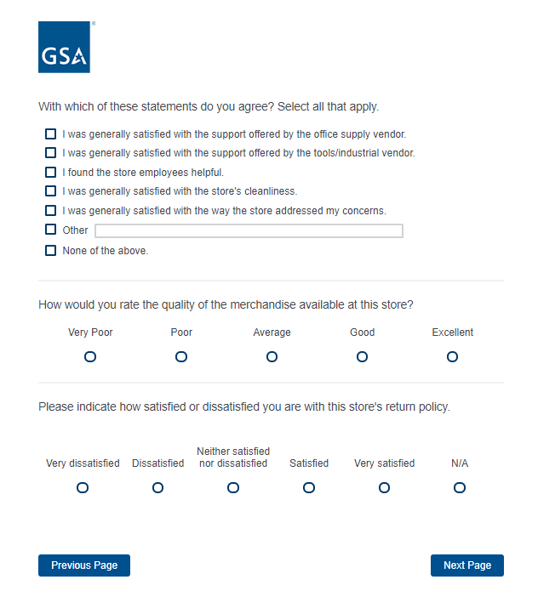
Proceed to Screen 31.
Screen 18

Display if Program Office = GSA Global Supply

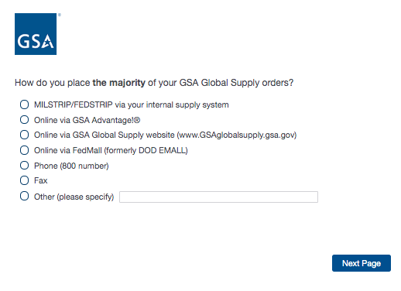
If “How do you place the majority of your GSA Global Supply orders?” = MILSTRIP/FEDSTRIP, display additional question 19a.
If “How do you place the majority of your GSA Global Supply orders?” = Online via GSA Advantage or Online via GSA Global Supply website, display additional question 19b.
If “How do you place the majority of your GSA Global Supply orders?” = Online via FedMall, display additional question 19c.
If “How do you place the majority of your GSA Global Supply orders?” = Phone (800 number), display additional question 19d.

Screen 19a

Display if “How do you place the majority of your GSA Global Supply orders?” = MILSTRIP/FEDSTRIP
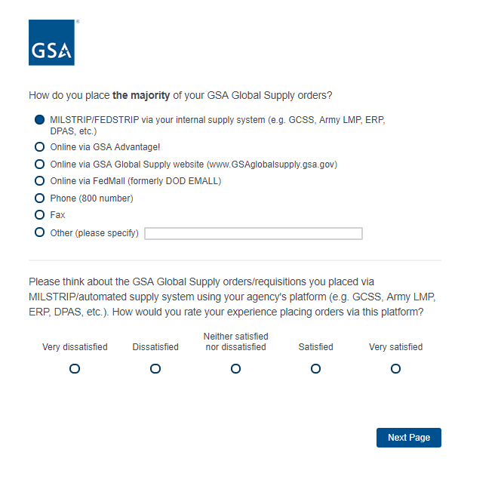
Proceed to Screen 31.
Screen 19b

Display if “How do you place the majority of your GSA Global Supply orders?” = Online via GSA Advantage or Online via GSA Global Supply website
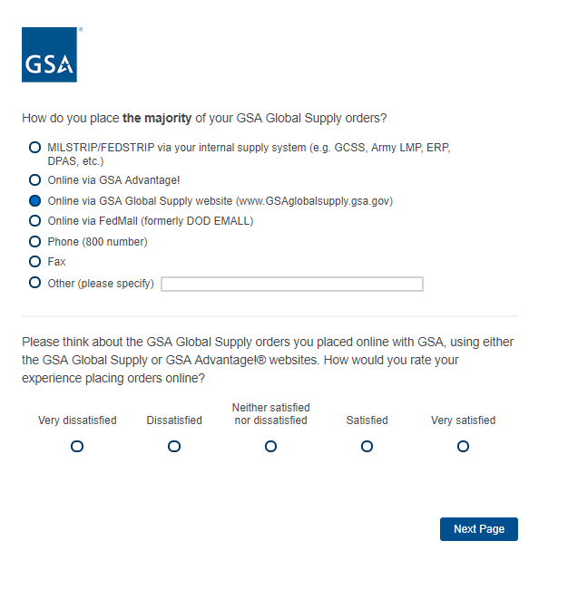
Proceed to Screen 20.

Screen 19c

Display if “How do you place the majority of your GSA Global Supply orders?” = Online via FedMall
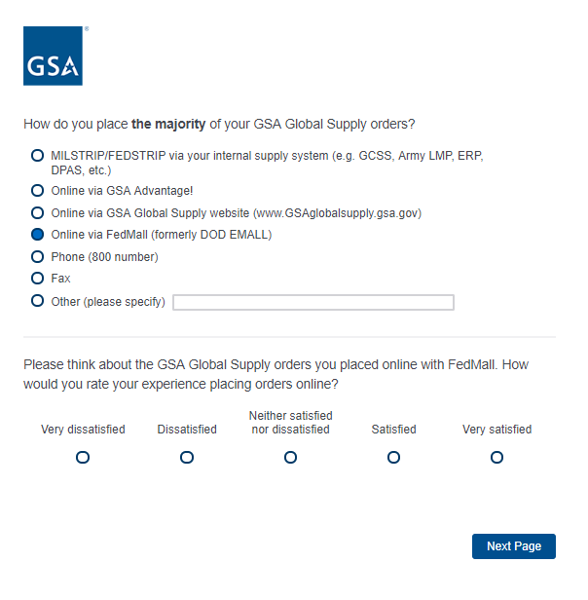
Proceed to Screen 20.

Screen 19d

Display if “How do you place the majority of your GSA Global Supply orders?” = Phone (800 number)

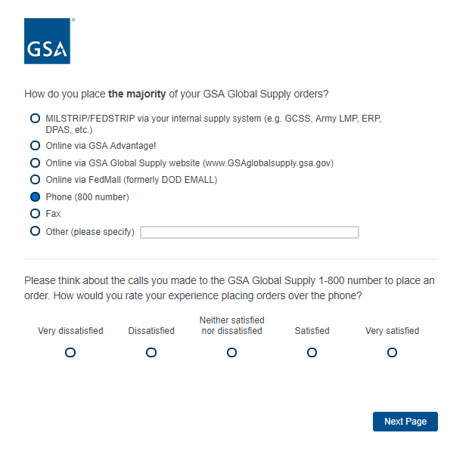
Proceed to Screen 20.
Screen 20

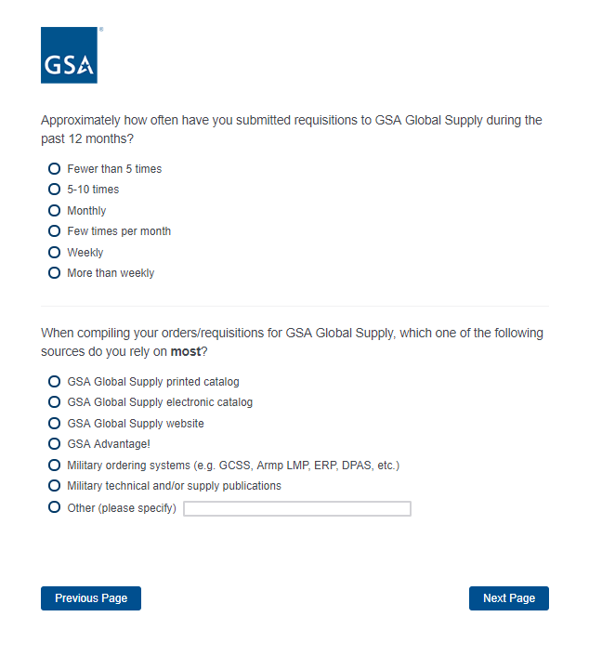
If “When compiling your orders, which of the following sources do you rely on most?” = GSA Global Supply printed catalog, display additional question on Screen 21a.

If “When compiling your orders, which of the following sources do you rely on most?” = GSA Global Supply electronic catalog, display additional question on Screen 21b.

Screen 21a

Display if “When compiling your orders, which of the following sources do you rely on most?” = GSA Global Supply printed catalog

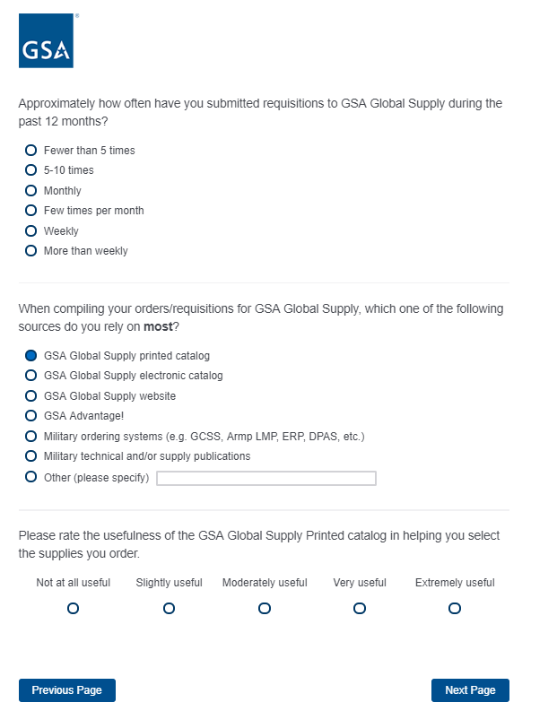
Proceed to Screen 22.
Screen 21b

Display if “When compiling your orders, which of the following sources do you rely on most?” = GSA Global Supply electronic catalog

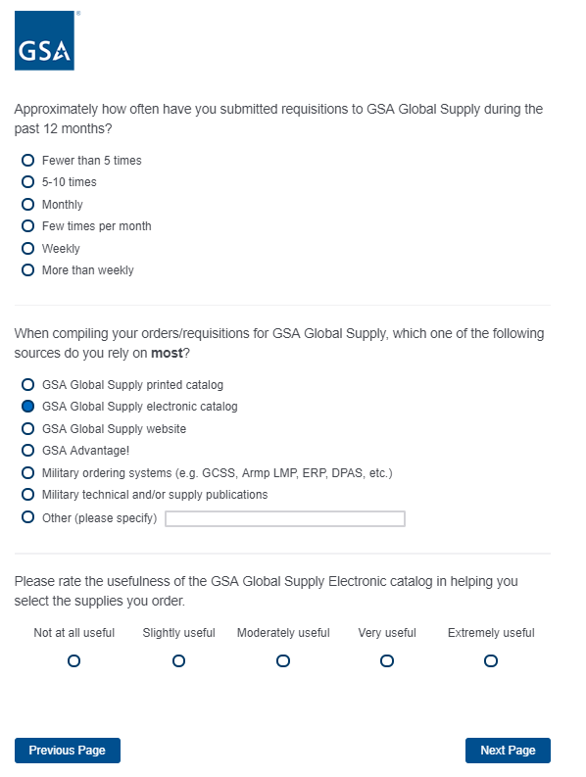
Proceed to Screen 22.
Screen 22

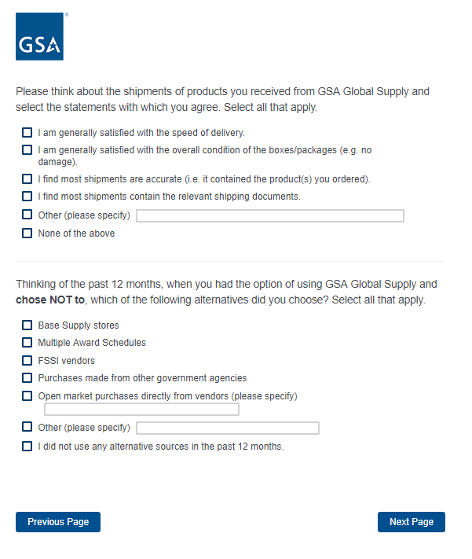

If “I did not use any alternative sources in the past 12 months” is selected, move to Screen 23, but do not display “Why did you choose to use the alternative supply source rather than GSA Global Supply?”

For all other response options, move to Screen 23.

Screen 23

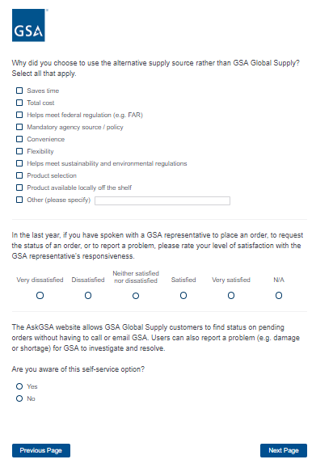

Proceed to Screen 31.

Screen 24

Display if Program Office = Data.gov

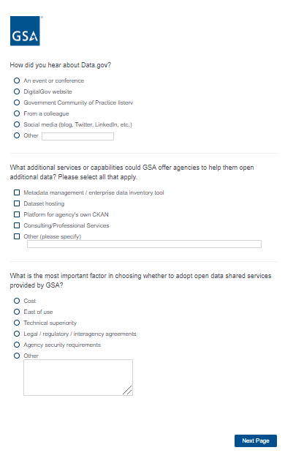

Proceed to Screen 31.

Screen 25

Display if Program Office = GSA SmartPay

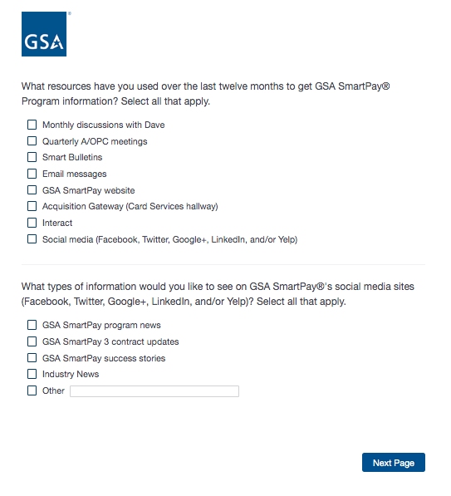

Screen 26

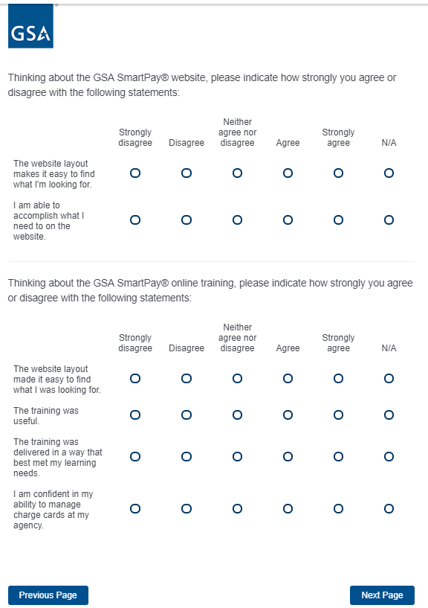

Screen 27

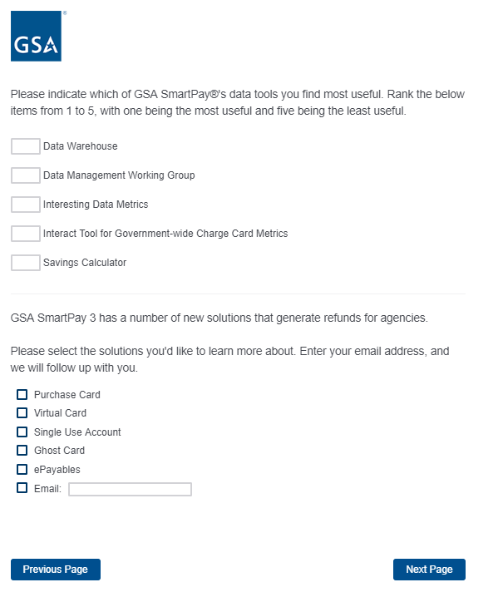
Proceed to Screen 31.

Screen 28

Display if Program Office = DigitalGov

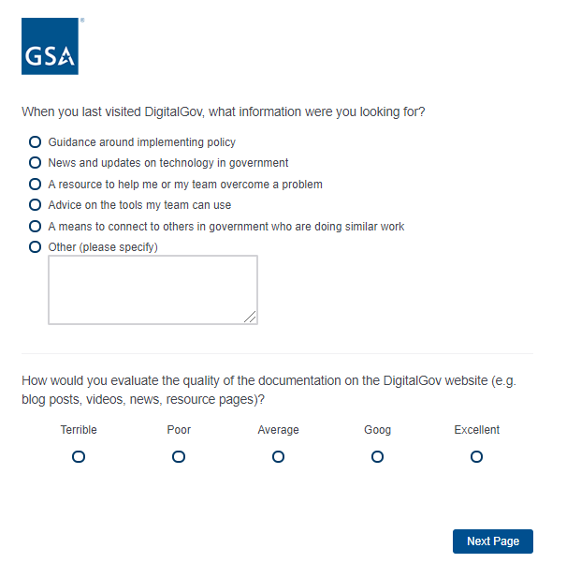
Screen 29

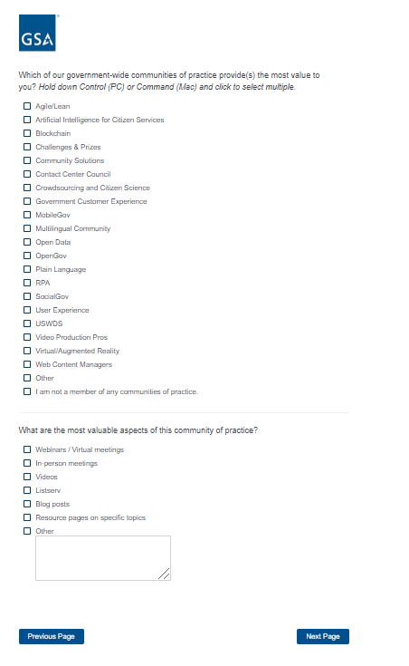
Screen 30

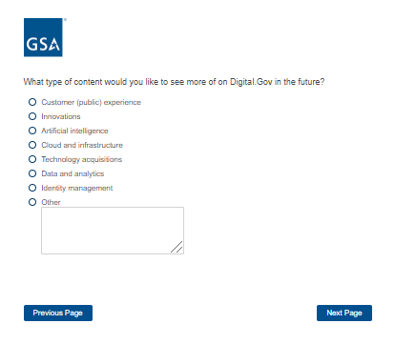

Proceed to Screen 31.
Screen 31

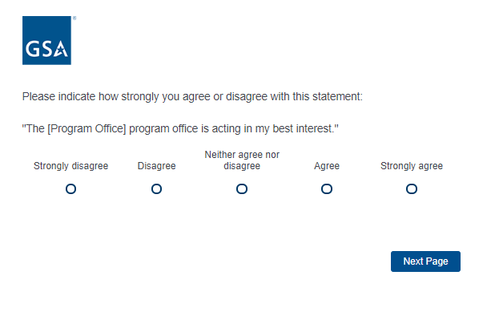

Screen 32

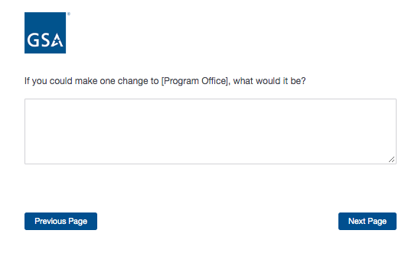

Screen 33

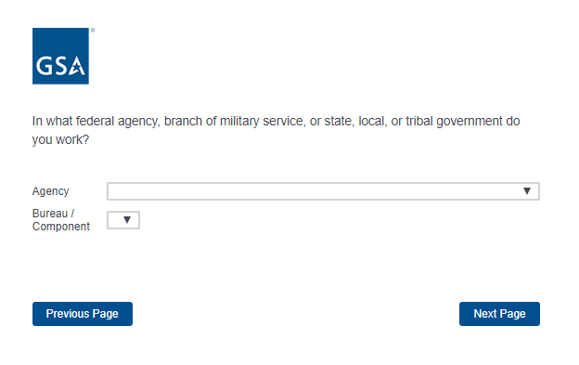

Screen 34

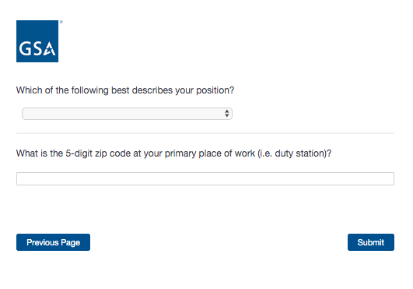

Screen 35

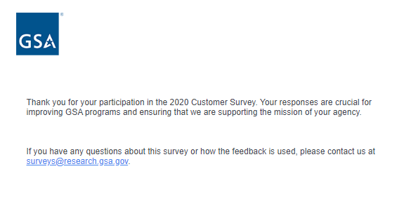
End of survey

