2020 Supplier Relationship Management Survey
Req-15
For PRA Review only – Contents of this box will not be displayed to recipients.

Note that this survey depends on embedded data to determine which questions will be displayed to each recipient. Embedded data are commands built into the survey that draw information from the contact list. Survey responses remain confidential, and personally identifiable information is not collected by the system.

The embedded data fields that are used in this survey are:
- GSA Program Office (program being rated)
- Schedule (Primary GSA contract through which the supplier does business)

On Screens 5 and 6, [Program Office] will be replaced by one of the following:
- One Acquisition Solution for Integrated Services (OASIS)
- GSA Schedule (Professional Services)
- Human Capital and Training Solutions (HCaTS)
- GSA Schedule (Human Capital)
- GSA General Supplies and Services
- GSA Information Technology Category
- GSA Fleet
- GSA Employee Relocation Resource Center (ERRC)
- GSA Center for Travel Management
- GSA Freight Management Program

Screen 1

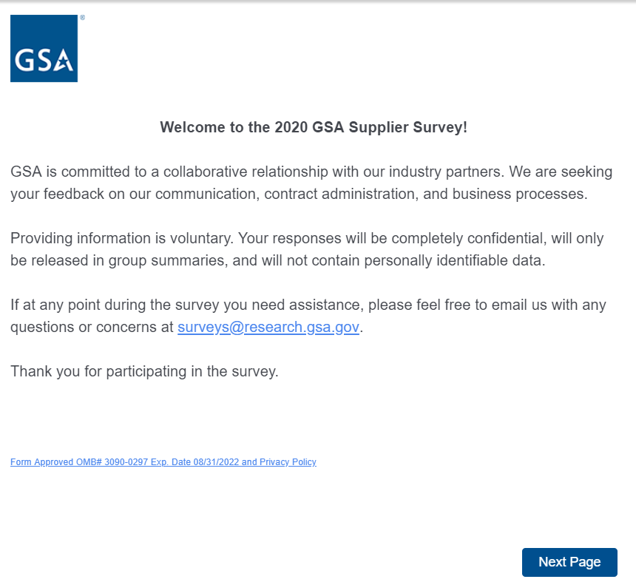
Link at the bottom of above page goes to a pdf displaying the PRA statement and a GSA Privacy Act Statement. See next page for screenshot.
Screen 1, continued

Screenshot of pdf linked from bottom of first page:

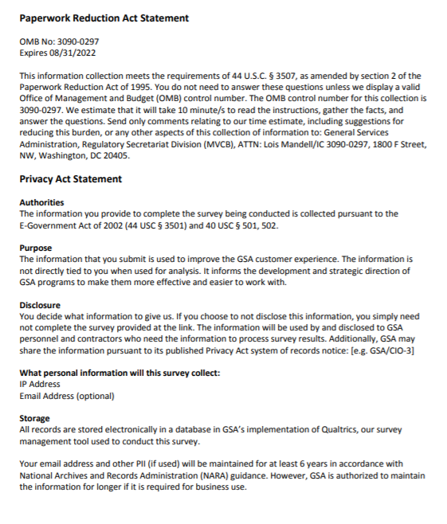
Screen 2a

Display if GSA Program Office (embedded data) = GSA General Supplies and Services.

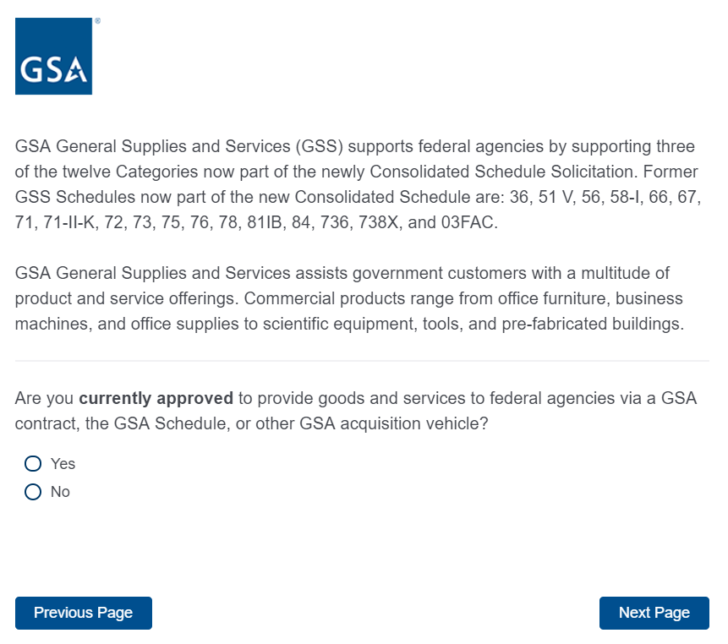

If No, then display Screen 3 and exit survey.
If Yes, skip to Screen 4.

Screen 2b

Display if GSA Program Office (embedded data) = GSA Fleet:
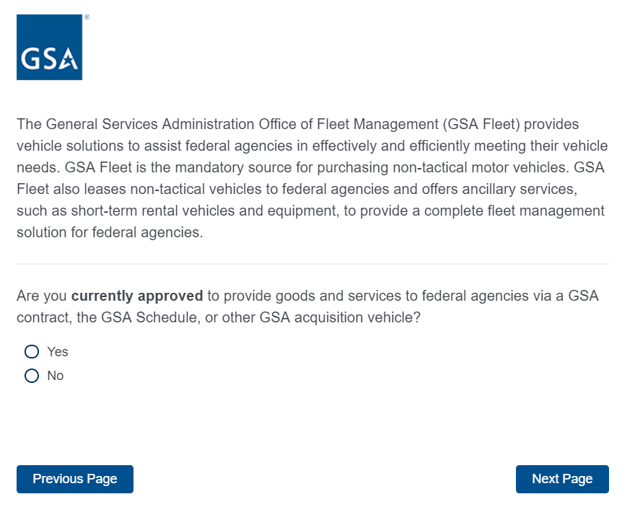
If No, then display Screen 3 and exit survey.
If Yes, skip to Screen 5.

Screen 2c

Display if GSA Program Office (embedded data) = GSA Information Technology Category:
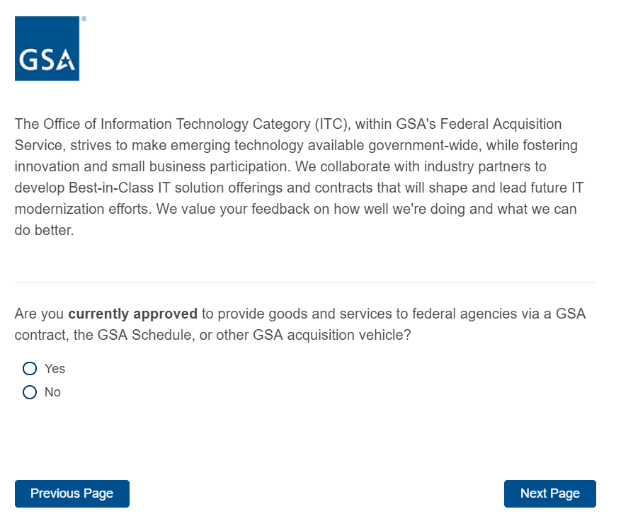
If No, then display Screen 3 and exit survey.
If Yes, skip to Screen 5.

Screen 2d

Display if GSA Program Office (embedded data) = GSA Center for Travel Management:

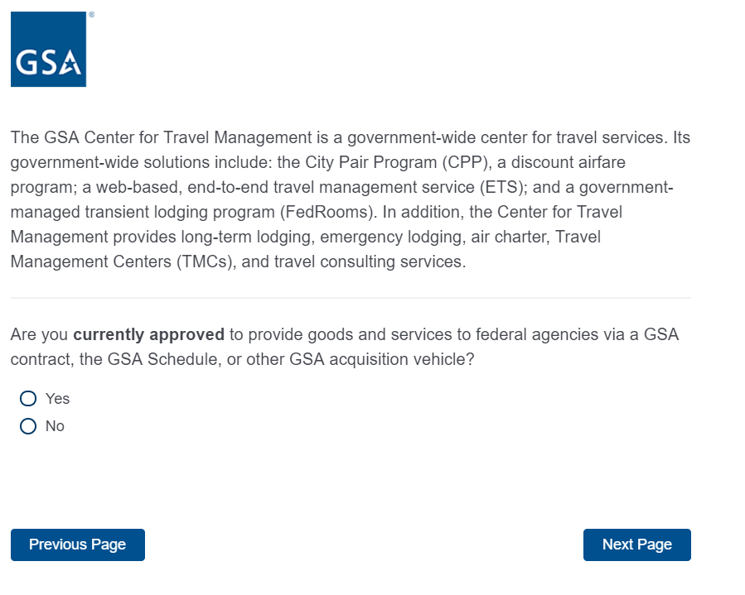
If No, then display Screen 3 and exit survey.
If Yes, skip to Screen 5.

Screen 2e

Display if GSA Program Office (embedded data) = GSA Freight Management Program
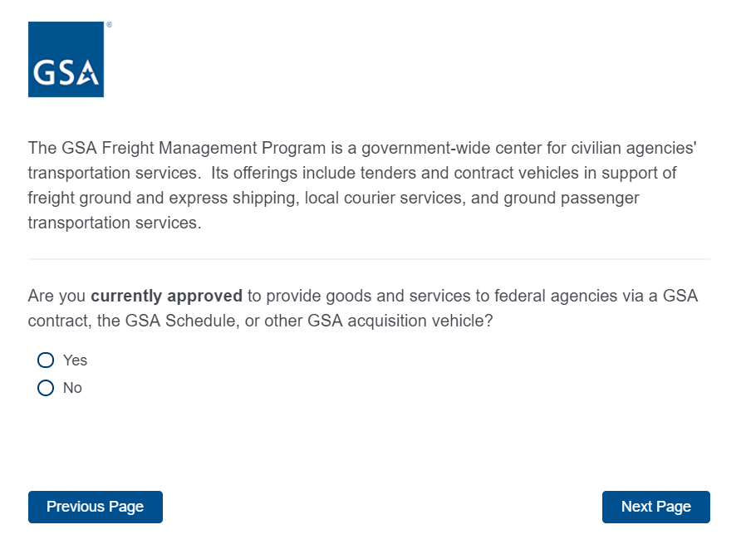
If No, then display Screen 3 and exit survey.
If Yes, skip to Screen 5.

Screen 2f

Display if GSA Program Office (embedded data) = GSA Employee Relocation Resource Center (ERRC):
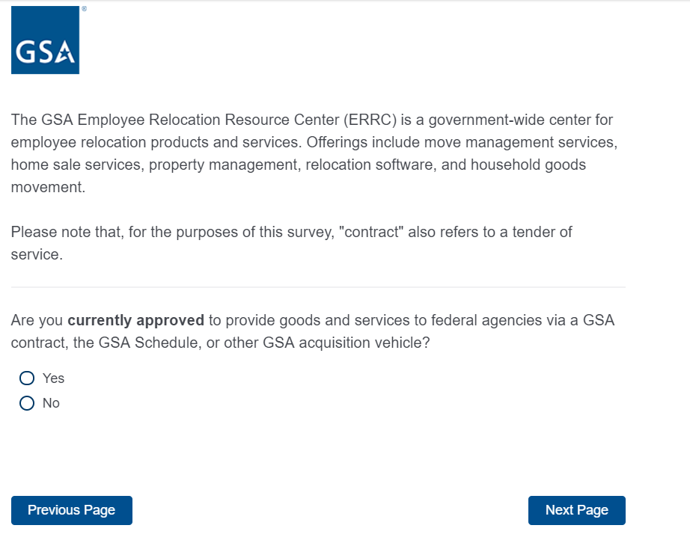
If No, then display Screen 3 and exit survey.
If Yes, skip to Screen 5.
Screen 2g

Display if GSA Program Office (embedded data) = One Acquisition Solution for Integrated Services (OASIS):
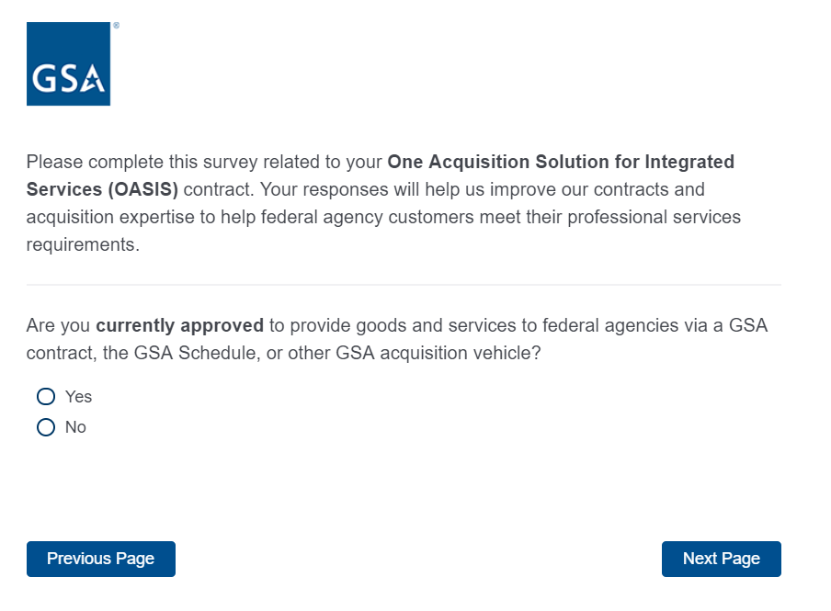
If No, then display Screen 3 and exit survey.
If Yes, skip to Screen 5.

Screen 2h

Display if GSA Program Office (embedded data) = GSA Schedule (Professional Services)

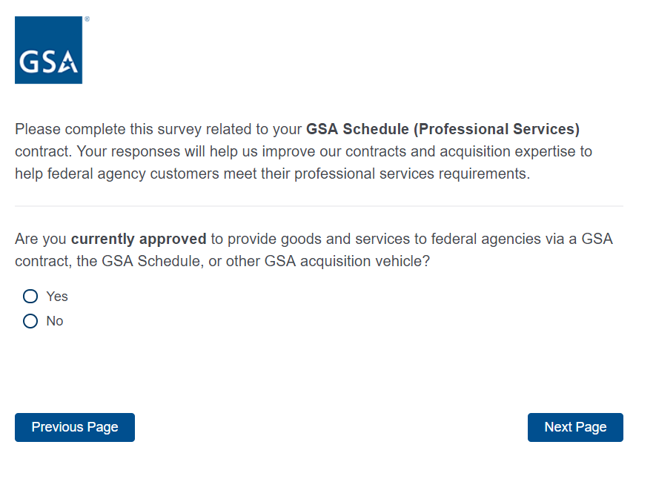
If No, then display Screen 3 and exit survey.
If Yes, skip to Screen 5.

Screen 2i

Display if GSA Program Office (embedded data) = Human Capital and Training Solutions (HCaTS)

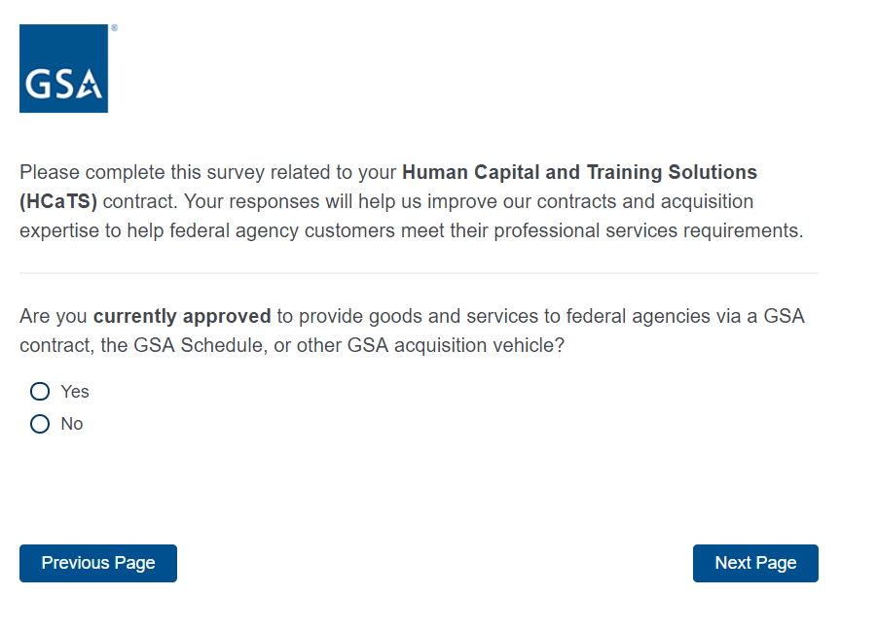

If No, then display Screen 3 and exit survey.
If Yes, skip to Screen 5.

Screen 2j

Display if GSA Program Office (embedded data) = GSA Schedule (Human Capital)

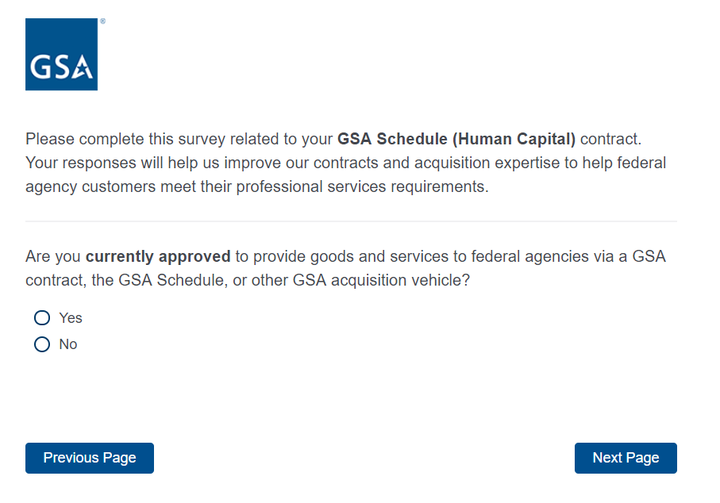
If No, then display Screen 3 and exit survey.
If Yes, skip to Screen 5.

Screen 3

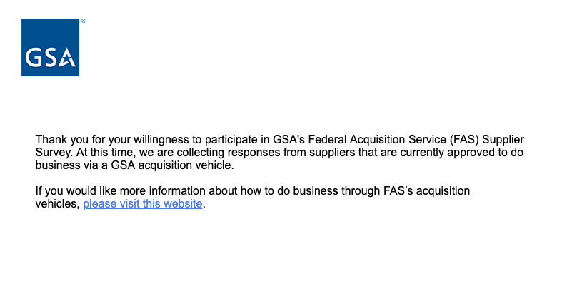Exit survey (for respondents who select “No” on Screens 2a-j). The above link goes to a page on GSA.gov that provides information on how to do business with GSA.
Screen 4

Display if GSA Program Office (embedded data) = GSA General Supplies and Services
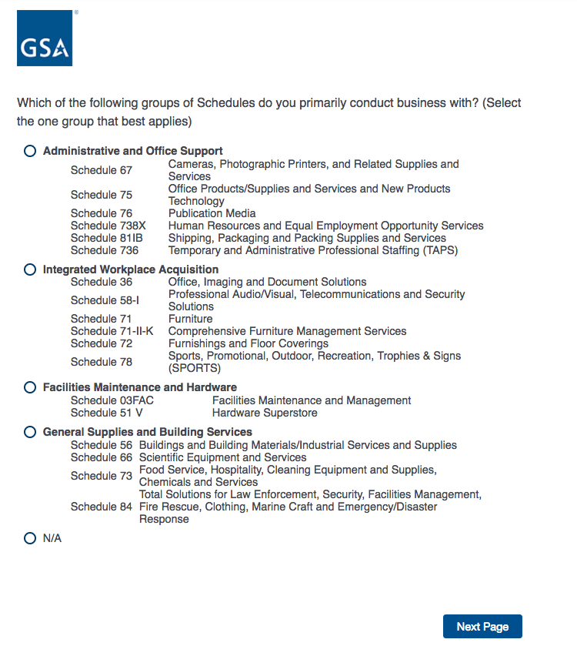

Proceed to Screen 5.

Screen 5

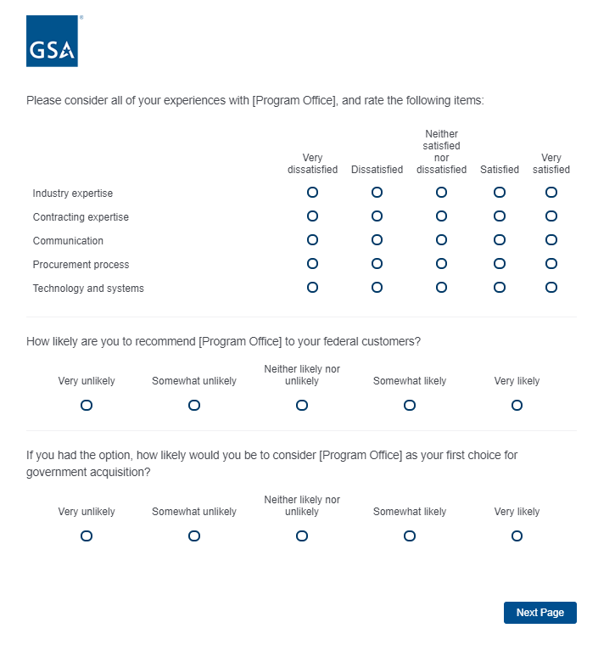

Proceed to Screen 6.
Screen 6

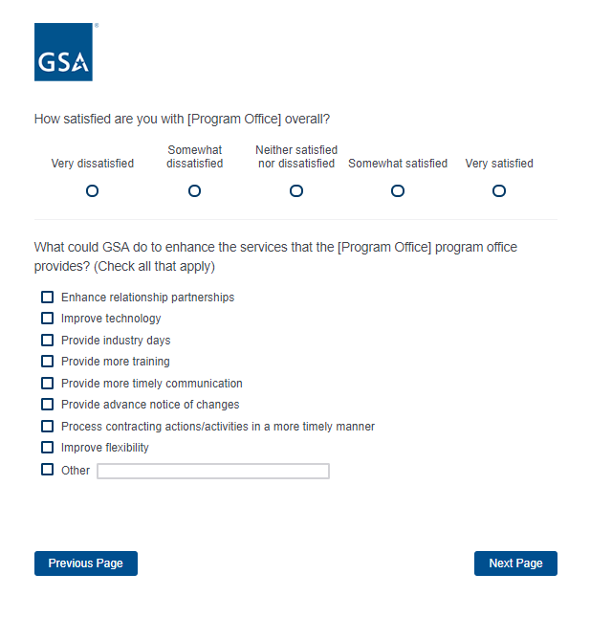
If Program Office = GSA General Supplies and Services, skip to Screen 7.
If Program Office = GSA Fleet, skip to Screen 9.
If Program Office = GSA Center for Travel Management, skip to Screen 10.
If Program Office = GSA Freight Management Program, skip to Screen 12.
If Program Office = GSA Employee Relocation Resource Center (ERRC), skip to Screen 14.
If Program Office = One Acquisition Solution for Integrated Services (OASIS), skip to Screen 16.
If Program Office = GSA Schedule (Professional Services), skip to Screen 19.
If Program Office = Human Capital and Training Solutions (HCaTS), skip to Screen 21.
If Program Office = GSA Schedule (Human Capital), skip to Screen 24.
If Program Office = GSA Information Technology Category, skip to Screen 27.

Screen 7

Display if GSA Program Office (embedded data) = GSA General Supplies and Services
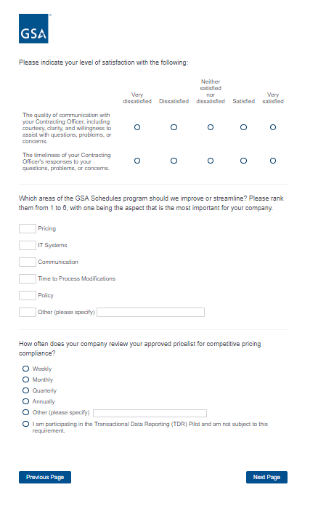

Screen 8

Display if GSA Program Office (embedded data) = GSA General Supplies and Services

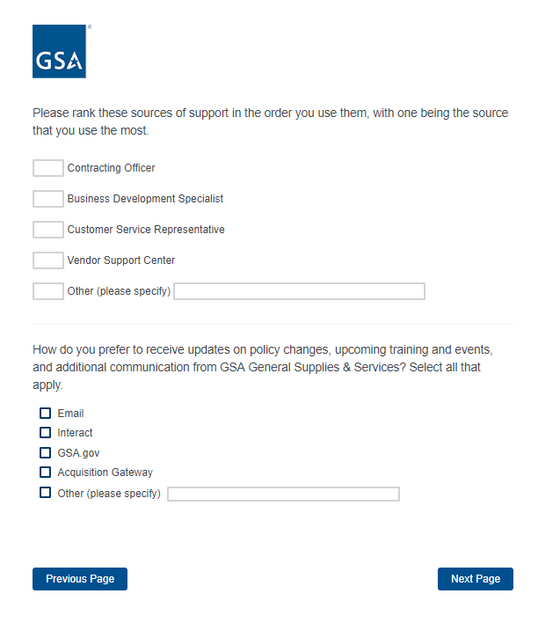
If Schedule = 51V, 58-I, 72, 73, 75, or 03FAC, proceed to Screen 26.
ELSE skip to Screen 27.

Screen 9

Display if GSA Program Office (embedded data) = GSA Fleet

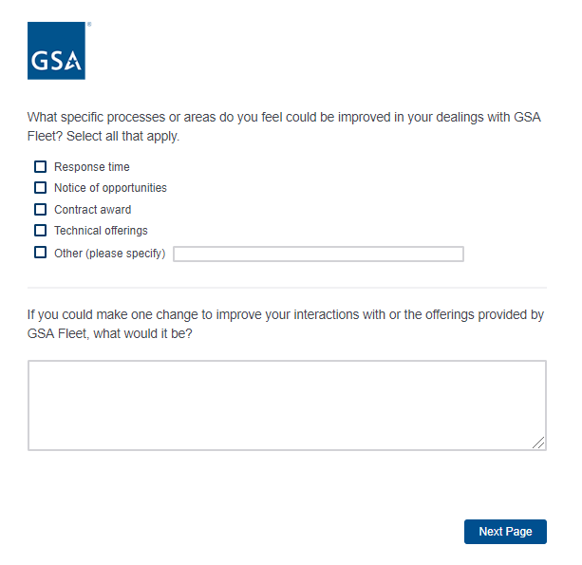
If Schedule = 23V, then skip to Screen 27.
ELSE skip to Screen 29.
Screen 10

Display if GSA Program Office (embedded data) = the GSA Center for Travel Management

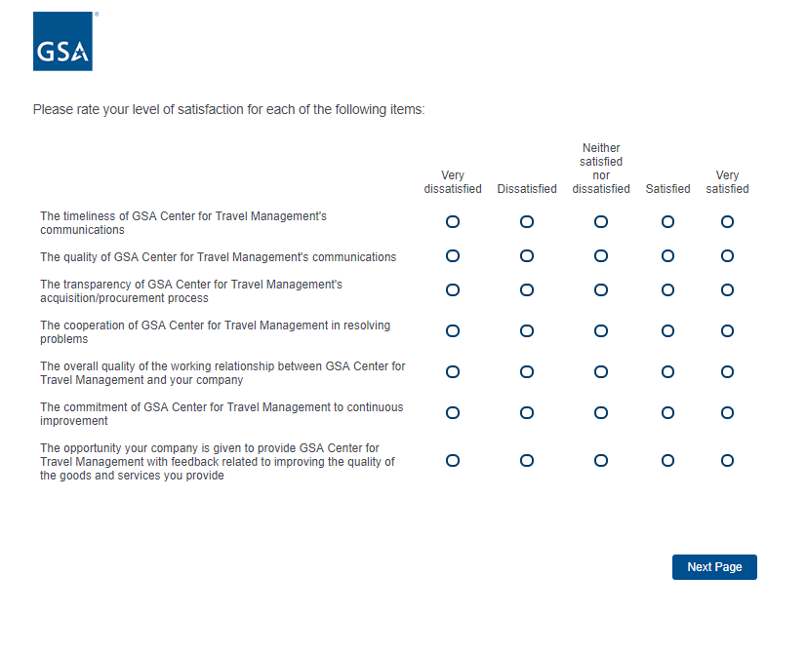

Screen 11

Display if GSA Program Office (embedded data) = the GSA Center for Travel Management

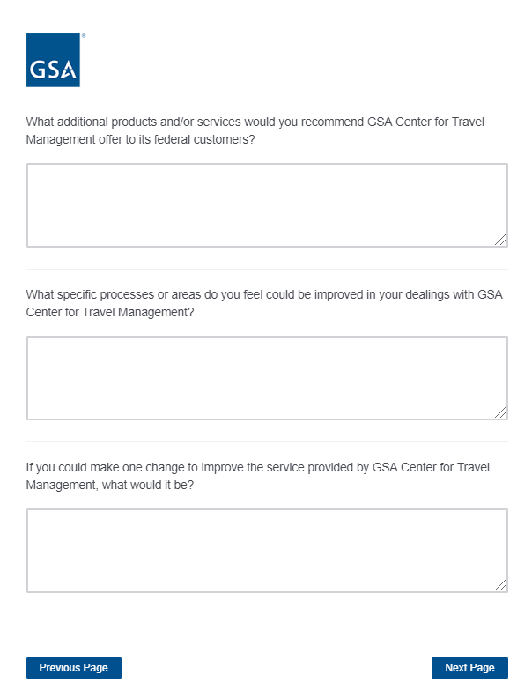

If Schedule = 599, skip to Screen 27.
ELSE skip to Screen 29.
Screen 12

Display if GSA Program Office (embedded data) = GSA Freight Management Program

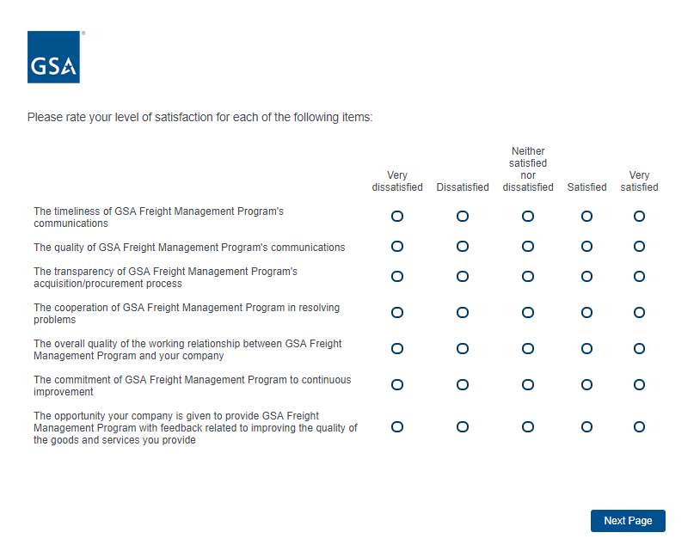

Screen 13

Display if GSA Program Office (embedded data) = GSA Freight Management Program

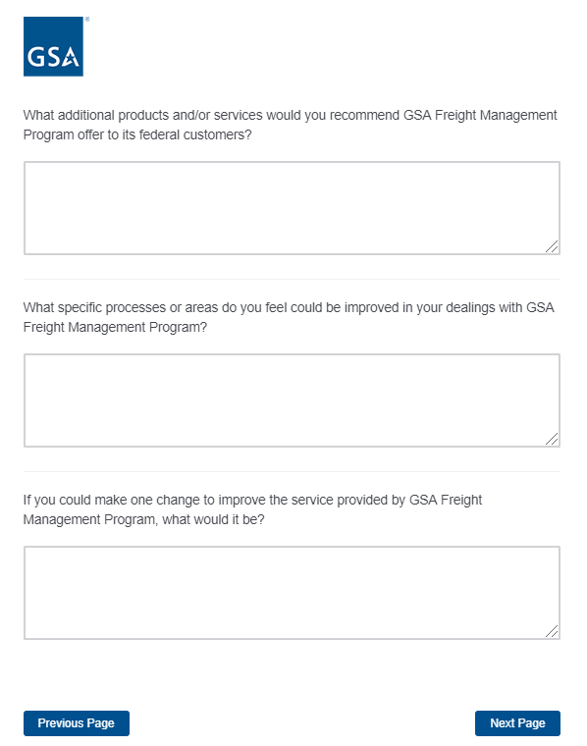

Then skip to Screen 29.
Screen 14

Display if GSA Program Office (embedded data) = GSA Employee Relocation Resource Center (ERRC)

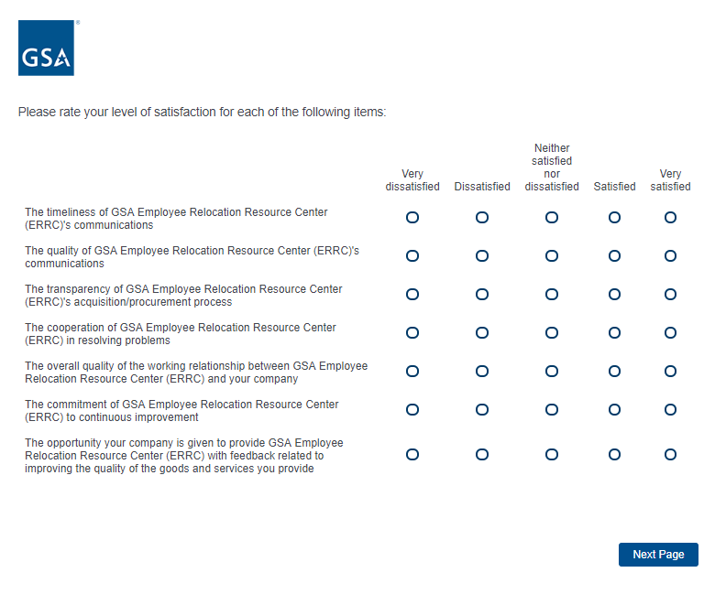

Screen 15

Display if GSA Program Office (embedded data) = GSA Employee Relocation Resource Center (ERRC)

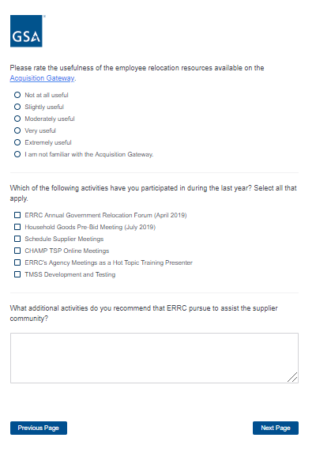

If Schedule = 48, skip to Screen 27.
ELSE skip to Screen 29.
Screen 16

Display if GSA Program Office (embedded data) = One Acquisition Solution for Integrated Services (OASIS)

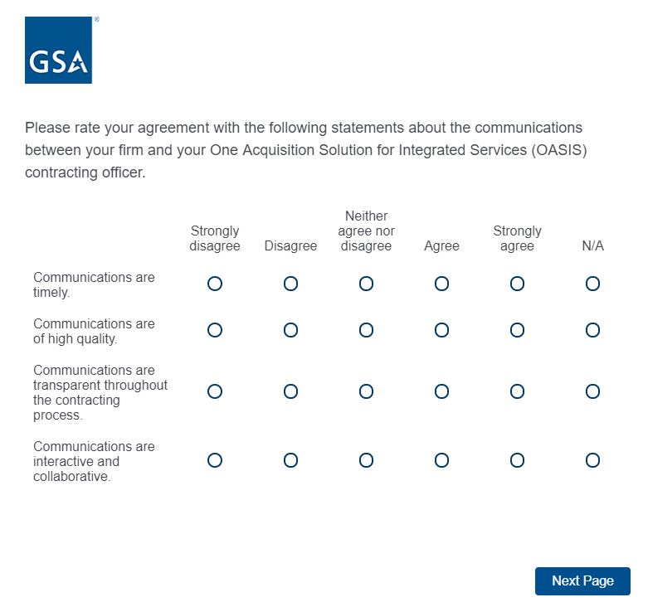

Screen 17

Display if GSA Program Office (embedded data) = One Acquisition Solution for Integrated Services (OASIS)

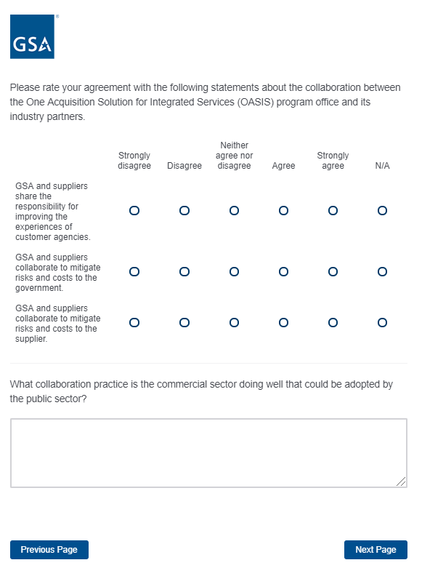

Screen 18

Display if GSA Program Office (embedded data) = One Acquisition Solution for Integrated Services (OASIS)

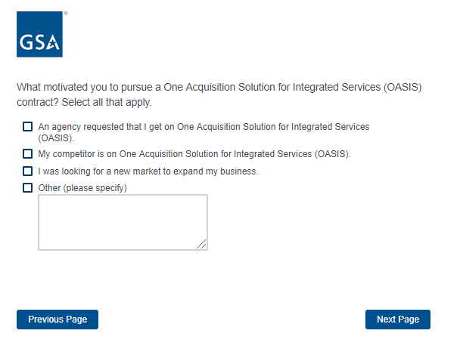
Proceed to Screen 29.

Screen 19

Display if GSA Program Office (embedded data) = GSA Schedule (Professional Services)

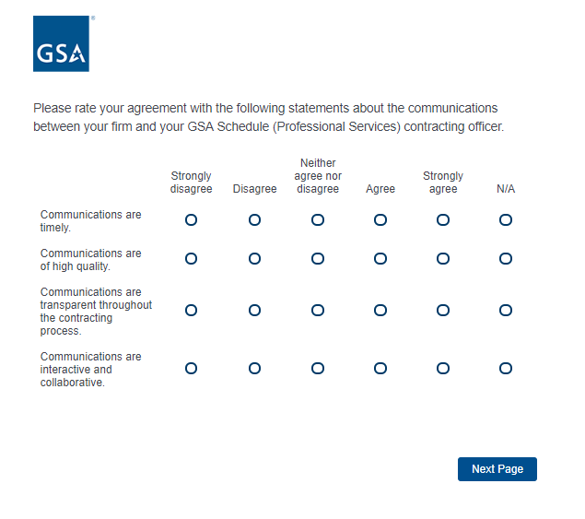

Screen 20

Display if GSA Program Office (embedded data) = GSA Schedule (Professional Services)

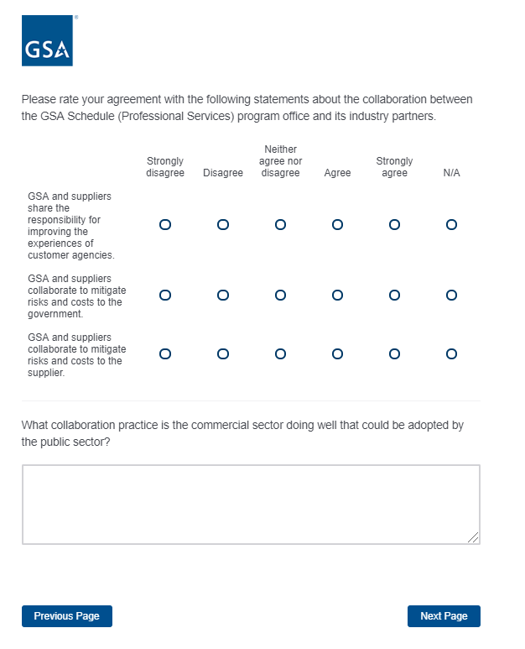
Skip to Screen 26.
Screen 21

Display if GSA Program Office (embedded data) = Human Capital and Training Solutions (HCaTS)

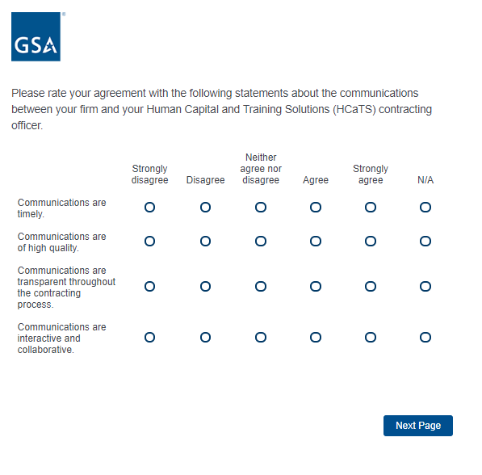

Screen 22

Display if GSA Program Office (embedded data) = Human Capital and Training Solutions (HCaTS)

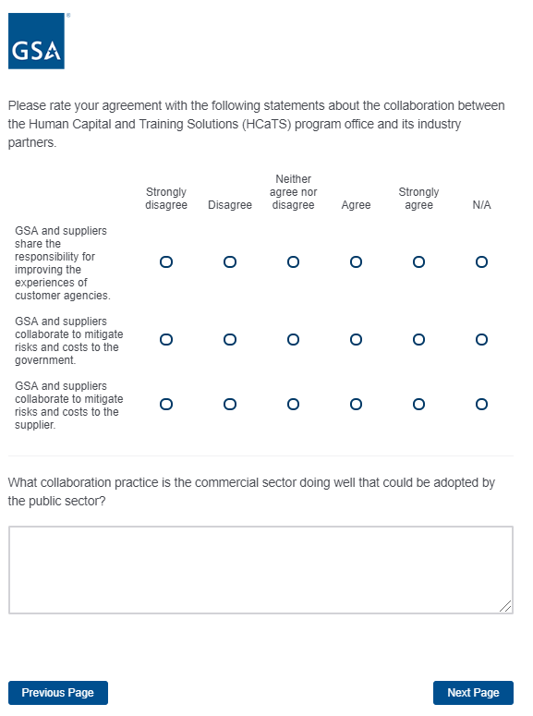

Screen 23

Display if GSA Program Office (embedded data) = Human Capital and Training Solutions (HCaTS)

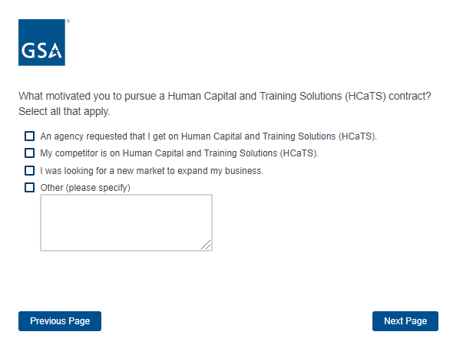
Proceed to Screen 29.

Screen 24

Display if GSA Program Office (embedded data) = GSA Schedule (Human Capital)

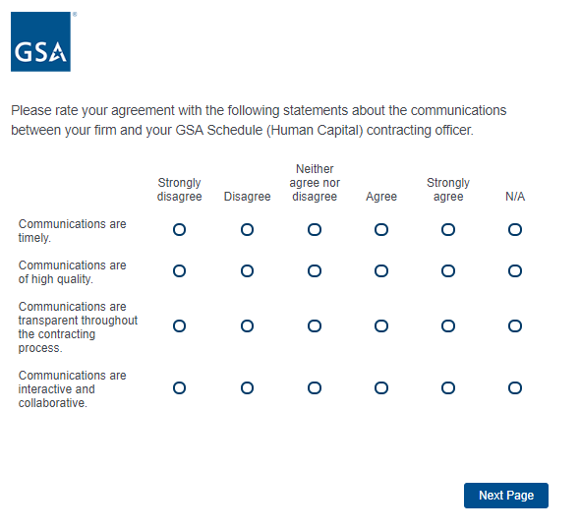

Screen 25

Display if GSA Program Office (embedded data) = GSA Schedule (Human Capital)

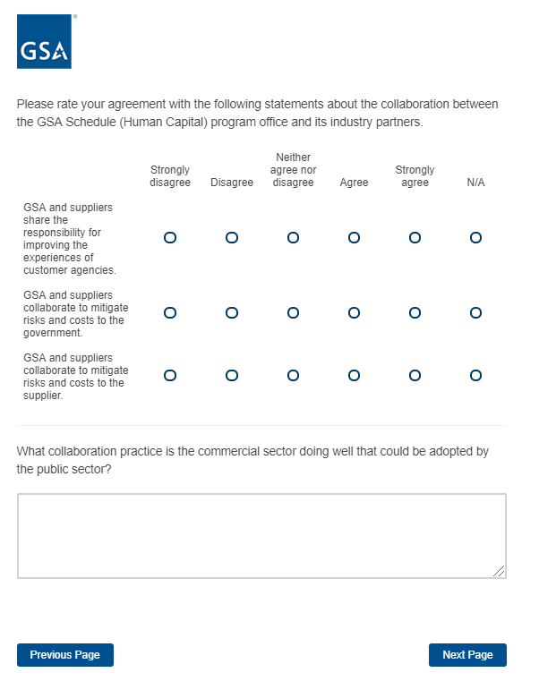
Proceed to Screen 27.
Screen 26

Display if Schedule = 51V, 58-I, 70, 72, 73, 75, or 03FAC
Or if Program Office = GSA Schedule (Professional Services)

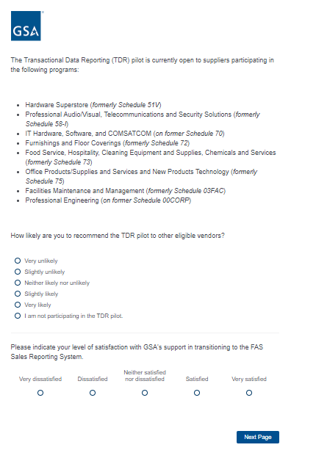
If Schedule is not null, proceed to Screen 27.
ELSE skip to Screen 29.
Screen 27

Display if Schedule is not null.
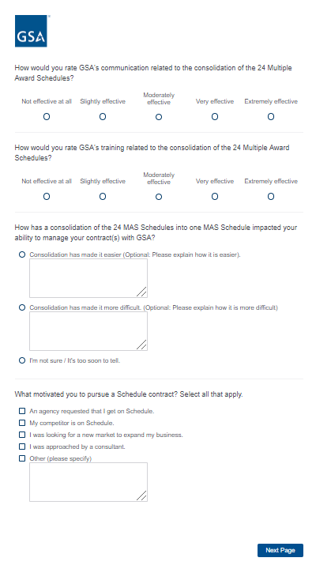

Screen 28

Display if Schedule is not null.
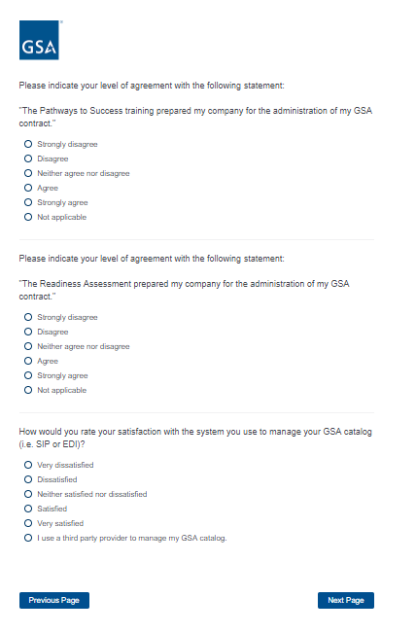
Then proceed to Screen 29.

Screen 29

Display to all respondents

Screen 30

Display to all respondents.

Screen 31

Display to all respondents

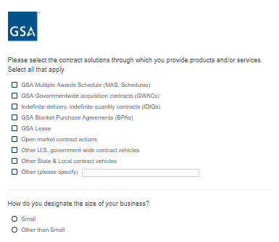

If “Small” is selected, then display the following question in the same page.

Screen 31, continued

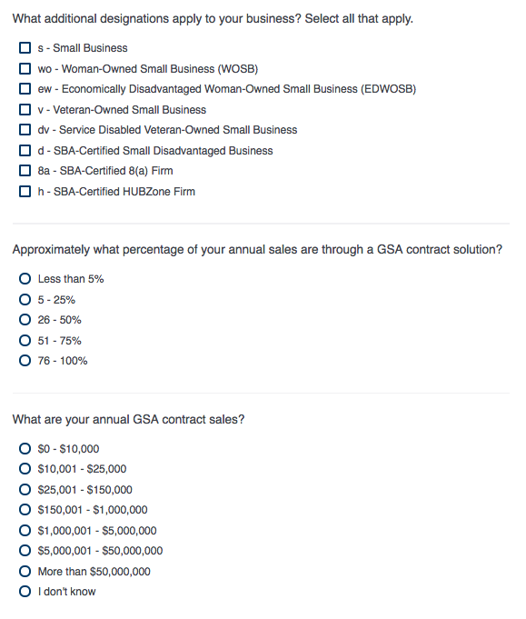
If “$0 - $10,000” or “$10,001 - $25,000” is selected, then display the following question in the same page:

Screen 31, continued

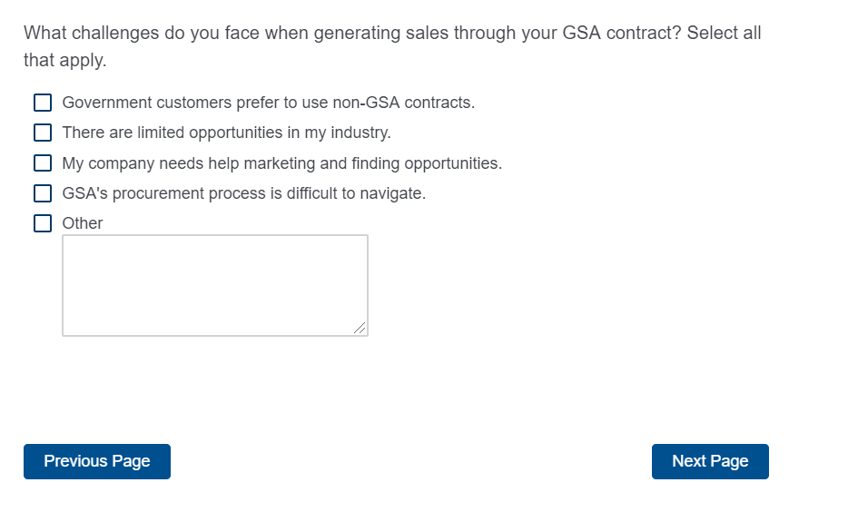

Screen 32

Display to all respondents.

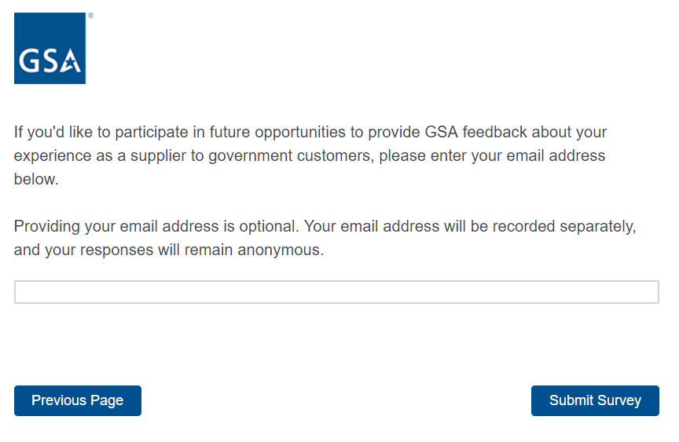
Screen 33

Display to all respondents.

