Req-22
Page 1
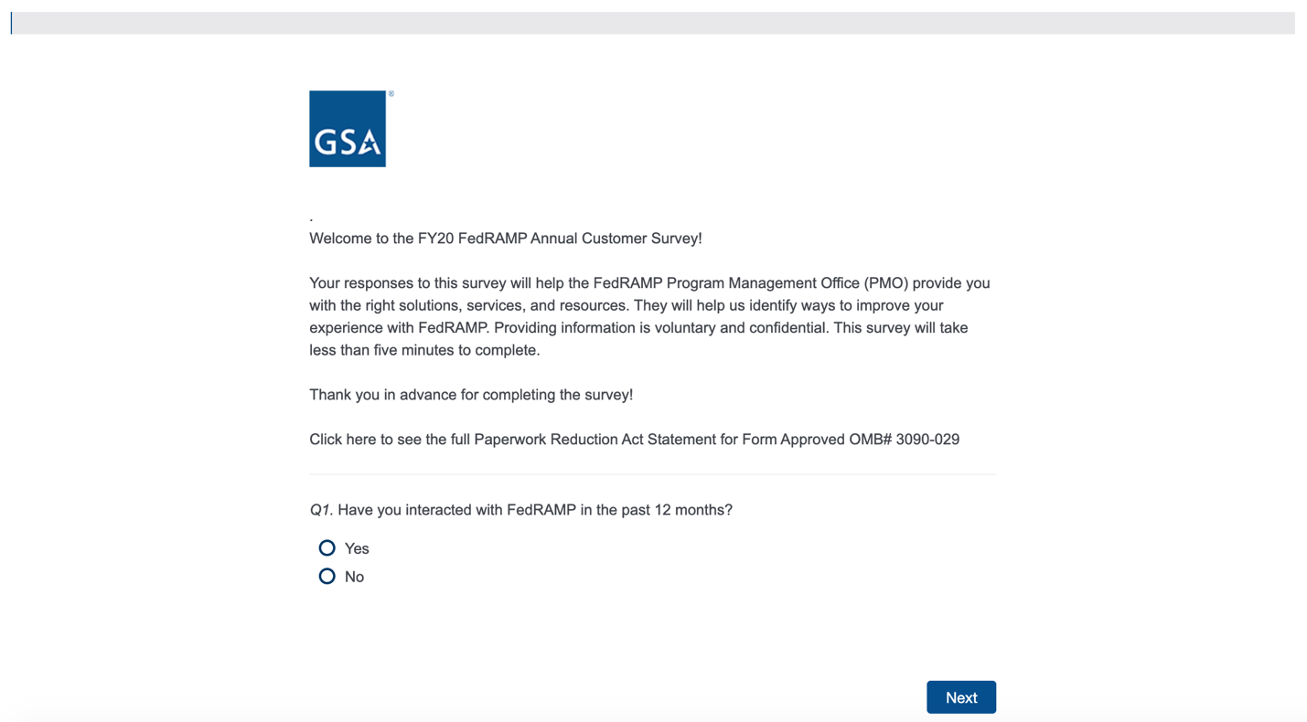
If users answer "yes", continue to Page 2. If users answer "no", the survey ends and users will be taken to an exit screen.

Page 2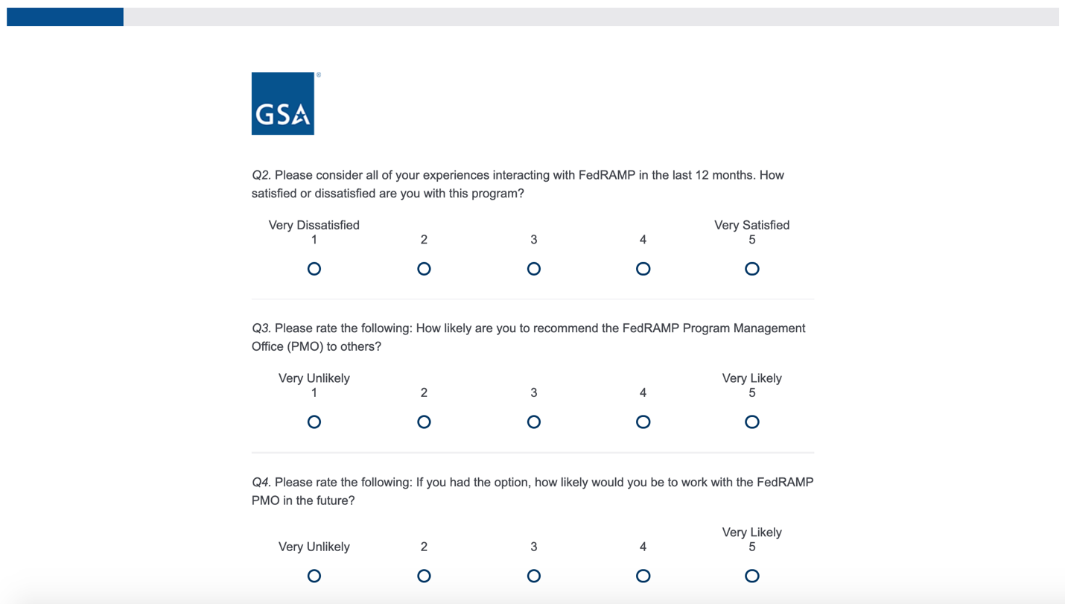
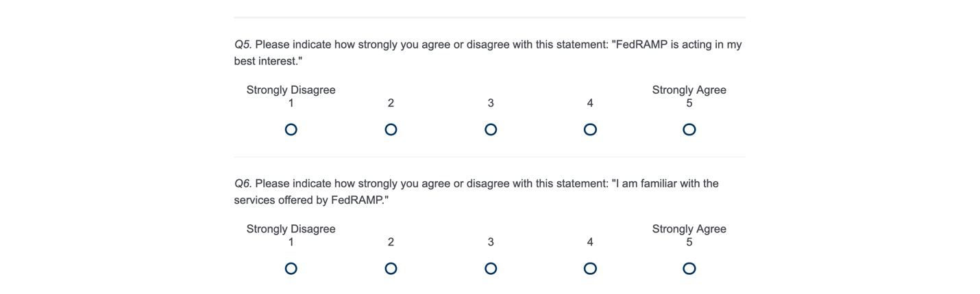
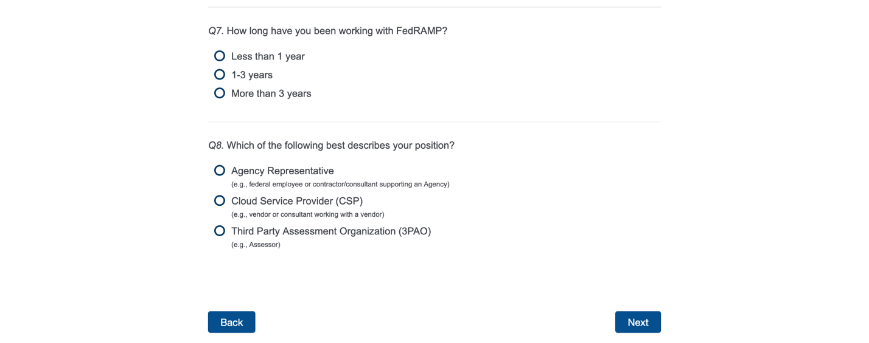If users answer "Agency", continue to Page 3. If users answer “3PAO”, continue to Page 4. If users answer "CSP", continue to Page 5

Page 3
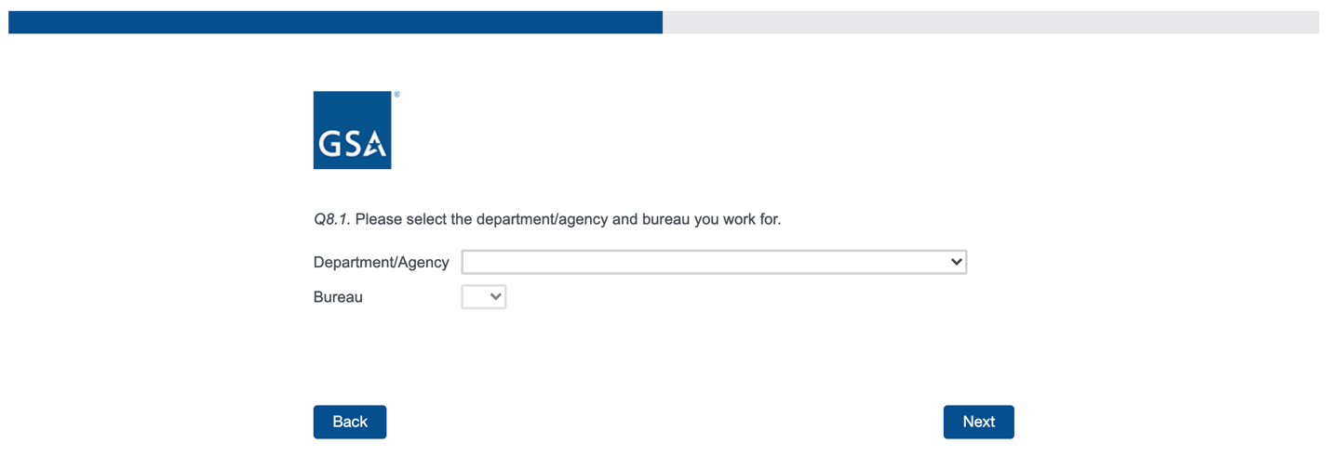
Continue to Page 5

Page 4
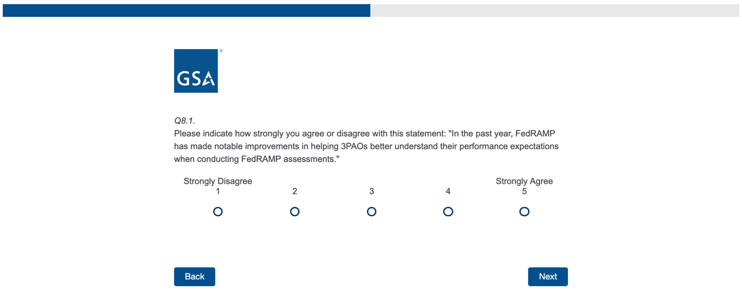
Continue to Page 5

Page 5
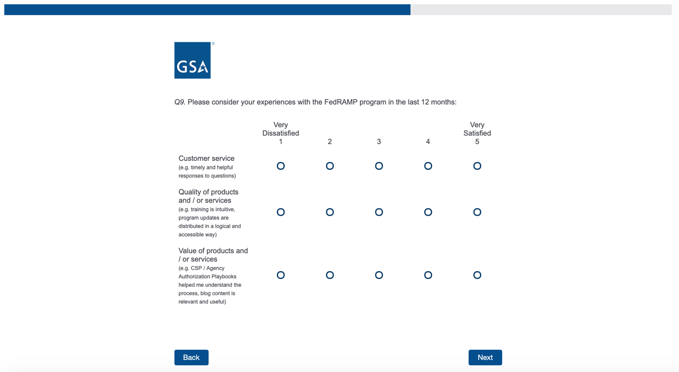

Page 6
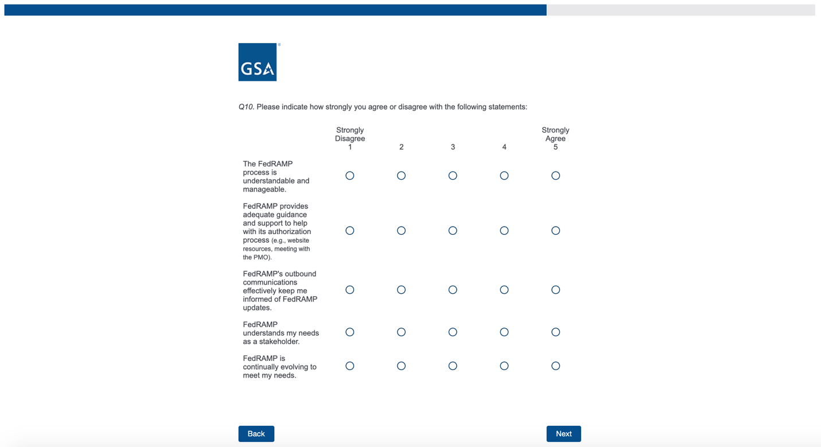

Page 7
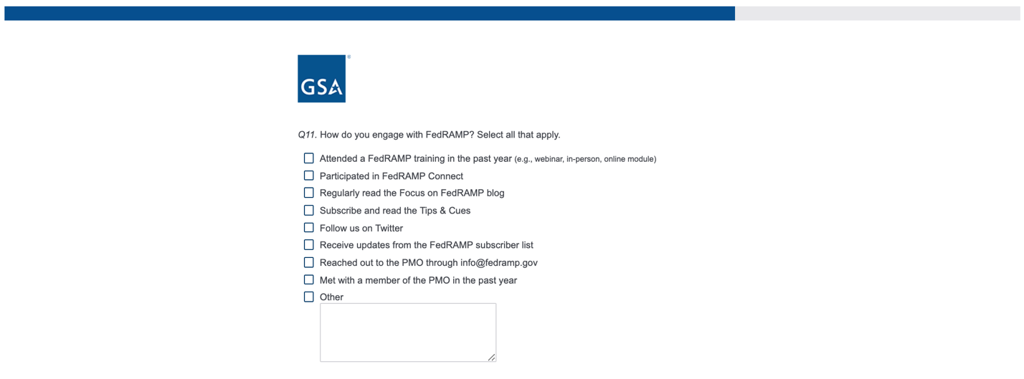
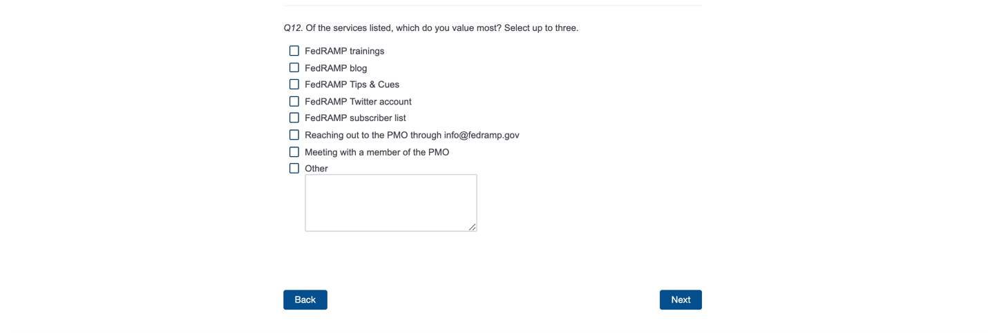

Page 8
