Instrument (OMB Control Number: 3090-0297)
Req-25

TITLE OF INFORMATION COLLECTION: USA.gov Website Customer Satisfaction Feedback Surveys

CONTACT: David Kaufmann david.kaufmann@gsa.gov

Pop-up invite Customer Satisfaction Survey English Version

1)
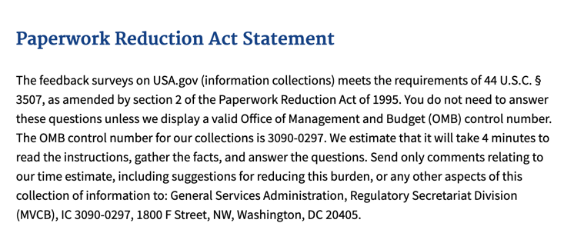

2)
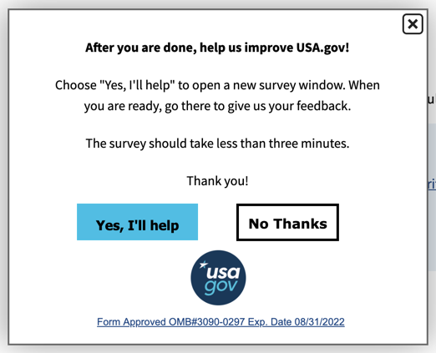
3)
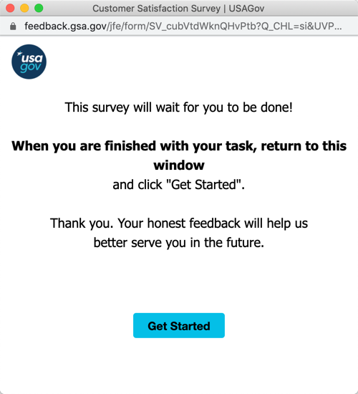

4)
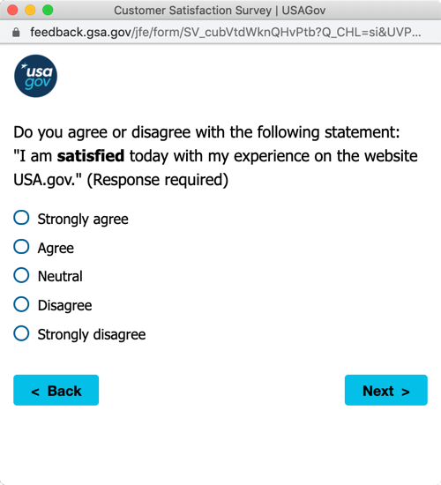
5)
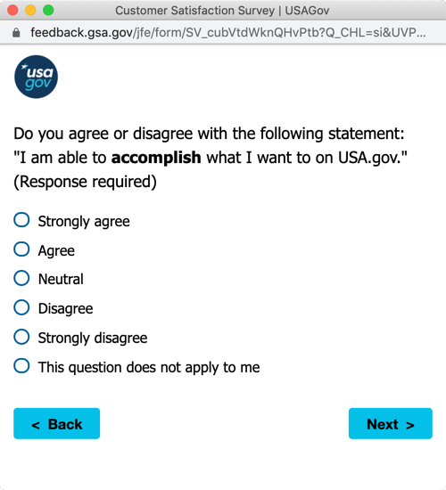

SURVEY BRANCHES

If response to (5) is “Disagree” or “Strongly Disagree” then proceed to (5B).
If response to (5) is “This question does not apply to me” then proceed to (10).
Otherwise, proceed to (6)

5B)
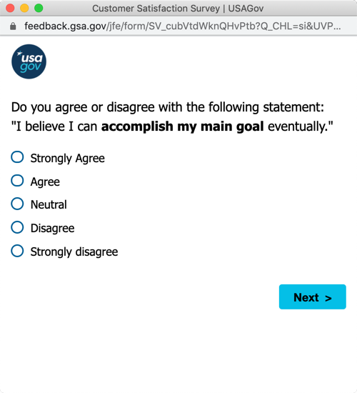

6)
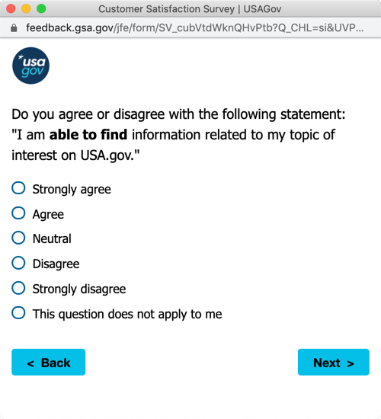

7)
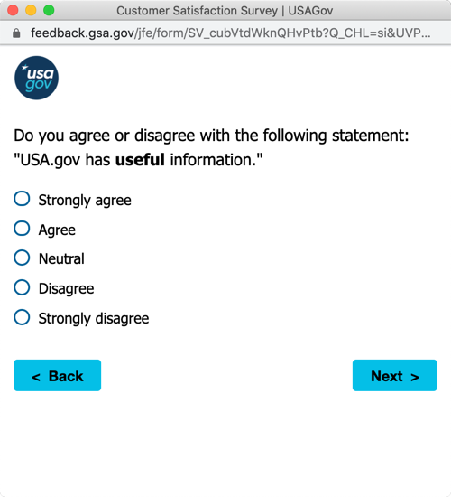
8)
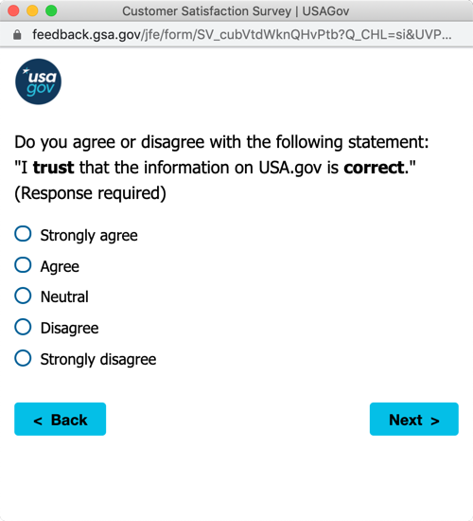

9)
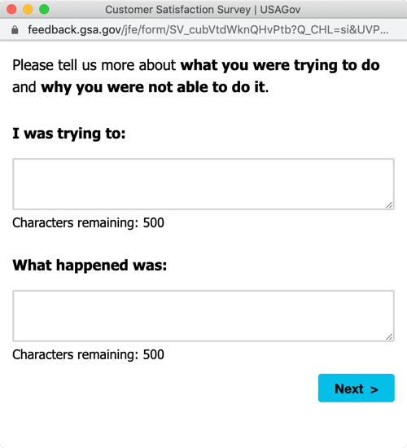
For this card, the text shown above is displayed if someone suggests they were not able to accomplish their task through their response to the question on card (5). The text is different for other choices.
Other text:
If neutral, then “... and what happened.”
If Agree or Strongly Agree then “... and had some success.”

10)
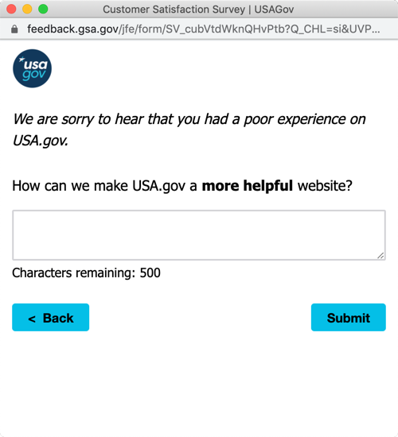

The message, “We are sorry to hear that you had a poor experience on USA.gov” only appears if the participant selects “Disagree” or “Strongly Disagree” for the first question about satisfaction on card 4.

(11)
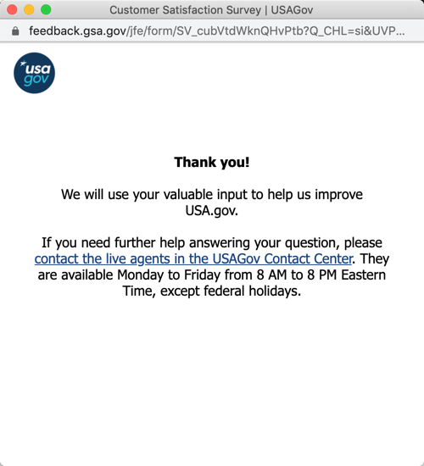

The survey will also be offered in Spanish.

Pop-up invite Customer Satisfaction Survey Spanish Version

1)
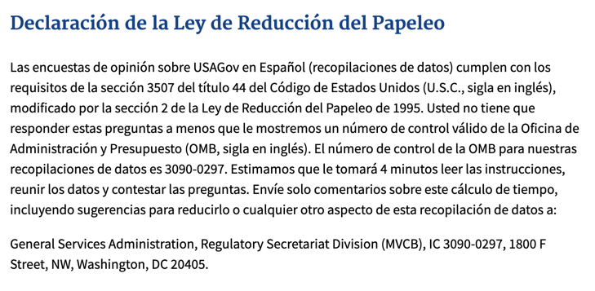

2)
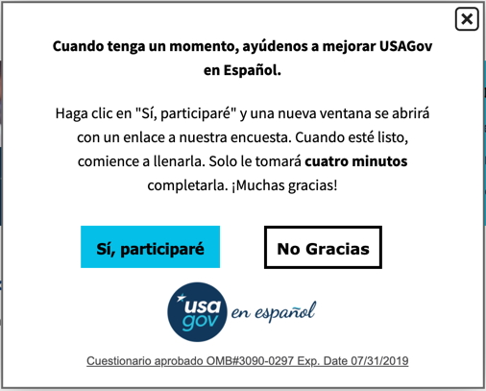
3)
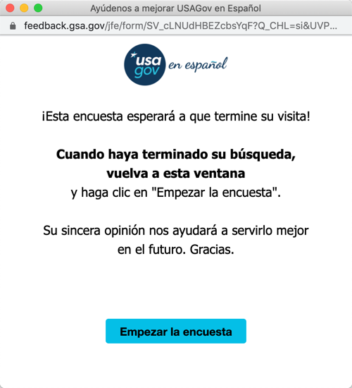

4)
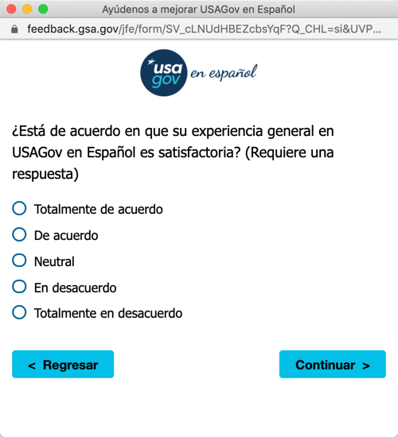
5)
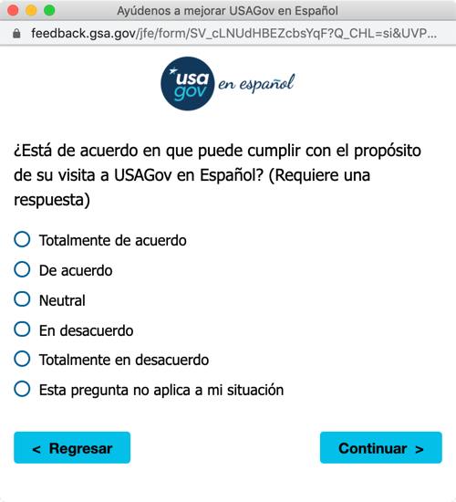

SURVEY BRANCHES

If response to (5) is “Disagree” or “Strongly Disagree” then proceed to (5B).
If response to (5) is “This question does not apply to me” then proceed to (10).
Otherwise, proceed to (6)

5B)
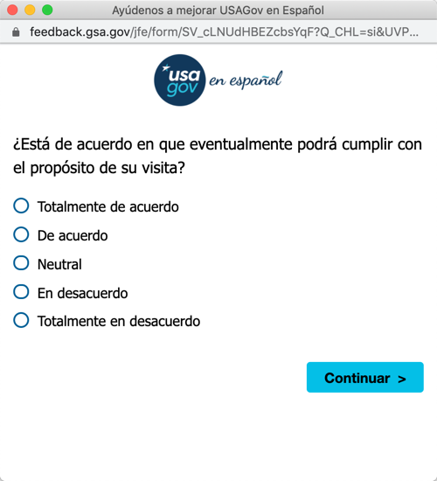

6)
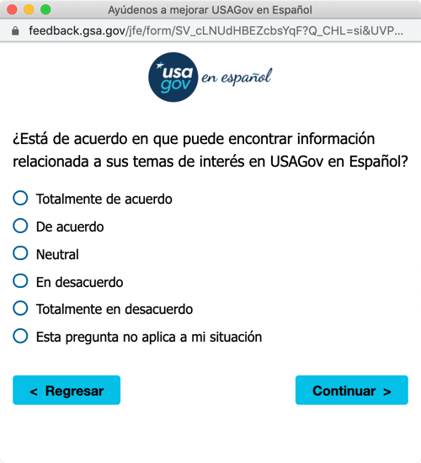

7)
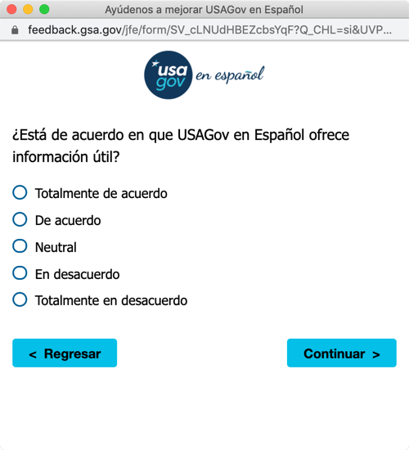
8)
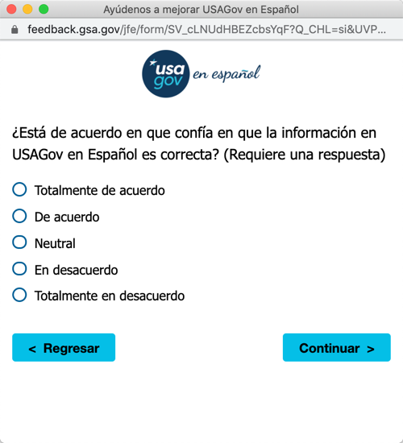

9)
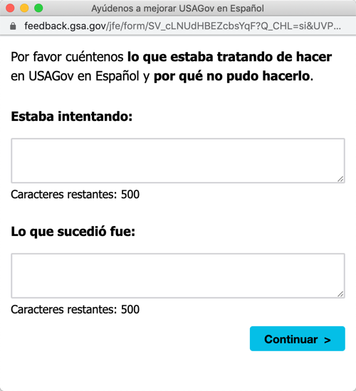
For this card, the text shown above is displayed if someone suggests they were not able to accomplish their task through their response to the question on card (5). The text is different for other choices.
Other text:
If neutral, then “... and what happened.”
If Agree or Strongly Agree then “... and had some success.”

10)
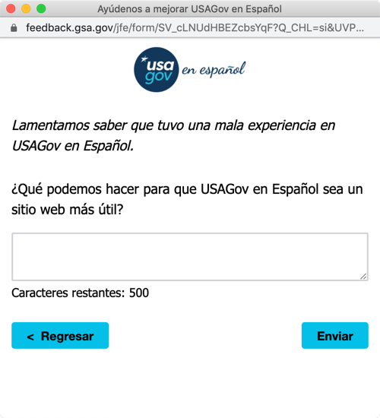

The message, “We are sorry to hear that you had a poor experience on USA.gov” only appears if the participant selects “Disagree” or “Strongly Disagree” for the first question about satisfaction on card 4.

(11)
