FAST Track 3090-0297
FAST2020 Training Conference Exhibitor Survey
Req-12

Screen 1

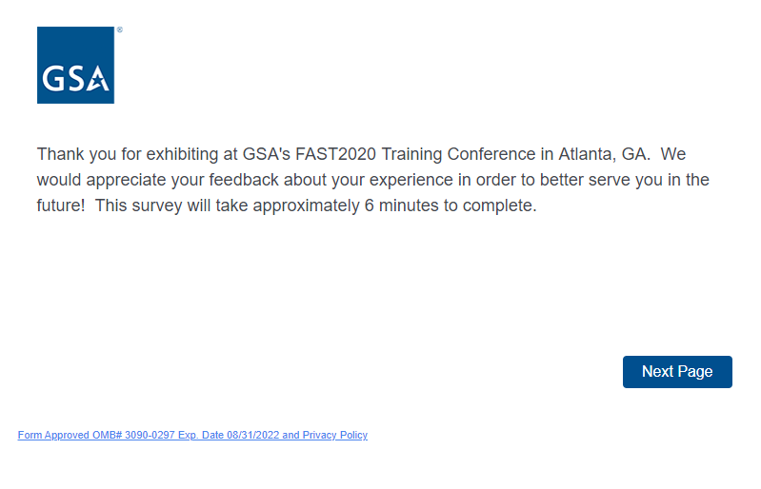
Below is the text that corresponds to the hyperlink above titled “Form Approved OMB# 3090-0297 Exp. Date 08/31/2022 and Privacy Policy”. The hyperlink appears on each page of the survey.

Paperwork Reduction Act Statement

OMB No: 3090-0297
Expires 08/31/2022

This information collection meets the requirements of 44 U.S.C. § 3507, as amended by section 2 of the Paperwork Reduction Act of 1995. You do not need to answer these questions unless we display a valid Office of Management and Budget (OMB) control number. The OMB control number for this collection is 3090-0297. We estimate that it will take 6 minutes to read the instructions, gather the facts, and answer the questions. Send only comments relating to our time estimate, including suggestions for reducing this burden, or any other aspects of this collection of information to: General Services Administration, Regulatory Secretariat Division (MVCB), ATTN: Lois Mandell/IC 3090-0297, 1800 F Street, NW, Washington, DC 20405.

Privacy Act Statement

The information you provide to complete the survey being conducted is collected pursuant to 6 USC §1523 (b)(1)(A)-(E), the E-Government Act of 2002 (44 USC § 3501) , and 40 USC § 501.
The information that you submit is used to improve the user experience on this GSA website. This survey does not collect any personal information, nor can the information you provide be directly tied to you when used for analysis. If you choose to not disclose this information, you simply need not complete the survey in the pop up box. The information will be used by and disclosed to GSA personnel and contractors to process survey results. Additionally, GSA may share the information pursuant to its published Privacy Act system of records notice GSA/CIO-3. All records are stored electronically in a secure database in GSA’s implementation of Qualtrics, our survey management tool used to conduct this survey.

You can read more about GSA’s Privacy Policy and use of browser cookies here.

Screen 2
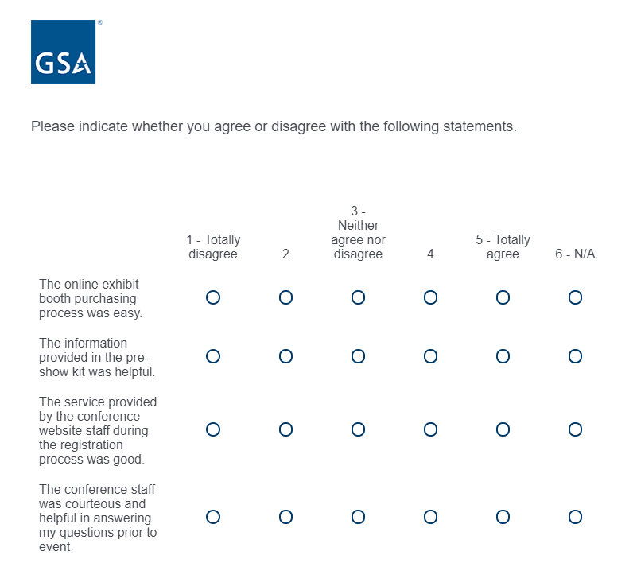

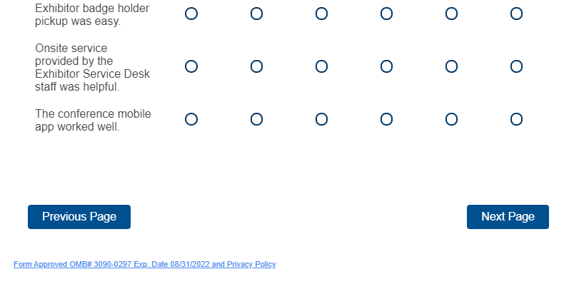

Screen 3
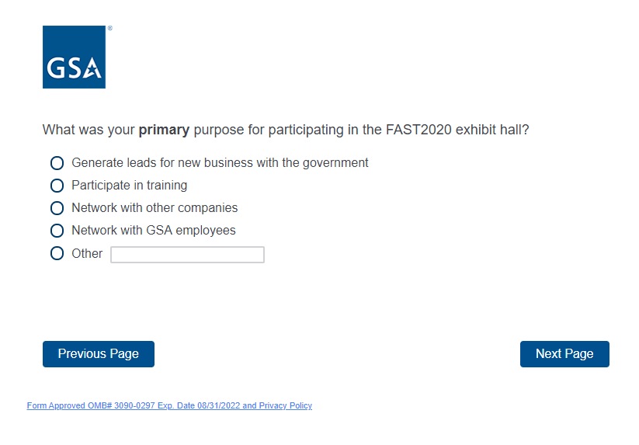

If the exhibitor selects “option 1 - Generate leads for new business with the government”, screen 4 will be displayed. If the exhibitor selects option 2, 3, 4 or 5, they skip to screen 9.

Screen 4

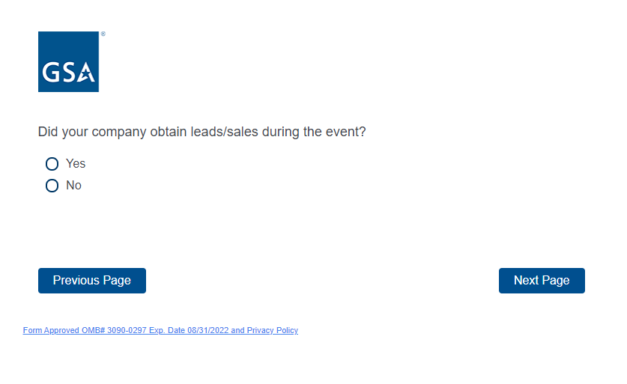
If the exhibitor selects “yes” from above, screens 5-8 will be displayed. If exhibitor selects “no”, they skip to screen 9.

Screen 5
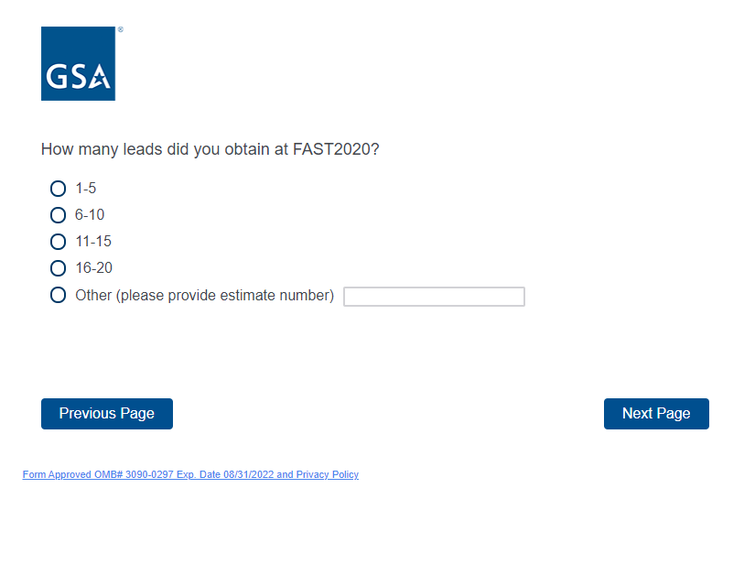

Screen 6
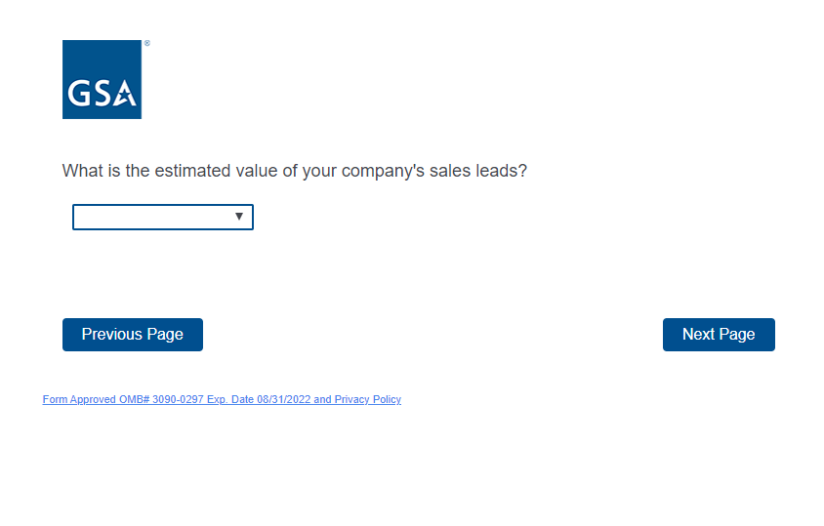
The exhibitor selects from the drop down list above. The options are:
Under $10,000
$10,001 - $99,999
$100,000 - $500,000
Over $500,000

Screen 7
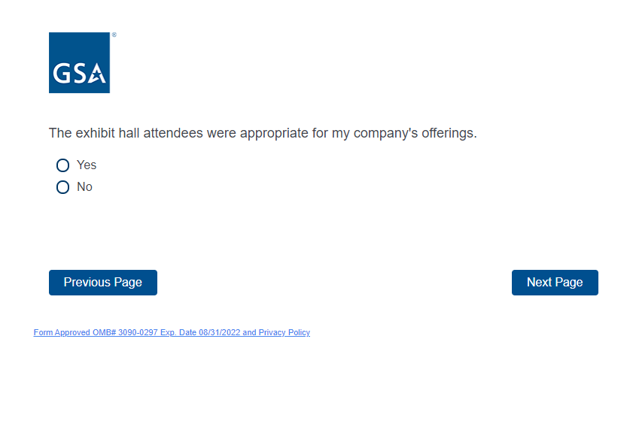

Screen 8

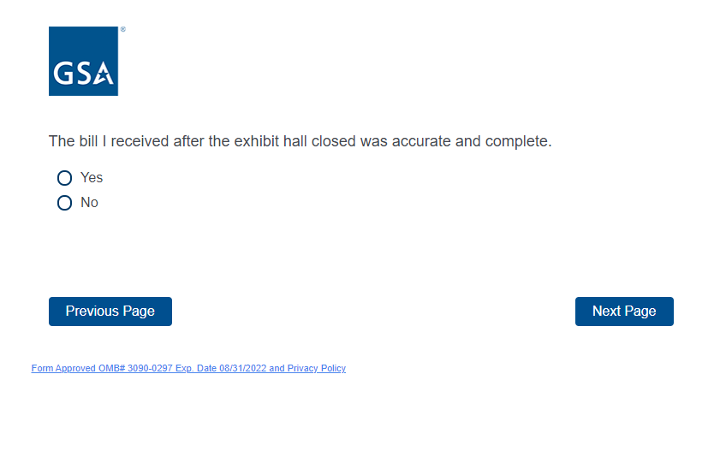

Screen 9

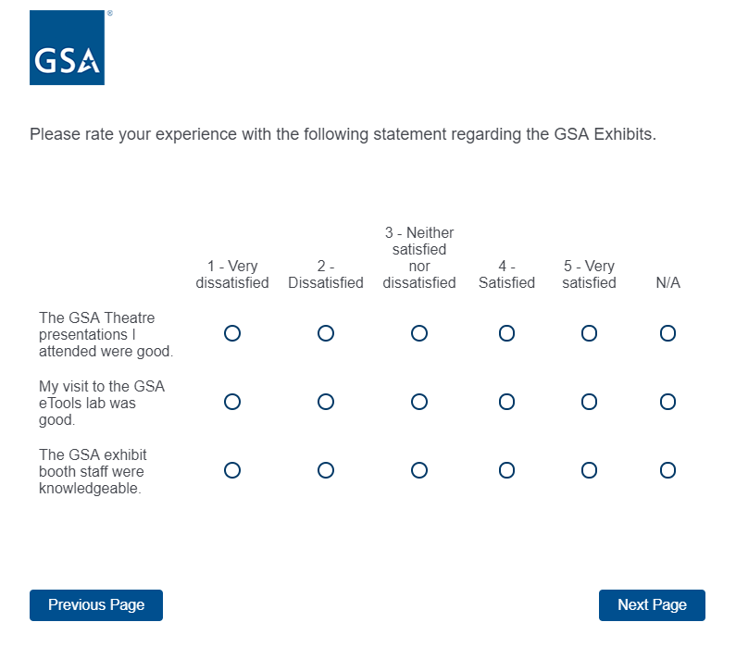

Screen 10

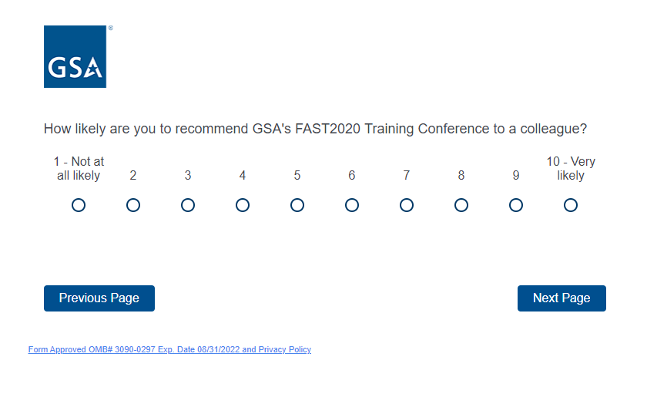

Screen 11

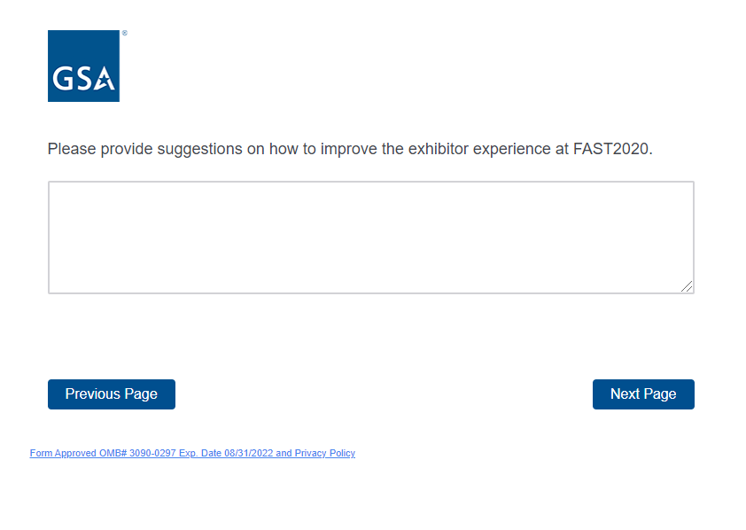
Screen 12

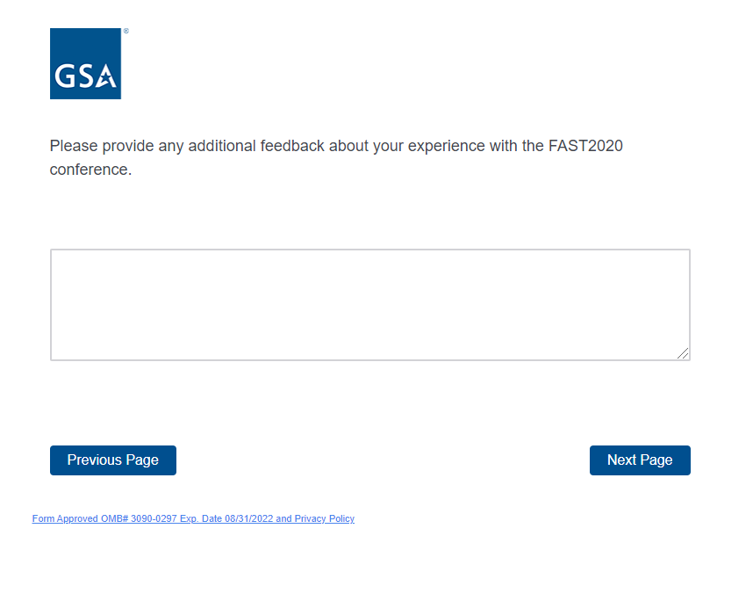

Screen 13

