FAST Track 3090-0297
Req-7
TITLE OF INFORMATION COLLECTION: Regulations.gov and Beta.Regulations.gov Feedback
OMB No: 3090-0297
Expires 08/31/2022

Paperwork Reduction Act Statement - This information collection meets the requirements of 44 U.S.C. § 3507, as amended by section 2 of the Paperwork Reduction Act of 1995. You do not need to answer these questions unless we display a valid Office of Management and Budget (OMB) control number. The OMB control number for this collection is 3090-0297. We estimate that it will take 5 minute/s to read the instructions, gather the facts, and answer the questions. Send only comments relating to our time estimate, including suggestions for reducing this burden, or any other aspects of this collection of information to: General Services Administration, Regulatory Secretariat Division (MVCB), ATTN: Lois Mandell/IC 3090-0297, 1800 F Street, NW, Washington, DC 20405.

If respondent clicks yes
Screenshot 1.
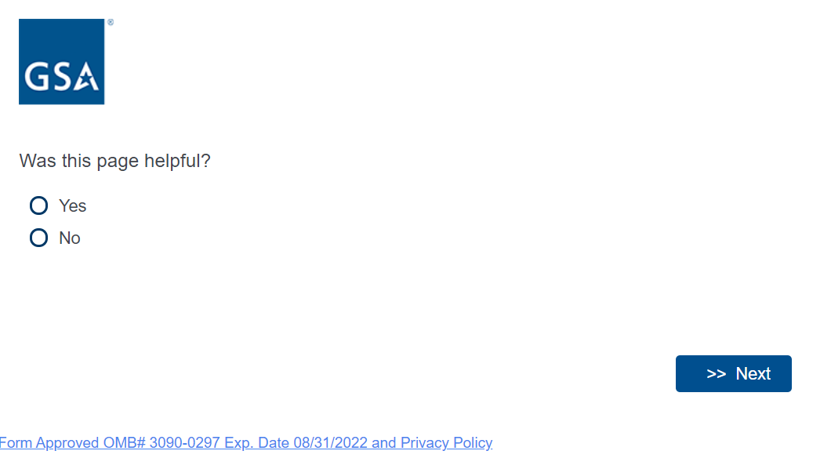

Screenshot 2
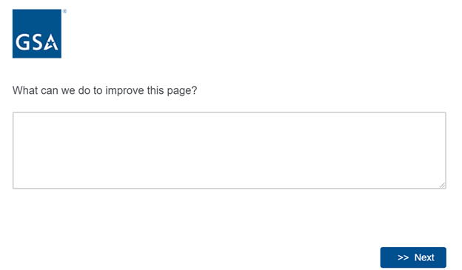

If respondent clicks no
Screenshot 1

Screenshot 2
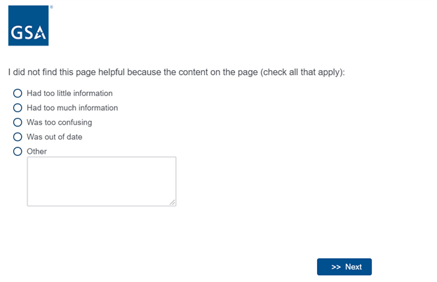

Screenshot 3

