 | NATIONAL AGRICULTURAL STATISTICS  SERVICE | 2019 ORGANIC SURVEY  Telephone Follow-Up Quality Control Form | Form Approved  OMB Number 0535-0249  Approval Expires  Project code 968
U.S. Department of Agriculture
Rm 5829, South Building
1400 Independence Avenue, S.W.
Washington, D.C. 20250-2000
1-800-727-9540
Fax: 202-690-2090
E-mail: nass-dc@nass.usda.gov
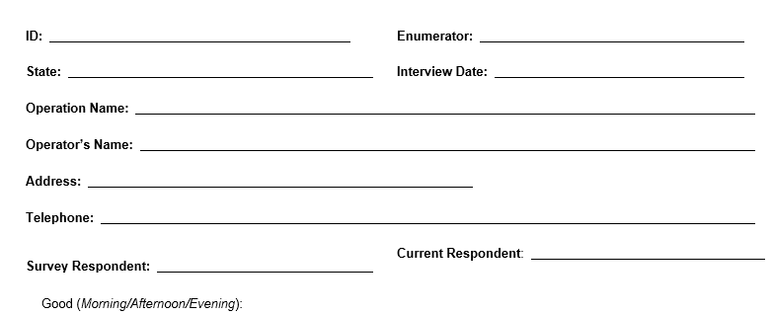

OMB No. 0535-0249
Approval Expires: 7/31/2017
Project Code:968 QID:
SMetaKey: Version 1
I am with the USDA’s National Agricultural Statistics Service. Thank you for your response for the 2019 Organic Survey. I am calling you today as part of our survey quality assurance measures. Your response is voluntary and not required by law, but your cooperation will be appreciated. Facts about your farm or ranch will be kept confidential. Will you help me by answering a few questions about the 2019 Organic Survey?

First, I would like to verify the data that were collected in Section 10 of the 2019 Organic Survey – GMO Presence in Organic Crops. Then, I will ask some follow-up questions based on the information you provide. Do you have any questions before we begin? (Information that was provided by the respondents will be entered into the table below.)
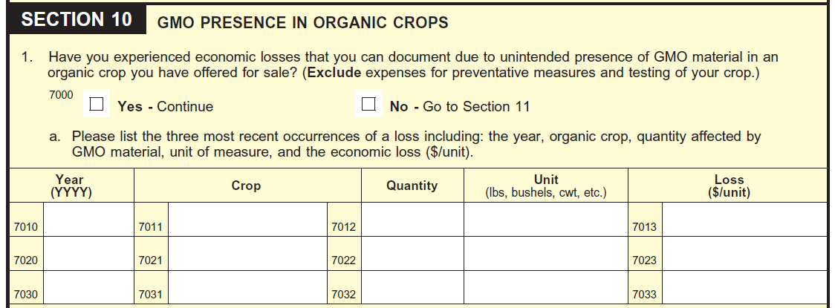
Transition Statement: We would like to know more about your experience with the unintended presence of GMO (Genetically Modified Organism) material in your organic crop. We would also like to know more about your understanding of the term GMO, which can also be referred to as GE (Genetically Engineered).

- At which of the following locations was the unintended presence of GMO/GE material discovered? (Check all that apply.)
100 On-farm
101 Processing facility
102 Marketing or transit point
103 Other (Specify: ¹⁰⁰⁰_________________________________________)
104 Don’t know

- What GMO/GE material was detected that resulted in the reported economic loss?

- How was the GMO/GE material detected? (Check all that apply.)
105 Test by a buyer or certifier
106 Seed mistake
107 Comingling
108 Other (Specify: ²⁰⁰⁰_________________________________________)
109 Don’t Know

- How did you calculate the loss?

- Did you receive documentation for the following items when the GMO/GE material was found in your crop:
  - the expected organic price for the crop?
110 Yes
111 No 112 Don’t Know

  - the GMO/GE detection in your crop?
113 Yes
114 No 115 Don’t Know

  - the price you actually received for your crop?

116 Yes
117 No 118 Don’t Know

