2019 ORGANIC SURVEY PRE-SURVEY POSTCARD TEXT
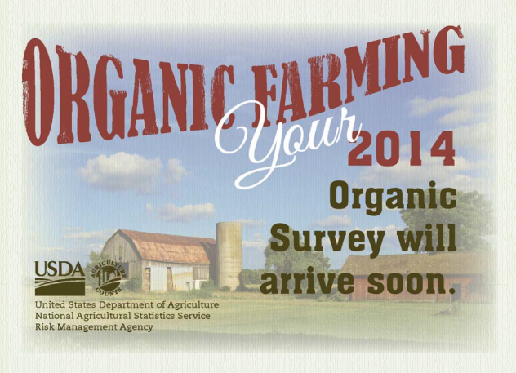 (previous postcard shown)

Postcard Front:
Organic Farming
Your 2019 Organic Survey will arrive soon.

Logos/Graphics:
USDA
NASS
CENSUS OF AGRICULTURE

Back:
Responding to the 2014 Organic Survey is important!

Your agriculture operation and products are a valuable part of the ag industry and should be counted.

- Total organic sales by farms in the U.S. increased by X percent between 2012 and 2017.
- Sales from farms with certified or exempt organic product sales totaled more than $X billion in
2017.
- Organic agriculture producers reported direct-to-consumers sales more often than conventional producers, with X percent of organic farmers selling directly to consumers in 2017.

Learn more at www.nass.usda.gov/AgCensus.

2019 ORGANIC SURVEY REMINDER POSTCARD TEXT

Postcard Front:
A Reminder about your 2019 Organic Survey

Logos/Graphics:
USDA
NASS
CENSUS OF AGRICULTURE

Back:
If you’ve already completed the 2019 Organic Survey, thank you! If not, please do so online or by mail by February XX, 2020.

Your input will be the foundation for many decisions involving the sustainability and growth of your industry for the next several years.

We guarantee that your individual responses will be kept confidential as required by Federal law. The same law also makes your participation in the 2019 Organic Survey mandatory, as it is part of the Census of Agriculture Program.

Learn more at www.nass.usda.gov/AgCensus. If you have questions or need assistance completing your questionnaire, call (888) 424-7828.

