January XX, 2020

Dear Producer,

According to the most recent Census of Agriculture, organic agriculture sales from farms in the United States increased X percent between 2012 and 2017. These data show the demand for, value of, and potential for continued growth in certified organic products.

Now the U.S. Department of Agriculture’s (USDA) National Agricultural Statistics Service (NASS) is conducting the 2019 Organic Survey to gather more detailed production, sales, and marketing information from organic farms in the United States. Please complete and return your form by February XX, 2020.

Your response is critical to help support the continued future success of organic agriculture production. Please respond promptly in one of the following ways:

- Online at www.agcensus.usda.gov. Responding online is fast and secure. All you need is your 17-digit survey code from the mailing label to begin.
- By mail. Complete the enclosed form and return it in the envelope provided.

As part of the Census of Agriculture Program, this survey and your response is required by law (Title 7 USC 2204(g) Public Law 105-113). These federal laws also require that NASS keeps your identity and your answers confidential.

For more information about this survey, visit www.nass.usda.gov/AgCensus. If you have questions or need assistance completing your questionnaire, call (888) 424-7828. Thank you in advance for your participation.

Sincerely,
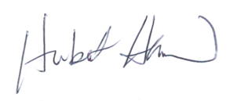
Hubert Hamer
Administrator, National Agricultural Statistics Service
United States Department of Agriculture

Enclosures

It’s Convenient. It’s Secure.
Online Survey Response

The online form:
- allows you to skip questions that don’t apply to you
- calculates totals automatically

To complete your survey online, follow these steps:

- Go to www.agcounts.usda.gov.
- Enter your unique 17-digit Survey Code from the label on the report form, then click “Continue.”
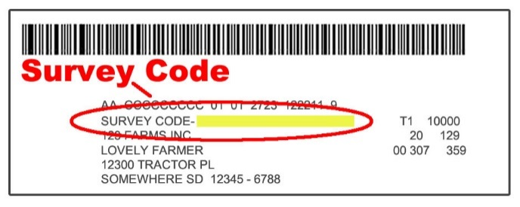

- Find the survey you are completing and click on it.
- Verify and complete your contact information, then continue to the survey.
- Complete the survey questions.

If you need to stop, click “Save & Return Later” at the top of the page. When you return, go back to Step 1 above. After the opening page, you will be taken to the last page you completed.

- When you finish the survey, click “Submit.” If you do not see the Submit button, reduce the zoom setting on your screen.

You will receive a confirmation code and can choose to view your completed survey form. Using the options provided by your browser (Internet Explorer, Chrome, Mozilla, etc.), you can print, copy, or save the completed form.

