February XX, 2020

Dear Producer,

In 2017, there were XX farms with certified or exempt organic product sales totaling more than $X billion. The latest Census of Agriculture data are used to help determine federal and state programs, research, and support to better meet the needs of organic agriculture producers like you. Now, the results of the 2019 Organic Survey will provide even more in-depth knowledge of your significant and growing part of the agriculture industry.

According to our records, the U.S. Department of Agriculture’s National Agricultural Statistics Service (NASS) has not received your completed response. Please complete and return the 2019 Organic Survey by February XX, 2020. If you have recently responded, thank you.

Please respond in one of the following ways:

- Online at www.agcensus.usda.gov. Responding online is fast and secure. All you need is your 17-digit survey code from the mailing label to begin.
- By mail. Complete the enclosed form and return it in the envelope provided.

If a response is not received, a NASS representative may follow-up with you to gather this information. As part of the Census of Agriculture program, this survey and your response is required by law (Title 7 USC 2204(g) Public Law 105-113). These federal laws also require that NASS keeps your identity and your answers confidential.

For more information about this survey, visit www.nass.usda.gov/AgCensus. If you have questions or need assistance completing your questionnaire, call (888) 424-7828. Thank you in advance for your participation.

Sincerely,
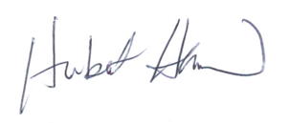
Hubert Hamer
Administrator, National Agricultural Statistics Service
United States Department of Agriculture

Enclosures

It’s Convenient. It’s Secure.
Online Survey Response

The online form:
- allows you to skip questions that don’t apply to you
- calculates totals automatically

To complete your survey online, follow these steps:

- Go to www.agcounts.usda.gov.
- Enter your unique 17-digit Survey Code from the label on the report form, then click “Continue.”
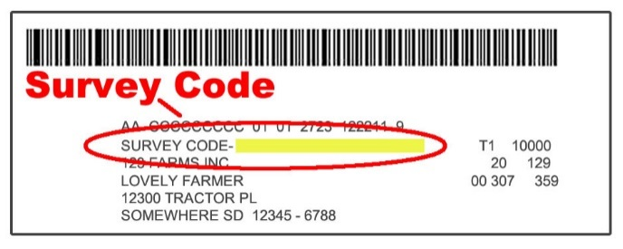

- Find the survey you are completing and click on it.
- Verify and complete your contact information, then continue to the survey.
- Complete the survey questions.

If you need to stop, click “Save & Return Later” at the top of the page. When you return, go back to Step 1 above. After the opening page, you will be taken to the last page you completed.

- When you finish the survey, click “Submit.” If you do not see the Submit button, reduce the zoom setting on your screen.

You will receive a confirmation code and can choose to view your completed survey form. Using the options provided by your browser (Internet Explorer, Chrome, Mozilla, etc.), you can print, copy, or save the completed form.

