February 26, 2016

Dear Respondent:

Enclosed is your copy of the 2016 Prices Paid survey questionnaire. This survey collects data from agricultural suppliers to estimate the average prices producers pay for farming inputs and calculate the USDA Prices Paid Indexes.

For your convenience, you have the following options to respond:
- Online at www.agcounts.usda.gov beginning February 26, 2016. Responding online is the easiest, fastest, most secure way to complete your survey. You need the identification number on the survey form to begin.

- By mail. Complete the survey questionnaire and mail it back in the return envelope provided.

If you do not respond by March 15, 2016 we will contact you to arrange a telephone or personal interview.

As required by Federal law (Title 7, U.S. Code, and CIPSEA, Public Law 107-347), your responses are completely confidential. We safeguard the privacy of all respondents, ensuring that no individual operation or producer can be identified.

Thank you for participating and for your support of agricultural statistics. If you have questions or concerns, please contact the National Agricultural Statistics Service Helpline at 1-888-424-7828.

Sincerely,
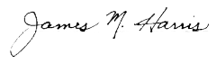
Mark Harris
Chairman, Agricultural Statistics Board
U.S. Department of Agriculture
National Agricultural Statistics Service

Enclosures

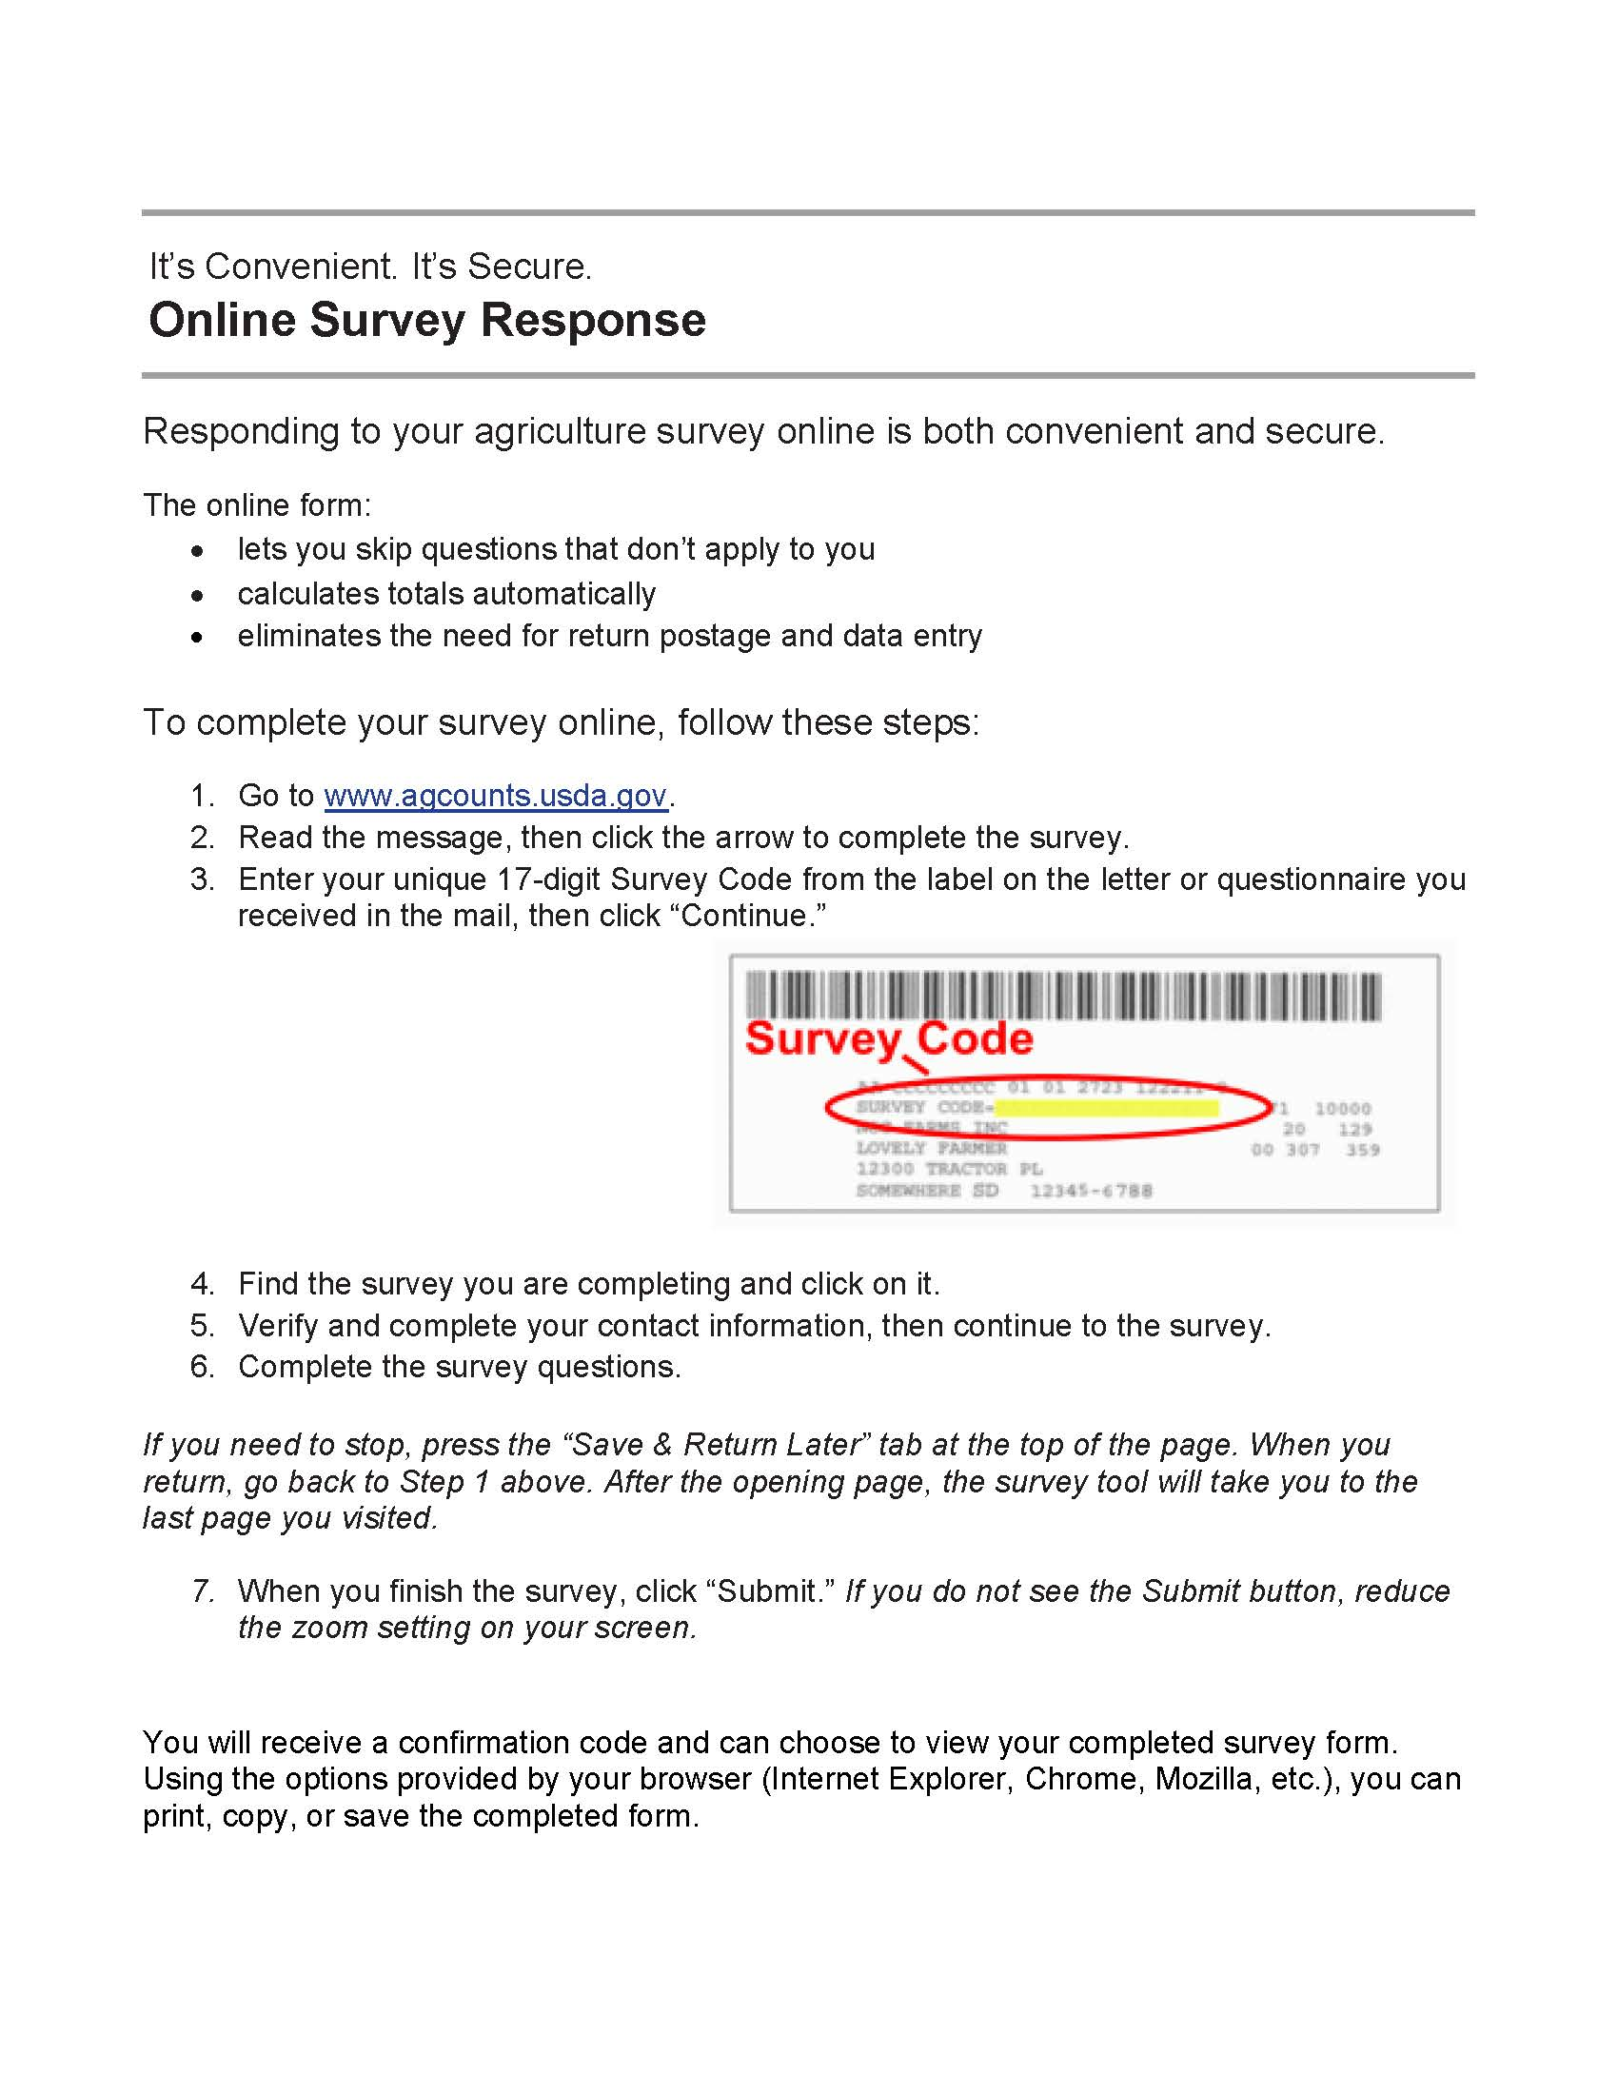

If you need assistance completing your Internet questionnaire, please contact the National Agricultural Statistics Service Helpline at 1-888-424-7828

