Request for Non-Substantive Change to the
2020 Census New Construction Program
OMB Control No. 0607-1007

U.S. Department of Commerce
U.S. Census Bureau
Purpose

The U.S. Census Bureau offers the 2020 Census New Construction Program as a decennial opportunity for tribal, state, and local governments to submit addresses of new housing units, group quarters, and transitory locations for which construction is in progress during or after March 1, 2018 and completion is expected by Census Day, April 1, 2020. The Census Bureau collects city-style addresses for the newly built housing units, group quarters, and transitory locations in blocks where the Census Bureau plans to mail the 2020 Census questionnaires and households are expected to use a self-response mode to complete the census.

This non-substantive change is to notify the public of a proposed schedule change to the approved and continuing information collection for the 2020 Census New Construction Program. It also gives the public an additional 30 days to comment on the proposed schedule change.

Background

The current 2020 Census New Construction Program OMB collection was approved on 12/21/2018 for three years with an expiration date of 12/31/2021. This non-substantive change is a request to inform the public of two schedule changes associated with the notice for public comment, titled “2020 Census New Construction Program,” published in the Federal Register on October 5, 2018 (Vol 83., No. 194, pp. 50332-50334) and to allow the public to comment on the proposed schedule changes.

There are no substantive changes to the program resulting from this change.

Burden

The burden of the 2020 Census New Construction Program is unchanged by this update.

Attachments

New Construction Program Materials
Changes as part of this NSC | Material identification | Description
Postponed the publication of the eligible governments to a later time. | 30-Day FRN. | Publication of the list of governments eligible for participation in the New Construction Program by Fall 2018 (p. 50333): The Census Bureau will publish the list of governments eligible for participation in the New Construction Program in early 2019, instead of Fall 2018. The Census Bureau made the change to conduct additional quality control prior to publishing the list. This change does not affect the respondents who are eligible to participate in the New Construction Program.  FRN - List of governments eligible to participate in the New Construction Program (Attachment 1).
Moved up the registration deadline. | 30-Day FRN | Registration Deadline – Invitation Phase (p. 50334): The Census Bureau is rescheduling the registration deadline from what was previously stated in the Federal Register on October 5, 2018 (Vol 83., No. 194, pp. 50332-50334). The registration deadline was moved from July 19, 2019 to June 14, 2019 to provide the Census Bureau adequate time to conduct quality control of the registered universe and to prepare materials prior to the participation phase in September 2019. During the first week of April 2019, the Census Bureau will invite respondents to register online or by mail, with registration responses due by June 14, 2019. Given the average response time per respondent of one hour for the invitation phase, the proposed change is not anticipated to have an impact on a respondent’s ability to reply during the proposed time frame.  FRN - Invitation Phase. (Attachment 2).

Attachment 1: FRN - List of governments eligible to participate in the New Construction Program will be posted on the website in early 2019 instead of fall 2018.

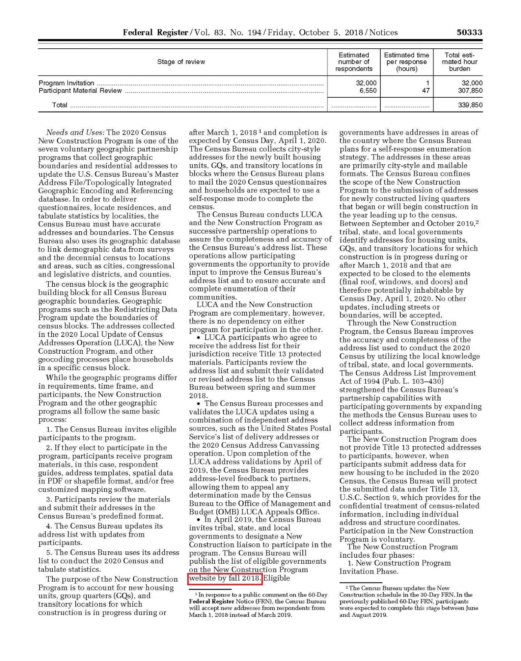

Attachment 2: Invitation Phase – Registration Deadline is updated from July 19, 2019 to June 14, 2019.

