Attachment 4
ALS Case Validation Questions (screenshots)

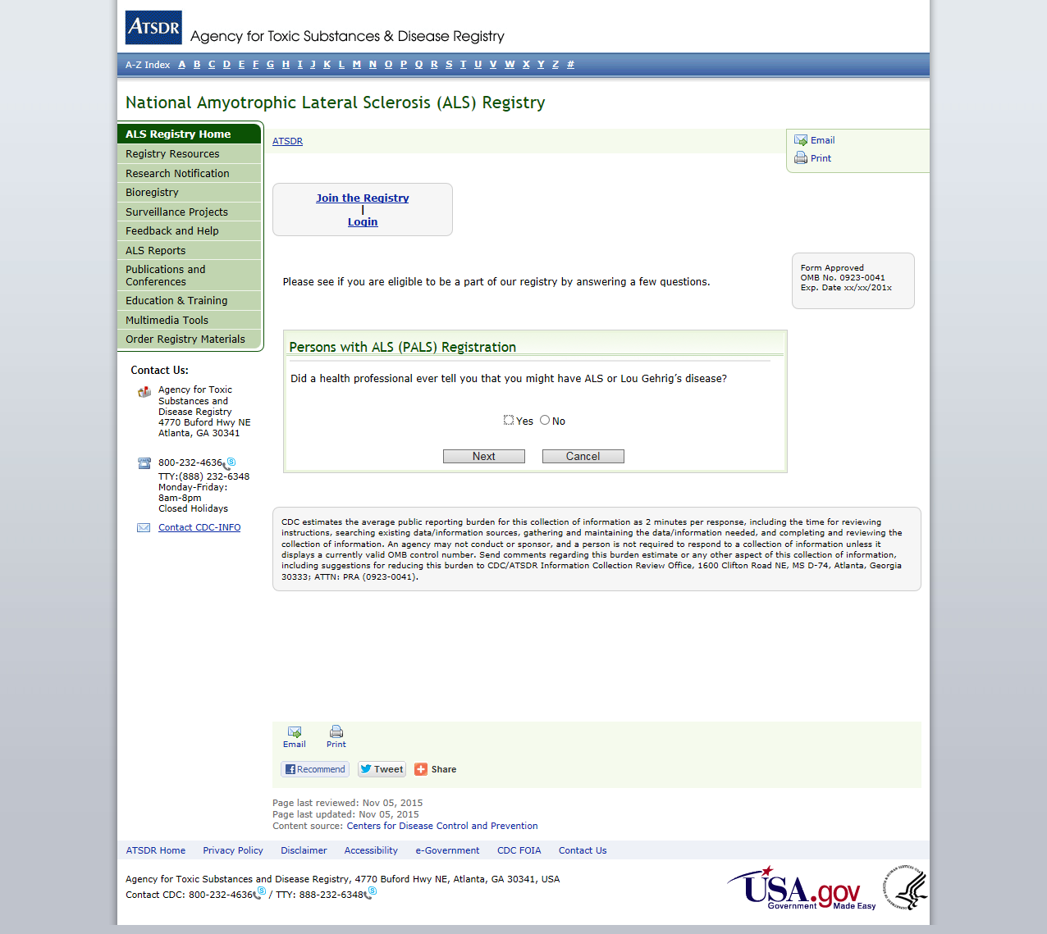

PALS Validation Question 1

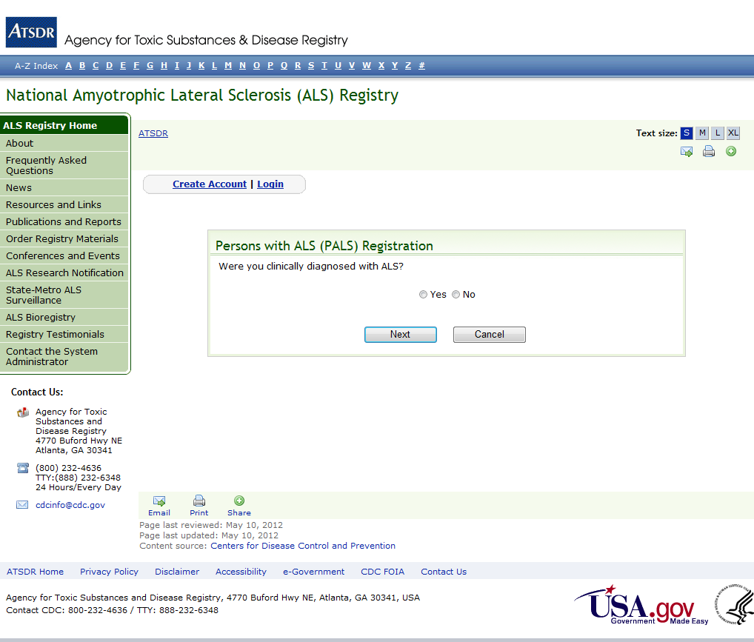

PALS Validation Question 2
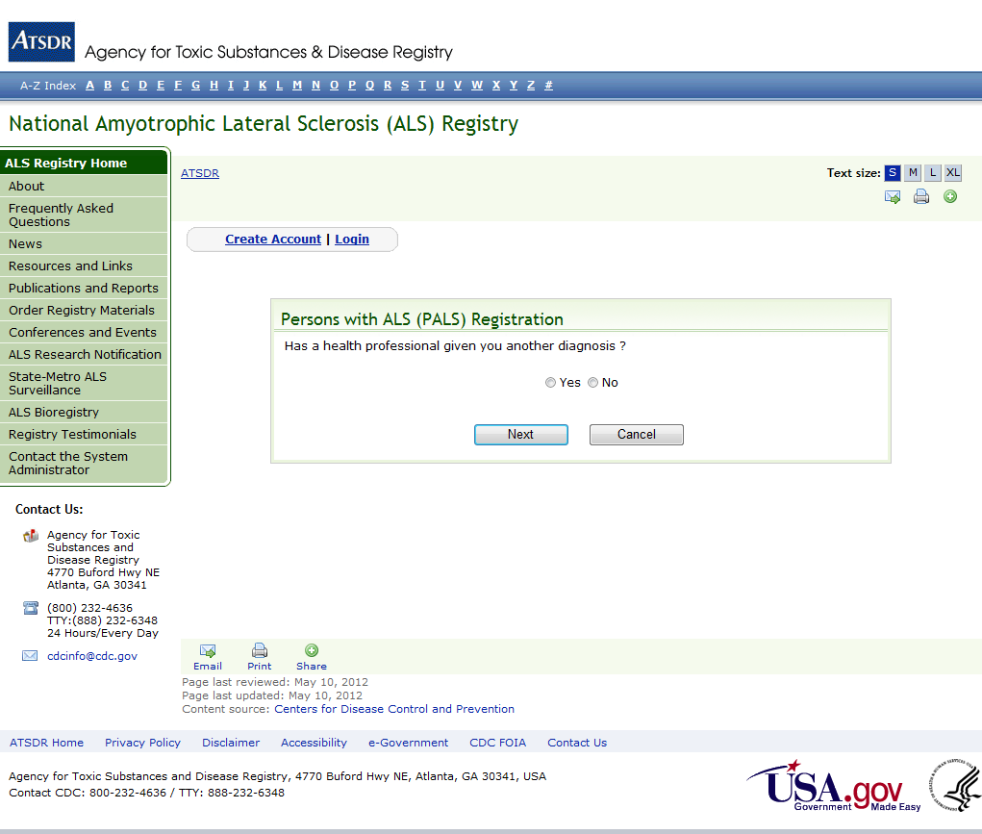
PALS Validation Question 3
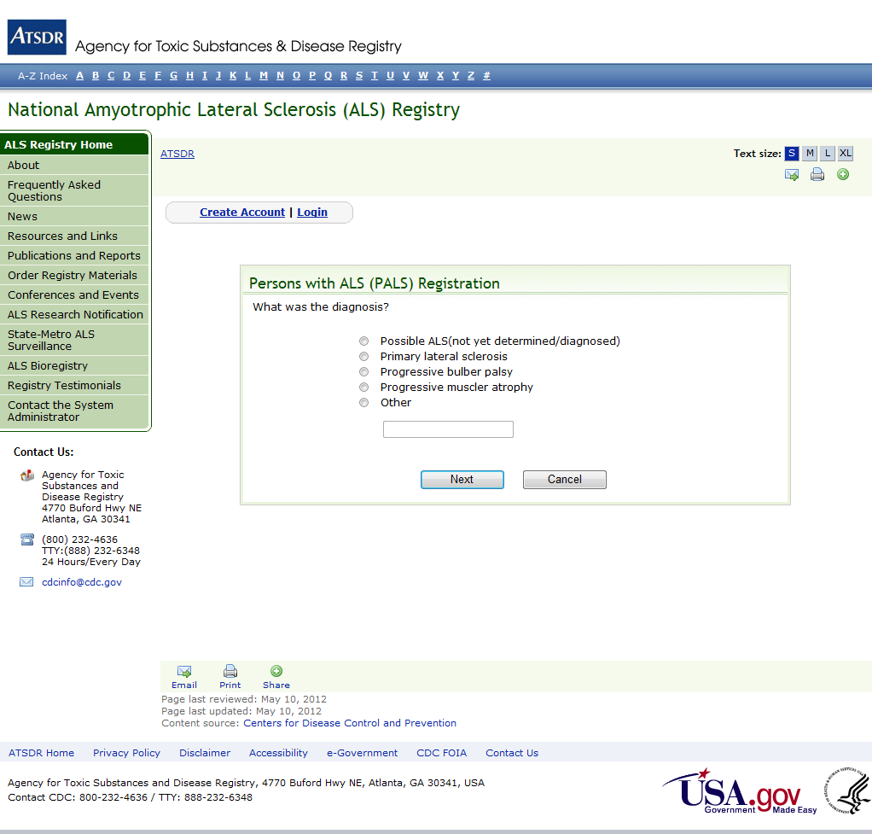
PALS Validation Question 4

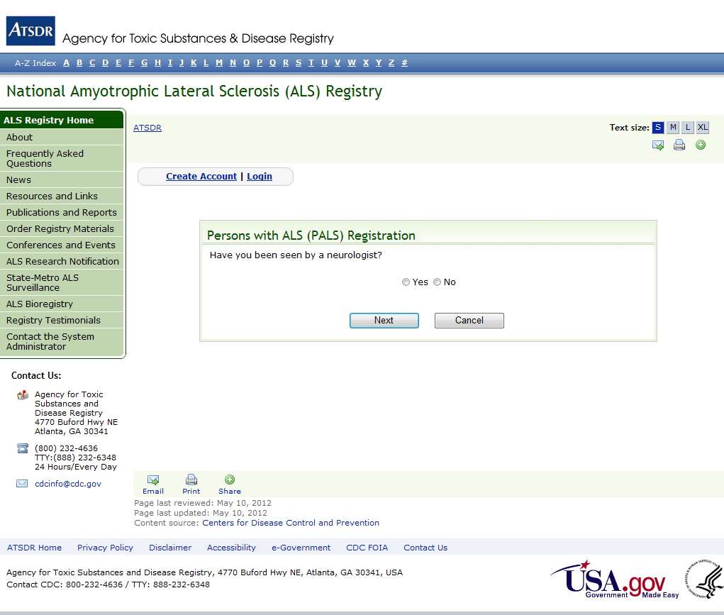

PALS Validation Question 5

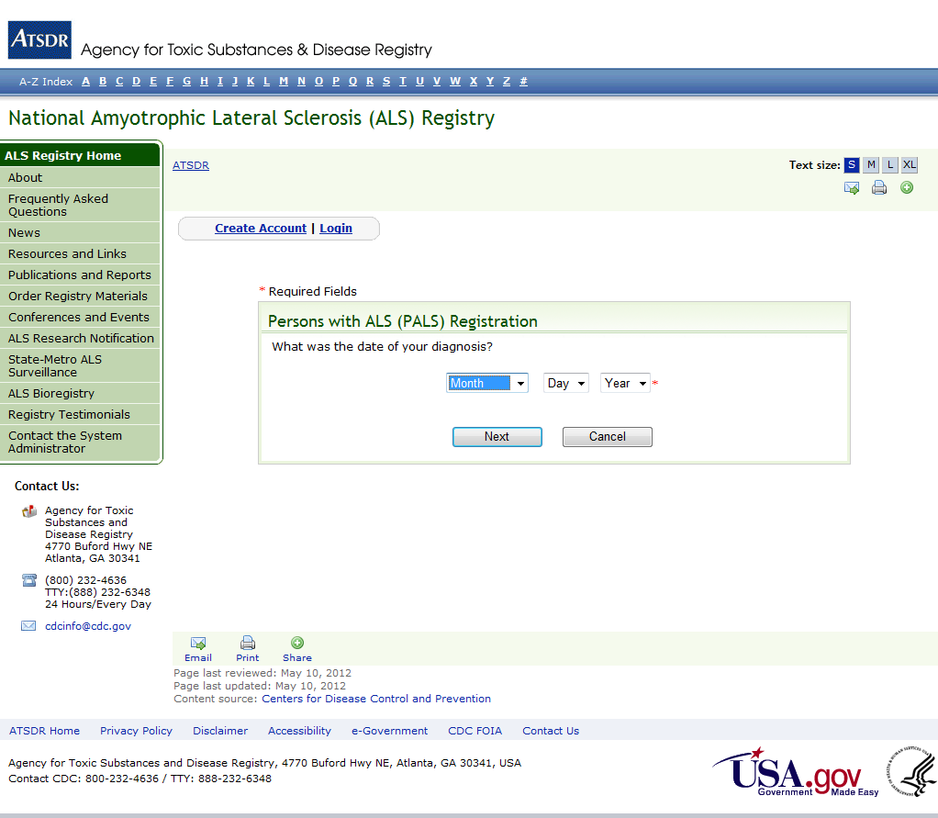

PALS Validation Question 6

