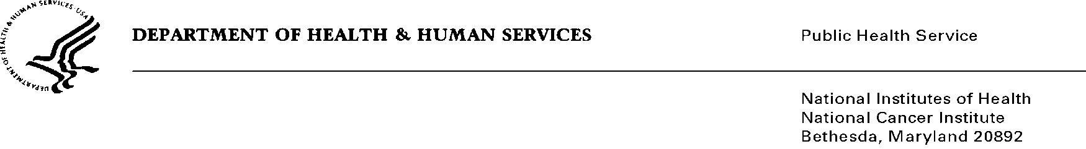
Date: June 27, 2019

To: Office of Management and Budget (OMB)

Through: Reports Clearance Officer, DHHS
Project Clearance Chief, NIH
Project Clearance Liaison, NCI

From: Michael Montello, Pharm. D., CTEP (National Cancer Institute)

Subject: Nonmaterial/Non-substantive change request for:
CTEP Branch and Support Contracts Forms and Surveys (National Cancer Institute)
(OMB #0925-0753, Expiration Date: 07/31/2021)

This is a request for OMB to approve a non-substantive change to the CTEP Branch and Support Contracts Forms and Surveys (National Cancer Institute) approved on 7/31/2018.

This non-substantive change request does not change the purpose or objectives of the website or change the overall burden to the public. The Financial Disclosure Form (FDF) includes disclosure questions that have been revised for regulatory alignment and compliance. In addition, minor edits were made for readability and consistency.

Two files are provided – A clean copy of the revised form, and a Revised Marks file. All the changes can be seen in red (additions and strike throughs) in the “Revised Marks” file.

Summary of Changes:
The requested changes to the Financial Disclosure Form (FDF) include:

- Updated Code of Federal Regulations (CFR) citations.

- Changes to text for readability and consistency; to include the primary use and disclosure information were made.

- Changes to the text regarding the definition of “You” has been added.

- Changes were made to the Confidentiality statement (located within the Agreement section of the form).

- The Document Revision Date was changed to reflect the current form revision date (located on the left within the footer of the form).

