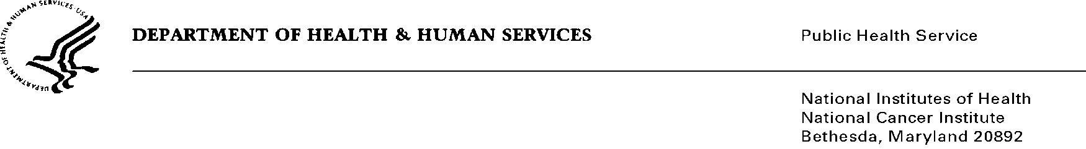

Date: August 15, 2019

To: Office of Management and Budget (OMB)

Through: Reports Clearance Officer, DHHS
Project Clearance Chief, NIH
Project Clearance Liaison, NCI

From: Angela R. Jones, Management and Program Analyst, Office of the Director, Center for Cancer Training (CCT), National Cancer Institute, National Institutes of Health

Subject: Nonmaterial/Non-substantive change request for:
National Cancer Institute Future Fellows Resume Databank
(OMB #0925-0759, Expiration Date: 02/28/2022)

This is a request for OMB to approve a nonmaterial/non-substantive change to the National Cancer Institute Future Fellows Resume Databank approved on 2/14/2019.

NIH/NCI is proposing additional fields for references and selection of NCI’s Division and Centers which are aligned with the objectives of the website. In the 2018 submission of the Supporting Statement A, Section A.2, states that information will be collected to ensure candidates meet basic eligibility requirements; assess their potential as future scientists; determine where mutual research interests exist; and to make decisions regarding which candidates will be eligible and invited to attend program positions that may have future openings. This non-substantive request does not change the purpose or objectives of the website or change the overall burden to the public.

Summary of Changes:
The requested changes to the Future Fellows Resume Databank - Website:

- Edited/added Job Categories

- Undergraduate Degree GPA removed

- Education changes (not just asking levels anymore)

- Scientific Focus Areas – added additional options

- Addition of an optional Publications Section (not a required field); will provide interested NCI staff an opportunity to quickly view candidates’ research focus best aligned with specific NCI scientists.

- Addition of a Division and Centers Option; allows candidates to specify which NCI Division and Center of interest.

- Addition of a Reference Section; which will provide NCI staff an opportunity to confirm the potential candidate’s eligibility during the pre-screening of applications.

- Redesign of the website; to improve the usability for visitors by making the site responsive when accessed using mobile devices. The goals of redesigning the Future Fellows’ website is to conform with HHS’s web policies on branding, mobile responsiveness and 508 compliance. The current Future Fellows website does not have the proper HHS, NIH, and NCI branding and logos; the website is unresponsive; and is not 508 compliance. The newly design website addresses and meets all of HHS and NIH web policies.

Attachments:
• Revised file shows the proposed changes (new sections are highlighted to denote additions (all changes can be seen in yellow).
• Clean file shows the proposed changes, with no comments/highlights.

Your full consideration is appreciated

