Permits Online (PONL)
New Manufacturer of Processed Tobacco or Tobacco Products, or New Tobacco Export Warehouse, Permit Applications

The following PONL screens are equivalent to form TTB F 5200.3, Application for Permit to Manufacture Tobacco Products or Processed Tobacco or to Operate an Export Warehouse:
Screens Common to All Tobacco Industry Permit Applications Page 2
Original Entity Page 23
New Manufacturer of Processed Tobacco Page 37
New Manufacturer of Tobacco Products Page 52
New Tobacco Export Warehouse Page 70
Common Application Package Submission Screens: Page 88

Screens Common to All New Tobacco Industry Permit Applications:
PONL Log-in Screen — (https://www.ttbonline.gov/permitsonline/Default.aspx) —

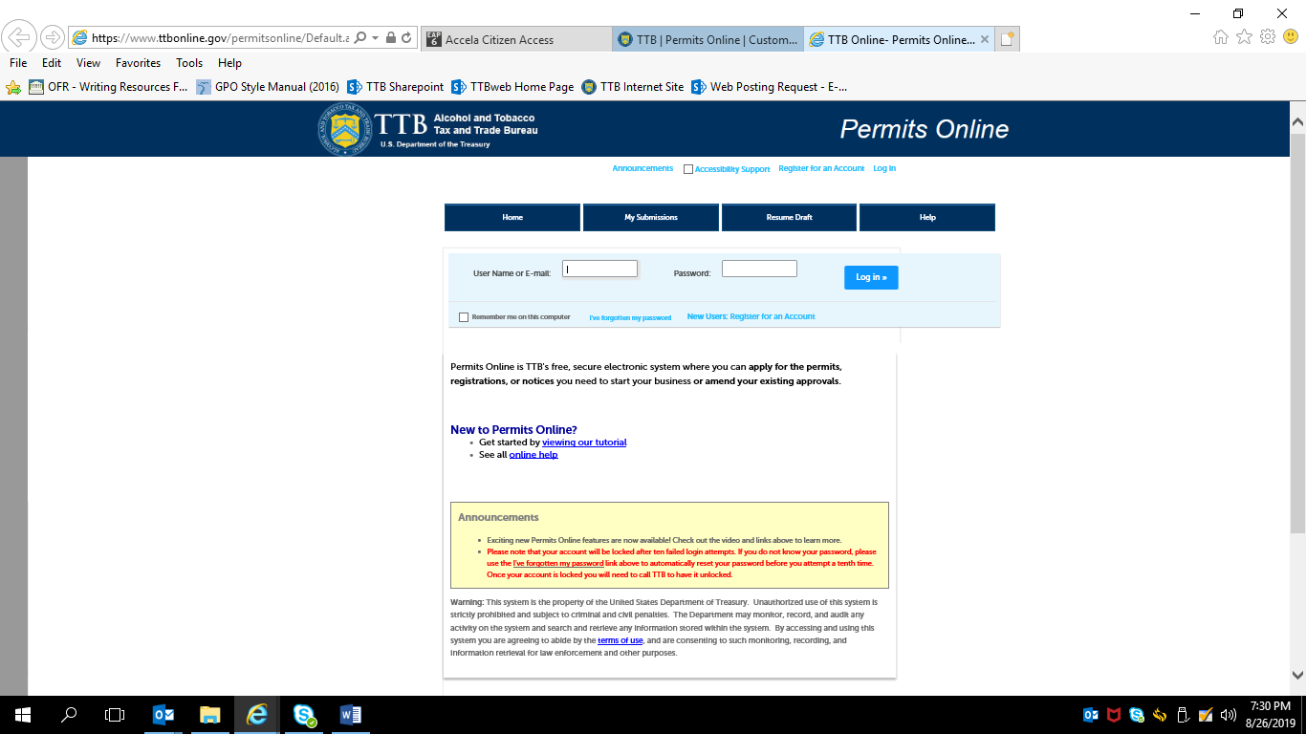
Terms of Use | Privacy Act | Privacy Impact Assessment | Paperwork Reduction Act Notice | Questions? 877-882-3277
or submit an online inquiry
After a successful log-in, respondent sees PONL Welcome Page:
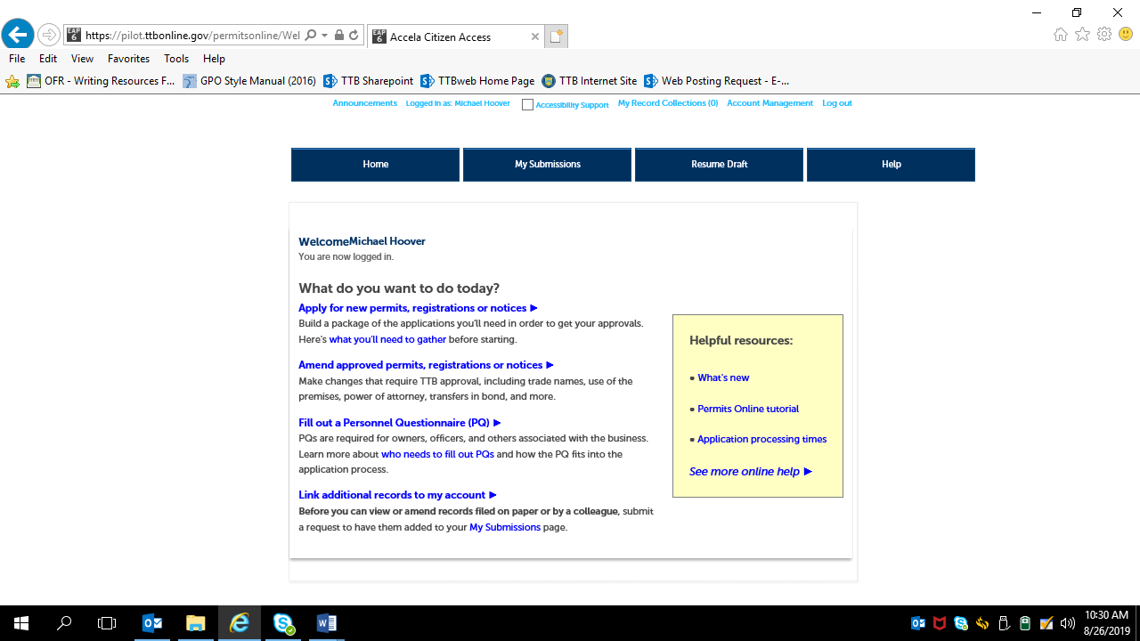

Clicking an option under the heading “What do you want to do today?” results in the Rules and Responsibilities page, which includes a Penalty of Perjury clause, as shown below. A new tobacco industry permit applicant will select the “Apply for new permits, registrations or notices” option.
Rules and Responsibilities page:

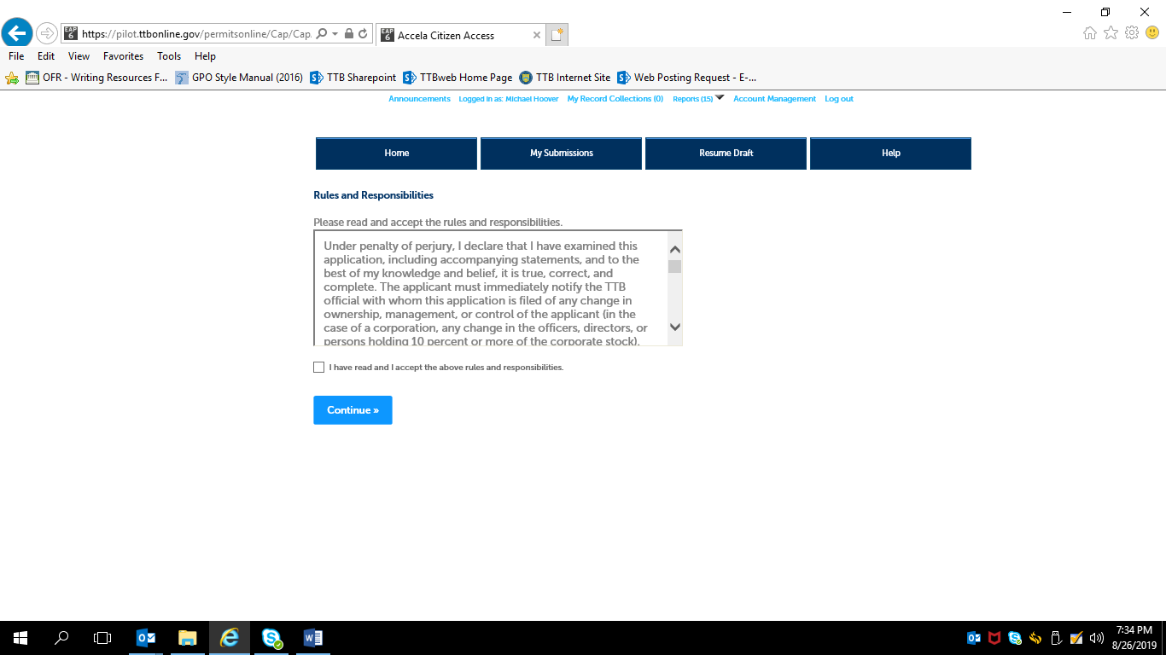

The entire Rules and Responsibilities Statement reads as follows:
Under penalty of perjury, I declare that I have examined this application, including accompanying statements, and to the best of my knowledge and belief, it is true, correct, and complete. The applicant must immediately notify the TTB official with whom this application is filed of any change in ownership, management, or control of the applicant (in the case of a corporation, any change in the officers, directors, or persons holding 10 percent or more of the corporate stock). The business for which this application is made does not violate the law of the State in which the business will be conducted. In addition, if this application is approved, the applicant will conduct operations within a reasonable period of time and maintain such operations in conformity with Federal law.
I further declare:
That I have read the instructions for this form and that I understand that I may need to file additional documentation before TTB may act on this application;
That an appropriate TTB officer may require additional information to determine if I am entitled to the permit for which I am applying;
That if any information provided on this application changes before I have received from TTB a final determination on this application, I must immediately notify the Director, National Revenue Center;
With respect to any water quality information furnished in connection with this application, that copies of this rider may be furnished to the applicable State Water Quality Agency and Regional Administrator, Environmental Protection Agency;
With respect to applications for Industrial Alcohol User Permits, I understand that any permit issued is subject to the following conditions: (1) that all employees conform to all of the laws of the United States relating to the manufacture, taxation, and control of and traffic in intoxicating liquors and all regulations pursuant to these laws, in force now or later while on the permit premises; (2) that I must pay the tax, with interest and penalties, on all alcohol diverted while being transported to me, and on all alcohol withdrawn, transported, used, or disposed of by me in violation of the laws and regulations, in force now or later; (3) that all persons interested in the business to be conducted under this permit are, under the laws and regulations, qualified to receive the privileges applied for, and (4) that specially denatured and tax-free spirits will be stored and secured in accordance with the requirements of 27CFR, Parts 20 and 22.
I understand that the information supplied by me in connection with this application will be used by TTB to make a determination on the application. Where such disclosure is not prohibited, TTB officers may disclose this information pursuant to the routine uses in TTB’s System of Records Notice (SORN).
I understand that if I fail to supply the information requested TTB may delay or deny the issuance of the permit. I understand that TTB is asking for my Employer Identification Number and/or my Social Security Number for identification purposes. If I do not supply the numbers, I understand my application may be delayed.

After reading and accepting the rules and responsibilities, the applicant clicks “Continue,” which leads to the New Applications Wizard, shown below:

(1) New Application Wizard, Determine Applications Screens:
Application Contact Information --
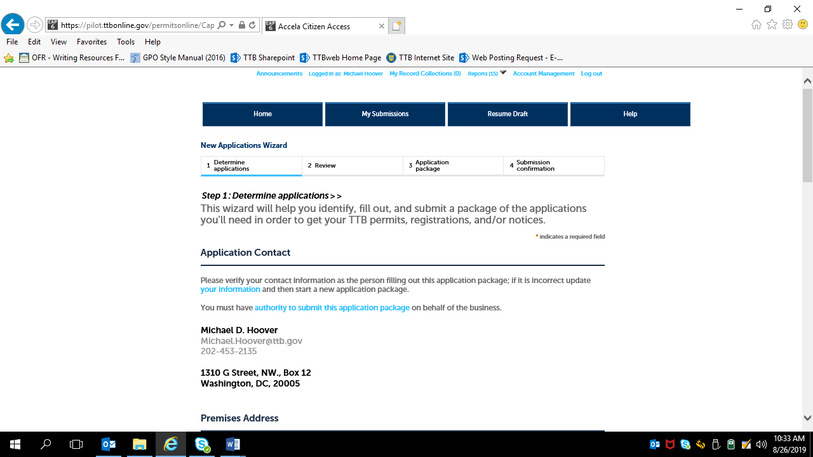

Premises Address Information --
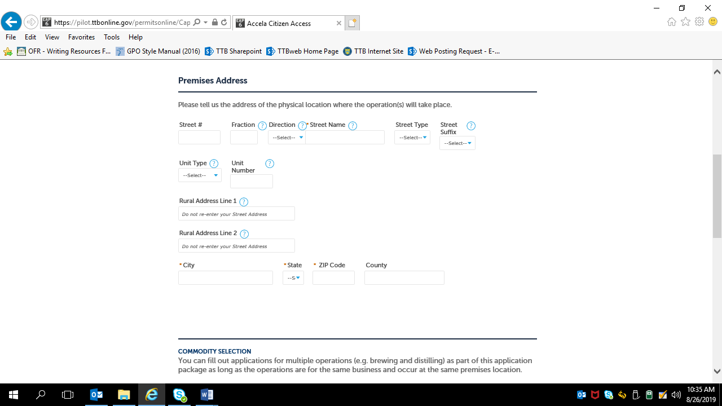

Commodity Selection –
For new tobacco industry permit applications, the applicant selects “Tobacco” from the Commodity Selection drop-down menu, which brings up the appropriate tobacco industry permit application options under the heading “Select Application(s),” as shown below:
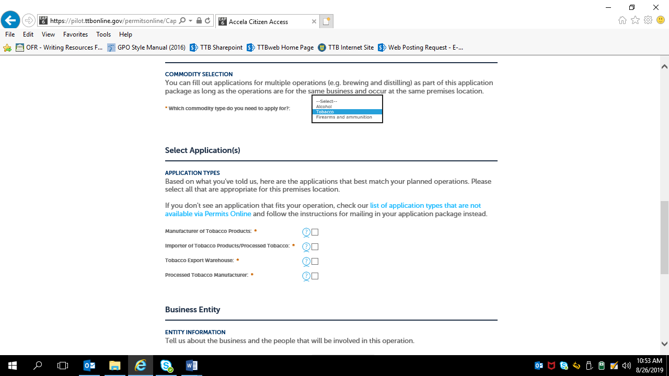

Business Entity Information –
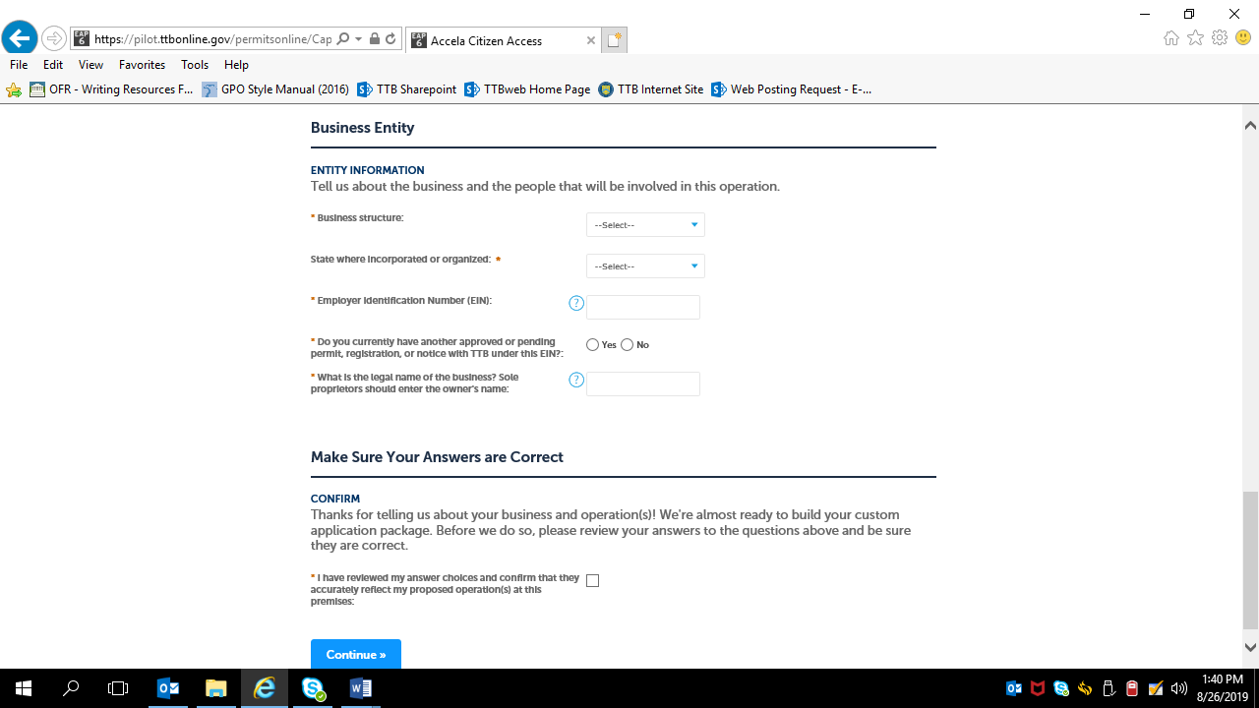

Business Entity Information –
For “Business Structure,” the applicant selected the appropriate response from the drop-down menu shown below. The Business Entity data fields following that selection do not change based on the selection.
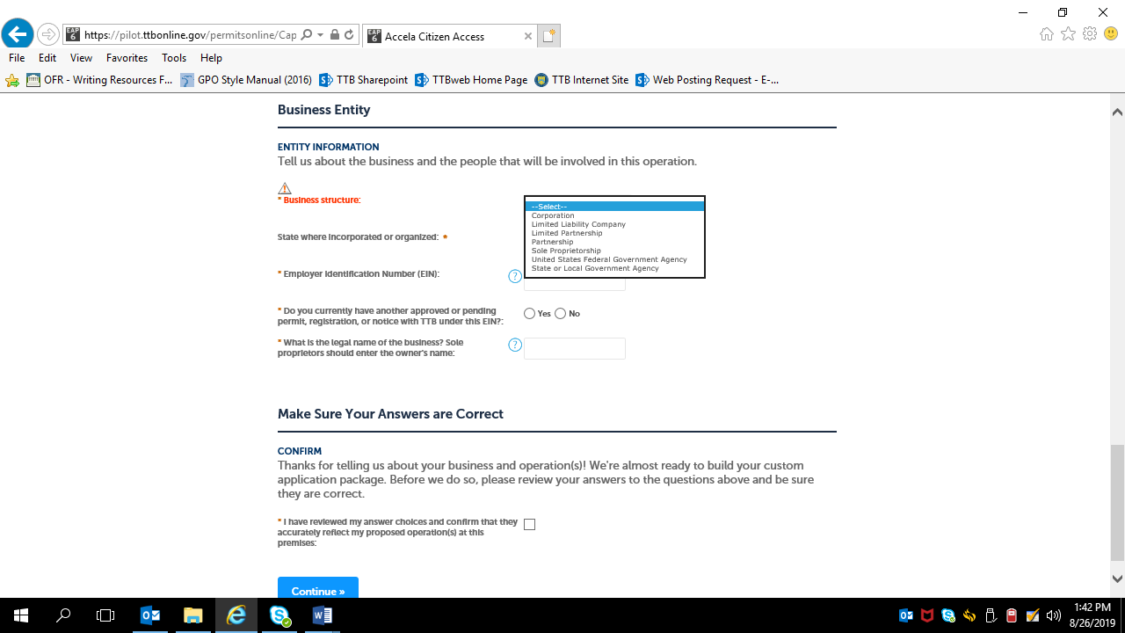

Answering “Yes” to “Do you currently have another approved or pending permit, registration, or notice with TTB under this EIN?” results in the data fields shown below --
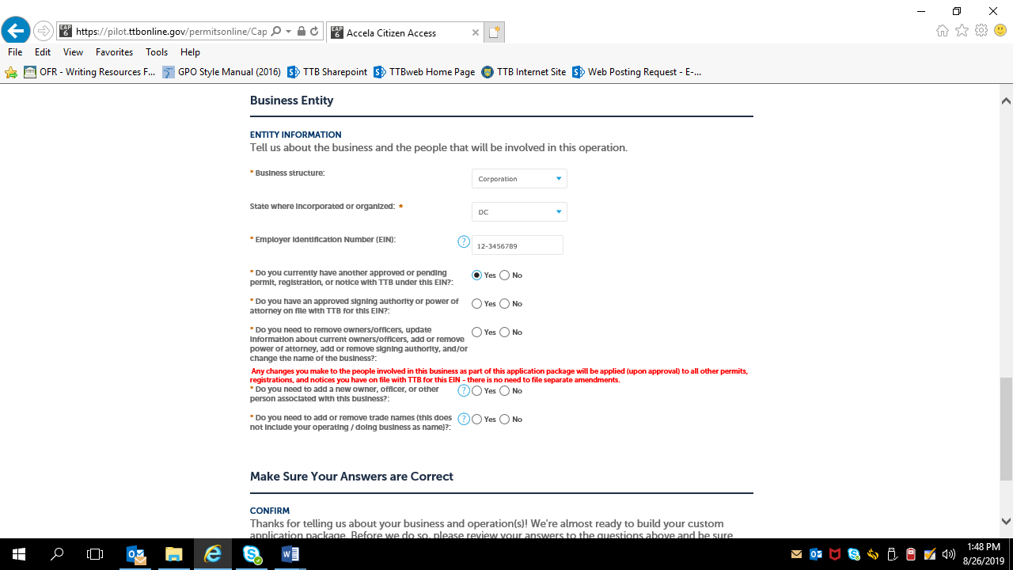

Answering “No” to “Do you currently have another approved or pending permit, registration, or notice with TTB under this EIN?” results in the data fields shown below --
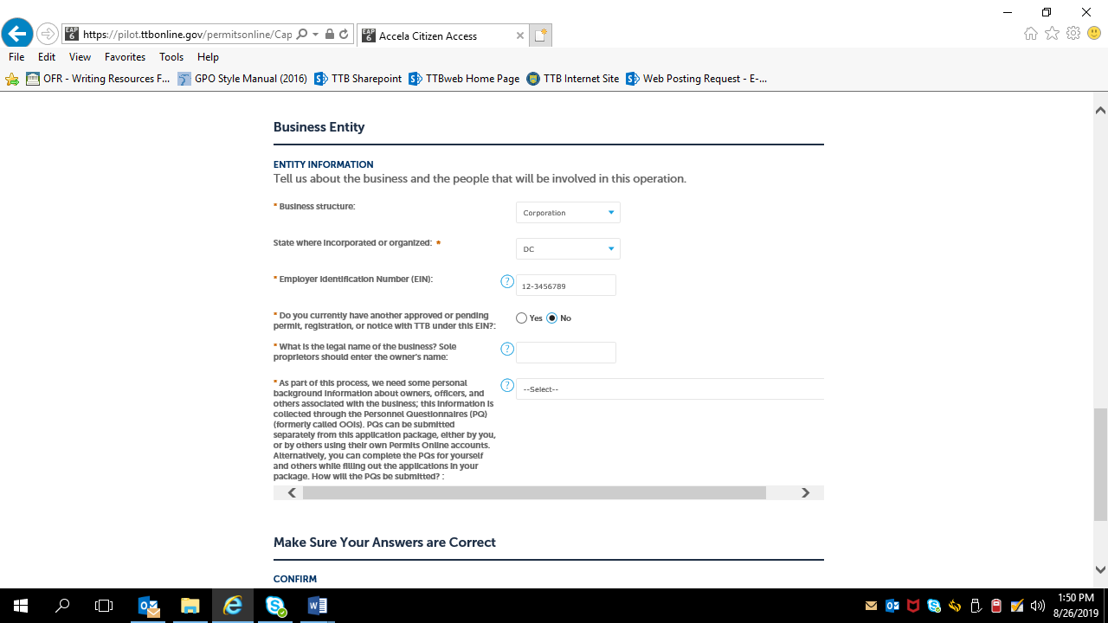
NOTE: Personnel Questionnaires (TTB F 5000.9 and its PONL equivalent) are approved under OMB Control No. 1513–0002.)

The applicant then confirms the information provided in Step 1 –

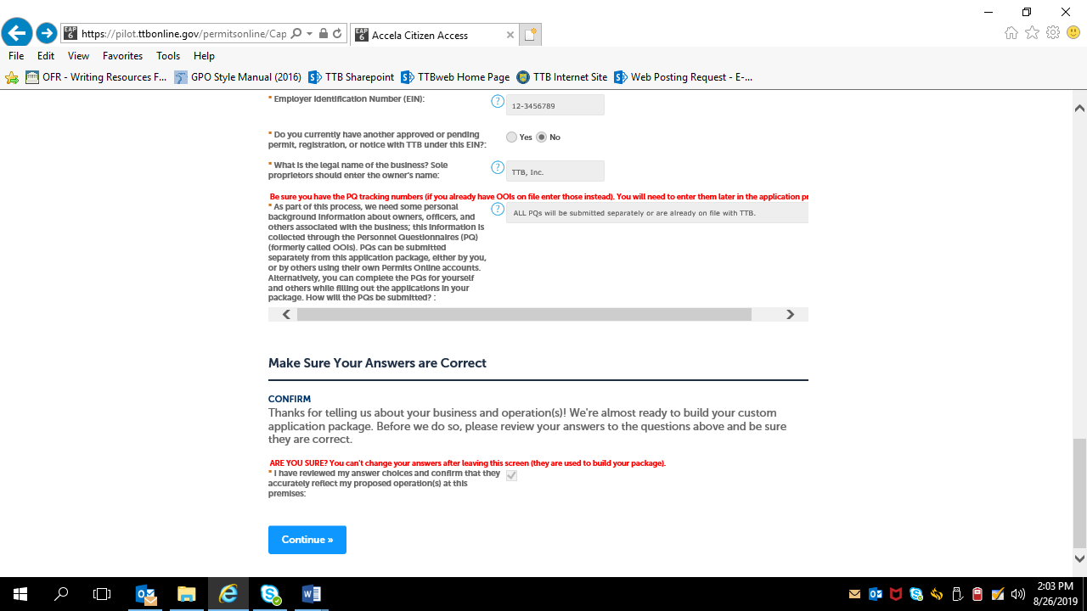

Step 2, Review:

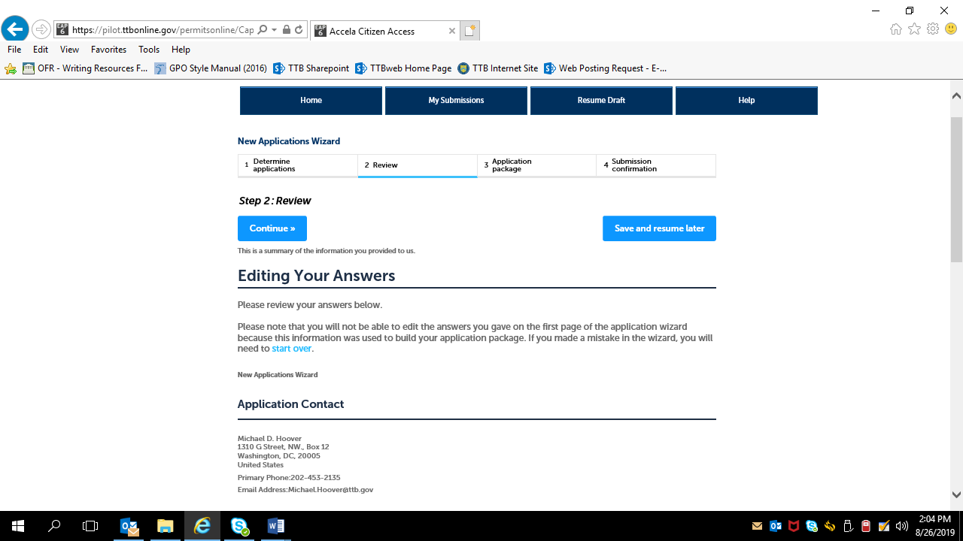

Review screen continues:

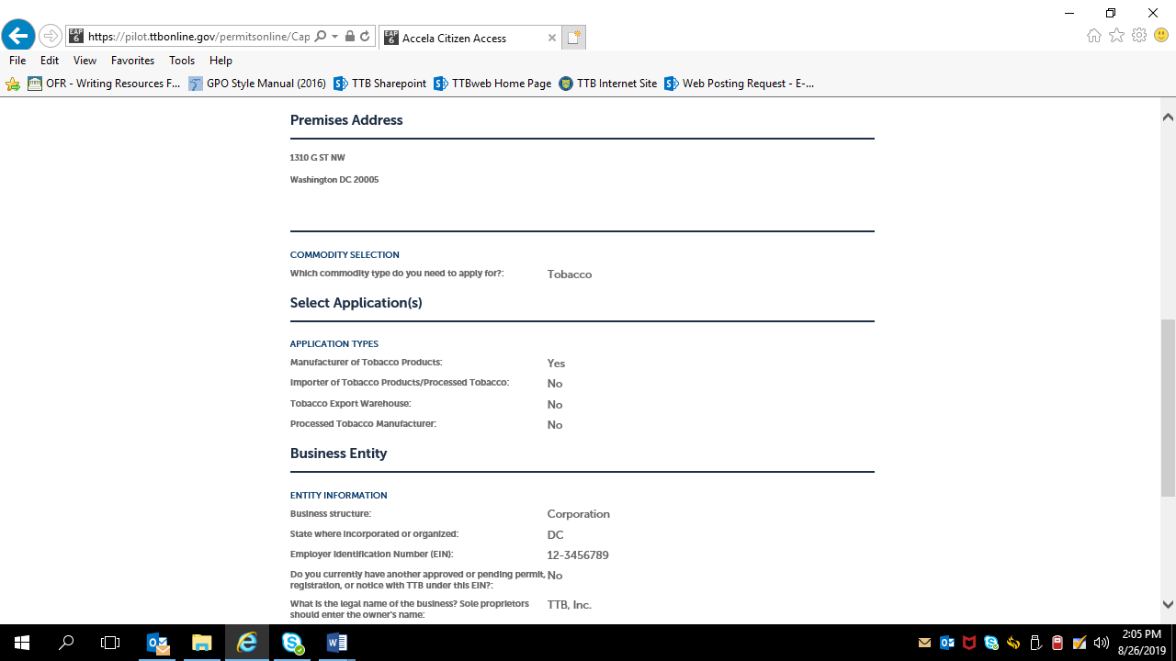

The review screen continues:
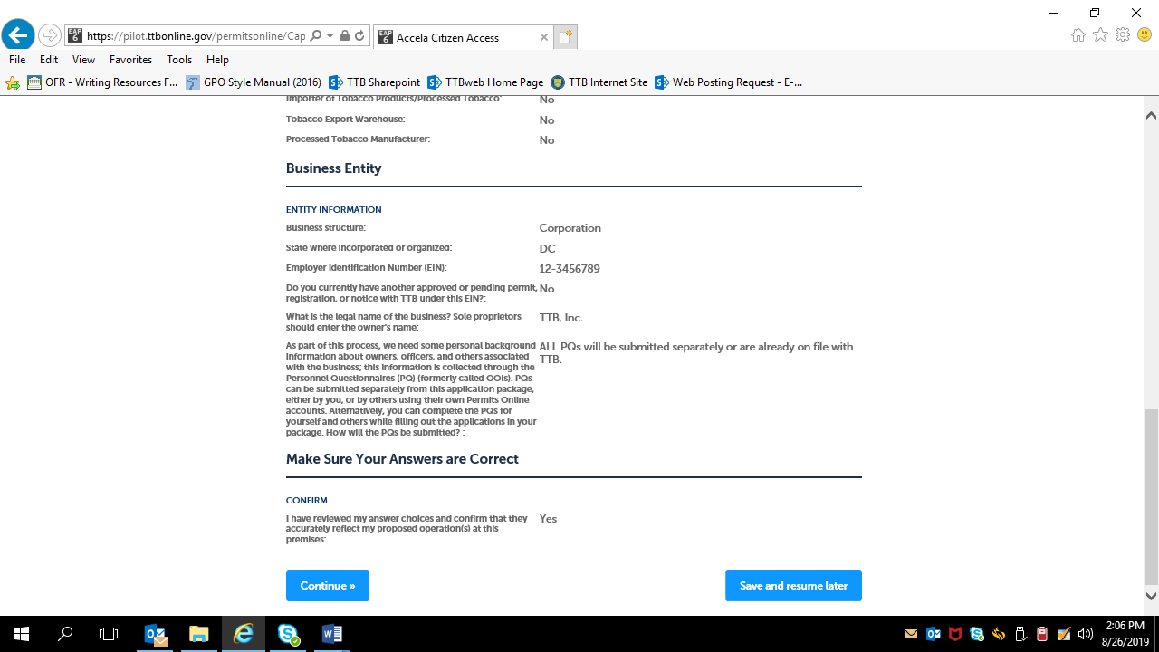

After confirming (or editing and confirming) the provided information, the applicant clicks “Continue,” and is presented with the Application Package screen:
Step 3 –Application Package:

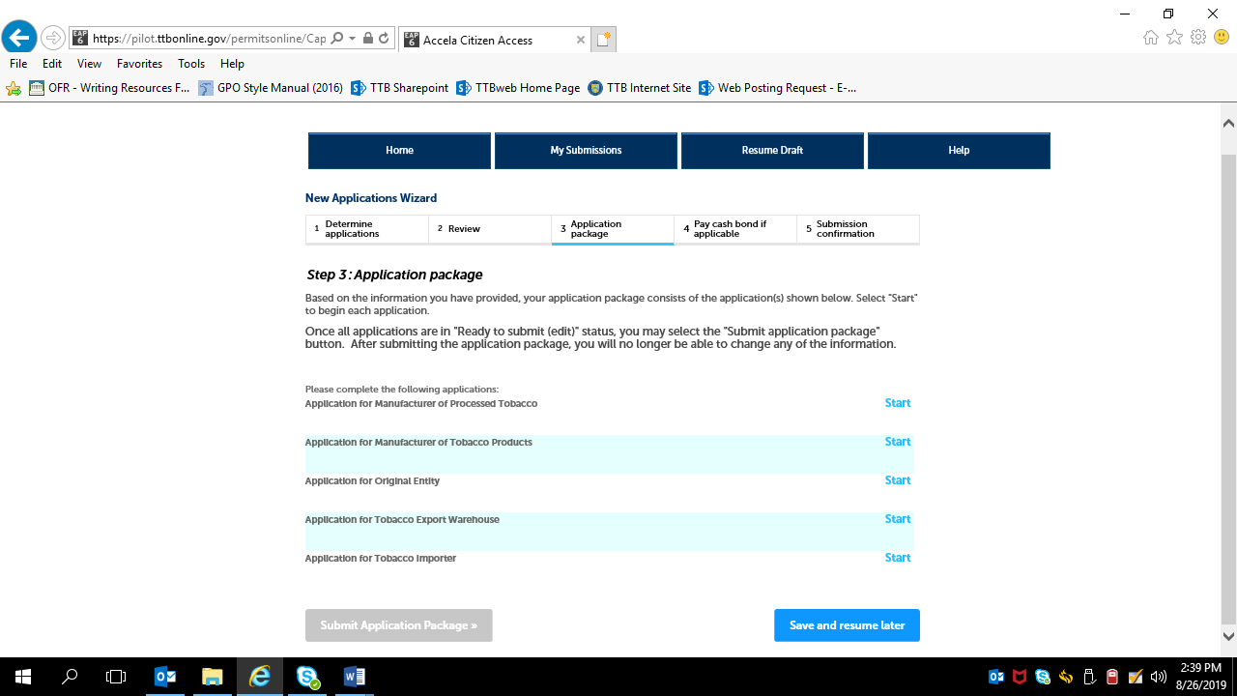

Application Packages:
Step 1: Mailing Address Screens (These screens are the same for all new types of new tobacco industry permits) —
Note: Many data fields auto-fill based on information provided earlier.)
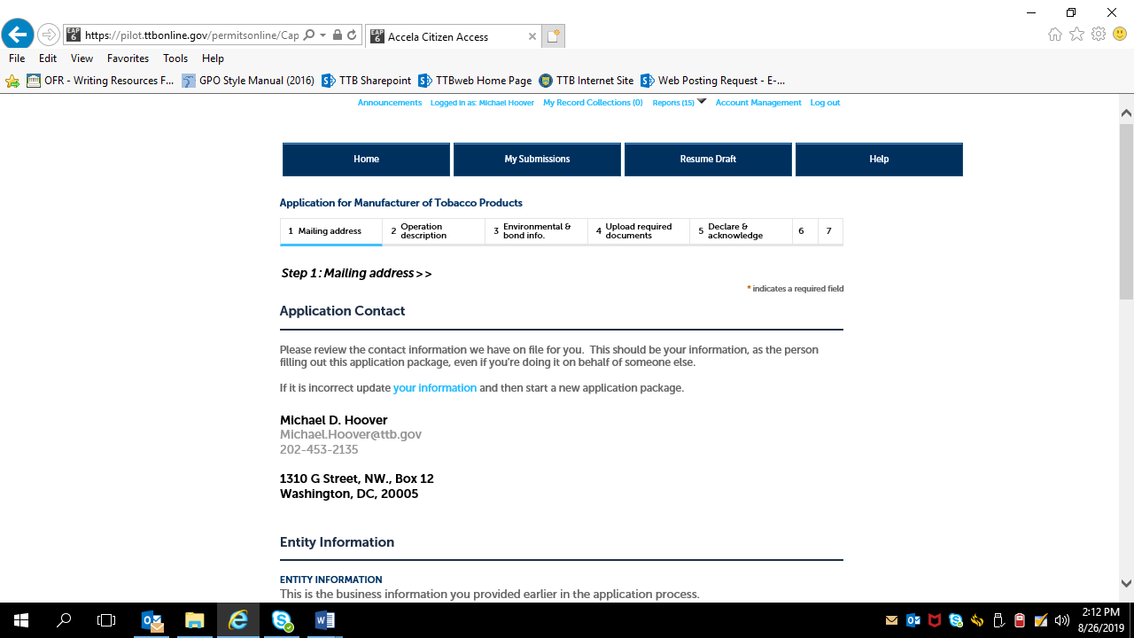

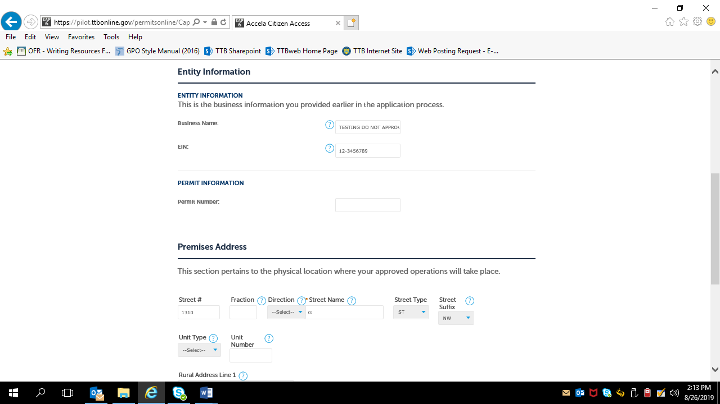

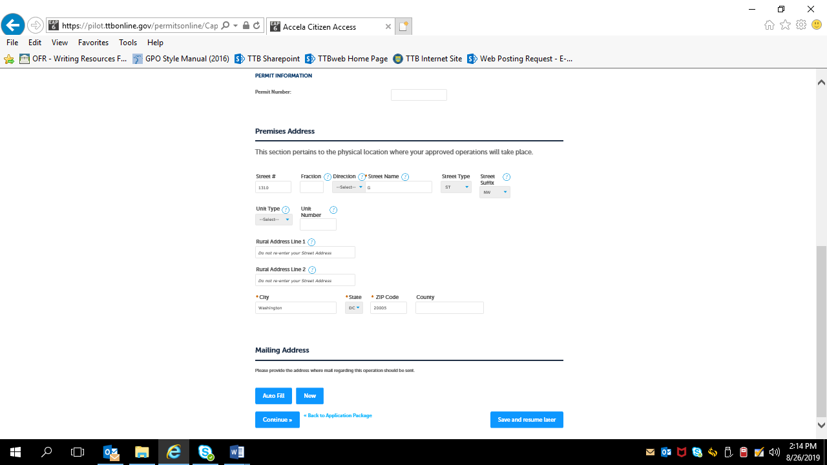

For “Mailing Address,” the applicant may select Auto Fill or New. If Auto Select is chosen, the mailing address information will auto fill from the contact information provided earlier. If “New” is selected, the data fields shown below appear:
Contact Information (Mailing Address) data fields, if “New” Mailing Address is chosen, as shown above.
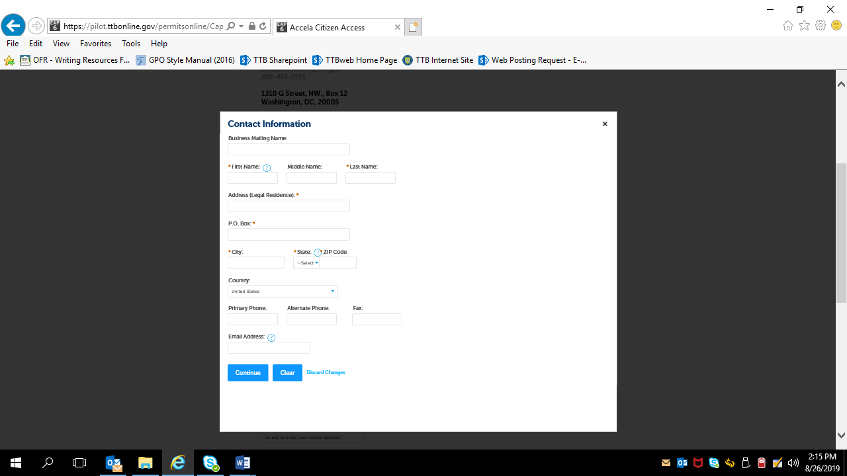

After mailing address information is provided:
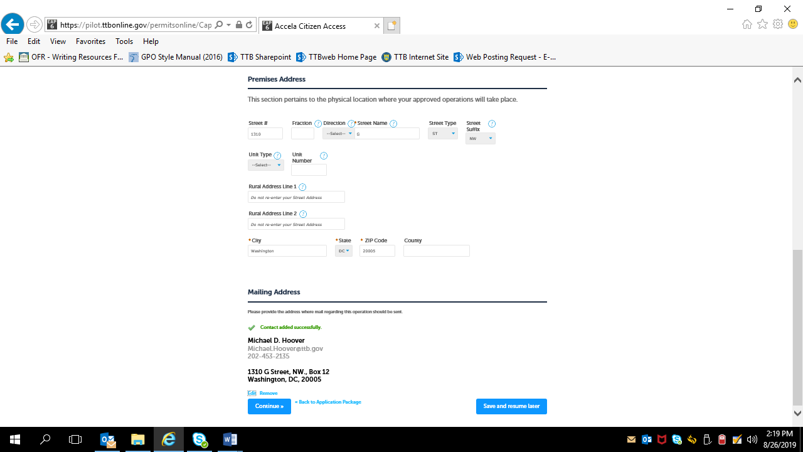

After clicking continue, screens will vary depending on the type of tobacco permit being applied for.

Application for Original Entity:
The information in Step 1 auto-fills based on the information provided on the Common Screens (except Business Website) —
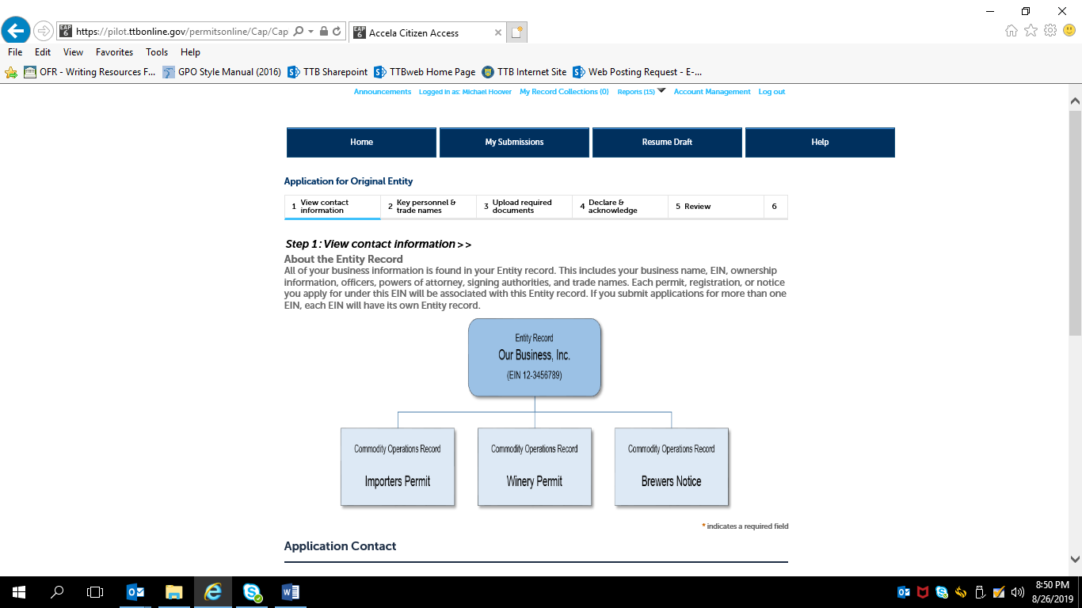

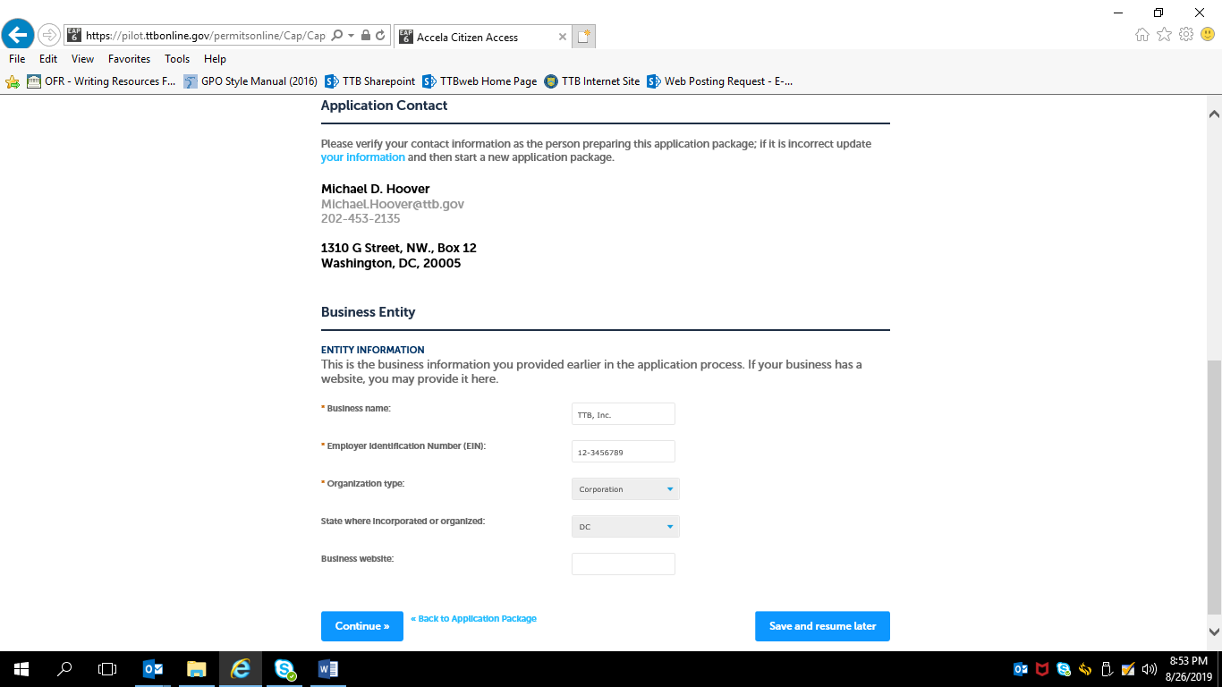

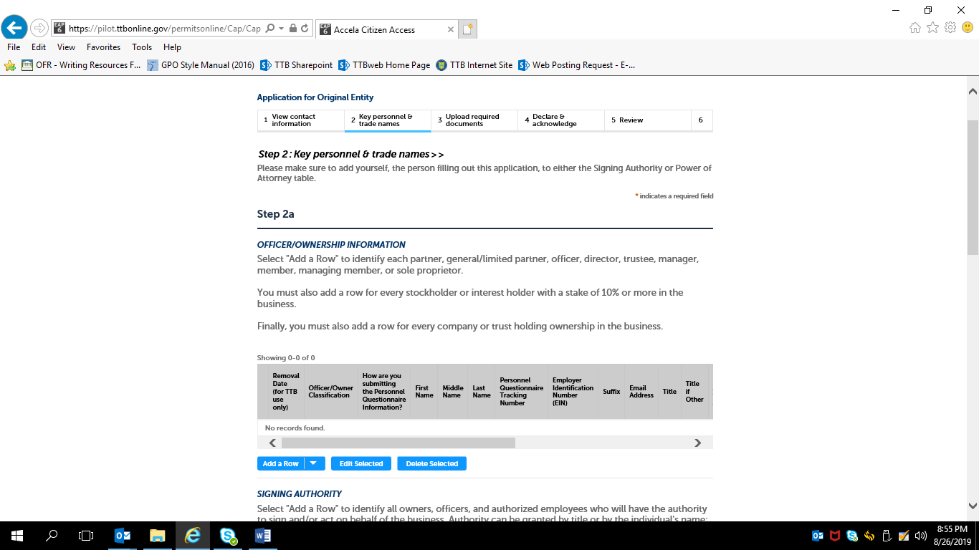

Officer / Ownership Information sub-screen:

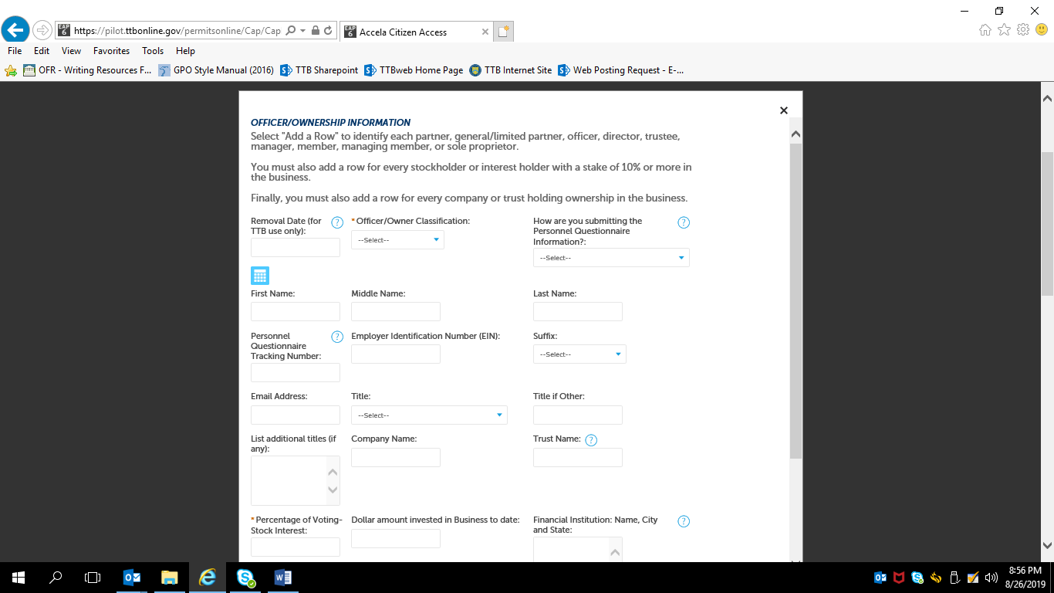

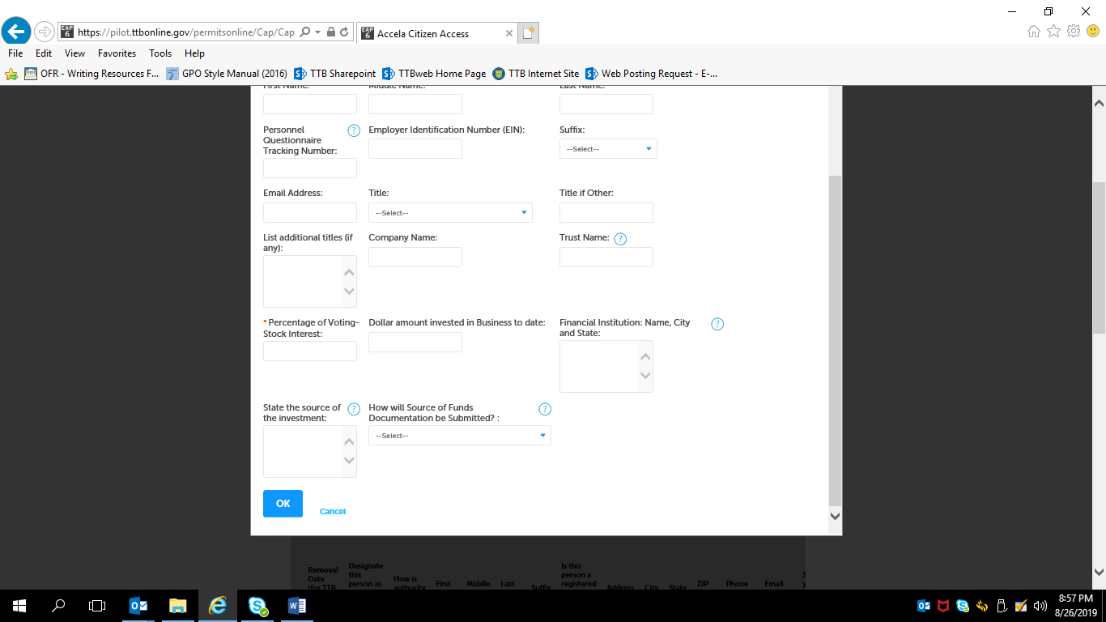

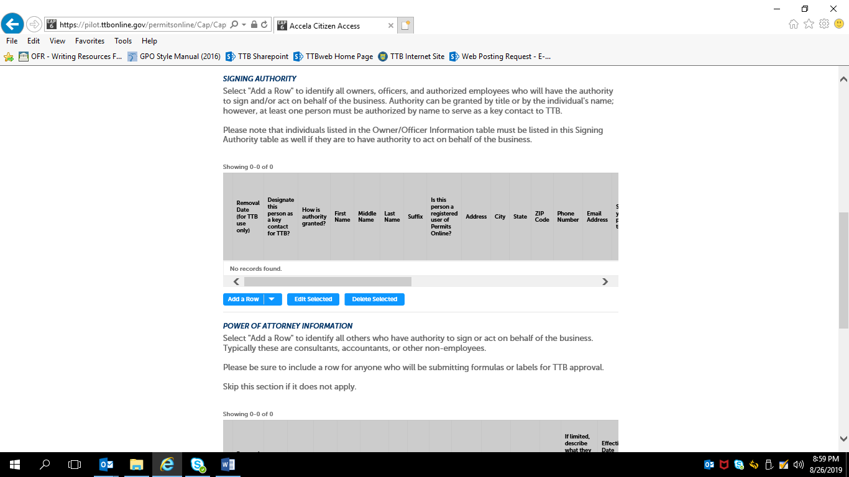
NOTE: Signing Authority information collection approved under OMB No. 1513–0036, and Power of Attorney information collection approved
OMB No. 1513–0014.

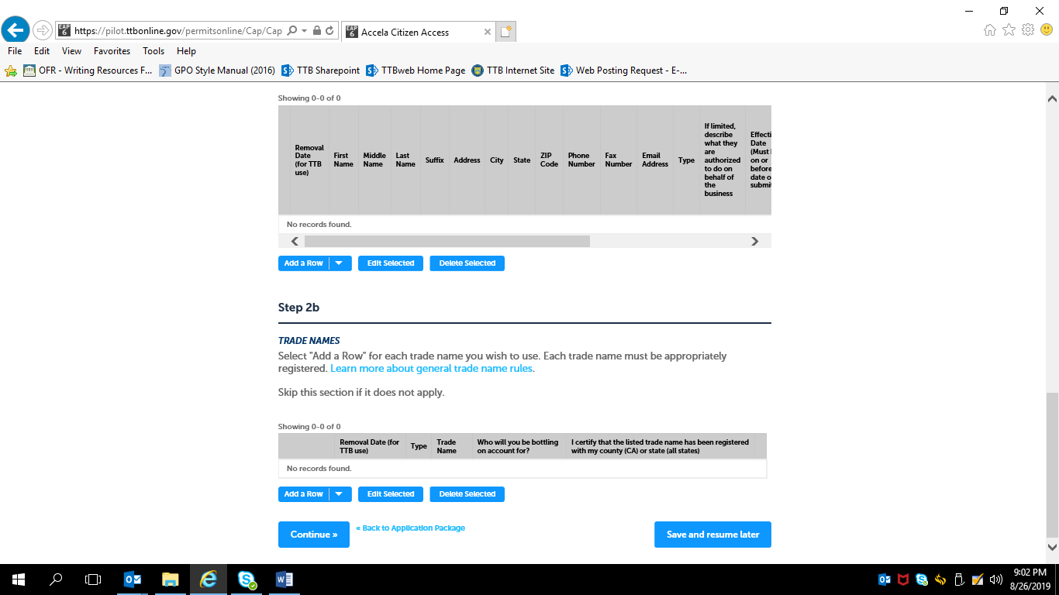

Trade Names sub-screen:
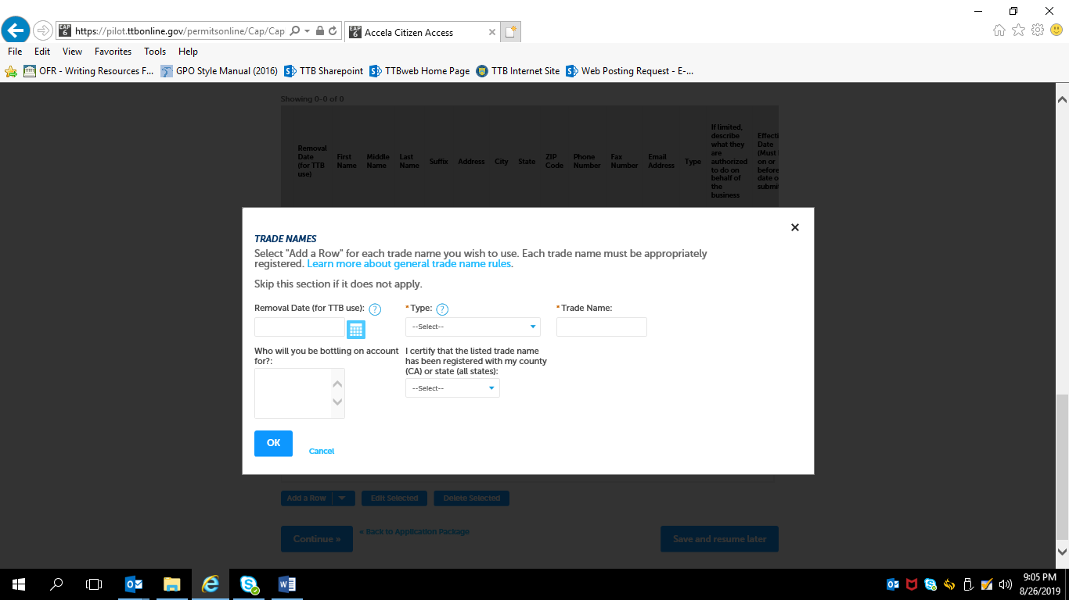

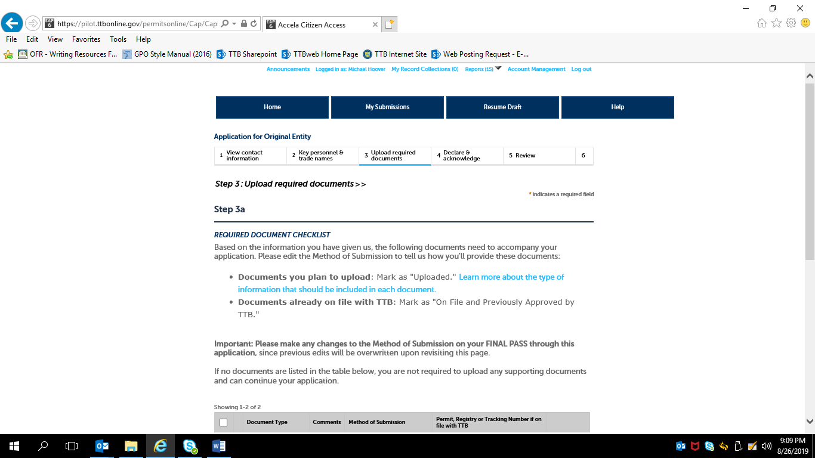

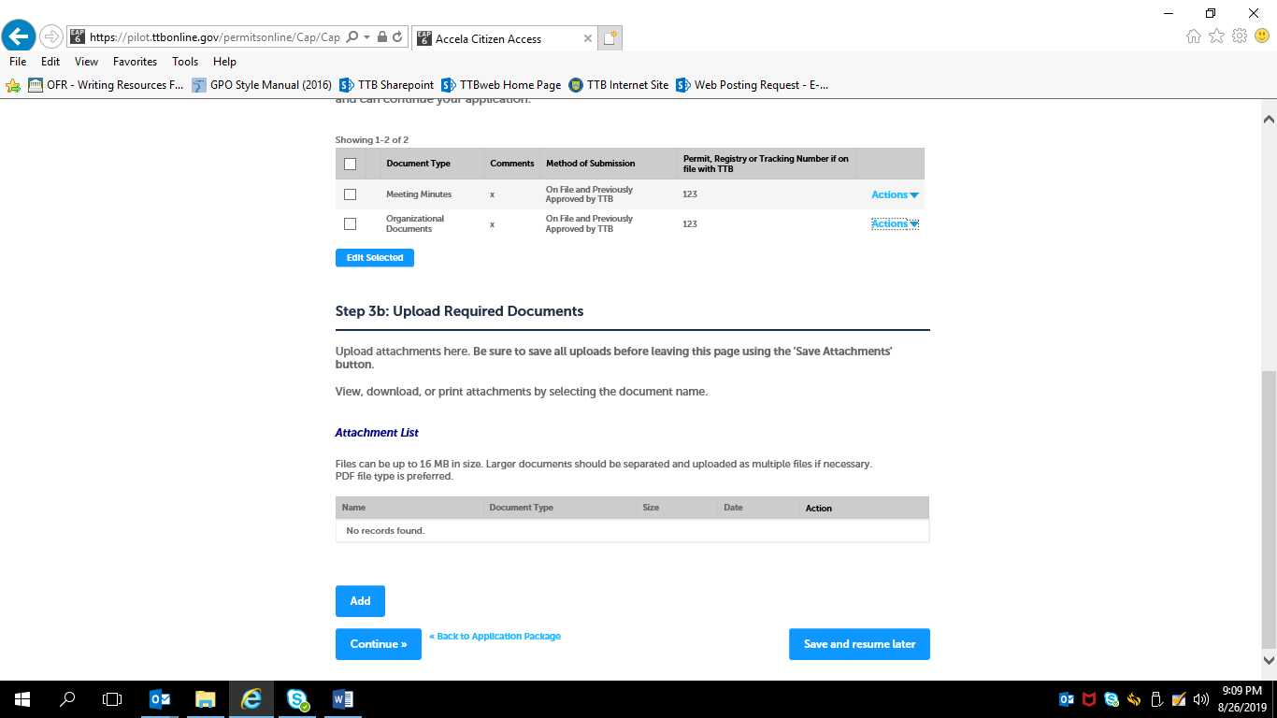

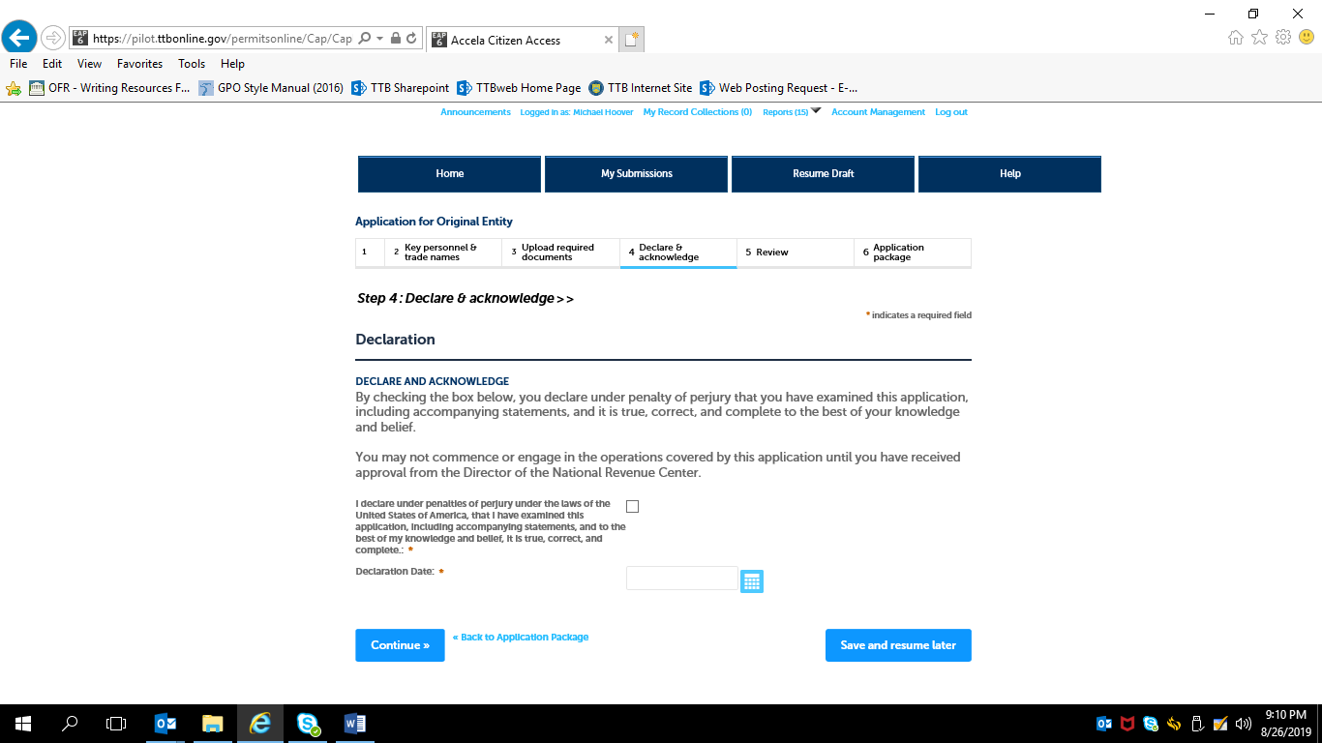

Review of Original Entity Application —

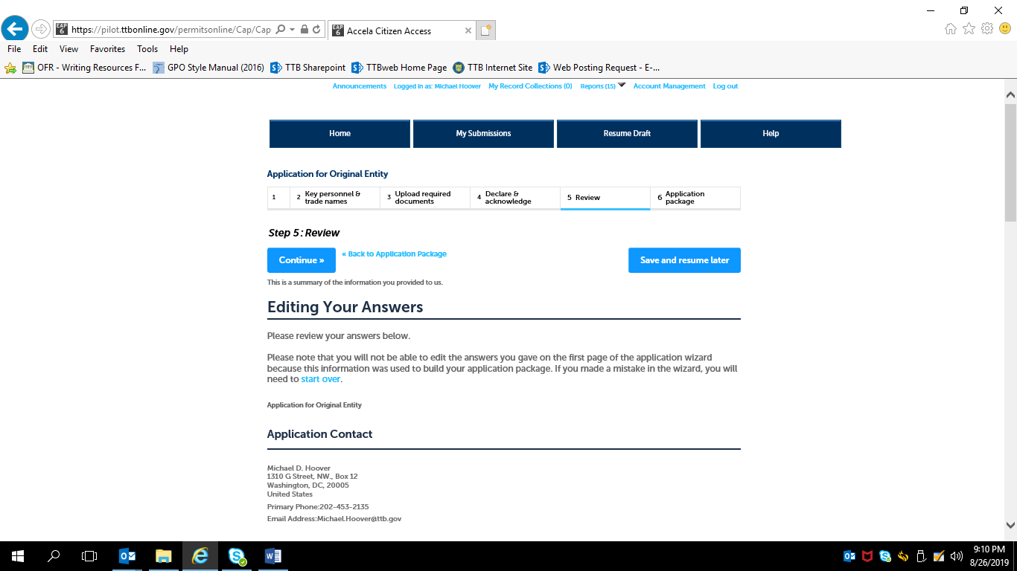

Bottom of Original Entity review screen:

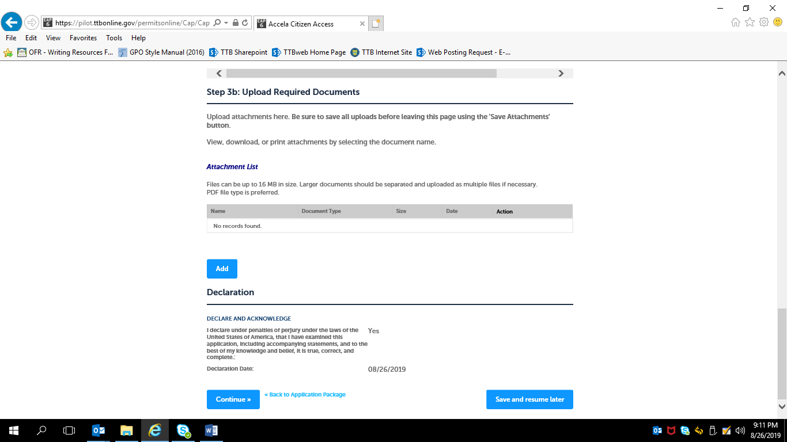

After review, the applicant is returned to the Step 3, Application Package, of the Common Screens. If only one type of permit is applied for, the applicant is taken to the Step 5, Submission Confirmation, screen.

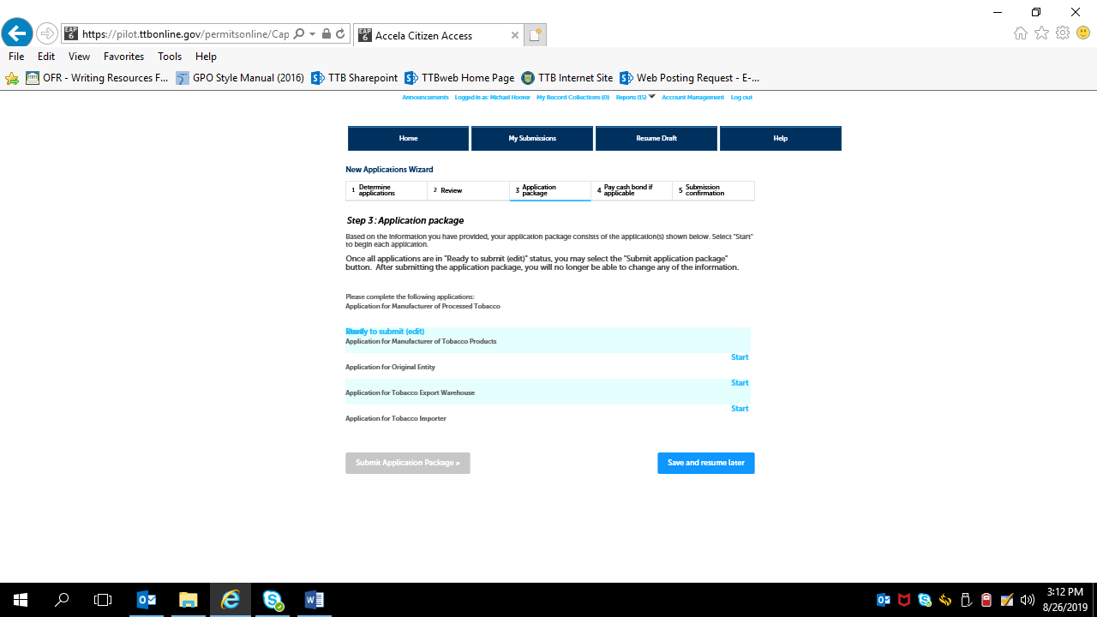

Screens for New Manufacturer of Processed Tobacco Permit:

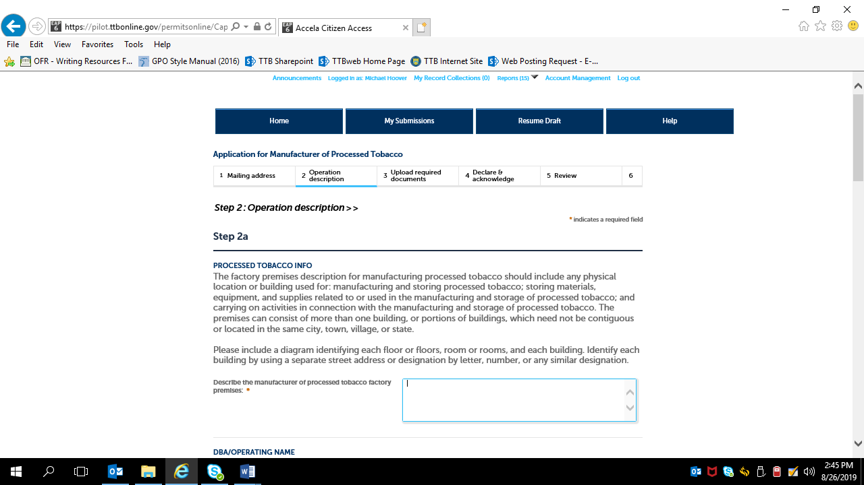

Screen continues:

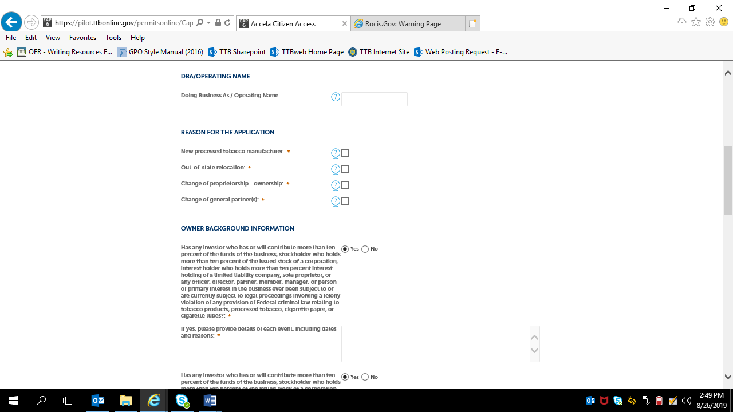

Screen continues:

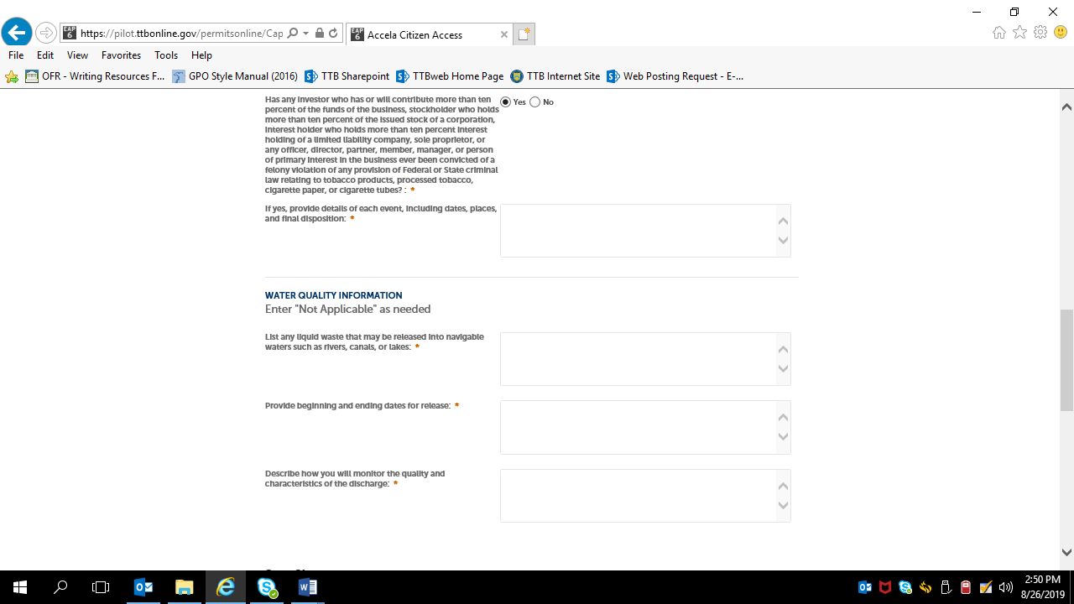

Screen continues:

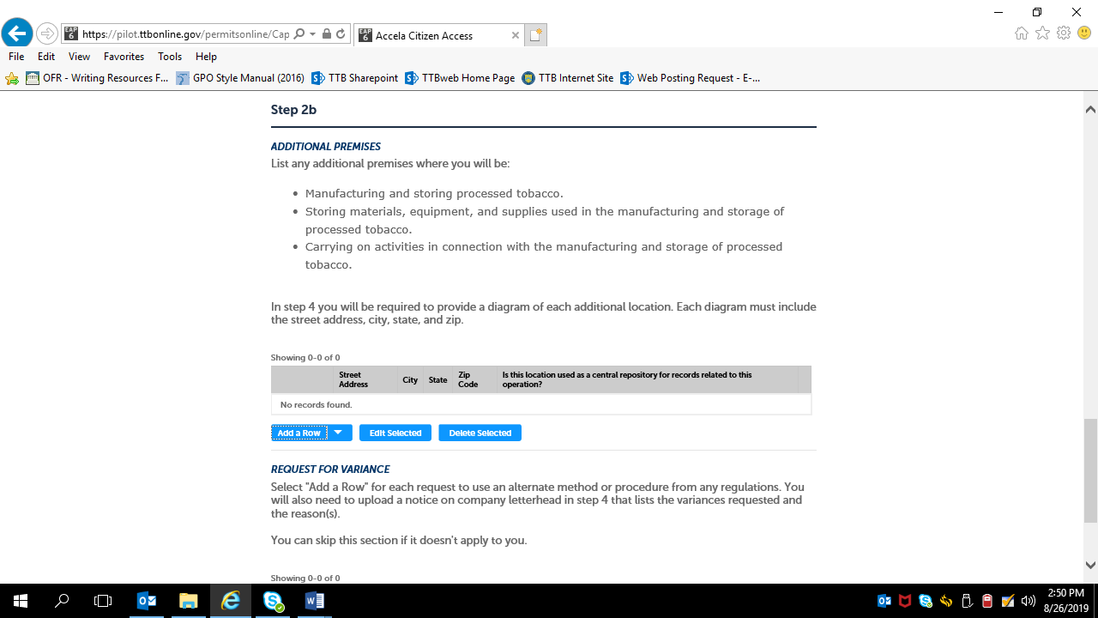

If Additional Premises information required, applicants will see and complete this screen:

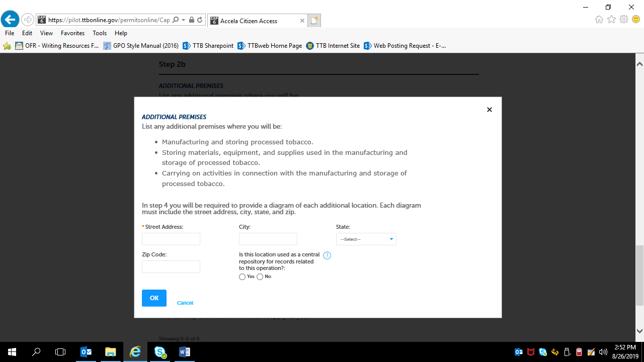

Screen continues:

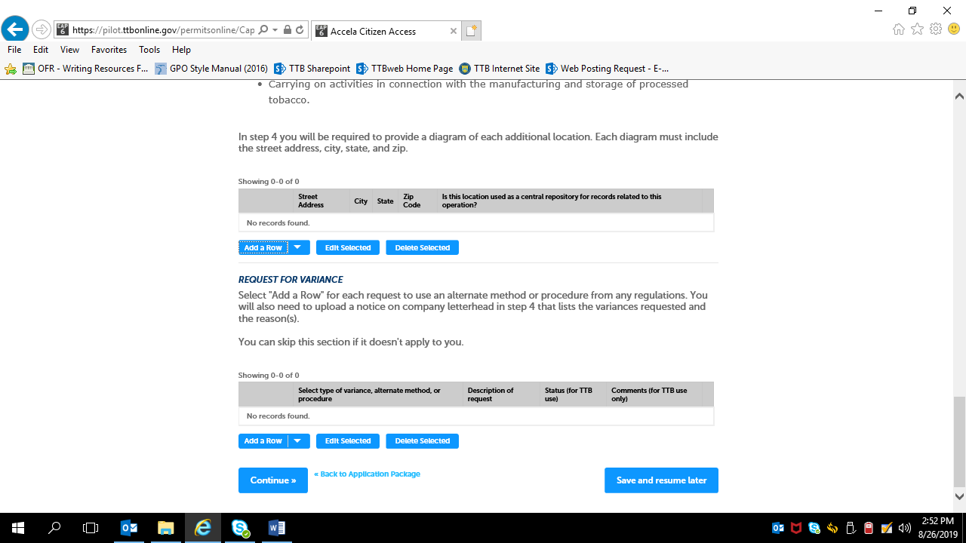

If Requests for Variances are required, applicants will see and complete this screen:

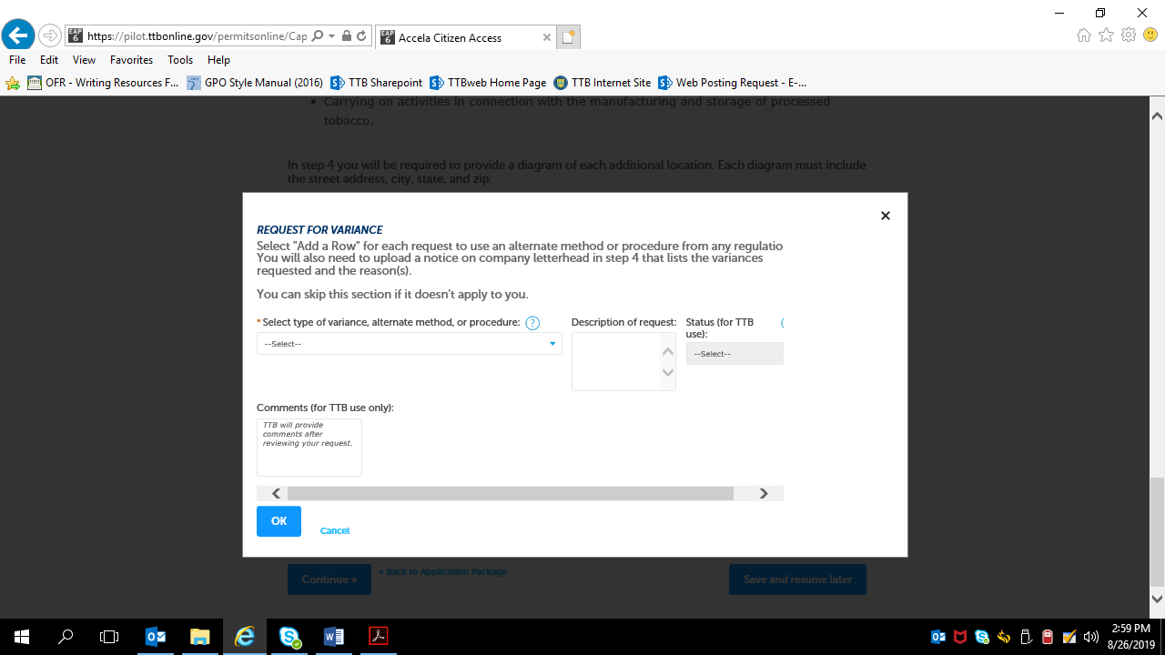

The Types of variances, alternative methods, or procedures are:

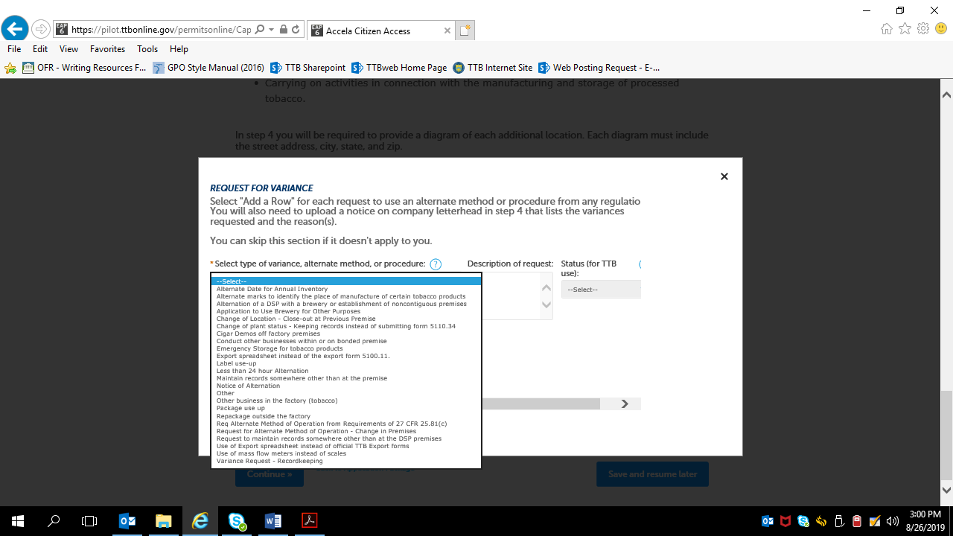

Selecting “continue” at the bottom of the Step 2a screen results in:

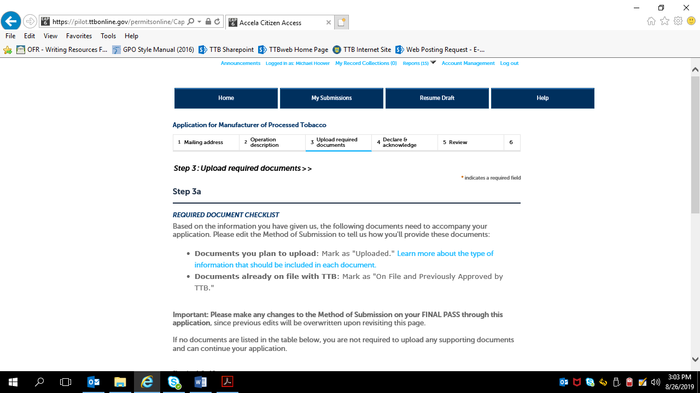

Screen continues:

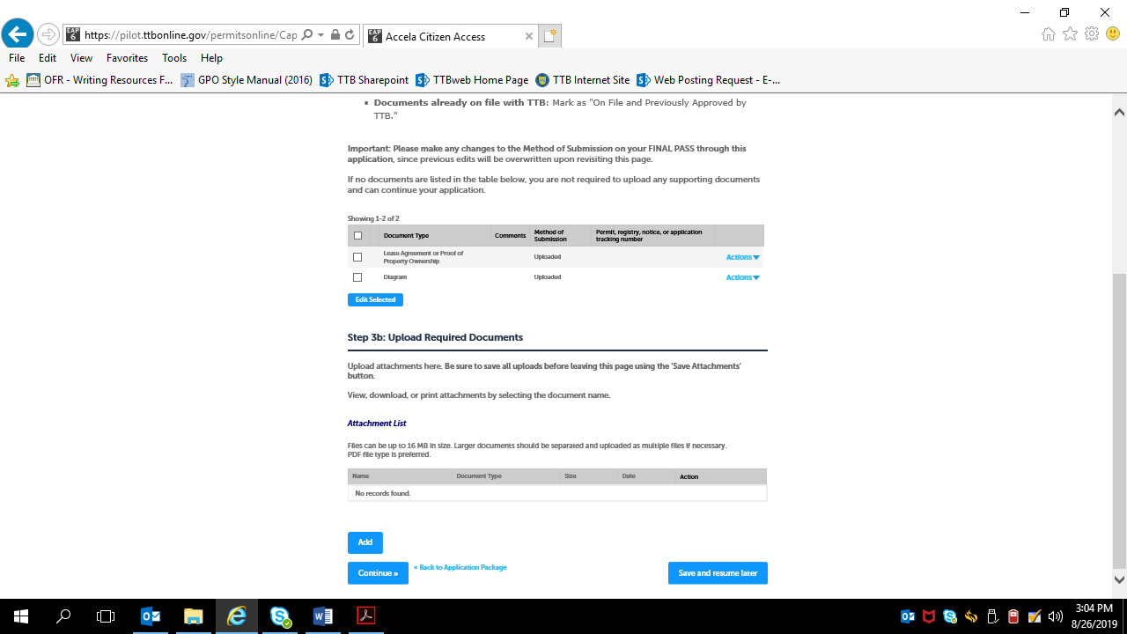

Uploading Required Documents screen:

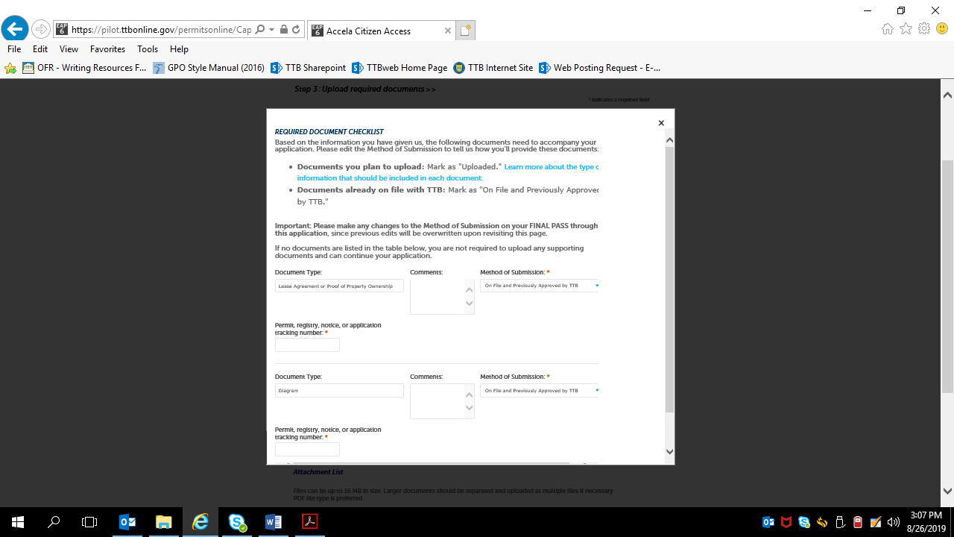

Step 4 – Declare and acknowledge:

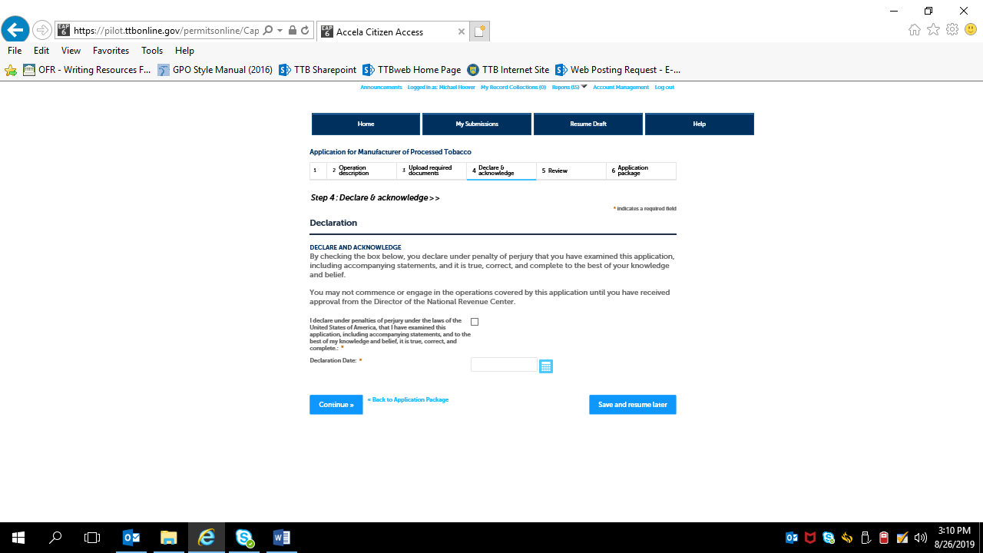

Step 5: Review:

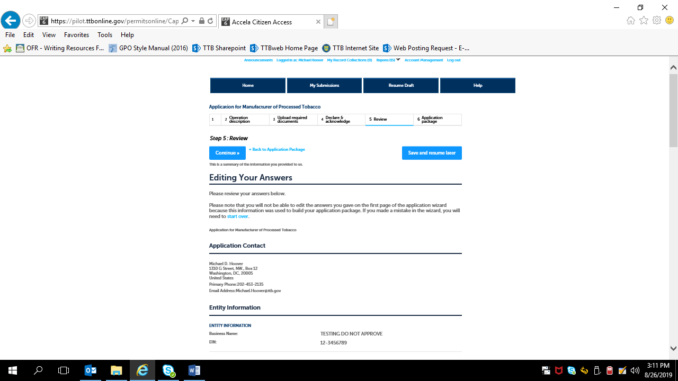

Review screen continues:

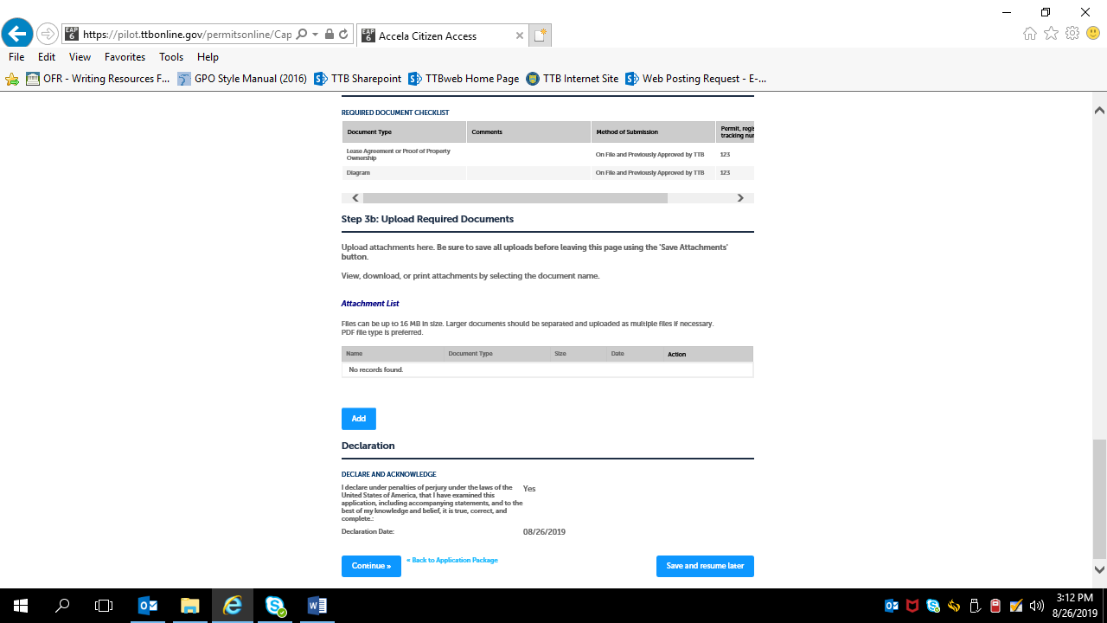

If multiple types of permits are being applied for, the applicant is returned to the Step 3, Application Package, of the Common Screens. If only one type of permit is applied for, the applicant is taken to the Step 5, Submission Confirmation, screen.

Screens for New Manufacturer of Tobacco Products Permit:
Step 1: Mailing Address Screens (These screens are the same for all new types of new tobacco industry permits; see pages 18 – 22 above). —
Step 2: Operation Description Screens —
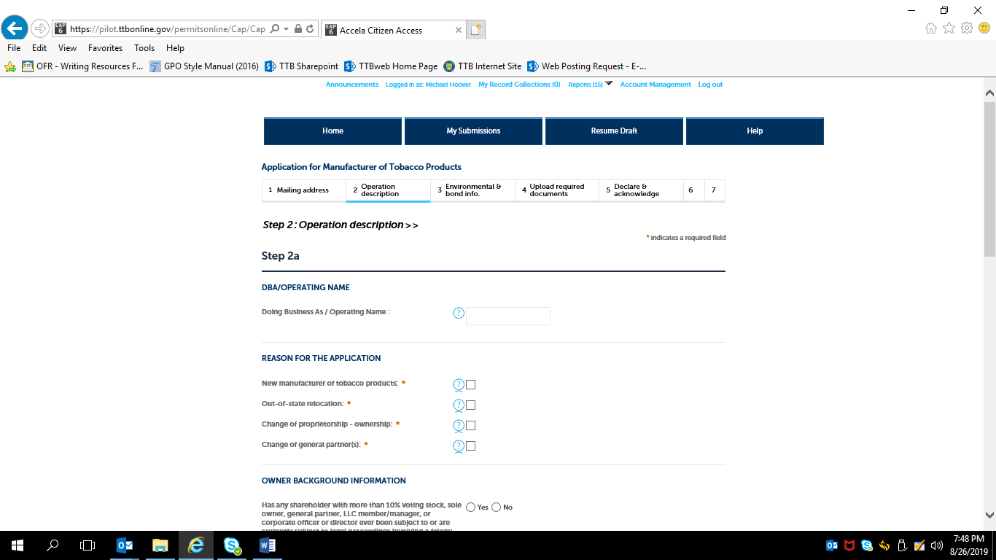

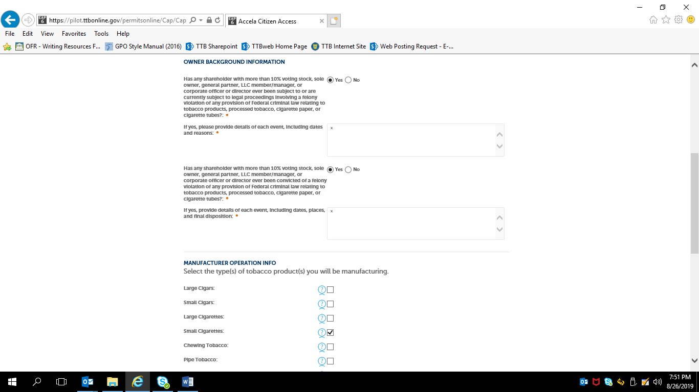
Note: Selection of the type(s) of tobacco products to be manufactured does not change of the following screens.

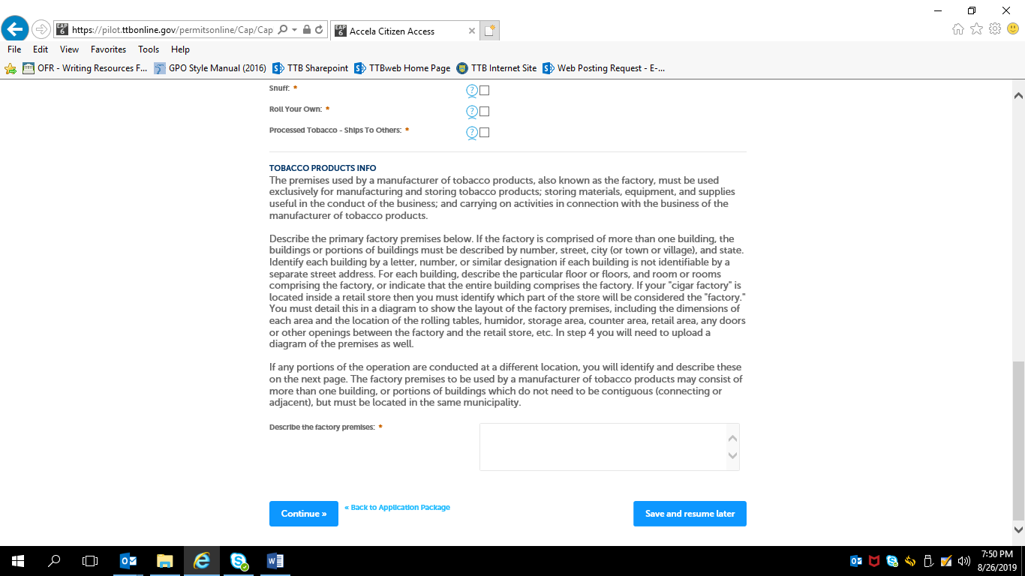

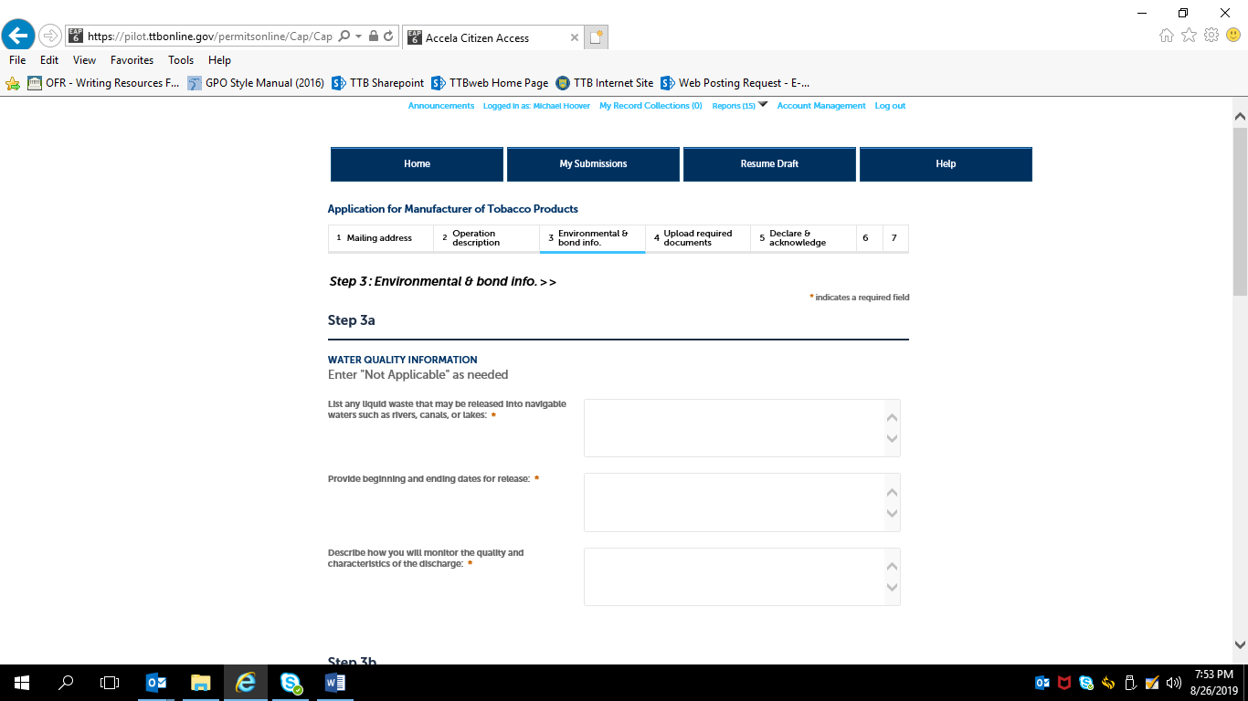
NOTE: Step 3a, Water Quality Information, approved under OMB No. 1513–0023.

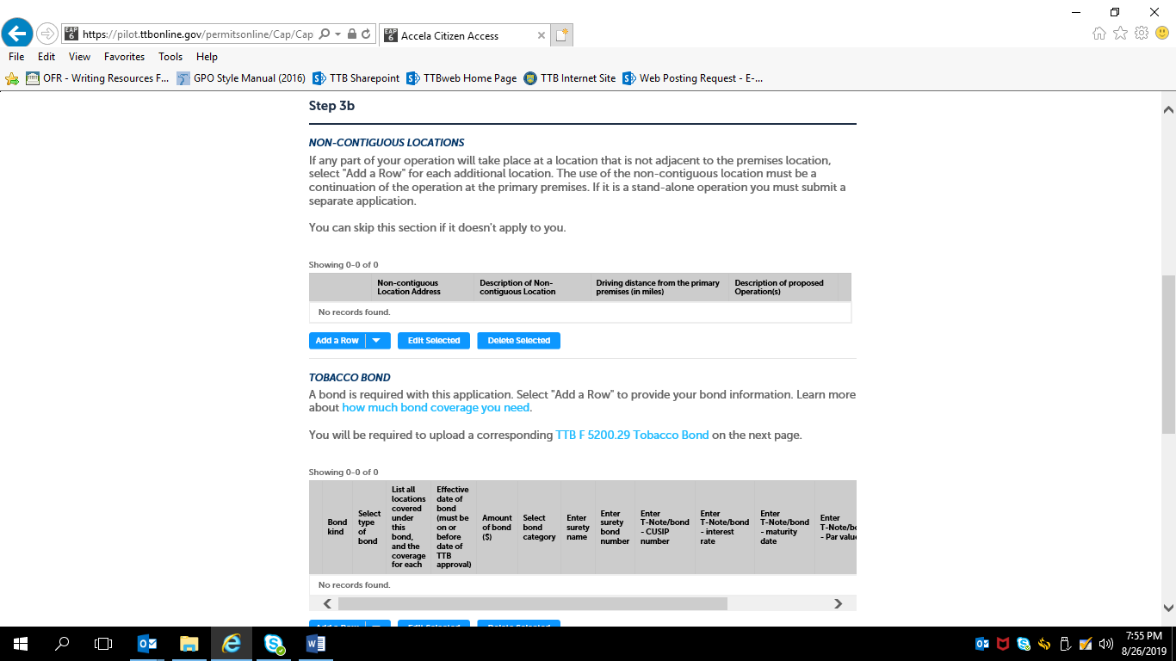

If non-contiguous location information is needed, the applicant will see this screen:
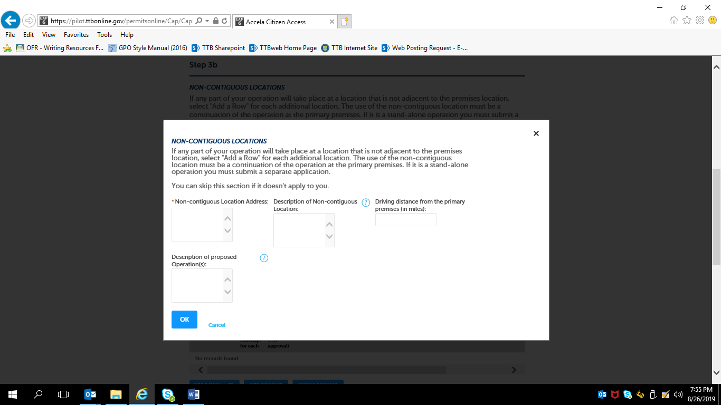

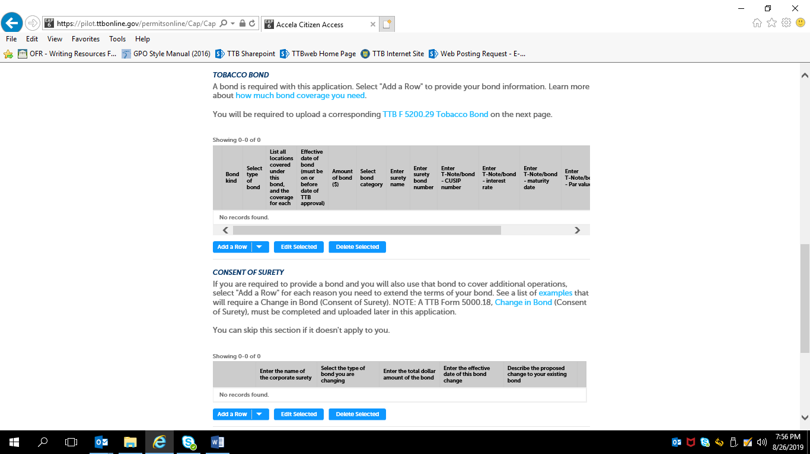
NOTE: Tobacco Bond information collection approved under OMB No. 1513–0103; Consent of Surety information collection approved under
OMB No. 1513–0013.

If Tobacco Bond information needed, the applicant completes this screen:

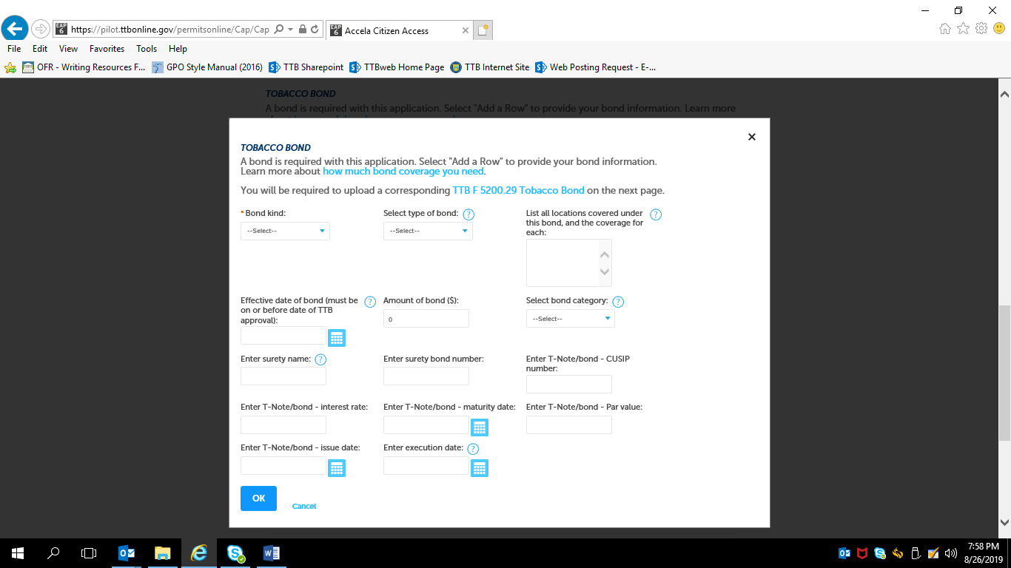

If Consent of Surety information needed, the applicant completes this screen:

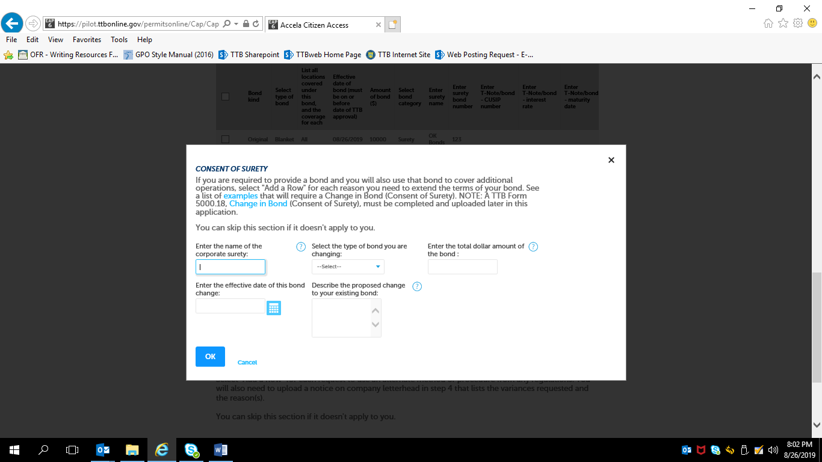

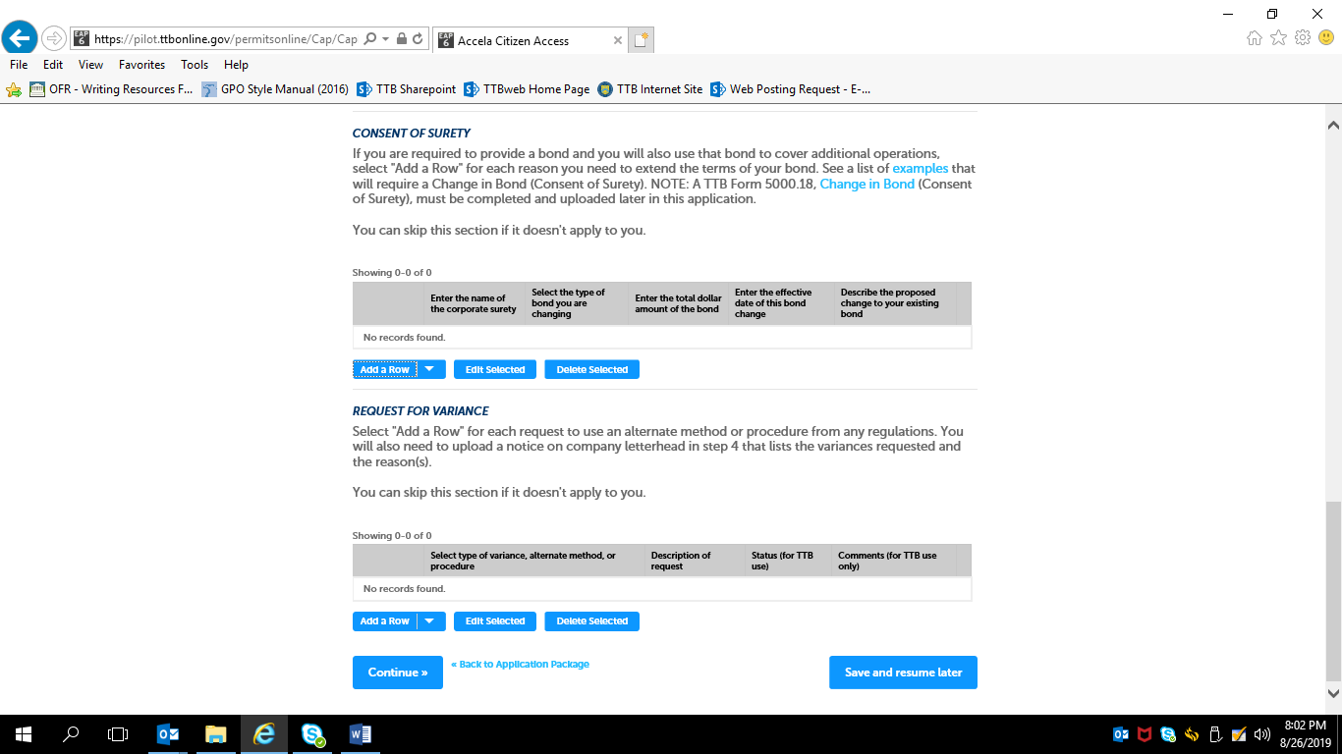

Step 4: Upload Required Documents —

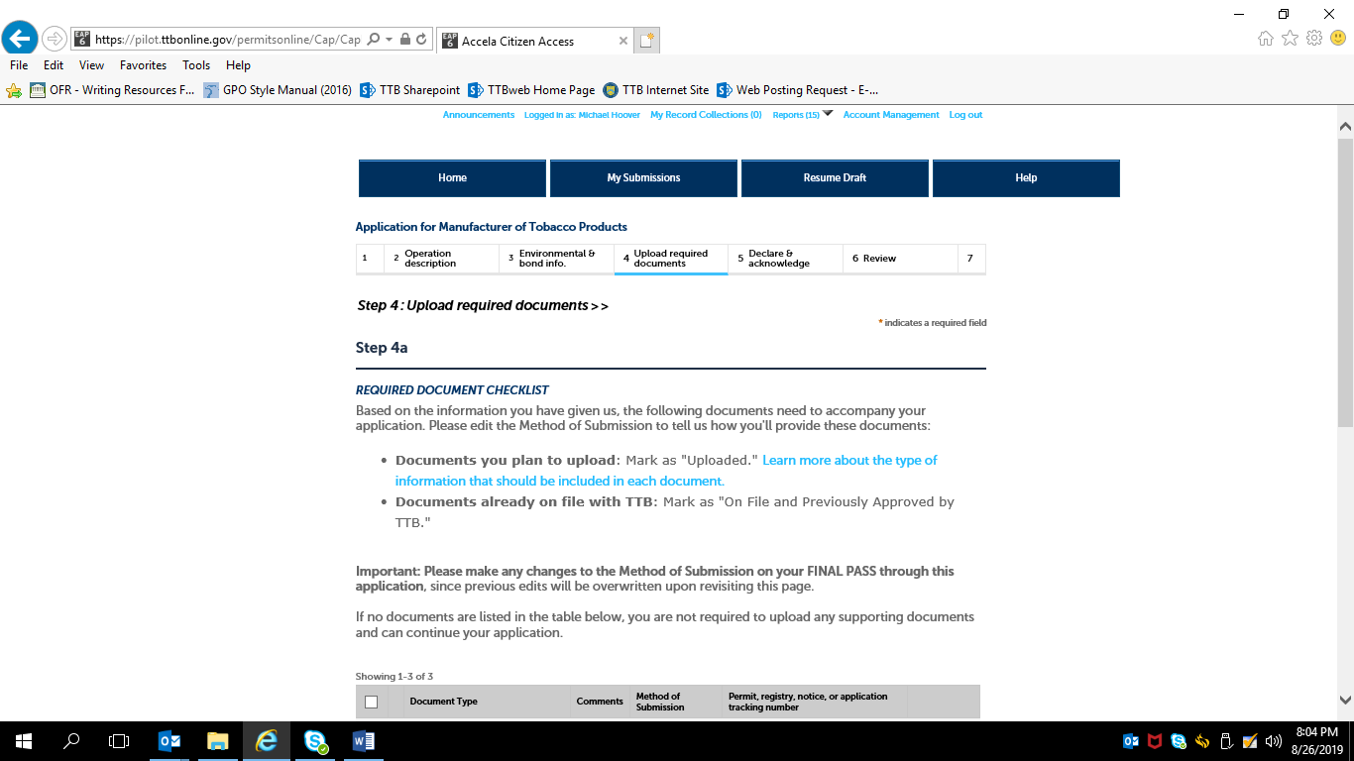

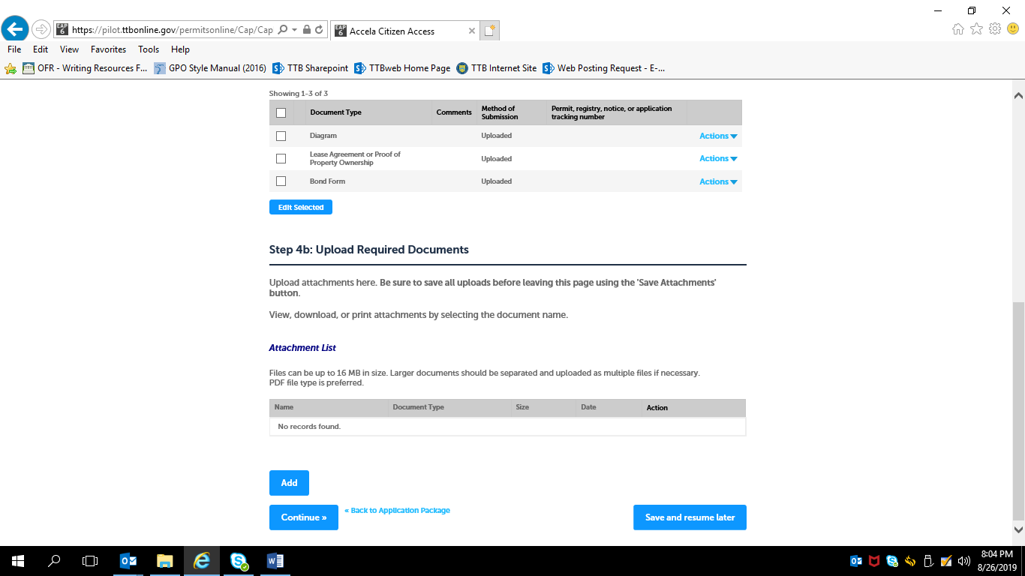

Example of Uploading Document sub-screen:

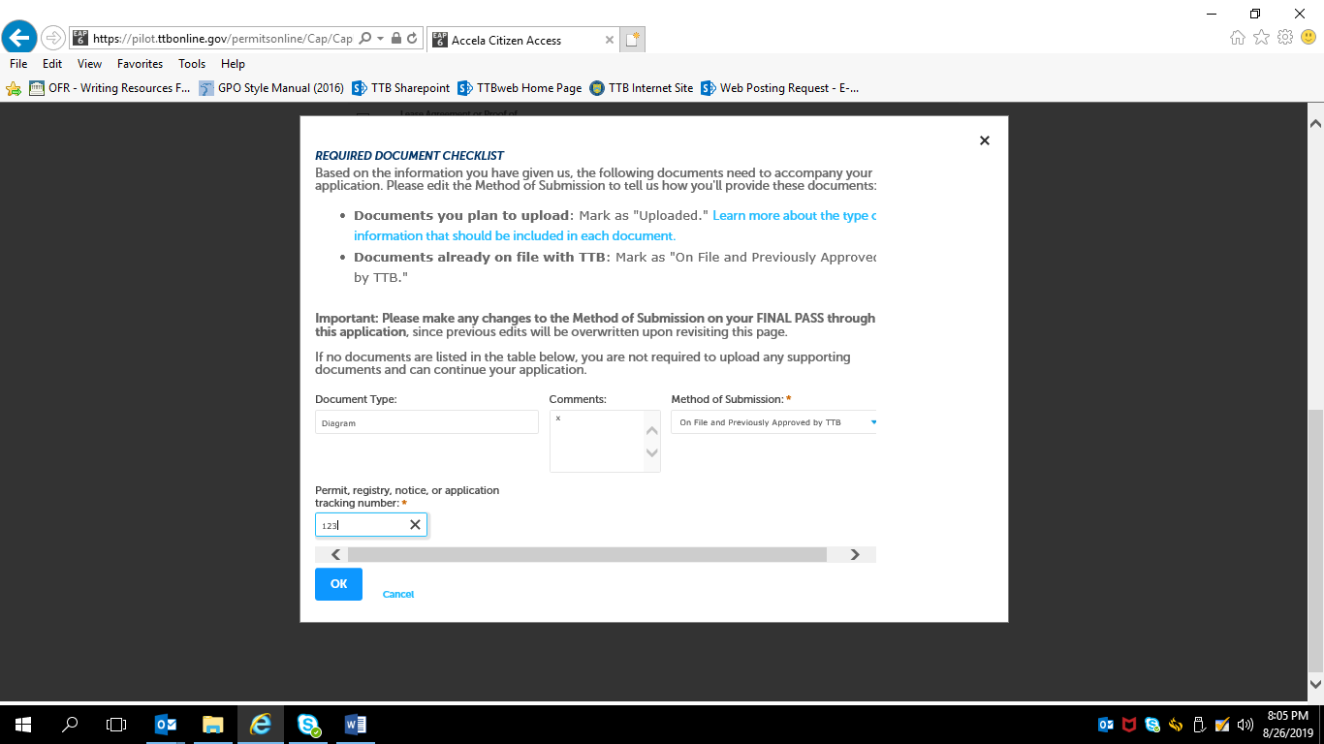

After uploading any required documents and clicking “Continue” in Step 4, the applicant goes on to —
Step 5: Declare and Acknowledge —

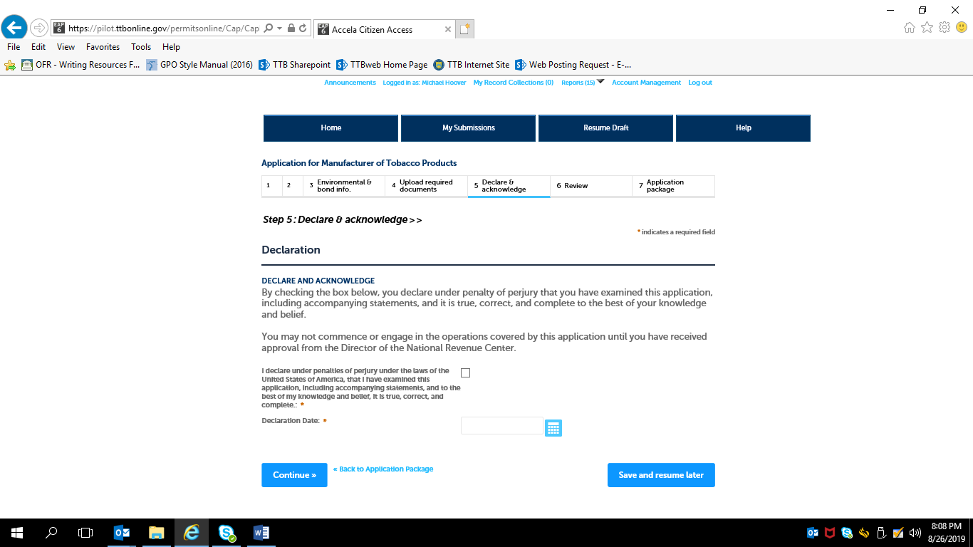

Step 6: Review —

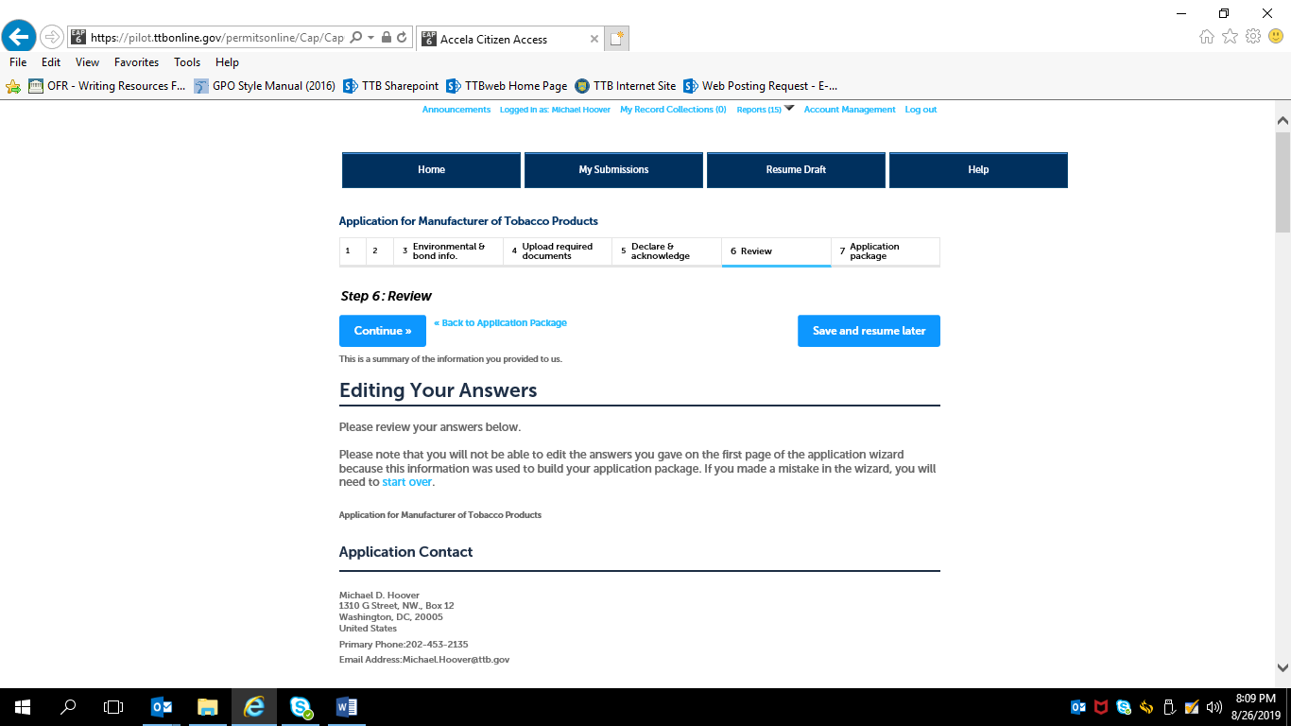

Review screens continue; applicant may make edits to the provided information, and then clicks “Continue” at the bottom of Step 6 when the review is complete:

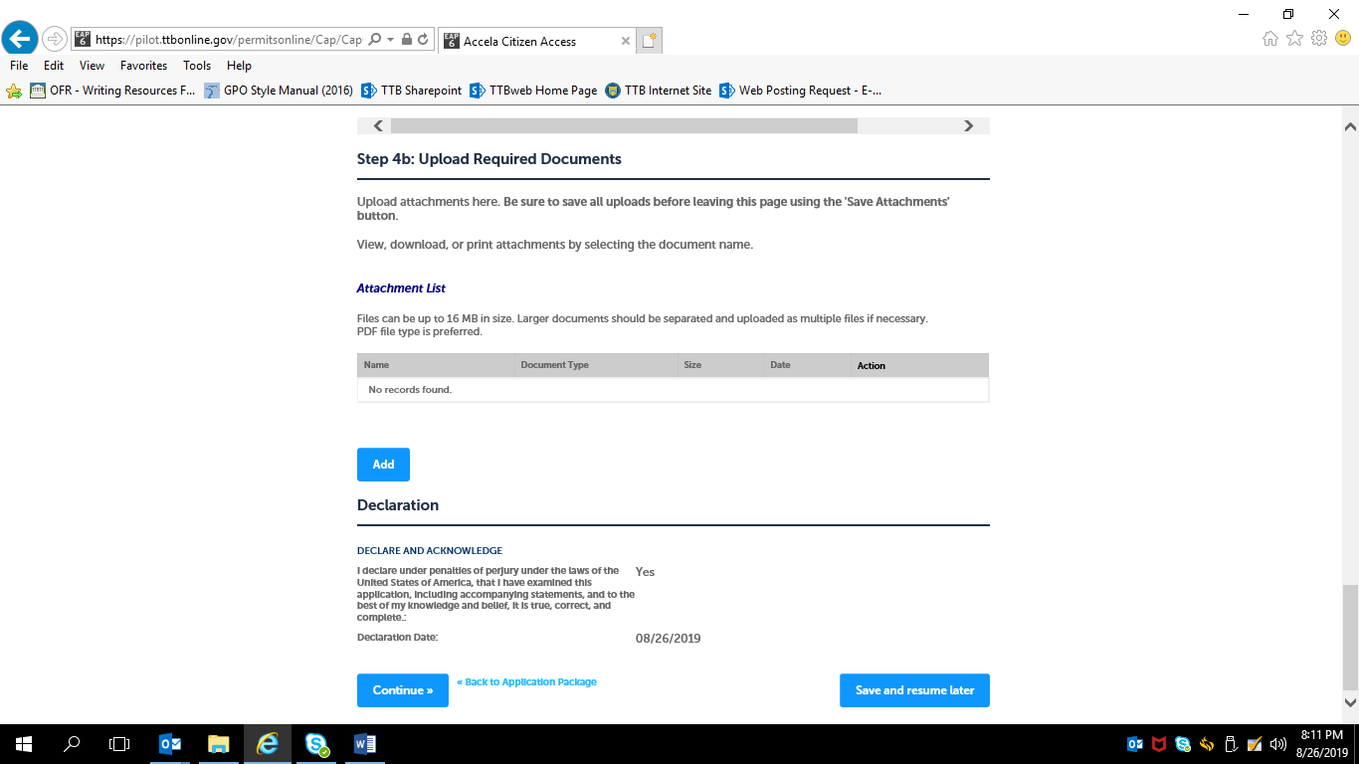

If multiple types of permits are being applied for, the applicant is returned to the Step 3, Application Package, of the Common Screens. If only one type of permit is applied for, the applicant is taken to the Step 5, Submission Confirmation, screen.

Screens for New Tobacco Export Warehouse Permit:
Step 1: Mailing Address Screens (These screens are the same for all new types of new tobacco industry permits; see pages 18 – 22 above). —
Step 2: Operation Description Screens —
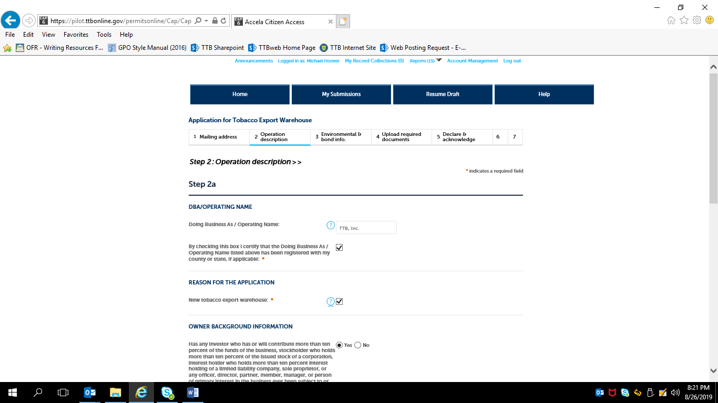

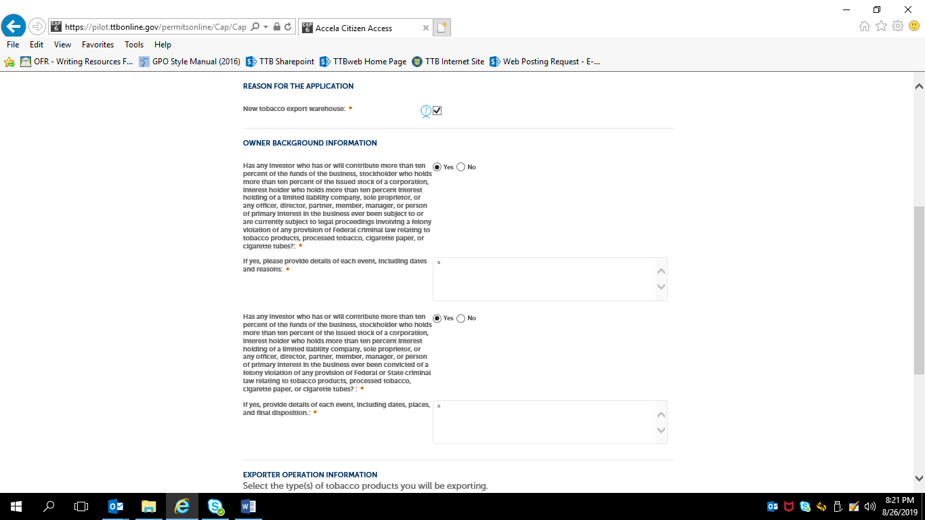

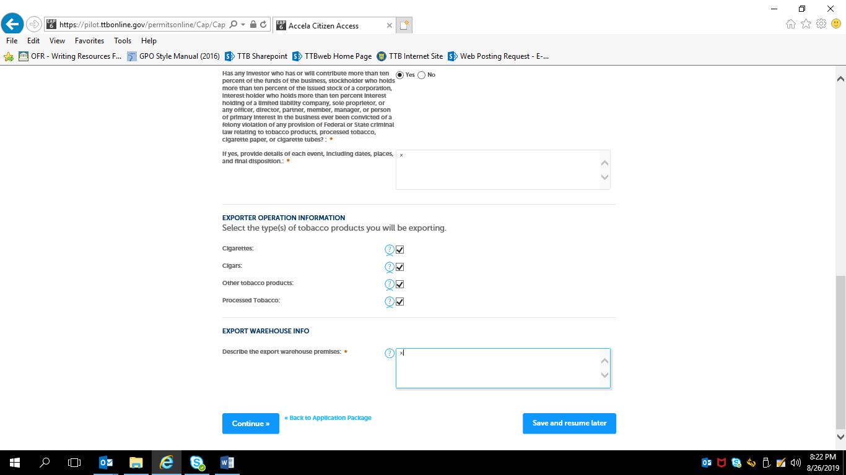
NOTE: Checking the various types of tobacco products to be exported does NOT change the data collected on the following screens.

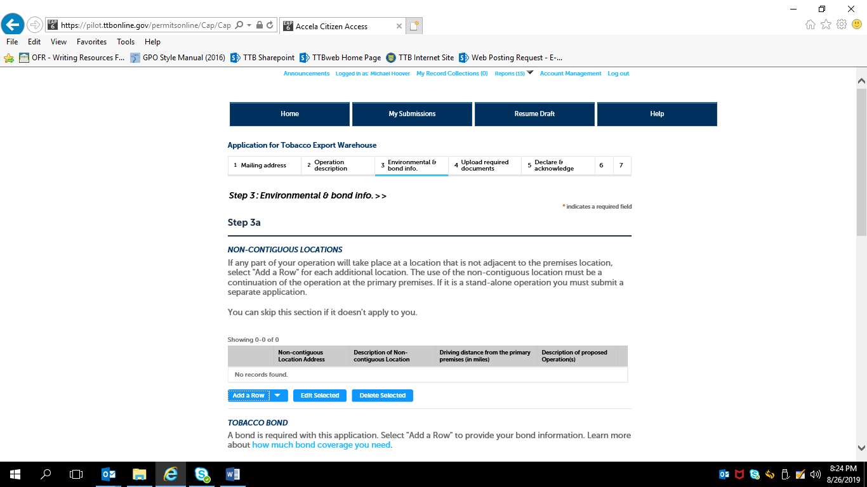
NOTE: Water quality information is not collected as part of the New Tobacco Export Warehouse application.

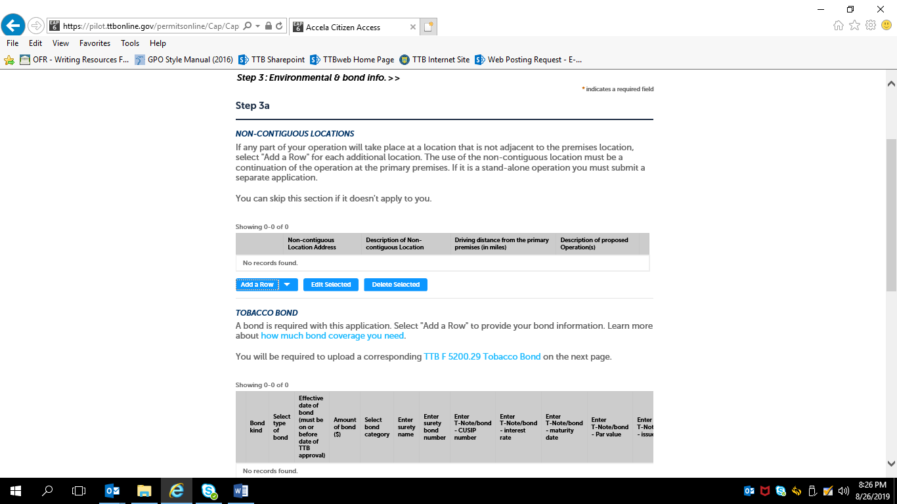

If non-contiguous location information is needed, the applicant will see this screen:

NOTE: Tobacco Bond information collection approved under OMB No. 1513–0103; Consent of Surety information collection approved under
OMB No. 1513–0013.

If Tobacco Bond information needed, the applicant completes this screen:

If Consent of Surety information needed, the applicant completes this screen:

Step 4: Upload Required Documents —

Example of Uploading Document sub-screen:

After uploading any required documents and clicking “Continue” in Step 4, the applicant goes on to —
Step 5: Declare and Acknowledge —

Step 6: Review —

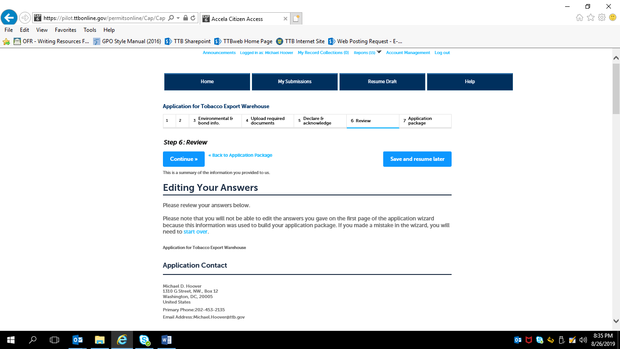

Review of information continues; applicant may edit the provided information; after any edits are made, applicant clicks “Continue” at the bottom of Step 6:

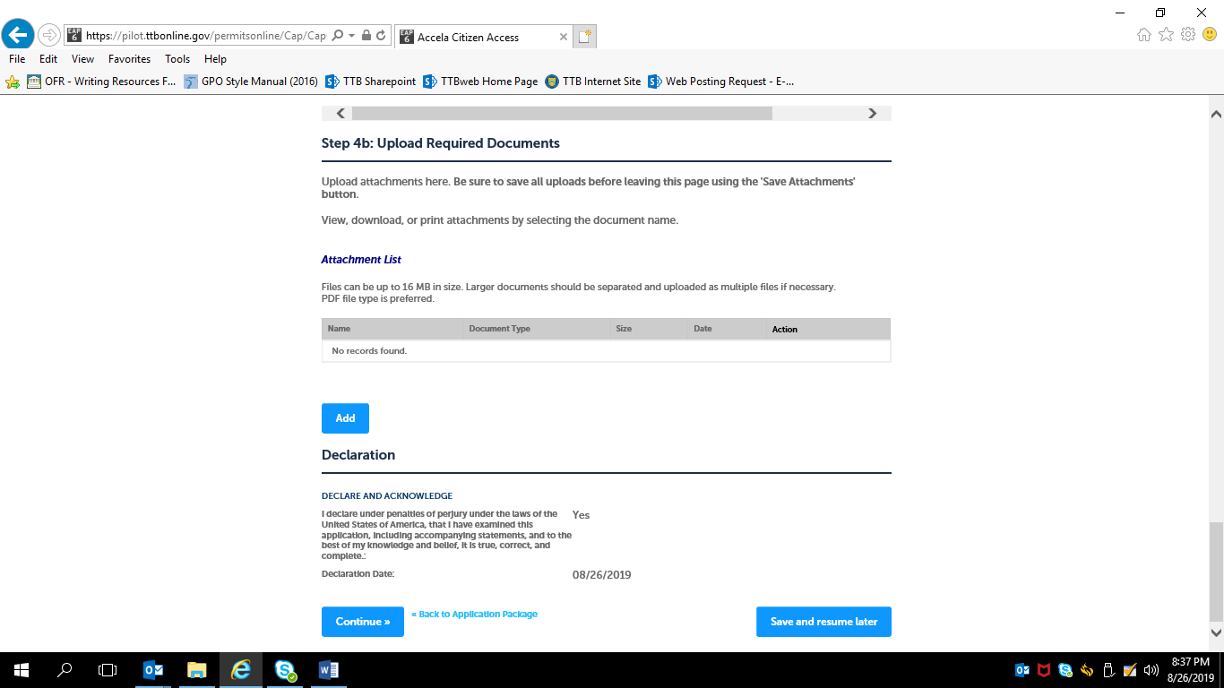

If multiple types of permits are being applied for, the applicant is returned to the Step 3, Application Package, of the Common Screens. If only one type of permit is applied for, the applicant is taken to the Step 5, Submission Confirmation, screen.

COMMON APPLICATION PACKAGE SUBMISSION SCREENS:
After review, the applicant is presented with the Application Package Submission screen —
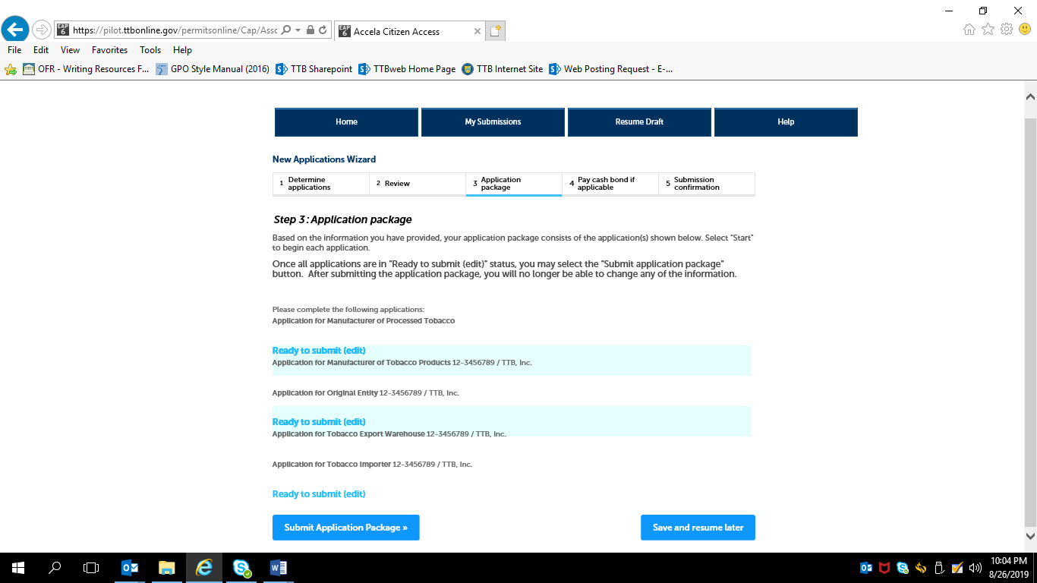

After submitting the application(s) package, the applicant receives a Submission Confirmation from the PONL system —

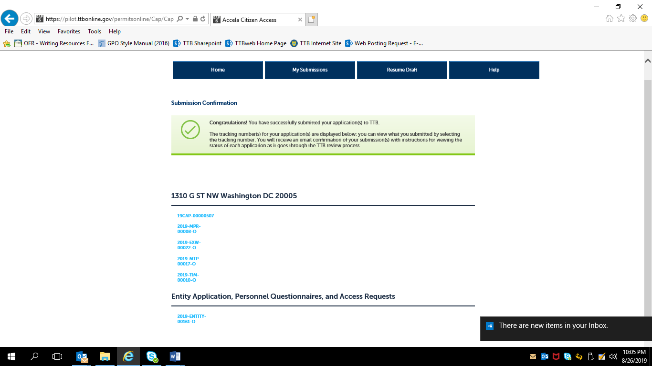

— END —

When using PONL, entities that hold no TTB permits of any kind are required to complete an “Original Entity” application in addition to the Common Screens and the activity-specific application. Entities that already hold at least one TTB permit will not have to complete an Original Entity application.

