Permits Online (PONL)
Amended Tobacco Importer Permit Applications

The following PONL screens are equivalent to form TTB F 5230.5, Application for Amended Permit to Import Tobacco Products or Processed Tobacco.

Screens Common to All Amended Tobacco Industry Permit Applications:
PONL Log-in Screen — (https://www.ttbonline.gov/permitsonline/Default.aspx) —

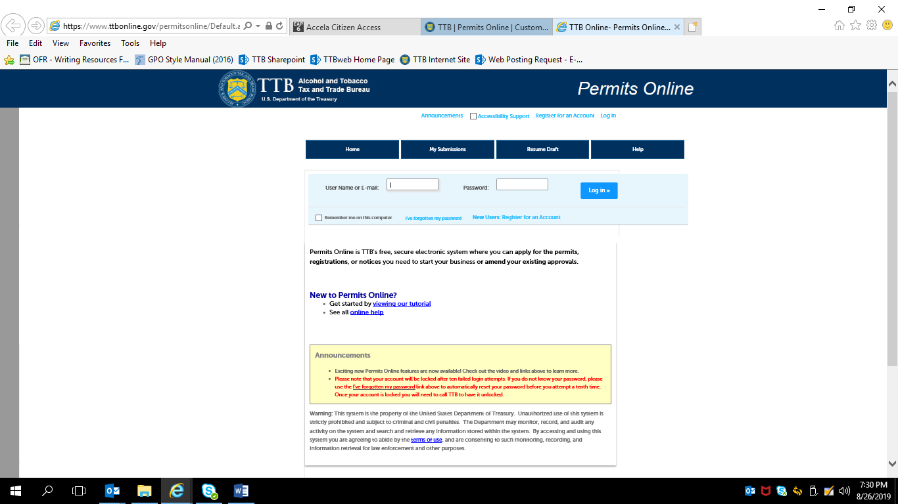
Terms of Use | Privacy Act | Privacy Impact Assessment | Paperwork Reduction Act Notice | Questions? 877-882-3277
or submit an online inquiry
After a successful log-in, respondent sees PONL Welcome Page:

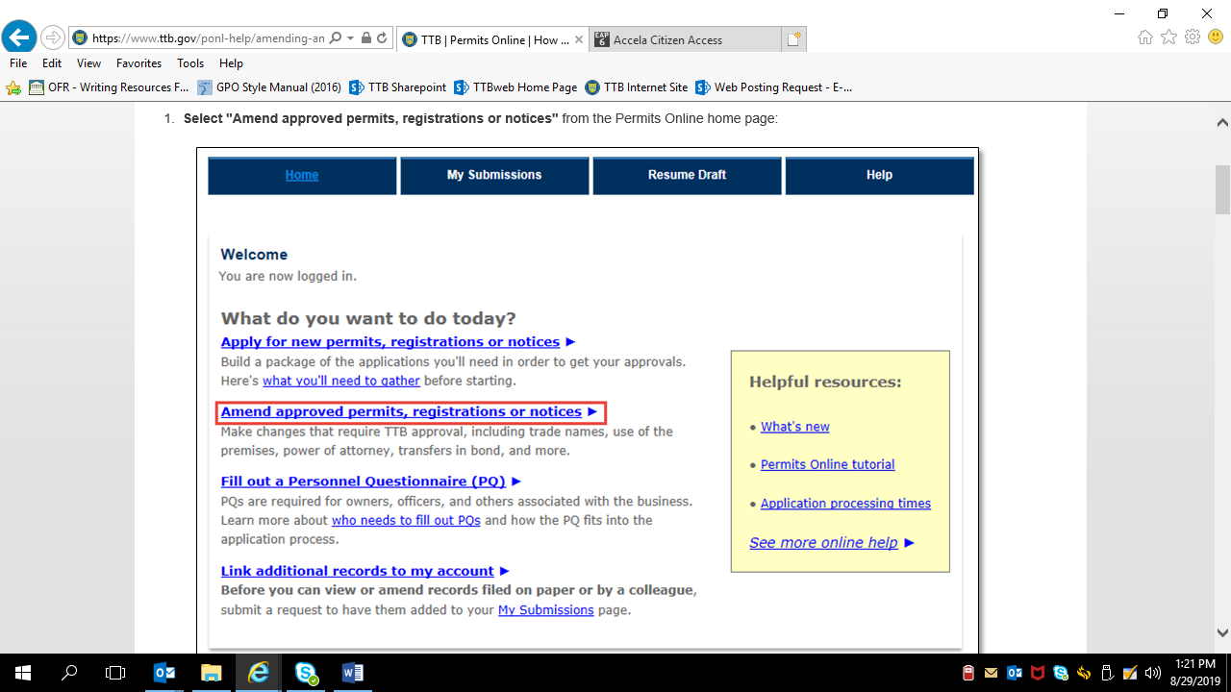

Clicking an option under the heading “What do you want to do today?” results in a list of permits, registrations, and notices held by the applicant.

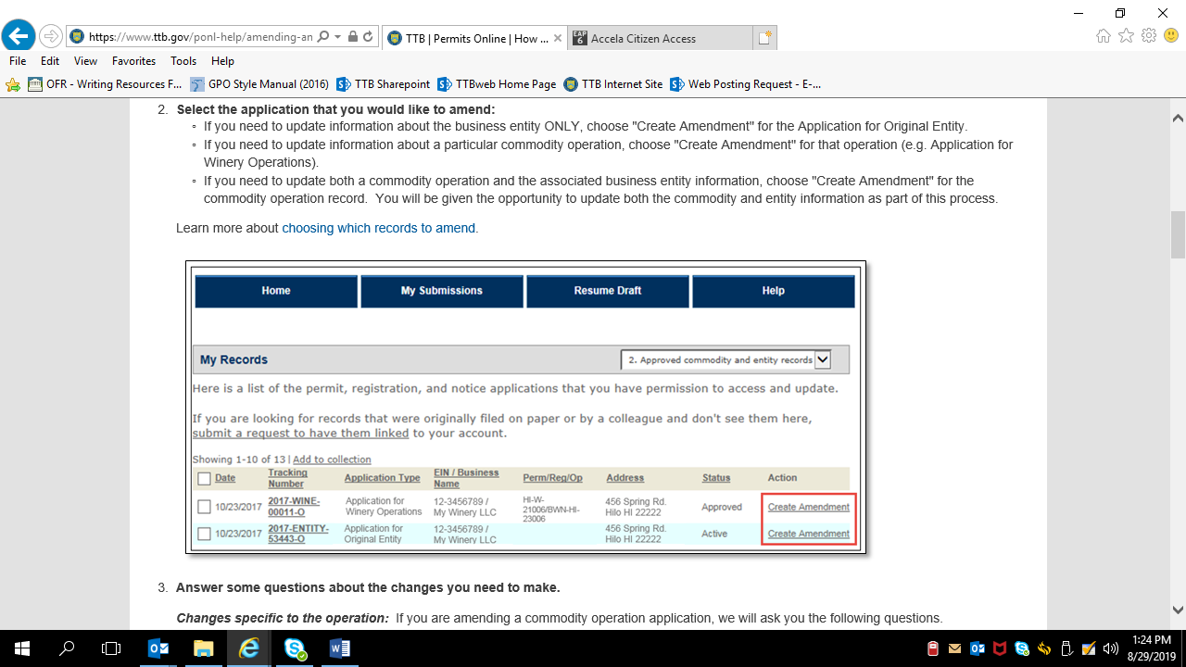

The respondent selects the tobacco-related permit to be amended from the list of permits held by the respondent.
The respondent then selects the link for “Commodity Operations Amendment Wizard” which is required for all amended permit applications.
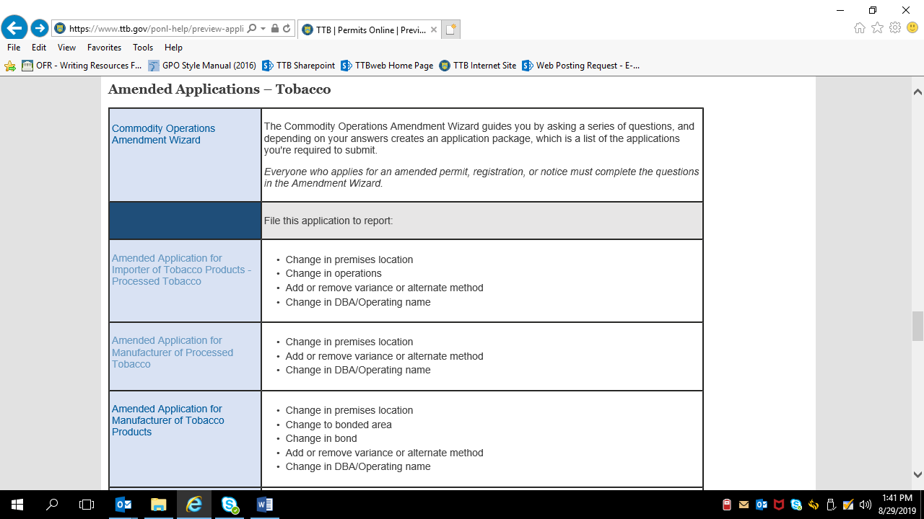

NOTE: Information collected regarding certain amendments, such as changes to bonds, consents of surety, signing authority, and power of attorney, are approved under other OMB control numbers.
COMMODITY OPERATIONS AMENDMENT WIZARD:
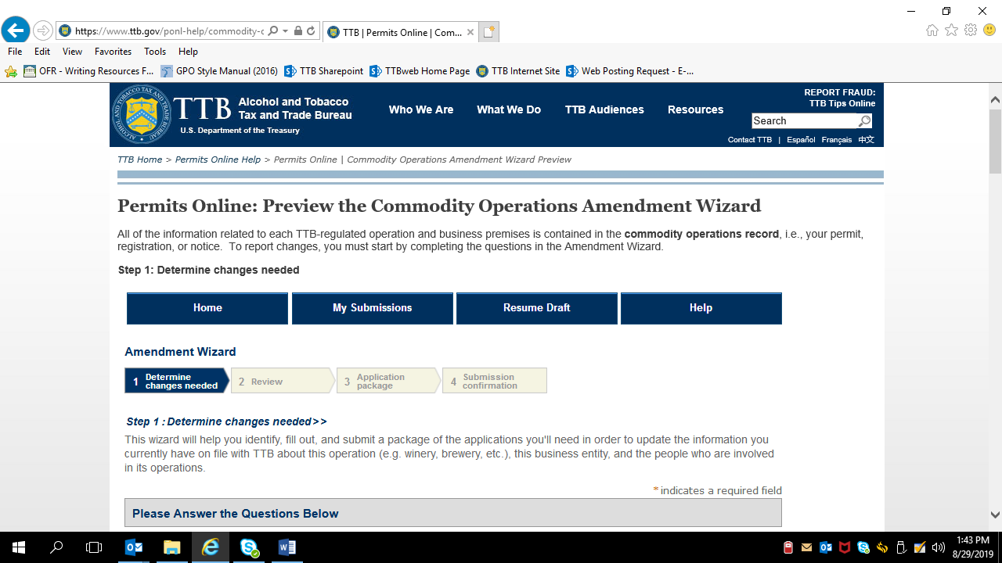

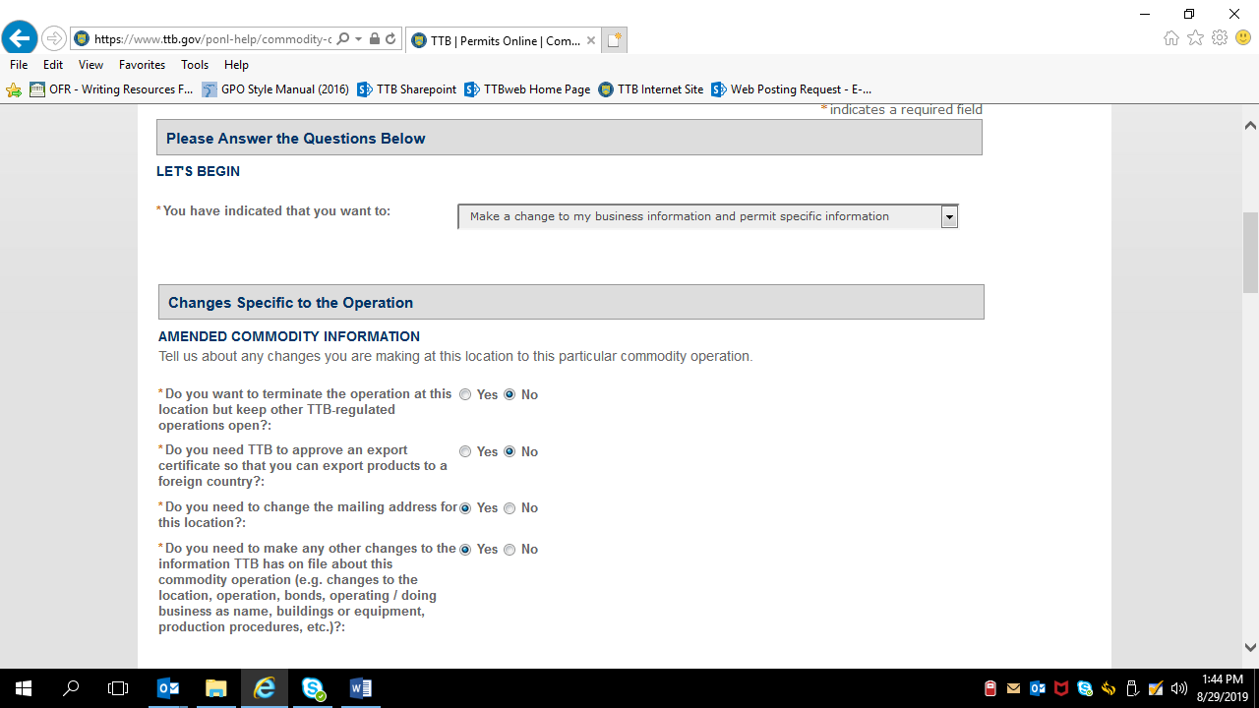

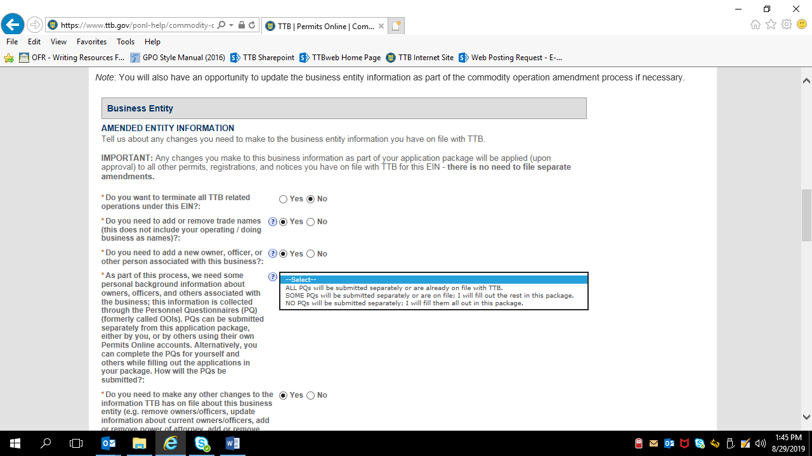

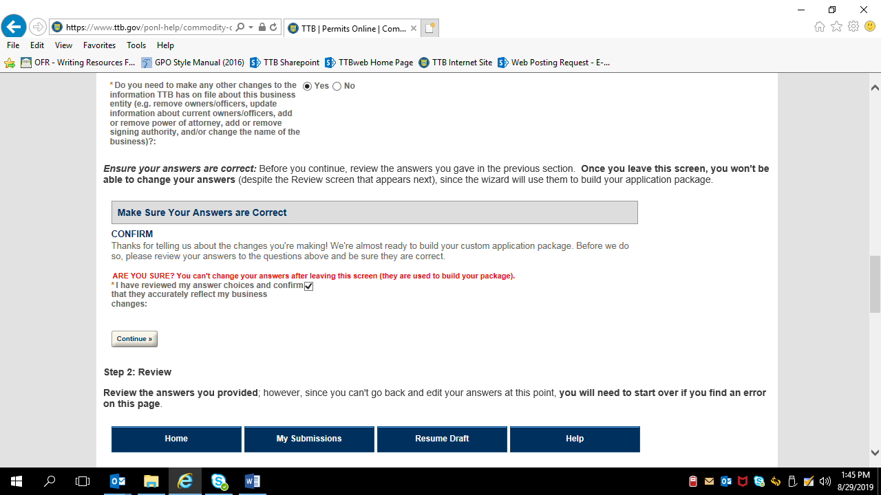

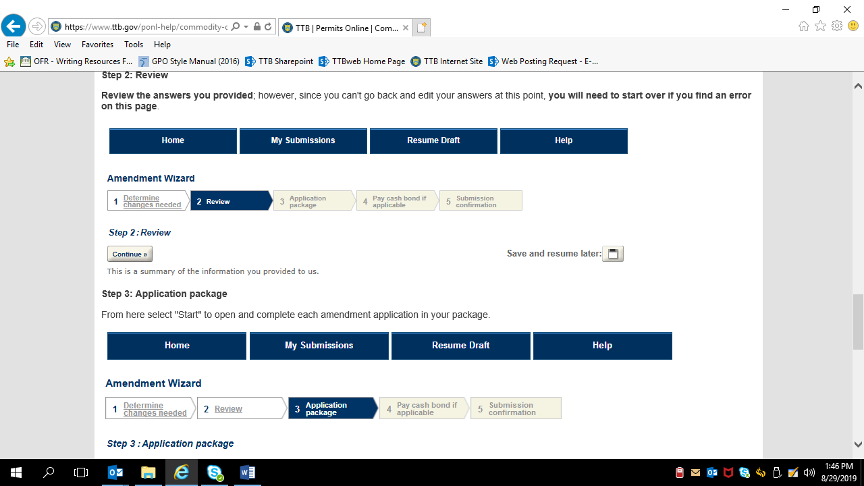

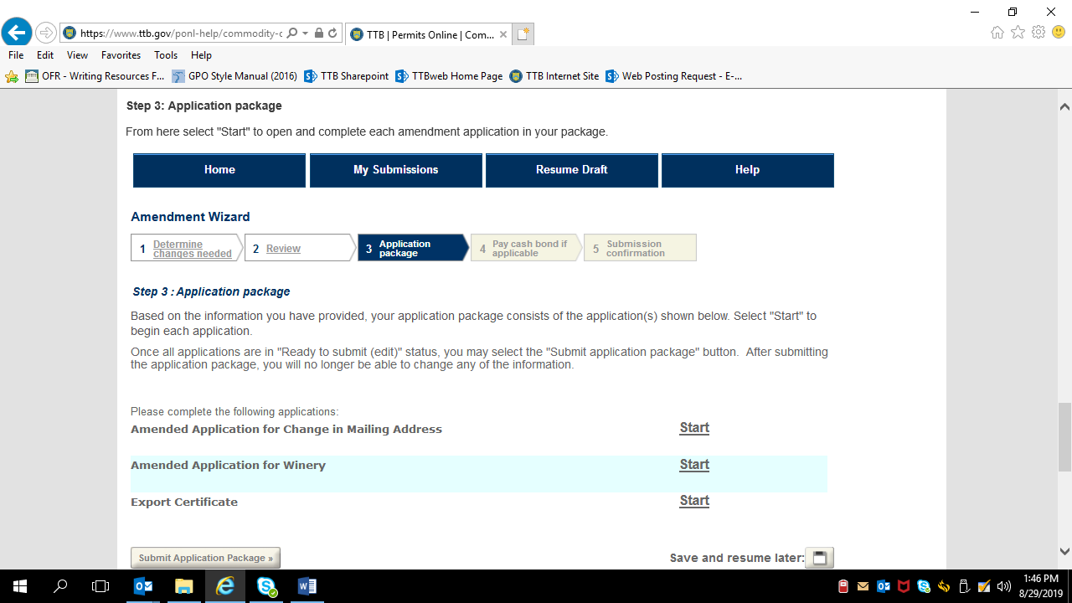

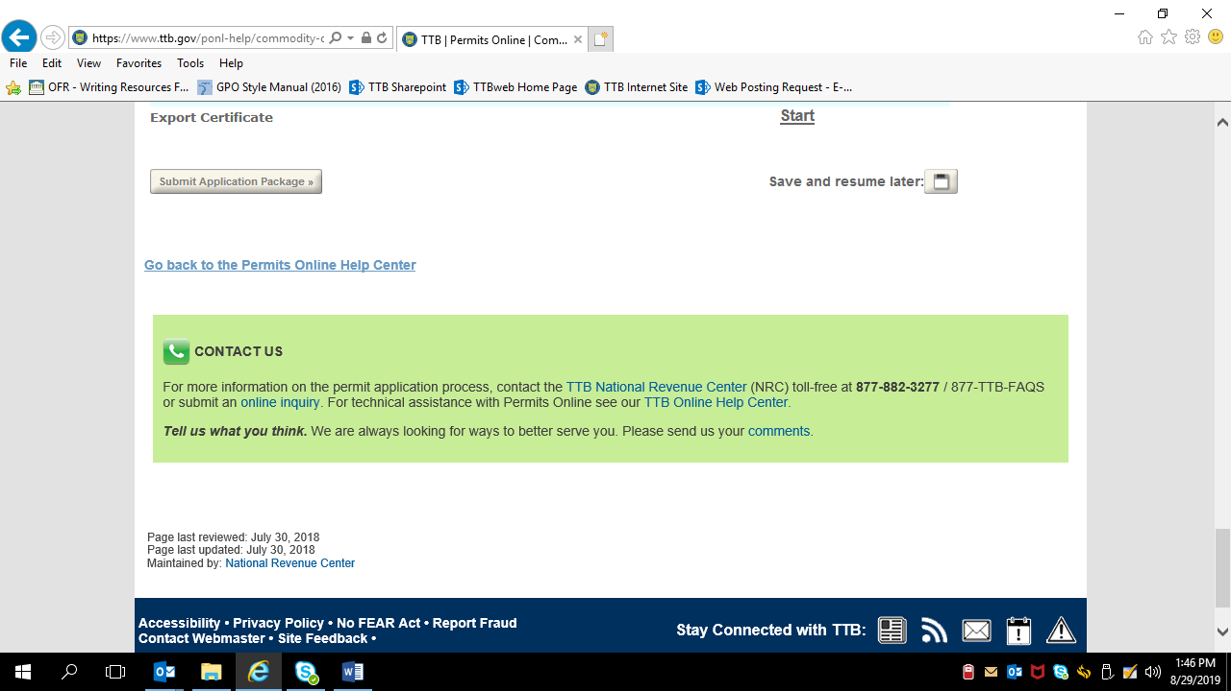

The respondent then returns to the amendment type chart shown on page 5 of this document and selects “Amended Application for Importer of Tobacco Products – Processed Tobacco” from that chart, which leads to the Amended Application for Tobacco Importers, shown below:

AMENDED APPLICATION FOR TOBACCO IMPORTER:
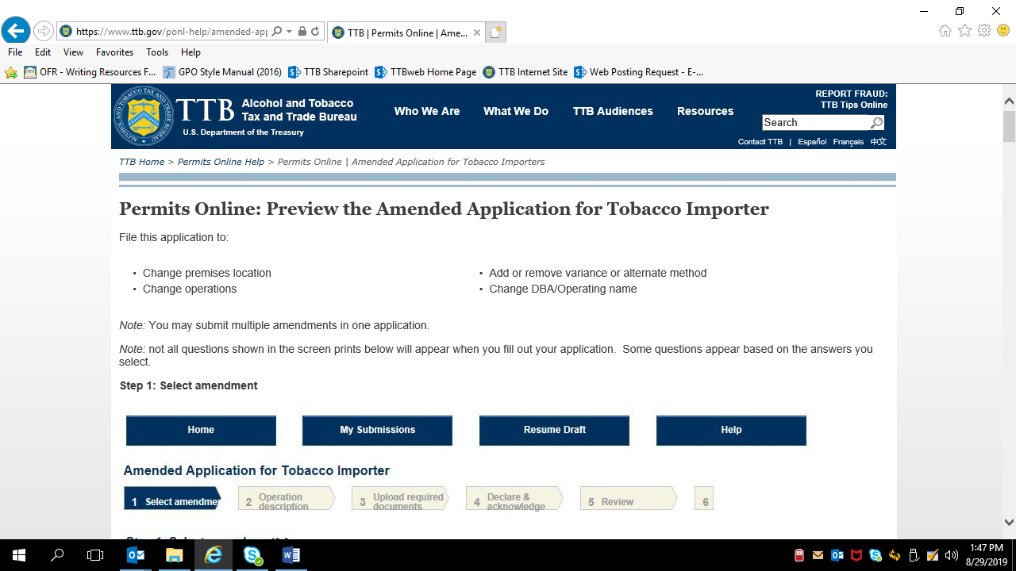

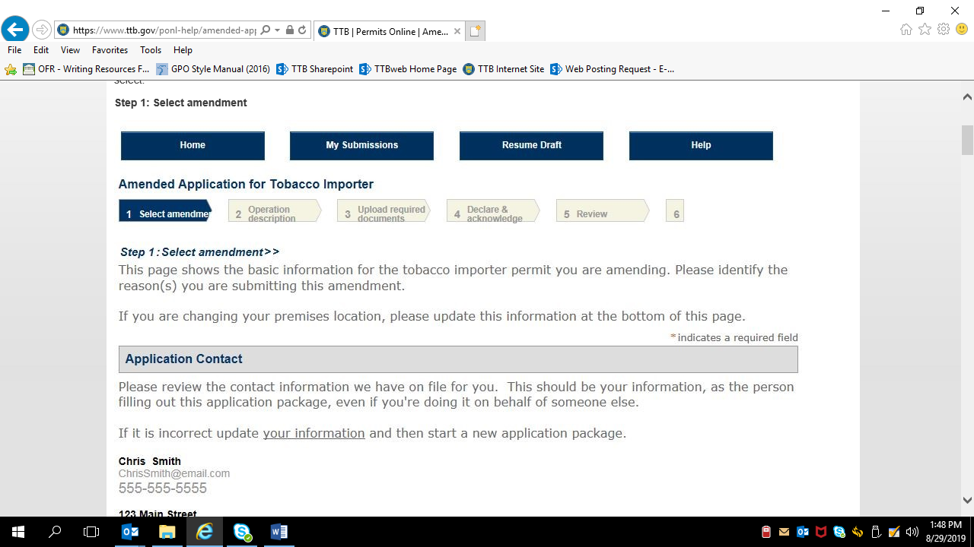

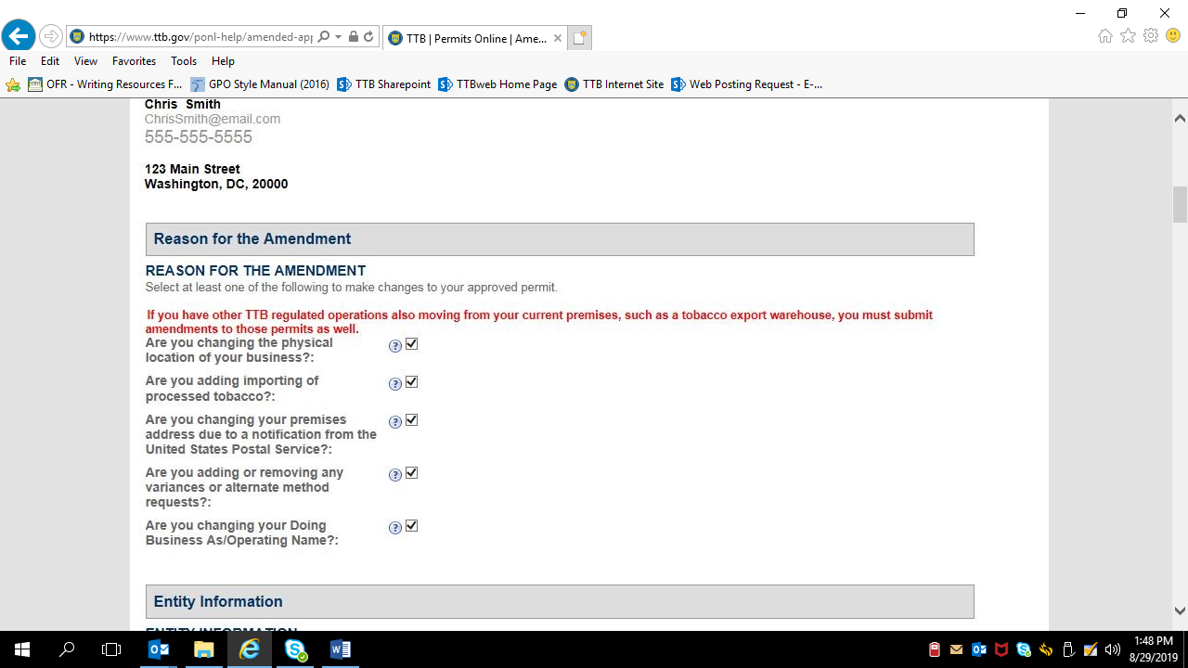

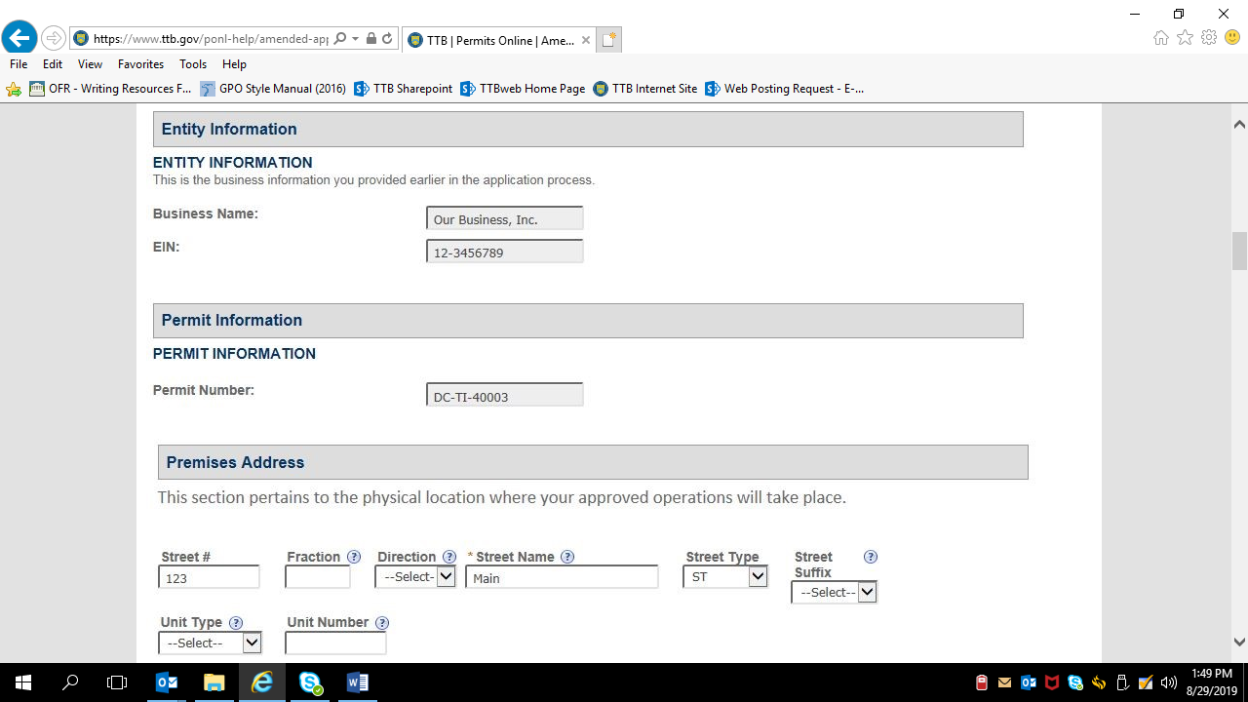

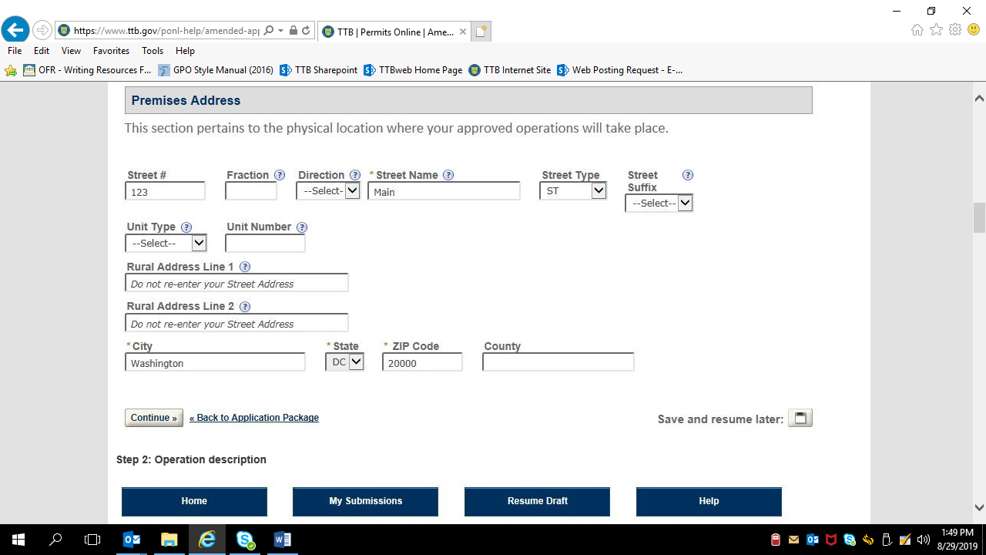

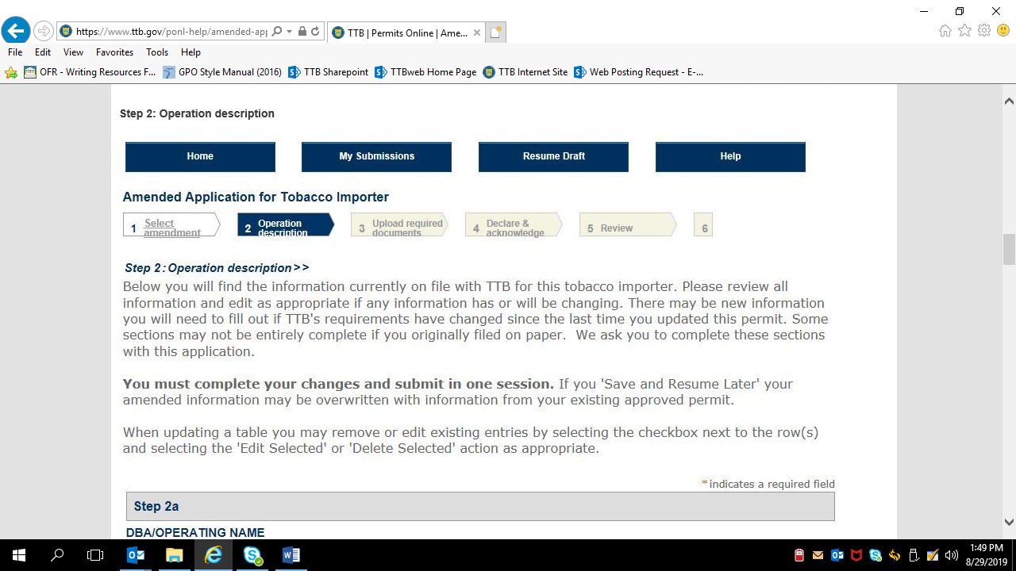

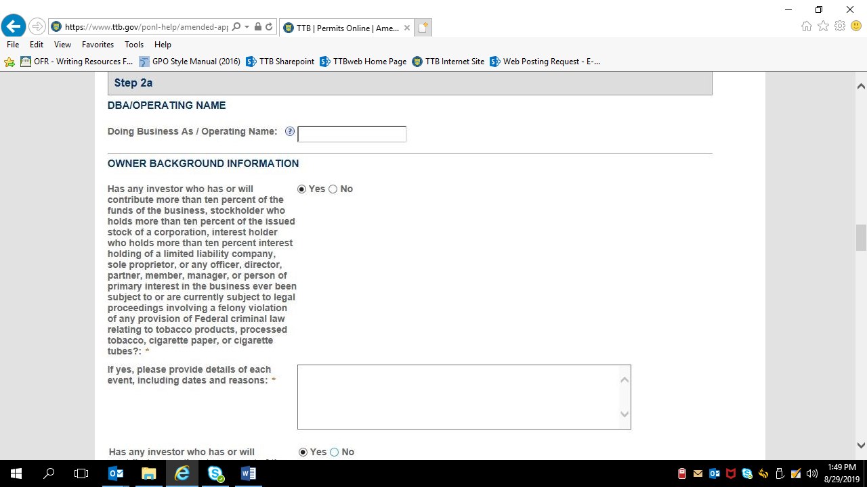

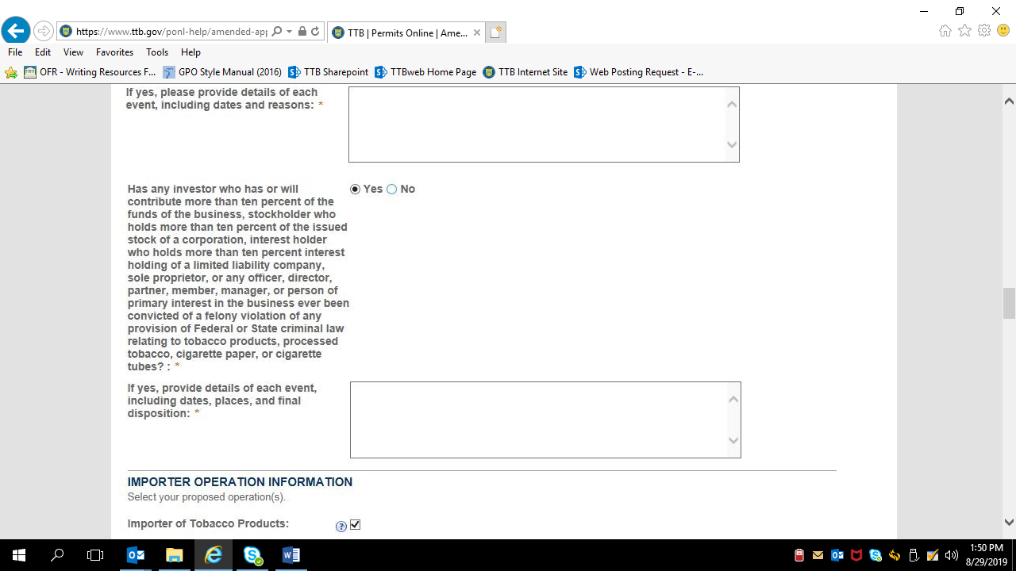

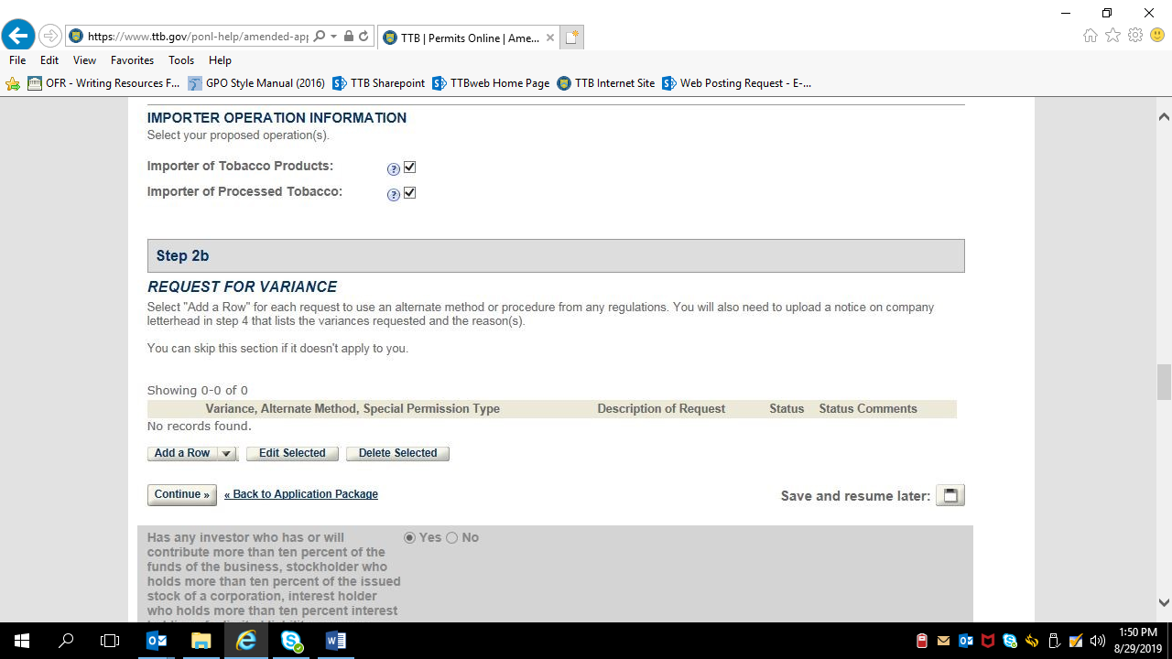

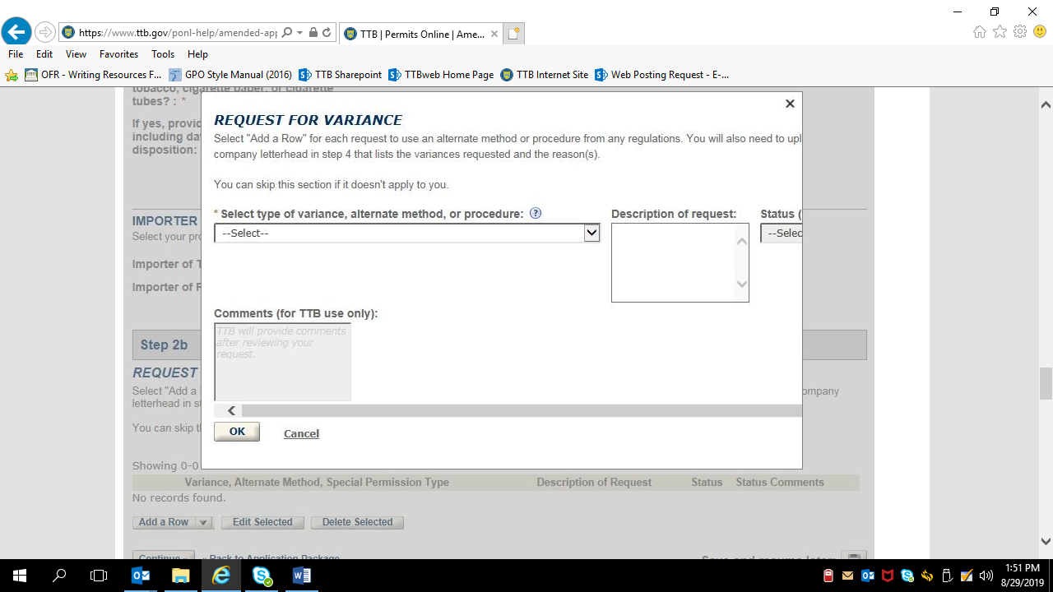

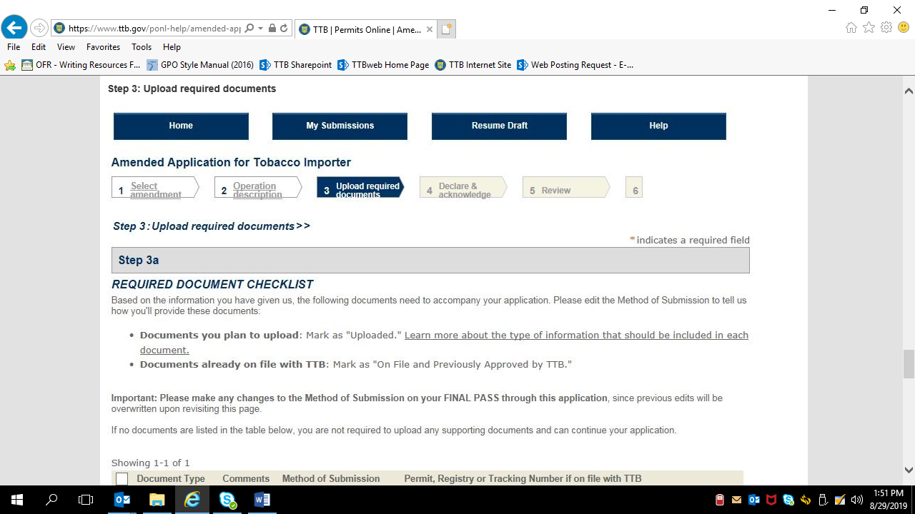

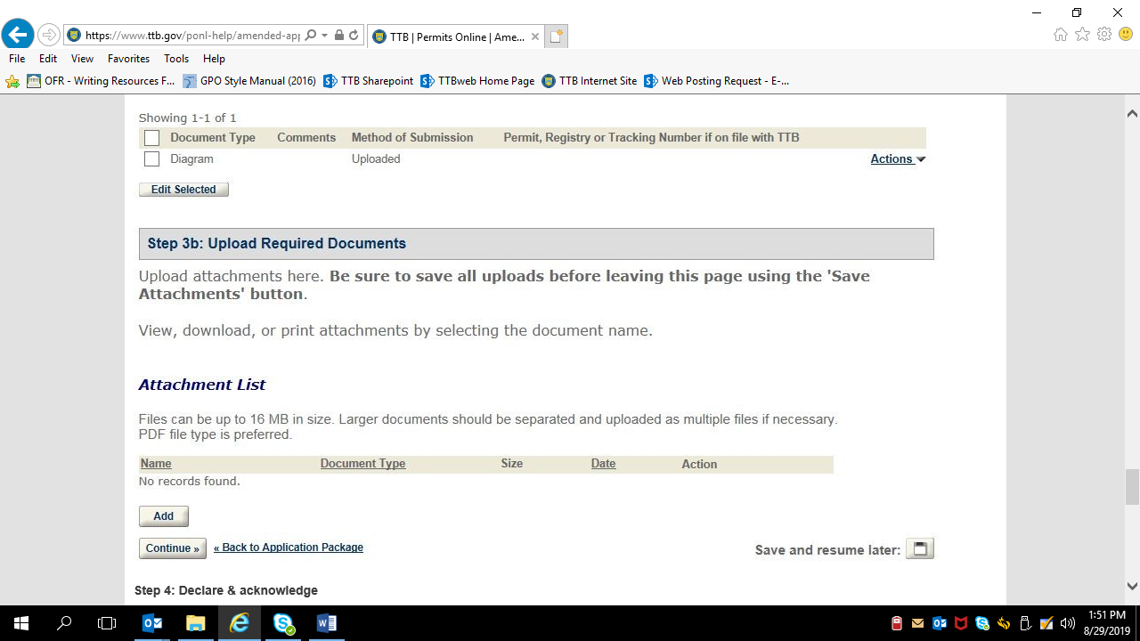

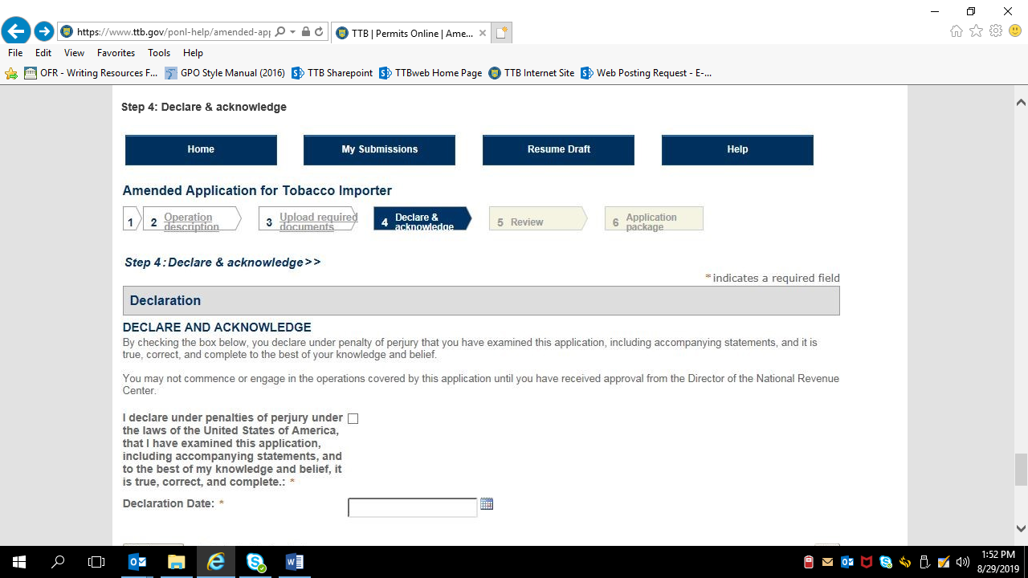

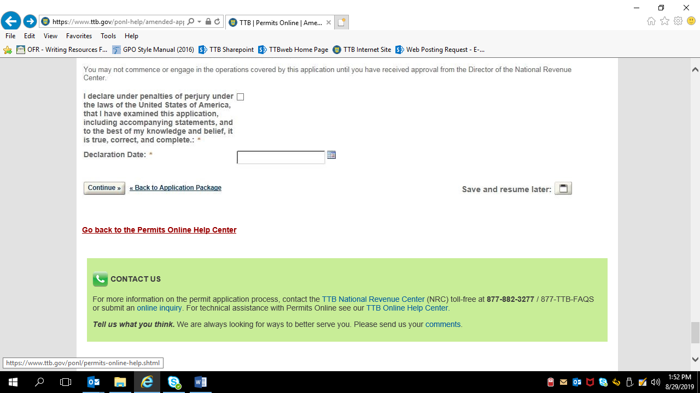

[END]

