TTB Website -- Permits Online Help Center
See: https://www.ttb.gov/ponl/permits-online-help.shtml
Each category shown below includes links to more detailed guidance, videos, and other tools to assist respondents in using TTB’s
Permits Online system.
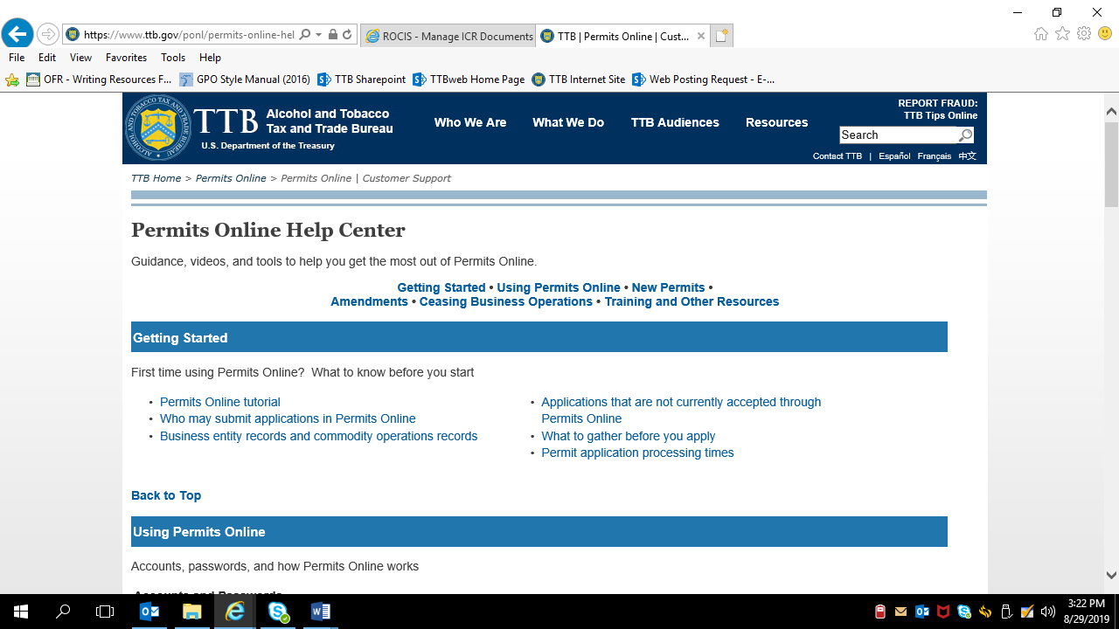

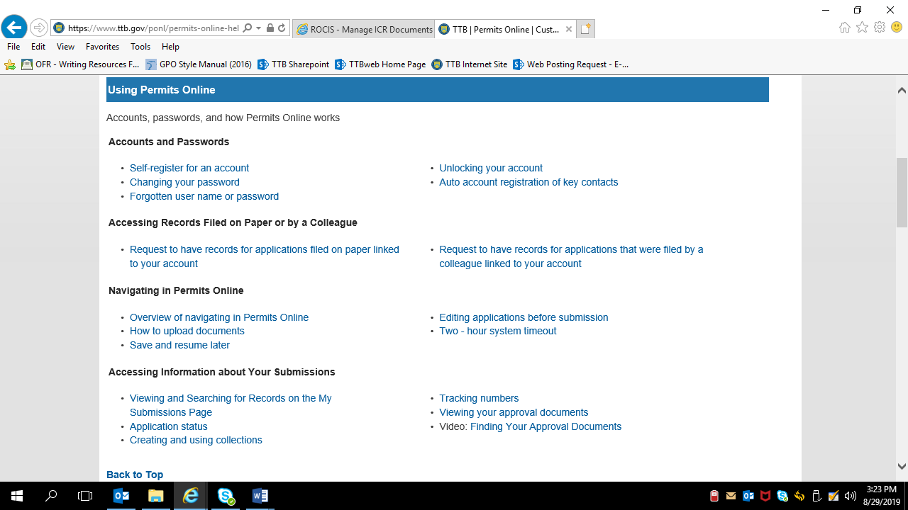

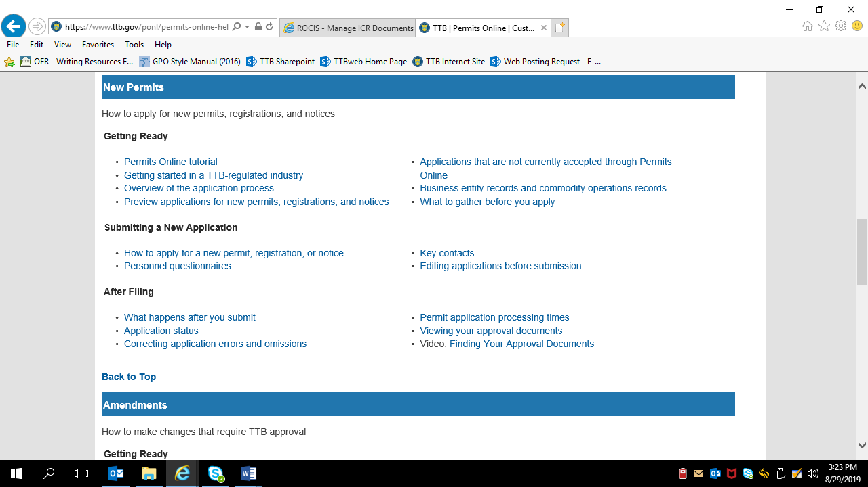

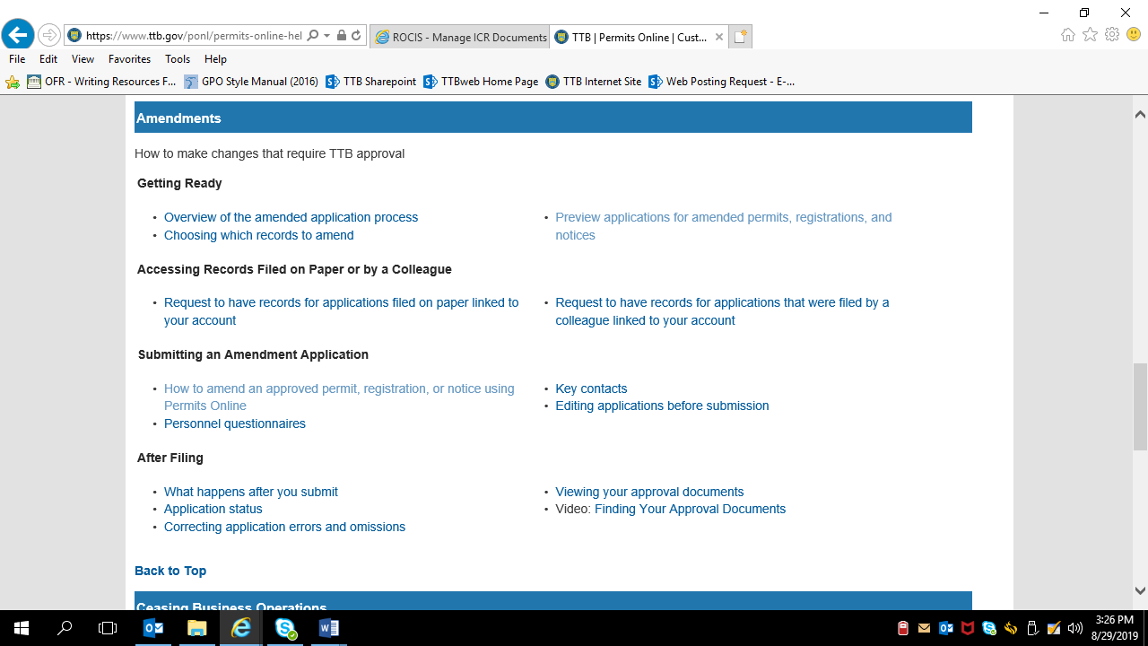

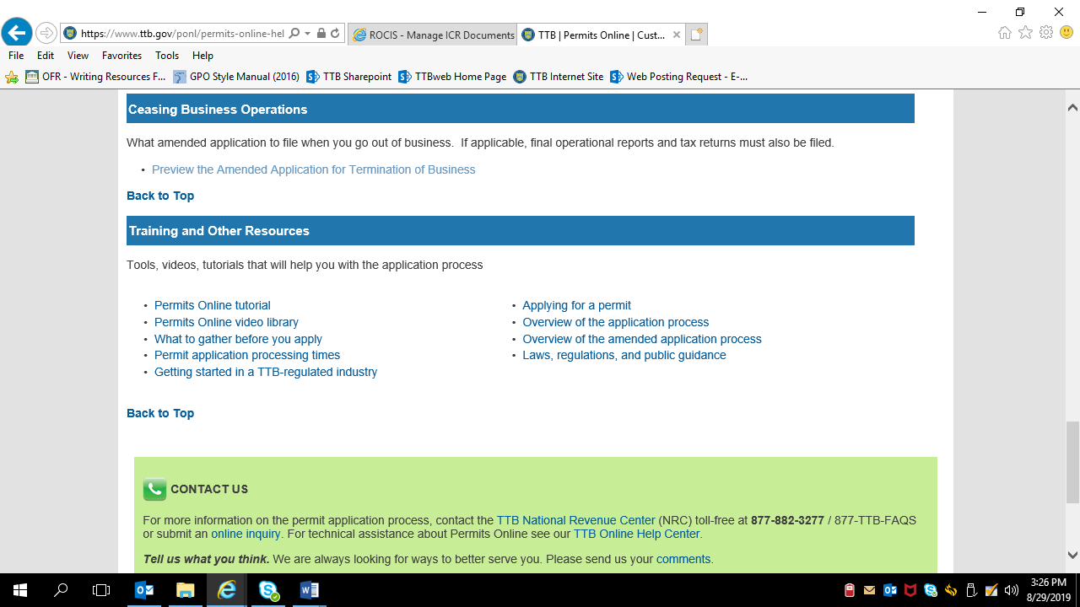

[END]

