July 30, 2018 |  | TTB G: 2018-3
 | TTB Public Guidance

Permits Online: Personnel Questionnaires

Subjects covered in this guidance:
People and Positions that must be covered by a Personnel Questionnaire
Who may complete and/or submit the Personnel Questionnaire?
OOIs and Personnel Questionnaires already on file with TTB
Options for submitting Personnel Questionnaires
Step-by-Step: Completing a Personnel Questionnaire

People and Positions that must be covered by a Personnel Questionnaire
The Personnel Questionnaire, or PQ, (formerly called Owner Officer Information Application, or OOI) is how TTB gathers background information about owners, officers, and others associated with TTB-regulated businesses. We use the PQ to determine the eligibility, suitability, and/or qualifications of an applicant.
We require completed Personnel Questionnaires for the following people:
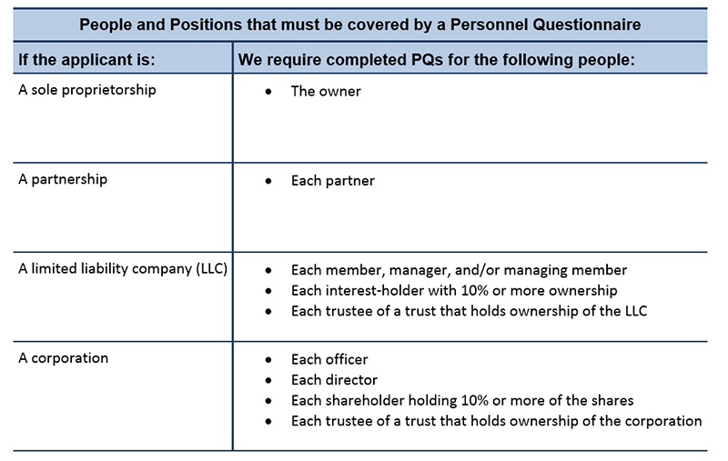
There are exceptions to the PQ requirements. We do not need PQs for any person in conjunction with the following types of applications:
- Specially Denatured Spirits - Dealer
- Specially Denatured Spirits - User
- Tax-Free Alcohol User
- U.S. Government Specially Denatured Spirits
- U.S. Government Tax Free Alcohol
Note: We may request a PQ on a case-by-case basis from anyone associated with an application for a TTB-regulated business.
Back to Top

Who may complete and/or submit the Personnel Questionnaire?
Personnel Questionnaires (PQs) may be completed and submitted either by the person named on the PQ, or by someone else on that person's behalf. For example, if the applicant has hired a consultant to prepare and submit an application package, that consultant can prepare/submit some, all, or none of the required PQs. PQs ask for detailed personal information (see Instructions for completing a Personnel Questionnaire, so some people may prefer to submit the PQ directly to TTB themselves. Regardless of who submits the PQ, the person named on the PQ is responsible for the accuracy of information submitted to TTB.
Back to Top

OOIs and Personnel Questionnaires already on file with TTB
If you, or someone on your behalf, previously submitted a Personnel Questionnaire (PQ) or Owner Officer Information Application (OOI) in conjunction with another application, and TTB has that PQ/OOI on file, you are not required to submit another one when a new application or amendment application is filed. This is true even if the version on file is an older version of the PQ.
The exception is if the person's name or criminal history has changed since the PQ/OOI was originally filed. In that case, TTB requires a new PQ. For example, if TTB already has a PQ/OOI on file for Jane Smith, president of a corporation that holds a brewer's notice, we do not need a new PQ for Jane Smith if that corporation files a new application to open a second brewery. However, if Jane Smith has changed her name to Jane Doe, then we do require a new PQ.
Back to Top

Options for submitting Personnel Questionnaires
Personnel Questionnaires (PQs) can either be submitted together with a new or amended permit/registration/notice application package, or they can be submitted to TTB separately from an application package.
Note: If some or all of the PQs will be submitted separately from the application package, we strongly recommend that those PQs be prepared and submitted BEFORE the associated application package is begun because the person submitting the application package will need the PQ tracking numbers for any PQs submitted separately.
Back to Top
PQs submitted to TTB separately from an application package
Use this option when the person named on the Personnel Questionnaire (PQ) wants to submit it themselves, rather than having the person who will be submitting the application package complete the PQ on their behalf.
In order to submit a PQ via Permits Online, the submitter must have a Permits Online account. Registering for an account can be done from the Permits Online log in page.
Once logged in, the submitter should select "Fill out a Personnel Questionnaire (PQ)" from the home page.
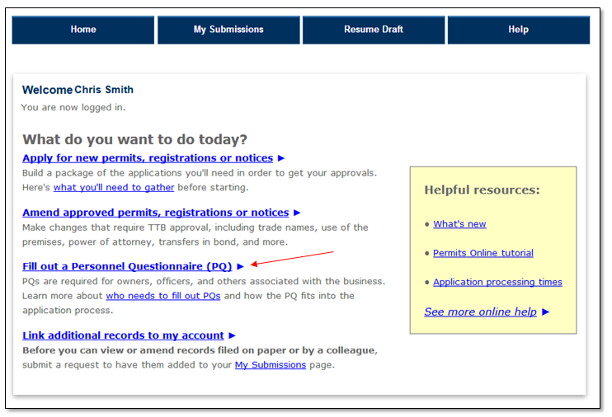
For step-by step instructions on how to complete the PQ see Instructions for completing a Personnel Questionnaire
Back to Top
PQs submitted together with a new or amended application package
Use this option when the person submitting a new or amended application package will be completing some or all of the PQs as part of the application package.
After logging in, select "Apply for New Permits, Registrations or Notices" or "Amend Approved Permits, Registrations or Notices" as applicable, on the home page to start the application wizard.
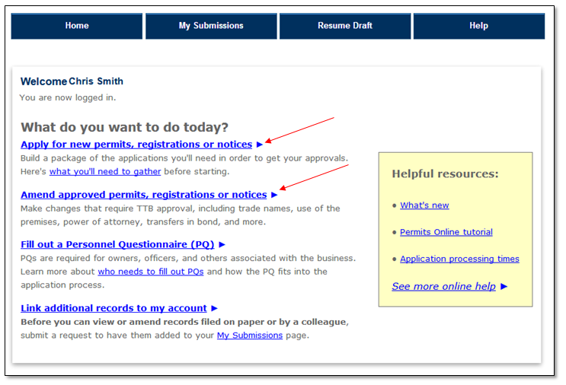
Back to Top
In step 1 of the wizard you must indicate how you are submitting the Personnel Questionnaires required for your application type. Select from these options:
- All PQs will be submitted separately or are already on file with TTB
Choose this option when all of the required PQs either will be submitted to TTB separately from the application package, or are already on file with TTB. PQs already on file with TTB include information submitted as an Owner Officer Information (OOI) application, PQs submitted previously through Permits Online, and PQs that were submitted as part of a paper application.
- Some PQs will be submitted separately or are on file; I will fill out the rest in this package
Choose this option if you will be submitting some of the required PQs, but other PQs will be submitted to TTB separately from the application package or are already on file with TTB. You will be required to enter the number of blank PQs that you will fill out with this application. See People and Positions that must be covered by a Personnel Questionnaire if you are uncertain about how many PQs you should complete. Do not count PQs that are being submitted separately or that are already on file with TTB.
- No PQs will be submitted separately; I will fill them out in this package
Choose this option if no one will be submitting PQs separately from the application package and/or none are already on file with TTB. You must complete and submit all of the required PQs as part of the application package. You will be required to enter the number of blank PQs that you will fill out with this application. See People and Positions that must be covered by a Personnel Questionnaire if you are uncertain about how many PQs you should complete.
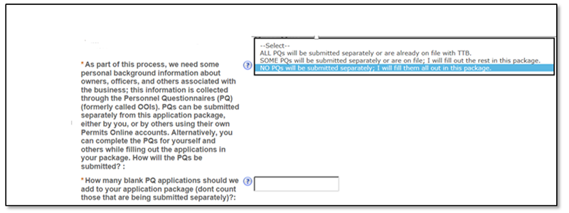
In step 3 of the wizard, you will see a list of applications that make up your application package, including blank Personnel Questionnaires, based on how you answered the question above from Step 1 of the wizard. For step-by step instructions on how to complete the PQ see Instructions for completing a Personnel Questionnaire.
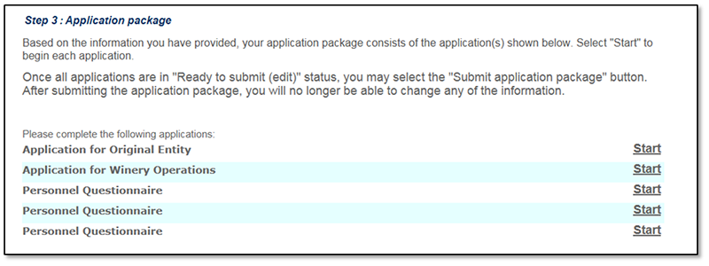
Back to Top

Step-by-Step: Completing a Personnel Questionnaire
Step 1: Contact Information
Select "Auto Fill," if you are completing the PQ for/about yourself. Information from your user account will be automatically entered, but you'll also have to supply some additional information. Select "New" if you are completing the PQ on behalf of someone else.
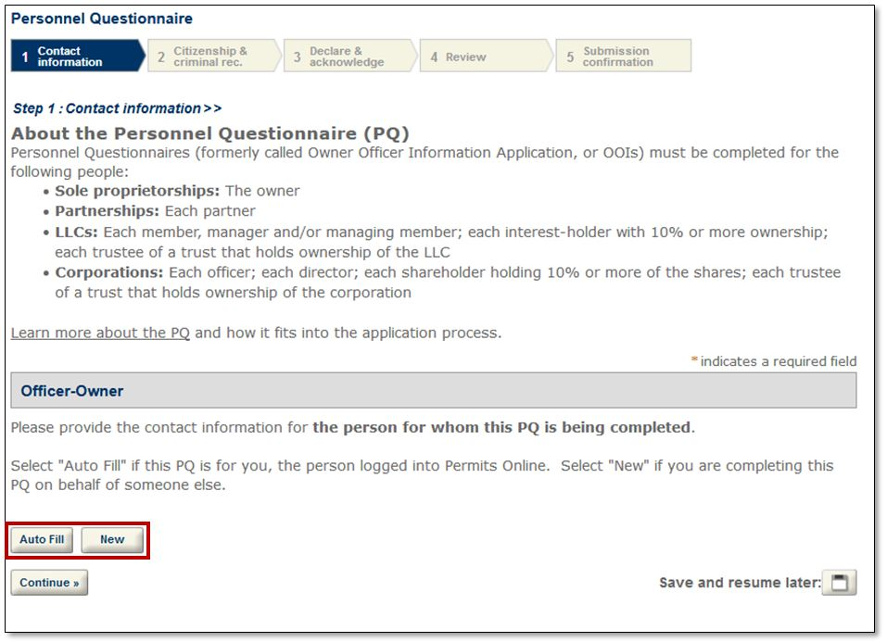
Complete all fields with a red asterisks (*). You will find onscreen help by clicking the blue question marks .
Select "Continue."
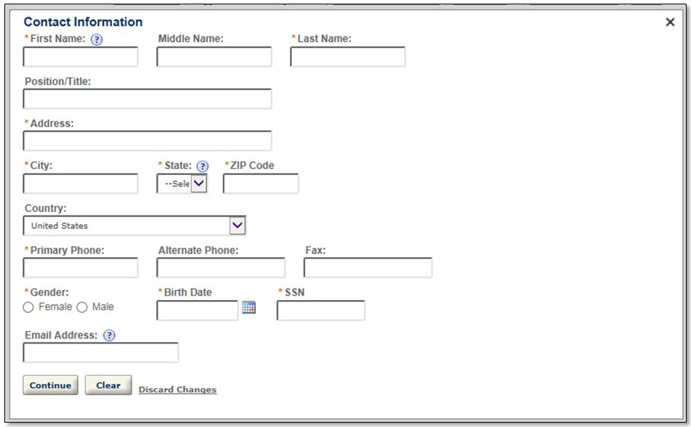
Verify the information is correct or select "Edit." When finished, select "Continue."
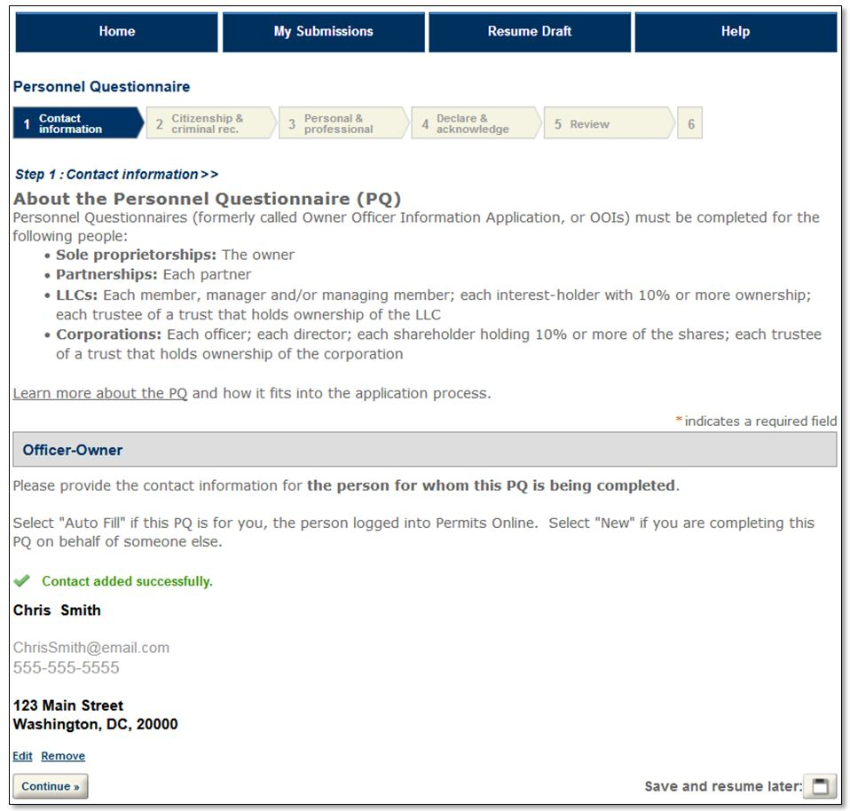
Back to Top
Step 2: Citizenship & criminal rec.
Complete all fields with a red asterisks (*). You will find onscreen help by clicking the blue question marks .
Select "Continue."
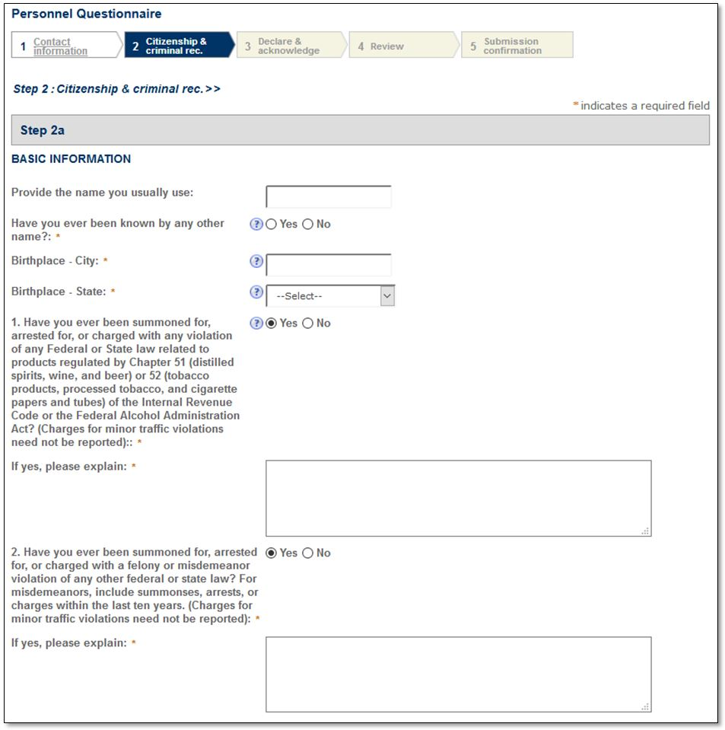
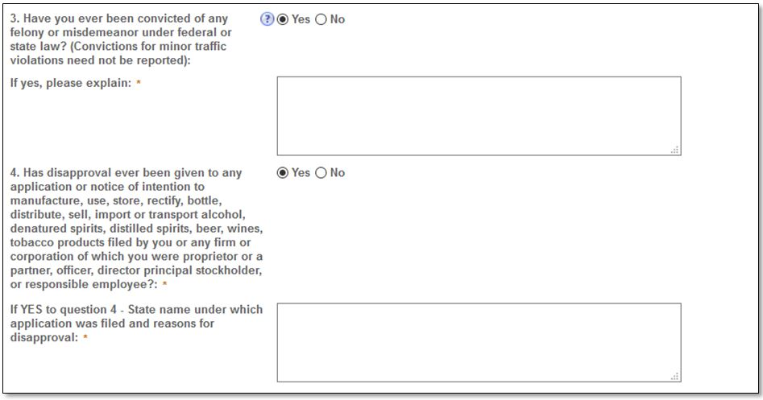
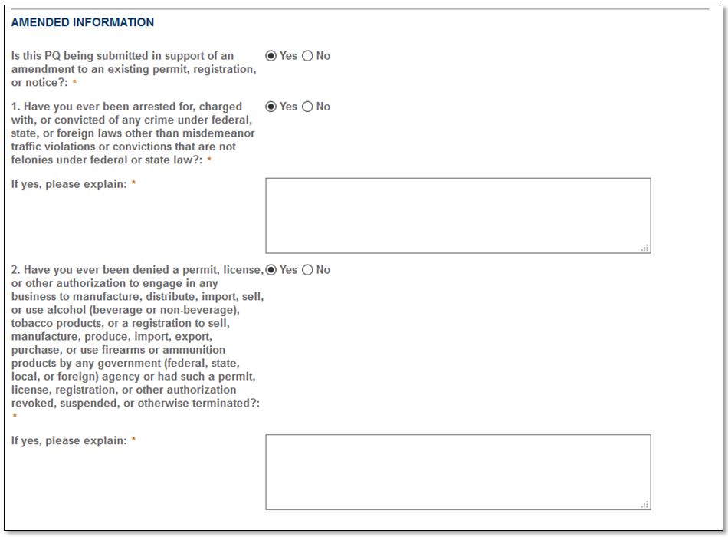
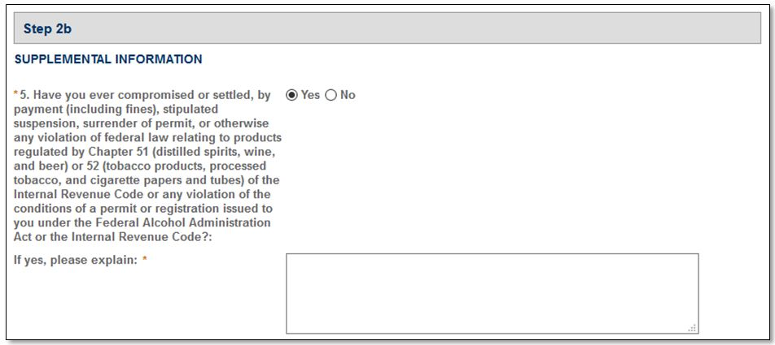
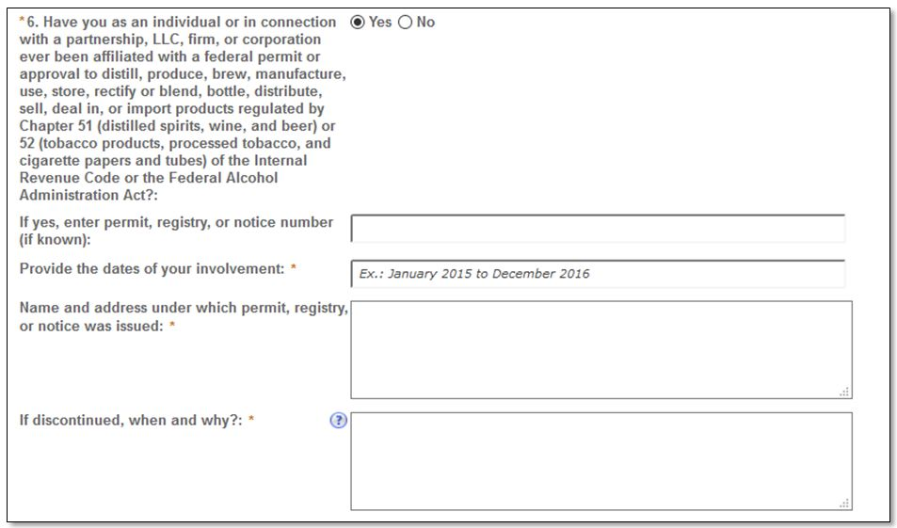
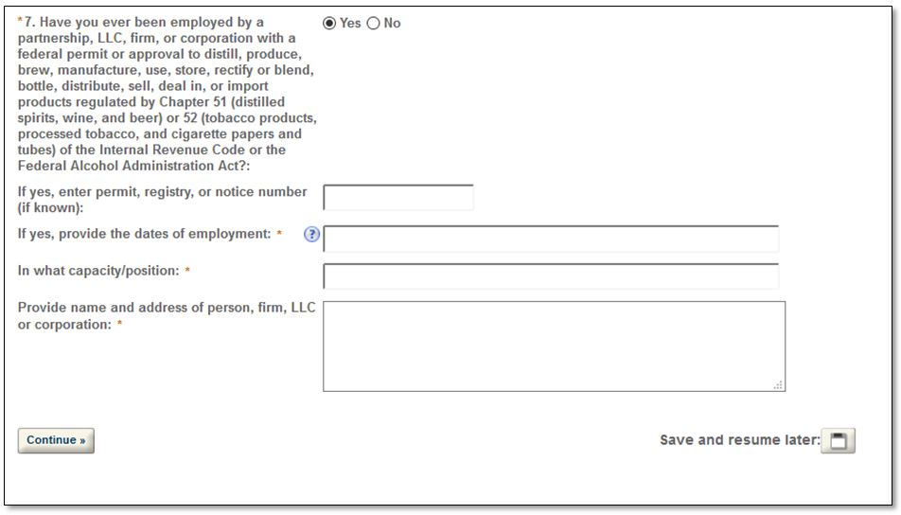
Back to Top

Step 3: Declare and acknowledge
Read the statement and check the box. Select "Continue."
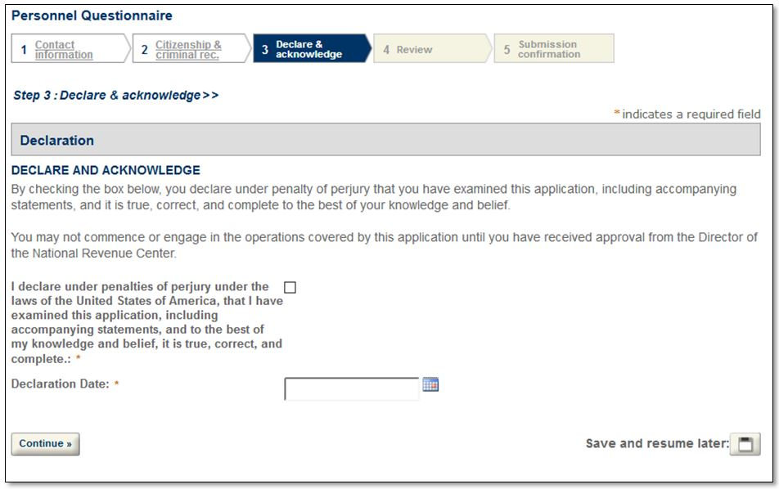
Back to Top

Step 4: Review
Here you may review a summary of the information you provided to us.
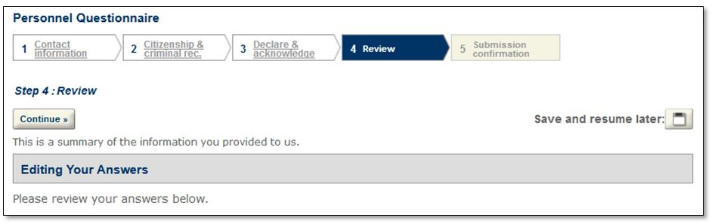
Back to Top
Step 5: Submission Confirmation >> OR Application package
If you are submitting the PQ separately from an application package, Step 5 is a confirmation page with the PQ Tracking Number. Please save this number and provide it to the person who is submitting the associated application package. They will need to provide this tracking number in Step 2a of either the Application for Original Entity or Amended Application for Entity Information (as applicable). You will also receive a confirmation email that contains the PQ Tracking Number.
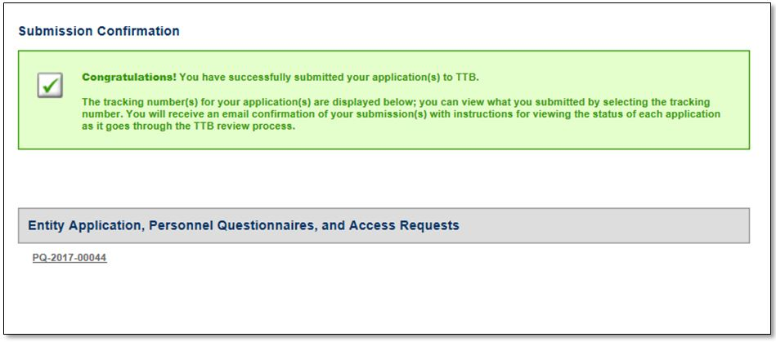

If you are submitting the PQ as part of an application package, you will automatically return to Step 3 of the wizard, where you will notice in your application package that the Personnel Questionnaire is now notated as "Ready to submit (edit)." The PQ will not actually be submitted to TTB until you have completed all the parts of the application package, at which time you will need to select "Submit Application Package" to submit everything at once.
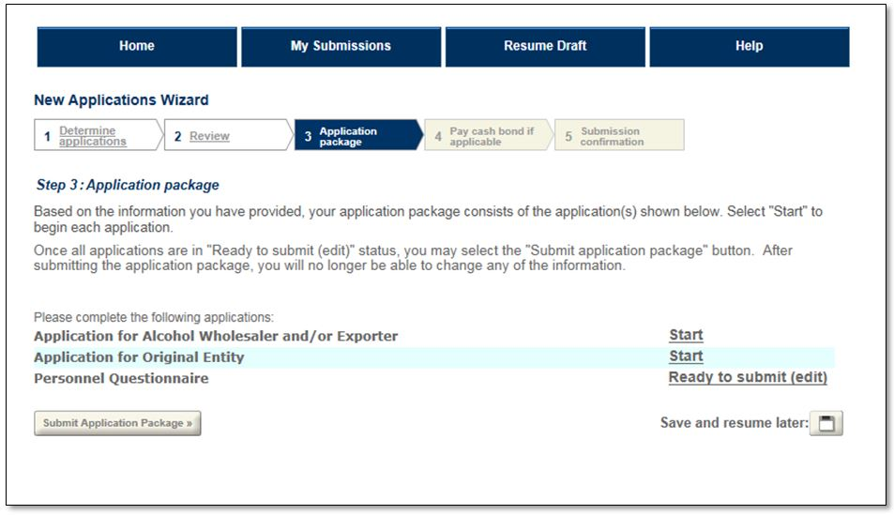
Back to Top

TTB G: 2018-3
OPR: NRC
DATE: July 30, 2018

