Early Childhood Longitudinal Study, Kindergarten Class of 2022-23 (ECLS-K:2023)

Preschool Field Test

OMB# 1850-0750 v.19

Attachment C

MyECLS Website Specifications

National Center for Education Statistics
U.S. Department of Education

July 2019
revised August 2019

TABLE OF CONTENTS
Purpose of Attachment 4
Screen 1: Home/Login – Spring 5
Page Details 7
Screen 2: Initial PIN Validation 8
Page Details 8
Screen 2a: Subsequent Use PIN Validation 9
Page Details 9
Screen 3: Eligibility Question 11
Page Details 11
Screen 4: Ineligible Response 12
Page Details 12
Screen 5: Eligible Response/Additional Security 13
Page Details 14
Placeholder: Screener 15
Page Details 15
Placeholder: Survey 16
Page Details 16
Screen 6: Survey Complete – Spring 17
Page Details 18
Screen 7: Cash Thank You – Spring 19
Page Details 20
Screen 7a: Cash Thank You – Edit Address - Spring 21
Page Details 22
Screen 7b: Cash Thank You – Updated Address - Spring 23
Page Details 24
Screen 8: Thank You Confirmation – Amazon Spring 25
Page Details 26
Screen 9: Thank You Confirmation – Cash - Spring 27
Page Details 28
Screen 10a: Logout Validation – Contact Information Not Provided 29
Page Details 30
Screen 10b: Logout Validation – Contact Information Provided 31
Page Details 32
Screen 11: Returning User Spring 33
Page Details 34
Screen 12: Email/Mobile Validation Message Spring 35
Page Details 35
Screen 13: Login – Returning User Spring 36
Page Details 37
Screen 13a: Login – Returning User - Temporary Code Validation Spring 38
Page Details 38
Screen 14: Home/Login – Fall 39
Page Details 41
Screen 15: Email/Mobile Validation Message – Fall 42
Page Details 42
Screen 16: Returning User – Fall 43
Page Details 44
Screen 16a: Returning User – Fall – Temporary Code Validation 45
Page Details 45
Placeholder: Survey 46
Page Details 46
Screen 17: Survey Complete – Fall 47
Page Details 48

TABLE OF CONTENTS—Continued
Screen 18: Cash Thank You – Fall 49
Page Details 50
Screen 18a: Cash Thank You – Edit Address - Fall 51
Page Details 52
Screen 18b: Cash Thank You – Updated Address - Fall 53
Page Details 54
Screen 19: Thank You Confirmation – Amazon - Fall 55
Page Details 56
Screen 20: Thank You Confirmation – Cash - Fall 57
Page Details 58
Screen 21: Study Information Page – Spring/Fall 59
Page Details 65

Purpose of Attachment
This attachment outlines the page contents and functionality of the MyECLS website, (https://MyECLS.ed.gov). Each screenshot is followed by the English and Spanish text that is displayed on the screen, and relevant information about the functionality of the screen. This version of the website is planned for the ECLS preschool field test to be conducted in spring and fall 2020. The survey screens may have minor differences in appearance to accommodate survey programming.

All screens will have:
- three logos, including the ECLS logo on the left side of the screen, the National Center for Education Statistics logo at center-right, and the Department of Education logo on the right side of the screen. Clicking the ECLS logo will route the respondent to the ECLS home page (https://MyECLS.ed.gov), clicking the National Center for Education Statistics logo will route to the NCES website (https://nces.ed.gov/), and clicking the Department of Education logo will route to the Department of Education website (https://www.ed.gov/);
- help desk contact information and a link to Screen 21 (Study Information Page – Spring/Fall). The text will read: “Questions or problems? Contact the study at 1-855-898-2018 or email ECLS@westat.com. Please click here for more information about the study.”;
- standard color scheme, consisting of a green and yellow horizontal bar beneath the three logos, and blue text boxes; and
- “English” and “Spanish” link options on the left side, beneath the ECLS logo, to give the respondent options to toggle the page between the two languages. If Spanish is chosen at any point on this page, it will continue to display the content of the instrument in Spanish.
Several screens will have:
- a “Logout” button, which is preset on all screens that appear after a login has occurred.

Screen 1: Home/Login – Spring
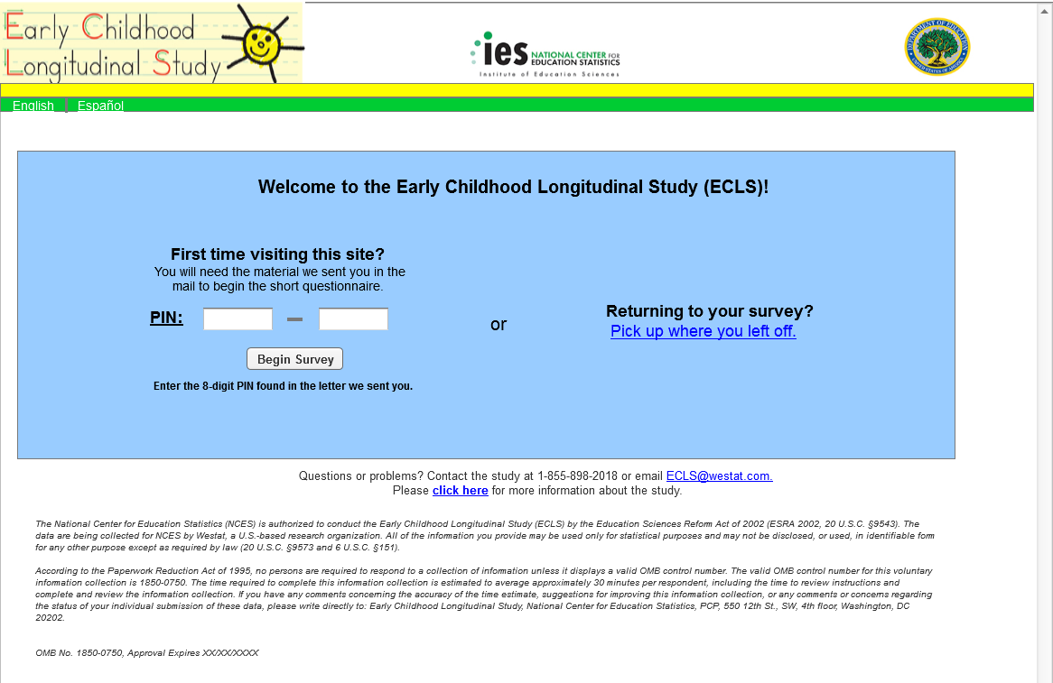

English Text Reads:
Welcome to the Early Childhood Longitudinal Study (ECLS)!

First time visiting this site? You will need the material we sent you in the mail to begin the short questionnaire.

PIN: - -

Begin Survey (button)
Enter the 8-digit PIN found in the letter we sent you.
or
Returning to your survey? Pick up where you left off. (link)

The National Center for Education Statistics (NCES) is authorized to conduct the Early Childhood Longitudinal Study (ECLS) by the Education Sciences Reform Act of 2002 (ESRA 2002, 20 U.S.C. §9543). The data are being collected for NCES by Westat, a U.S.-based research organization. All of the information you provide may be used only for statistical purposes and may not be disclosed, or used, in identifiable form for any other purpose except as required by law (20 U.S.C. §9573 and 6 U.S.C. §151).

According to the Paperwork Reduction Act of 1995, no persons are required to respond to a collection of information unless it displays a valid OMB control number. The valid OMB control number for this voluntary information collection is 1850-0750. The time required to complete this information collection is estimated to average up to 30 minutes per respondent, including the time to review instructions and complete and review the information collection. If you have any comments concerning the accuracy of the time estimate, suggestions for improving this information collection, or any comments or concerns regarding the status of your individual submission of these data, please write directly to: Early Childhood Longitudinal Study, National Center for Education Statistics, PCP, 550 12th St., SW, 4th floor, Washington, DC 20202.

OMB No. 1850-0750, Approval Expires XX/XX/XXXX

Spanish Text Reads:
¡Bienvenido(a) al Estudio Longitudinal de la Primera Infancia (ECLS, por sus siglas en inglés)!

¿Es la primera vez que visita este sitio? Usted va a necesitar el material que le enviamos por correo para poder comenzar con el cuestionario breve.

PIN: - -

Comience la encuesta (botón)
Ponga su PIN de 8 dígitos que está en la carta que le enviamos.
o
¿Está regresando a la encuesta? Continúe a partir de donde estaba (enlace)

El Centro Nacional para Estadísticas de Educación (NCES, por sus siglas en inglés) está autorizado a hacer el Estudio Longitudinal de la Primera Infancia (ECLS, por sus siglas en inglés) por el Acta de la Reforma de las Ciencias de la Educación de 2002 (ESRA 2002, 20 U.S.C. §9543). La firma Westat, una organización que realiza estudios y está basada en los Estados Unidos, está recopilando los datos para NCES. Toda la información que usted proporcione podrá usarse solamente para propósitos estadísticos y no podrá divulgarse ni usarse de manera que permita identificar a los participantes para ningún otro propósito, salvo que lo requiera la ley (20 U.S.C. §9573 y 6 U.S.C. §151).

Según lo establece el Acta de Reducción del Papeleo de 1995, ninguna persona está obligada a responder a un pedido de información si la misma no contiene un número de control de OMB válido. El número de control de OMB válido para recolectar esta información que se proporciona voluntariamente es 1850-0750. Se calcula que el tiempo necesario para completar este pedido de información es en promedio de 30 minutos aproximadamente por participante, incluyendo el tiempo que lleva revisar las instrucciones, juntar los datos necesarios, y completar y revisar la información que se solicita. Si usted tiene algún comentario con respecto a la precisión del cálculo de tiempo, sugerencias para mejorar esta encuesta, o cualquier comentario o inquietud acerca del estatus del envío de su encuesta individual, por favor escriba directamente a: Early Childhood Longitudinal Study, National Center for Education Statistics, PCP, 550 12th St., SW, 4th floor, Washington, DC 20202.

No. OMB 1850-0750. La aprobación vence el XX/XX/XXXX.

Page Details
This page serves as the landing page for all new and returning household participants during the spring phase of the preschool field test. Respondents will access this page using the URL: https://MyECLS.ed.gov. If this is the respondent’s first visit, they are directed to enter the 8-digit PIN found in the letter they received in the mail. If the PIN is recognized, the respondent will be directed to Screen 3 (Eligibility Question). If the PIN is not recognized, the message in red text on Screen 2 (Initial PIN Validation) will be displayed and the respondent will be given the opportunity to enter their PIN correctly.

For subsequent visits, respondents can click on “Pick up where you left off.” (Link directs to Screen 11 – Returning User.)

OMB and security notices are included on this page.

Screen 2: Initial PIN Validation
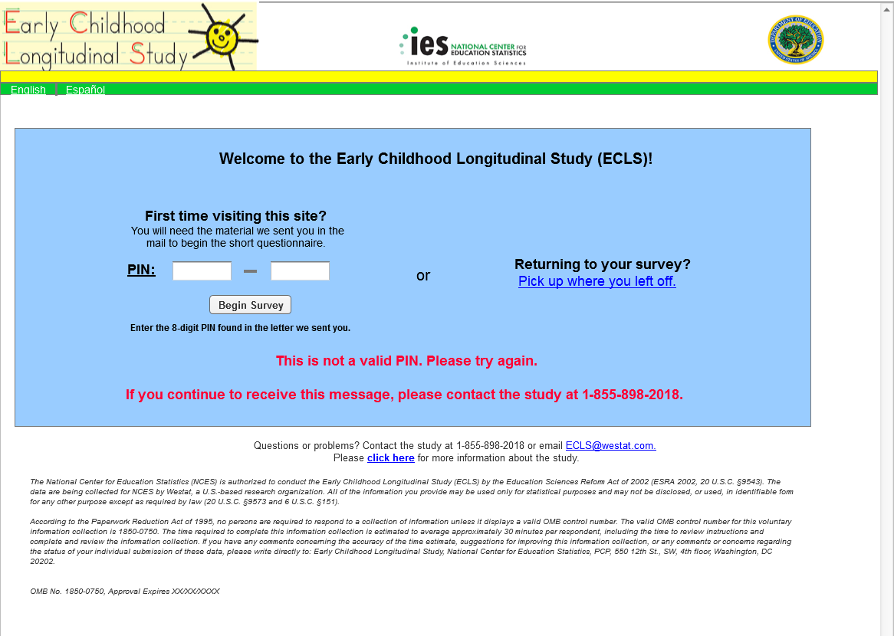

Additional English Text Reads:
This is not a valid PIN. Please try again.
If you continue to receive this message, please contact the study at 1-855-898-2018.

Additional Spanish Text Reads:
Este no es un PIN válido. Por favor vuelva a intentarlo.
Si sigue recibiendo este mensaje, por favor comuníquese con el estudio al número de teléfono 1-855-898-2018.

Page Details
If a PIN that is not recognized by our system is entered, the error message will be displayed in red, along with all text already on Screen 1. The respondent must re-enter their PIN and select the “Begin Survey” button again to validate the PIN, or contact the help desk for assistance.

Screen 2a: Subsequent Use PIN Validation
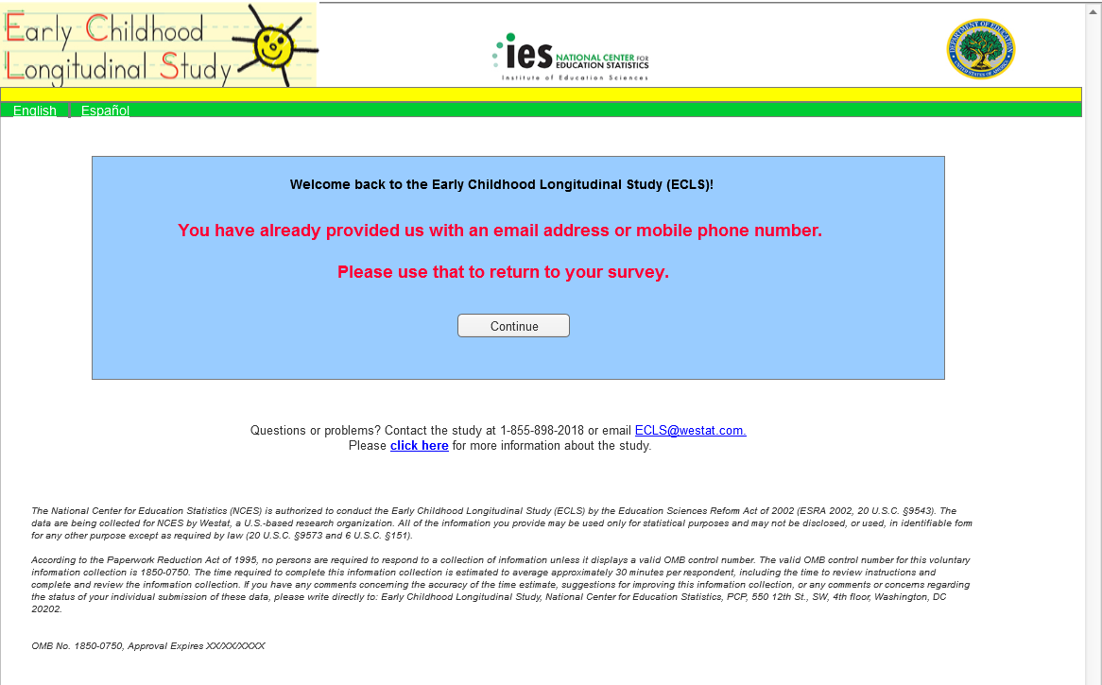

English Text Reads:
Welcome back to the Early Childhood Longitudinal Study (ECLS)!

You have already provided us with an email address or mobile phone number.
Please use that to return to your survey.

Continue (button)

Spanish Text Reads:
¡Bienvenido(a) nuevamente al Estudio Longitudinal de la Primera Infancia (ECLS)!

Usted ya nos dio una dirección de correo electrónico o número de teléfono celular.
Por favor use eso para regresar a su encuesta.

Continuar (button)

Page Details
The PIN from the respondent’s initial mailing will be valid until the respondent provides an email address or mobile phone number. Once the respondent’s contact information is provided, the PIN will be turned off. If the respondent returns to the MyECLS website and enters the PIN from their initial mailing after already providing their email address or mobile phone number, they will receive a notification that they have already provided that information and should use it to login. The respondent will select the “Continue” button, which will route them to Screen 11 (Returning User – Spring). If the respondent returns to the MyECLS website and enters the PIN from the initial mailing, and they had not previously provided an email address or mobile phone number, they will start over with the eligibility question.

Screen 3: Eligibility Question
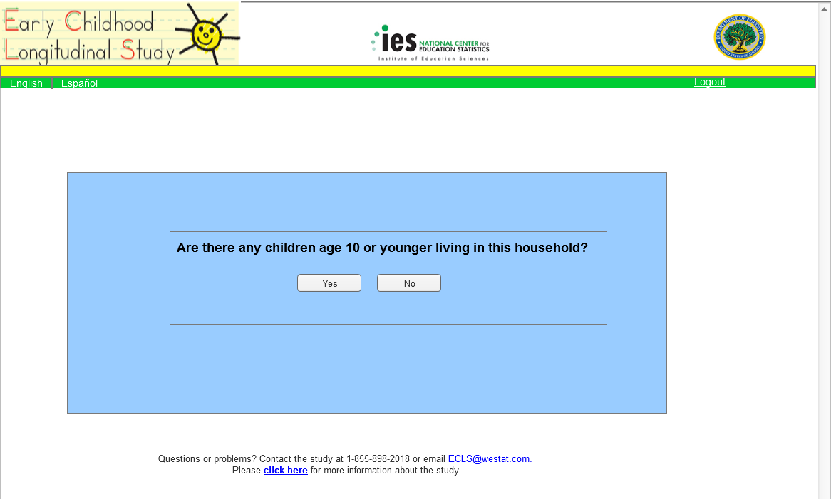

English Text Reads:
Are there any children age 10 or younger living in this household?

Yes (button)

No (button)

Spanish Text Reads:
¿Hay niños o niñas de 10 años o menos que vivan en este hogar?
Sí (button)

No (button)

Page Details
Successful entry of the 8-digit PIN will direct the respondent to Screen 3 (Eligibility Question). The respondent’s actions on this page will determine whether or not they are eligible to continue on to the ECLS screener. If the respondent selects No,” they will land on Screen 4, (Ineligible Response), and if they select “Yes,” they will land on Screen 5 (Eligible Response/Additional Security).

Screen 4: Ineligible Response
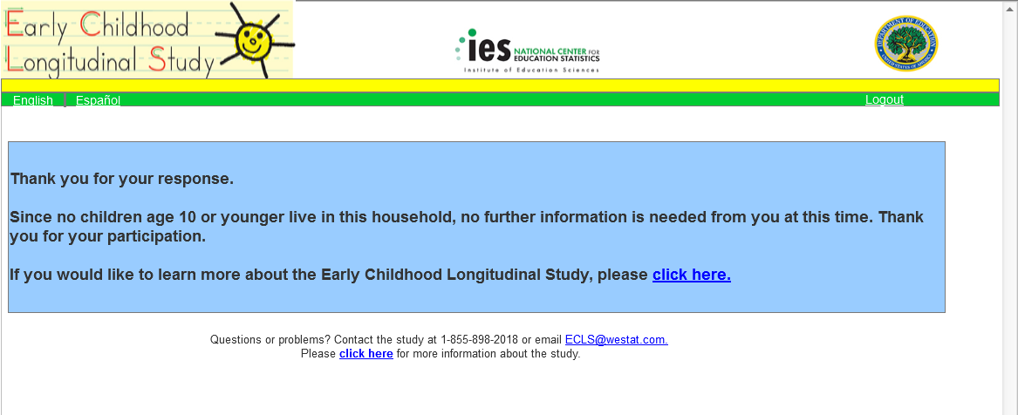

English Text Reads:

Thank you for your response.

Since no children age 10 or younger live in this household, no further information is needed from you at this time. Thank you for your participation.

If you would like to learn more about the Early Childhood Longitudinal Study, please click here. (link)

Spanish Text Reads:
Gracias por su respuesta.

Dado que ningún niño o niña de 10 años o menos vive en este hogar, no necesitamos más información de usted por este momento. Gracias por su participación.

Si le gustaría informarse más sobre el Estudio Longitudinal de la Primera Infancia, por favor haga clic aquí. (link)

Page Details
Ineligible respondents land on this screen after answering the eligibility question on Screen 3. A link is provided to Screen 21 (Study Information Page), where the respondent can find additional information about the study. The respondent does not need to take additional action when landing on this page. They will not receive additional notifications or reminders.

Screen 5: Eligible Response/Additional Security
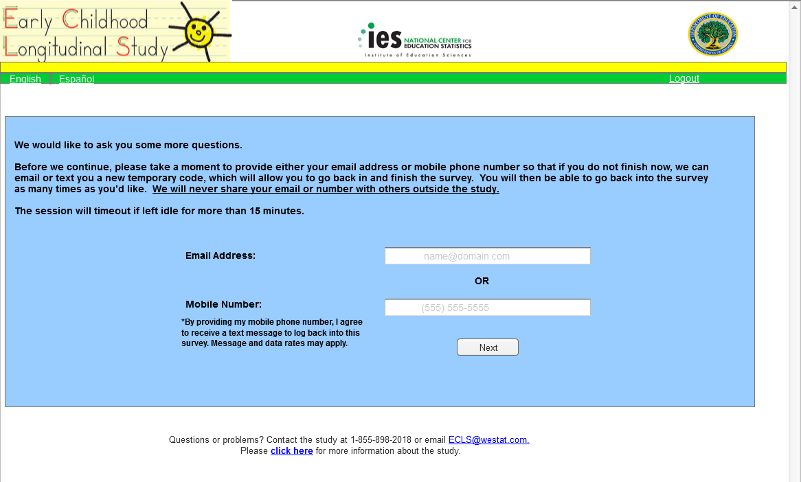

English Text Reads:
We would like to ask you some more questions.

Before we continue, please take a moment to provide either your email address or mobile phone number so that if you do not finish now, we can email or text you a new temporary code, which will allow you to go back in and finish the survey. You will then be able to go back into the survey as many times as you’d like. We will never share your email or number with others outside the study.

The session will timeout if left idle for more than 15 minutes.

Email Address: (Watermark: name@domain.com)
OR
Mobile Number: (Watermark: (555) 555-5555)
*By providing my mobile phone number, I agree to receive a text message to log back into this survey. Message and data rates may apply.

Next (button)

Spanish Text Reads:
Nos gustaría hacerle algunas preguntas más.

Antes de continuar, por favor dedique un momento para proporcionar su dirección de correo electrónico o su número de teléfono celular. Así, en caso de que usted no termine ahora, nosotros podremos enviarle un código temporal en un correo electrónico o por mensaje de texto, que le permitirá volver y terminar la encuesta. Usted podrá volver a la encuesta tantas veces como lo desee. Nunca le daremos su dirección de correo electrónico o su número de teléfono a nadie que no sea parte del estudio.

Si permanece inactivo(a) por más de 15 minutos, la sesión será finalizada.

Dirección de correo electrónico: (Watermark: nombre@dominio.com)
O
Número de teléfono celular: (Watermark: (555) 555-5555)
*Al proporcionar mi número de teléfono celular, acepto recibir un mensaje de texto para volver a iniciar sesión en esta encuesta. Pueden aplicarse tarifas de mensaje y transmisión de datos.

Siguiente (button)

Page Details
Selecting “Yes” on Screen 3 (Eligibility Question) will direct the respondent to this page. Here, the respondent will be given information about the procedures to access the screener or survey if they are unable to finish in one sitting. The respondent is asked to provide an email address or a mobile phone number, so that they may receive a new temporary code to access their incomplete screener or survey at a later time. When the information is entered and the respondent clicks on the submit button, the respondent will be taken to the screener.

The respondent will be allowed to progress through the screener, even if they do not provide any contact information at this point. If the respondent does not provide any contact information and tries to continue the survey at a later time by re-entering the initial PIN, the respondent will be taken to the beginning of the screener the next time they access the instrument (see screen 11 for more details).

Placeholder: Screener
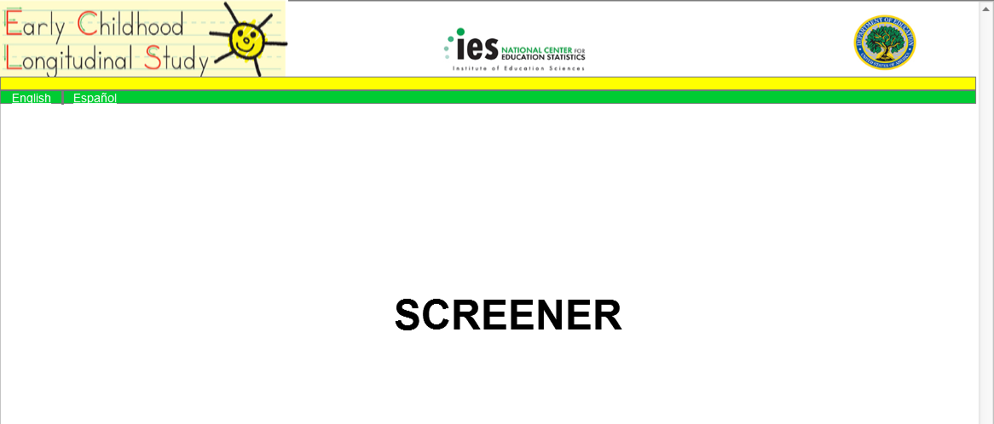

Page Details
After the respondent has either entered contact information on the previous screen or has indicated a preference to not provide this information, he or she is taken directly to the screener. The screener items appear in Attachment B.

Placeholder: Survey
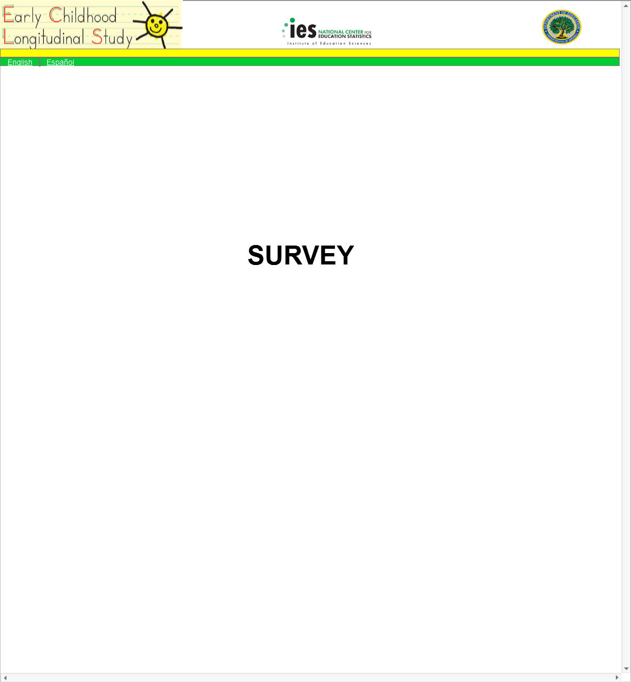

Page Details
After the respondent has completed the screener, an algorithm will be run to determine if the respondent is eligible to continue to the parent survey. If the respondent is eligible, then he or she will be directed to the parent survey. The parent survey items appear in Attachment B. After completing the screener, if the respondent is not eligible for participation in the study, he or she will be taken to Screen 21 (Study Information Page).

Screen 6: Survey Complete – Spring
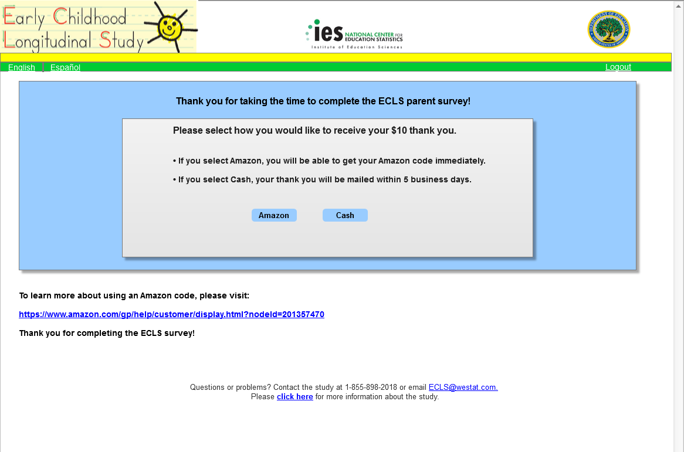

English Text Reads:
Thank you for taking the time to complete the ECLS parent survey!

Please select how you would like to receive your $10 thank you.
- If you select Amazon, you will be able to get your Amazon code immediately.
- If you select Cash, your thank you will be mailed within 5 business days.

Amazon (button)
Cash (button)

To learn more about using an Amazon code, please visit:
https://www.amazon.com/gp/help/customer/display.html?nodeId=201357470

Thank you for completing the ECLS survey!

Spanish Text Reads:
¡Gracias por tomarse el tiempo de completar la encuesta para padres ECLS!

Por favor seleccione cómo le gustaría recibir sus $10 de agradecimiento.
- Si usted selecciona Amazon, podrá recibir un código de Amazon inmediatamente.
- Si usted selecciona dinero en efectivo, este agradecimiento será enviado en un plazo de 5 días hábiles o de negocio.

Amazon (button)
Dinero en efectivo (button)

Para obtener más información sobre el uso de un código de Amazon, por favor visite la página:
https://www.amazon.com/gp/help/customer/display.html?nodeId=201357470

¡Gracias por completar la encuesta ECLS!

Page Details
Upon successful completion of the parent survey, the respondent is routed to Screen 6 (Survey Complete – Spring) to claim their $10 thank you. The respondent has the option to click the “Amazon” button to immediately receive a digital Amazon code, which would be displayed on Screen 8 (Thank You Confirmation – Amazon - Spring). There is a link to Amazon’s help page for applying codes to their accounts to use for purchase on Amazon.com. If the respondent prefers, they can instead select the “Cash” button, which will direct them to Screen 7 (Cash Thank You – Spring). The cash thank you will be mailed to the respondent within 5 business days after submission, if they choose to receive cash.

Screen 7: Cash Thank You – Spring
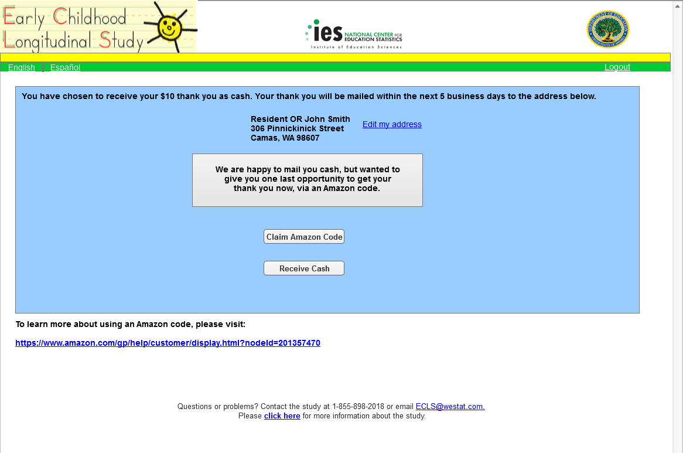
English Text Reads:
You have chosen to receive your $10 thank you as cash. Your thank you will be mailed within the next 5 business days to the address below.

Resident OR John Smith
306 Pinnickinick Street
Camas, WA 98607

Edit my address (link)

We are happy to mail you cash, but wanted to give you one last opportunity to get your thank you now, via an Amazon code.

Claim Amazon Code (button)
Receive Cash (button)

To learn more about using an Amazon code, please visit:
https://www.amazon.com/gp/help/customer/display.html?nodeId=201357470

Spanish Text Reads:
Usted ha elegido recibir sus $10 de agradecimiento en dinero en efectivo. Este agradecimiento será enviado en un plazo de 5 días hábiles o de negocios a la siguiente dirección.

Familia en esta dirección O John Smith
306 Pinnickinick Street
Camas, WA 98607

Corregir mi dirección (link)

Con mucho gusto le enviaremos el dinero en efectivo por correo, pero nos gustaría ofrecerle una última vez la opción de recibir nuestra muestra de agradecimiento ahora, a través de un código de Amazon.

Solicitar código de Amazon (button)
Recibir dinero en efectivo (button)

Para obtener más información sobre el uso de un código de Amazon, por favor visite la página:
https://www.amazon.com/gp/help/customer/display.html?nodeId=201357470

Page Details
Respondents who select to receive a cash thank you are directed to this page. The address where their thank you will be mailed is displayed. The respondent can click the Edit my address link, which will direct them to Screen 7a (Cash Thank You – Edit Address – Spring), where they can update any or all of the pre-filled fields. The cash will be sent to “Resident” if the respondent does not provide their name when they complete the screener. They are also notified that they still have the choice to receive their thank you immediately in the form of an Amazon digital code. The respondent can either select the “Claim Amazon Code” button, which will route them back to Screen 8 (Thank You Confirmation – Amazon - Spring), where their digital Amazon code will be displayed, or they can click the “Receive Cash” button, which will direct them to Screen 9 (Thank You Confirmation – Cash - Spring).

Screen 7a: Cash Thank You – Edit Address - Spring
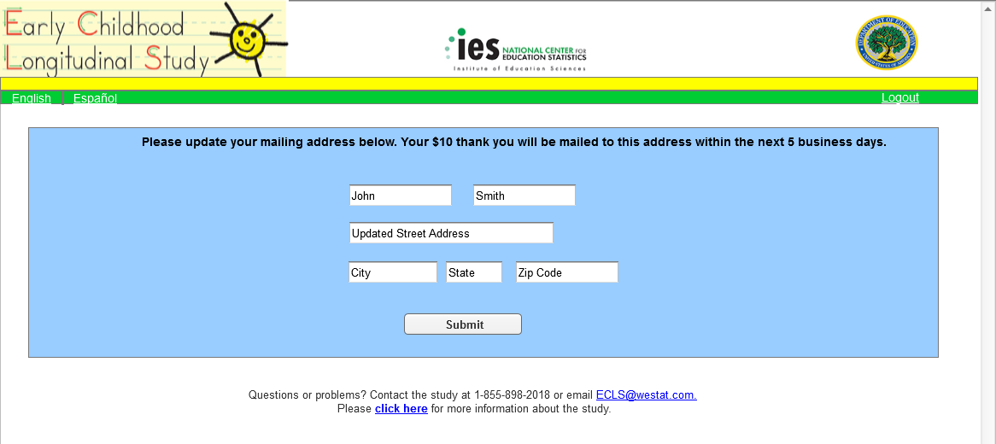
English Text Reads:
Please update your mailing address below. Your $10 thank you will be mailed to this address within the next 5 business days.

Editable fields with pre-filled text:
John Smith
Updated Street Address
City, State, Zip Code

Submit (button)

Spanish Text Reads:
Por favor actualice su dirección postal que está a continuación. Sus $10 de agradecimiento le serán enviados a esta dirección dentro de los próximos 5 días hábiles o de negocios.

Editable fields with pre-filled text:
John Smith
Updated Street Address
City, State, Zip Code

Enviar (button)

Page Details
Respondents who select the Edit my address link on Screen 7 (Cash Thank You – Spring) or Screen 9 (Thank You Confirmation – Cash – Spring) will be routed to this page, where they can update any or all of the pre-filled fields. If the respondent navigated to this page from Screen 7, clicking the “Submit” button will route them to Screen 7b (Cash Thank You – Updated Address – Spring), where their new address will be displayed. The respondent will proceed to confirm that they wish to receive a cash thank you at this updated address by selecting the “Receive Cash” button. Respondents who navigated to this page from Screen 9 will be routed back to Screen 9, where their updated address will show in the mailing confirmation message. The address will be saved as a second variable and will not overwrite the original address from sampling.

Screen 7b: Cash Thank You – Updated Address - Spring
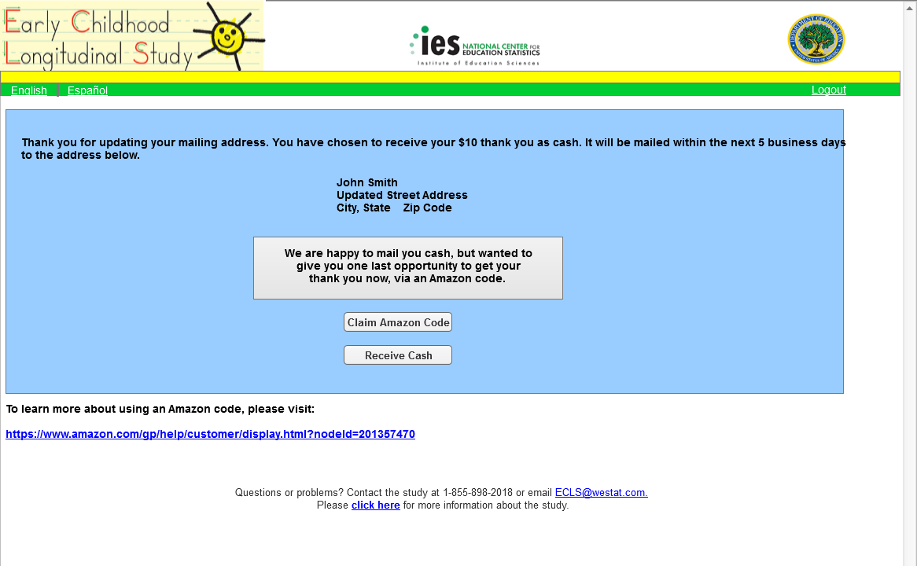
English Text Reads:
Thank you for updating your mailing address. You have chosen to receive your thank you as cash. It will be mailed within the next 5 business days to the address below.

John Smith
Updated Street Address
City, State Zip Code

We are happy to mail you cash, but wanted to give you one last opportunity to get your thank you now, via an Amazon code.

Claim Amazon Code (button)
Receive Cash (button)

To learn more about using an Amazon code, please visit:
https://www.amazon.com/gp/help/customer/display.html?nodeId=201357470

Spanish Text Reads:
Gracias por actualizar su dirección. Usted ha elegido recibir su agradecimiento en dinero en efectivo. Le será enviado dentro de los próximos 5 días hábiles o de negocios a la dirección siguiente.

John Smith
Updated Street Address
City, State Zip Code

Con mucho gusto le enviaremos el dinero en efectivo por correo, pero nos gustaría ofrecerle una última vez la opción de recibir nuestra muestra de agradecimiento ahora, a través de un código de Amazon.

Solicitar código de Amazon (button)
Recibir dinero en efectivo (button)

Para obtener más información sobre el uso de un código de Amazon, por favor visite la página:
https://www.amazon.com/gp/help/customer/display.html?nodeId=201357470

Page Details
Respondents who update their address and click “Submit” on Screen 7a (Cash Thank You – Edit Address – Spring) will be routed to this page to confirm that they wish to receive their thank you in cash. These respondents will have navigated to Screen 7a from the Edit my address link on Screen 7.

Screen 8: Thank You Confirmation – Amazon Spring

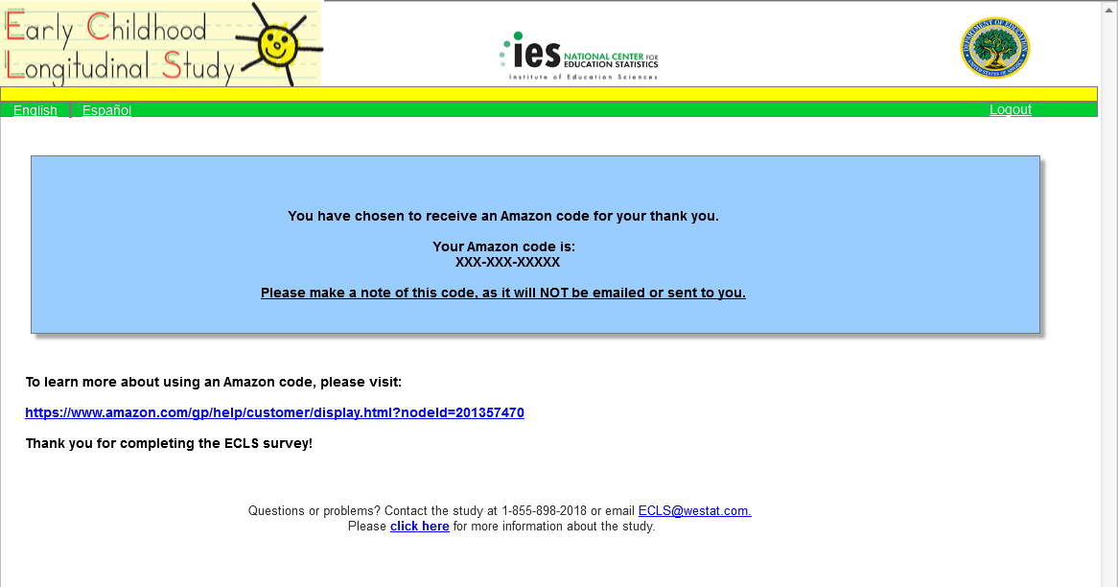
English Text Reads:
You have chosen to receive an Amazon code for your thank you.

Your Amazon code is:
XXX-XXX-XXXXX

Please make a note of this code, as it will NOT be emailed or sent to you.

To learn more about using an Amazon code, please visit:
https://www.amazon.com/gp/help/customer/display.html?nodeId=201357470
Thank you for completing the ECLS survey!

Spanish Text Reads:
Usted ha elegido recibir un código de Amazon como su agradecimiento.

Su código de Amazon es:
XXX-XXX-XXXXX

Por favor anote este código, ya que NO se le va a enviar por correo electrónico ni de otro modo.

Para obtener más información sobre el uso de un código de Amazon, por favor visite la página:
https://www.amazon.com/gp/help/customer/display.html?nodeId=201357470

¡Gracias por completar la encuesta ECLS!

Page Details
Respondents who choose to receive an Amazon digital code for their thank you will view this page after selecting the “Amazon” button on Screen 6 (Survey Complete – Spring), or the “Claim Amazon Code” button on Screen 7 (Cash Thank You – Spring).

Screen 9: Thank You Confirmation – Cash - Spring
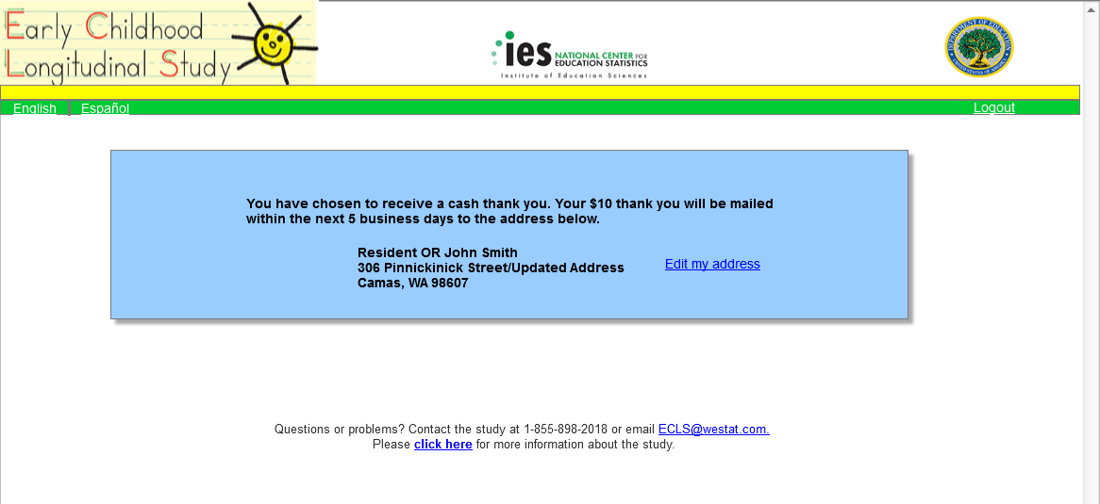

English Text Reads:
You have chosen to receive a cash thank you. Your $10 thank you will be mailed within the next 5 business days to the address below.

Resident OR John Smith
306 Pinnickinick Street/Updated Address
Camas, WA 98607

Edit my address (link)

Spanish Text Reads:
Usted ha elegido recibir su agradecimiento en dinero en efectivo. Sus $10 de agradecimiento le serán enviados dentro de los próximos 5 días hábiles o de negocios a la dirección siguiente.

Familia en esta dirección O John Smith
306 Pinnickinick Street/Updated Address
Camas, WA 98607

Corregir mi dirección (link)

Page Details
Respondents who choose to receive cash for their thank you will view this confirmation page after selecting the “Receive Cash” button on Screen 7 (Cash Thank You – Spring). Respondents may make last minute edits to the mailing address for their thank you at this point. If a respondent selects the Edit my address link on this screen, they will be routed to Screen 7a (Cash Thank You – Edit Address – Spring), where they can update any or all of the pre-filled fields. When the respondent navigates to Screen 7a from Screen 9, selecting the “Submit” button on Screen 7a will return the respondent back to Screen 9, with the updated address showing on the confirmation message. The address will be saved as a second variable and will not overwrite the original address from sampling.

Screen 10a: Logout Validation – Contact Information Not Provided
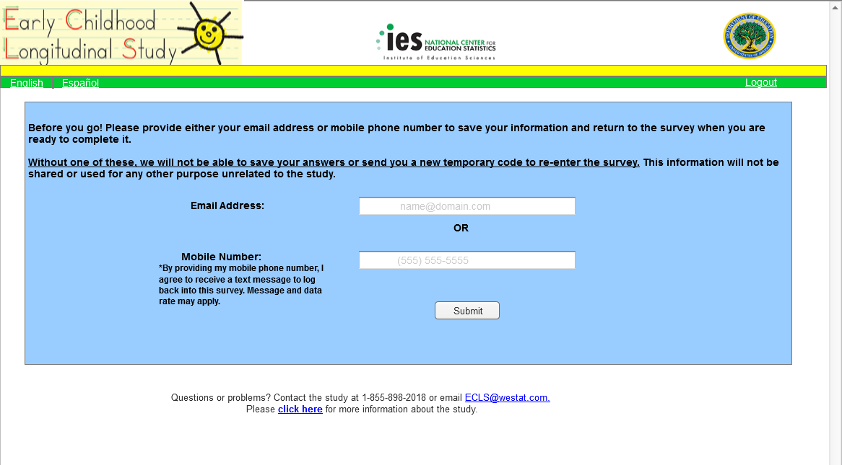

English Text Reads:
Before you go! Please provide either your email address or mobile phone number to save your information and return to the survey when you are ready to complete it.

Without one of these, we will not be able to save your answers or send you a new temporary code to re-enter the survey. This information will not be shared or used for any other purpose unrelated to the study.

Email Address: (Watermark: name@domain.com)
OR
Mobile Number: (Watermark: (555) 555-5555)
*By providing my mobile phone number, I agree to receive a text message to log back into this survey. Message and data rates may apply.

Submit (button)

Spanish Text Reads:
¡Antes de que se vaya! Por favor proporcione su dirección de correo electrónico o su número de teléfono celular. Así podremos guardar su información y usted podrá volver a la encuesta cuando esté listo(a) para completarla.

Sin uno de estos, no podremos guardar sus respuestas ni enviarle un código temporal para continuar la encuesta. Esta información no se compartirá ni se usará para algún otro propósito que no esté relacionado con el estudio.

Dirección de correo electrónico: (Watermark: nombre@dominio.com)
O
Número de teléfono celular: (Watermark: (555) 555-5555)
*Al proporcionar mi número de teléfono celular, acepto recibir un mensaje de texto para volver a iniciar sesión en esta encuesta. Pueden aplicarse tarifas de mensaje y transmisión de datos.

Enviar (button)

Page Details
The Logout Validation – Contact Information Not Provided screen is shown to eligible respondents who have not provided an email address or mobile number on Screen 5 and click on the logout button while completing the screener or survey. This screen notifies the respondent that if they continue the logout process without providing an email address or mobile number, they will need to restart their screener and survey the next time the instrument is accessed. The respondent is able to continue to logout without providing contact information.

Screen 10b: Logout Validation – Contact Information Provided
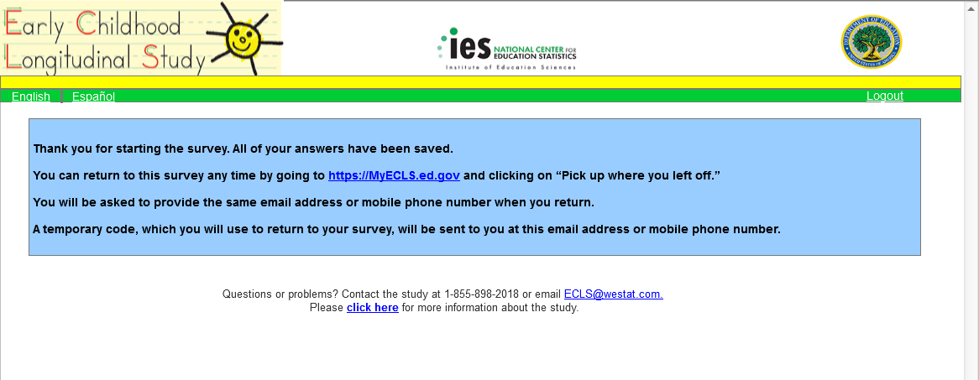

English Text Reads:
Thank you for starting the survey. All of your answers have been saved.

You can return to this survey any time by going to https://MyECLS.ed.gov and clicking on “Pick up where you left off.”

You will be asked to provide the same email address or mobile phone number when you return.

A temporary code, which you will use to return to your survey, will be sent to you at this email address or mobile phone number.

Spanish Text Reads:
Gracias por comenzar la encuesta. Todas sus respuestas se han guardado.

Usted puede volver a esta encuesta en cualquier momento yendo a https://MyECLS.ed.gov y haciendo click en “Continúe donde se quedó.”

Cuando vuelva a la encuesta, se le pedirá que proporcione la misma dirección de correo electrónico o número de teléfono celular.

Se le enviará un código temporal a esta dirección de correo electrónico o a este número de teléfono celular y usted usará el código para volver a su encuesta.

Page Details
The Logout Validation – Contact Information Provided screen is shown to eligible respondents who have provided an email address or mobile number on Screen 5 and click on the logout button while completing the screener or survey. This screen thanks the respondent for starting the survey, and provides instructions for returning to complete the survey at a later time.

Screen 11: Returning User Spring
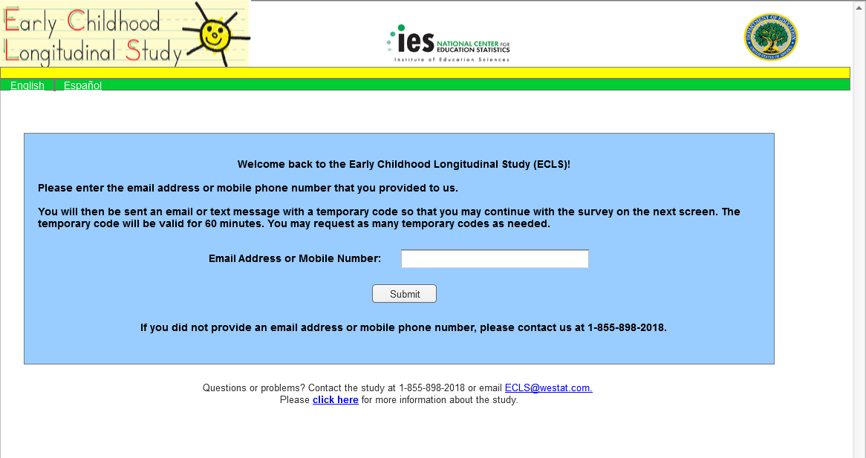

English Text Reads:
Welcome back to the Early Childhood Longitudinal Study (ECLS)!

Please enter the email address or mobile phone number that you provided to us.

You will then be sent an email or text message with a temporary code so that you may continue with the survey on the next screen. The temporary code will be valid for 60 minutes. You may request as many temporary codes as needed.

Email Address or Mobile Number:

Submit (button)

If you did not provide an email address or mobile phone number, please contact us at 1-855-898-2018.

Spanish Text Reads:
¡Bienvenido(a) nuevamente al Estudio Longitudinal de la Primera Infancia (ECLS)!

Por favor ponga la dirección de correo electrónico o número de teléfono celular que nos dio.

A continuación, se le enviará un correo electrónico o un mensaje de texto con un código temporal para que pueda continuar con la encuesta en la siguiente pantalla. El código temporal será válido por 60 minutos. Puede volver a solicitar un código temporal tantas veces como lo necesite.

Dirección de correo electrónico o número de teléfono celular:

Enviar (button)

Si usted no proporcionó una dirección de correo electrónico o un número de teléfono celular, por favor comuníquese con nosotros al 1-855-898-2018.

Page Details
Respondents are directed to the Returning User - Spring page if they click the “Pick up where you left off.” link on Screen 1 (Home/Login – Spring). Here, the respondent must enter the email address or mobile number that they provided on Screen 5 (Eligible Response/Additional Security) to return to where they left off in the screener or survey. If the respondent enters an unrecognized email address or mobile number, the additional text in red on Screen 12 (Email/Mobile Validation Message – Spring) will be displayed and they will be given the option to try again. If they enter a recognized email address or mobile number, they will be sent a new, 6-digit temporary code in an email and/or text message, if provided by the respondent. The page will automatically redirect to Screen 13 (Login - Returning User - Spring), where the respondent should then enter the 6-digit temporary code found in their email or text message. The language for the email and/or text message used to provide the respondents with the 6-digit temporary code is provided in Attachment A.

Respondents who did not provide an email address or phone number will not be able to return to where they left off in the screener or survey. For security reasons, they will not be able to access their previous data and they must begin again at the very first eligibility question. These respondents may return to the MyECLS website and enter their initial PIN to start over at with the eligibility question. If they select the “Pick up where you left off.” link on Screen 1 (Home – Spring), they will be routed to Screen 11 (Returning User - Spring), which instructs the respondent to contact the ECLS help desk. The help desk will provide the respondent with their original PIN so that they can start their survey over again with the eligibility question. Note that respondents are prompted to provide either an email address or mobile phone number:
- prior to entering the screener;
- if not previously provided, before moving to the parent survey; and
- if not previously provided, when clicking on the “Logout” button to leave any screen where it appears.

Screen 12: Email/Mobile Validation Message Spring
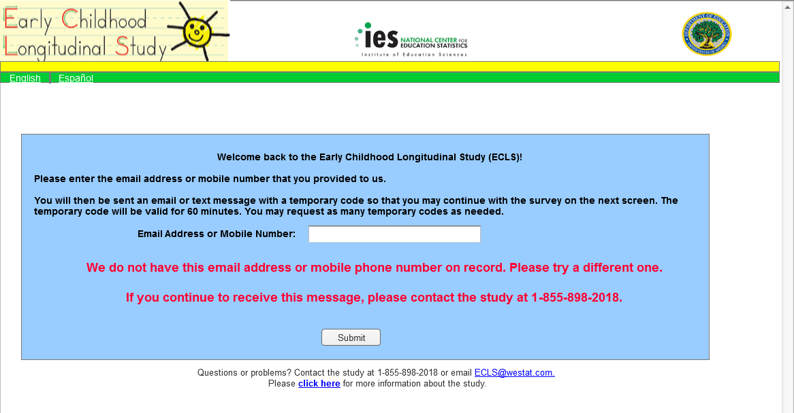

Additional English Text Reads:
We do not have this email address or mobile phone number on record. Please try a different one.

If you continue to receive this message, please contact the study at 1-855-898-2018.

Submit (button)

Additional Spanish Text Reads:
No tenemos esta dirección de correo electrónico o número de teléfono celular en nuestros registros. Por favor intente con uno diferente.

Si usted sigue recibiendo este mensaje, por favor comuníquese con el estudio al número de teléfono 1-855-898-2018.
Enviar (button)

Page Details
Entering an unrecognized email address or mobile number on Screen 11 (Returning User – Spring) will cause the text in red to display on that screen. The respondent has the option to enter their contact information again or contact the help desk for assistance.

Screen 13: Login – Returning User Spring
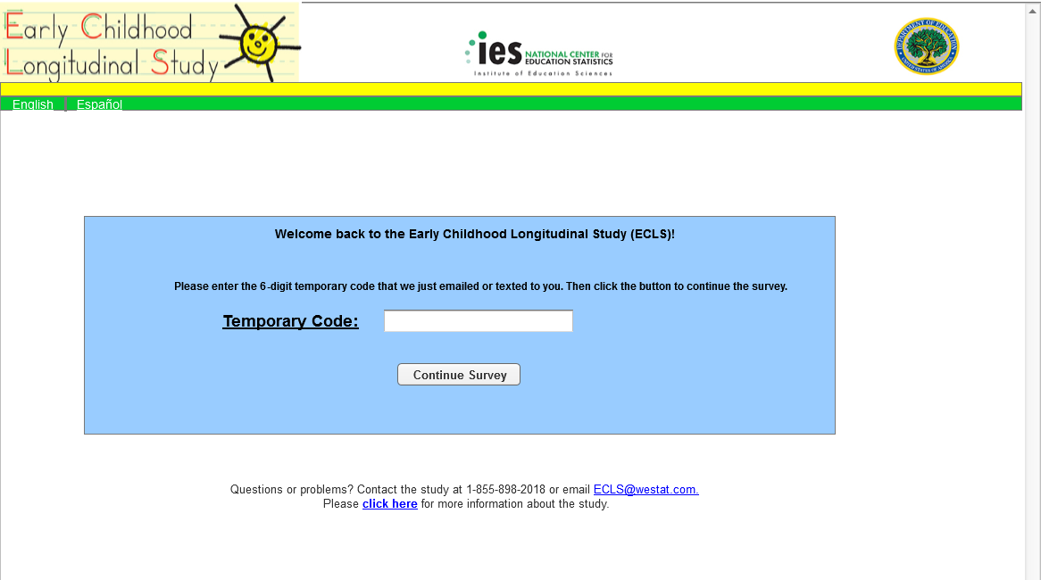

English Text Reads:

Welcome back to the Early Childhood Longitudinal Study (ECLS)!

Please enter the 6-digit temporary code that we just emailed or texted to you. Then click the button to continue the survey.

Temporary Code:

Continue Survey (button)

Spanish Text Reads:
¡Bienvenido(a) nuevamente al Estudio Longitudinal de la Primera Infancia (ECLS)!

Por favor ponga el código temporal de 6 dígitos que le acabamos de enviar por correo electrónico o por mensaje de texto. Después haga clic en el botón para continuar con la encuesta.

Código temporal:

Continuar con la encuesta (button)

Page Details
Respondents will land on this page once they enter a recognized email address or mobile number on Screen 11 (Returning User – Spring). The respondent must enter their new 6-digit temporary code and select the “Continue Survey” button to return to where they left off in their screener or survey.

Screen 13a: Login – Returning User - Temporary Code Validation Spring
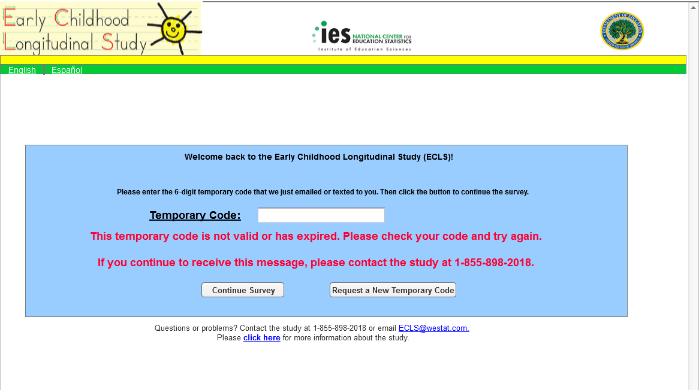

Additional English Text Reads:
This temporary code is not valid or has expired. Please check your code and try again.

If you continue to receive this message, please contact the study at 1-855-898-2018.

Request a New Temporary Code (button)

Additional Spanish Text Reads:
Este código temporal no es válido o ya ha expirado. Por favor verifique su código e inténtelo de nuevo.
Si sigue recibiendo este mensaje, por favor comuníquese con el estudio al número de teléfono 1-855-898-2018.
Solicitar un nuevo código temporal (button)

Page Details
If a temporary code that is not recognized by our system is entered, the error message will be displayed in red, along with all text already on Screen 13. The respondent must re-enter their temporary code and select the “Continue Survey” button again to validate the temporary code. If the temporary code has expired, the respondent can select the “Request a New Temporary Code” button, which will route them back to Screen 11 (Returning User - Spring), where they will re-enter their email address or phone number. There is also an option for the respondent to contact the help desk for assistance.

Screen 14: Home/Login – Fall
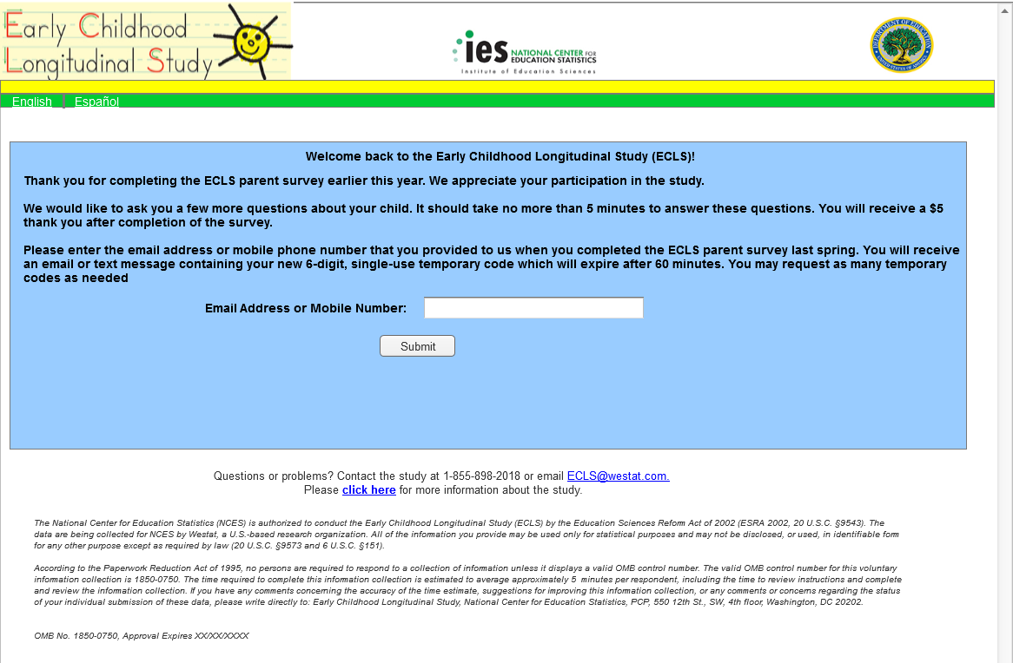
English Text Reads:
Welcome back to the Early Childhood Longitudinal Study (ECLS)!

Thank you for completing the ECLS parent survey earlier this year. We appreciate your participation in the study.

We would like to ask you a few more questions about your child. It should take no more than 5 minutes to answer these questions. You will receive a $5 thank you after completion of the survey.

Please enter the email address or mobile phone number that you provided to us when you completed the ECLS parent survey last spring. You will receive an email or text message containing your new 6-digit, single-use temporary code which will expire after 60 minutes. You may request as many temporary codes as needed.

Email Address or Mobile Number:

Submit (button)

The National Center for Education Statistics (NCES) is authorized to conduct the Early Childhood Longitudinal Study (ECLS) by the Education Sciences Reform Act of 2002 (ESRA 2002, 20 U.S.C. §9543). The data are being collected for NCES by Westat, a U.S.-based research organization. All of the information you provide may be used only for statistical purposes and may not be disclosed, or used, in identifiable form for any other purpose except as required by law (20 U.S.C. §9573 and 6 U.S.C. §151).

According to the Paperwork Reduction Act of 1995, no persons are required to respond to a collection of information unless it displays a valid OMB control number. The valid OMB control number for this voluntary information collection is 1850-0750. The time required to complete this information collection is estimated to average approximately 5 minutes per respondent, including the time to review instructions and complete and review the information collection. If you have any comments concerning the accuracy of the time estimate, suggestions for improving this information collection, or any comments or concerns regarding the status of your individual submission of these data, please write directly to: Early Childhood Longitudinal Study, National Center for Education Statistics, PCP, 550 12th St., SW, 4th floor, Washington, DC 20202.

OMB No. 1850-0750, Approval Expires XX/XX/XXXX

Spanish Text Reads:
¡Bienvenido(a) nuevamente al Estudio Longitudinal de la Primera Infancia (ECLS)!

Gracias por haber completado la encuesta para padres de ECLS a principios de este año. Agradecemos su participación en el estudio.

Nos gustaría hacerle unas preguntas más sobre su hijo(a). No debería tomarle más de 5 minutos responder a estas preguntas. Usted recibirá $5 de agradecimiento después de que complete la encuesta.

Por favor ponga la dirección de correo electrónico o número de teléfono celular que nos dio cuando completó la encuesta para padres de ECLS en la primavera pasada. Usted recibirá un correo electrónico o un mensaje de texto con su código temporal de 6 dígitos nuevo, para un solo uso, el cual expirará después de 60 minutos. Puede volver a solicitar un código temporal tantas veces como lo necesite.

Dirección de correo electrónico o número de teléfono celular:

Enviar (button)

El Centro Nacional para Estadísticas de Educación (NCES, por sus siglas en inglés) está autorizado a hacer el Estudio Longitudinal de la Primera Infancia (ECLS, por sus siglas en inglés) por el Acta de la Reforma de las Ciencias de la Educación de 2002 (ESRA 2002, 20 U.S.C. §9543). La firma Westat, una organización que realiza estudios y está basada en los Estados Unidos, está recopilando los datos para NCES. Toda la información que usted proporcione podrá usarse solamente para propósitos estadísticos y no podrá divulgarse ni usarse de manera que permita identificar a los participantes para ningún otro propósito, salvo que lo requiera la ley (20 U.S.C. §9573 y 6 U.S.C. §151).

Según lo establece el Acta de Reducción del Papeleo de 1995, ninguna persona está obligada a responder a un pedido de información si la misma no contiene un número de control de OMB válido. El número de control de OMB válido para recolectar esta información que se proporciona voluntariamente es 1850-0750. Se calcula que el tiempo necesario para completar este pedido de información es en promedio de 5 minutos aproximadamente por participante, incluyendo el tiempo que lleva revisar las instrucciones, y completar y revisar la información que se solicita. Si usted tiene algún comentario con respecto a la precisión del cálculo de tiempo, sugerencias para mejorar esta encuesta, o cualquier comentario o inquietud acerca del estatus del envío de su encuesta individual, por favor escriba directamente a: Early Childhood Longitudinal Study, National Center for Education Statistics, PCP, 550 12th St., SW, 4th floor, Washington, DC 20202.

No. OMB 1850-0750. La aprobación vence el XX/XX/XXXX.

Page Details
This page serves as the fall 2020 follow-up landing page for all returning parents who provided contact information when they completed their parent survey online in spring 2020.

Respondents will access this page using the same URL: https://MyECLS.ed.gov. The respondent must provide the same email address or mobile number that they provided in the spring to access the fall follow-up survey. If the respondent enters an unrecognized email address or mobile number, the additional red text on Screen 15 (Email/Mobile Validation Message – Fall) will be displayed, and the respondent will have the opportunity to try again. If they enter a recognized email address or mobile number, they will be sent a new, 6-digit temporary code in an email and/or text message. The page will automatically redirect to Screen 16 (Returning User - Fall), where the respondent can enter the 6-digit temporary code found in their email address or text message. Email and text message text providing the respondent with the temporary code is provided in Attachment A.

OMB and security notices are displayed on this page.

Screen 15: Email/Mobile Validation Message – Fall
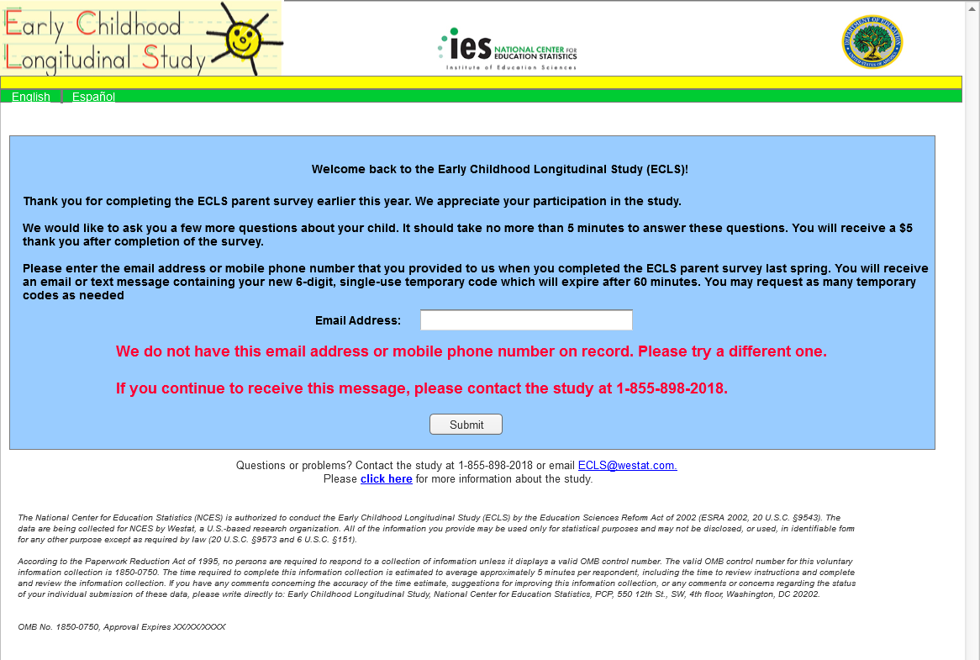
Additional English Text Reads:
We do not have this email address or mobile phone number on record. Please try a different one.

If you continue to receive this message, please contact the study at 1-855-898-2018.

Submit (button)

Additional Spanish Text Reads:
No tenemos esta dirección de correo electrónico o número de teléfono celular en nuestros registros. Por favor intente con uno diferente.

Si sigue recibiendo este mensaje, por favor comuníquese con el estudio al número de teléfono 1-855-898-2018.

Page Details
Entering an unrecognized email address or mobile phone number on Screen 14 (Home/Login – Fall) will cause the text in red to display on that screen. The respondent has the option to enter the contact information again or contact the help desk for assistance.

Screen 16: Returning User – Fall
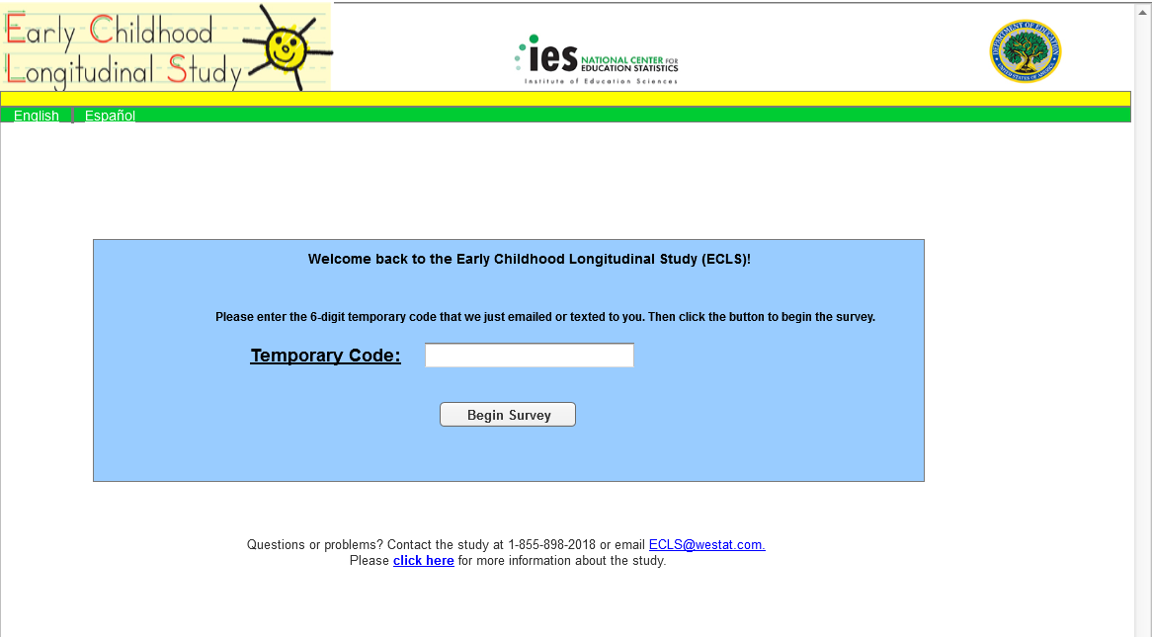

English Text Reads:
Welcome back to the Early Childhood Longitudinal Study (ECLS)!

Please enter the 6-digit temporary code that we just emailed or texted to you. Then click the button to begin the survey.

Temporary Code:

Begin Survey (button)

Spanish Text Reads:
¡Bienvenido(a) nuevamente al Estudio Longitudinal de la Primera Infancia (ECLS)!

Por favor ponga el código temporal de 6 dígitos que le acabamos de enviar por correo electrónico o por mensaje de texto. Después haga clic en el botón para comenzar con la encuesta.

Código temporal:

Comenzar con la encuesta (button)

Page Details
Respondents are directed to Screen 16 (Returning User – Fall) once they enter a recognized email address or mobile number. The respondent must enter the new 6-digit temporary code and select the “Begin Survey” button to complete the fall follow-up survey.

Screen 16a: Returning User – Fall – Temporary Code Validation
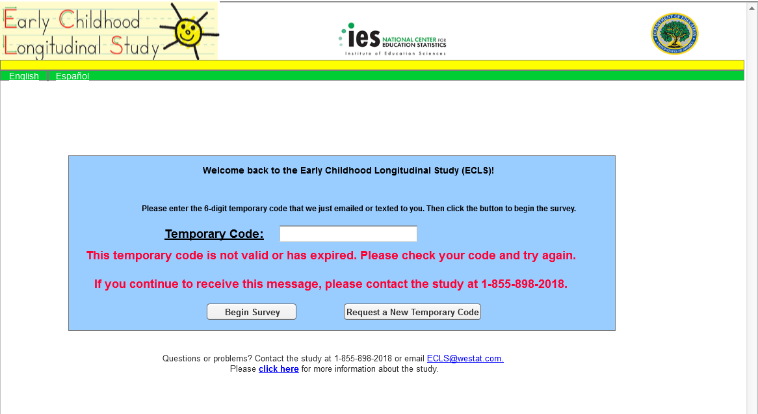

Additional English Text Reads:
This temporary code is not valid or has expired. Please check your code and try again.

If you continue to receive this message, please contact the study at 1-855-898-2018.

Request a New Temporary Code (button)

Additional Spanish Text Reads:
Este código temporal no es válido o ya ha expirado. Por favor verifique su código e inténtelo de nuevo.

Si sigue recibiendo este mensaje, por favor comuníquese con el estudio al número de teléfono 1-855-898-2018.
Solicitar un nuevo código temporal (button)

Page Details
If a temporary code that is not recognized by our system is entered, the error message will be displayed in red, along with all text already on Screen 16. The respondent must re-enter their temporary code and select the “Begin Survey” button again to validate the temporary code. If the temporary code has expired, the respondent can select the “Request a New Temporary Code” button, which will route them back to Screen 14 (Home/Login – Fall), where they will re-enter their email address or phone number. There is also an option for the respondent to contact the help desk for assistance.

Placeholder: Survey

Page Details
After the respondent has entered their 6-digit temporary code, they are directed to the fall follow-up survey. The fall follow-up survey items appear in Attachment B.

Screen 17: Survey Complete – Fall
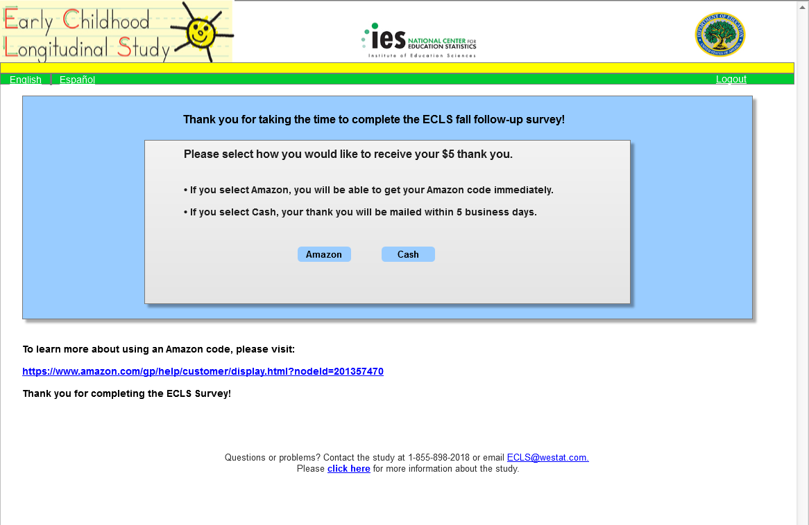

English Text Reads:
Thank you for taking the time to complete the ECLS fall follow-up survey!

Please select how you would like to receive your $5 thank you.
- If you select Amazon, you will be able to get your Amazon code immediately.
- If you select Cash, your thank you will be mailed within 5 business days.

Amazon (button)
Cash (button)

Spanish Text Reads:
¡Gracias por tomarse el tiempo de completar la encuesta de seguimiento de otoño de ECLS!

Por favor seleccione cómo le gustaría recibir sus $5 de agradecimiento.
- Si usted selecciona Amazon, podrá recibir un código de Amazon inmediatamente.
- Si usted selecciona dinero en efectivo, este agradecimiento será enviado en un plazo de 5 días hábiles o de negocio.

Amazon (button)
Dinero en efectivo (button)

Page Details
Upon successful completion of the fall follow-up survey, the respondent is routed to Screen 17 (Survey Complete – Fall) to claim their $5 thank you. The respondent has the option to click the “Amazon” button to immediately receive a digital Amazon code, which would be displayed on Screen 19 (Thank You Confirmation – Amazon - Fall). There is a link to Amazon’s help page for applying codes to their accounts to use for purchase on Amazon.com. If the respondent prefers, they can instead select the “Cash” button, which will direct them to Screen 18 (Cash Thank You – Fall). The cash thank you will be mailed to the respondent within 5 business days after submission, if they choose to receive cash.

Screen 18: Cash Thank You – Fall
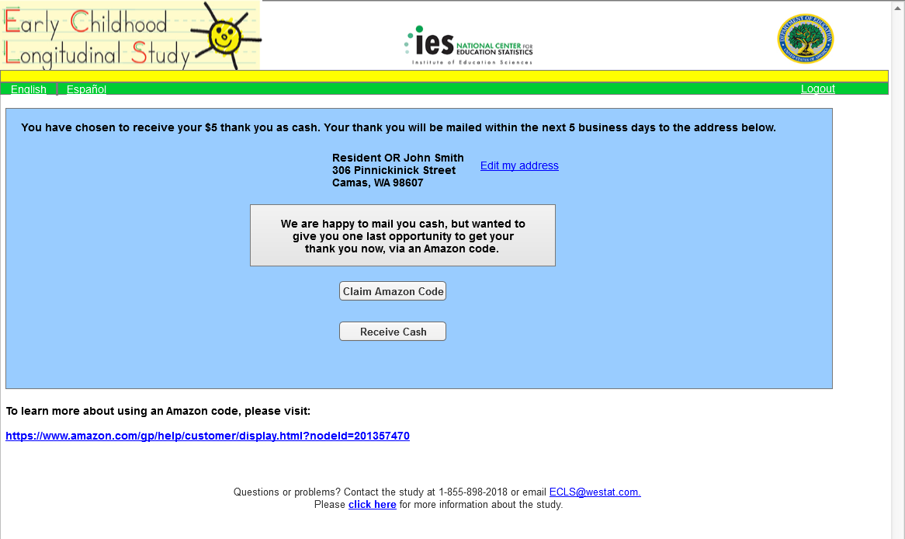

English Text Reads:
You have chosen to receive your $5 thank you as cash. Your thank you will be mailed within the next 5 business days to the address below.

Resident OR John Smith
306 Pinnickinick Street
Camas, WA 98607

Edit my address (link)

We are happy to mail you cash, but wanted to give you one last opportunity to get your thank you now, via an Amazon code.

Claim Amazon Code (button)
Receive Cash (button)

To learn more about using an Amazon code, please visit:
https://www.amazon.com/gp/help/customer/display.html?nodeId=201357470

Spanish Text Reads:
Usted ha elegido recibir sus $5 de agradecimiento en dinero en efectivo. Este agradecimiento será enviado en un plazo de 5 días hábiles o de negocios a la siguiente dirección.

Familia en esta dirección O John Smith
306 Pinnickinick Street
Camas, WA 98607

Corregir mi dirección (link)

Con mucho gusto le enviaremos el dinero en efectivo por correo, pero nos gustaría ofrecerle una última vez la opción de recibir nuestra muestra de agradecimiento ahora, a través de un código de Amazon.

Solicitar código de Amazon (button)
Recibir dinero en efectivo (button)

Para obtener más información sobre el uso de un código de Amazon, por favor visite la página:
https://www.amazon.com/gp/help/customer/display.html?nodeId=201357470

Page Details
Respondents who select to receive a cash thank you are directed to this page. The address where their thank you will be mailed is displayed. The respondent can click the Edit my address link, which will direct them to Screen 18a (Cash Thank You – Edit Address – Fall), where they can update any or all of the pre-filled fields. The cash will be sent to “Resident” if the respondent does not provide their name when they complete the screener. Respondents routed to this page are also notified that they still have the choice to receive their thank you immediately in the form of an Amazon digital code. The respondent can either select the “Claim Amazon Code” button, which will route back to Screen 18 (Thank You Confirmation – Amazon - Fall), where a digital Amazon code will be displayed, or can click the “Receive Cash” button, which will direct to Screen 20 (Thank You Confirmation – Cash - Fall).

Screen 18a: Cash Thank You – Edit Address - Fall
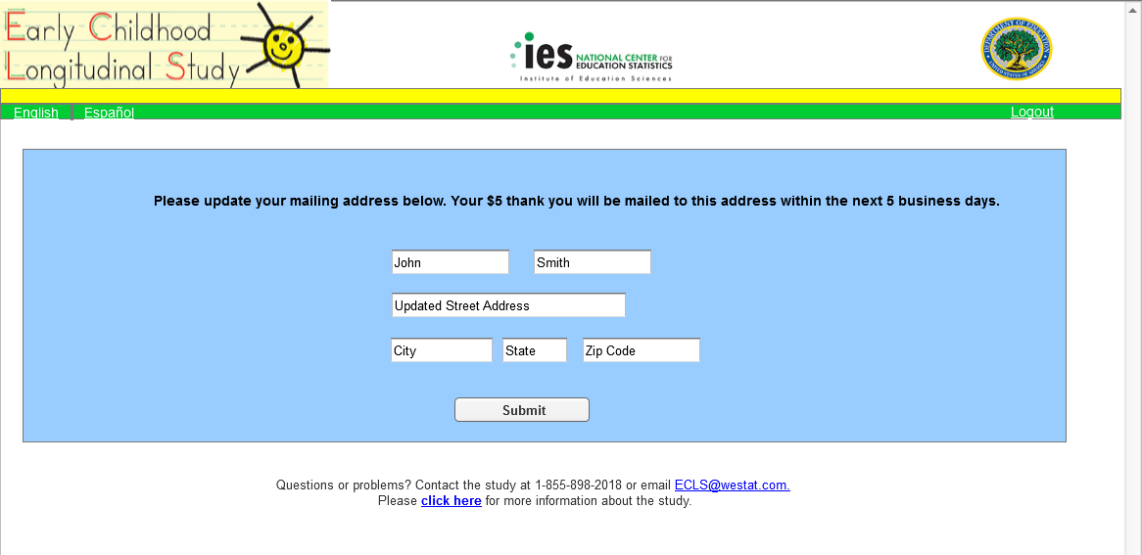
English Text Reads:
Please update your mailing address below. Your $5 thank you will be mailed to this address within the next 5 business days.

Editable fields with pre-filled text:
John Smith
Updated Street Address
City, State, Zip Code

Submit (button)

Spanish Text Reads:
Por favor actualice su dirección postal que está a continuación. Sus $5 de agradecimiento le serán enviados a esta dirección dentro de los próximos 5 días hábiles o de negocios.

Editable fields with pre-filled text:
John Smith
Updated Street Address
City, State, Zip Code

Enviar (button)

Page Details
Respondents who select the Edit my address link on Screen 18 (Cash Thank You – Fall) or Screen 20 (Thank You Confirmation – Cash – Fall) will be routed to this page, where they can update any or all of the pre-filled fields. If the respondent navigated to this page from Screen 18, clicking the “Submit” button will route them to Screen 18b (Cash Thank You – Updated Address – Fall), where their new address will be displayed. The respondent will proceed to confirm that they wish to receive a cash thank you at this updated address by selecting the “Receive Cash” button. Respondents who navigated to this page from Screen 20 will be routed back to Screen 20, where their updated address will show in the mailing confirmation message. The address will be saved as a second variable and will not overwrite the original address from sampling.

Screen 18b: Cash Thank You – Updated Address - Fall
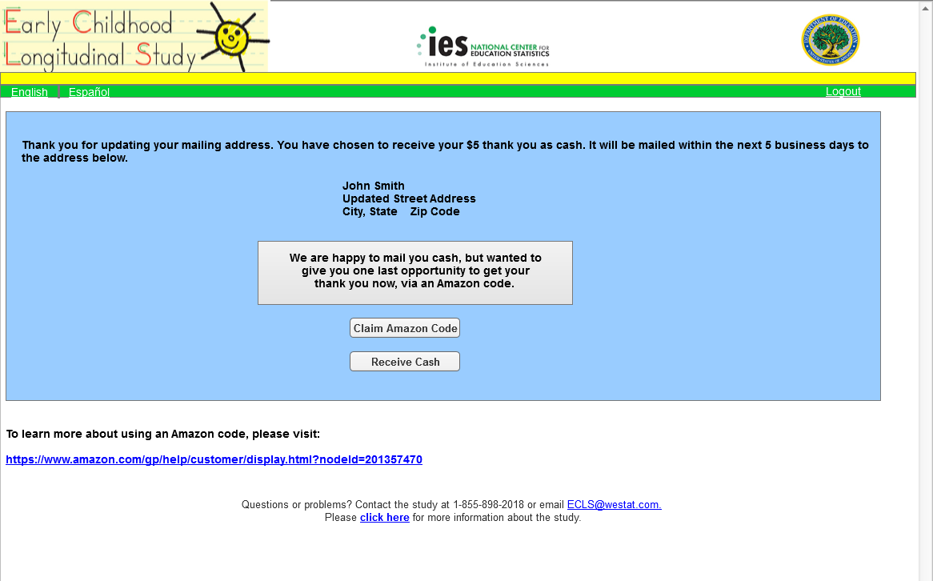
English Text Reads:
Thank you for updating your mailing address. You have chosen to receive your $5 thank you as cash. It will be mailed within the next 5 business days to the address below.

John Smith
Updated Street Address
City, State Zip Code

We are happy to mail you cash, but wanted to give you one last opportunity to get your thank you now, via an Amazon code.

Claim Amazon Code (button)
Receive Cash (button)

To learn more about using an Amazon code, please visit:
https://www.amazon.com/gp/help/customer/display.html?nodeId=201357470

Spanish Text Reads:
Gracias por actualizar su dirección. Usted ha elegido recibir sus $5 de agradecimiento en dinero en efectivo. Le será enviado dentro de los próximos 5 días hábiles o de negocios a la dirección siguiente.

John Smith
Updated Street Address
City, State Zip Code

Con mucho gusto le enviaremos el dinero en efectivo por correo, pero nos gustaría ofrecerle una última vez la opción de recibir nuestra muestra de agradecimiento ahora, a través de un código de Amazon.

Solicitar código de Amazon (button)
Recibir dinero en efectivo (button)

Para obtener más información sobre el uso de un código de Amazon, por favor visite la página:
https://www.amazon.com/gp/help/customer/display.html?nodeId=201357470

Page Details
Respondents who update their address and click “Submit” on Screen 18a (Cash Thank You – Edit Address – Fall) will be routed to this page to confirm that they wish to receive their thank you in cash. These respondents will have navigated to Screen 18a from the Edit my address link on Screen 18.

Screen 19: Thank You Confirmation – Amazon - Fall

English Text Reads:
You have chosen to receive an Amazon code for your thank you.
Your Amazon code is:
XXX-XXX-XXXXX
Please make a note of this code, as it will NOT be emailed or sent to you.
To learn more about using an Amazon code, please visit:
https://www.amazon.com/gp/help/customer/display.html?nodeId=201357470
Thank you for completing the ECLS survey!

Spanish Text Reads:
Usted ha elegido recibir un código de Amazon como su agradecimiento.
Su código de Amazon es:
XXX-XXX-XXXXX
Por favor anote este código, ya que NO se le va a enviar por correo electrónico ni de otro modo.
Para obtener más información sobre el uso de un código de Amazon, por favor visite la página:
https://www.amazon.com/gp/help/customer/display.html?nodeId=201357470
¡Gracias por completar la encuesta ECLS!

Page Details
Respondents who choose to receive an Amazon digital code for their thank you will view this page after selecting the “Amazon” button on Screen 17 (Survey Complete – Fall), or the “Claim Amazon Code” button on Screen 18 (Cash Thank You – Fall).

Screen 20: Thank You Confirmation – Cash - Fall
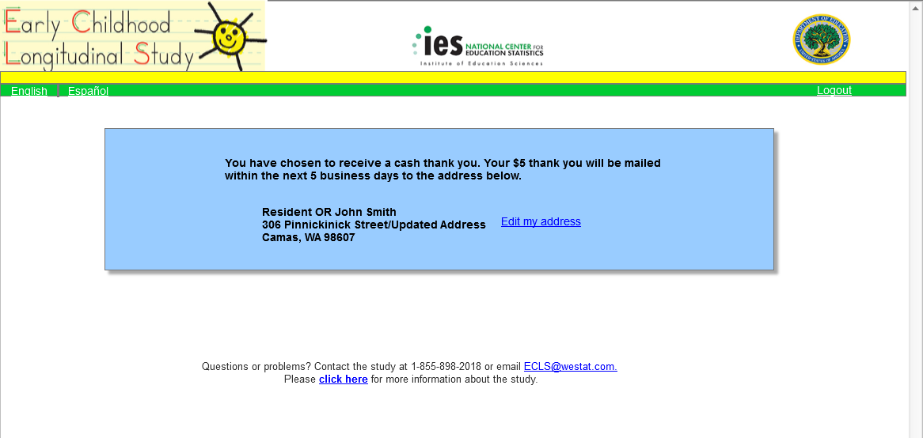

English Text Reads:
You have chosen to receive a cash thank you. Your $5 thank you will be mailed within the next 5 business days to the address below.

Resident OR John Smith
306 Pinnickinick Street/Updated Address
Camas, WA 98607

Edit my address (link)

Spanish Text Reads:
Usted ha elegido recibir su agradecimiento en dinero en efectivo. Sus $5 de agradecimiento le serán enviados dentro de los próximos 5 días hábiles o de negocios a la dirección siguiente.

Familia en esta dirección O John Smith
306 Pinnickinick Street/Updated address
Camas, WA 98607

Corregir mi dirección (link)

Page Details
Respondents who choose to receive cash for their thank you will view this confirmation page after selecting the “Continue to claim your $5 in cash” on Screen 18 (Cash Thank You – Fall). Respondents may make last minute edits to the mailing address for their thank you at this point. If a respondent selects the Edit my address link on this screen, they will be routed to Screen 18a (Cash Thank You – Edit Address – Fall), where they can update any or all of the pre-filled fields. When the respondent navigates to Screen 18a from Screen 20, selecting the “Submit” button on Screen 18a will return the respondent back to Screen 20, with the updated address showing on the confirmation message. The address will be saved as a second variable and will not overwrite the original address from sampling.

Screen 21: Study Information Page – Spring/Fall
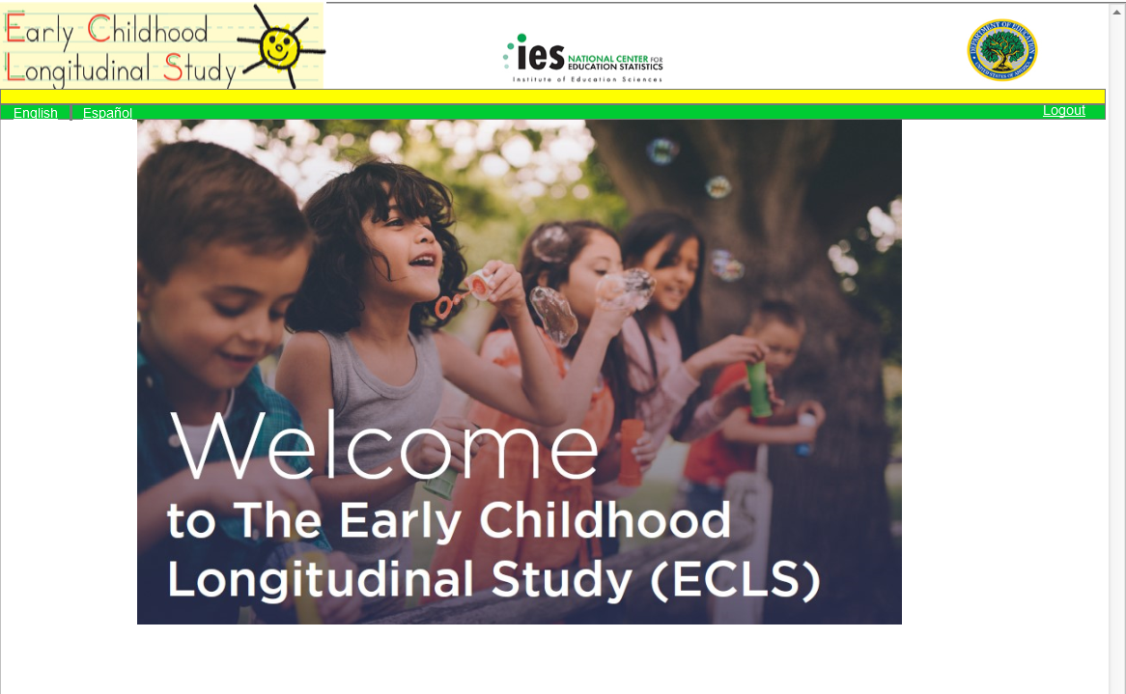
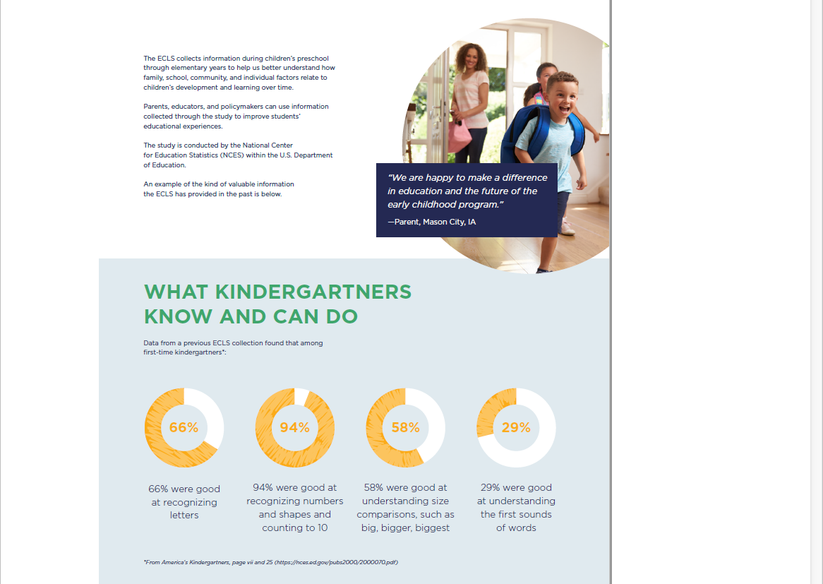

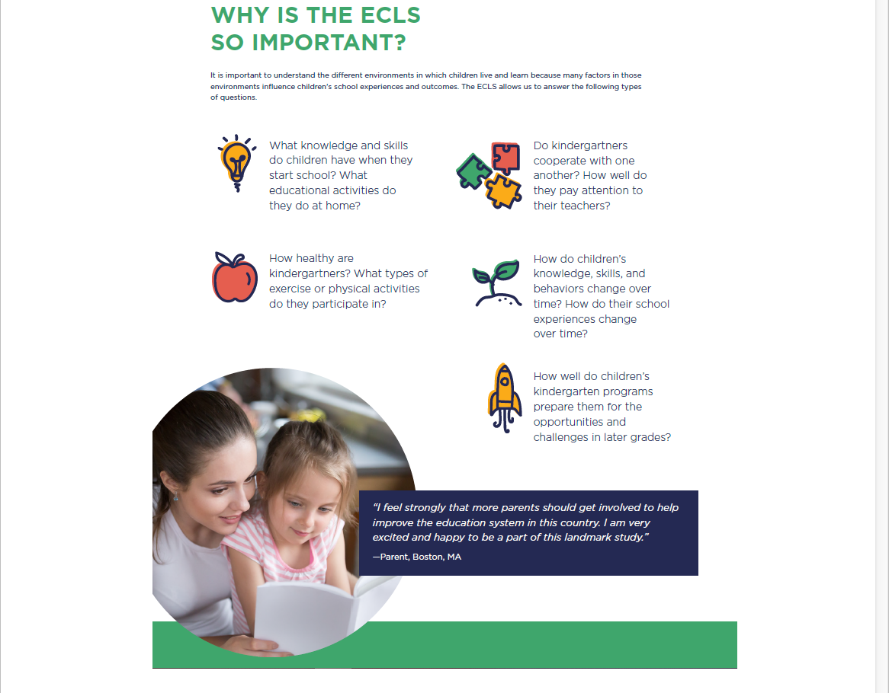
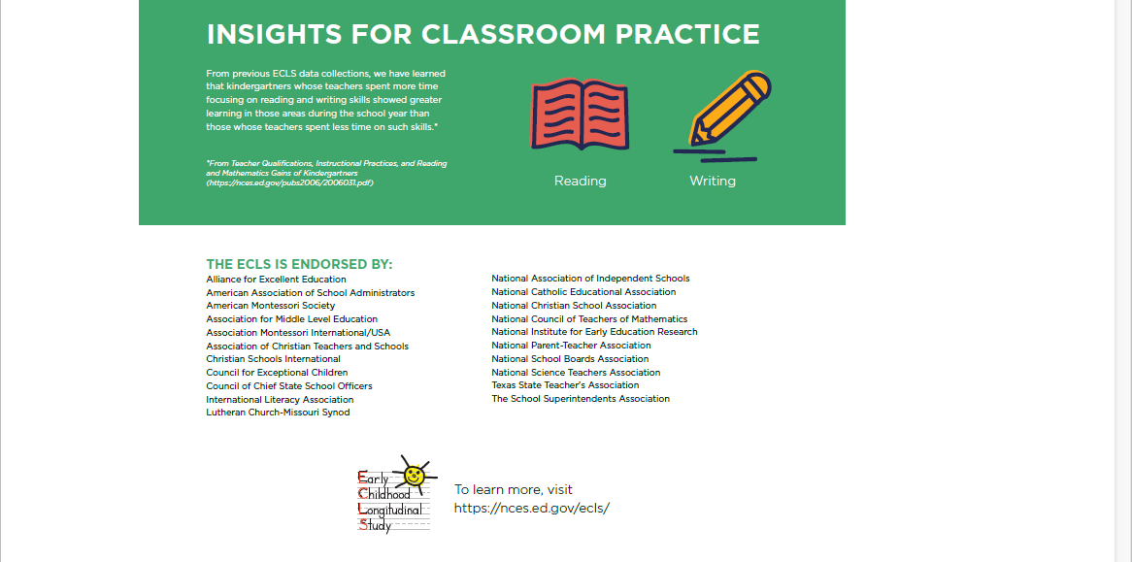

English Text Reads:
Welcome to the Early Childhood Longitudinal Study (ECLS)

The ECLS collects information during children’s preschool through elementary years to help us better understand how family, school, community, and individual factors relate to children’s development and learning over time.

Parents, educators, and policymakers can use information collected through the study to improve students’ educational experiences.

The study is conducted by the National Center for Education Statistics (NCES) within the U.S. Department of Education.

An example of the kind of valuable information the ECLS has provided in the past is below.

“We are happy to make a difference in education and the future of the early childhood program.”
—Parent, Mason City, IA

WHAT KINDERGARTNERS KNOW AND CAN DO
Data from a previous ECLS collection found that among ﬁrst-time kindergartners*:

66%
66% were good at recognizing letters

94%
94% were good at recognizing numbers and shapes and counting to 10

58%
58% were good at understanding size comparisons, such as big, bigger, biggest

29%
29% were good at understanding the first sounds of words

*From America's Kindergartners, page vii and 25 (https://nces.ed.gov/pubs2000/2000070.pdf)

WHY IS THE ECLS SO IMPORTANT?

It is important to understand the different environments in which children live and learn because many factors in those environments inﬂuence children's school experiences and outcomes. The ECLS allows us to answer the following types of questions.

What knowledge and skills do children have when they start school? What educational activities do they do at home?

How healthy are kindergartners? What types of exercise or physical activities do they participate in?

Do kindergartners cooperate with one another? How well do they pay attention to their teachers?

How do children’s knowledge, skills, and behaviors change over time? How do their school experiences change over time?

How well do children’s kindergarten programs prepare them for the opportunities and challenges in later grades?

“I feel strongly that more parents should get involved to help improve the education system in this country. I am very excited and happy to be a part of this landmark study.”
—Parent, Boston, MA

INSIGHTS FOR CLASSROOM PRACTICE

From previous ECLS data collections, we have learned that kindergartners whose teachers spent more time focusing on reading and writing skills showed greater learning in those areas during the school year than those whose teachers spent less time on such skills.*

*From Teacher Qualiﬁcations, Instructional Practices, and Reading and Mathematics Gains of Kindergartners
(https://nces.ed.gov/pubs2006/2006031.pdf)

THE ECLS IS ENDORSED BY:
Alliance for Excellent Education
American Association of School Administrators
American Montessori Society
Association for Middle Level Education
Association Montessori International/USA
Association of Christian Teachers and Schools
Christian Schools International
Council for Exceptional Children
Council of Chief State School Officers
International Literacy Association
Lutheran Church-Missouri Synod
National Association of Independent Schools
National Catholic Educational Association
National Christian School Association
National Council of Teachers of Mathematics
National Institute for Early Education Research
National Parent-Teacher Association
National School Boards Association
National Science Teachers Association
Texas State Teacher's Association
The School Superintendents Association
To learn more, visit https://nces.ed.gov/ecls/

Spanish Text Reads:
Bienvenido al Estudio Longitudinal de la Primera Infancia (ECLS, por sus siglas en inglés)

El estudio ECLS obtiene información durante los años de educación preescolar hasta la primaria para ayudarnos a entender mejor la manera en que la familia, la escuela, la comunidad y los factores individuales están relacionados con el desarrollo y aprendizaje de los niños a través del tiempo.

Los padres, los educadores y los legisladores pueden usar la información obtenida a través del estudio para mejorar las experiencias educativas de los estudiantes.

El estudio lo está llevando a cabo el Centro Nacional para Estadísticas de Educación (NCES, por sus siglas en inglés) en el Departamento de Educación de los Estados Unidos.

A continuación, se muestra un ejemplo del tipo de valiosa información que el estudio ECLS ha proporcionado en el pasado.

“Estamos muy contentos de tener impacto en educación y el futuro del programa de la primera infancia.”
—Padre/Madre, Mason City, IA

LO QUE LOS NIÑOS DE KINDERGARTEN SABEN Y PUEDEN HACER
De anteriores recolecciones de datos que hizo ECLS se encontró que entre los niños que asisten al kindergarten por primera vez *:

66%
El 66% reconocía bien las letras.

94%
El 94% reconocía bien los números y las figuras geométricas, y contaba bien hasta el número 10.

58%
El 58% entendía bien comparaciones de tamaño, como por ejemplo, reconocer un objeto grande, uno más grande que otro, y el más grande de todos.

29%
El 29% distinguía bien el sonido con que comienzan las palabras

*Fuente: America's Kindergartners (Los niños de kindergarten de los Estados Unidos), página vii y 25 (https://nces.ed.gov/pubs2000/2000070.pdf)

¿POR QUÉ EL ECLS ES TAN IMPORTANTE?

Es importante entender los diferentes ambientes en que los niños viven y aprenden, porque muchos factores de esos ambientes influyen en las experiencias y los resultados escolares de los niños. El ECLS nos permite responder los siguientes tipos de preguntas:

¿Qué conocimientos y habilidades tienen los niños cuando comienzan la escuela? ¿Qué actividades educativas hacen en el hogar?

¿Qué tan saludables son los niños que asisten a kindergarten? ¿En qué tipo de ejercicios o actividades físicas participan?

¿Los niños que asisten a kindergarten cooperan entre sí? ¿Qué tan bien ponen atención a sus maestros?

¿De qué manera cambian los conocimientos, las habilidades y los comportamientos de los niños a lo largo del tiempo? ¿Cómo cambian sus experiencias escolares a lo largo del tiempo?

¿Qué tan bien preparan los programas de kindergarten a los niños para las oportunidades y los desafíos en los grados posteriores?

“Creo firmemente que más padres o madres deberían involucrarse para ayudar a mejorar el sistema educativo en este país. Estoy muy emocionado(a) y feliz de ser parte de este estudio histórico.”
—Padre/Madre, Boston, MA

IDEAS PARA PONER EN PRÁCTICA EN UN SALÓN DE CLASES

De anteriores recolecciones de datos que hizo ECLS hemos aprendido que los niños que asisten a kindergarten y cuyos maestros pasaron más tiempo enfocándose en las habilidades de lectura y escritura, mostraron un mayor aprendizaje en esas áreas durante el año escolar que aquellos cuyos maestros pasaron menos tiempo en dichas habilidades.*

*Fuente: Teacher Qualiﬁcations, Instructional Practices, and Reading and Mathematics Gains of Kindergartners (Calificaciones de los maestros, prácticas de instrucción y logros en lectura y matemáticas de los niños de kindergarten) (https://nces.ed.gov/pubs2006/2006031.pdf)

EL ESTUDIO ECLS ESTÁ AVALADO POR:
Alliance for Excellent Education
American Association of School Administrators
American Montessori Society
Association for Middle Level Education
Association Montessori International/USA
Association of Christian Teachers and Schools
Christian Schools International
Council for Exceptional Children
Council of Chief State School Officers
International Literacy Association
Lutheran Church-Missouri Synod
National Association of Independent Schools
National Catholic Educational Association
National Christian School Association
National Council of Teachers of Mathematics
National Institute for Early Education Research
National Parent-Teacher Association
National School Boards Association
National Science Teachers Association
Texas State Teacher's Association
The School Superintendents Association

Para obtener más información, visite: https://nces.ed.gov/ecls/

Page Details
Respondents can navigate to this page from any page, via the link in “Please click here for more information about the study.” Respondents can also navigate to this page if they are determined to be ineligible on Screen 4, via the link in “If you would like to learn more about the Early Childhood Longitudinal Study, please click here.” Finally, respondents will be redirected to this page from the parent survey if they identify as a person who can’t answer questions about the child (parent item INQ001=2).

