CBI UNSANITIZED DATA ELEMENT FORM
The annual public reporting and recordkeeping burden for this collection of information for those sources that claim CBI is estimated to average 9.5 hours per claim. This collection of information is approved by OMB under the Paperwork Reduction Act, 44 U.S.C. 3501 et seq. (OMB Control No. 2050-0144). Responses to this collection of information are mandatory (40 CFR 370.40 to 370.42). An agency may not conduct or sponsor, and a person is not required to, respond to a collection of information unless it displays a currently valid OMB control number. Form completion and mailing instructions can be found at https://www.epa.gov/rmp/rmpesubmit-users-manual. Send comments on the Agency's need for this information, the accuracy of the provided burden estimates, and any suggested methods for minimizing respondent burden, including through the use of automated collection techniques to the Director, Collection Strategies Division, U.S. Environmental Protection Agency (2822T), 1200 Pennsylvania Ave., NW, Washington, D.C. 20460. Include the OMB control number in any correspondence. Do not send the completed form to this address.
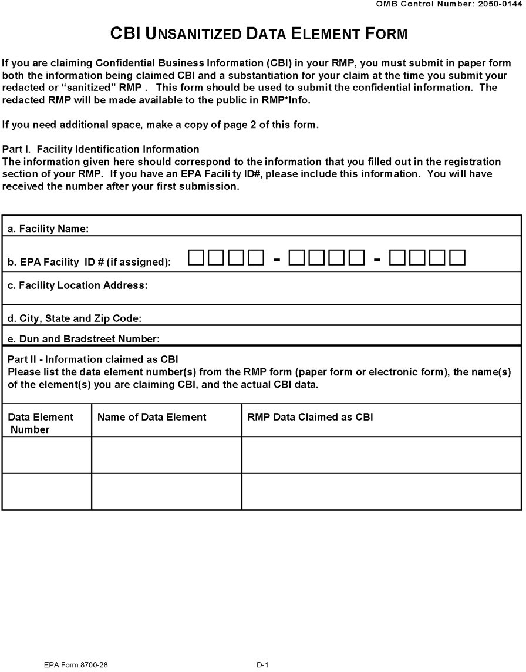
Expiration Date XX/XX/XXXX

