Supporting Statement for EPA’s Information Collection Request
Number 2254.03
Responsible Appliance Disposal Program (Renewal)

TABLE OF CONTENTS

1. IDENTIFICATION OF THE INFORMATION COLLECTION 1
1(a) Title of the Information Collection 1
1(b) Short Characterization/Abstract 1
2. NEED FOR AND USE OF THE INFORMATION COLLECTION 2
2(a) Need and Authority for the Collection 2
2(b) Practical Utility and Users of the Data 3
3. NONDUPLICATION, CONSULTATIONS, AND OTHER COLLECTION CRITERIA 4
3(a) Nonduplication 4
3(b) Public Notice Request Prior to ICR Submission to OMB 4
3(c) Consultations 4
3(d) Effects of Less Frequent Collection 5
3(e) General Guidelines 5
3(f) Confidentiality 5
3(g) Sensitive Questions 6
4. THE RESPONDENTS AND THE INFORMATION REQUESTED 6
4(a) Respondents/ and NAICS Codes 6
4(b) Information Requested 6
5. THE INFORMATION COLLECTED: AGENCY ACTIVITIES, COLLECTION METHODOLOGY, AND INFORMATION MANAGEMENT 10
5(a) Agency Activities 10
5(b) Collection Methodology and Management 11
5(c) Small Entity Flexibility 11
5(d) Collection Schedule 11
6. ESTIMATING THE BURDEN AND COST OF THE COLLECTION 11
6(a) Estimating Respondent Burden 11
6(b) Estimating Respondent Costs 15
6(c) Estimating Agency Burden and Cost 15
6(d) Estimating the Respondent Universe and Total Respondent Burden and Costs 18
6(e) Bottom Line Burden Hours and Costs 19
6(f) Reasons for Change in Burden 20
6(g) Burden Statement 20
7. SUPPLEMENTARY INFORMATION 22
7(a) Guidance Document for Existing and Prospective Partners 22
7(b) Partnership Agreement Form 24
7(c) Annual Reporting Form for Partners 27

1. IDENTIFICATION OF THE INFORMATION COLLECTION

1(a) Title of the Information Collection

This ICR is entitled "Responsible Appliance Disposal Program (Renewal)," EPA ICR number 2254.03, OMB Control Number 2060-0703.

1(b) Short Characterization/Abstract

The Responsible Appliance Disposal program (RAD) is a voluntary partnership program sponsored by the Environmental Protection Agency (EPA) that encourages partners to reduce emissions of ozone depleting substances (ODS) and their alternatives that can be attributed to improper disposal of appliances. Appliances may contain ozone-depleting refrigerants and foams as well as universal wastes such as mercury, used oil, and polychlorinated biphenyls (PCBs). Federal law requires refrigerant recovery and proper management of universal waste but does not require the recovery of appliance foam. The RAD program works with utilities, retailers, manufacturers, state affiliates, and others to dispose of appliances using best environmental practices.
To encourage reductions in emissions associated with appliance disposal in the United States, the EPA launched the RAD program. The RAD program supports Section 608 of the Clean Air Act (CAA) and is an important component of the EPA’s mission to protect the ozone layer by reducing emissions of ODS. RAD program partners reduce emissions of ODS and realize other benefits through recovery and destruction/reclamation of refrigerants and foam blowing agents–the latter of which is not covered under existing Federal regulations–and by ensuring that all other hazardous and recyclable materials are handled using best environmental practices. Greenhouse gas (GHG) emissions are avoided through recovery of both ODS and many non-ODS foam blowing agents not covered under existing regulations. Additionally, through the RAD program, the EPA is partnering with utilities, retailers, manufacturers, state agencies, and others to promote the retirement of old appliances and permanently remove energy inefficient units from the electricity grid, providing energy savings to consumers.
Participation in the program begins with completion of a mutually agreed upon Partnership Agreement that outlines mutual responsibilities for participation in RAD program. By voluntarily joining the program, a partner agrees to complete an annual reporting form identifying the number and types of appliances handled and the fates of their individual components. The electronic reporting form automatically generates feedback for the user on the results of their participation in terms of emissions avoided, quantity of used oil/PCBs/mercury destroyed or recycled, energy savings achieved, and consumer savings realized. An annual report provides partners with information on their progress towards achieving emissions reductions and information about developments in the latest recycling technologies and practices. Through recognition of partner efforts, and the program’s promotion of recycling best practices through webinars, web updates, fact sheets, and presentations, non-partners become aware of recycling best practices and can evaluate what best practices could work for them. The RAD program largely serves to disseminate information on recycling best practices and creates a platform for information sharing on recycling and waste management practices. The data collected are used as an indicator of whether industry is reducing emissions from end-of-life appliances.

2. NEED FOR AND USE OF THE INFORMATION COLLECTION

2(a) Need and Authority for the Collection
The RAD program is an important action contributing to the overall reduction of ODS emissions, specifically through increased ODS refrigerant and foam destruction or reclamation, and dissemination of information on recycling best practices and technologies. The RAD program also contributes to the overall reduction of other emissions, solid waste and landfill space used, as well as the removal of energy inefficient appliances off the electrical grid, providing energy savings. The information to be obtained under this ICR is not collected by EPA or any other Federal agency. The refrigerant management program under Section 608 of the Clean Air Act does not collect, nor does it require records, of the data described in this ICR (See 40 CFR 82.155).
EPA is renewing this ICR to continue to collect information from partners participating in the RAD program. By participating in the program, a partner agrees to the terms of information collection specified by EPA in the Partnership Agreement. Specifically, partners agree to submit the Partnership Agreement to EPA, as well as an annual reporting form that details the quantity of materials handled by the partner in their appliance recycling practices and how those materials were handled.

2(b) Practical Utility and Users of the Data
The Agency will use the Partnership Agreement to establish a framework for a voluntary agreement with partners in the program. EPA will use information submitted in the annual reports to demonstrate that partners are reducing ODS emissions from appliance recycling operations. Data collected in the annual reports will show individual respondents’ emissions reductions benefits. EPA also will use the information to determine trends in partner efforts including: (1) the types, number, average age, and charge levels of refrigerant-containing appliances collected by partner recycling programs, (2) the ultimate fates of appliance components, (3) the energy savings resulting from programs that offer an incentive for removing old appliances from the electricity grid, (4) the amount of emissions avoided, (5) the amount of durable materials prevented from being landfilled, and (6) the number of PCB-containing capacitors and mercury switches properly disposed. In addition, EPA will use the information to publicize partner successes.
EPA may use data submitted by partners to develop documents on technologies and practices and prepare case studies highlighting partner successes. These documents are publicly available and demonstrate what can be achieved through the RAD program.
The RAD program conducts the following activities:
- Developing technical fact sheets
- Hosting technology analysis webinars and roundtable discussions
- Providing support to partners
- Publicizing achievements of partners
- Making available to partners a mechanism for recording and storing information about refrigerant and foam emission reduction activities
- Serving as a technical clearing house on the most environmentally friendly recycling technologies.
In addition to benefitting partner companies, the above activities benefit non-partner companies. Technical documents, annual reports, partner highlights and achievements, and webinars are available to both partners and non-partners. For example, technical documents developed by the Program are made available to the public on the RAD website, and webinar attendance is not restricted to program partners.

The annual reports submitted by partners go through a quality assurance/quality control process to ensure all data are accurate. Any inconsistencies are resolved via direct correspondence with the partner in question. The refrigerant and foam emission reduction data submitted to EPA are used to determine program emission reduction totals and measure the overall partner progress. The practical utility of the information received by EPA is to give partners recognition for their efforts to reduce emissions of end-of-life appliances through recycling and best practices.

3. NONDUPLICATION, CONSULTATIONS, AND OTHER COLLECTION CRITERIA

3(a) Nonduplication
The information obtained under this ICR is not collected by any other EPA program or Federal agency. The information is not available from other sources because it is proprietary information submitted by industry sources.

3(b) Public Notice Request Prior to ICR Submission to OMB
In compliance with the Paperwork Reduction Act of 1995, EPA issued a public notice in the Federal Register (84 FR 2853) on February 8, 2019 soliciting public comments for a 60-day period. One comment was received regarding recycling to build water filtration, storage and shipment facilities for water shortage areas. Appliance recycling and related technologies are not applicable to those referred to by commenter and is not relevant to this ICR or any related rulemaking, so EPA is not providing a specific response. EPA will issue a second notice soliciting public comments for a 30-day period concurrent with the submission of this renewal to OMB.

3(c) Consultations
Recently, EPA’s RAD program consulted with existing partners about the time associated with the partnership’s reporting activities. EPA contacted existing partners representing all partner categories, recent and long-standing partners, and a wide range of program sizes. The following partners provided input for this ICR:
Partner Category | Partner | Partnership Contact
Utility | Commonwealth Edison | Violeta Gonzalez
Utility | PPL Electric Utilities | Mary Ann Kelly-Merenda
Utility | Puget Sound Energy | Holly Mulvenon
Manufacturer | GE Appliances | Cynthia Broskey
Retailer | Sears Holdings Corporation | Christie Kochis
State | Delaware Department of Health and Social Services | Jarrod Fala

After collecting this feedback, EPA determined that the information included in the original ICR remains accurate. This is largely because partner reporting activities and associated reporting forms have undergone minimal changes since the original ICR. See Section 6 of this ICR for these calculations.

3(d) Effects of Less Frequent Collection
EPA requests that the partner submit information on its appliance recycling practices to the Agency once per year. Any reduction in the frequency of this information collection would impede efforts by EPA to evaluate the usefulness of this program to partners. Less frequent collection of data would also place an undue burden on both EPA and partners to ensure accuracy of data. For example, any one data inaccuracy would be compounded by the greater time between actual data collection and the efforts required to correct the historical information.

3(e) General Guidelines
This ICR follows all the regulations established by OMB in 5 CFR 1320.5.

3(f) Confidentiality
Participation in the RAD program is voluntary. EPA informs the respondents that they may assert claims of business confidentiality for any of the information they submit. Information claimed as confidential will be treated in accordance with the procedures for handling information claimed as confidential under 40 CFR Part 2, Subpart B (“Confidentiality of Business Information”) and will be disclosed only if EPA determines that the information is not entitled to confidential treatment. If no claim of confidentiality is asserted when the information is received by EPA, it may be made available to the public without further notice to the respondents (40 CFR 2.203).

3(g) Sensitive Questions
No questions of a sensitive nature or of matters usually considered private to individuals will be asked.

4. THE RESPONDENTS AND THE INFORMATION REQUESTED

4(a) Respondents/ and NAICS Codes
The North American Industry Classification System (NAICS) codes of entities most likely to be affected by the information collection requirements covered under this ICR are listed below in Table 1.

Table 1. NAICS Classification of Affected Industries
Potentially Affected Entities | NAICS Code | NAICS Category
Utilities | 2211 | Electric Power Generation, Transmission and Distribution
Manufacturers | 3352 | Household Appliance Manufacturing
Retailers | 443141 | Household Appliance Stores
Universities | 611310 | Colleges, Universities, and Professional Schools
Municipality | 999300 | Local Government

4(b) Information Requested
Partners participating in the RAD program submit a Partnership Agreement to the EPA. The partners also agree to submit the annual reporting form that provides data on materials handled by the appliance recycling program and calculates environmental benefits achieved through the program. Each of these information collections is described separately below, along with the respective data items and respondent activities.

Partnership Agreement
A number of partners worked with EPA to prepare the model Partnership Agreement establishing the terms of participation in the RAD program. Each partner may choose to further work with EPA on their individual agreement and after finalizing the Partnership Agreement, each partner reviews, signs, and submits it to the Agency.
(i) Data Item
- Partnership Agreement
(ii) Respondent Activities
- Prepare the Partnership Agreement in collaboration with EPA (varies by partner);
- Review and sign the Partnership Agreement; and
- Submit the Partnership Agreement to EPA.

Annual Reporting Form
The partner agrees that it will complete an annual reporting form either electronically, using Excel, or manually, using a printed PDF form. The electronic version of the reporting form includes an auto-generated sheet that summarizes the environmental benefits achieved through the Partner’s program, based on the data entered for that reporting year. The forms are provided by EPA, and the partner submits the completed form to the Agency.
(i) Data items
The reporting form requests the following information:
- Partner name;
- Reporting period;
- Contact information including names, addresses, phone numbers, fax numbers, and e-mail addresses of a primary and alternative contact;
- Category of the RAD Partner’s program (utility, retailer, manufacturer, or state);
- Number of households/stores/states/facilities in the area served by the program;
- Equipment types included in the Partner’s program (refrigerators/freezers, stand-alone freezers, window air conditioning units, and/or dehumidifiers);
- Whether the program jointly processes/administers some appliances with another RAD Partner;
- Whether the program actively encourages the disposal of old, working equipment (e.g., provides a financial incentive);
- Contact information for all companies used by a partner’s program to collect/treat appliances and recovered materials in order to fulfill the requirements of the RAD program including:
  - Company name
  - Contact name
  - Phone number
  - Address
  - Company/facility role
  - Foam recovery items (doors, case) and recovery process used
  - Type of technology/equipment used if applicable
- For each type of appliance included in the partner’s recycling program:
  - Total number of units processed;
  - Average age of appliances collected;
  - Number of units processed and processed with refrigerant/foam recovery with each refrigerant and insulating material type;
  - Whether foam was recovered from appliance doors;
  - Method for estimating the total number/amounts of various components processed;
  - Total amount and fate(s) of each appliance component processed;
  - If the program provides an incentive to encourage the disposal of old equipment: the average energy consumed/year/unit and the average energy cost for residential consumers; and
  - Additional comments.
- For partners that jointly process/administer some appliances with another RAD partner: number of units processed with refrigerant/foam recovery for each refrigerant and insulating material type for each appliance type
- Partner feedback on the RAD program; and
- Partner signature.

In the electronic version of the reporting form, the following calculations are automatically generated for the user:

- Average quantity recovered per unit, calculated based on reported total quantity and number of units processed. The user reviews these calculations and compares them to the typical range reported, included for all the calculations, to perform a quality assurance check on the data provided. No data or additional information is requested.
- Summary of the total quantity and ODS and ODS substitute emissions prevented from being emitted as a result of the user’s activities. This page is intended only for the user’s interest; no data or additional information is requested.
- Estimates of gross energy impact, if the partner’s recycling program provides an incentive to encourage the disposal of old equipment. This page is intended only for the user’s interest; no data or additional information is requested.
- Key messages and figures for RAD partners to promote the benefits of their appliance disposal program. This page is intended only for the user’s interest; no data or additional information is requested.
- If the program provides an incentive to encourage the disposal of old equipment: the average number of remaining years of useful life of that equipment. This calculation is intended only for the user’s interest; no data or additional information is requested.

(ii) Respondent activity
- Partners complete and submit the annual reporting form each calendar year the Partnership Agreement is in effect.

In the electronic version of the reporting form, the following calculations are automatically generated for the user:
- Average quantity recovered per unit, calculated based on reported total quantity and number of units processed. The user reviews these calculations and compares them to the typical range reported, included for all the calculations, to perform a quality assurance check on the data provided. No data or additional information is requested.
- Summary of the ODS and ODS substitute emissions avoided as a result of the user’s activities. This page is intended only for the user’s interest; no data or additional information is requested.
- Estimates of gross energy impact, if the partner’s recycling program provides an incentive to encourage the disposal of old equipment. The user reviews these estimates (which include total saved energy and total dollar savings to residential consumers) and provides corrections if necessary.

5. THE INFORMATION COLLECTED: AGENCY ACTIVITIES, COLLECTION METHODOLOGY, AND INFORMATION MANAGEMENT

5(a) Agency Activities
EPA performs certain activities associated with the Partnership Agreement, the annual reporting forms, and information sharing. Each of these three information collections, and the Agency’s activities associated with them, are described in more detail below.
Partnership Agreement
EPA performs the following activities related to the Partnership Agreement for RAD partners:
- Develop the draft Partnership Agreement in collaboration with partner(s);
- Solicit and review stakeholder comments;
- Develop the final Partnership Agreement;
- Disseminate the Partnership Agreement; and
- Review and file the completed Partnership Agreement.

Annual Reporting Form
EPA performs the following activities with regard to the annual reporting form to be submitted by the partners:
- Develop the reporting form;
- Solicit and review stakeholder comments;
- Disseminate the reporting form;
- Review annual reporting forms submitted by partners and aggregate/ analyze the data to estimate aggregate RAD partner emissions reductions;
- Develop a summary annual report; and
- File and maintain copies of the reporting forms.

5(b) Collection Methodology and Management
In collecting and analyzing the information associated with this ICR, EPA uses electronic equipment, such as personal computers and applicable database software. EPA also provides hardcopies of all forms at request. EPA will ensure the accuracy and completeness of collected information by reviewing each partner’s submitted information. EPA will maintain files of Partnership Agreements and reporting forms.
EPA maintains an Internet web page for this program (www.epa.gov/rad) that facilitates access to general program information and allows interested parties to download relevant documents including guidelines for proper appliance handling, and the annual reporting form.

5(c) Small Entity Flexibility
EPA has designed its reporting forms to minimize respondent burden while obtaining sufficient and accurate information. In addition, the burden associated with the partnership is inherently minimized since the initial agreement to participate is voluntary.

5(d) Collection Schedule
EPA collects basic partner information in the Partnership Agreement, which is completed and submitted by the partner. EPA collects reporting forms from partners on an annual basis. EPA may collect other program information on a periodic basis or as the information is submitted.

6. ESTIMATING THE BURDEN AND COST OF THE COLLECTION

6(a) Estimating Respondent Burden
Table 2 presents the estimated annual respondent burden and costs for information collection activities associated with the RAD program. In the “Hours and costs per respondent or activity” section, Table 2 presents the average burden for each partner, accounting for the varying labor rates among the four types of partners. Table 2 includes the number of hours required to conduct the information collection activity and the cost associated with each requirement. In developing burden estimates for each information collection requirement in this ICR, EPA consulted with third party stakeholders and considered partner feedback. (See Section 3(c) of this ICR for information on the consultations.) As shown in Table 2, EPA estimates a total average annual respondent burden of approximately 6 hours. Assumptions used in calculating this estimate are described below.

Table 2. Respondent Burden and Costª
INFORMATION COLLECTION ACTIVITY | Frequency/ Number of Responses ^{b} | Per-Activity |  |  |  |  | Average Hours/Year | Average Cost/Year
 |  | Legal | Manager | Technical | Clerical | Total Labor  Hours
Review the Partnership Agreement | One occurrence per partner; 9 new partners assumed over 3 years | 2 | 2 | 2 | 0 | 6 | 18.00 | $1,955.46
Complete the Partnership Agreement |  | 0 | 0.25 | 0 | 0 | 0.25 | 0.75 | $266.25
Submit the Partnership Agreement to EPA |  | 0 | 0 | 0 | 0.25 | 0.25 | 0.75 | $34.29
Subtotal – Partnership Agreements |  | 2 | 2.25 | 2 | 0.25 | 6.5 | 19.50 | $2,078.51
Complete and submit first annual report | One occurrence per partner; 9 first annual reports assumed to be completed by partners over 3 years (from 5 partners in Program Year 1, 3 partners in Program Year 2, and 1 partner in Program Year 3) | 0 | 6 | 0 | 0.25 | 6.25 | 18.75 | $2,164.28
Complete and submit subsequent annual report | Zero to two occurrences per partner over 3 years; 145 subsequent annual reports assumed to be completed over 3 years (from 44 partners in Program Year 1, 49 partners in Program Year 2, and 52 partners in Program Year 3) | 0 | 5 | 0 | 0.25 | 5.25 | 253.75 | $32,510.01
Subtotal -- Annual Reports |  |  |  |  |  |  | 275.50 | $34,674.33
TOTAL  (for next 3 yrs of RAD) |  |  |  |  |  |  | 292.00 | $36,752.84
ª See Section 6(b) for more information on how respondent burden is estimated.
^{b} Number of responses is based on the estimated number of new partners over a 3-year period, 2019-2021, as presented in Table 6.
^{c} Labor costs are calculated based on the labor rates presented in Table 3.

6(b) Estimating Respondent Costs
Labor Costs
EPA estimates respondent labor costs (hourly rate plus overhead and fringe) based on the average hourly labor rates of the partners. For each partner, EPA estimates average hourly labor rates according to the type of partner – utility, state/municipality, retailer, or manufacturer. These labor rates are based on national averages reported by the Bureau of Labor Statistics, to which 110% is added to reflect the estimated additional costs for overhead and fringe. Table 3 summarizes the labor rates.

Table 3. Average Hourly Respondent Labor Rates
 | Managerial | Technical | Clerical | Legal
Utilities | $138.39 | $87.68 | $53.24 | $148.53
States/Municipalities | $90.95 | $87.19 | $41.43 | $86.86
Retailers | $102.46 | $116.76 | $32.03 | $94.98
Manufacturers | $136.12 | $67.52 | $42.25 | $121.97

Capital and Operation and Maintenance (O&M) Costs
The partners participating in the RAD program are not required to incur any notable capital costs under the partnership. The partners normally keep track of their program data as a standard business practice.
The partners participating in the RAD program are not required to incur any notable operation and maintenance (O&M) costs. The partners need only to submit their information to EPA.

6(c) Estimating Agency Burden and Cost
Table 4 estimates of average hourly EPA labor costs for legal, managerial, technical, and clerical staff. Table 5 presents the estimated Agency burden hours and costs associated with the information collection activities for this ICR. Agency labor costs are based on national averages for the Federal Executive branch reported by the Bureau of Labor Statistics, which are multiplied by 1.6, the standard government benefits multiplier. As shown in Table 5, EPA estimates that the annual Agency burden for all activities covered in this ICR is 1,181 hours at a total cost of $82,606 per year.

Table 4. Average Hourly Agency Labor Rates
Managerial | Technical | Clerical | Legal
$94.56 | $62.27 | $35.09 | $87.41

Table 5. Agency Burden and Costª
INFORMATION COLLECTION ACTIVITY | Frequency/ Number of Activities | Hours |  |  |  |  |  | Costs
 |  | Legal Hours per Activity | Manager Hours per Activity | Technical Hours per Activity | Clerical Hours per Activity | Total Labor  Hours per Activity | Average Total Hours/Year | Total Labor  Cost per Activity ^{b} | Average Cost/Year
Partnership Agreement
Disseminate the Partnership Agreement | One occurrence per partner; 9 new partners assumed over 3 years. | 0 | 0 | 0 | 0.25 | 0.25 | 0.75 | $8.77 | $26.32
Review the completed Partnership Agreement |  | 0 | 0 | 0.5 | 0 | 0.5 | 1.5 | $31.14 | $93.41
Subtotal |  | 0 | 0 | 0.5 | 0.25 | 0.75 | 2.25 | $39.91 | $119.72
Annual Report
Disseminate the reporting form | One occurrence per year | 0 | 0 | 0 | 1 | 1 | 1.0 | $35.09 | $35.09
Review annual reports and analyze data | One occurrence per reporting form submitted (total of 154 over 3 years)^{c} | 0 | 5 | 15 | 0 | 20 | 1026.67 | $1,406.88 | $72,219.84
Develop summary annual report | One occurrence per year | 0 | 25 | 75 | 0 | 100 | 100 | $7,034.40 | $7,034.40
File and maintain copies of annual reports | One occurrence per reporting form submitted (total of 154 over 3 years)^{c} | 0 | 0 | 1 | 0 | 1 | 51.33 | $62.27 | $3,196.63
Subtotal |  |  |  |  |  |  | 1179.0 |  | $82,485.96
TOTAL (for next 3 yrs. of RAD) |  |  |  |  |  |  | 1181.25 |  | $82,605.68
ª See Sections 6(c) and 6(d) for more information on how Agency burden is estimated.
^{b} Labor costs are calculated based on the labor rates presented in Table 4.
^{c} Number of partner responses is based on the estimated number of new partners over a 3-year period, as presented in Table 6.

6(d) Estimating the Respondent Universe and Total Respondent Burden and Costs
Table 6 summarizes the number of partners expected to participate in the RAD Program during the three-year effective life of this ICR. EPA currently has 43 partners and is expecting one additional partner by the end of 2018 giving 44 by the beginning of the first year. Five new partners are anticipated in 2019 giving 49 partners by the start of the second year and 3 new partners in 2020 giving a total of 52 partners by the start of the third year. Table 6 also breaks down the new and existing partners each year by the four different types of partners in the program. The following paragraphs discuss the information collections these partners will perform under the partnership. Table 2 calculates the annual burden and cost to partners in performing these collections
Table 6: Estimated Number of Program Partners by Partner Type
Type of Partner | 2019 | 2020 | 2021 | Average  (For Three Year lifetime of ICR)
Utilities
New | 2 | 1 | 1 | 1
Existing | 38 | 40 | 41 | 40
Retailers
New | 1 | 0 | 0 | 0
Existing | 3 | 4 | 4 | 4
States/Municipalities
New | 2 | 1 | 0 | 1
Existing | 2 | 4 | 5 | 4
Manufacturers
New | 0 | 1 | 0 | 0
Existing | 1 | 1 | 2 | 1
Total
New | 5 | 3 | 1 | 3
Existing | 44 | 49 | 52 | 48

Partnership Agreement

As shown in Table 6, EPA estimates that, over the three-year life of this ICR, an average of 48 partners will participate in the partnership. All partners must review, sign and submit the Partnership Agreement to EPA to begin their participation in the RAD program. As shown in Table 2, EPA has annualized the one-time burden of Partnership Agreement preparation over three years to estimate that on average 3 new partners will prepare and submit a Partnership Agreement each year. Note that Table 2 calculates respondent burden and costs on an annual basis. The table calculates the burden and cost of one-time activities (i.e., activities performed once during the three-year period of this ICR) by dividing the total number of respondents by three.

Annual Reporting Form
Each partner agrees to complete an annual reporting form to be submitted to the Agency. The report will contain data on the types of appliances handled and the fates of each appliance component. In estimating burden and costs for this information collection, EPA believes that new partners will incur a greater burden in preparing their first report (i.e., for their first year of membership), than in preparing reports for their subsequent years of membership. That is, new partners may encounter a one-time learning curve in compiling and examining data for their “first-year” reporting forms. After gaining such experience, these partners would likely incur a lower burden in preparing their “subsequent-year” reports.
As shown in Tables 2 and 6, EPA estimates that an average of 3 partners each year will be new to the partnership and that each will incur about 6 hours in preparing and submitting their first-year reports to the Agency. EPA further estimates that, over the three-year life of this ICR, 48 partners will submit subsequent-year reports to the Agency each year and incur about 5 hours per report.

6(e) Bottom Line Burden Hours and Costs
Respondent Tally
In Table 2, EPA estimates the total annual respondent burden and cost for the Responsible Appliance Disposal partnership to be approximately 292 hours and $36,753.

Agency Tally
As shown in Table 5, the annual Agency burden and cost are estimated to be approximately 1,181 hours and $82,606 per year.

Variations in the Annual Bottom Line
EPA anticipates no significant variation in the annual respondent reporting and/or recordkeeping burden over the next three years.

6(f) Reasons for Change in Burden
This is the first renewal of the ICR for the RAD program. Adjustments have been made to the number of partners expected to participate in the RAD program during the three-year effective life of this renewal ICR in order to better reflect the current state of the industry.

6(g) Burden Statement
The annual reporting burden for this information collection is estimated to average approximately 6 hours per response. Burden means the total time, effort, or financial resources expended by persons to generate, maintain, retain, or disclose or provide information to or for a Federal agency. This includes the time needed to review instructions; develop, acquire, install, and utilize technology and systems for the purposes of collecting, validating, and verifying information, processing and maintaining information, and disclosing and providing information; adjust the existing ways to comply with any previously applicable instructions and requirements; train personnel to be able to respond to a collection of information; search data sources; complete and review the collection of information; and transmit or otherwise disclose the information. An agency may not conduct or sponsor, and a person is not required to respond to, a collection of information unless it displays a currently valid OMB control number. The OMB control numbers for EPA’s regulations are listed in 40 CFR Part 9 and 48 CFR Chapter 1.
To comment on the Agency's need for this information, the accuracy of the provided burden estimates, and any suggested methods for minimizing respondent burden, including the use of automated collection techniques, EPA has established a public docket for this ICR under Docket ID Number EPA-HQ-OAR-2007-0358, which is available for online viewing at www.regulations.gov, or in person viewing at the Air Docket in the EPA Docket Center (EPA/DC), EPA West Room 3334, 1301 Constitution Avenue, NW, Washington, D.C. The EPA Docket Center Public Reading Room is open from 8:30 a.m. to 4:30 p.m., Monday through Friday, excluding legal holidays. The telephone number for the Reading Room is (202) 566-1744, and the telephone number for the Air Docket is (202) 566-1742. An electronic version of the public docket is available at www.regulations.gov. This site can be used to submit or view public comments, access the index listing of the contents of the public docket, and to access those documents in the public docket that are available electronically. When in the system, select “search,” then key in the Docket ID Number identified above. Also, you can send comments to the Office of Information and Regulatory Affairs, Office of Management and Budget, 725 17th Street, NW, Washington, D.C. 20503, Attention: Desk Officer for EPA. Please include the EPA Docket ID Number EPA-HQ-OAR-2007-0358 and OMB Control Number 2060-0703 in any correspondence.

7. SUPPLEMENTARY INFORMATION

7(a) Guidance Document for Existing and Prospective Partners
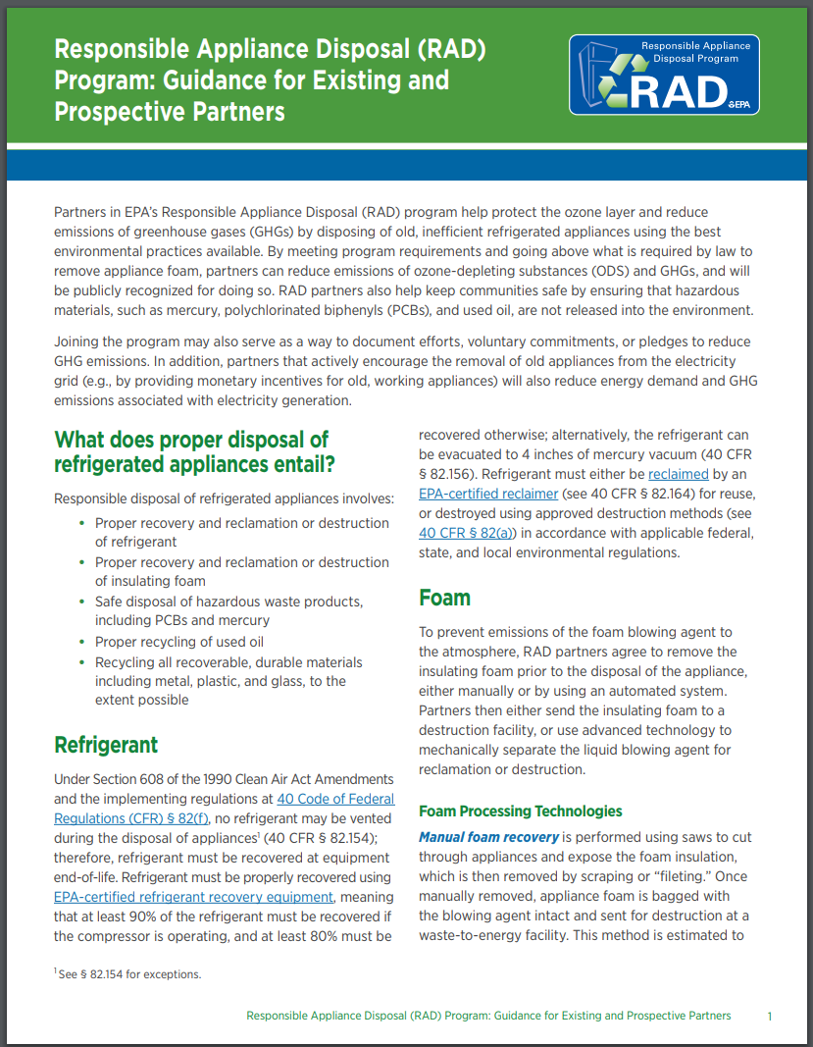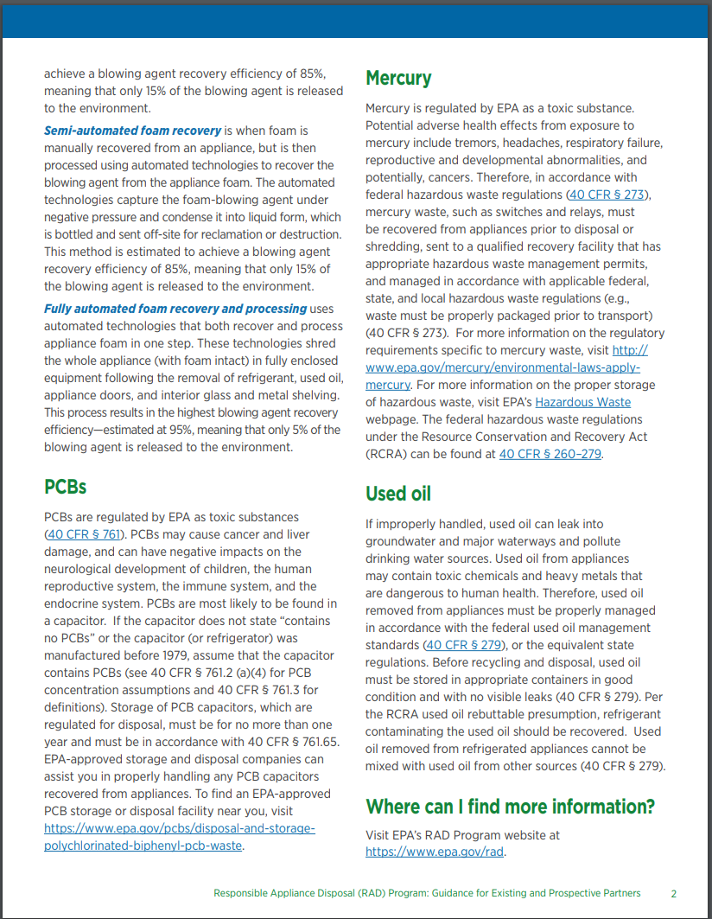

7(b) Partnership Agreement Form
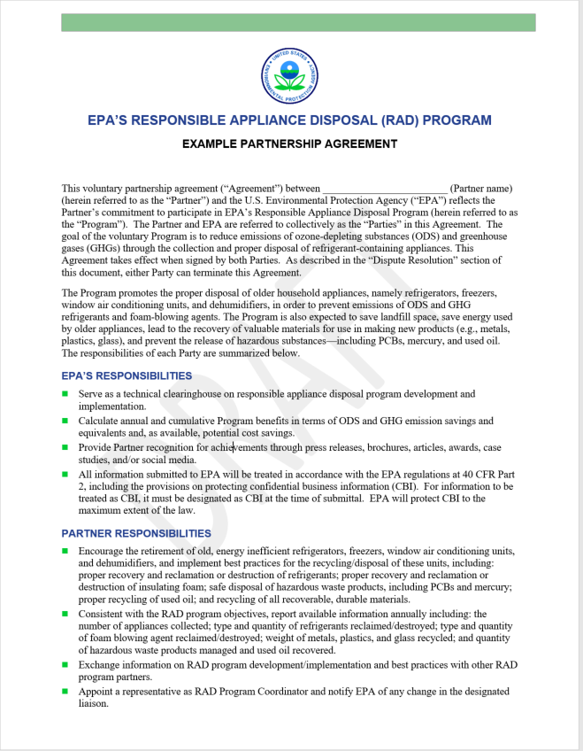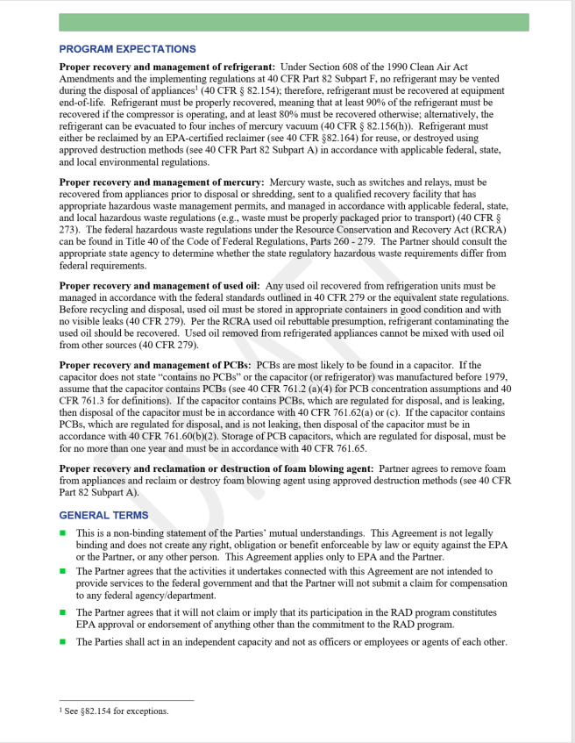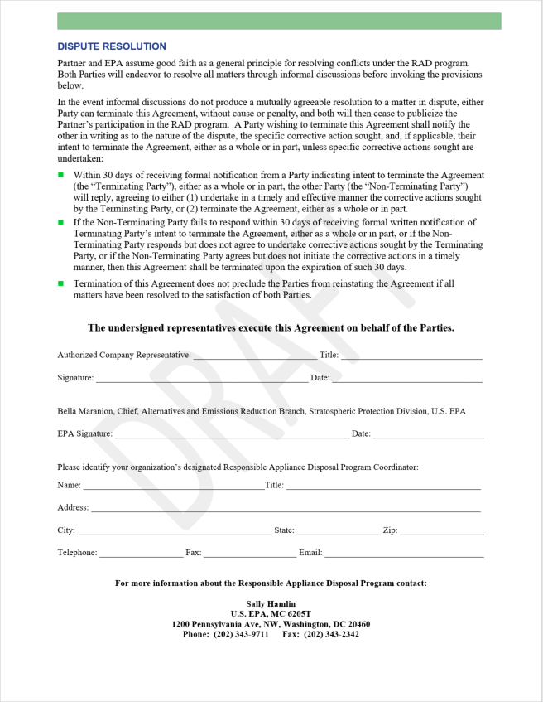

7(c) Annual Reporting Form for Partners
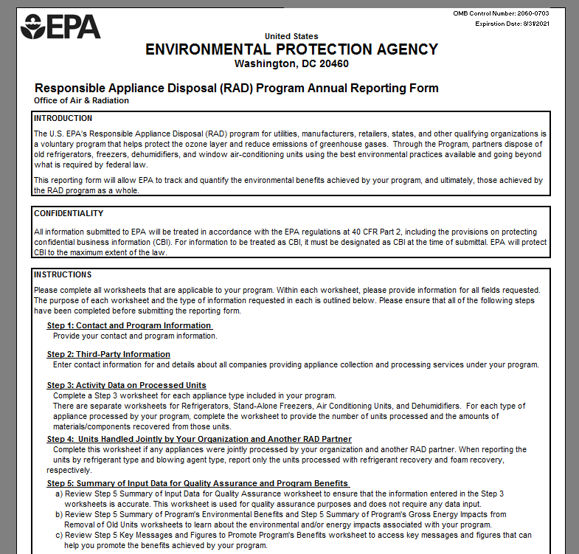

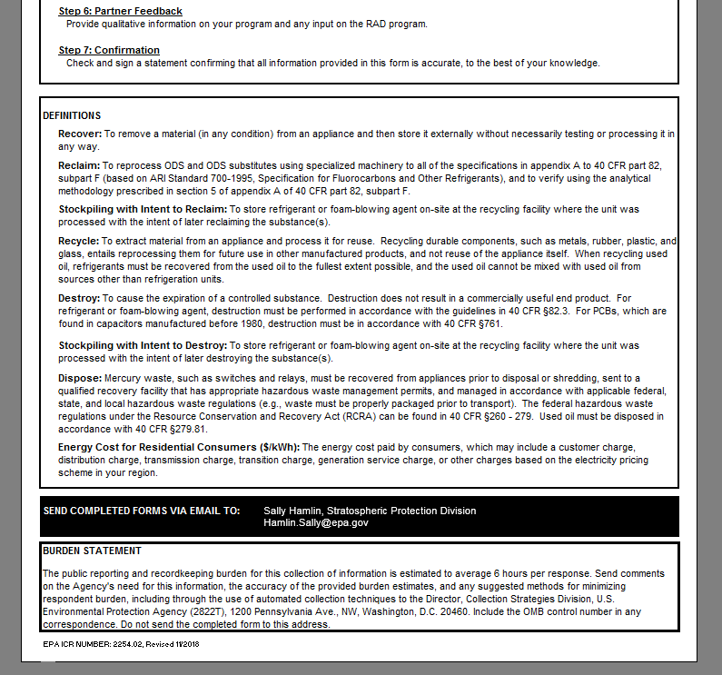

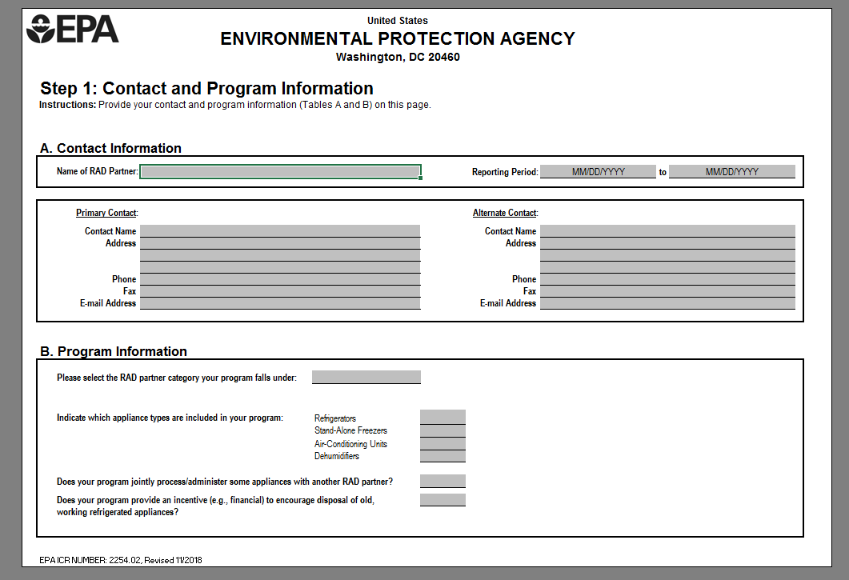

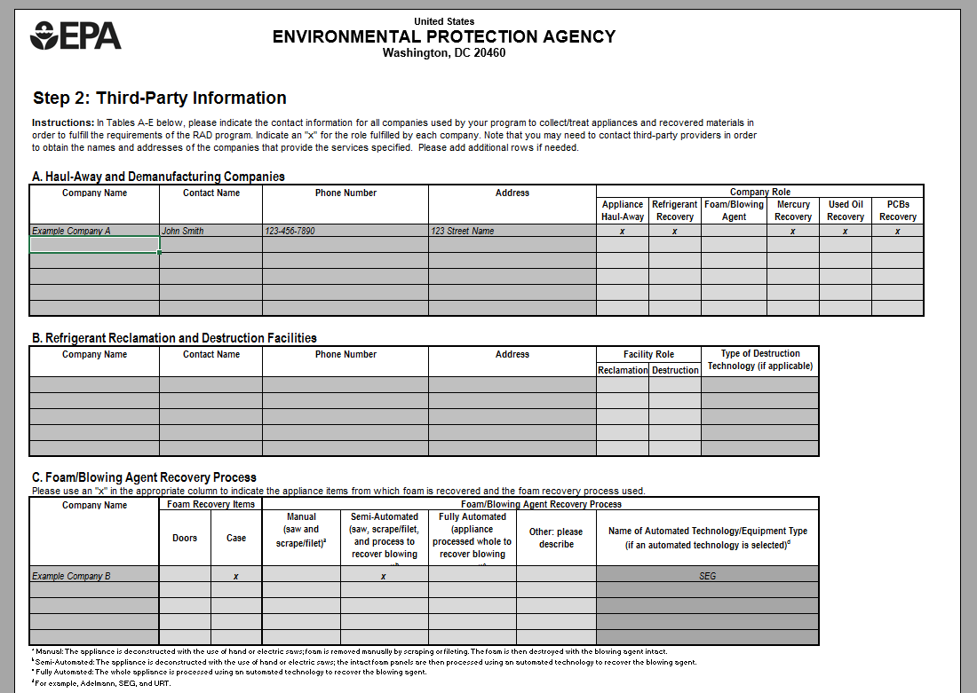
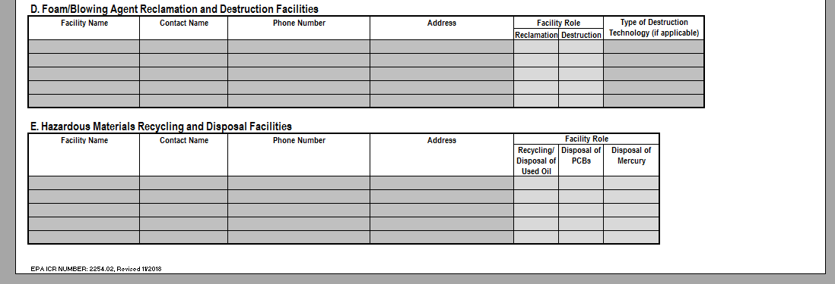

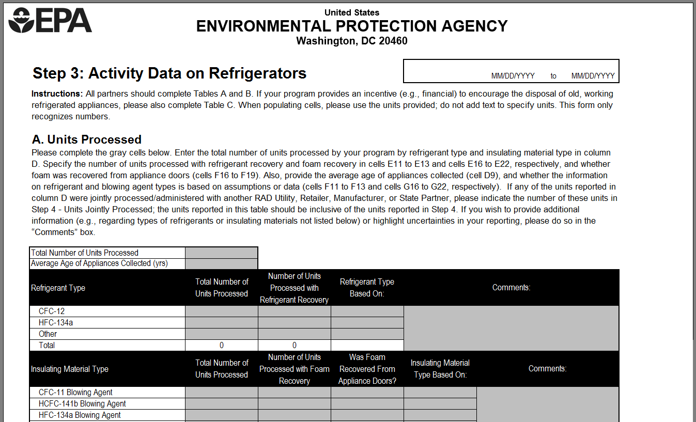
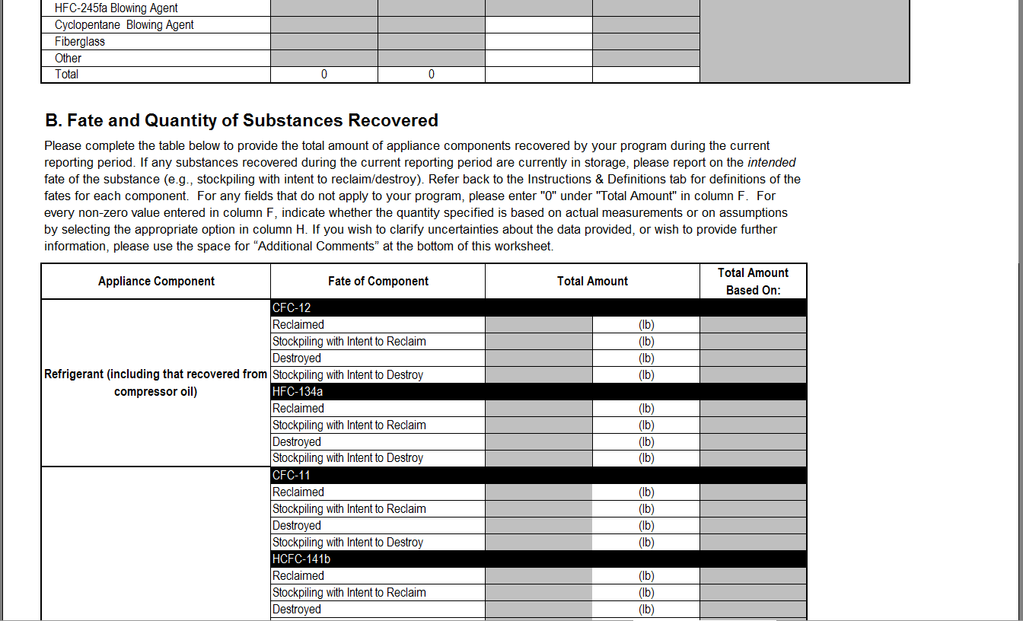
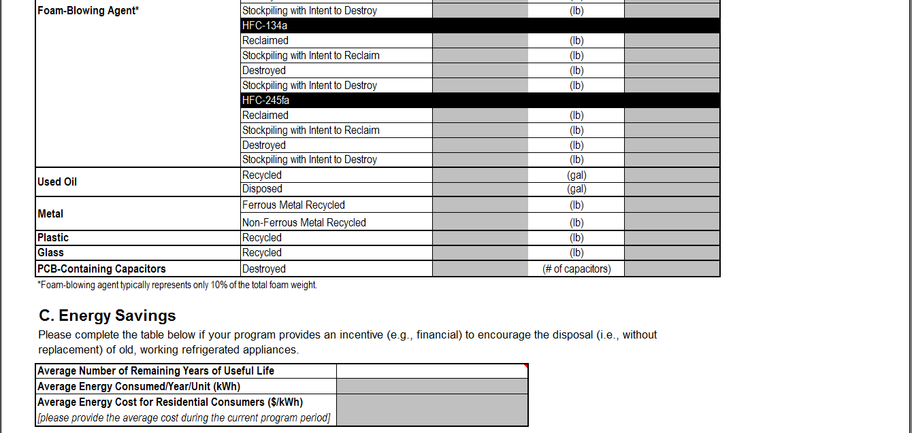

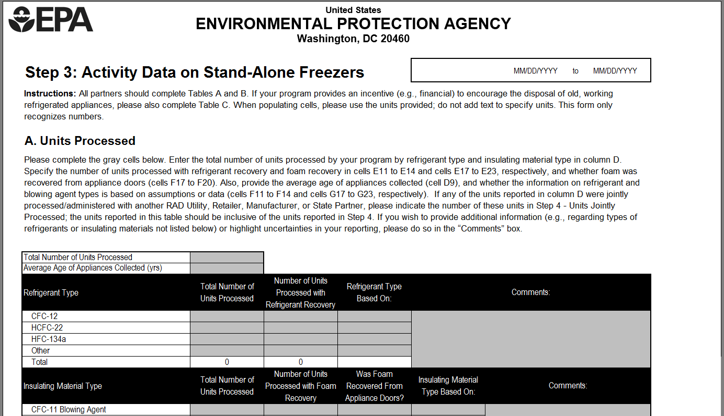
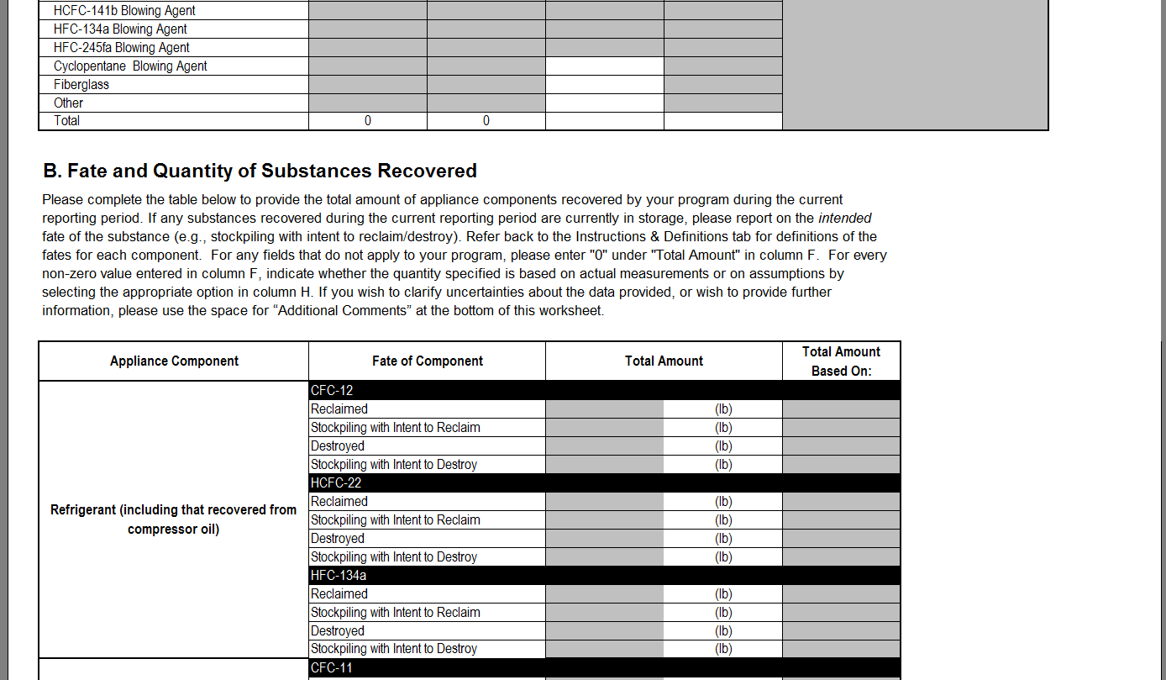
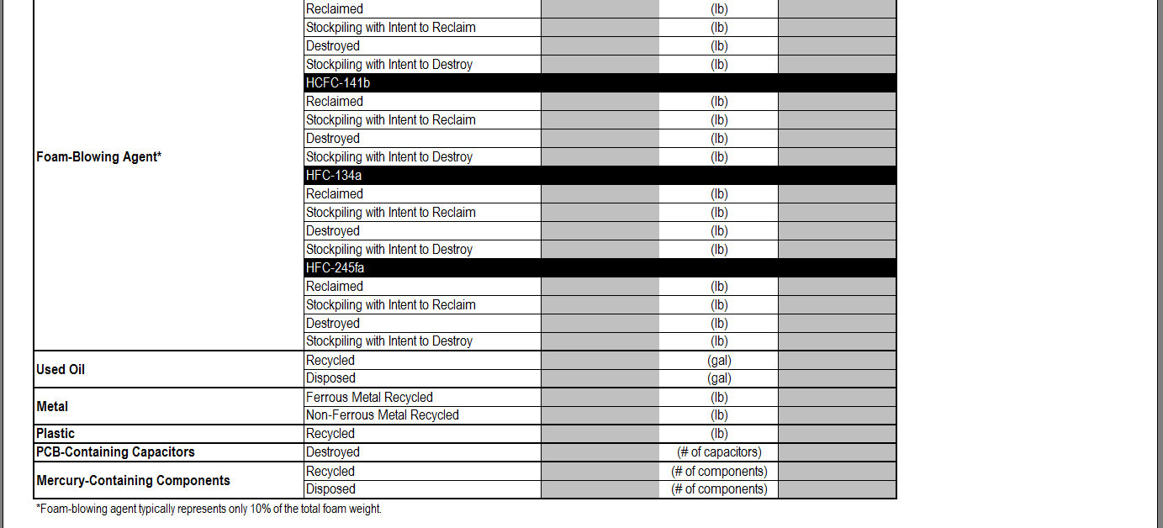
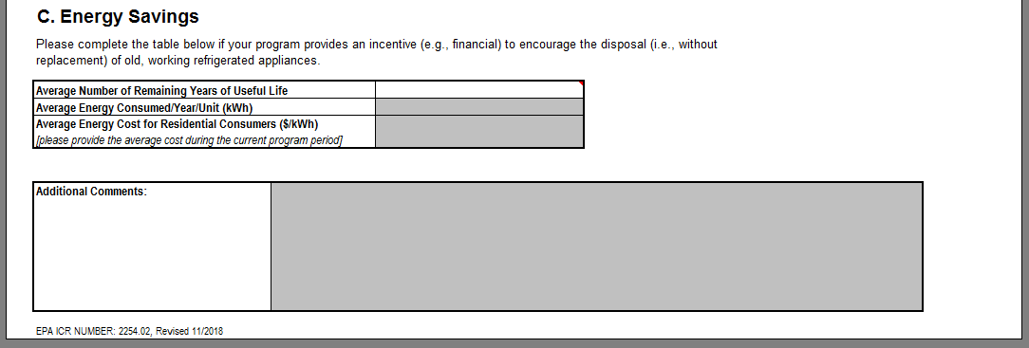

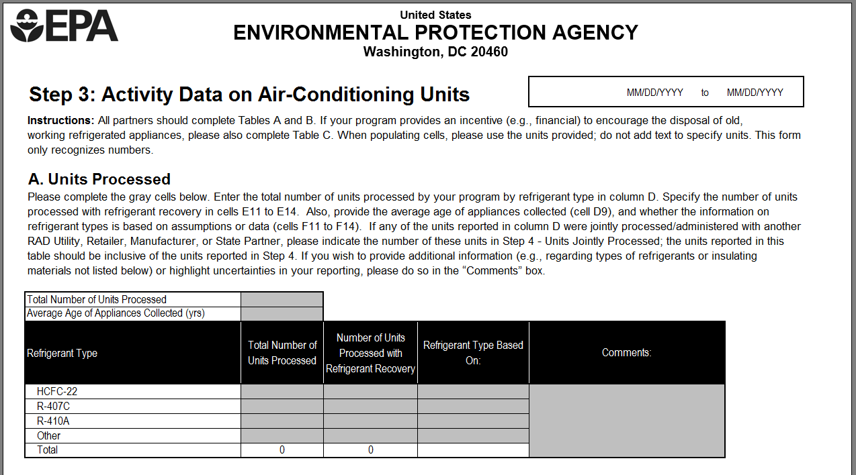
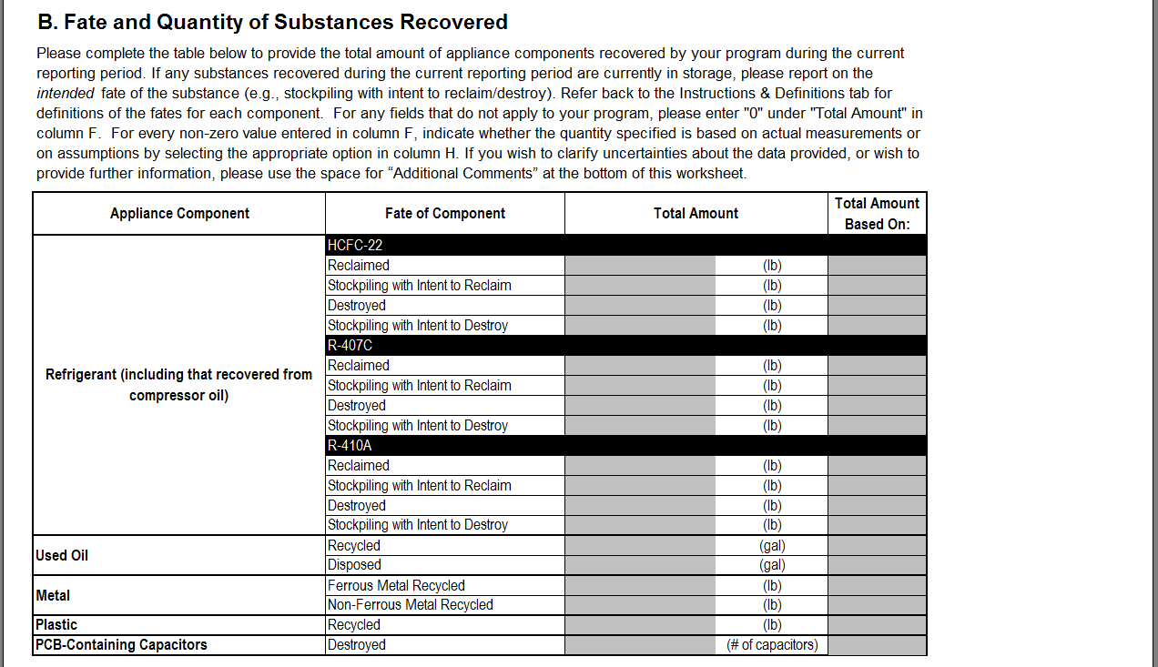
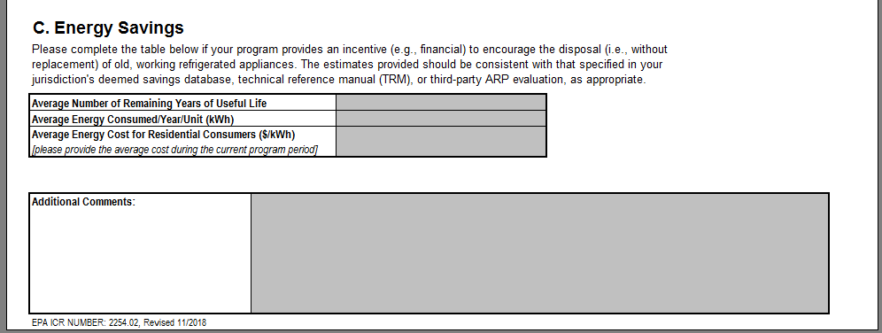

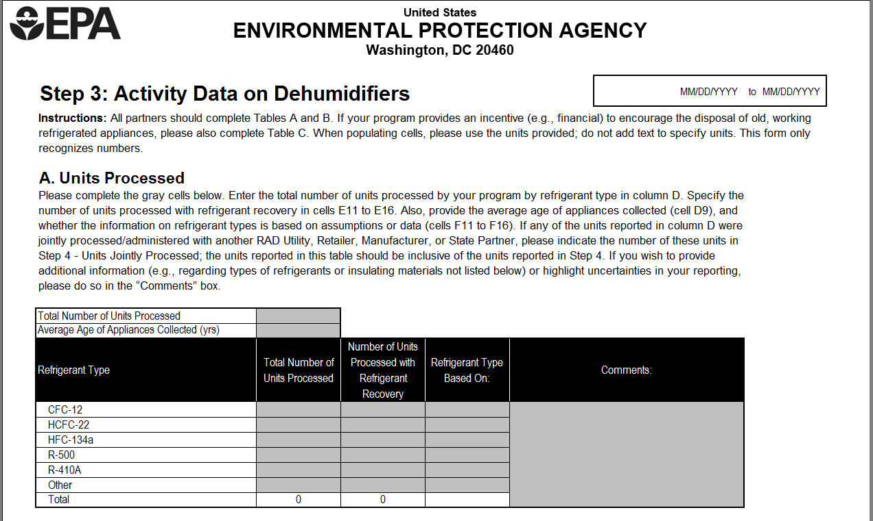
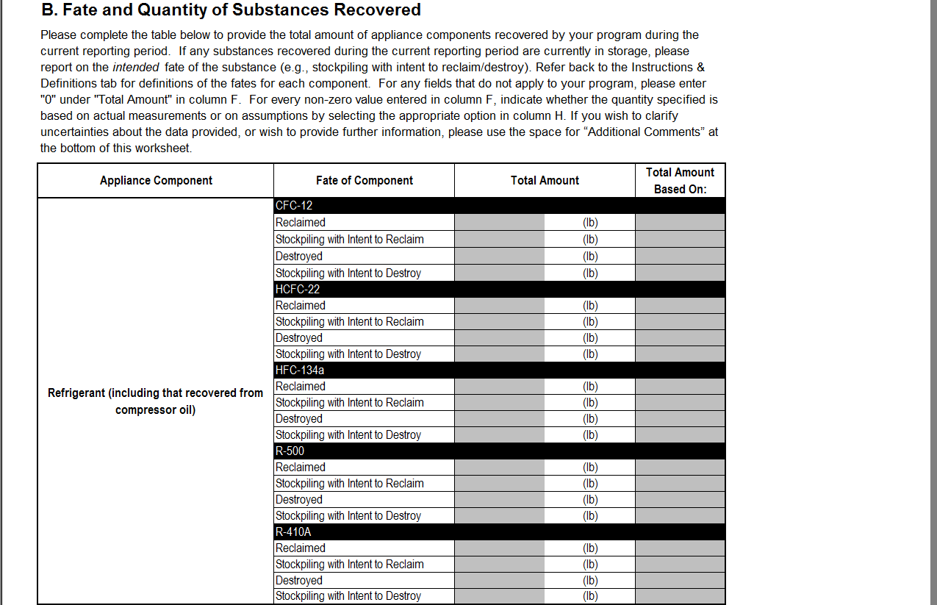
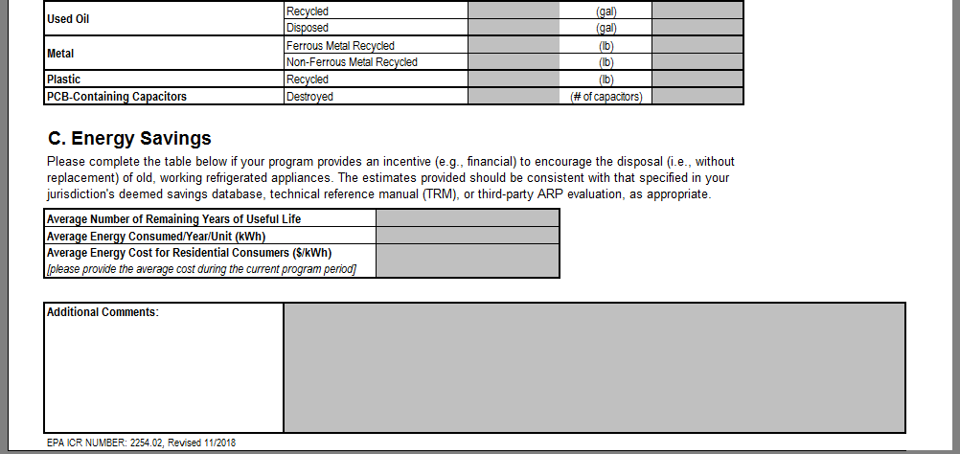

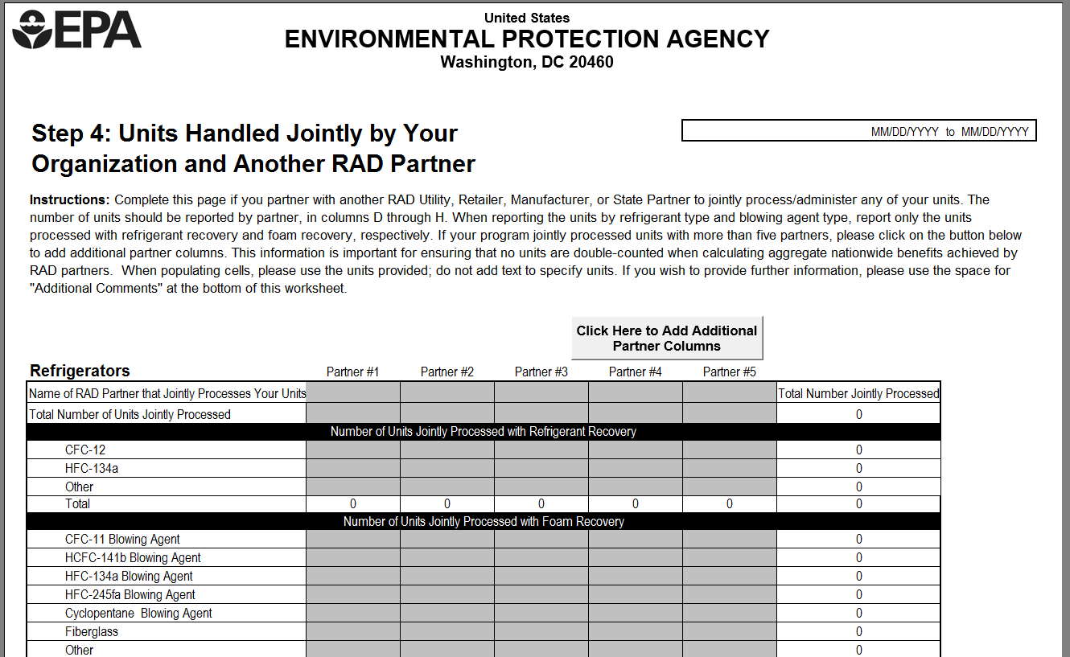
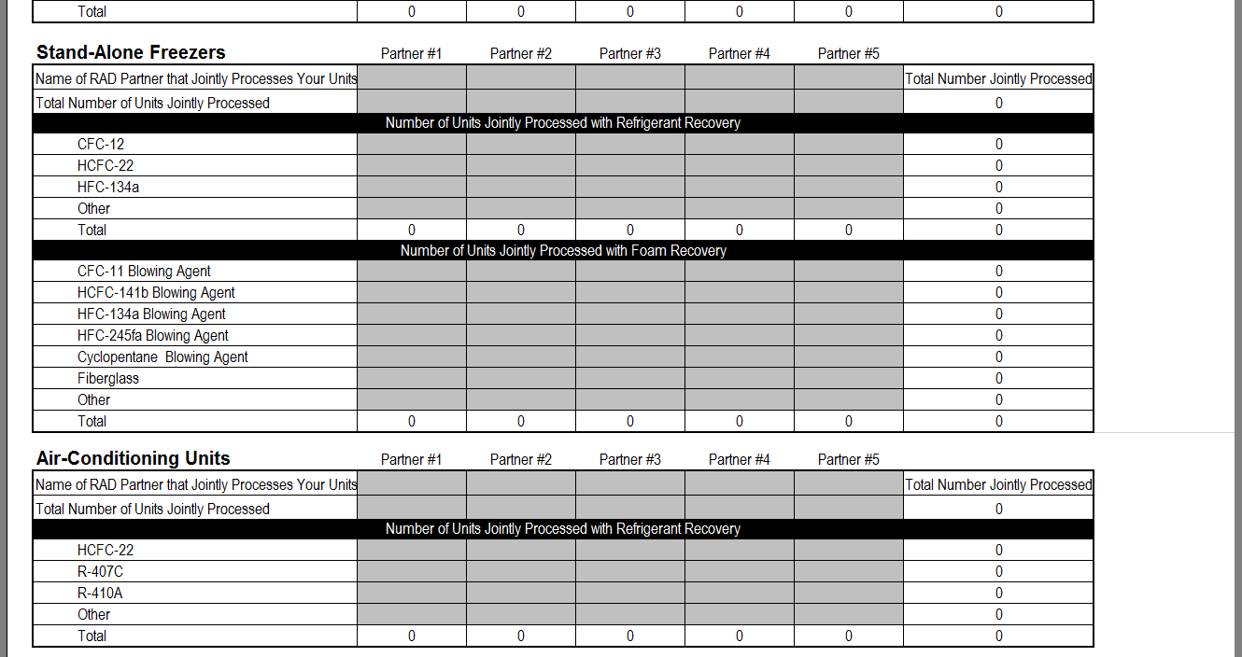
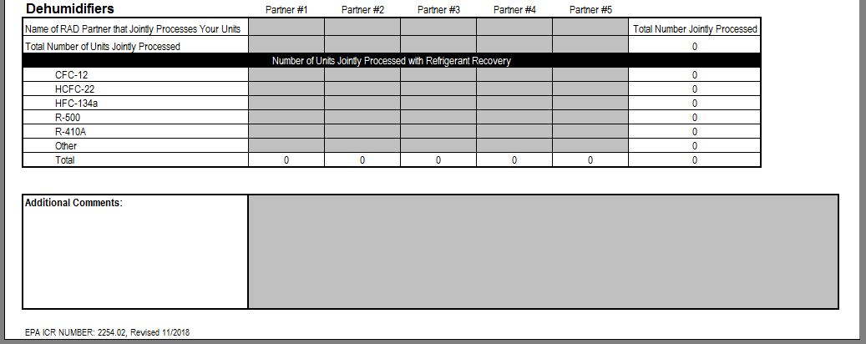

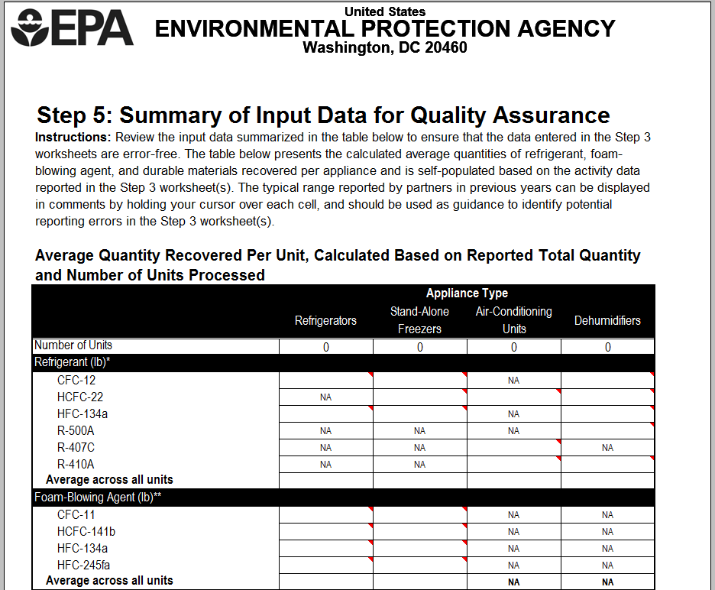
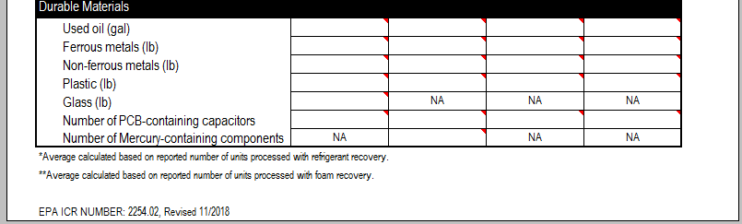

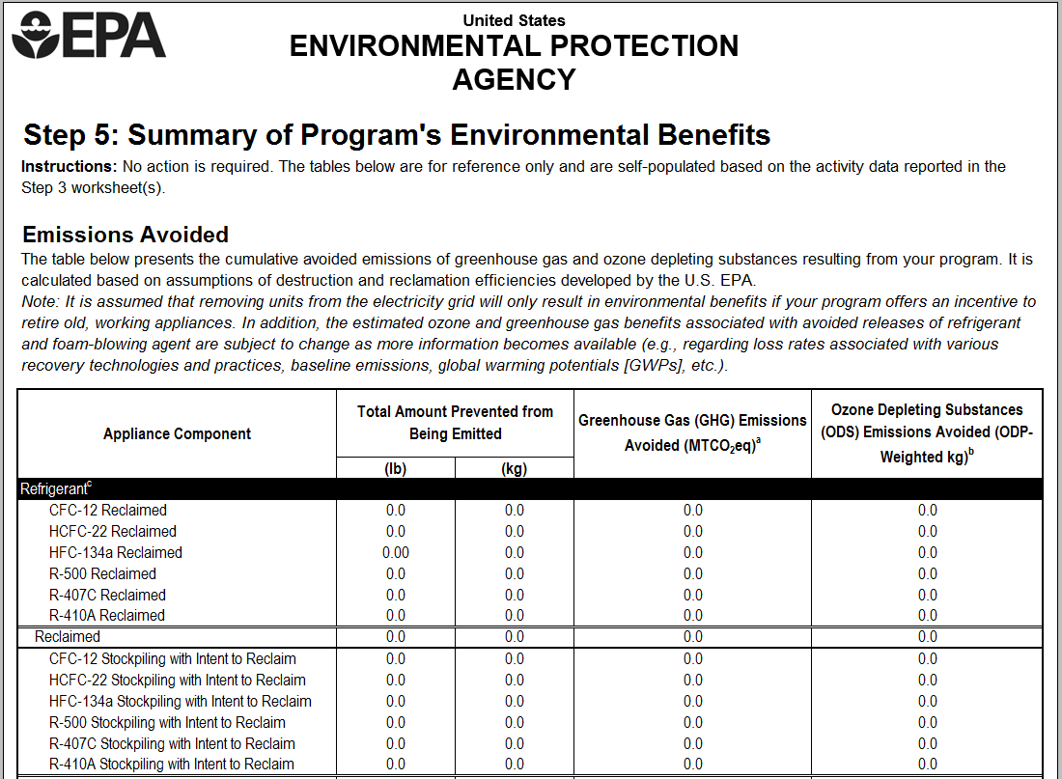
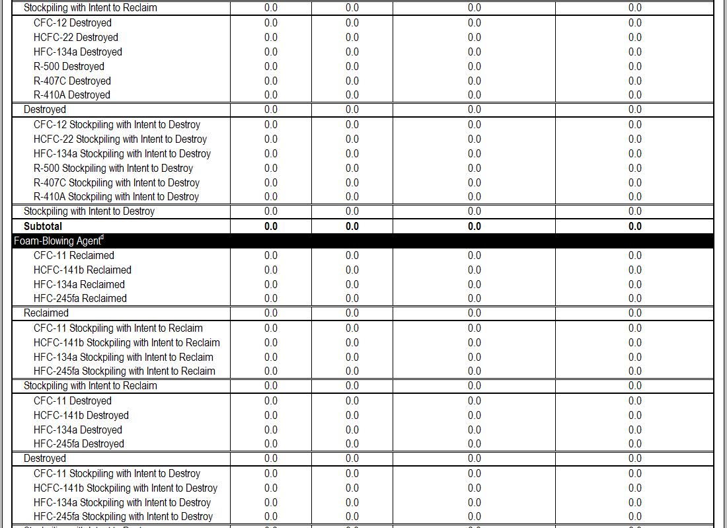
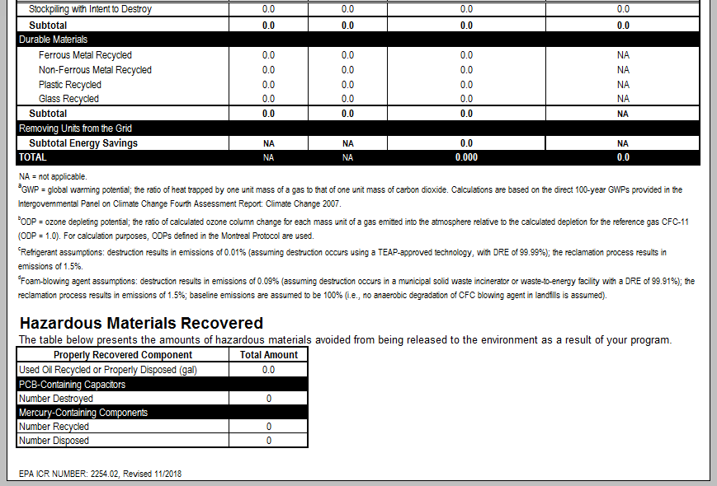

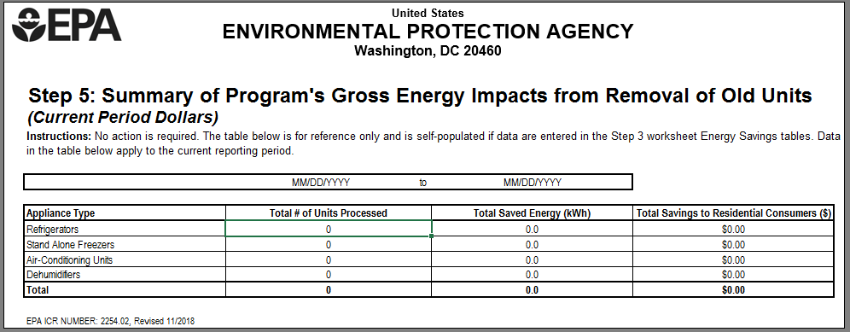

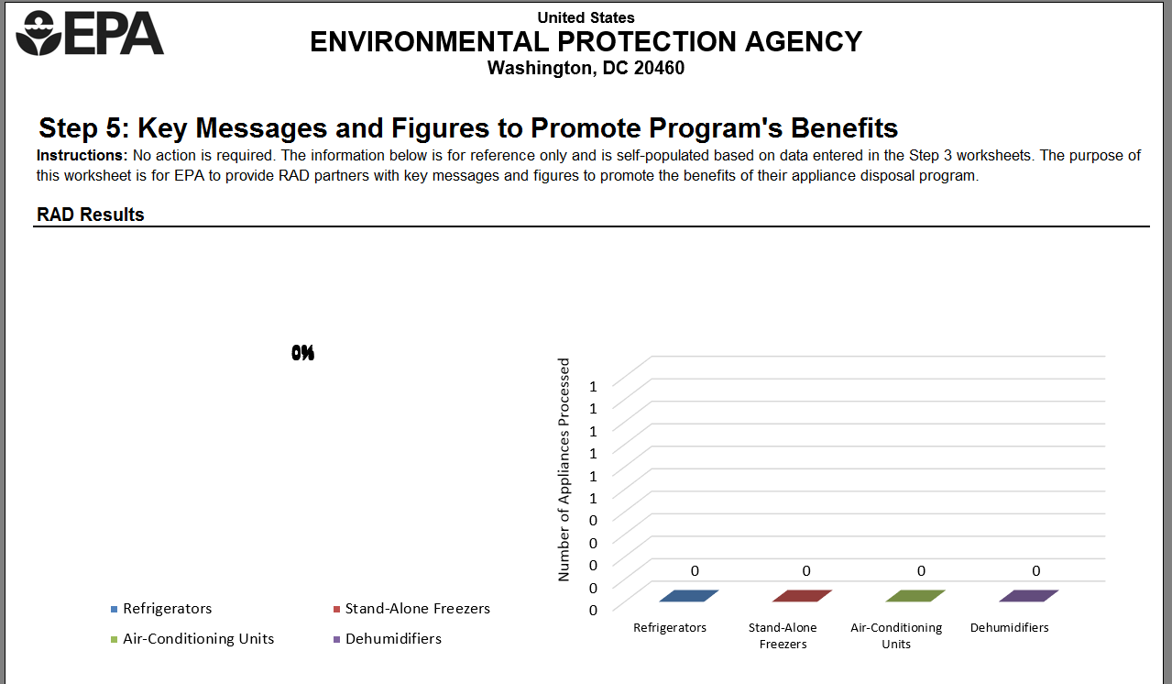
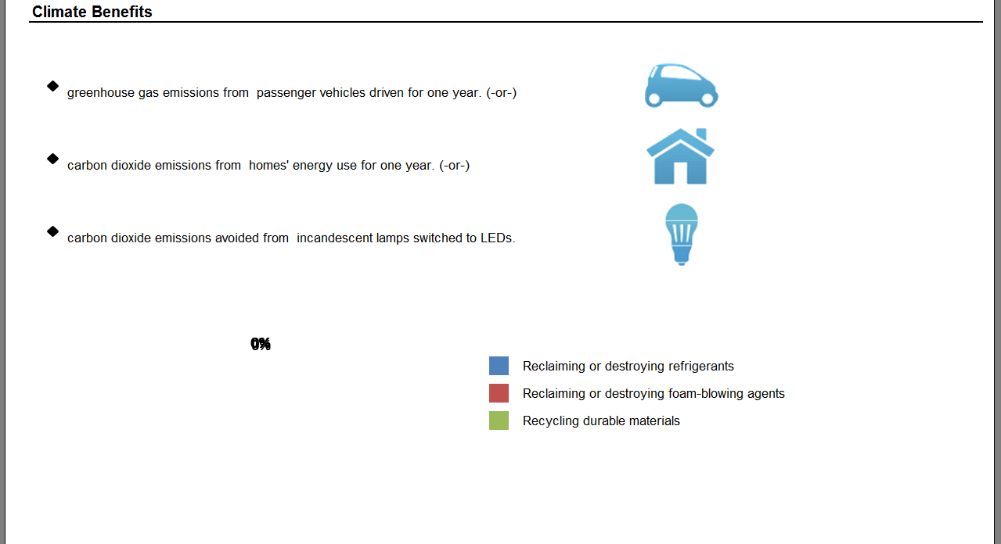
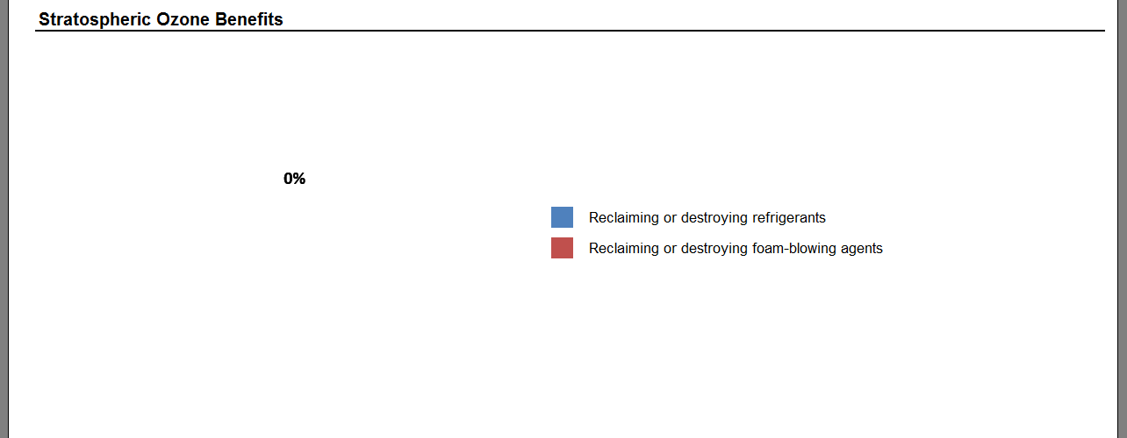
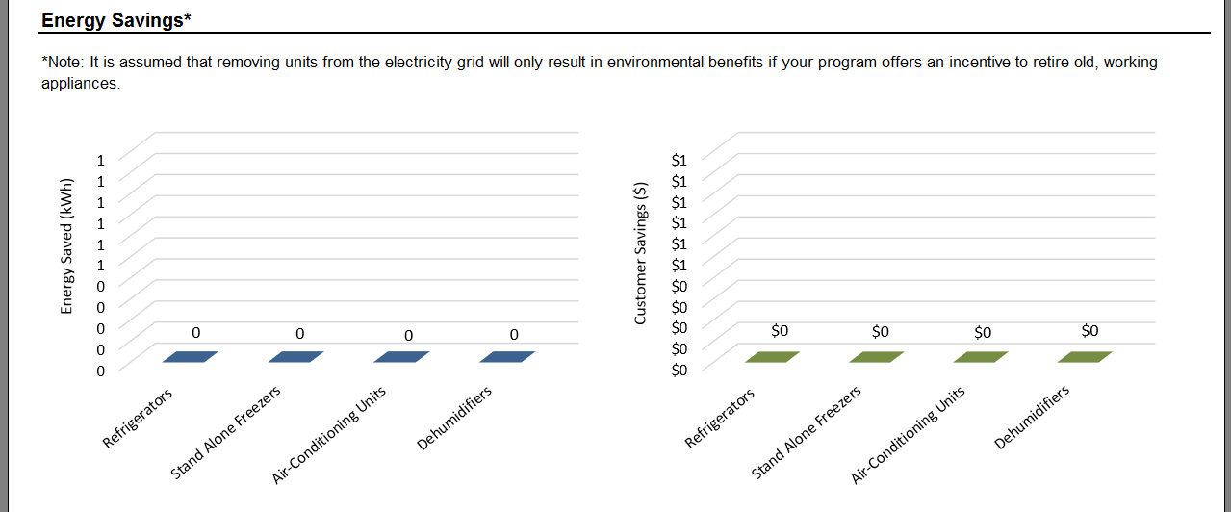
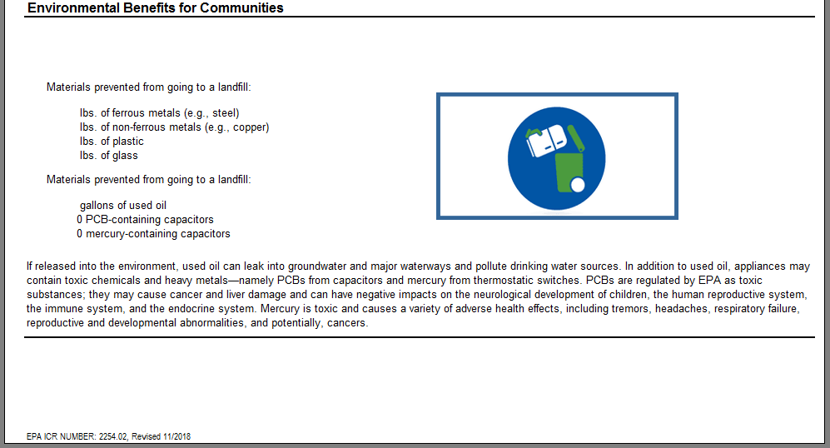
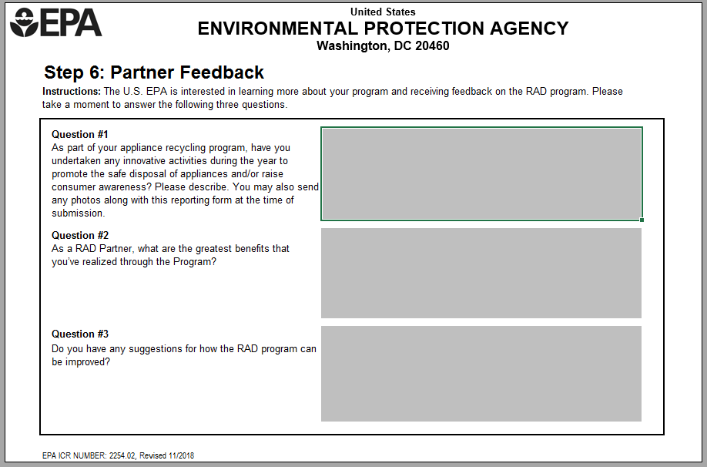

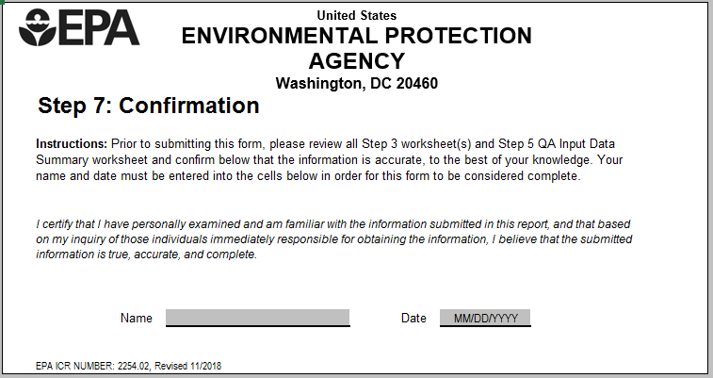

NAICS codes were retrieved from the “2017 NAICS Search” provided by the U.S. Census Bureau at, https://www.census.gov/cgi-bin/sssd/naics/naicsrch?chart=2017.
Labor rates were retrieved from the “May 2017 National Industry-Specific Occupational Employment and Wage Estimates” provided by the U.S. Bureau of Labor Statistics at, http://www.bls.gov/oes/current/oessrci.htm.
Labor rates were retrieved from the “May 2017 National Industry-Specific Occupational Employment and Wage Estimates” for the Federal Executive Branch (NAICS Code 999100) provided by the U.S. Bureau of Labor Statistics at, http://www.bls.gov/oes/current/naics4_999100.htm.

