FCC Form 486
The below screenshots demonstrate how an FCC Form 486 may be filed within the E-Rate Productivity Center (EPC).
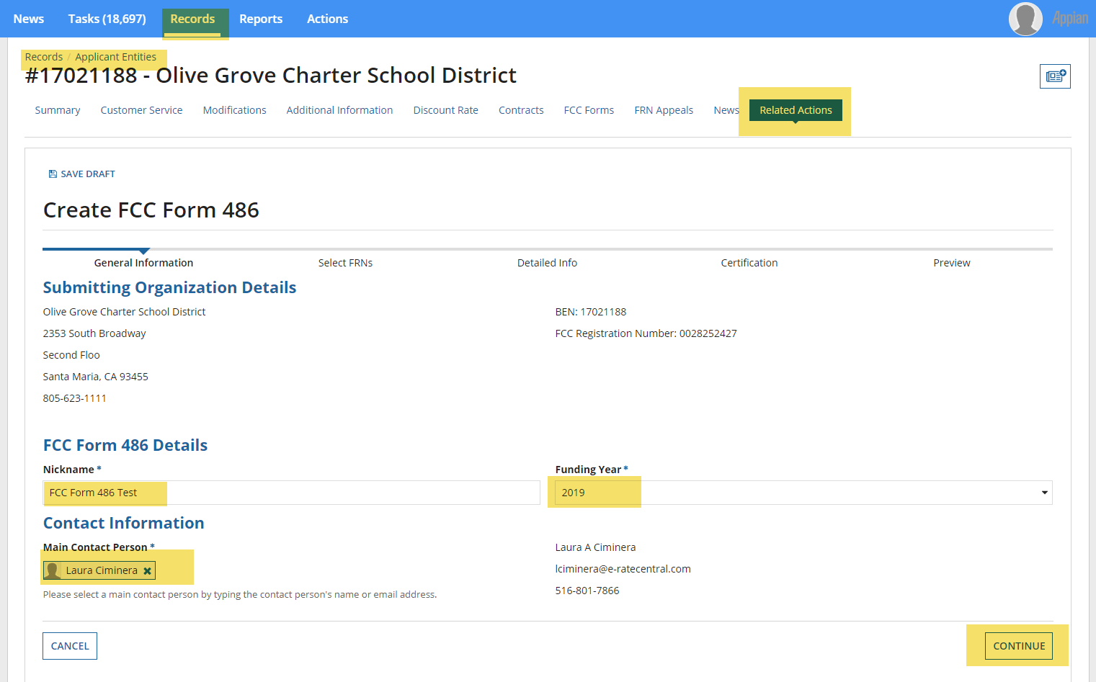
Respondents provide contact information.

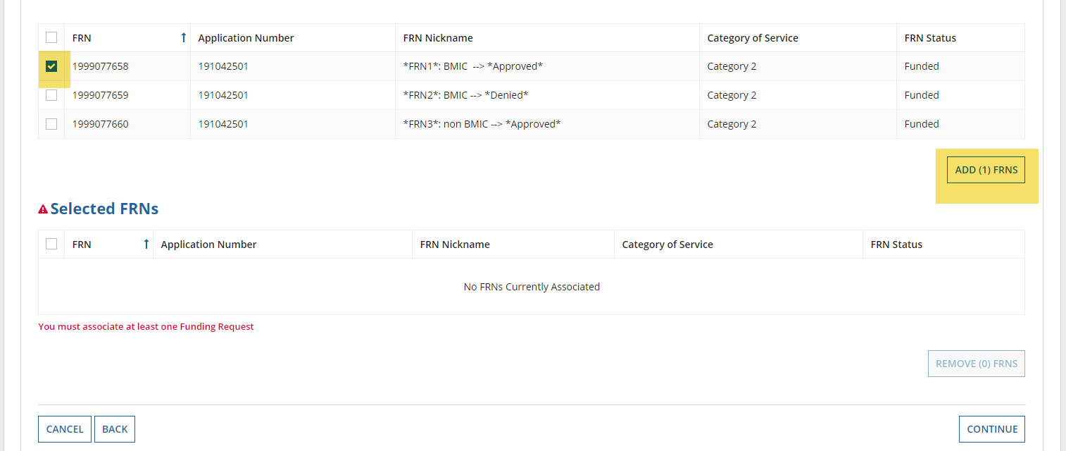
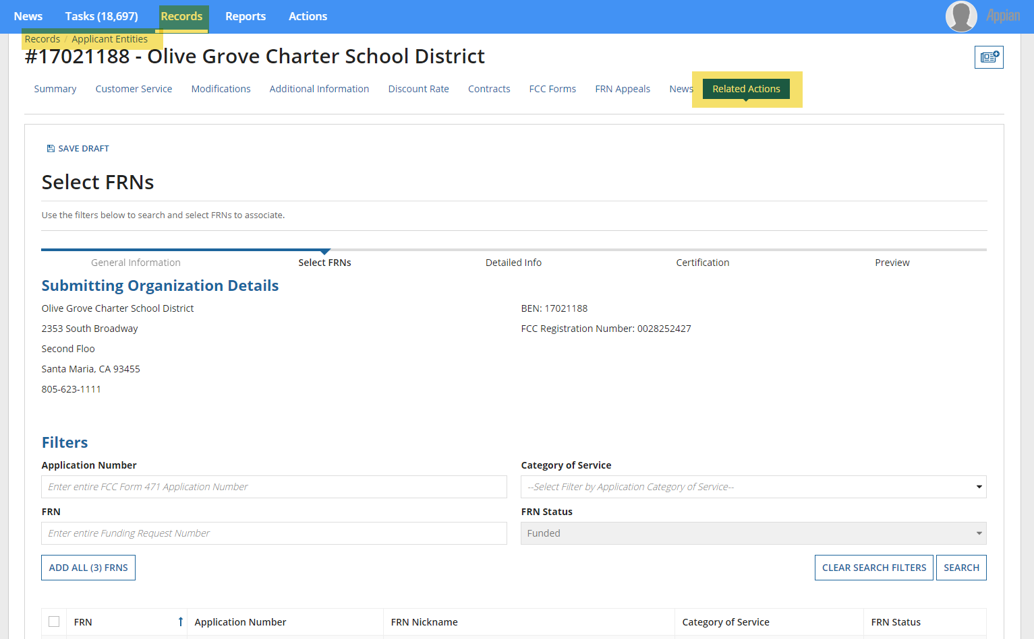
Respondents provide information about relevant applications and funding requests.

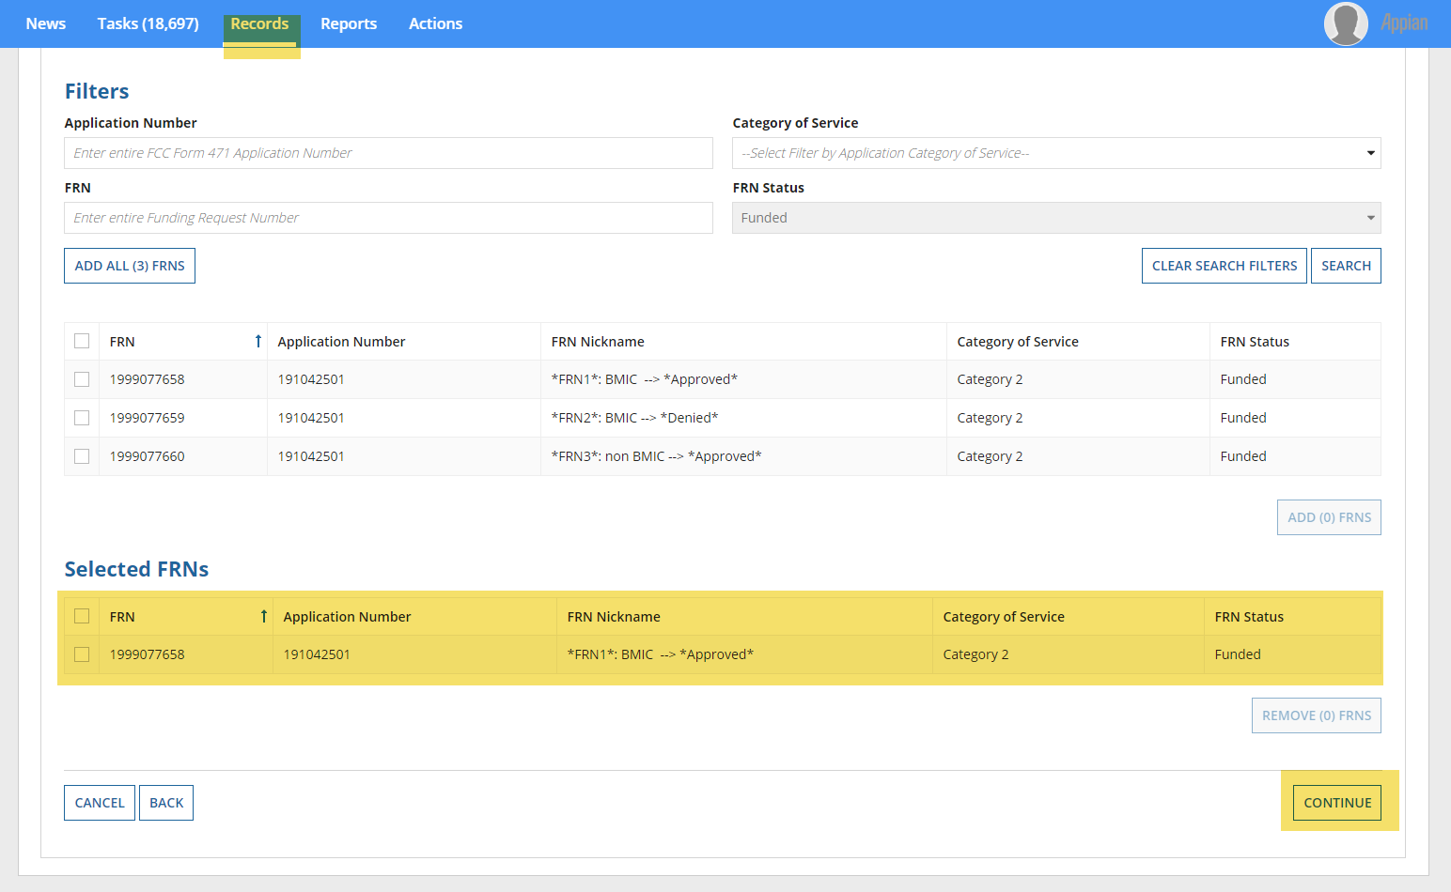
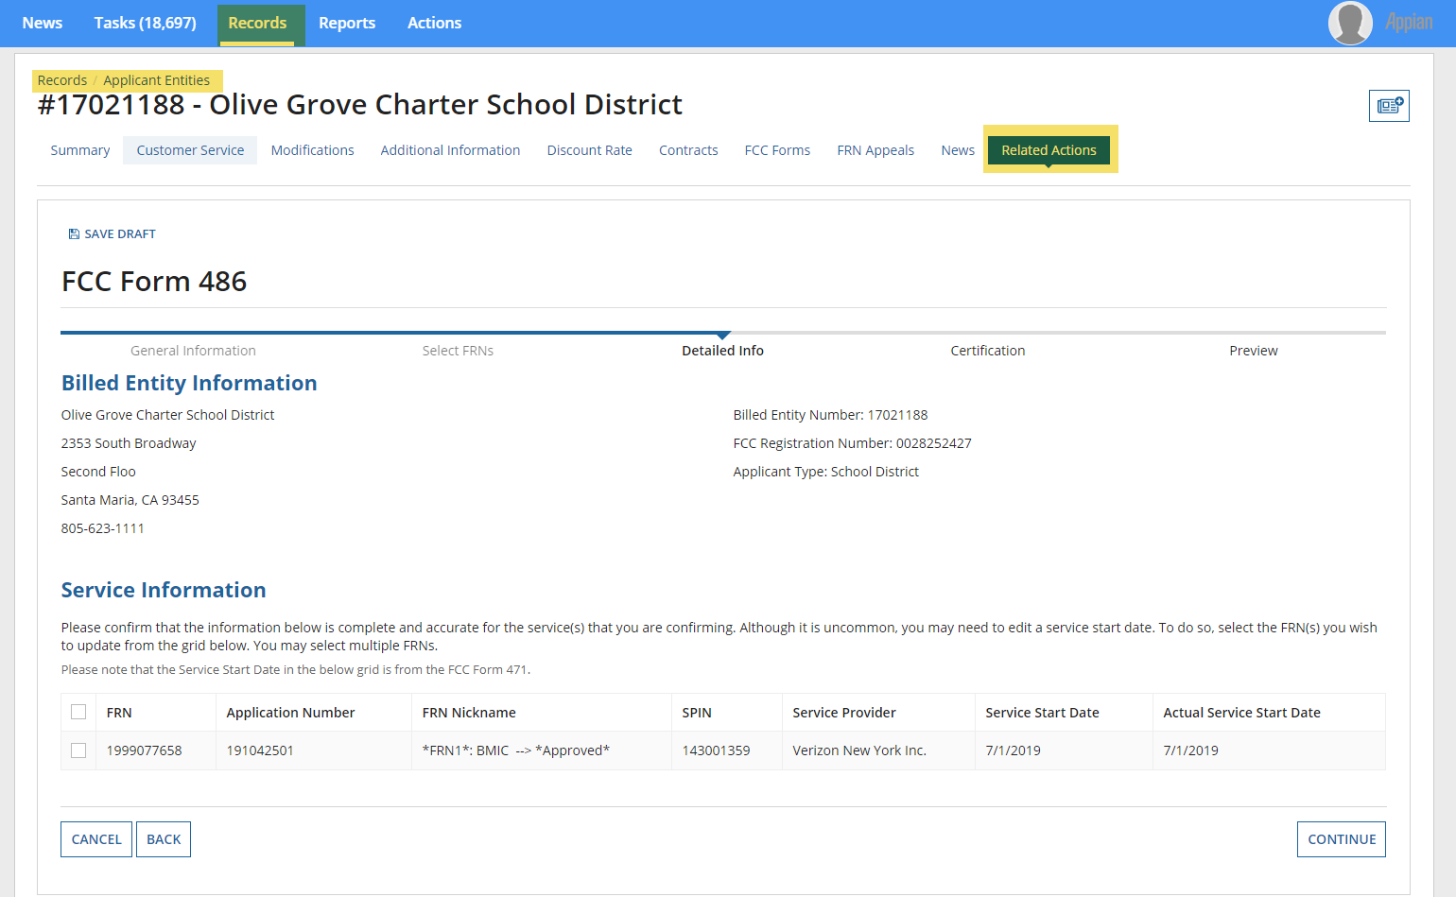
Respondents confirm the service start date.
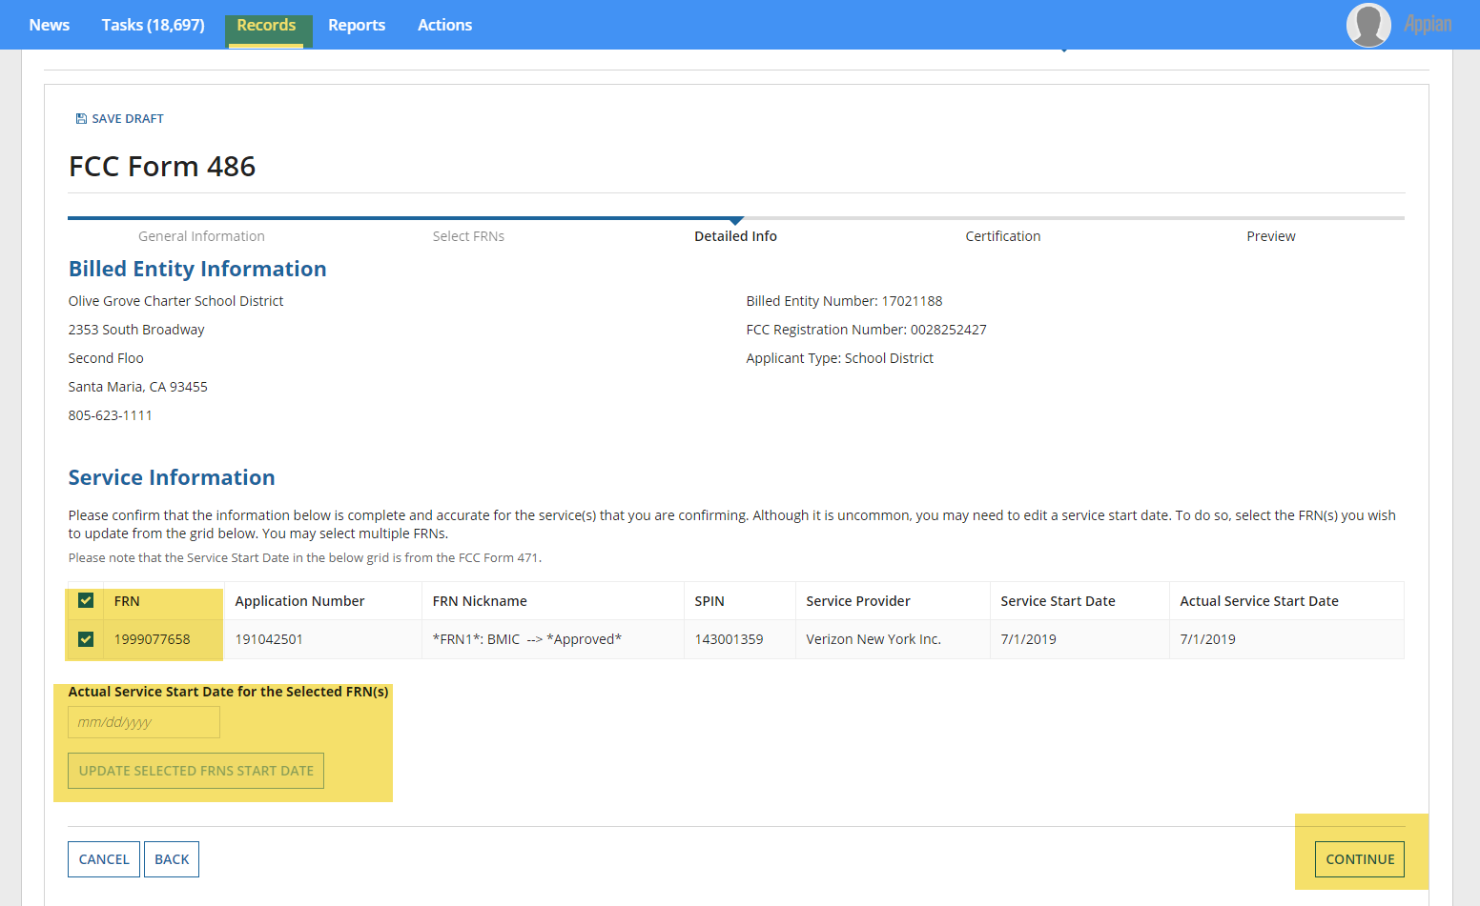
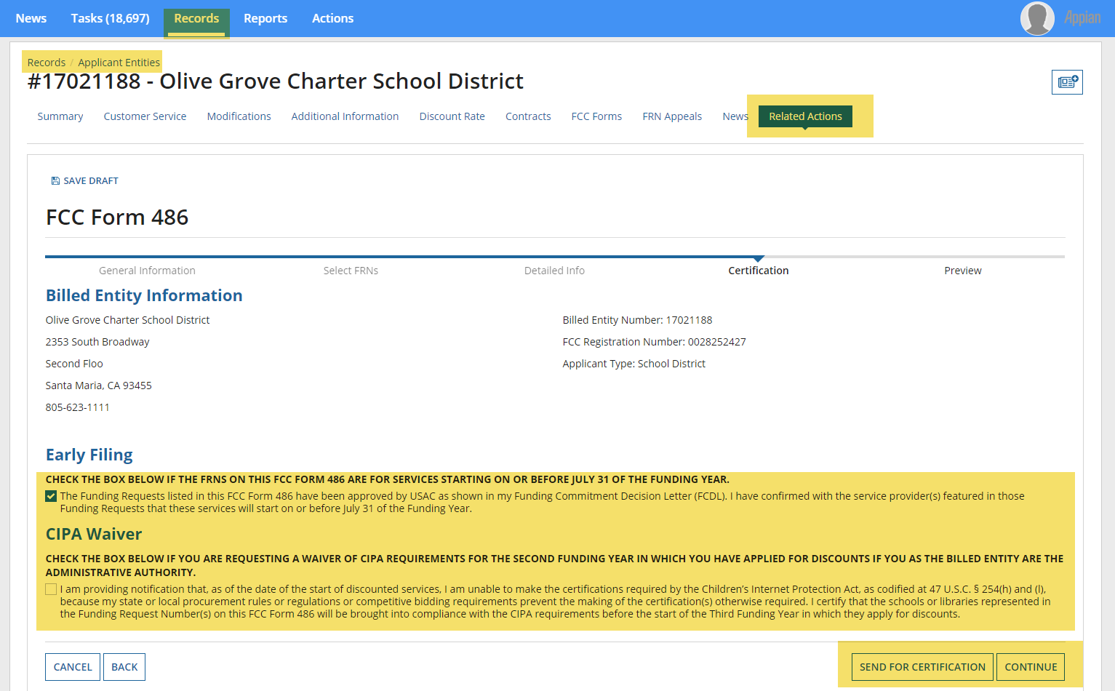
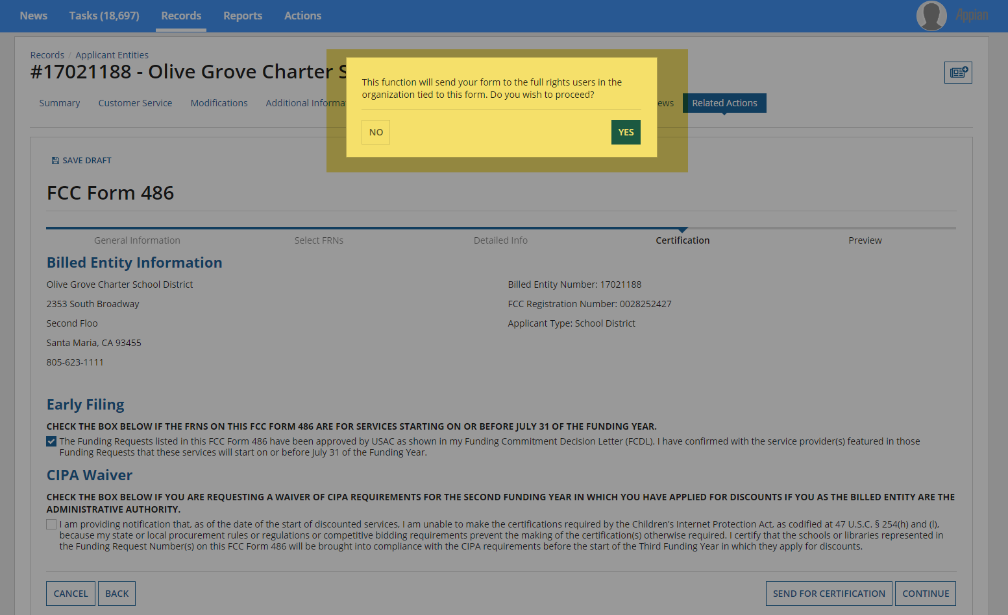
Respondents indicate whether they are early filing the Form 486 or whether they are requesting a waiver of the Children’s Internet Protection Act requirements. If the respondent is not authorized to certify forms, they may send it to an authorized user within their organization.
Respondents that are authorized to certify the FCC Form 486 will navigate through the following screens.
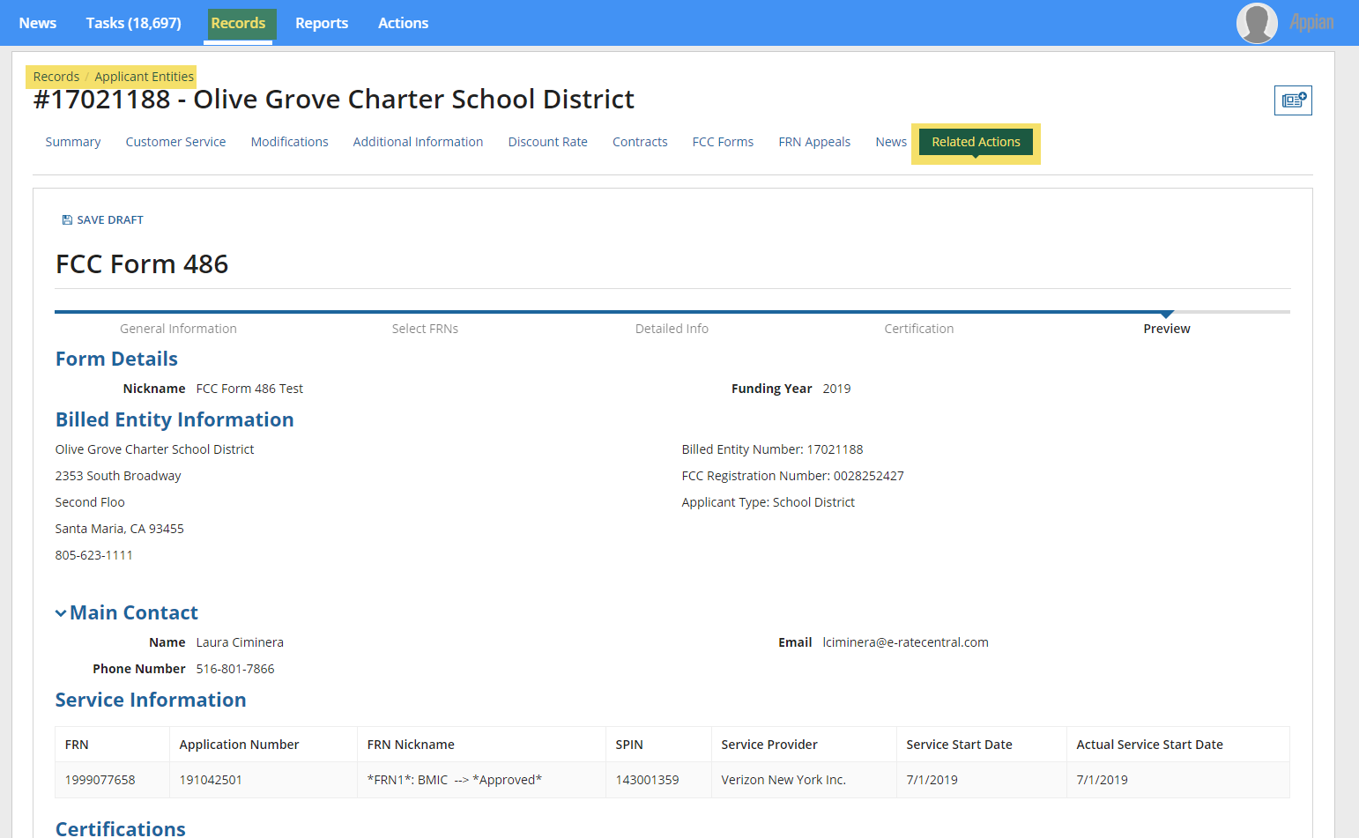

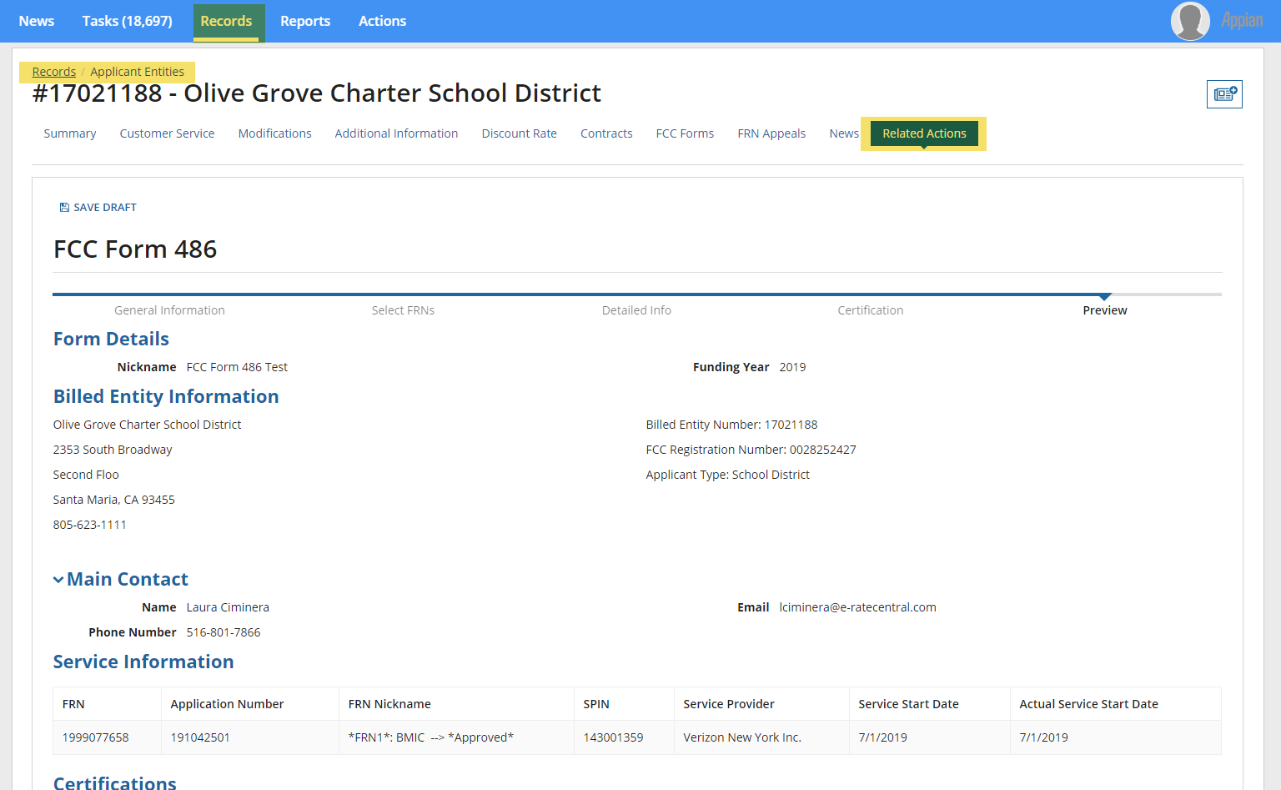
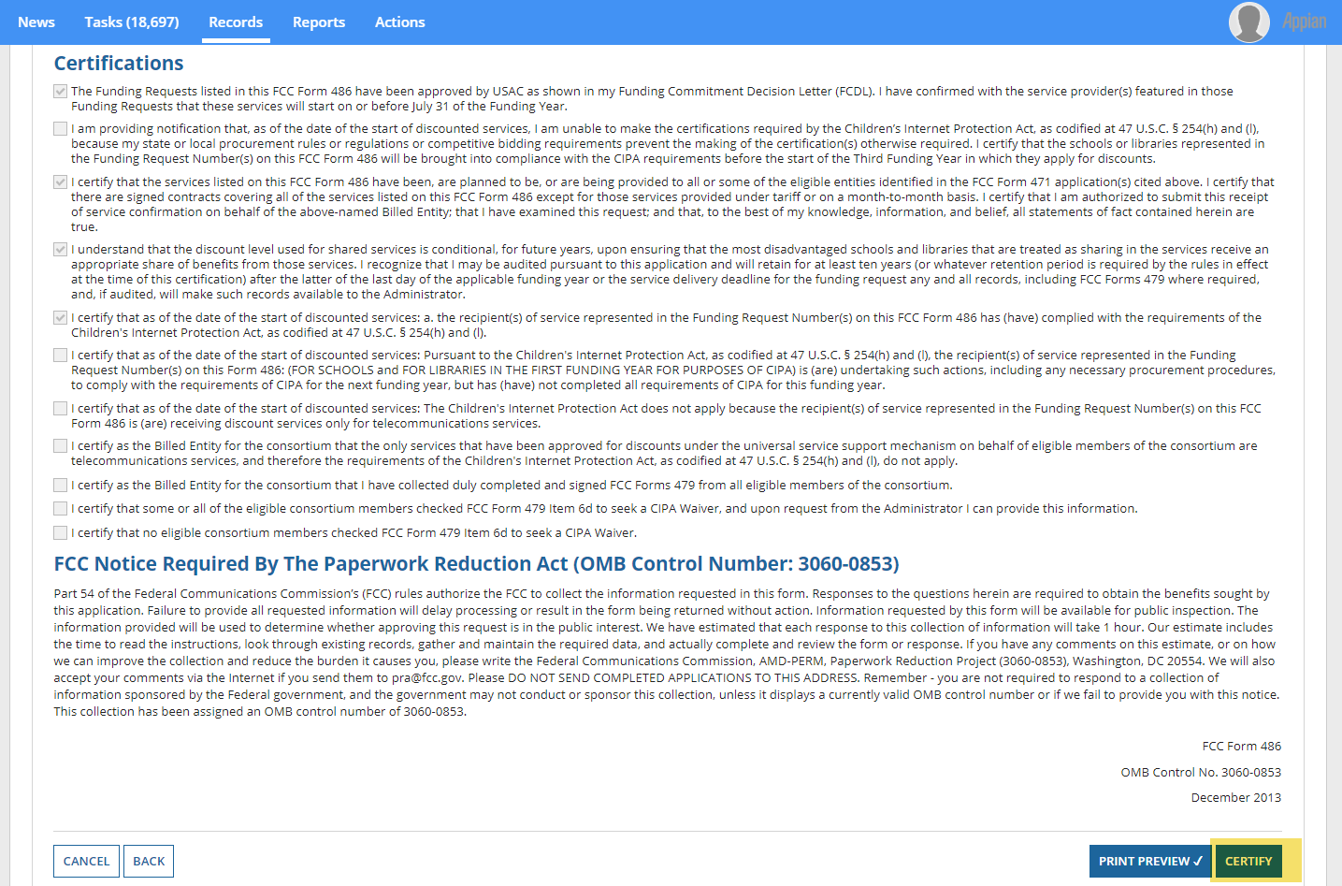
Selecting “Print Preview” expands the certifications and service information sections.

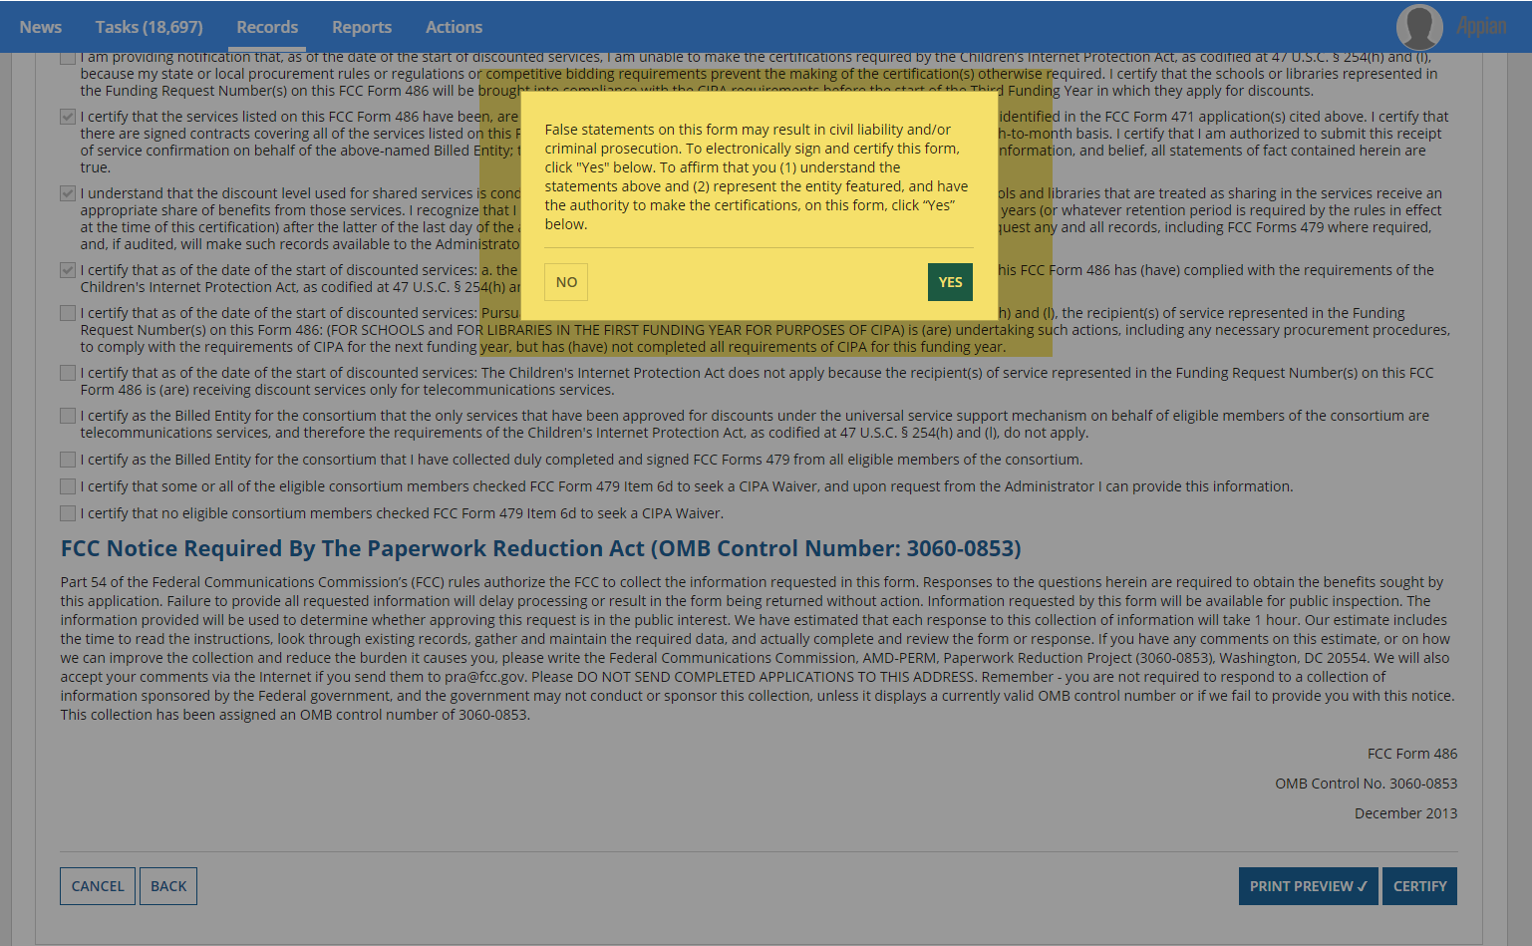
Respondents that certify the FCC Form 500 are prompted to affirm their certification.

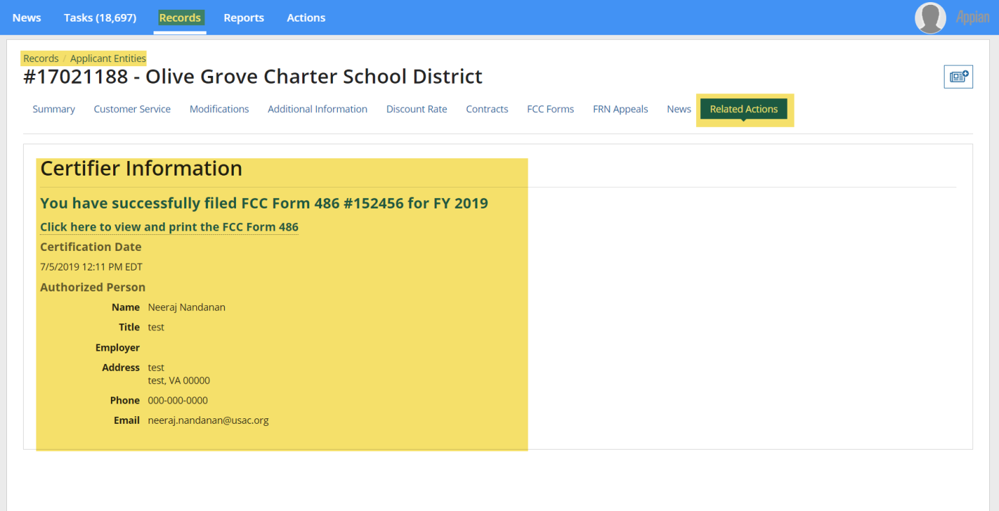
After the FCC Form 486 has been certified, a notification screen confirms that the FCC Form 486 has been successfully submitted.

