## Login Screen

## Shipment Verification

## Best Time for Reporting Data

## Address Verification

## Outbound Shipment Activity

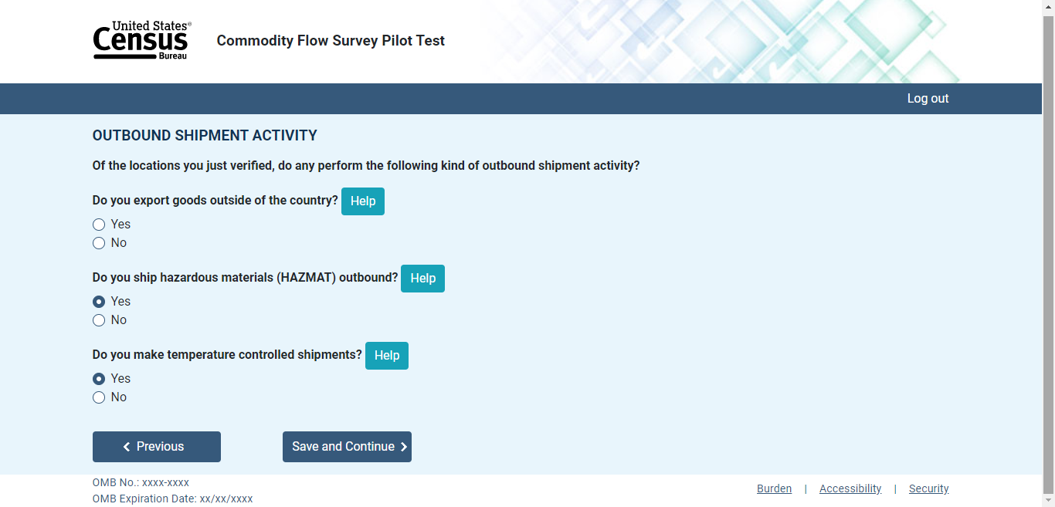

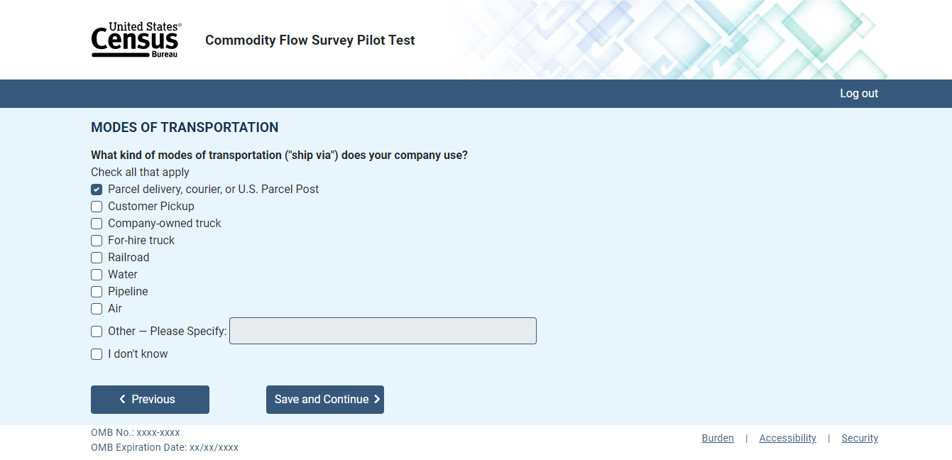Modes of Transportation

## Upload Shipments

## Contact Information