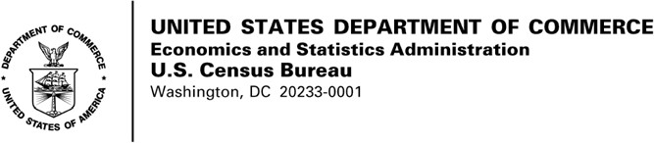

CONSENT FORM

The U.S. Census Bureau routinely conducts research on how we, and our partners, collect information in order to produce the best statistics possible.

You have volunteered to take part in a study of data collection procedures. In order to have a complete record of your comments, your interview will be audio- recorded. We will also capture your eye movements with our eye tracking technology to better understand how you are interacting with the site. We plan to use your feedback to improve the design and layout of the website for future data collections. Only staff involved in this product design research will have access to the recording.

This collection has been approved by the Office of Management and Budget (OMB). This eight-digit OMB approval number, 0607-0725, confirms this approval and expires on 12/31/2022. Without this approval, we could not conduct this study.

I have volunteered to participate in this U.S. Census Bureau study, and I give permission for my audio recordings to be used for the purposes stated above.

Participant’s Signature Researcher’s Signature

Printed Name Printed Name

Date Date

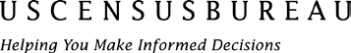
www.census.gov

Authority and Confidentiality
This collection is authorized under Title 13 U.S. Code, Sections 131 and 182. The U.S. Census Bureau is required by Section 9 of the same law to keep your information confidential and can use your responses only to produce statistics. Your privacy is protected by the Privacy Act, Title 5 U.S. Code, Section 552a. The uses of these data are limited to those identified in the Privacy Act System of Record Notice titled “COMMERCE/CENSUS-4, Economic Survey Collection.” The Census Bureau is not permitted to publicly release your responses in a way that could identify you, your business, organization, or institution. Per the Federal Cybersecurity Enhancement Act of 2015, your data are protected from cybersecurity risks through screening of the systems that transmit your data.

Burden Estimate
We estimate that completing this interview will take 60 minutes on average, including the time for reviewing instructions, searching existing data sources, gathering and maintaining the data needed, and completing and reviewing the collection of information. You may send comments
regarding this estimate or any other aspect of this survey, including suggestions for reducing the time it takes to complete this survey to rebecca.keegan@census.gov.

CONSENT FORM

The U.S. Census Bureau routinely conducts research on how we, and our partners, collect information in order to produce the best statistics possible.

You have volunteered to take part in a study of data collection procedures. In order to have a complete record of your comments, your interview will be audio- recorded. We plan to use your feedback to improve the design and layout of the form for future data collections. Only staff involved in this product design research will have access to the recording.

This collection has been approved by the Office of Management and Budget (OMB). This eight-digit OMB approval number, 0607-0725, confirms this approval and expires on 12/31/2022. Without this approval, we could not conduct this study.

I have volunteered to participate in this U.S. Census Bureau study, and I give permission for my audio recordings to be used for the purposes stated above.

Participant’s Signature Researcher’s Signature

Printed Name Printed Name

Date Date

www.census.gov

Authority and Confidentiality
This collection is authorized under Title 13 U.S. Code, Sections 131 and 182. The U.S. Census Bureau is required by Section 9 of the same law to keep your information confidential and can use your responses only to produce statistics. Your privacy is protected by the Privacy Act, Title 5 U.S. Code, Section 552a. The uses of these data are limited to those identified in the Privacy Act System of Record Notice titled “COMMERCE/CENSUS-4, Economic Survey Collection.” The Census Bureau is not permitted to publicly release your responses in a way that could identify you, your business, organization, or institution. Per the Federal Cybersecurity Enhancement Act of 2015, your data are protected from cybersecurity risks through screening of the systems that transmit your data.

Burden Estimate
We estimate that completing this interview will take 60 minutes on average, including the time for reviewing instructions, searching existing data sources, gathering and maintaining the data needed, and completing and reviewing the collection of information. You may send comments
regarding this estimate or any other aspect of this survey, including suggestions for reducing the time it takes to complete this survey to Rebecca.keegan@census.gov.

