Cognitive Interviewing for the Content Harmonization
and Collection Unit Determination Instrument
Protocol

Introduction:

Hello; may I speak to [PIPED TEXT FOR CONTACT NAME?
This is [Name]. I am a researcher with the Census Bureau's Economic Statistical Methods Division.
Thank you for your time today. We are looking to obtain feedback on how company records are kept to help inform content definition, survey instrument design, units of collection, and collection strategy for our surveys, as well as assess the gap of availability of data between company record keeping, our surveys, and the needs of our data users.
I see that you have completed your consent form; thank you for that! Just to reiterate, this study is being conducted under the authority of Title 13 of the United States Code. We plan to use your feedback to inform changes to our surveys.
[If applicable:]
We have a few additional researchers listening in on our conversation today, though they will not be participating. This staff is assigned to this project and are under the same requirements as I am with regard to keeping your information and the information about your business confidential.
To make sure I'm capturing all of the important information, the consent form included information about recording our session. I'm going to turn on the recorder now, and I will again ask for your consent to proceed, just so that I have it on the tape. <turn on recording> Do you give your consent to participate in this research and be recorded?
Great - let's get started with some background information about your business.

Respondent Background:

What is your job title?
What is your role in the business?
What kind of responsibilities do you have?
________________________________________________________________
________________________________________________________________
________________________________________________________________
________________________________________________________________
________________________________________________________________

Reporting Roles

What is your role relative to the company's financial reporting needs?
________________________________________________________________
________________________________________________________________
________________________________________________________________
________________________________________________________________
________________________________________________________________

Do you have a role in any external company reporting?
- Yes (1)
- No (2)

Display This Question: If Q = Yes
Describe your role in external company reporting.
________________________________________________________________
________________________________________________________________
________________________________________________________________

What is your role in completing government surveys?
________________________________________________________________
________________________________________________________________
________________________________________________________________
________________________________________________________________
________________________________________________________________

Do you work with anyone else in your company to get the data for government surveys?
Do you ask people in other parts of the company for data requested on government surveys?
- Yes (1)
- No (2)

Display This Question: If question = No
Can/do you query databases yourself to answer government surveys?
Do you need multiple databases or are your systems integrated, or something in between? In what way?
________________________________________________________________
________________________________________________________________
________________________________________________________________
________________________________________________________________
________________________________________________________________

Display This Question: If question = Yes
How are those other people involved?
How do you contact others who provide data to you for government surveys? Phone, email, some other way, some combination?
How many people are involved?
________________________________________________________________
________________________________________________________________
________________________________________________________________

History of reporting

Here we will show the reporting history for this company, including:
Response status for 2017 Economic Census
Response status for Annual surveys
Response status for Quarterly surveys

Probes:
Do you remember completing the following surveys? What do you remember about them?
What are the major factors that encourage you to respond to Census Bureau surveys?

________________________________________________________________
________________________________________________________________
________________________________________________________________
________________________________________________________________
________________________________________________________________

Business Background

Could you tell me a little bit about your business?
What types of goods or services does this business provide?
________________________________________________________________
________________________________________________________________
________________________________________________________________
________________________________________________________________
________________________________________________________________

Which industry(ies) does your company operate in?
Interviewer: Searchable NAICS documentation available here: Click here for NAICS codes
Currently, the Census Bureau has the following NAICS codes associated with this business:
<<INSERT PIPED NAICS CODES HERE>>
________________________________________________________________
________________________________________________________________
________________________________________________________________
________________________________________________________________
________________________________________________________________

Q13 Briefly, can you describe how your company is organized?
________________________________________________________________
________________________________________________________________
________________________________________________________________
________________________________________________________________
________________________________________________________________

What is your fiscal year?
What is the first month and day and the last month and day?
First month: ________________________________________________
First day: ________________________________________________
Last month: ________________________________________________
Last day: ________________________________________________

Chart of Accounts

Next, I'd like to get some background information on how your chart of accounts is designed. I'm going to ask you about categories commonly found on charts of accounts. I would like for you to discuss how your company's chart of accounts is set up relative to these categories.

Let's start with Expenses:
How are expenses set up in your chart of accounts based on:
- your company's organizational structure?
- the industry(ies) that your company operates within?
- the level of detail for inventory within chart of accounts with regard to:
  - Product lines?
  - Location (establishment)?
  - Kind of activity (KAU), e.g., manufacturing plants, retail stores, etc.?
________________________________________________________________
________________________________________________________________
________________________________________________________________
________________________________________________________________
________________________________________________________________

Next, let's look at REVENUE:
How is income set up in your chart of accounts based on:
- your company's organizational structure?
- the industry(ies) that your company operates within?
- the level of detail for inventory within chart of accounts with regard to:
  - Product lines?
  - Location (establishment)?
  - Kind of activity (KAU), e.g., manufacturing plants, retail stores, etc.?
________________________________________________________________
________________________________________________________________
________________________________________________________________
________________________________________________________________
________________________________________________________________

Finally, let's look at ASSETS:
How are assets set up in your chart of accounts based on:
- your company's organizational structure?
- the industry(ies) that your company operates within?
- the level of detail for inventory within chart of accounts with regard to:
  - Product lines?
  - Location (establishment)?
  - Kind of activity (KAU), e.g., manufacturing plants, retail stores, etc.?
________________________________________________________________
________________________________________________________________
________________________________________________________________
________________________________________________________________
________________________________________________________________

Start of Block: Card sorting

Ok, now I'm going to have you do an activity we call "card sorting." Card sorting is a method of categorizing information based on similar attributes or uses. This may be the first time you've done an exercise like this, so I thought we could start with a practice.
[Instruct respondent to click on the URL you emailed to them]
Here, you'll see four categories - very far, far, close, very close - followed by five American cities. Please categorize each of the cities based on your location right now. And, while you are working through this, please think aloud - that is, let me know what you're doing and, more importantly, what you're doing.
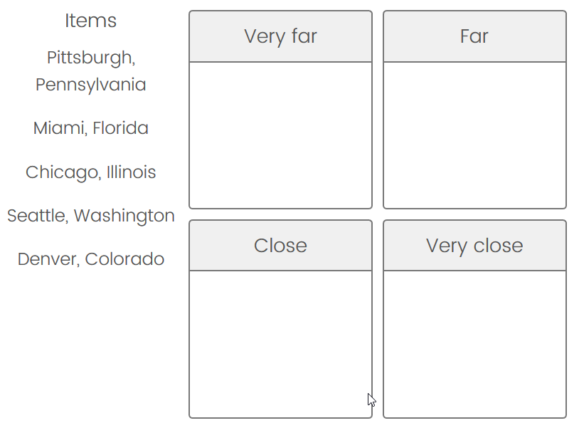

Alright! Thank you!
Advance to the next screen, and let's try the first card sort using a Census Bureau question.
For this, first, you'll see a question based on a Census Bureau survey. Then, I'd like you to 'sort' how accessible or inaccessible the answer to that question at various levels of organization at your business into four categories:
- GREEN: Easily accessible: The information is easily and readily available
- YELLOW: Accessible with minor effort: The information is available at a central location, but not in the group accounts, which requires more effort.
- ORANGE: Accessible with major effort: The information is available but decentralized (general ledger level), which requires considerable effort to acquire.
- RED: Inaccessible: The information is not available.
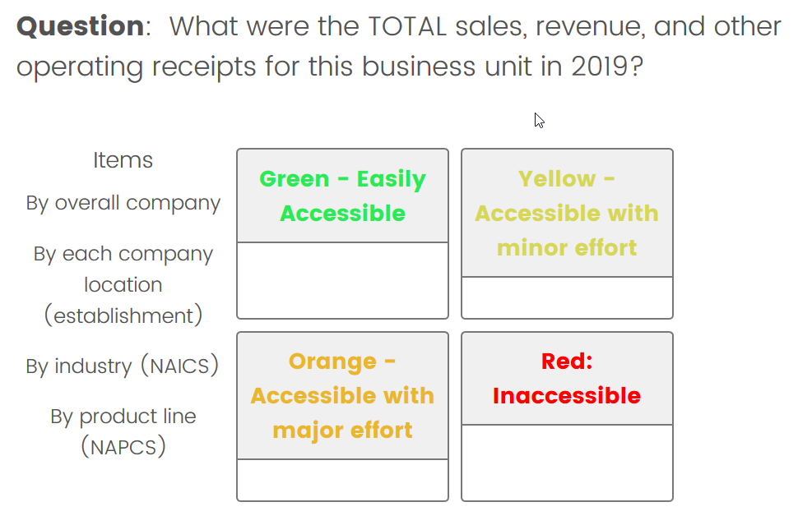

Probes:
How easy or difficult was it for you to think through the accessibility of this information?

If difficult, why? Some anticipated examples might be: definitional differences, timing, access to data, data sources, industry, and reporting unit.

If difficult, how easy or difficult would it be to resolve these issues? What definitions, instructions, or other language do you think you might need on a survey to accurately report your data?
________________________________________________________________
________________________________________________________________
________________________________________________________________
________________________________________________________________
________________________________________________________________

Ok, on to the next question. Remember to think aloud as you organize the different levels of your business.
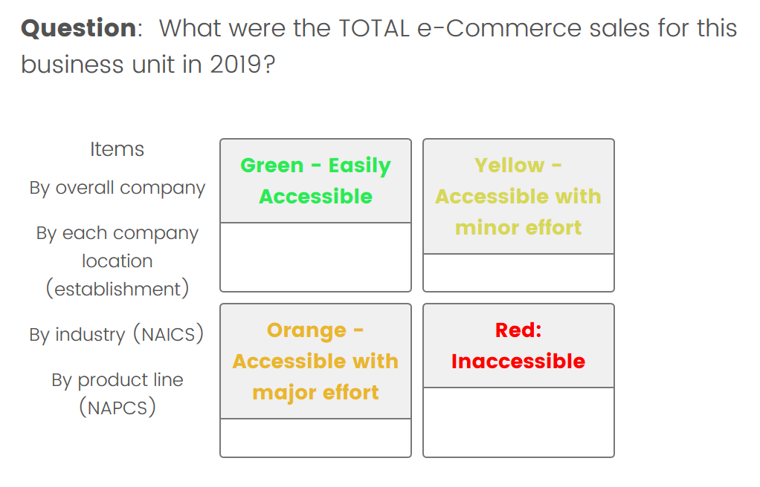

Probes:
How easy or difficult was it for you to think through the accessibility of this information?

If difficult, why? Some anticipated examples might be: definitional differences, timing, access to data, data sources, industry, and reporting unit.

If difficult, how easy or difficult would it be to resolve these issues? What definitions, instructions, or other language do you think you might need on a survey to accurately report your data?
________________________________________________________________
________________________________________________________________
________________________________________________________________
________________________________________________________________
________________________________________________________________

Let's turn our attention to expenses now.
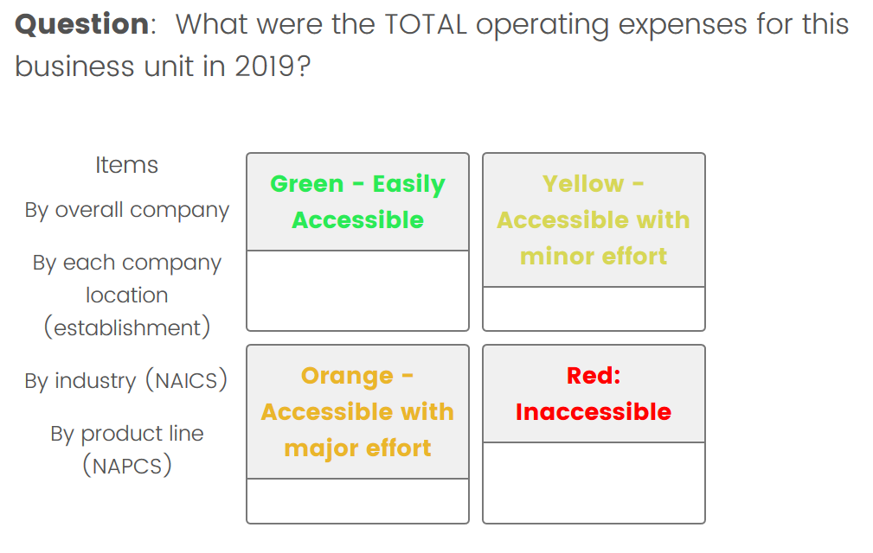
Probes:
How easy or difficult was it for you to think through the accessibility of this information?

If difficult, why? Some anticipated examples might be: definitional differences, timing, access to data, data sources, industry, and reporting unit.

If difficult, how easy or difficult would it be to resolve these issues? What definitions, instructions, or other language do you think you might need on a survey to accurately report your data?
________________________________________________________________
________________________________________________________________
________________________________________________________________
________________________________________________________________
________________________________________________________________

Q31
And next, payroll.
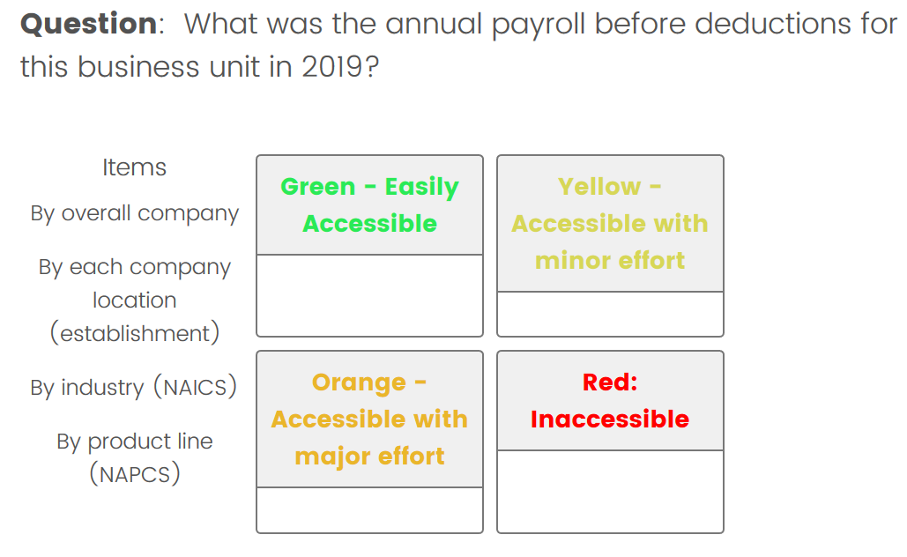

Probes:
How easy or difficult was it for you to think through the accessibility of this information?

If difficult, why? Some anticipated examples might be: definitional differences, timing, access to data, data sources, industry, and reporting unit.

If difficult, how easy or difficult would it be to resolve these issues? What definitions, instructions, or other language do you think you might need on a survey to accurately report your data?
________________________________________________________________
________________________________________________________________
________________________________________________________________
________________________________________________________________
________________________________________________________________
Question: What were the employer's 2019 annual costs for each of the following at each business unit:
- Health Insurance? - Insurance premiums for hospitals, medical plans, and single service plans such as dental, vision, and prescription drug plans.
- Defined benefit pension plans? - Costs for both qualified and nonqualified defined benefit pension plans. Plans that specify the benefit to be paid to employees upon retirement, generally either a specific amount or a percentage of compensation. Employer contributions are based on actuarial computations that include an employee's compensation and years of service and are not allocated to specific accounts maintained for employees.
- Defined contribution plans? - Costs for defined contribution plans. Pension plans that define the employer contributions to a separate account provided for each employee. The employee "benefit" at retirement depends on the amount contributed and the results of the account's activity.
- Payroll taxes, employer-paid insurance premiums, and other employer-paid benefits?
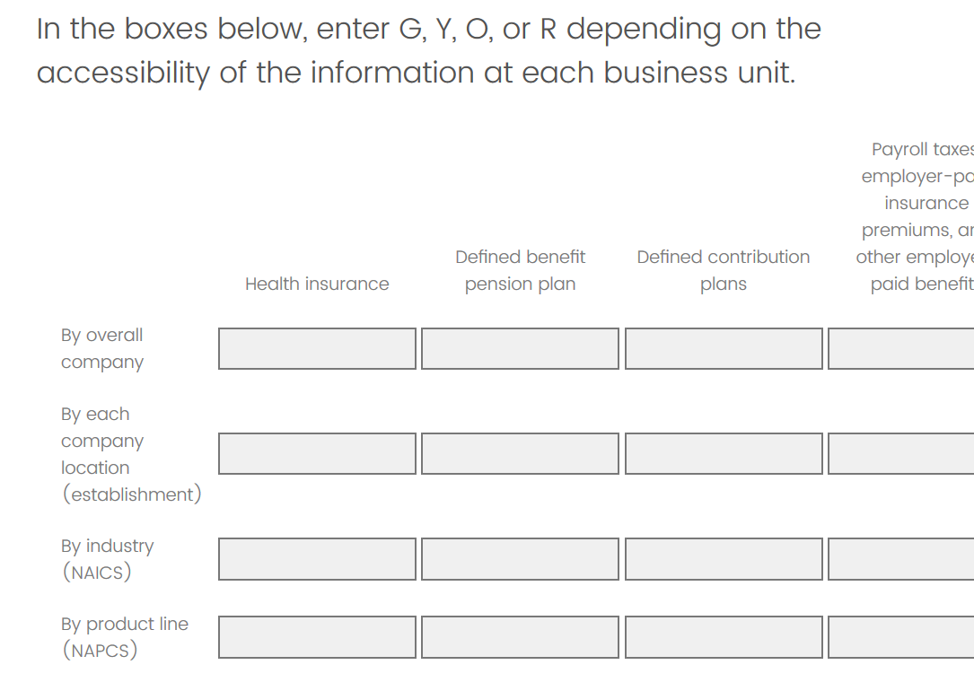

Probes:
How easy or difficult was it for you to think through the accessibility of this information?

If difficult, why? Some anticipated examples might be: definitional differences, timing, access to data, data sources, industry, and reporting unit.

If difficult, how easy or difficult would it be to resolve these issues? What definitions, instructions, or other language do you think you might need on a survey to accurately report your data?
________________________________________________________________
________________________________________________________________
________________________________________________________________
________________________________________________________________
________________________________________________________________

And next, inventory.

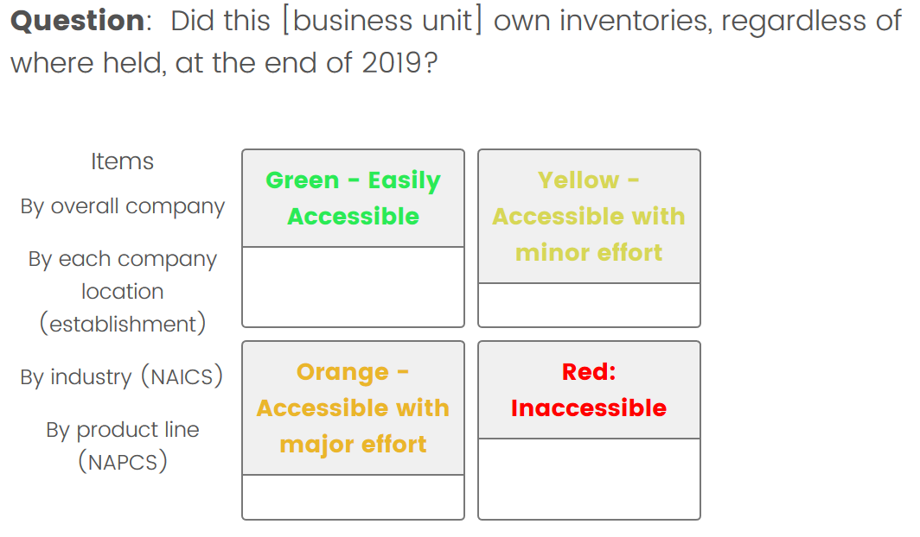
Probes:
How easy or difficult was it for you to think through the accessibility of this information?

If difficult, why? Some anticipated examples might be: definitional differences, timing, access to data, data sources, industry, and reporting unit.

If difficult, how easy or difficult would it be to resolve these issues? What definitions, instructions, or other language do you think you might need on a survey to accurately report your data?
________________________________________________________________
________________________________________________________________
________________________________________________________________
________________________________________________________________
________________________________________________________________

Q37
And now finally, capital assets.
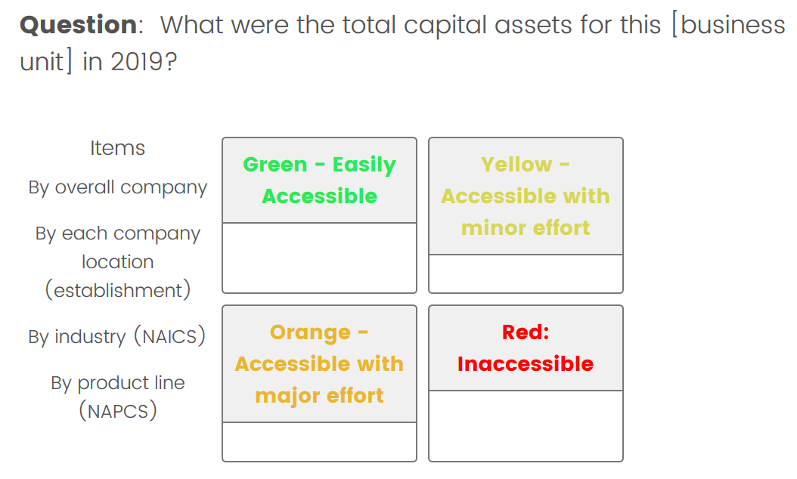
Probes:
How easy or difficult was it for you to think through the accessibility of this information?

If difficult, why? Some anticipated examples might be: definitional differences, timing, access to data, data sources, industry, and reporting unit.

If difficult, how easy or difficult would it be to resolve these issues? What definitions, instructions, or other language do you think you might need on a survey to accurately report your data?
________________________________________________________________
________________________________________________________________
________________________________________________________________
________________________________________________________________
________________________________________________________________

Wrap up

Lastly, I would like to hear any suggestions you have on the way we structure, organize, design, and/or deliver our surveys? Examples include: topics, industries, company structure (e.g., departments), timing.

In the ideal world, what would our survey look like? Examples include: topics, industries, company structure (e.g., departments), timing.
________________________________________________________________
________________________________________________________________
________________________________________________________________
________________________________________________________________
________________________________________________________________

If you received an overall survey for your company, and it asked for each of the topics we have talked about today - assets, incomes, and expenses - for the overall company and then for each industry you operate in, would that change the way you are currently reporting your company data? How and why?
________________________________________________________________
________________________________________________________________
________________________________________________________________
________________________________________________________________
________________________________________________________________

Any other questions, comments, or suggestions? [Capture here].
Thank you so much for your time and attention!
________________________________________________________________
________________________________________________________________
________________________________________________________________
________________________________________________________________
________________________________________________________________

