# Attachment A: American Community Survey (ACS) Cognitive Testing of American Community Survey Recipients during a Decennial Year

# Research Goals, Recruiting Requirements, Research Questions and 2020 Modified Materials

**November 21, 2019**

# Introduction

1. **Research Objective:** This round of cognitive testing will examine the experiences of 48 recipients of the American Community Survey (ACS) during the 2020 Census. This research will assess recipients’ (1) reaction to receiving both the ACS and the 2020 Census, and (2) impression of ACS mail materials with added messaging communicating that households need to complete both the ACS and the Decennial Census.
2. **Background:** Households in sample for the ACS in 2020 are legally required to complete both the ACS and the Decennial Census. Receiving two sets of mailings in one calendar year may be confusing to respondents. Also, being asked to complete both the Decennial Census and the ACS may be burdensome and may decrease the rate of self-response.  
     
   During the 2010 Decennial Census, ACS response rates were higher than usual in the first few months of the year but were lower than usual in the spring and summer months (see Chesnut and Davis 2011, Baumgardner 2013). The increase early in the year may have occurred because the decennial census communications campaign brought attention to the U.S. Census Bureau. The decrease later in the year may be because recipients thought the ACS was the Decennial Census and disregarded the ACS questionnaire.   
     
   To mitigate these issues in 2020, a set of modified mail materials have been developed with language that directly addresses the difference between the ACS and the 2020 Decennial Census. These materials will be used during the main response period for the 2020 Census, March through September. The 2020 ACS language modifications are based on an evaluation conducted by the Census Bureau in 2010 (see Chesnut and Davis 2011). Frequently Asked Questions (FAQs) that address recipients’ questions on the difference between the ACS and the 2020 Census have been added to mail materials as well.

# Recruitment and Interviews

* 1. **Recruitment Requirements:**
* Participants have to be in the ACS sample for March, April or May panels.
  + One-third of participants must be in the March Panel.
  + One-third of participants must be in the April Panel.
  + One-third of participants must be in the May Panel.
* Participants must have received the ACS and the 2020 Decennial Census.
* Participant’s response to either or both requests are not required.
* At least six participants must live in a rural area.
  + **The Census Bureau defines rural as any population, housing, or territory NOT in an urban area. The Census Bureau defines rural as any population, housing, or territory NOT in an urban area.** The Census Bureau will define the areas and provide cases to Westat. urban areas" consist of two types of geographies:
* **"Urbanized Areas" have a population of 50,000 or more.**
* **"Urban Clusters" have a population of at least 2,500 and less than 50,000.**Participants must handle the mail for their household, either alone or in combination with other household members.
* At least 10 participants should have less than a Bachelor’s degree.
* Participants should be diverse on demographic characteristics such as:
  + Race/ethnicity
  + Age
  + Sex
  + Household size
* Participants must not have participated in a Westat cognitive testing project in the past six months.
  1. **Recruitment Modules:**

Table 1. Recruitment modules per interview and total number of participants

|  |  |  |
| --- | --- | --- |
| **# of Modules** | **Interviews per Module** | **Total # of Participants** |
| 4 | 12 | 5 |

* 1. **Interview Timeline:**

Table 2. Recruitment and interview schedule by panel month and response type

|  |  |  |  |
| --- | --- | --- | --- |
| **Panel** | **Response type** | **Recruitment begins** | **Interviewing occurs** |
| March | Self-Response households | April | April - May |
| Non-Response households | May | May - June |
| April | Self-Response households | May | May - June |
| Non-Response households | June | June - July |
| May | Self-Response households | June | June - July |
| Non-Response households | July | July- August |

* Self-respondents should be interviewed as soon as possible after they respond (Non-respondents prior to CAPI).
* Non-respondents should not be interviewed until they have been exposed to the full ACS and 2020 Census mailing strategies.
* The Census Bureau will provide Westat with a list of respondents and non-respondents.
  1. **Research Questions:**
* What are participants’ general engagement with civic activities or community involvement (e.g. voting, Parent Teacher Association, Homeowner Association, volunteer work, other political activities)?
* How and how often is mail handled in participants’ households?
* What did participants remember about the ACS’s and the 2020 Census’ mailings and questionnaire?
* Did participants notice that they were asked to complete two different questionnaires?
  + How did participants know that they were being asked to complete two different questionnaires?
  + What did participants think were the differences between the ACS and the 2020 Census?
  + What aspects of the mailings, if any, helped participants understand that the ACS is different from the 2020 Census?
* How did participants decide to answer either or both questionnaires?
  + Were participants aware that their response was mandatory (to either or both)?
  + What aspects of the mailings influenced participants’ decision to participate (to either or both)?
* How did participants feel when they received the ACS and the 2020 Census? What thought processes did participants go through when they received the ACS and 2020 Census?
* What were participants’ general reaction to the mailings?
* What were participants’ perceptions of the usefulness of the 2020 FAQs?
  + Did participants notice the FAQs on the mailings?
  + Did it answer questions that they had?
  + Did it help differentiate the ACS from the 2020 Census?
* What action, if any, did participants take to get additional information about the ACS or 2020 Census?

# Appendix A – Interaction between ACS and 2020 Census

| ACS Panel | Census Cohort | Contact 1 | Contact 2 | Contact 3 | Contact 4 | Contact 5 | Contact 6 | Contact 7 | Contact 8 | Contact 9 | Contact 10 |
| --- | --- | --- | --- | --- | --- | --- | --- | --- | --- | --- | --- |
| March | Internet Push Cohort 1&2 | March 2 ACS Initial Mailing | March 9  ACS Pressure Seal Reminder | March 12 Decennial letter | March 16 Decennial letter | March 23 ACS Qnaire package | March 26 ACS postcard | March 26 Decennial postcard | April 8 Decennial qnaire | April 17 ACS Final Pressure Seal | April 20 Decennial postcard |
| March | Internet Push Cohort 3&4 | March 2  ACS Initial Mailing | March 9  ACS Pressure Seal Reminder | March 19 Decennial letter | March 23 ACS Qnaire package | March 23 Decennial letter | March 26 ACS postcard | April 2 Decennial postcard | April 15 Decennial qnaire | April 17 ACS Final Pressure Seal | April 27 Decennial postcard |
| March | Internet Choice | March 2  ACS Initial Mailing | March 9  ACS Pressure Seal Reminder | March 12 Decennial **qnaire** | March 16 Decennial letter | March 23 ACS Qnaire package | March 26 ACS postcard | March 26 Decennial postcard | April 8 Decennial qnaire | April 17 ACS Final Pressure Seal | April 20 Decennial postcard |
| April | Internet Push Cohort 1&2 | March 12 Decennial letter | March 16 Decennial letter | March 26 Decennial postcard | March 30 ACS Initial Mailing | April 6 ACS Pressure Seal Reminder | April 8 Decennial qnaire | April 20 ACS Qnaire package | April 20 Decennial postcard | April 23 ACS postcard | May 15 ACS Final Pressure Seal |
| April | Internet Push Cohort 3&4 | March 19 Decennial letter | March 23 Decennial letter | March 30 ACS Initial Mailing | April 2 Decennial postcard | April 6 ACS Pressure Seal Reminder | April 15 Decennial qnaire | April 20 ACS Qnaire package | April 23 ACS postcard | April 27 Decennial postcard | May 15 ACS Final Pressure Seal |
| April | Internet Choice | March 12 Decennial **qnaire** | March 16 Decennial letter | March 26 Decennial postcard | March 30 ACS Initial Mailing | April 6 ACS Pressure Seal Reminder | April 8 Decennial qnaire | April 20 ACS Qnaire package | April 20 Decennial postcard | April 23 ACS postcard | May 15 ACS Final Pressure Seal |
| May | Internet Push Cohort 1&2 | March 12 Decennial letter | March 16 Decennial letter | March 26 Decennial postcard | April 8 Decennial qnaire | April 20 Decennial postcard | May 4 ACS Initial Mailing | May 11 ACS Pressure Seal Reminder | May 26 ACS Qnaire package | May 29 ACS postcard | June 19 ACS Final Pressure Seal |
| May | Internet Push Cohort 3&4 | March 19 Decennial letter | March 23 Decennial letter | April 2 Decennial postcard | April 15 Decennial qnaire | April 27 Decennial postcard | May 4 ACS Initial Mailing | May 11 ACS Pressure Seal Reminder | May 26 ACS Qnaire package | May 29 ACS postcard | June 19 ACS Final Pressure Seal |
| May | Internet Choice | March 12 Decennial **qnaire** | March 16 Decennial letter | March 26 Decennial postcard | April 8 Decennial qnaire | April 20 Decennial postcard | May 4 ACS Initial Mailing | May 11 ACS Pressure Seal Reminder | May 26 ACS Qnaire package | May 29 ACS postcard | June 19 ACS Final Pressure Seal |

# Appendix B – ACS 2020 Mail Materials

ACS 2020 Mail Materials with 2020 Census-specific language **include:**

**Initial Mailing – Letter** (front)

The second paragraph contains two sentences with 2020 Census-specific language.

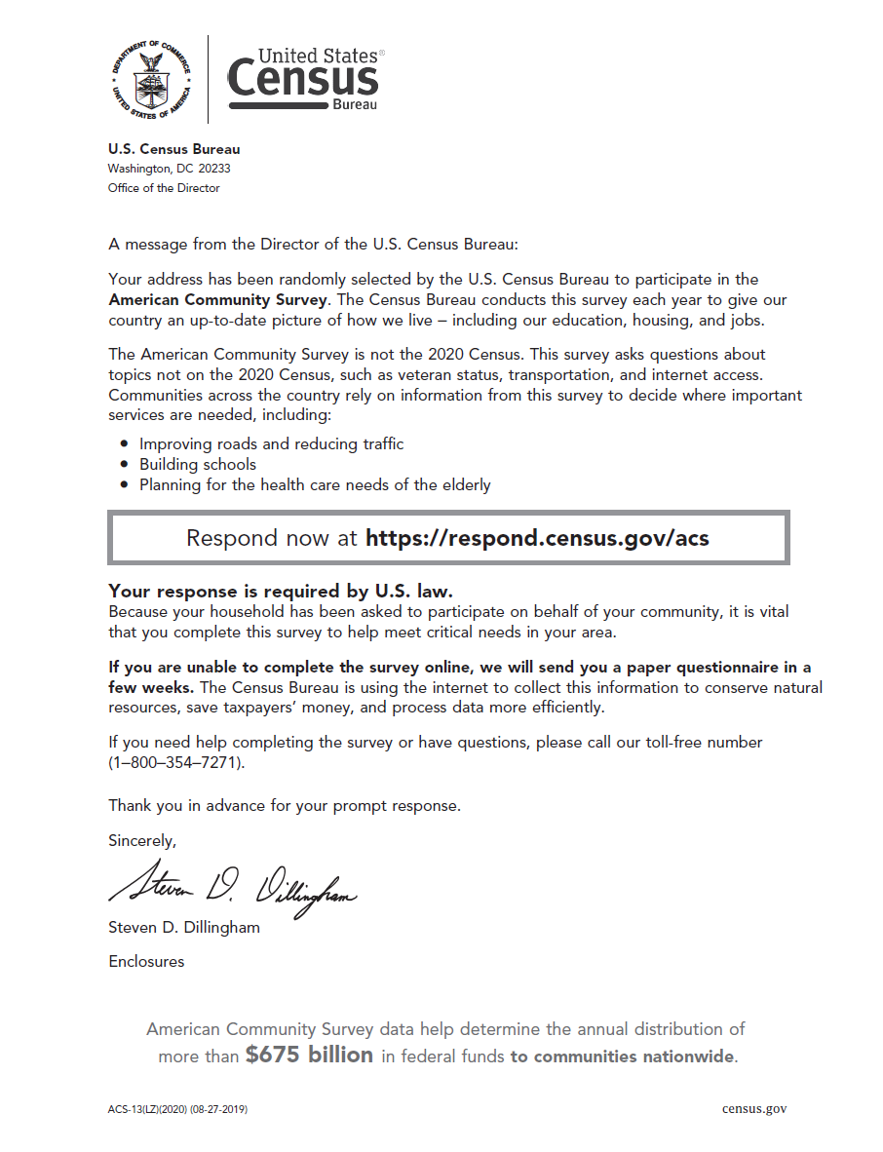

**Initial Mailing – Letter** (back)

The first two FAQs discuss the 2020 Census.

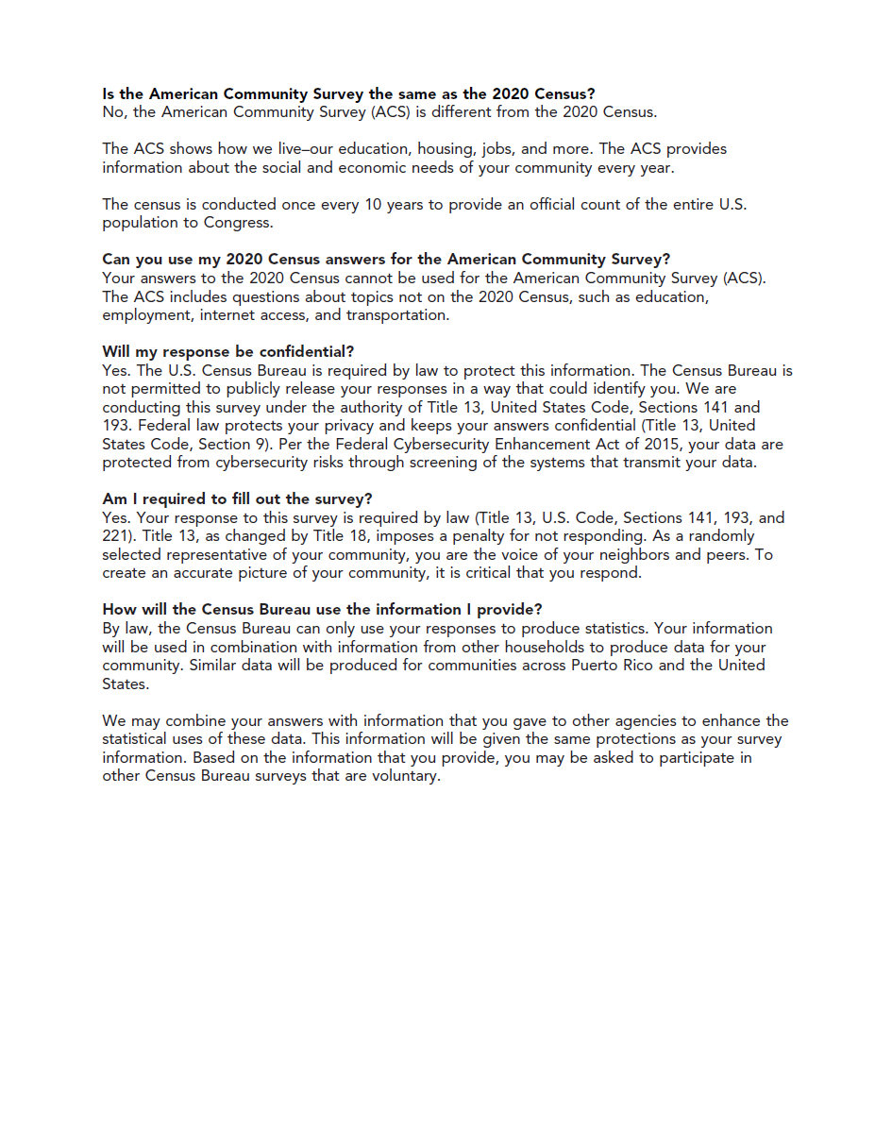

**2nd Mailing – Pressure Seal Mailer** **(**address side**)**

The address side of the pressure seal mailer mentions the American Community Survey.

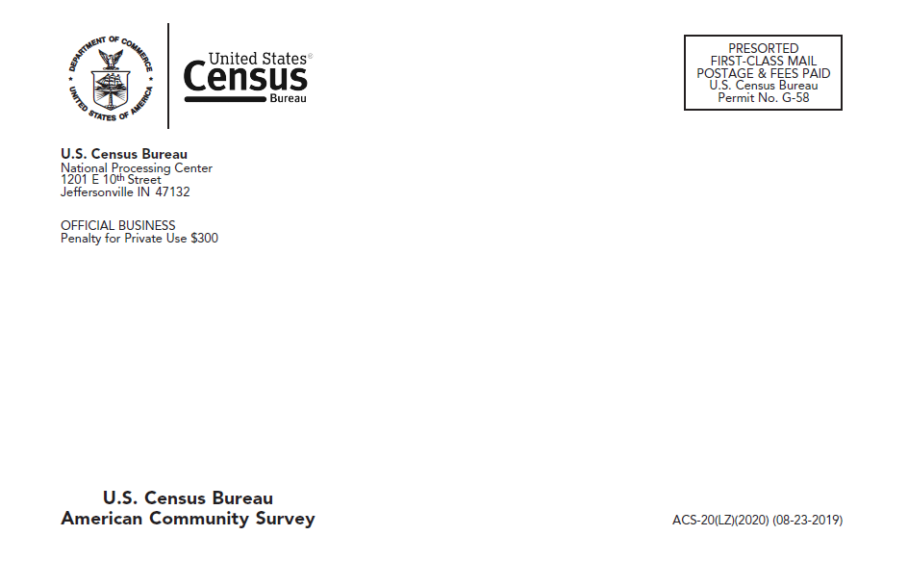

**2nd Mailing – Pressure Seal Mailer** (letter side)

2020 Census-specific language is in the second paragraph.

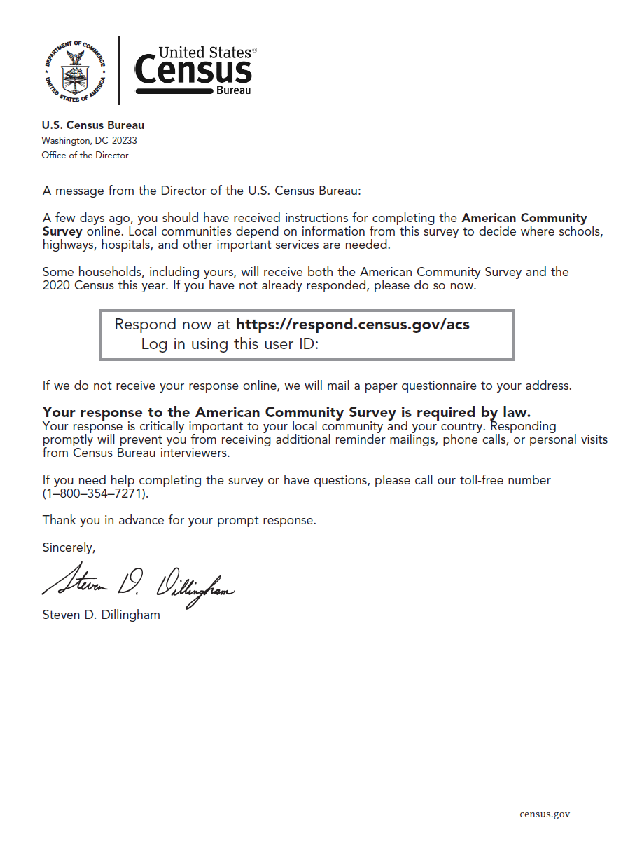

**3rd Mailing – Letter** (front)

The paragraph below the response options contains 2020 Census-specific language.

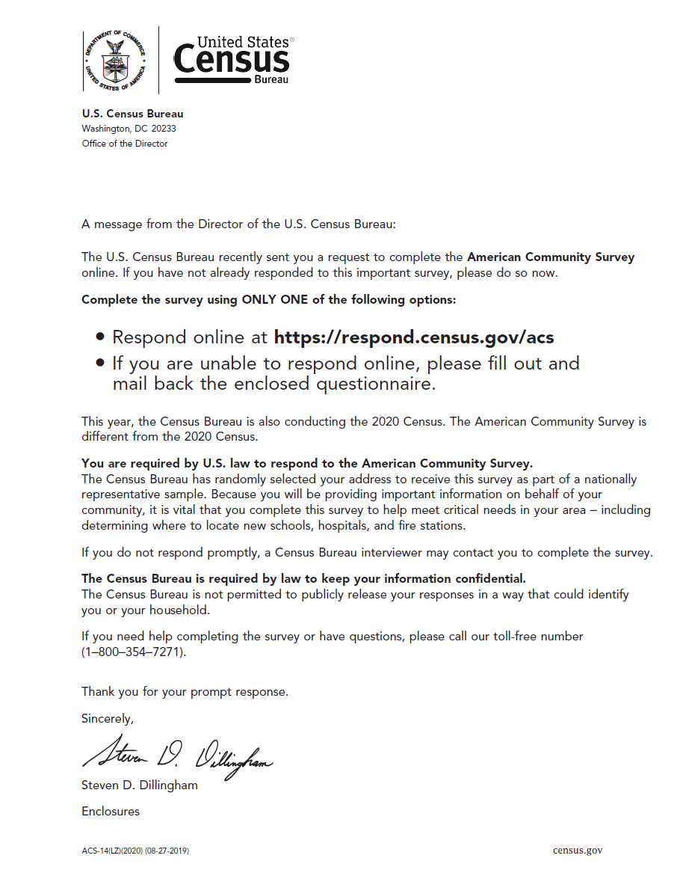

**3rd Mailing – Letter** (back)

The first two FAQs contain 2020 Census-specific language.

