Annual Retail Trade Survey (0607-0013)
Non-substantive Change Request

This non-substantive change request proposes to add 'Ceased Operation' option to existing Organizational Change question on all 8 ARTS collection instruments (SA-44, SA-44A, SA-44C, SA-44-D, SA-44E, SA-44N, SA-44S and SA-44T) for Survey Year 2019.
CEASED OPERATION:
The Census Bureau is proposing the addition of a 'Ceased Operation' check box with a date as an option for selection to the existing Organizational Change question (Section 2B). The current options for this question do not accurately capture closures/deaths that occurred during or prior to the survey year. Companies in this situation are required to complete the entire survey although they may not have any responses for the current survey year creating an unnecessary burden for them.

Existing question:
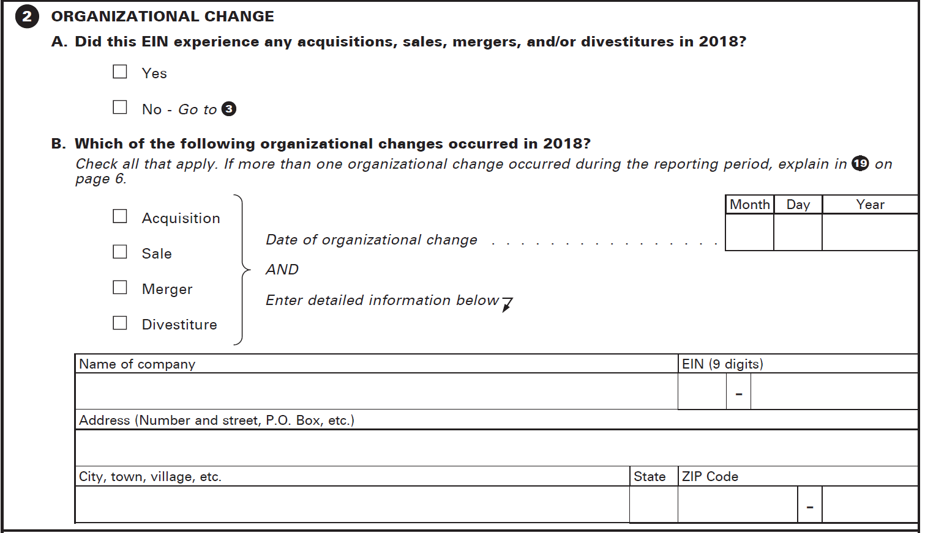

Proposed question (detailed company information lines will remain, modification is in red):
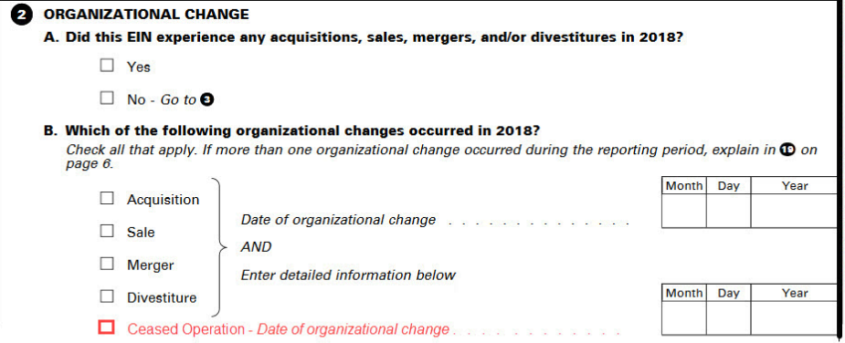

This change would affect all 8 of the existing forms and would reduce unnecessary respondent burden for companies that ceased operation prior to the survey year. Within the current instrument, companies that have 'Ceased Operation' (closure/death) during or prior to the survey year have to continue throughout the entire survey. With the proposed collection instrument change, companies that report out of business due to 'Ceased Operation' (closure/death) where the change date is prior to the survey year would be automatically skipped to the end of the survey in the electronic collection instrument. Companies that report out of business due to 'Ceased Operation' (closure/death) and the change date was during the survey year would continue their responses through the remainder of the survey in order to capture their partial year data.
BURDEN:
It is clear that by offering a “ceased operation” check box, the burden on respondents that should no longer be in the survey will decrease. However, the amount of that reduction is difficult for the Census Bureau to quantify at this time. It is our intent to conduct an analysis of the burden at the end of survey year 2018. The results of this analysis, and any burden change will be included our next formal request for extension of the survey’s expiration date.

