Under regulations at 50 CFR 679.51(a)(4), the owner of a BSAI trawl catcher vessel may annually request that NMFS place that vessel in the full observer coverage category for all directed fishing for groundfish in the Bering Sea and Aleutian Islands Management Area in the upcoming year. The instructions below provide a step-by-step guide to submit a request for placement in the full observer coverage category for one year.

1. Log into ODDS website.
2. Enter User ID and password. (Email [ODDS.help@noaa.gov](mailto:ODDS.help@noaa.gov) for assistance with User ID and password.)
3. Click “Login”.

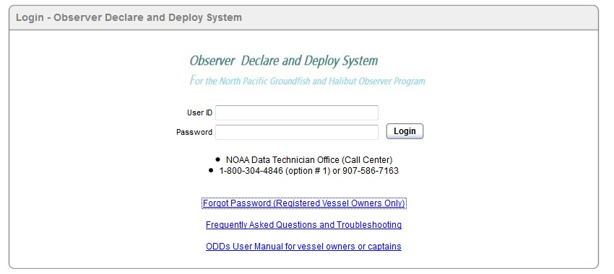

Select Login

Enter Password

Enter User ID

1. Click “Request Full Coverage”.

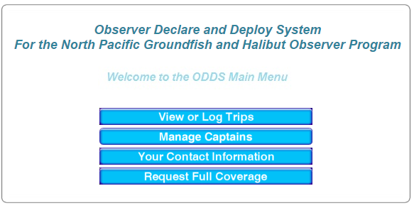

1. Read the text at the top of the screen. Find the name of the boat for which you want full coverage, and click “Request Full Coverage” next to the vessel name.

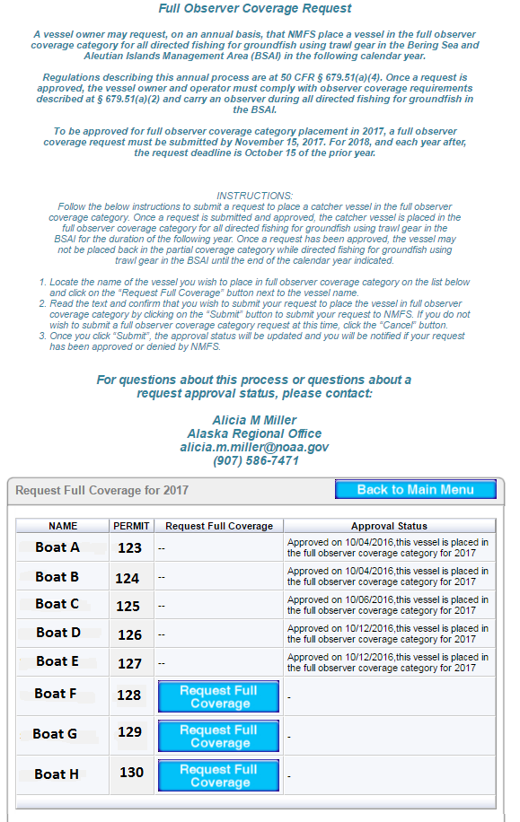

1. Read the text at the top of the screen. If you agree with the text, click “Submit”.

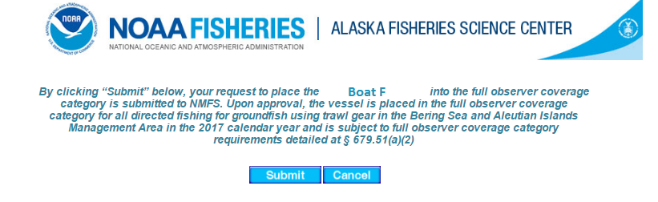

1. The vessel’s approval status will display in the Approval Status column.

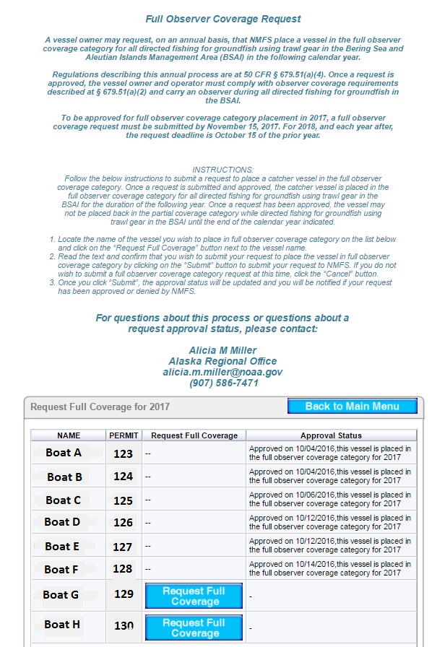

1. To request full observer coverage for additional vessels, repeat steps 7 and 8 for each vessel until finished.
2. The text in the Approval Status column is written notification from NMFS to inform you if your request has been approved or denied. For questions about your approval status, please contact Alicia M Miller by email at [alicia.m.miller@noaa.gov](mailto:alicia.m.miller@noaa.gov) or by phone at (907) 586-7471. If your request is denied, this initial administrative decision may be appealed according to regulation at 50 CFR 679.51(a)(4)(vi).