The screen capture images that follow show ALL of the questions included in the survey. Questions numbered with decimals (e.g., 1.1) are only displayed when the preceding response option is selected, triggering the display logic for the sub-question. For example, selecting the response option “Other, please specify.” triggers display of a follow-up question and open-ended response text box.
The actual survey appears as one web page; this enables the respondent to view the entire set of questions except the questions that appear only when a specific option is selected. The pagination of this document is used to accommodate the screen capture images.

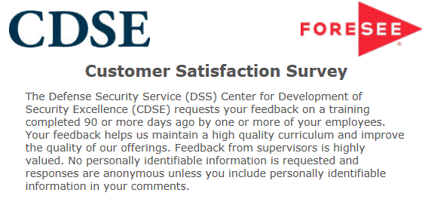

Agency Disclosure Notice
OMB CONTROL NUMBER: 0704-AABI
Expiration date: 5/31/2022

The public reporting burden for this collection of information, 0704-AABI, is estimated to average 10 minutes per response, including the time for reviewing instructions, searching existing data sources, gathering and maintaining the data needed, and completing and reviewing the collection of information. Send comments regarding the burden estimate or burden reduction suggestions to the Department of Defense, Washington Headquarters Services, at whs.mc.alex.esd.mbx.dd-dod-information-collections@mail.mil. Respondents should be aware that notwithstanding any other provision of law, no person shall be subject to any penalty for failing to comply with a collection of information if it does not display a currently valid OMB control number.

