SUPPORTING STATEMENT – PART A

U.S. Army Corps of Engineers

2019 Agricultural Shipper Transportation Needs Survey – Ohio River System

OMB Control Number: 0710-XXXX

1. Need for the Information Collection

At the broadest level, information from the questionnaire items for the collection of planning data is needed to formulate and evaluate alternative water resources development plans in accordance with the *Economic and Environmental* *Principles and Guidelines for Water Related Land Resources Implementation Studies*, promulgated by the U.S. Water Resources Council, 1983.

Within the Corps of Engineers’ Navigation mission, the Navigation Investment Model (NIM) is used to evaluate the costs and benefits of investments in the waterway and, in particular, the benefits and costs of lock improvements and replacements. Shipper response models are a key component of the NIM model. Under the Navigation and Economics Technology Program (NETS) of the Institute for Water Resources, a novel and new approach to estimating shipper response models (referred to as the Survey Model). The approach has been used to estimate shipper response models for the Columbia-Snake, the Upper Mississippi, the Ohio River, and the Calcasieu. The survey model combines revealed and stated preference data collected from (in this case) agricultural shippers to estimate shipper response models. These are then integrated into NIM to estimate the benefits of waterway investments.

The proposed research design closely follows that of other studies conducted (see above). The general approach is to estimate shipper response models using revealed and stated preference data collected from surveys and to assess annual tonnage responses from stated preference data. The data collection is based on a mixed mode approach to the survey has been used. This involves a web link, paper (mail), and telephone contact. In all cases, revealed preference data are collected for the last shipment made, followed by stated preference questions based on the revealed question responses. Since the stated preference questions depend on the response to the revealed preference response, special estimation procedures. Estimation of the modal choice model requires procedures were developed by Kenneth Train and Wesley W. Wilson, and they published the result in *Transportation Research – Part B.* The annual volume model is based on stated preference data wherein the effect of hypothetical changes in rate and shipment characteristics on annual volumes can be addressed through conventional techniques e.g., Tobit models.

Once estimated, the results of the choice model and of the annual model, can be (and have been) integrated into NIM and have been used to assess the benefits of different investment options.

1. Use of the Information

Our general approach to estimating shipper responses involves two primary models. One is a random utility model that explains model/destination choices of shippers based on rates, time in transit and reliability. Such models are used by economists to describe an individual decision making based on the attributes of the options available to the individual. The results explain to mode used and the destination chosen by agricultural shippers. In this case, it allows an assessment of the responsiveness of decisions to changes in key determinants of interest – rates, time and reliability. The other model is of annual shipment volumes. Theoretically, these volumes can be explained by a standard profit maximization problem, wherein shippers choose annual volumes shipped based on prices received for the product shipped, the costs of transportation (captured in the rate, time in transit, and reliability), and shipper attributes such as capacity. The result explains annual volumes in terms of shipper characteristics such as capacity but more importantly on rates, time in transit, and reliability. These attributes are perturbed to generate expected shipper responses to changes in rates, time in transit and reliability. This information gleaned from the surveys can be used in multiple ways, but it is primarily used by the Corps’ Inland Navigation Planning Center of Expertise to quantify of the navigation benefits of the Ohio River system.

Choice modeling is the standard for estimating shipper response models and data do not exist, which is the basis for using a survey. This survey will be conducted by a mixed mode method for shippers based in the Ohio River Basin and located within 200 miles of the nearest dock. There are 1,174 shippers in the study region and all will be contacted. The shippers will be sent a weblink, follows by a paper survey, and telephone reminders and completions.

The rest of this response is organized into three sections

1. **Overview of the RUM Model:** This section provides a brief summary or RUM models and how the model will be used to support benefit calculations in the Navigation Investment Model (NIM)
2. **Shipper Survey Implementation Plan:** This section reviews how the shipper survey will be implemented. Each phase is described along with the expected response rates. This is followed by a discussion of potential analyses to evaluate non-response bias.
3. **Analysis Methodology:** This section describes how the information collected through the shipper survey will be used to estimate the RUM models, and how these models will be used to calculate the responses of shipper to changes in rate, time in transit and reliability.

**Overview of RUM Model**

The study will use data on individual shippers of agricultural commodities in the study region. The instrument as three basic components. First, a set of questions is asked to provide general information on the shippers such as capacity, distance from the waterway, distance to the nearest rail facility, capacity of the elevator, etc. Second, a set of questions is asked to provide information on the decision made by shippers along with the alternative shipments that could have been made. These give the necessary data to estimate a choice model (a RUM). These data include the mode/destination chosen, the cost (rate), time in transit and reliability of the option chosen. The same information is solicited for alternative choices that could have been made. These comprise the revealed preference data. The survey then perturbs the attributes of the choice randomly, and shippers are then asked how their decision would be affected. These data are the stated data, which combined to form the dataset used to estimate shipper responses. The dataset then consists of revealed data and stated preference data where the latter is constructed from the revealed choice. The third set of questions is designed to estimate the responses of annual tonnages to changes in shipment attributes. The survey instruments solicits the annual volume, and then shippers are asked if these volumes change in response to randomly drawn changes in rates, time, and reliability. The result yields a stated preference dataset which can and has been used effectively to estimate shipper responses using conventional techniques e.g., a TOBIT model.

**Shipper Survey Implementation Plan**

USDA estimates a total population of 1,958 locations in PA, OH, IN, IL, KY, TN, and WV. A list of facilities, specifically focused on grain elevators and warehouses, has been developed from USDA, Waterborne Commerce Port Series, on-line search, State Departments of Agriculture, Grain Association Directories, lists compiled by other organizations (Upper Great Plains Transportation Institute), and other sources from previous studies and includes contact information. This list has 1,487 locations, and after omitting shippers located more than 200 miles from the Ohio River reduces the number to 1,174 shippers in the study region. All 1,174 shippers will be contacted. (see Figure 1). Based on previous research and supplemental material this region should capture most, if not all, agricultural shippers that use or potentially use the Ohio River for waterway shipments. The survey will be conducted in multiple phases. During the first phase, all 1,174 shippers will be sent a mailer containing a web-link which directs them to the web-based survey. During Phase 2, non-respondents will be sent a paper version of the survey. In Phase 3, the remaining non-respondent shippers will be contacted by telephone.

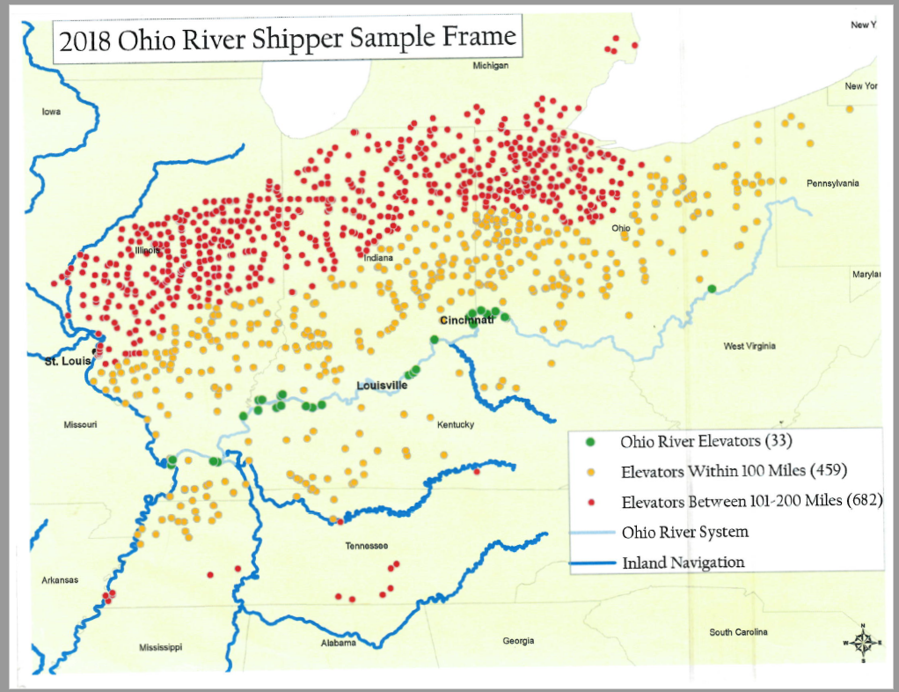

**Figure 1**

*Phase 1: Web-Link Mailer*

In the first phase of the survey, all 1,174 shippers will be sent a mailer containing a web link and an invitation to participate in the survey. Based on past experience, we expect the response rate for this phase to be approximately 23%.

*Phase 2: Paper Version of Survey*

During the second phase of the survey, the remaining non-respondents will receive a hard copy of the survey instrument along with a weblink. Based on past experience, the expected response rate for this phase is 6%. This survey will follow a modified Dillman method (Dillman 2014). The survey will be formatted as an oversize postcard and sent via first-class mail with a cover letter and pre-paid return envelope. Selected shippers will also have the option of completing the survey on-line. The cover letter (and subsequent mailings) will contain a unique *https* address that links to the questionnaire. A postcard reminder to complete the survey will be sent 7 days after the initial mailing. Up to two replacement surveys will be sent to non-respondents. All mailings (envelopes, letterhead, and survey instrument) will be “branded” with the USACE logo, which will encourage response by signaling that the survey is a high-quality, government-sponsored effort rather than a marketing effort. In addition, a toll-free number will be provided in the survey correspondence to address any questions.

*Phase 3: Telephone Follow-Up*

During the third and final phase, the remaining non-respondent shippers will be contacted by telephone with a request to provide answers to the survey questions over the phone to the expert who can facilitate and elaborate on the survey. From this approach, the expected response rate is 71%.

Overall, a total of 352 responses are expected from this mixed mode approach, and an overall response rate (not adjusted for non-contacts) of about 30 percent.

**Potential Non-Response Bias**

Given the efforts, expected response rates are 30 percent, but are very much comparable to other surveys of this kind. The primary concerns are an inadequate number of responses to achieve statistically significant results, non-response bias, differences with respect to survey protocol. As noted above, the previous surveys with similar sample sizes as those expected have yielded statistically significant results on the key parameters estimated. Non-response bias is always a concern, but the contact list employed has some information which can be used to compare the attributes e.g., capacity, distance to the waterway between respondents and non-respondents. The survey uses a mixed mode approach as has been done in past surveys. The primary intent is to increase the number of responses. However, there can be differences among the respondents due to the mode used. Again, a comparison of attributes across survey mode will identify whether there are statistical differences in observed attributes. Finally, the questions asked in the survey have been used effectively in previous surveys. They have been pre-tested and refined many times in past surveys and in initial survey design efforts.

**Analysis Methodology**

The shipper survey will be combined with other existing data to estimate the choice and volume models. These models allow the response of shippers to changes in rates, time and reliability which are necessary in the NIM model to calculate benefits of different waterway investments. Essentially, the choice and volume models are inputs into NIM. These models simulate equilibrium values associated with different waterway investments e.g., a lock improvement, which have an impact on the rates, times and reliability over the entirety of the system, which then yield changes in the volumes shipped over the system.

1. Use of Information Technology

Information from the survey screener will be collected on-line, through the mail, and by telephone. Respondents will be encouraged to fill out the screener online but will have the opportunity complete a hard copy screener and mail it back, if that is their preference. The web version of the instrument has been developed and has been used successfully in previous studies. The hard copy version is based directly on the web version.

1. Non-Duplication

The information obtained through this collection is unique and is not already available for use or adaptation from another cleared source.

1. Burden on Small Businesses

This information collection does not impose a significant economic impact on a substantial number of small businesses or entities.

1. Less Frequent Collection

This is a one-time survey and is therefore the most infrequent collection interval possible.

1. Paperwork Reduction Act Guidelines

This collection of information does not require collection to be conducted in a manner inconsistent with the guidelines delineated in 5 CFR 1320.5(d)(2).

1. Consultation and Public Comments

Part A: PUBLIC NOTICE

A 60-Day Federal Register Notice for the collection published on Friday, June 28, 2019. The 60-Day FRN citation is 84 FRN 31052.

No comments received during 60 day notice comment period.

A 30-Day Federal Register Notice for the collection published on Monday, September 30, 2019. The 30-Day FRN citation is 84 FRN 51528.

Part B: CONSULTATION

No additional consultation apart from soliciting public comments through the 60-Day Federal Register Noticed was conducted for this submission.

1. Gifts or Payment

No payments or gifts are being offered to respondents as an incentive to participate in the collection.

1. Confidentiality

A Privacy Act Statement is not required for this collection because we are not requesting individuals to furnish personal information for a system of records.

A System of Record Notice (SORN) is not required for this collection because records are not retrievable by PII.

A Privacy Impact Assessment (PIA) is not required for this collection because PII is not being collected electronically.

1. Sensitive Questions

As in most establishment surveys, there are a number of sensitive questions. These relate to the prices they receive for the product transported and the rate. This information is critical for the analysis, but the responses are confidential and not released in any way that compromises confidentiality. With some exception this has not been an issue in previous surveys.

1. Respondent Burden and its Labor Costs

We expect a resulting survey completion amount of 352 shippers, which would be a yield based on a response rate of 30% from the 1174 shippers we expect to contact. The response estimate of 30% is based on similar data collection efforts on the Ohio River system conducted in previous years and similar studies conducted by the primary investigator and survey administrator. The burden estimate for completion of offering mixed mode surveys for 352 completions through mail, email, and telephone contacts with non-respondents is 79.5 hours. Telephone reminders for non-contacts and for reminders where respondents are reached are estimated to require approximately 3 minutes per case.

1. Labor Cost of Respondent Burden

The labor cost burden is calculated with the median hourly wage of all farming, fishing and forestry workers as reported by the Bureau of Labor Statistics in their National Occupational Employment and Wage Estimates (<http://www.bls.gov/oes/current/oes_nat.htm>). The reported value was $22.57 at the time this supporting document was written. The estimated burden times are summarized in the following table for a 30 percent response rate. The total time for the 30 percent is estimated to be 79.5 hours. This gives an estimated cost of approximately $1,786.

|  |  |  |  |  |
| --- | --- | --- | --- | --- |
| **Category of Respondent** | **Survey mode response percentage of completions** | **No. of Respondents**  **N=352** | **Participation Time** | **Burden** |
| Ag Shipper – Web Survey | 23% | 81 | 15 minutes | 20 hrs. |
| Ag Shipper – Paper Survey | 6% | 21 | 15 minutes | 6 hrs. |
| **TOTAL** |  | **102** | 15 | **26 hrs.** |

A. Estimation of Respondent Burden

**1.1 Web Survey**

* 1. Number of Respondents: 81
  2. Response Time: 15 minutes
  3. Respondent Hourly Wage: $22.57
  4. Labor Burden per Response: $5.64
  5. Total Labor Burden: $456.84
  6. **Paper Survey**

1. Number of Total Annual Responses: 21
2. Response Time: 15 minutes
3. Respondent Hourly Wage: $22.57
4. Labor Burden per Response: $5.64
5. Total Labor Burden (*P: A multiplied by B multiplied by C)*: $118.49

**1.5 Overall Labor Burden to respondents**

1. Total Number of Annual Responses (*P: add all “a’s” in this section*): 102
2. Total Labor Burden (*P: add all “e’s” in this section*): $575.33
3. Respondent Costs Other Than Burden Hour Costs

There are no annualized costs to respondents other than the labor burden costs addressed in Section 12 of this document to complete this collection.

1. Cost to the Federal Government
   * 1. Labor Cost to the Federal Government

The labor cost burden was estimated by a GS11 Step 5, Washington-Baltimore-Arlington locality rate of $37.79/hour.

**1.1 Web Survey**

* 1. Number of Total Annual Responses: 81
  2. Processing Time per Response: .15 hours
  3. Hourly Wage of Worker(s) Processing Responses: $37.79 average $/hour all staff
  4. Cost to Process Each Response (*P: B multiplied by C*): $5.66
  5. Total Cost to Process Responses (*P: A multiplied by B multiplied by C*): $459.15

**1.2 Paper Survey**

1. Number of Total Annual Responses: 21
2. Processing Time per Response: # 1.79 hours
3. Hourly Wage of Worker(s) Processing Responses: $37.79
4. Cost to Process Each Response *(P: B multiplied by C)*: $67.64
5. Total Cost to Process Responses *(P: A multiplied by B multiplied by C)*: $1,420

**1.3 Phone Call Completions**

1. Number of Total Annual Responses: 250
2. Processing Time per Response: # 0.5 hours
3. Hourly Wage of Worker(s) Processing Responses: $37.79
4. Cost to Process Each Response *(P: B multiplied by C)*: $18.90
5. Total Cost to Process Responses *(P: A multiplied by B multiplied by C)*: $4,725

**1.4 Non-Respondent Contacts**

1. Number of Total Annual Responses: 822
2. Processing Time per Response: 2 minutes (0.033/hour)
3. Hourly Wage of Worker(s) Processing Responses: $37.79
4. Cost to Process Each Response *(P: B multiplied by C)*: $1.25
5. Total Cost to Process Responses *(P: A multiplied by B multiplied by C)*: $1,034

**1.5. Overall Labor Burden to Federal Government**

1. Total Number of Annual Responses (P: add all “a’s” in this section): 1,174
2. Total Labor Burden (P: add all “e’s” in this section): $7,638
   * 1. Operational and Maintenance Costs

*If you do have incur any Operational and Maintenance costs through this collection, please put “$0” next to each category.*

1. Equipment: $0
2. Printing: $2,000
3. Postage: $500
4. Software Purchases: $ 100
5. Licensing Costs: $ 0
6. Other: $ 250
7. Total *(P: add A through F in this section*): $ 2,850

Thus,

1. Total Operational and Maintenance Costs: $ 2,850
2. Total Labor Cost to the Federal Government: $ 7,638
3. Total Cost to the Federal Government *(P: Add 1 and 2 in this section)*: $ 10,488
4. Reasons for Change in Burden

This is a new collection with a new associated burden.

1. Publication of Results

The results of this information collection are planned for release in December of 2020.

Data tabulation will include response frequencies and measures of central tendency, as appropriate. The recreation survey will be combined with other existing data to estimate the RUM models, and these models will be used to estimate shipper responses.

The estimated schedule for the full survey and reporting is as follows:

* Final Material Preparation & Coordination Upon Approval
* Survey implementation August of 2019
* Data analysis and Reporting September through December 2019.

1. Non-Display of OMB Expiration Date

The OMB control number and expiration date will be displayed on the mail screener and the accompanying cover letter each survey associated with this collection. Because the telephone follow-up survey instrument will not visible to the public, respondents will be reminded of the OMB control number and expiration date at the start of the survey.

1. Exceptions to “Certification for Paperwork Reduction Submissions”

We are not requesting any exemptions to the provisions stated in 5 CFR 1320.9.

**References**

Dillman, D.A., J.D. Smyth, and L.M. Christian. 2014 *Internet, Phone, Mail, and Mixed-Mode Surveys: The Tailored Design Method* (4th Ed.). Hoboken, NJ: John Wiley Co.

Train, K. and Wilson, W.W., 2008. Estimation on stated-preference experiments constructed from revealed-preference choices. *Transportation Research Part B: Methodological*, *42*(3), pp.191-203.

**Appendix A.**

Mail Screener and Telephone Follow-Up Survey Instruments