Social and Economic Sciences Research Center

Month Day, 2019 (Cover letter 2nd Mailing)

«Contact_Name»

«Company_Name»

«Mail_Address»

«Mail_City», «Mail_State» «mail_zip»«mail_dash»«mail_zip4»

The U.S. Army Corps of Engineers is currently evaluating of the use and reliability of the navigable waterway along the Ohio River system, including the Ohio River, Kentucky River, Cumberland River, Tennessee River, and other tributaries. To assess the potential impact and demand responses to different levels of investment, the Corps is collecting information related to transportation movements along this waterway. We need to know more about the transportation and shipping decisions you make when shipping your commodities. Enclosed is a questionnaire about the Ohio River System Transportation Needs for you to complete. *It would be very helpful if you would answer the questionnaire even if you do not use the Ohio River system for your shipping needs. You can also complete the survey online at:*

# [http://opinion.wsu.edu/AgShipper201](http://opinion.wsu.edu/AgShipper)9

Access Code:xxxxx

All of the information you provide on this questionnaire will be kept strictly confidential. A code number is printed on the back page; this is only used to check your code number off the mailing list when it is returned.

We hope you will complete and return the questionnaire so that we can have the benefit of knowing your opinions and decisions regarding shipping and transportation choices available of the different shippers in our region. Previous experience suggests each questionnaire takes less than 15 minutes to complete.

We would be happy to answer any questions that you might have about this study or your participation. Feel free to call us at (800) 833-0867 and ask for the Transportation Choice Survey or send a fax message to (509) 335-0116. You can also email me at [moored@wsu.edu](mailto:moored@wsu.edu) if you prefer.

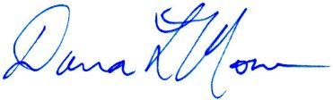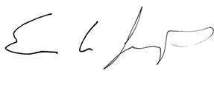Thank you for your assistance! Sincerely,

Eric Jessup Danna L. Moore

Associate Research Professor Study Director

School of Economic Sciences Social & Economic Sciences Research Center Washington State University Washington State University

OMB CONTROL NUMBER: 0710-xxxx OMB EXPIRATION DATE: xxxxxxxx

Research and Administrative Offices, 133 Wilson-Short Hall

PO Box 644014, Pullman, WA 99164-4014 | 509-335-1511 | Fax: 509-335-0116

Public Opinion Laboratory, 1615 NE Eastgate Blvd, Section F

PO Box 641801, Pullman, WA 99164-1801 | 509-335-1721 | Fax: 509-335-4688