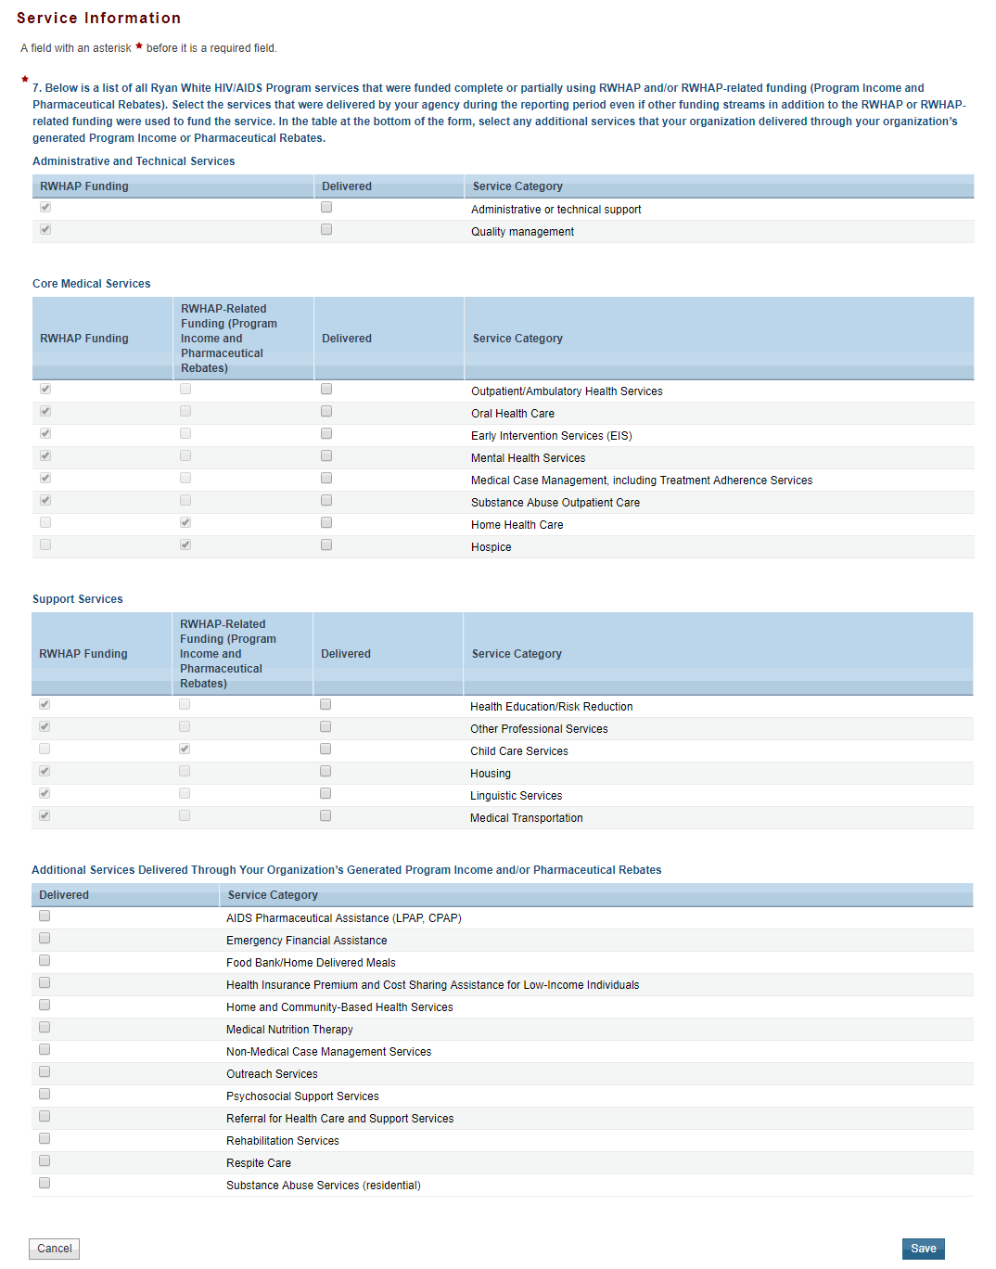
- Add a table called to Additional Services to include “Ending the HIV Epidemic (EHE) Initiative Services” under Service Category

