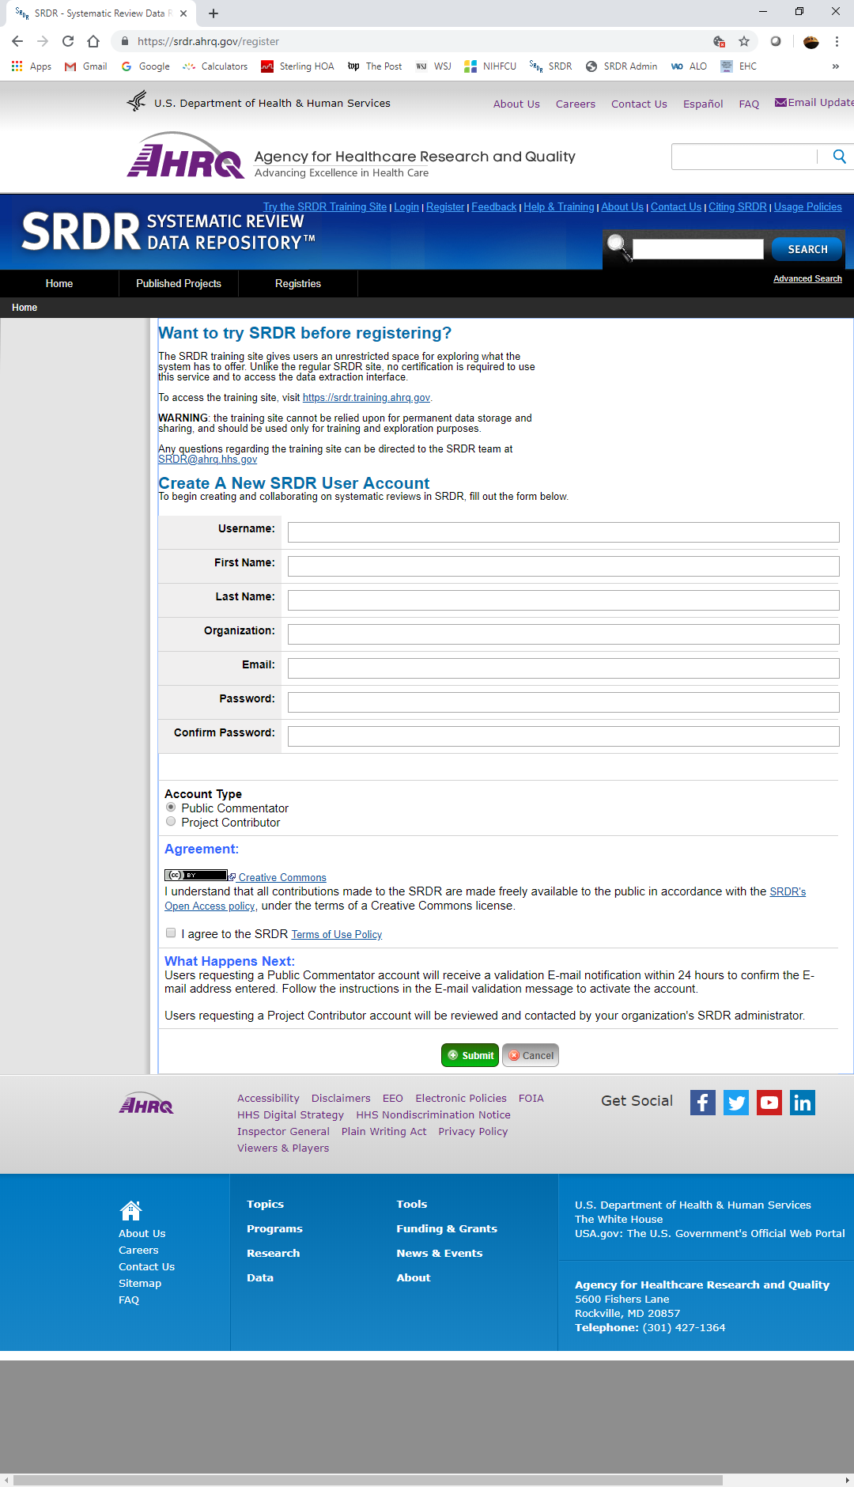
Attachment B: Data Collection Instrument
Public reporting burden for this collection of information is estimated to average XX minutes per response, the estimated time required to complete the survey. An agency may not conduct or sponsor, and a person is not required to respond to, a collection of information unless it displays a currently valid OMB control number. Send comments regarding this burden estimate or any other aspect of this collection of information, including suggestions for reducing this burden, to: AHRQ Reports Clearance Officer Attention: PRA, Paperwork Reduction Project (0935-XXXX) AHRQ, 5600 Fishers Lane, # 07W41A, Rockville, MD 20857.
Your responses will be kept confidential to the extent permitted by law, including AHRQ’s confidentiality statute, 42 USC 299c-3(c).
Form Approved
OMB No. 0935-XXXX
Exp. Date XX/XX/20XX

