The screen shots provided below are taken from the data collection instruments for the ASCQR Program on QualityNet.org. These program measures represent current requirements for data submitted via a web-based tool for facilities participating in the ASCQR Program.
Structural Measures for the ASCQR Program
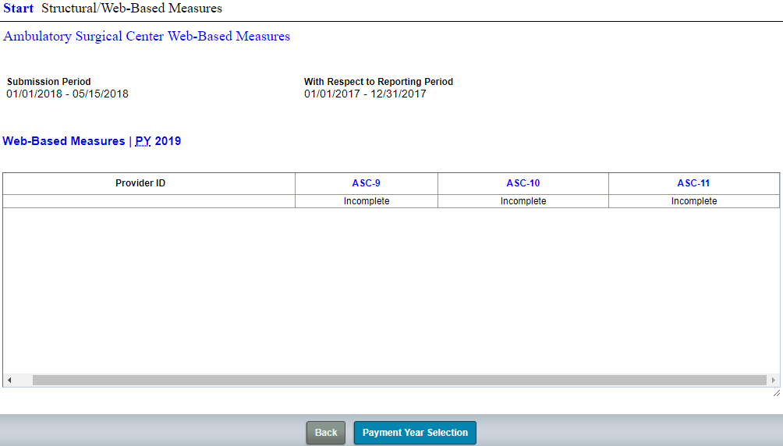
ASC-9: Endoscopy/Polyp Surveillance: Appropriate Follow-up Interval for Normal Colonoscopy in Average Risk Patients
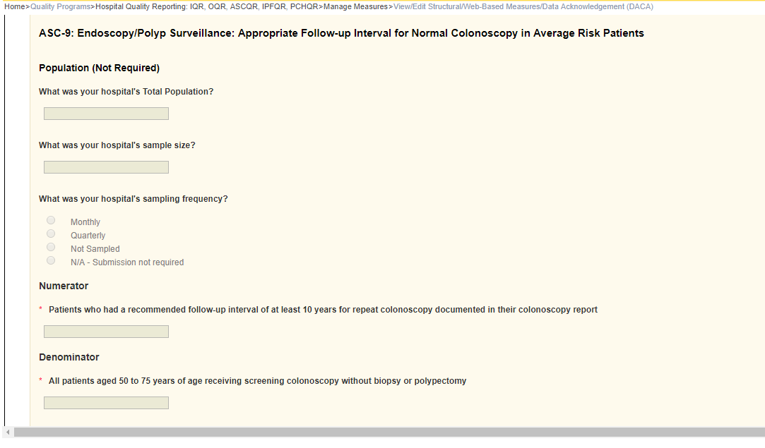
ASC-10: Endoscopy/Polyp Surveillance: Colonoscopy Interval for Patients with a History of Adenomatous Polyps – Avoidance of Inappropriate Use
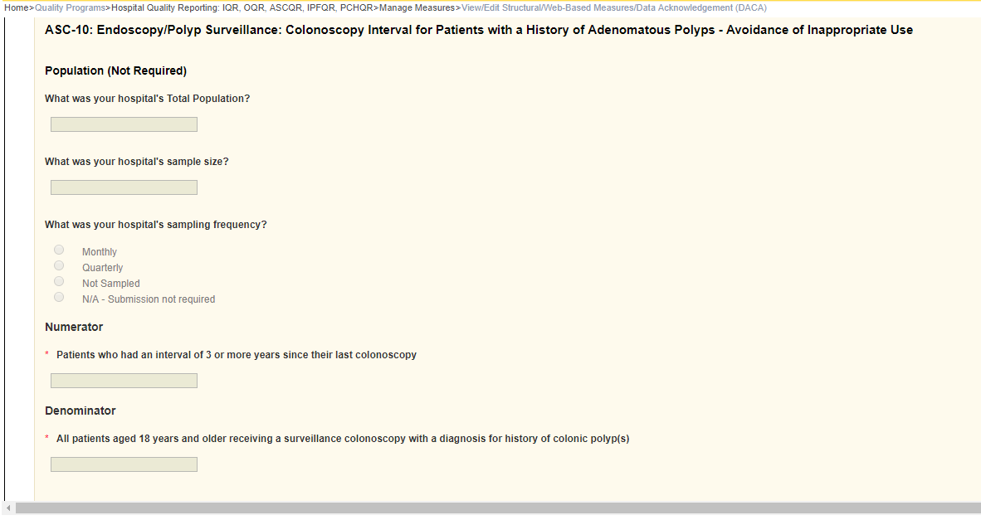
ASC-11: Cataracts: Improvement in Patient’s Visual Function within 90 Days Following Cataract Surgery
