Digital Identity

Release Package

September 2019

Table of Contents

Digital Identity 1
Digital Identity - INTERNET SCREENS 3
Sign in Terms of Service 3
Digital Identity - Registration and Customer Support (RCS) Screens 4
Temporary Password Print Optional Success (IPL3FXV) 4
Reset Code Print Optional Notice (IPL3FXV 4
Temporary Password Success (IPL3FXV) 5
Reset Code Mailed Success (IPL3FXV) 5
Temporary Password Print Confirmation (RCPC) (Temporary Password) In Person 6
Reset Code Print Confirmation (RCPC) in Person 7
Cannot Add Extra Security (CAES) 8
Confirmation - Upgrade Code Mailed (CUCM) 8
Standard enrollment - Activation Code Mailed (ENMAIL) 9
Standard enrollment - Activation Code Mailed (ENMAIL) - refused the Identity Services Provider check 9

Digital Identity - INTERNET SCREEN

Sign in Terms of Service
- Added a new bullet “Give false or misleading information to obtain or alter Social Security benefits; or”
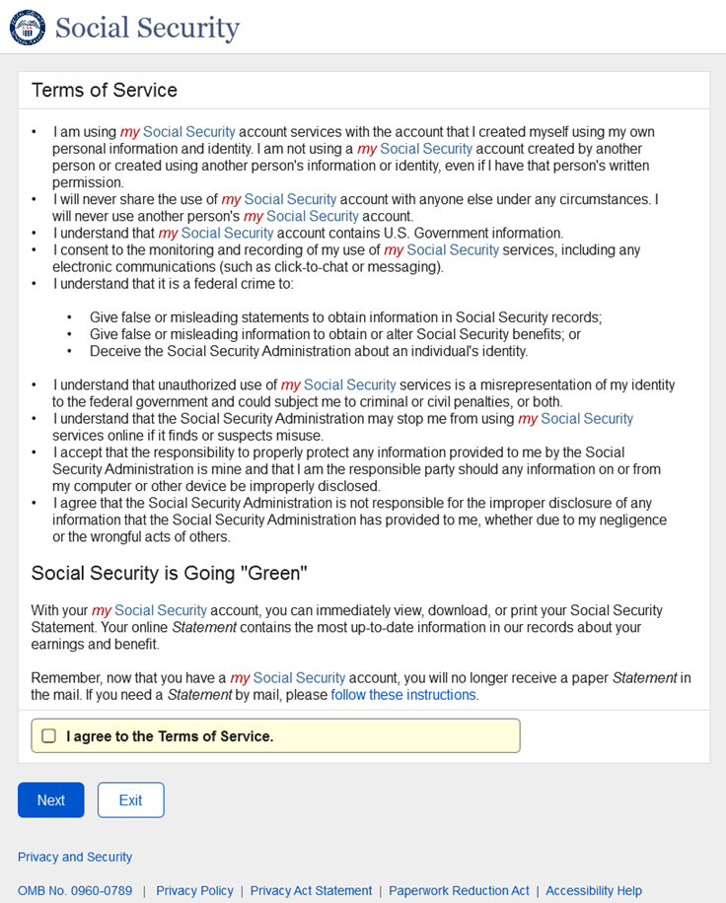

Digital Identity - Registration and Customer Support (RCS) Screens

Temporary Password Print Optional Success (IPL3FXV)
- The banner language was changed from "The temporary password letter was sent to the printer." to "The receipt was sent to the printer."
- Primary and secondary buttons were assigned.
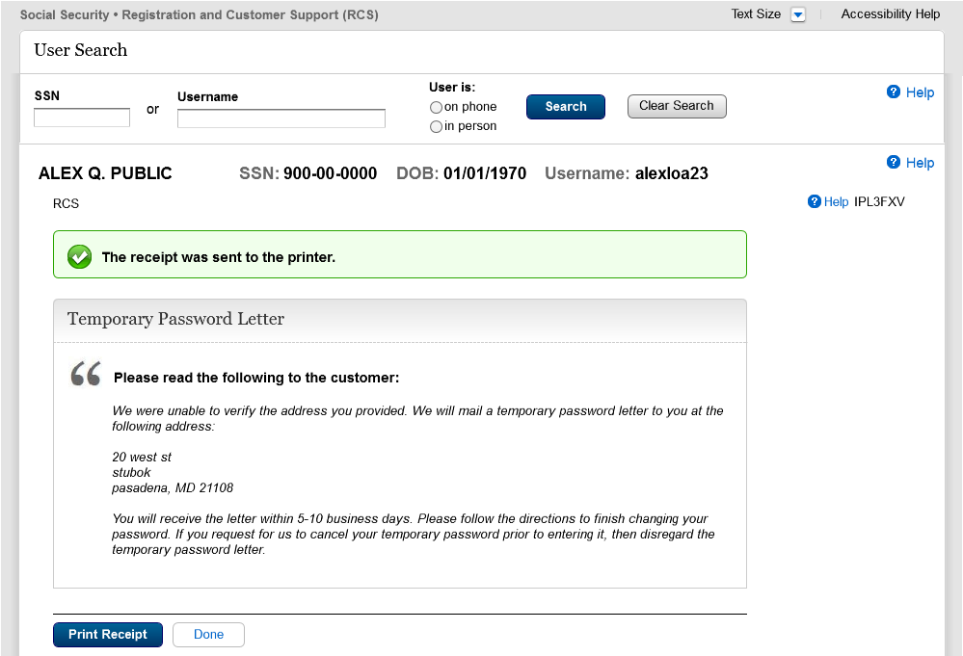

Reset Code Print Optional Notice (IPL3FXV
- The banner language was changed from "The reset code letter was sent to the printer." to "The receipt was sent to the printer."
- Primary and secondary buttons were assigned.
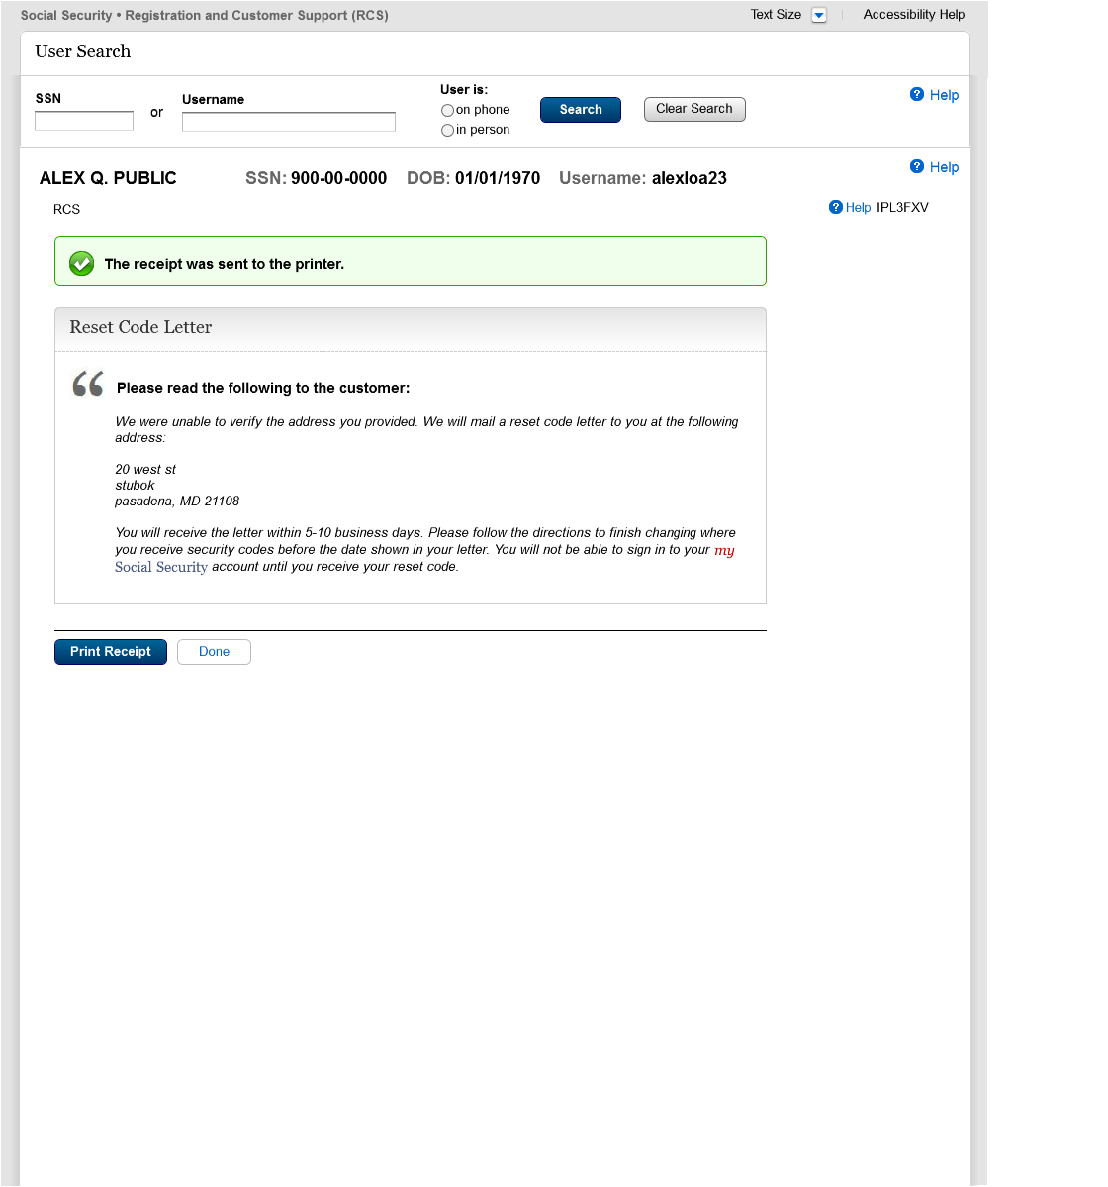

Temporary Password Success (IPL3FXV)
- Primary and secondary buttons were assigned
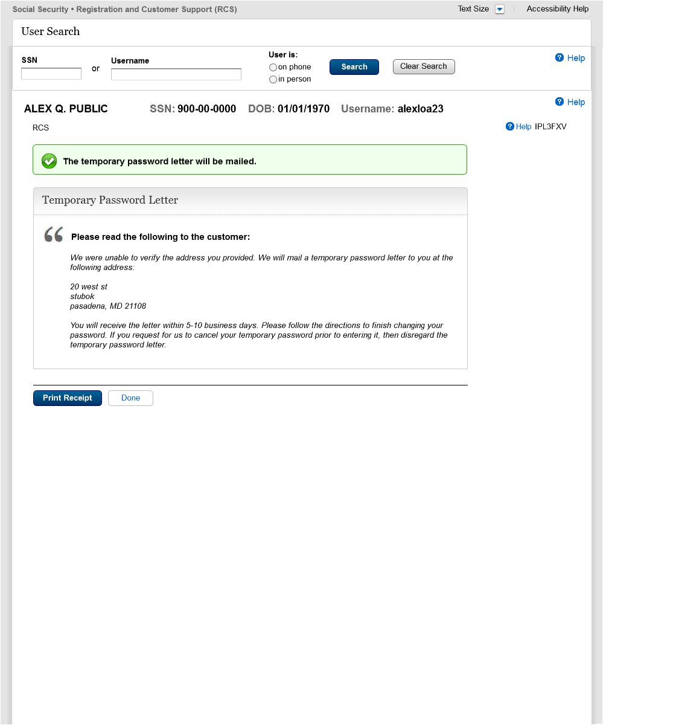

Reset Code Mailed Success (IPL3FXV)
- Primary and secondary buttons were assigned.
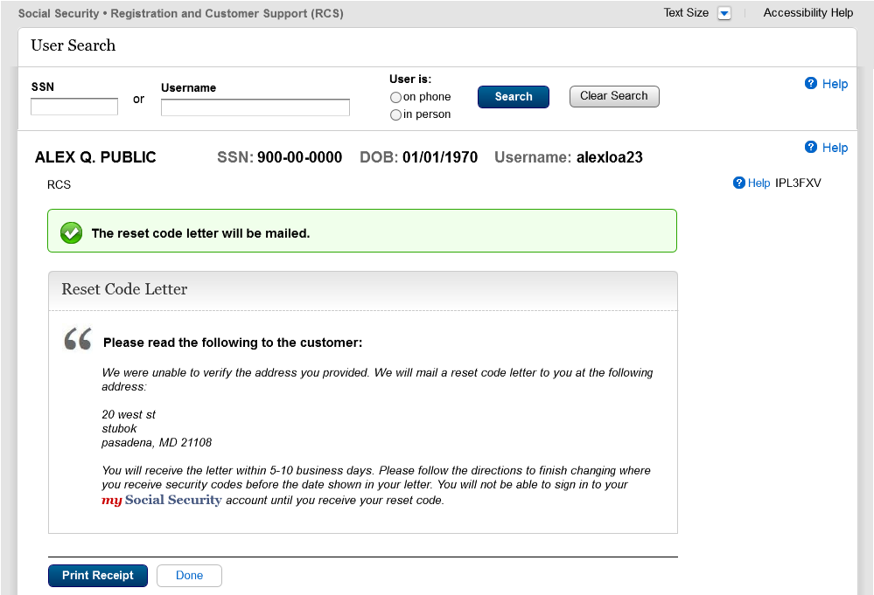

Temporary Password Print Confirmation (RCPC) (Temporary Password) In Person
- The word "successfully" was removed from the banner changing the banner language from "The temporary password letter was successfully sent to the printer." to "The temporary password letter was sent to the printer.
- The words "print" and "confirmation" were added to the title changing it from "Temporary Password Letter" to "Print Temporary Password Letter Confirmation"
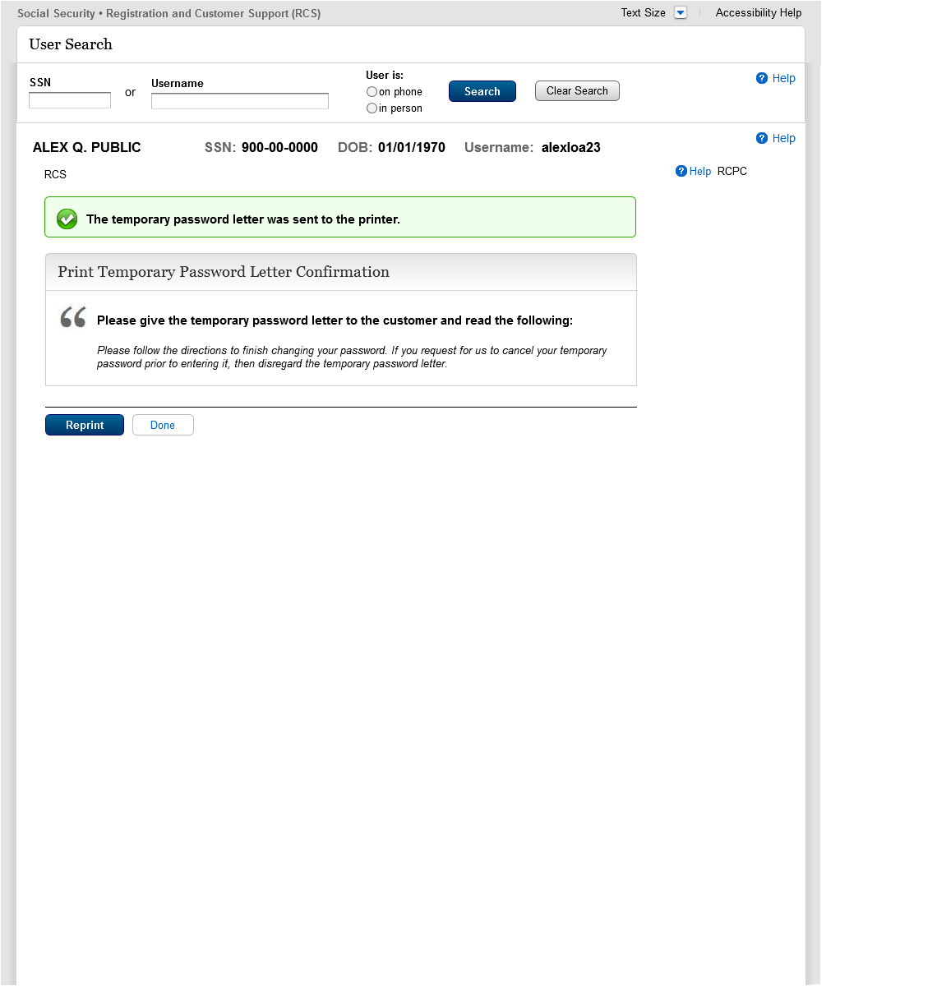

Reset Code Print Confirmation (RCPC) in Person
- The word "successfully" was removed from the banner changing the banner language from "The reset code letter was successfully sent to the printer." to "The reset code letter was sent to the printer
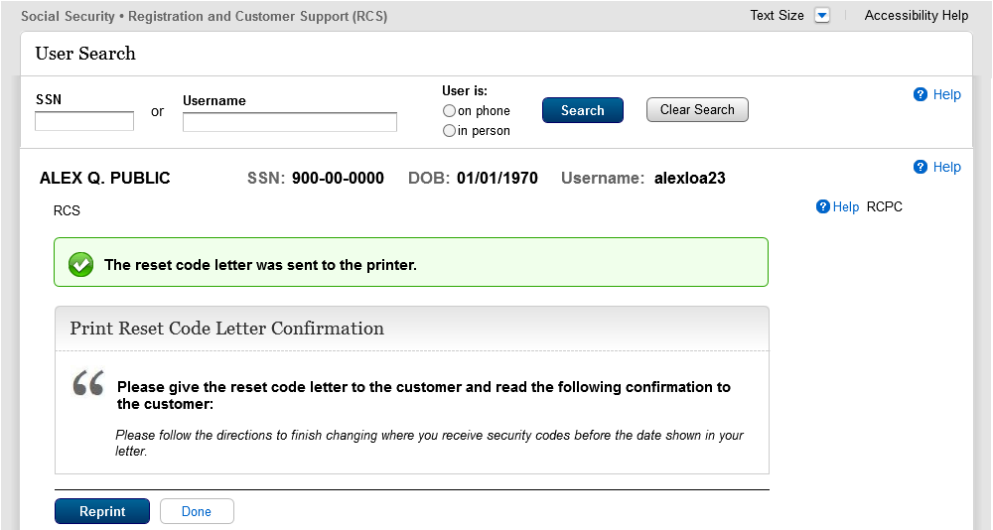

Cannot Add Extra Security (CAES)
- The “DONE” button was changed to the primary format and is consistent with other pages.
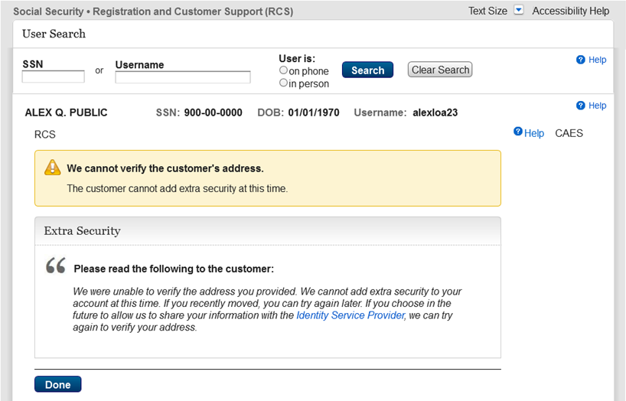

Confirmation - Upgrade Code Mailed (CUCM)
- Assigned primary and secondary buttons.
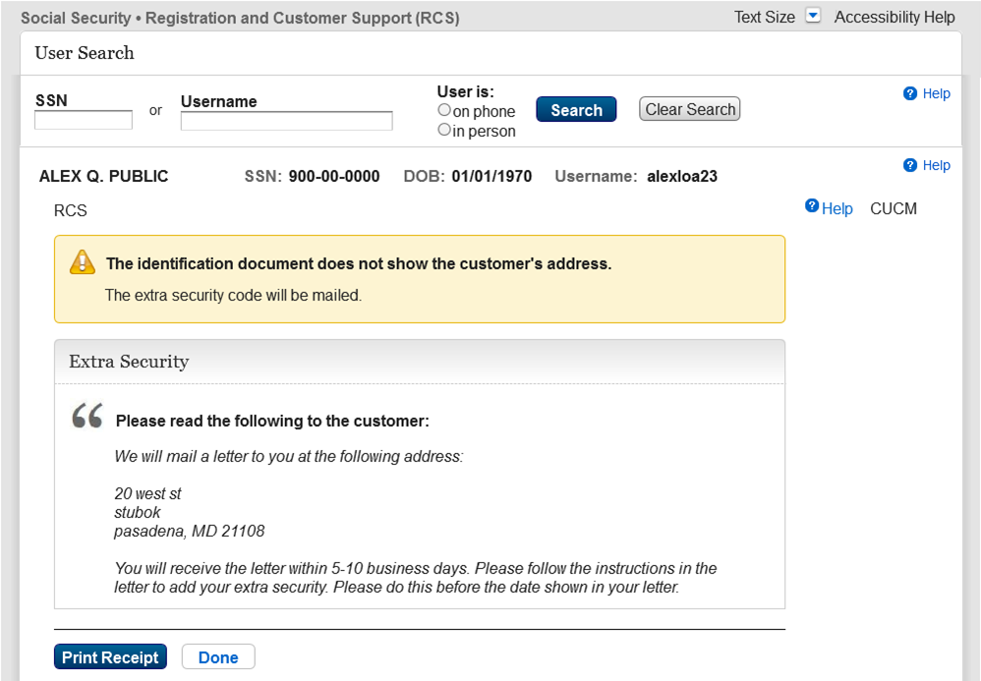

Standard enrollment - Activation Code Mailed (ENMAIL)
- Assigned primary and secondary buttons
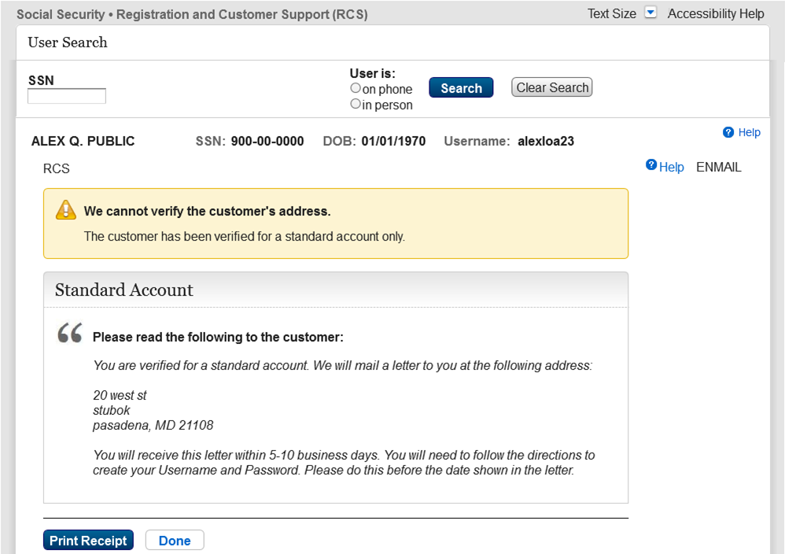

Standard enrollment - Activation Code Mailed (ENMAIL) - refused the Identity Services Provider check
- Assigned primary and secondary buttons.
