BA001 –

KBA-1 Screen used by Block Electronic Access:

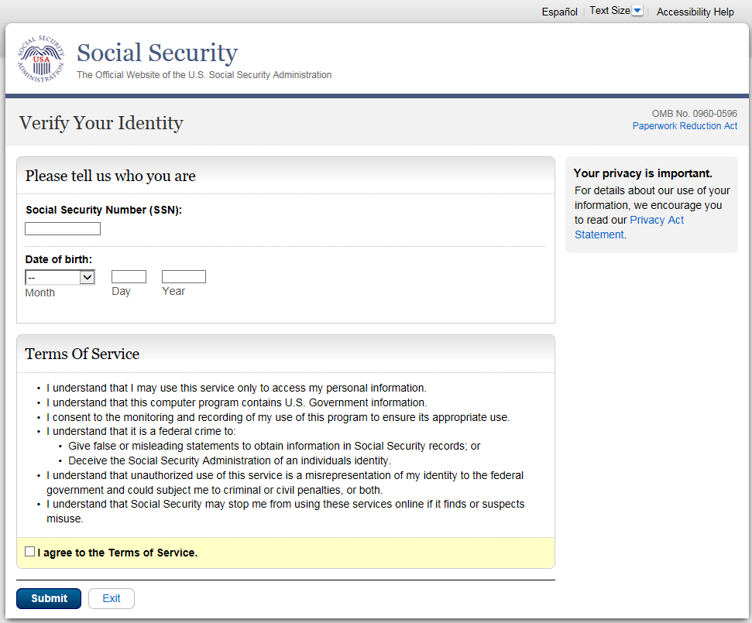

BA002 –

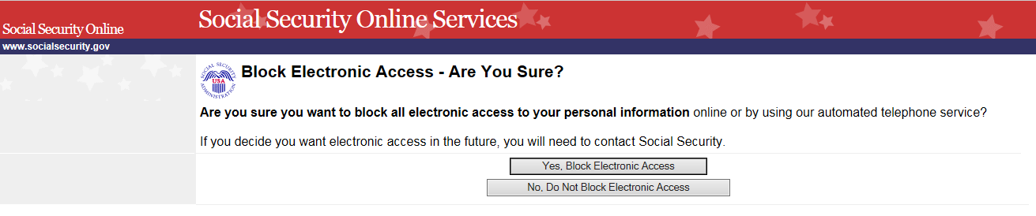

BA003 –

