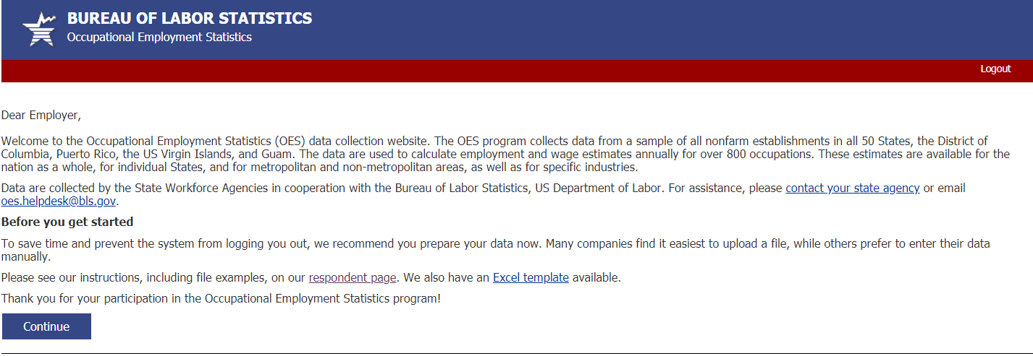We estimate that the time required to complete this report will vary from 10 minutes to 2 hours, depending on factors such as the size of the establishment. This includes time for reviewing instructions, searching existing data sources, gathering and maintaining the data needed, and completing and reviewing this information. If you have any comments regarding these estimates or any other aspects of this report, including suggestions for reducing this burden, send them to the U.S. Bureau of Labor Statistics, Division of Occupational Employment Statistics (1220-0042), 2 Massachusetts Ave NE, Suite 2135, Washington, DC 20212. This report is authorized by law 29 U.S.C. §2. We request your cooperation to make the results of this report comprehensive, accurate, and timely. You do not have to complete this questionnaire if it does not display a currently valid OMB control number. Form Approved, O.M.B. No. 1220-0042.
<state_mandatory>
The Bureau of Labor Statistics, its employees, agents, and partner statistical agencies, will use the information you provide for statistical purposes only and will hold the information in confidence to the full extent permitted by law. In accordance with the Confidential Information Protection and Statistical Efficiency Act (44 USC Section 3561 et seq.) and other applicable Federal laws, your responses will not be disclosed in identifiable form without your informed consent except in the case of state and local governments. The BLS publishes statistical tabulations from this report that may reveal the information reported by state and local governments. Upon request, however, the BLS will hold the information provided by state and local governments on this report in confidence. Per the Federal Cybersecurity Enhancement Act of 2015, Federal information systems are protected from malicious activities through cybersecurity screening of transmitted data.

Dear Employer,
Next month, you will receive a request to complete the Occupational Employment Statistics Report, which is the primary source of occupational employment and wage statistics in the U.S. OES data are used to calculate employment and wage estimates annually for over 800 occupations. These estimates are available for the nation as a whole, for individual states, and for metropolitan and nonmetropolitan areas, as well as for specific industries. Data are collected by the State Workforce Agencies in cooperation with the Bureau of Labor Statistics, U.S. Department of Labor.
We would like to identify a contact person who will report information for the Occupational Employment Statistics Report next month.
For assistance, please contact your state agency [link to https://www.bls.gov/respondents/oes/contact.htm] or email oes.helpdesk@bls.gov.
Visit our OES Respondent page [link to https://www.bls.gov/respondents/oes/home.htm] for more information on reporting.
Click “Continue” to provide the name and contact information of the person who should receive the OES data request.
We estimate that the time required to complete this report will vary from 10 minutes to 2 hours, depending on factors such as the size of the establishment. This includes time for reviewing instructions, searching existing data sources, gathering and maintaining the data needed, and completing and reviewing this information. If you have any comments regarding these estimates or any other aspects of this report, including suggestions for reducing this burden, send them to the U.S. Bureau of Labor Statistics, Division of Occupational Employment Statistics (1220-0042), 2 Massachusetts Ave NE, Suite 2135, Washington, DC 20212. This report is authorized by law 29 U.S.C. §2. We request your cooperation to make the results of this report comprehensive, accurate, and timely. You do not have to complete this questionnaire if it does not display a currently valid OMB control number. Form Approved, O.M.B. No. 1220-0042.
<state_mandatory>
The Bureau of Labor Statistics, its employees, agents, and partner statistical agencies, will use the information you provide for statistical purposes only and will hold the information in confidence to the full extent permitted by law. In accordance with the Confidential Information Protection and Statistical Efficiency Act (44 USC Section 3561 et seq.) and other applicable Federal laws, your responses will not be disclosed in identifiable form without your informed consent except in the case of state and local governments. The BLS publishes statistical tabulations from this report that may reveal the information reported by state and local governments. Upon request, however, the BLS will hold the information provided by state and local governments on this report in confidence. Per the Federal Cybersecurity Enhancement Act of 2015, Federal information systems are protected from malicious activities through cybersecurity screening of transmitted data.

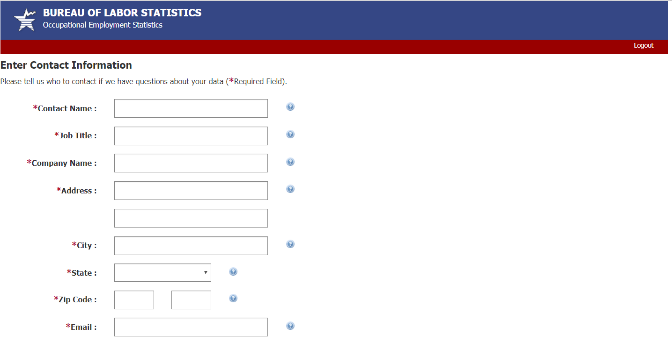

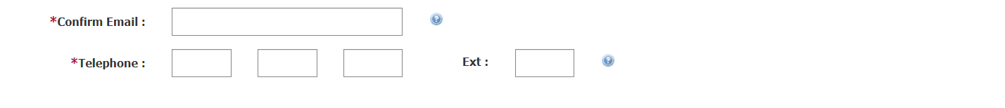
Submit
Thank you for providing your contact information
We will contact you soon via email or postal mail to request your establishment’s occupational employment and wage data.
For more information, visit our OES Respondent page [link to https://www.bls.gov/respondents/oes/home.htm] or the main OES webpage [link to https://www.bls.gov/oes/].

