*Passenger Perception of the Adobe Redefining the Passenger Experience System Survey*

Please answer each question to the best of your ability. Your answers will remain confidential and cannot be traced back to you by any means.

|  |  |  |  |  |  |  |
| --- | --- | --- | --- | --- | --- | --- |
| 1 | What is your approximate age? | Under 30 | | 30-49 | 50-69 | 70+ |
| 2 | How many Adobe kiosks did you notice at the checkpoint? | Please enter your numeric response here. | |  |  |  |
| 3 | The Adobe kiosk’s wait time indicator was accurate. | Strongly Disagree | Disagree | Neither Agree Nor Disagree | Agree | Strongly Agree |
| 4 | The Adobe kiosk(s) helped prepare me for the checkpoint process (having documents ready, divesting for screening, etc). | Strongly Disagree | Disagree | Neither Agree Nor Disagree | Agree | Strongly Agree |
| 5 | The Adobe kiosk(s) provided information regarding the MyTSA app. | Yes | No |  |  |  |
| 6 | I already downloaded, or plan to download the MyTSA App. | Strongly Disagree | Disagree | Neither Agree Nor Disagree | Agree | Strongly Agree |
| 7 | The time taken to get through the checkpoint today seemed: | Much slower than usual | Slightly slower than usual | Same as usual | Slightly faster than usual | Much faster than usual |

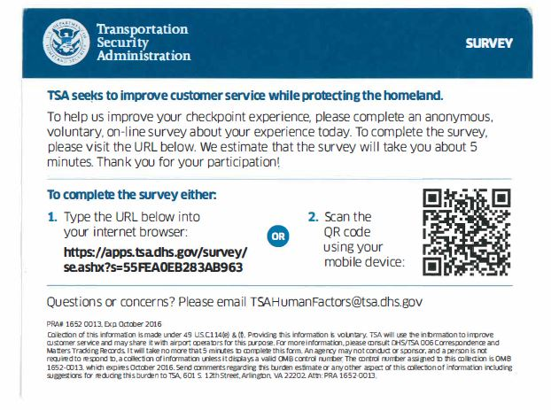

**Paperwork Reduction Act Statement: TSA is collecting this information to assess the** **Passenger Perception of the Adobe Red Pax communication system. The public burden for this voluntary collection of information is estimated to be approximately 1.5 minutes. An agency may not conduct or sponsor, and persons are not required to respond to a collection of information, unless it displays a valid OMB control number. The OMB control number assigned to this collection is 1652-0058, which expires 09/30/2022. Send comments regarding this burden estimate or collection to: TSA-11, Attention: PRA 1652-0058, Passenger Perception of Adobe Redefining the Passenger Experience system., 601 South 12th Street, Arlington, VA 20598-6011.**