Passenger Perception of
Walk Though Metal Detector- Advanced Imaging Technology Combination Survey.

INSTRUCTIONS:
You are eligible for this survey because you experienced the CEIA Enhanced Walk-Through Metal Detector (eWTMD) and Enhanced Advanced Imaging Technology (eAIT) Combined System at the Transportation Security Administration (TSA) security checkpoint today. TSA is seeking your opinion of the ease of use and general preference of this technology. Your participation is VOLUNTARY and will remain ANONYMOUS. Please answer each question to the best of your ability. No information you provide can be linked back to you.

One feature of this combined system is a “Passenger Call” that visually alerts passengers when the passengers can enter the scanning systems (e.g., green/red lights). There are slightly different versions of the questionnaire when this Call System is ON or OFF.

Version 1: When Passenger Call System is ON (green/red light)

1 | How old are you? | Under 18 | 18-20 | 20-29 | 30-39 | 40-49 | 50-59 | Over 60
2 | The eAIT I went through today is different from the ones I have been screened by in the past. | Yes | No |  |  |  |  |  | NA
3 | Compared with my past travel experience, the screening process that I went through today took: | Substantially Longer | Slightly Longer | Same as Usual | Slightly Less Time | Substantially Less Time
4 | The visual cues (LED lights on the metal detector) were easy to understand and helped guide me through the screening process. | Strongly Disagree | Disagree | Neither Agree Nor Disagree | Agree | Strongly Agree |  | I did not notice any LED lights
5 | How would you describe your experience using the eAIT today? | Overwhelmingly Negative | Negative | Slightly Negative | Neither Negative nor Positive | Slightly Positive | Positive | Overwhelmingly Positive

Version 2: When Passenger Call System is OFF

1 | How old are you? | Under 18 | 18-20 | 20-29 | 30-39 | 40-49 | 50-59 | Over 60
2 | The eAIT I went through today is different from the ones I have been screened by in the past. | Yes | No |  |  |  |  |  | NA
3 | Compared with my past travel experience, the screening process that I went through today took: | Substantially Longer | Slightly Longer | Same as Usual | Slightly Less Time | Substantially Less Time
4 | How would you describe your experience using the eAIT today? | Overwhelmingly Negative | Negative | Slightly Negative | Neither Negative nor Positive | Slightly Positive | Positive | Overwhelmingly Positive

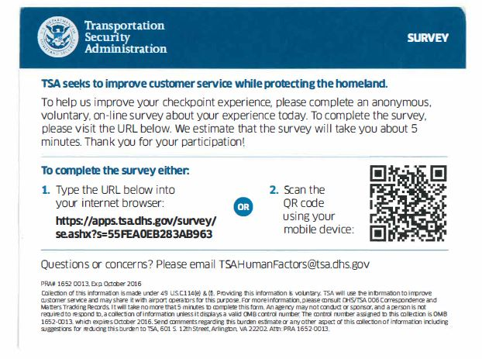

Paperwork Reduction Act Statement: TSA is collecting this information to assess passenger perception of the Walk Though Metal Detector- Advanced Imaging Technology Combination. The public burden for this voluntary collection of information is estimated to be approximately 1.5 minutes. An agency may not conduct or sponsor, and persons are not required to respond to a collection of information, unless it displays a valid OMB control number. The OMB control number assigned to this collection is 1652-0058, which expires 09/30/2022. Send comments regarding this burden estimate or collection to: TSA-11, Attention: PRA 1652-0058, Passenger Perception of Walk Though Metal Detector- Advanced Imaging Technology, 601 South 12th Street, Arlington, VA 20598-6011.

