U.S. Department of Education  
Office of Postsecondary Education



Teacher Shortage Areas (TSA)

Application Screenshots

**Executive Summary**

The Office of Postsecondary Education (OPE) in the U.S. Department of Education has developed the Teacher Shortage Areas (TSA) application to ensure the delivery of high-quality, timely, accurate, and responsive services to Chief State School Officers (CSSOs) and State representatives who provide the required data. The TSA Solution provides all customers and employees access to the same, current teacher shortage data from states and jurisdictions.

The system is designed to collect data from States and jurisdictions and generate Teacher Shortage Areas Reports intended to be reference documents that show where States and schools are looking to potentially hire academic administrators, licensed teachers, other educators and school faculty in specific disciplines/subject areas, grade levels, and/or geographic regions; and where recent graduates of Schools of Education are trained, experienced teaching professionals aiming to serve school districts with shortages can find (prospective) positions and fill the current voids in each State’s and territory’s Pre-Kindergarten through Grade 12 classrooms, in areas that match their certification credentials; as well as to inform Federal financial aid recipients on reducing, deferring, or cancelling/nullifying/discharging student loan repayments and meet other specified (e.g., teaching) obligations.

**Submit Teacher Shortage Areas**

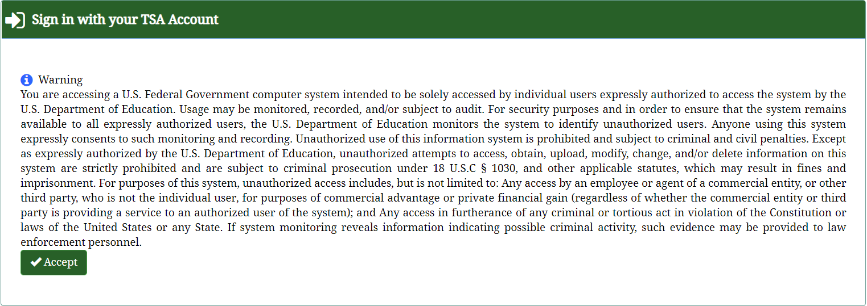

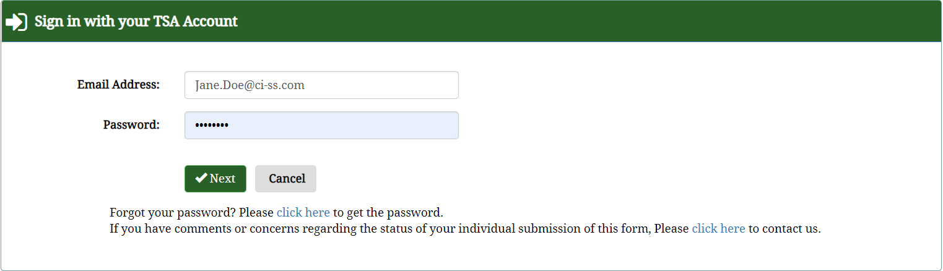

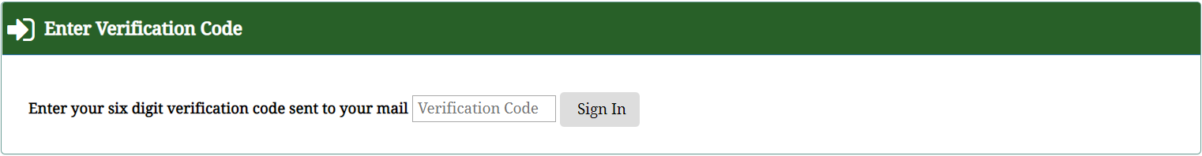

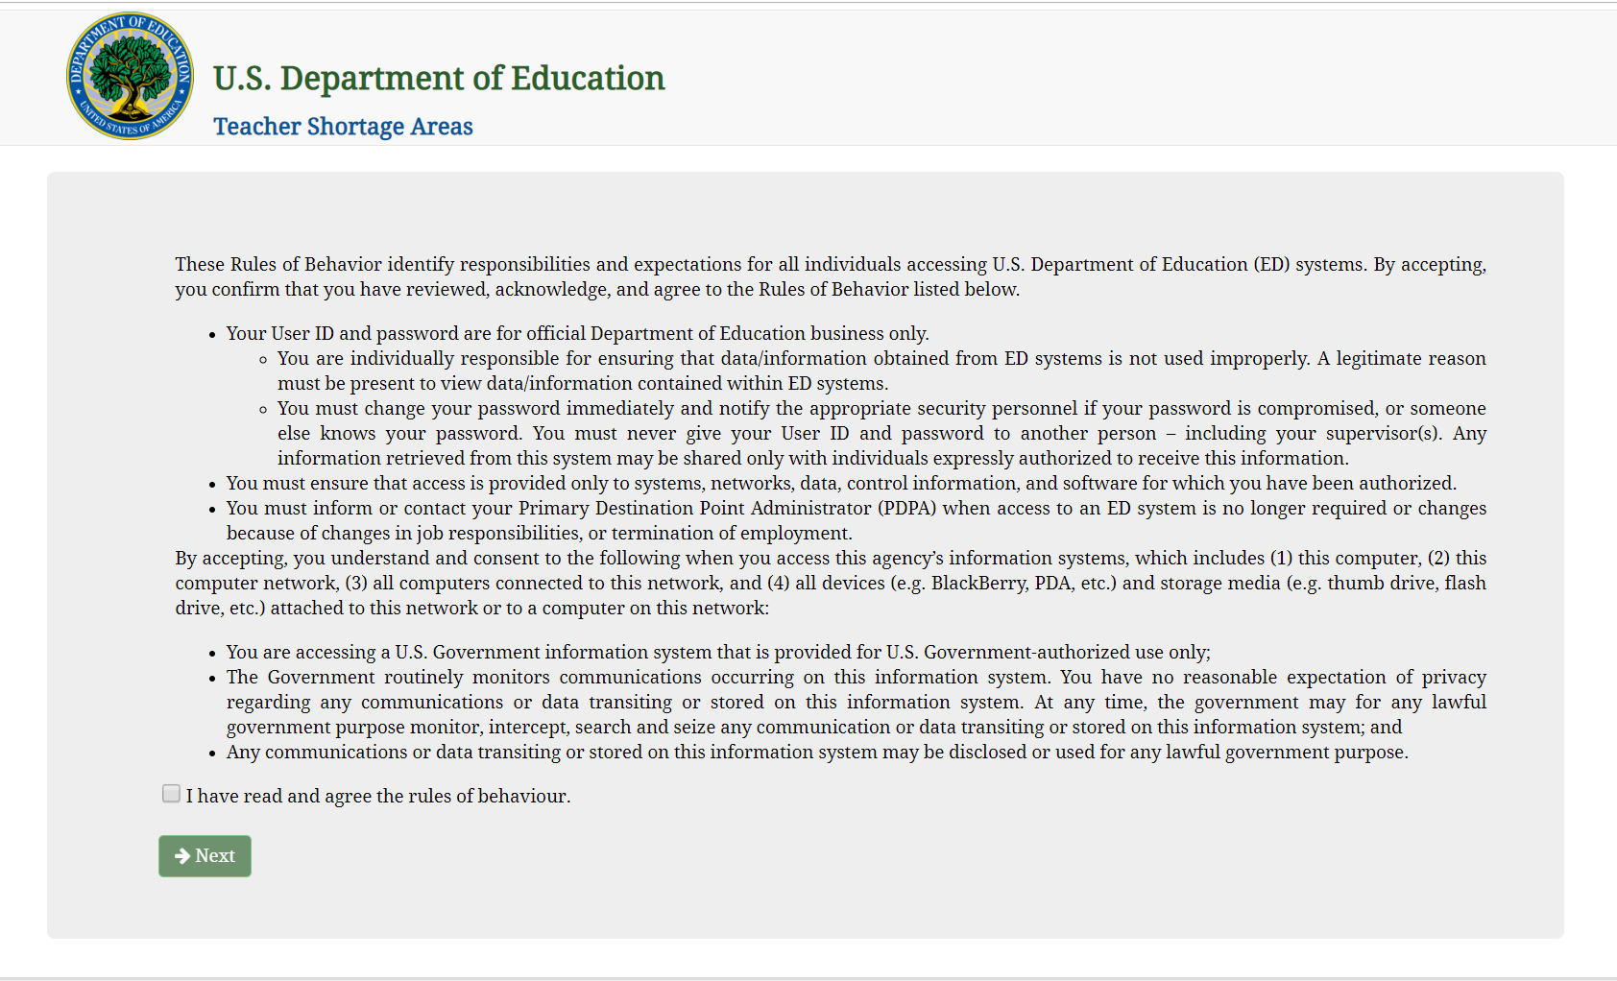

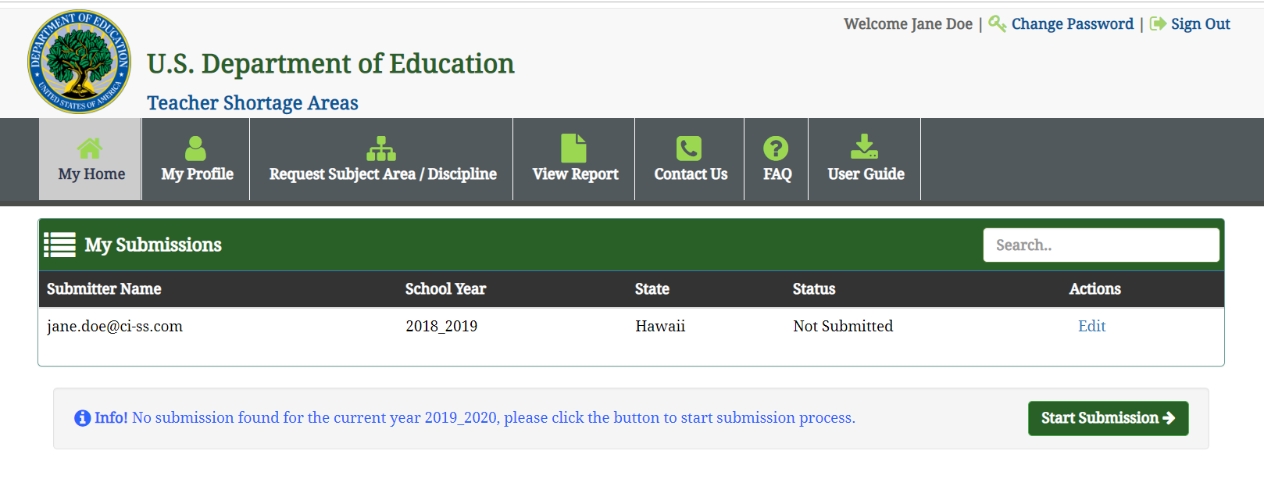



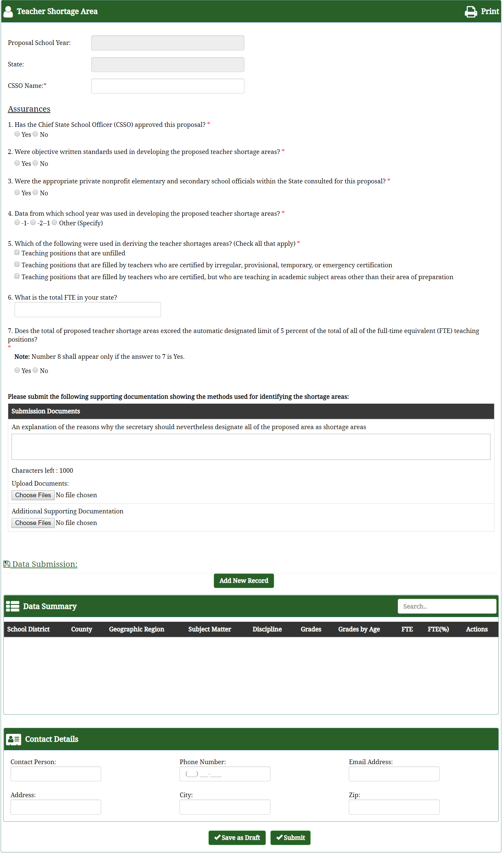

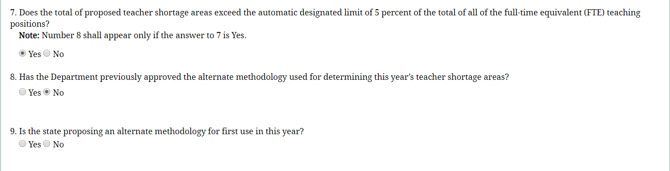

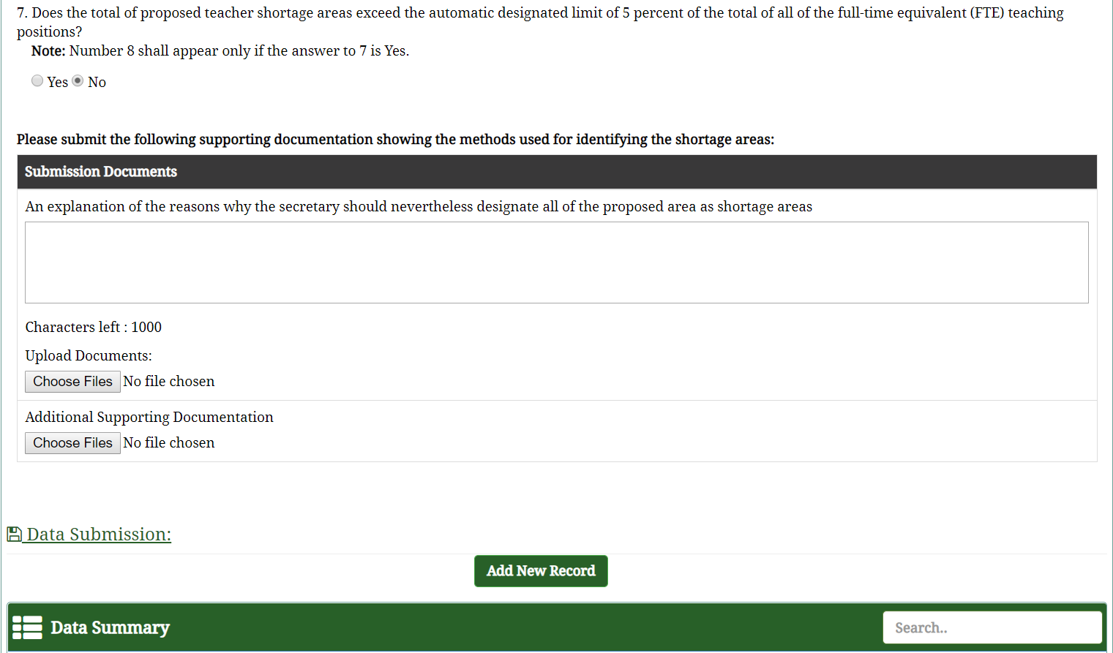

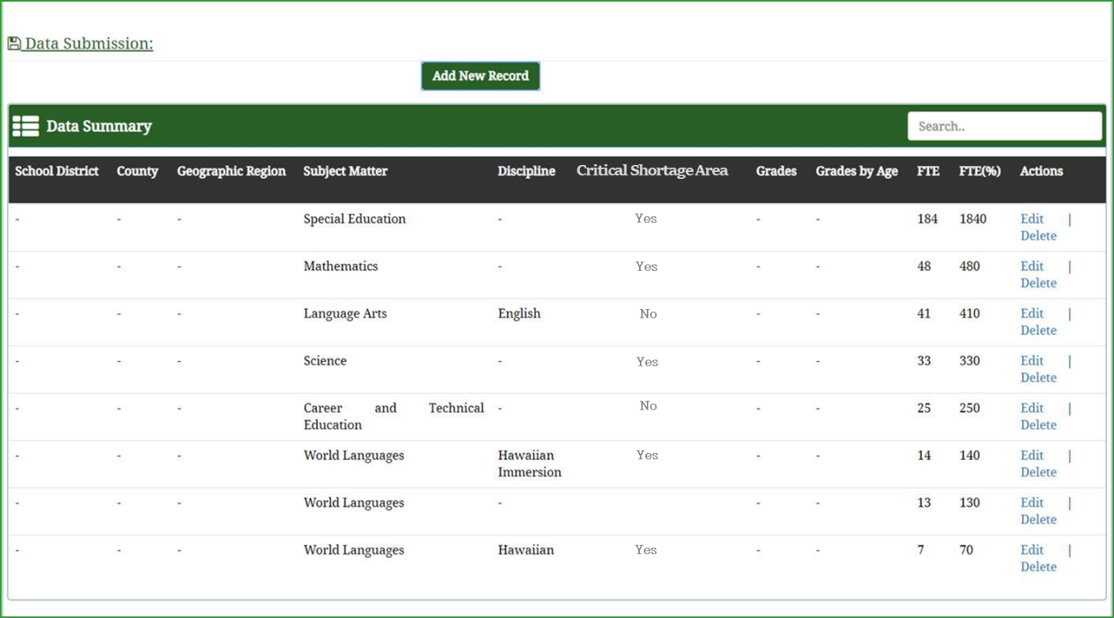

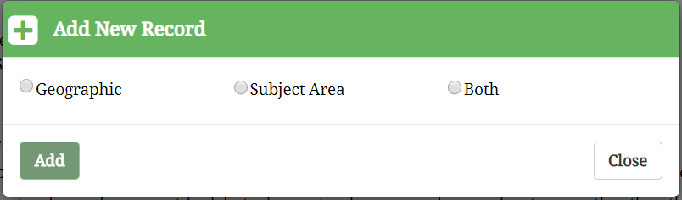

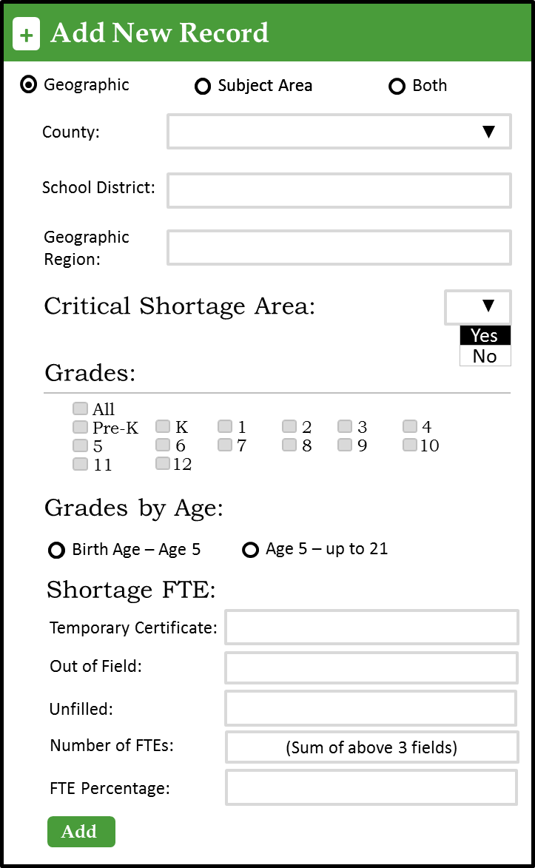

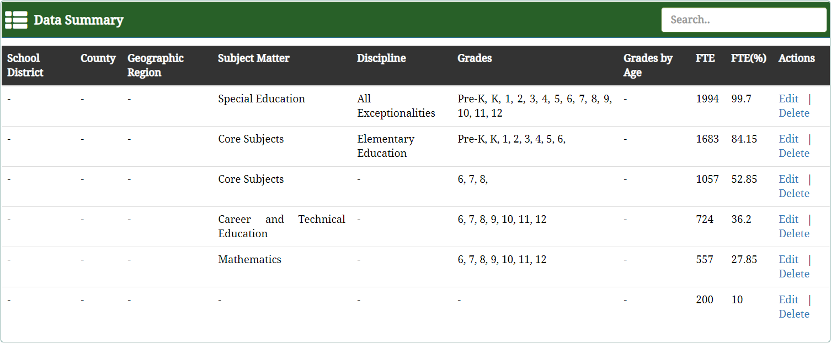

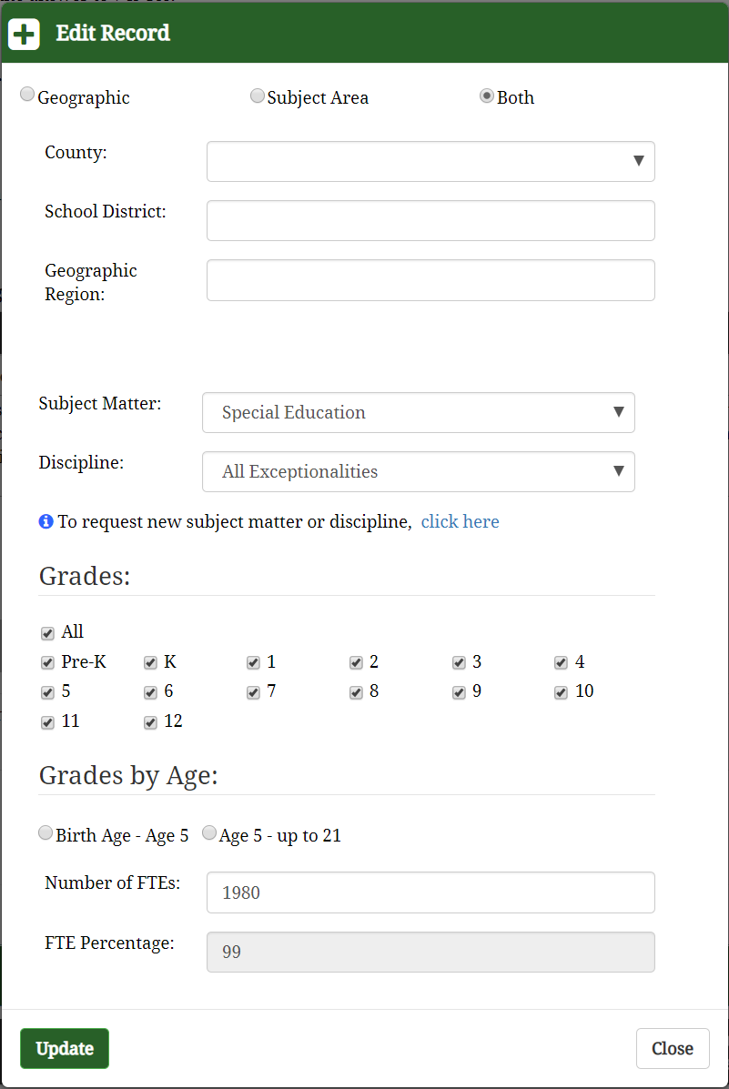

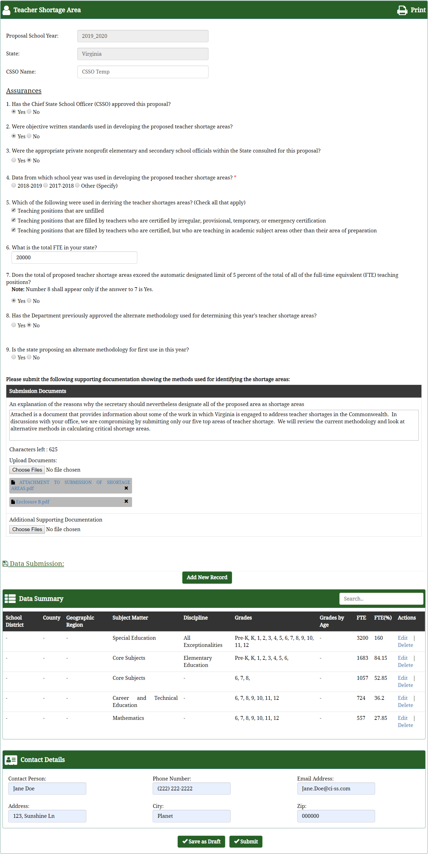

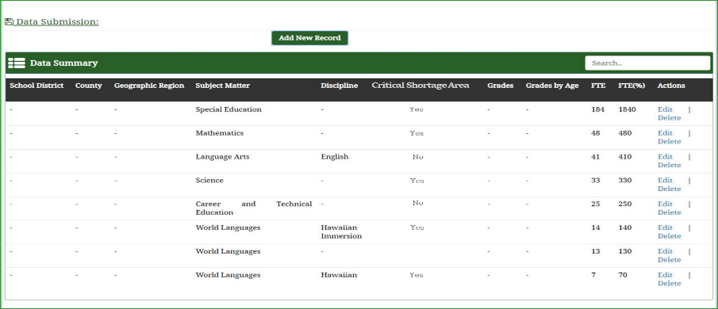

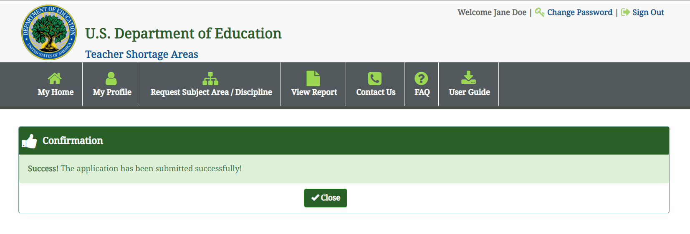

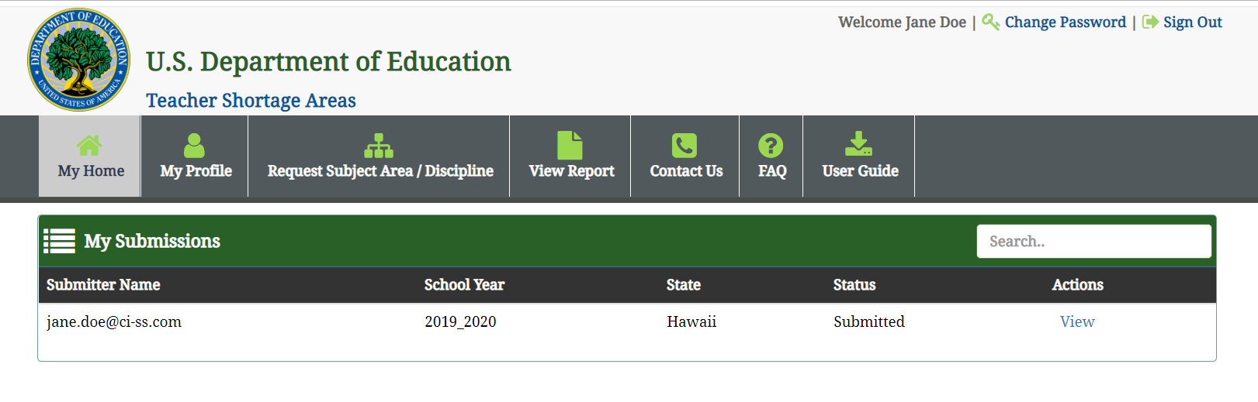

**User Registration**

