# Appendix B: Interview Guide for Cognitive Testing

**Title of the Information Collection (Study):** Cognitive Testing and Analysis of CFPB’s Financial Well-Being Scale in Spanish, Arabic, Chinese (Traditional), Haitian Creole, Korean, Russian and Tagalog.

## Introduction (5 minutes)

Hello, and thank you for participating in this interview today. My name is ____, and I work for the Federal Research Division (FRD) of the Library of Congress. My Division is working with the Consumer Financial Protection Bureau (CFPB), which is a U.S. government consumer protection agency. One of the things that the CFPB does is create educational materials that provide people with information they need to make informed financial decisions. Often, when they are developing those materials, they show them to people ahead of time, to get their feedback on how they can be improved. That is what we’ll be doing today—I’ll be showing you a document that has been translated and ask you for your thoughts and feedback on how well the document was translated.

Before we begin, I wanted to provide some ground rules for our session. First, if there are any questions that you prefer not to answer, that is okay. You do not need to answer. Second, if you need to take a break at any point, that is fine, we can pause if needed. Third, in addition to me, there are a few other people observing/listening in to this interview, both from FRD and from the CFPB. They will be listening to what you have to say and taking notes. Finally, we would also like to record this session, but the recording will not be shared with any outside parties and will be used only for research purposes pertaining to this project. Are you comfortable with us recording this interview? (*If participant is not comfortable with being recorded, continue with the session without recording.)*

I am also required to provide you with these statement regarding privacy and data collection policies. Please take a few minutes to read.

**Privacy Notice**

The responses you provide to the Library of Congress (LoC) will be used by the Consumer Financial Protection Bureau (CFPB) to determine if a CFPB resource is correctly translated in your language.

With your consent, LoC will record audio and video of your responses as you participate in the cognitive test. The recordings will only be shared within the LoC project team for transcription and research purposes.

Your feedback will be kept private and will not be linked to a direct personal identifier. Only information that is aggregated or de-identified will be shared with the CFPB. Additionally, the CFPB may publish de-identified reports based on the results of this study. None of your identifying information will be included in the reports.

This collection of information is authorized by Pub. L. No. 111-203, Title X, Sections 1013 and 1022, codified at 12 U.S.C. §§ 5493 and 5512.

Participation is voluntary, and you may withdraw participation at any time.

**Paperwork Reduction Act Statement**

According to the Paperwork Reduction Act of 1995, an agency may not conduct or sponsor a collection of information, nor is a person required to respond to a collection of information unless it displays a valid OMB control number. The OMB control number for this collection is 3170-0055.  The time burden required to complete this collection of information is estimated to be 1:30 minutes per response.  Comments regarding this collection of information (e.g comments regarding the time burden per response, suggestions for reducing the time burden per response, and/or suggestions for maximizing the utility of the collected information) should be submitted to the Consumer Financial Protection Bureau at [CFPB_PRA@cfpb.gov](mailto:PRA_Comments@cfpb.gov).

Do you have any questions before we begin?

**Interview Guide (60 minutes)**

## Review the Translation (55 minutes)

I would like to show you a questionnaire that the CFPB is developing. I’m going to ask you to look it over, and then I’m interested in getting your feedback on it. *Show participant the questionnaire, and give them control of the screen so that they can scroll through it at their own pace.*

I’d like you to start by just reading over the title, and the first section at the top. Let me know when you are done, and I’ll ask you some questions. *Give participant 1-2 minutes to review the first section, then continue.*

1. What are your first reactions to this questionnaire?
2. Is the meaning of the title clear to you?
   1. Based on what you have read so far, what do you think is contained in this questionnaire?
3. Who do you think this questionnaire is intended for? Who would be most likely to find it useful?
4. If you picked up this questionnaire and read this introduction, would you be likely to keep reading? Why or why not?

Now I’m going to give you a few minutes to look over the whole questionnaire, and then I will ask you some more questions about it. *Give participant a few minutes to review the resource.*

[Note: the specific questionnaire that participants will see will be in the interview language]

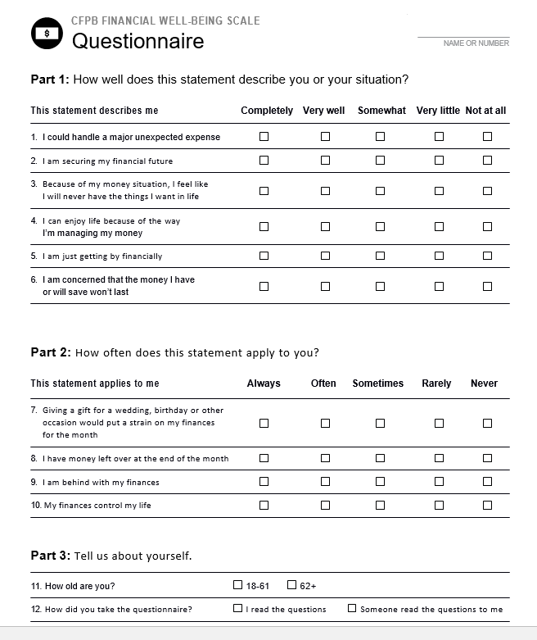

1. What questions, if any, do you have after reviewing this questionnaire?
2. Were there any parts of the questionnaire that you found confusing or difficult to understand? If so, what?
3. Which parts of the questionnaire, if any, did you find difficult to answer?
   1. Why?
   2. Which parts were the easiest to answer?
   3. Was there a question that caught your interest and attention?
4. When you were answering the questions, where you thinking about yourself, your household?
5. Do you think this questionnaire has the appropriate tone, given its content and intended audience?
   1. Why or why not?
6. What do you like about this questionnaire, if anything?
   1. Why?
7. What do you think could be improved about this questionnaire?
8. Are there words that you think could be confusing to people in your family or community? Where would you expect to find a questionnaire like this?
9. Who do you think can benefit answering questions like these?
   1. If you had to answer these questions, what would be your preference- online, on paper, or someone reading the questions to you?
   2. Why?

[*Note: At this point there may be additional questions to task about the content of specific JIT Guides. Those questions will be developed after the Guides are fully drafted.*]

## False Close (5 minutes)

*Inform the participant that you are going to take a couple of minutes to talk to the observers to see if they have any follow-up questions. Talk to the observers, and then return to the interview and ask any follow-up questions, and then conclude the interview.*