**Peace Corps Volunteer Application Screen Shots**

These screen shots are from the test environment, which is not yet 100% configured to the anticipated new application. Text edits and user testing are still pending. Screen shots represent the look and feel of the application, as well as the branching logic. Questions that only appear conditionally (based on branching logic) are called out in red boxes.

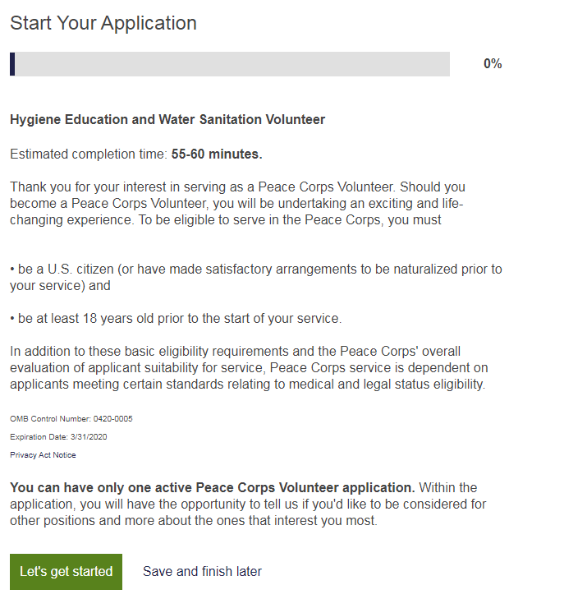

*Citizenship Page without Branching Logic*

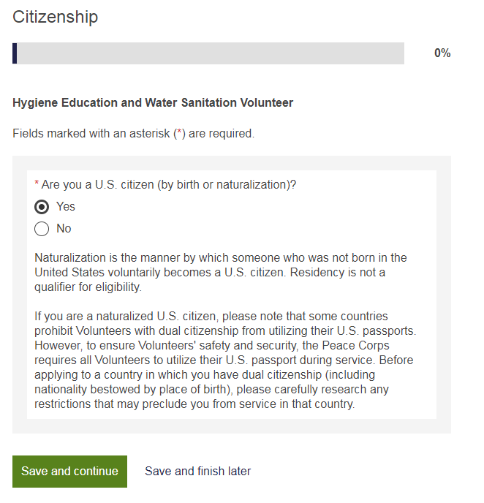

*Citizenship Page with Branching Logic*

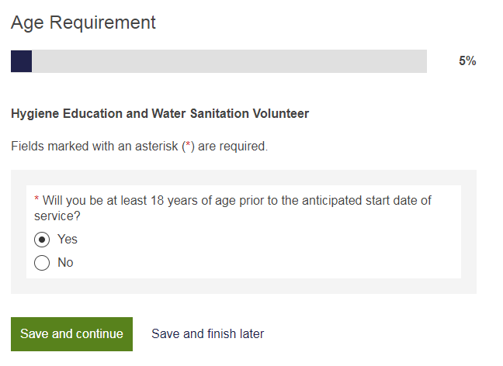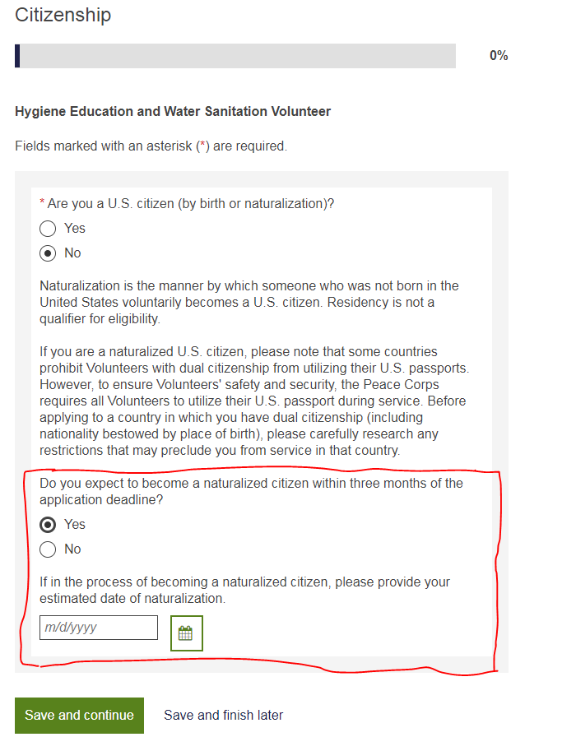

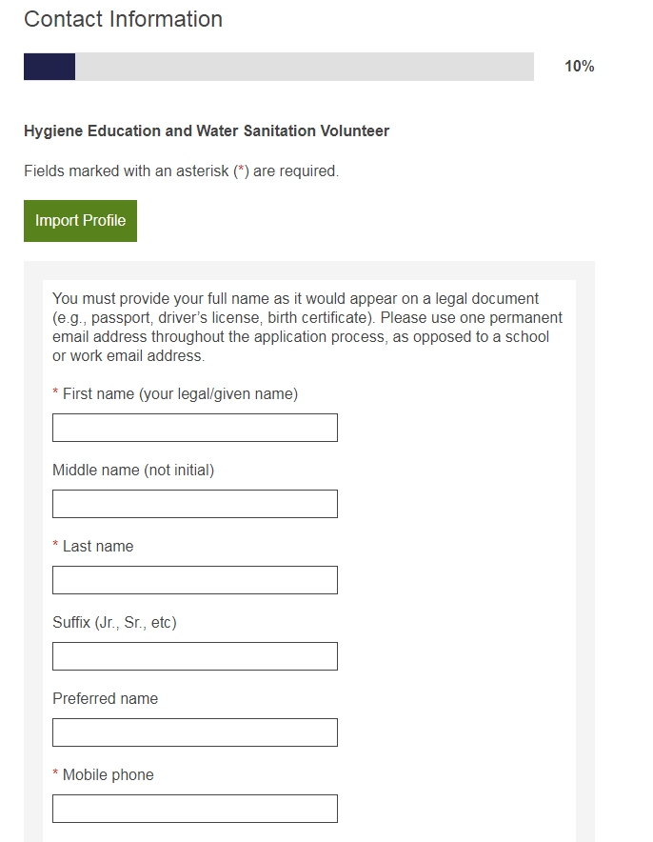

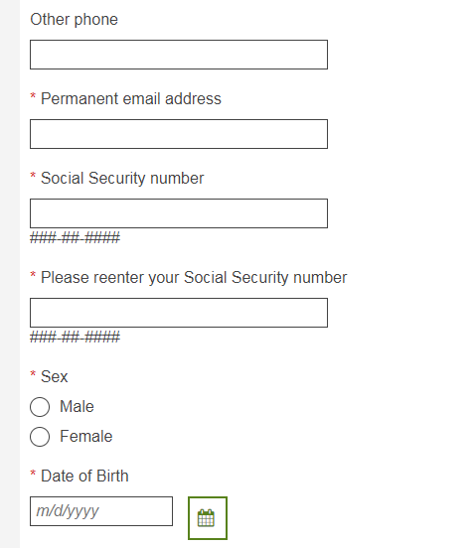

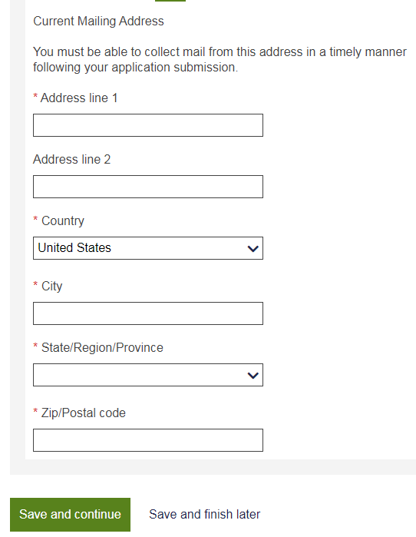

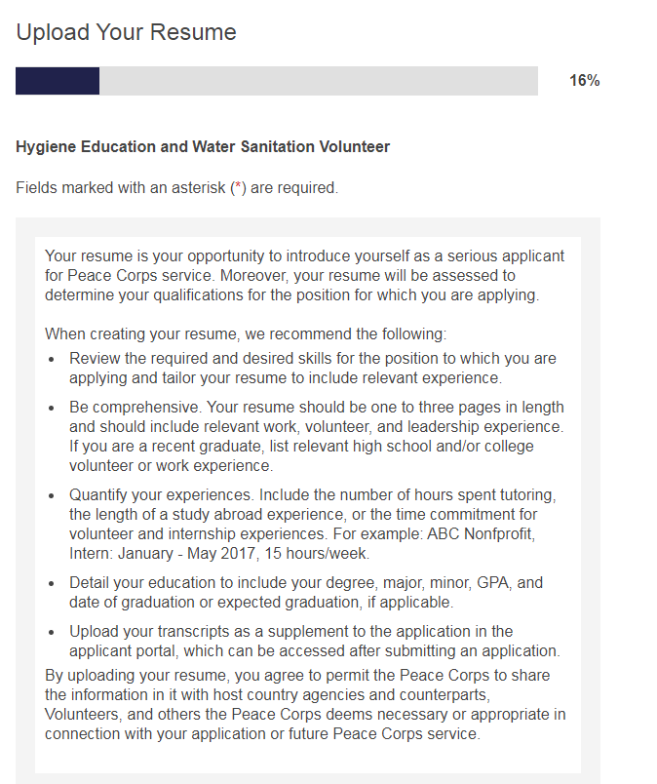



*Widget that is triggered by clicking the Add Resume/CV link, above*



*Previous Peace Corps History Page without Branching Logic*

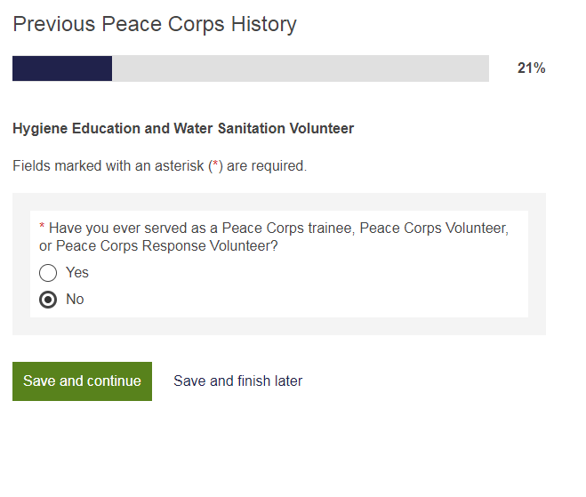

*Previous Peace Corps History Page with Branching Logic*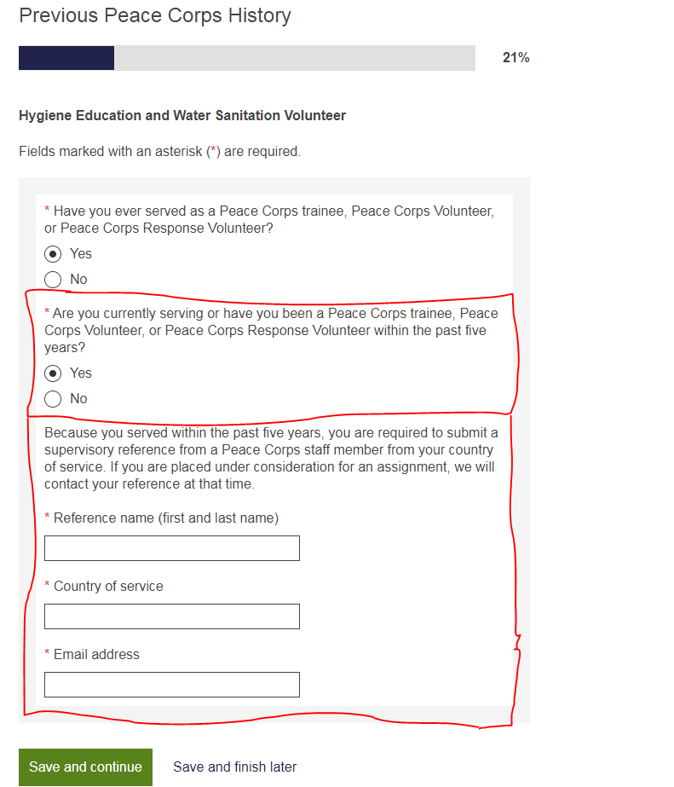

*Couples Page without Branching Logic*

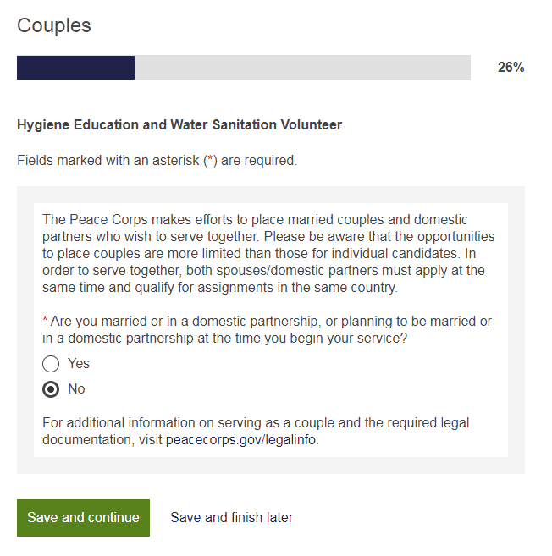

*Couples Page with Branching Logic (first branch)*

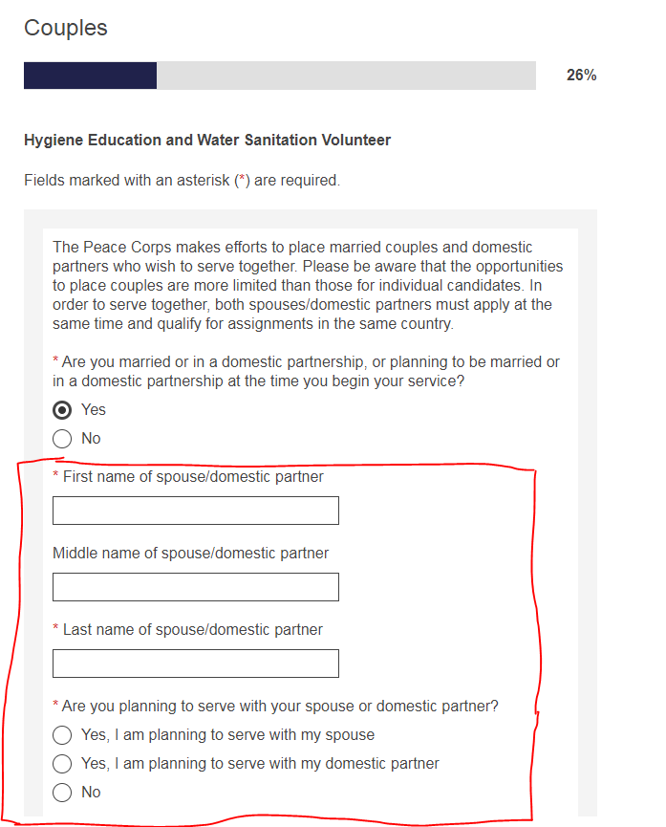

*Couples Page with Branching Logic (second branch branch)*

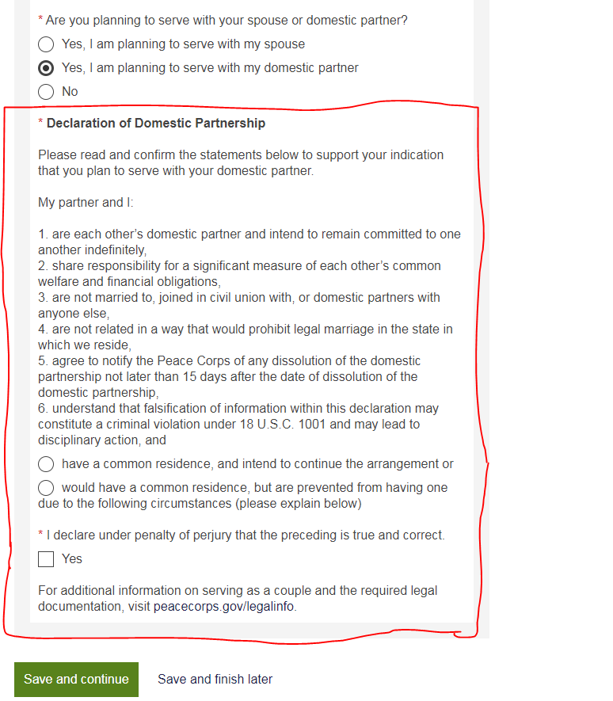

*Dependents Page without Branching Logic*

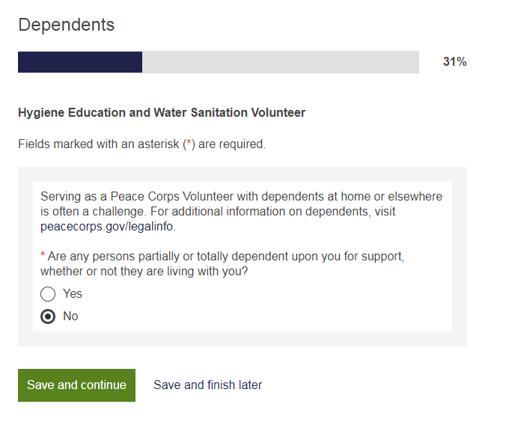

*Dependents Page with Branching Logic (answering “Yes” to additional dependent question will repeat branch to allow for additional dependents to be added).*

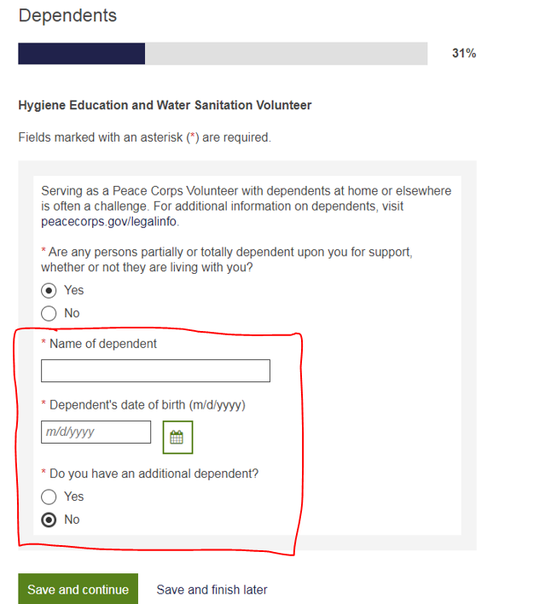

*Military Obligations Page without Branching Logic*

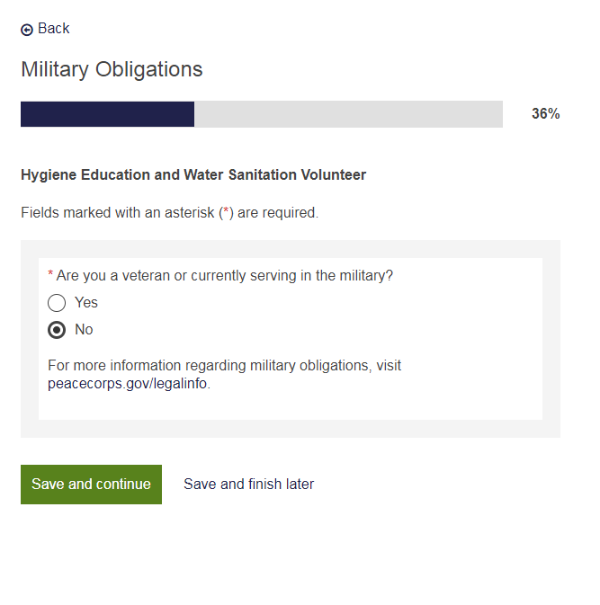

*Military Obligations Page with Branching Logic*

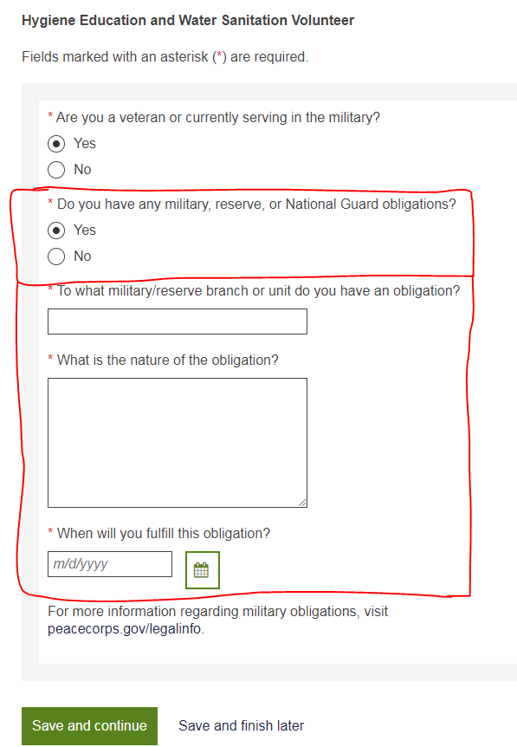

*Legal History Page without Branching Logic*

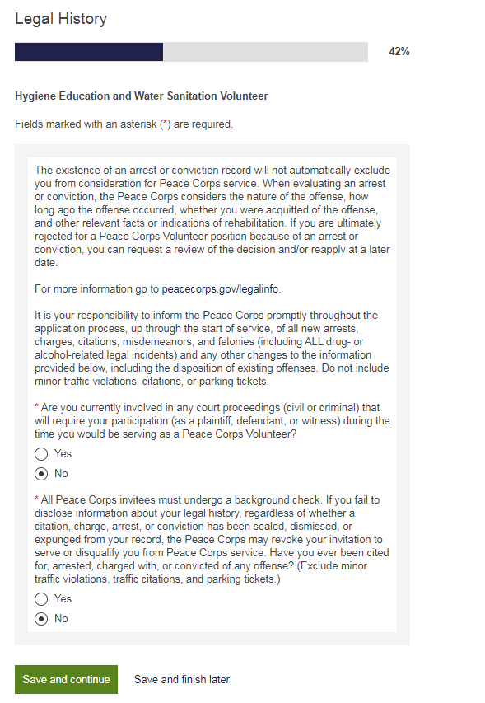

*Legal History Page with Branching Logic (answering “Yes” to other legal incidents question will repeat branch to allow for additional incidents to be added).*

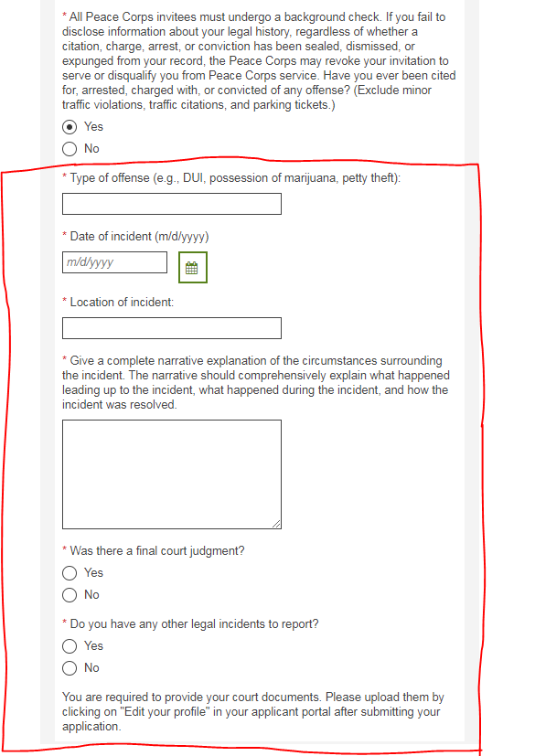

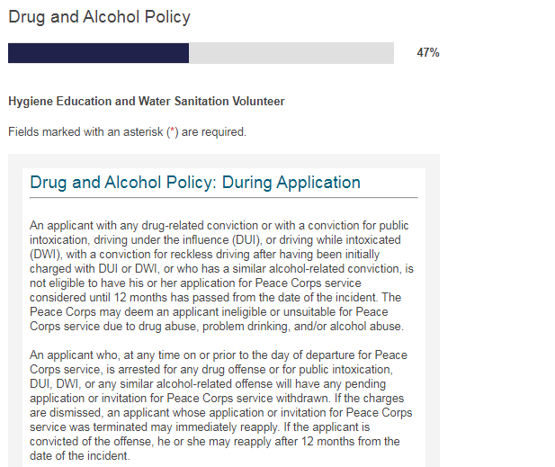

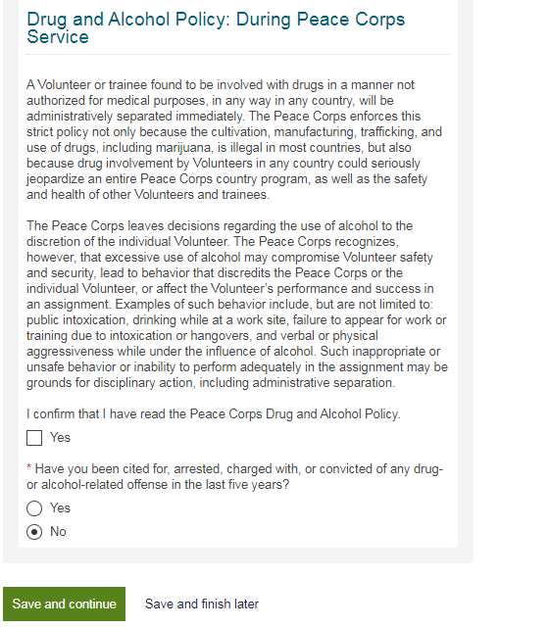

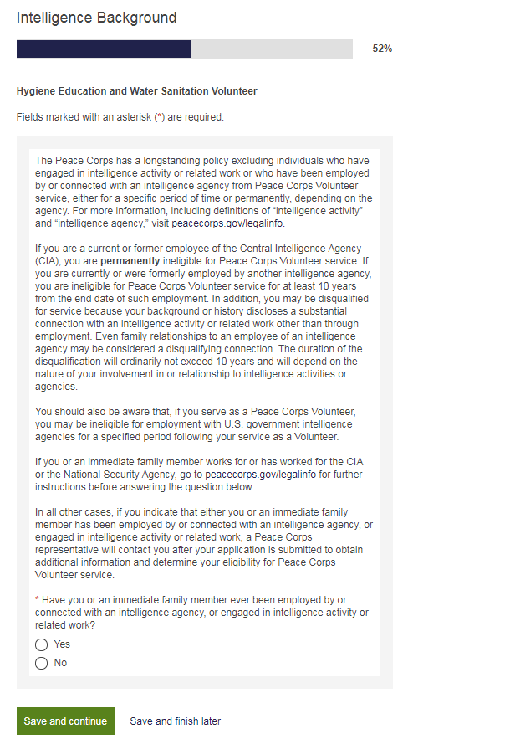

*Education Page without Branching Logic*

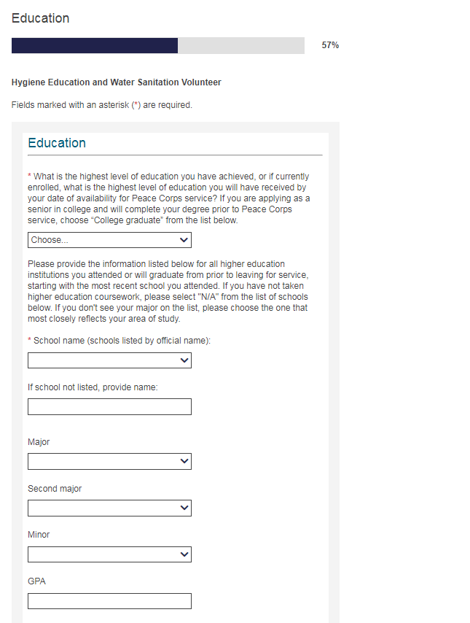

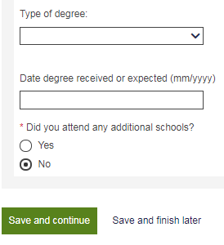

*Education Page with Branching Logic (“Additional schools” question will duplicate branch to allow applicant to list multiple schools).*

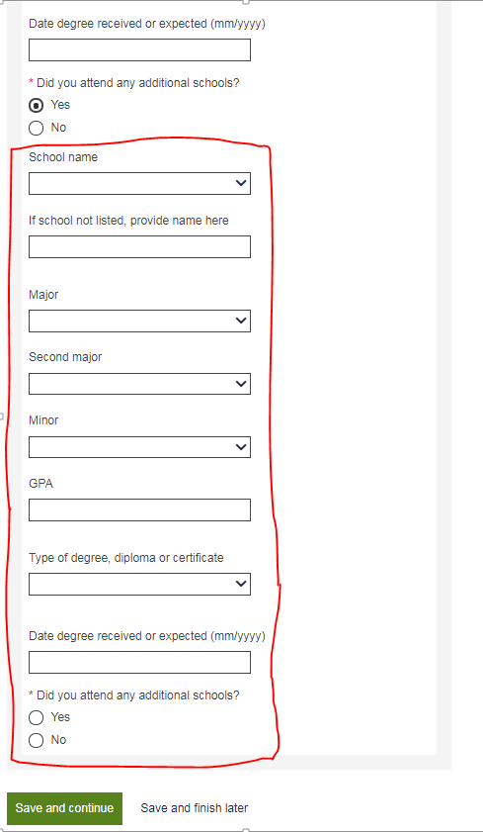

*Peace Corps Prep Page without Branching Logic*

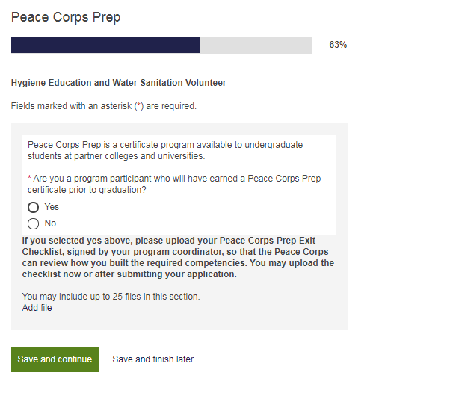

*Peace Corps Prep Page with Branching Logic*

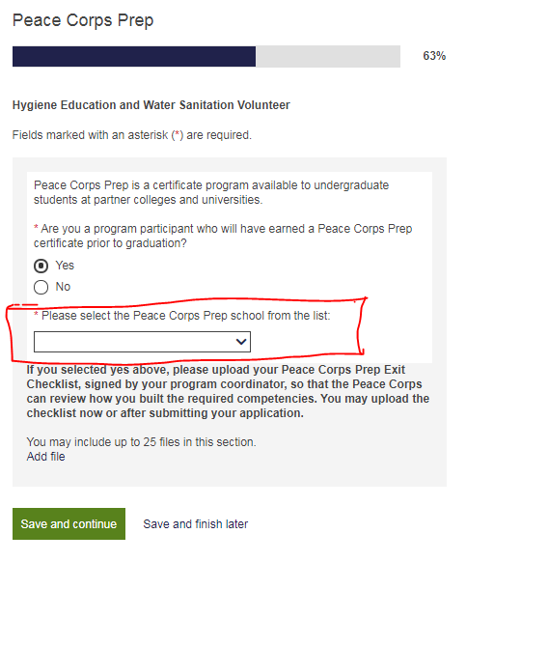

*Widget launched when candidates click “Add file”, above:*

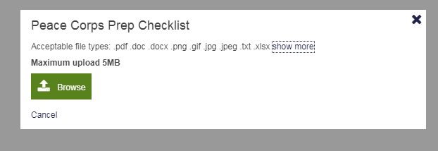

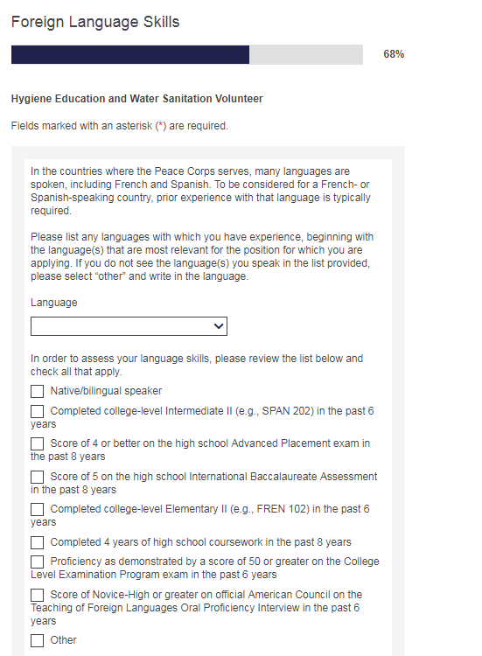

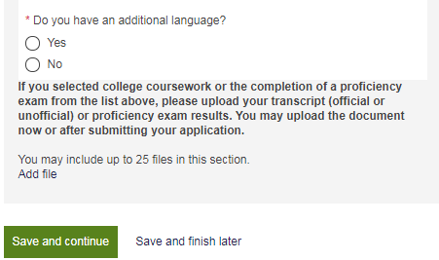

*Widget launched when candidates click “Add file”, above:*



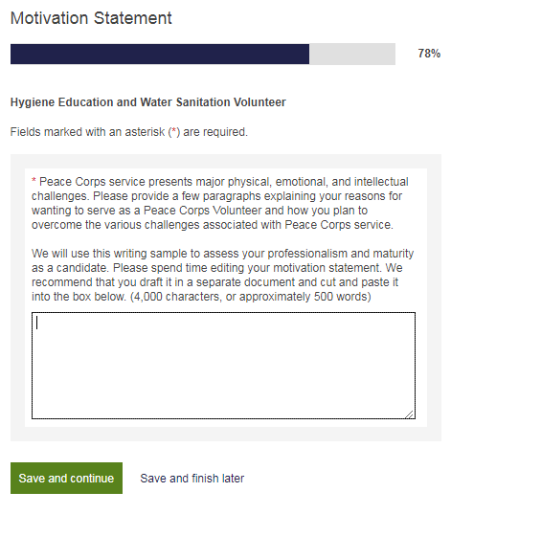

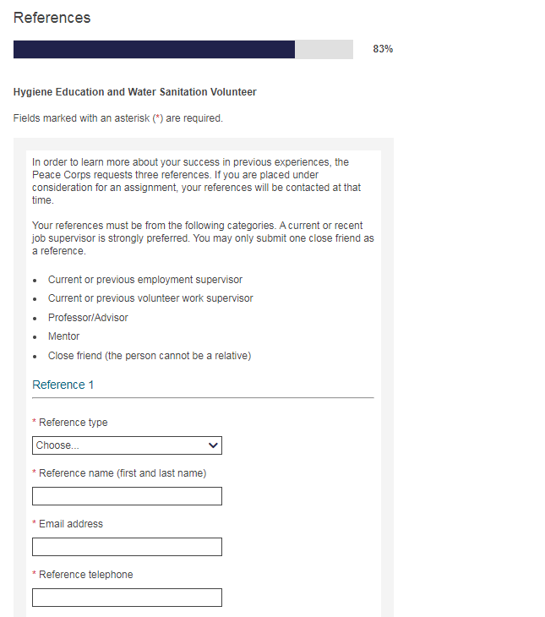

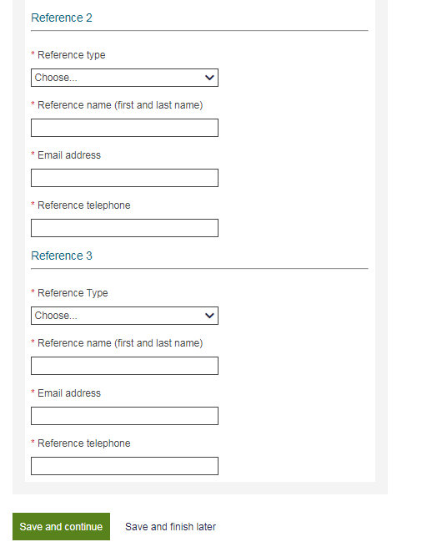

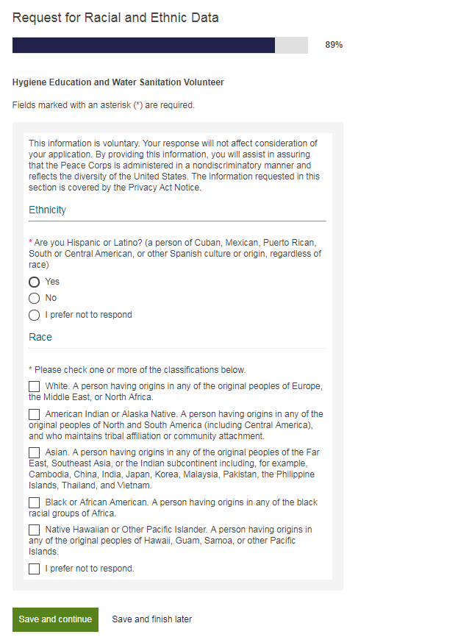

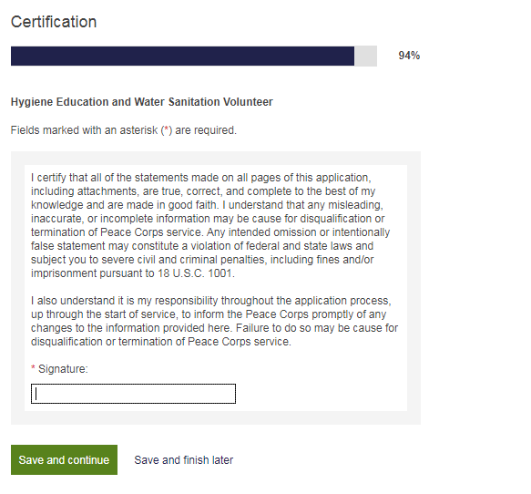

*Review page scrolls to allow candidate to review/edit all responses*

