Attachment C. FTP Site Instructions for Submitting Administrative Data
OMB No. 0584-[NEW]
Job Search as a Supplemental Nutrition Assistance Program (SNAP) Employment and Training (E&T) Component
January 13, 2020
Project Officer: Danielle Deemer
Office of Policy Support
Food and Nutrition Service
U.S. Department of Agriculture
1320 Braddock Place
Alexandria, VA 22314
703.305.2952
danielle.deemer@usda.gov

Email With FTP Site Address and User Name
Dear [State or E&T Provider DATABASE ADMINISTRATOR],
Thank you for your continued cooperation with The Role of Job Search as a SNAP E&T Component project. Please submit your data files using the SNAP Job Search FTP site.
SNAP Job Search FTP site link: http://snap.insightpolicyresearch.com
Your username is: [USERNAME]
Your password will be sent to you in a separate email.
For detailed submission instructions, please see the Administrative Data Submission Instructions and Variable List.
If you are unable to submit data files via the FTP site, please contact [PROJECT MANAGER NAME] at [PHONE NUMBER] or [EMAIL ADDRESS].
Sincerely,
[PROJECT MANAGER NAME]

Screenshot of website homepage:
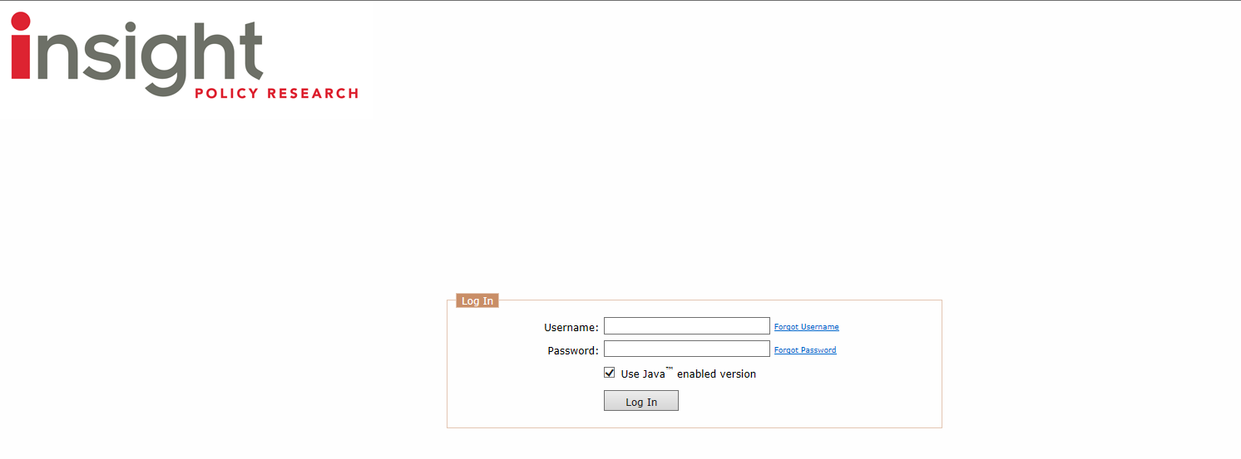
According to the Paperwork Reduction Act of 1995, an agency may not conduct or sponsor, and a person is not required to respond to, a collection of information unless it displays a valid OMB control number. The valid OMB control number for this information collection is 0584-xxxx. The time required to complete this information collection is estimated to average 2 minutes per response, including the time for reviewing instructions, searching existing data sources, gathering and maintaining the data needed, and completing and reviewing the collection of information. Send comments regarding this burden estimate or any other aspect of this collection of information, including suggestions for reducing this burden, to the following address: U.S. Department of Agriculture, Food and Nutrition Services, Office of Policy Support, 1320 Braddock Place, Alexandria, VA 22314, ATTN: PRA (0584-xxxx). Do not return the completed form to this address.

